**Class-16**

Date: 04-01-2024

HTML Iframe Syntax

## Iframe - Set Height and Width

Use the height and width attributes to specify the size of the iframe.

The height and width are specified in pixels by default:

### Example

<iframe src="demo_iframe.htm" height="200" width="300" title="Iframe Example"></iframe>

## Iframe - Remove the Border

By default, an iframe has a border around it.

To remove the border, add the style attribute and use the CSS border property:

### Example

<iframe src="demo_iframe.htm" style="border:none;" title="Iframe Example"></iframe>

With CSS, you can also change the size, style and color of the iframe's border:

### Example

<iframe src="demo_iframe.htm" style="border:2px solid red;" title="Iframe Example"></iframe>

## Iframe - Target for a Link

An iframe can be used as the target frame for a link.

The target attribute of the link must refer to the name attribute of the iframe:

### Example

<iframe src="demo_iframe.htm" name="iframe_a" title="Iframe Example"></iframe>  
  
<p><a href="https://www.w3schools.com" target="iframe_a">W3Schools.com</a></p>

# HTML Layout Elements and Techniques

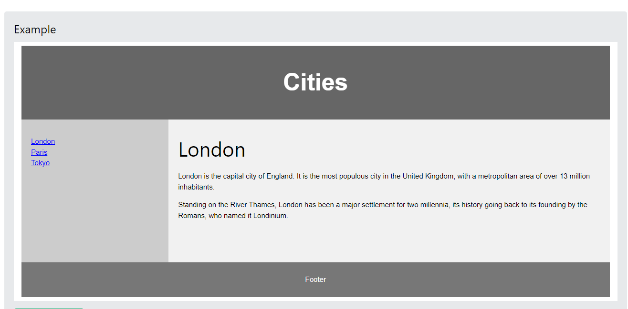

# HTML Forms

The <form> Element

The HTML <input> element is the most used form element.

An <input> element can be displayed in many ways, depending on the type attribute.

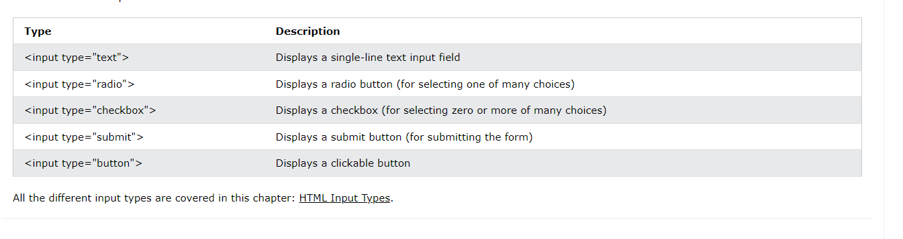

The <label> Element

Notice the use of the <label> element in the example above.

The <label> tag defines a label for many form elements.

The <label> element is useful for screen-reader users, because the screen-reader will read out loud the label when the user focuses on the input element.

The <label> element also helps users who have difficulty clicking on very small regions (such as radio buttons or checkboxes) - because when the user clicks the text within the <label> element, it toggles the radio button/checkbox.

The for attribute of the <label> tag should be equal to the id attribute of the <input> element to bind them together.

## Radio Buttons

The <input type="radio"> defines a radio button.

Radio buttons let a user select ONE of a limited number of choices.

### Example

A form with radio buttons:

<p>Choose your favorite Web language:</p>  
  
<form>  
  <input type="radio" id="html" name="fav_language" value="HTML">  
  <label for="html">HTML</label><br>  
  <input type="radio" id="css" name="fav_language" value="CSS">  
  <label for="css">CSS</label><br>  
  <input type="radio" id="javascript" name="fav_language" value="JavaScript">  
  <label for="javascript">JavaScript</label>  
</form>

## Checkboxes

The <input type="checkbox"> defines a **checkbox**.

Checkboxes let a user select ZERO or MORE options of a limited number of choices.

### Example

A form with checkboxes:

<form>  
  <input type="checkbox" id="vehicle1" name="vehicle1" value="Bike">  
  <label for="vehicle1"> I have a bike</label><br>  
  <input type="checkbox" id="vehicle2" name="vehicle2" value="Car">  
  <label for="vehicle2"> I have a car</label><br>  
  <input type="checkbox" id="vehicle3" name="vehicle3" value="Boat">  
  <label for="vehicle3"> I have a boat</label>  
</form>

## The Submit Button

The <input type="submit"> defines a button for submitting the form data to a form-handler.

The form-handler is typically a file on the server with a script for processing input data.

The form-handler is specified in the form's action attribute.

### Example

A form with a submit button:

<form action="/action_page.php">  
  <label for="fname">First name:</label><br>  
  <input type="text" id="fname" name="fname" value="John"><br>  
  <label for="lname">Last name:</label><br>  
  <input type="text" id="lname" name="lname" value="Doe"><br><br>  
  <input type="submit" value="Submit">  
</form>