Challenge:

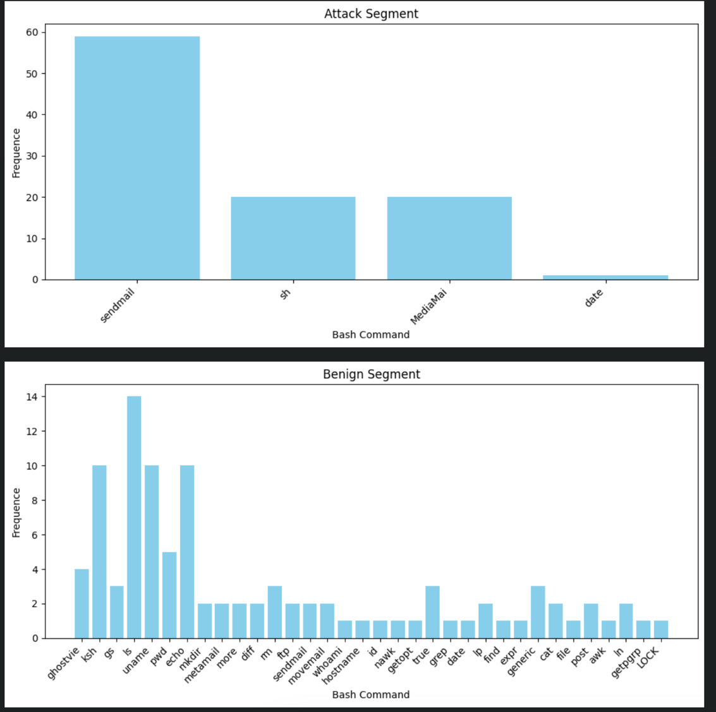
After reviewing the challenge, we first start to analyse the data using simple logic. Manually check for suspicious cli commands using our understanding; we notice there is no significance between the commands themselves. However, we’ve noticed a difference in frequency distribution within segments (as can be seen in Fig. 0)).

As we can see from the attack s segment, the number of unique commands is a lot smaller, but the frequency is much higher compared to the benign sample; therefore, we deduced that a simple TF-IDF will be a good start. After future analysis, we noticed the order of command is impartment, and therefore we utilised the n-gramme model for feature extraction. Afterward, we used the simple ‘RandomForestClassifier’ for our final solution.

