//happy no
//Happy Number are positive non-zero integer numbers.
//If we find the sum of the squares of its every digit and repeat that process until the number will be equals to 1(one).
//Otherwise, it is called Unhappy Number or Sad Number.
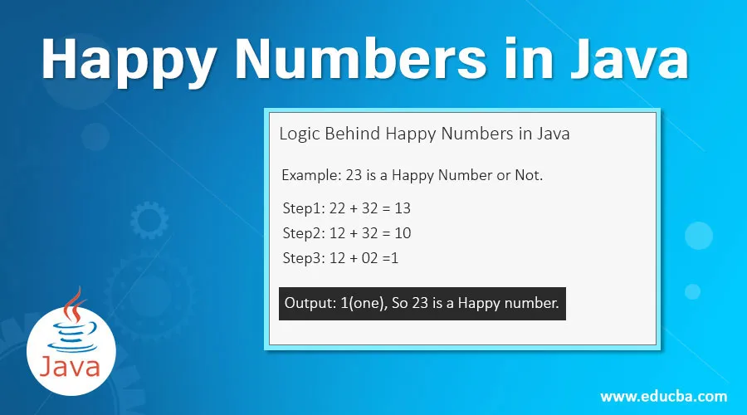

Goldbach Number in Java
In this section, we will learn what is a Goldbach number and also create Java programs to check if the given number is Goldbach or not. The Goldbach number Java program frequently asked in Java coding tests to check the logic of the programmer.
In 1742, German mathematician Christian Goldbach proposed speculation that all prime numbers that are greater than 2 can be expressed as the sum of 2 odd prime numbers. It is speculation because there is no proof for the same.

Goldbach Number
A positive and even number is called a Goldbach number if the number can be expressed as the sum of two odd prime numbers. Note that all even integers greater than 4 are Goldbach numbers.

Goldbach Number Example
6 = 3 + 3
14 = 7 + 7 and 11 + 3
30 = 23 + 7, 11 + 19, and 13 + 17
28 = 11 + 17
12 = 7 + 5
10 = 5 + 5 and 7 + 3
We see that the numbers are positive and even, expressed as the sum of odd numbers.

Steps to Find Goldbach Number
- Read or initialize a number N.
- Store it in another variable.
- Check if the given number N is even or not.
- If the number is odd, print "Invalid input".
- If the number is even, follow the procedure given below:
  - Define two arrays one for storing the prime numbers and the other for calculating the prime number.
  - Find all prime numbers till the entered number using a for loop and store it in an array.
  - In the second array, store only odd prime numbers using if statement.
  - Display the odd prime pairs.
- By using the for loop, store the sum of two odd prime numbers in a variable (sum).
- Using the if statement, compare the sum with the original number N. If the sum is equal to the original number, the given number N is Goldbach Number, else not.

Buzz Number Java
Buzz number is another special number in Java that ends with digit 7 or divisible by 7. Unlike Prime and Armstrong numbers, the Buzz number is not so popular and asked by the interviewers.
In simple words, a number is said to be Buzz if it ends with 7 or is divisible by 7.
Let's take some examples of Buzz numbers.
- 42 is a Buzz number because it is divisible by 7.
- 107 is a Buzz number because it ends with 7.
- 147 is a Buzz number because it ends with 7 and also divisible by 7.
- 134 is not a Buzz number because it is neither end with 7 nor divisible by 7.
These are the following steps that we use to check whether the given number is a Buzz number or not.
- We first take a number.
- We then find the last digit of the number and check whether it is equals to 7 or not. If it equals 7, print "the number is a Buzz" number.
- We then find the remainder of the number with 7. If the remainder equal to 0, print "the number is a Buzz number".
- Else print "number is not a buzz number".
Let's implement a program to check whether the user entered number is a Buzz number or not.

Automorphic Number Program in Java
In this section, we will learn automorphic numbers with examples and also create Java programs that check whether the number is automorphic or not.

What is an automorphic number?
A number is called an automorphic number if and only if the square of the given number ends with the same number itself. For example, 25, 76 are automorphic numbers because their square is 625 and 5776, respectively and the last two digits of the square represent the number itself. Some other automorphic numbers are 5, 6, 36, 890625, etc.

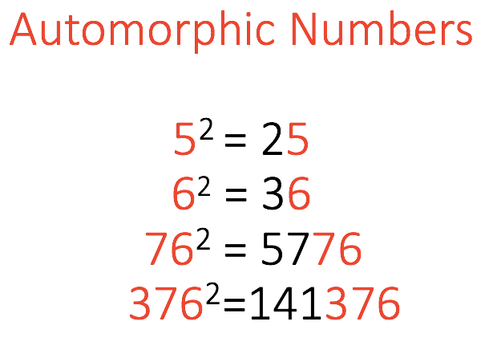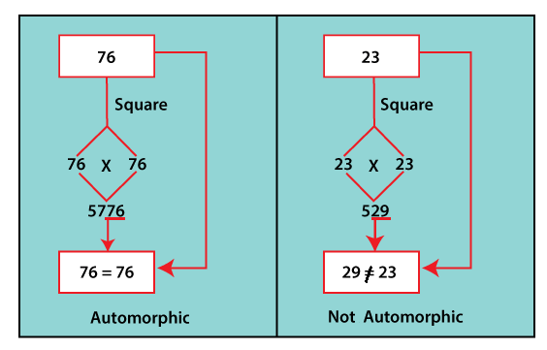

How to find automorphic number?
Follow the steps given below:
- Read a number (num) from the user.
- Find the square of the given number and store it in a variable (square).
- Find the last digit(s) of the square.
- Compare the last digit(s) of the variable with num.
  - If they are not equal, the given number is not an automorphic number.
  - If they are the same, go to the next step.
- Remove the last digit of the given number i.e. num.
- Repeat steps 4 to 6 until the given number becomes 0.

Armstrong Number in Java
In this section, we will discuss what is Armstrong number and also create Java programs to check if the given number is an Armstrong number or not. The Armstrong number program frequently asked in Java coding interviews and academics.

Armstrong Number
An Armstrong number is a positive m-digit number that is equal to the sum of the m^{th} powers of their digits. It is also known as pluperfect, or Plus Perfect, or Narcissistic number. It is an OEIS sequence A005188. Let’s understand it through an example.

Armstrong Number Example
1: 1¹ = 1
2: 2¹ = 2
3: 3¹ = 3
153: 1³ + 5³ + 3³ = 1 + 125+ 27 = 153
125: 1³ + 2³ + 5³ = 1 + 8 + 125 = 134 (Not an Armstrong Number)
1634: 1⁴ + 6⁴ + 3⁴ + 4⁴ = 1 + 1296 + 81 + 256 = 1643
Similarly, we can check other number also.
The first few Armstrong numbers between 0 to 999 are 1, 2, 3, 4, 5, 6, 7, 8, 9, 153, 370, 371, 407. Some other Armstrong numbers are 1634, 8208, 9474, 54748, 92727, 93084, 548834, 1741725, 4210818, 9800817, 9926315, 24678050, 24678051, 88593477, 146511208, 472335975, 534494836, 912985153, 4679307774, 32164049650, 32164049651.

Harshad number
A number is said to be the Harshad number if it is divisible by the sum of its digit.
For example, if number is 156, then sum of its digit will be 1 + 5 + 6 = 12. Since 156 is divisible by 12. So, 156 is a Harshad number.
Some of the other examples of Harshad number are 8, 54, 120, etc.
To find whether the given number is a Harshad number or not, calculate the sum of the digit of the number then, check whether the given number is divisible by the sum of its digit. If yes, then given number is a Harshad number.

Algorithm
- Define and initialize variable num.
- Make a copy of the num by storing the value of num in variable n.
- If num is greater than 0, then calculate the remainder by dividing num with 10.
- Add rem to a variable sum.
- Divide num by 10.
- Repeat the steps from 3 to 5, to calculate the sum of all digits present in a given number.
- If n (copy of original number) is divisible by the sum, then given number is a Harshad number. Else, given number is not a Harshad number.

Composite Number

A composite number is a positive integer that is not prime. In other words, it has a positive divisor other than one or itself. First few composite numbers are 4, 6, 8, 9, 10, 12, 14, 15, 16, 18, 20, ………
- Every integer greater than one is either a prime number or a composite number.
- The number one is a unit – it is neither prime nor composite.
How to check if a given number is a composite number or not?

Magic Number in Java
In programming, a magic number is a numeric value that is used directly in the code. It is used for identification purposes. In this section, we will discuss what is a magic number and how can we find a magic number through a Java program.

Magic Number in Programming
A magic number is a hard-coded numeric value (text value in some cases) in the code that may change at a later stage. It seems like arbitrary and has no context or meaning. It is hard to update

Magic Number in Mathematics
In mathematics, if the sum of its digits recursively is calculated till a single digit. If the single digit is 1 then the number is called a magic number. It is quite similar to the happy number.
For example, 325 is a magic number because the sum of its digits (3+2+5) is 10, and again sum up the resultant (1+0), we get a single digit (1) as the result. Hence, the number 325 is a magic number.
Some other magic numbers are 1234, 226, 10, 1, 37, 46, 55, 73, etc.
Note that if a number is a magic number then all the possible combinations of the number will also be the magic numbers.
For example, 532, 253, 325, 235, 352, 523 the sum of digits of all the numbers gives 10 and again sum up the resultant (1+0), we get a single-digit i.e. 1. Hence, we can say that the magic number and its combinations are also magic.
Let's implement the above logic in a Java program and check whether the given number is magic or not.

Ugly number Java
The Ugly number is another special positive number in Java. If a number has only 2, 3, or 5 prime factors and by convention 1 is also included, the number is called Ugly number.
Let's take some examples of Ugly numbers.
- 27 is not an Ugly number because its prime factors contain 7.
- 12 is an Ugly number because its prime factors are 2 and 3.
- 28 is also not an Ugly number because its prime factors also contain 7.
- 16 is an Ugly number because its prime factors only contain 2.

Ugly number Java
The Ugly number is another special positive number in Java. If a number has only 2, 3, or 5 prime factors and by convention 1 is also included, the number is called Ugly number.
Let's take some examples of Ugly numbers.
- 27 is not an Ugly number because its prime factors contain 7.
- 12 is an Ugly number because its prime factors are 2 and 3.
- 28 is also not an Ugly number because its prime factors also contain 7.
- 16 is an Ugly number because its prime factors only contain 2.

The simple method using for loop
In this method, we use the loop for each positive number until the Ugly number count is not greater than n. We increment the counter variable when the number is Ugly, and to check whether the number is Ugly or not, we divide the number by the greatest divisible powers of 2, 3, and 5. When the number becomes 1, it is an Ugly number. Otherwise, it is not an Ugly number.
Let's implement the code to get Nth Ugly number in Java.

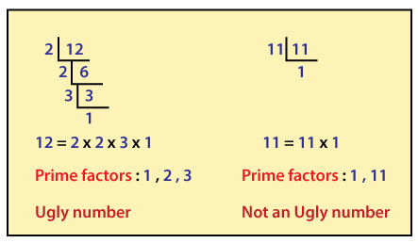

Krishnamurthy Number Java
Krishnamurthy number is another special number in Java. A number is said to be Krishnamurthy if the factorial sum of all its digits is equal to that number. Krishnamurthy number is also referred to as a Strong number. Just like Prime and Armstrong numbers, Krishnamurthy number is also frequently asked by the interviewers but with it's another name, i.e., Strong number.
These are the following steps which we use to check Krishnamurthy number
- We first take a number.
- We then find the factorial of each digit of the number.
- We add the factorial of each digit and store it into another variable.
- If the sum of the factorial of each digit is the same as the original number, the number is a Krishnamurthy number.
Let's take an example of Krishnamurthy number.
- Number = 145
- = 1! + 4! + 5!
- = 1 + ( 4 * 3 * 2 * 1 ) + ( 5 * 4 * 3 * 2 * 1 )
- = 1 + 24 + 120
- = 145

Neon Number in Java
In this section, we will discuss what is the neon numbers and also create a Java program to check if the given number is neon or not. Also, we will find all the neon numbers between a specified range.

Neon Number
A positive integer whose sum of digits of its square is equal to the number itself is called a neon number.

Example of Neon Number

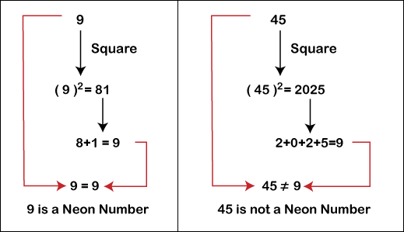

Steps to Find Neon Number
- Read an integer from the user or initialize a number (n) to check.
- Calculate the square of the given number (n) and store it in variable sq.
- Find the sum of the digits of the square (sq) and store the sum in the variable (sum).
- Compare the given number n with If both are equal, the given number is a neon number, else, not a neon number.

Perfect Number Program in Java
In this section, we will learn what is a perfect number in Java and also create Java programs to check if the given number is perfect or not. Also, we will create a Java program for finding all the perfect numbers between the given range. The perfect number program frequently asked in Java coding tests and academics.

What is a perfect number in Java?
A number whose sum of factors (excluding the number itself) is equal to the number is called a perfect number. In other words, if the sum of positive divisors (excluding the number itself) of a number equals the number itself is called a perfect number. Let's understood it through an example.

Example of a Perfect Number
Let's take the number 496 and heck it is a perfect number or not.
First, we find the factors of 496 i.e. 1, 2, 4, 8, 16, 31, 62, 124, and 248. Let's find the sum of factors (1 + 2 + 4 + 8 + 16 + 31 + 62 + 124 +248 = 496). We observe that the sum of factors is equal to the number itself. Hence, the number 496 is a perfect number. Similarly, we can check other numbers also.
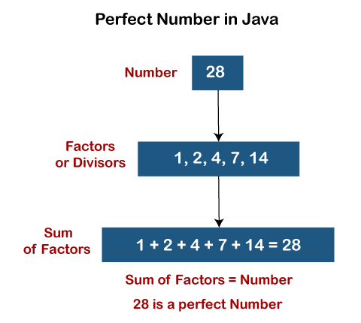

Steps to Find Perfect Number
- Read or initialize a number (n).
- Declare a variable (s) for storing sum.
- Find the factors of the given number (n) by using a loop (for/ while).
- Calculate the sum of factors and store it in a variable s.
- Compare the sum (s) with the number (n):
  - If both (s and n) are equal, then the given number is a perfect number.
  - Else, the number is not a perfect number.
Let's implement the above steps in a Java program.

Perfect Number Java Programs
There are the following ways to find the perfect number in Java:
- Using while Loop
- Using Method
- Using Recursion

Unique Number in Java Program
The number will be unique if it is positive integer and there are no repeated digits in the number. In other words, a number is said to be unique if and only if the digits are not duplicate. For example, 20, 56, 9863, 145, etc. are the unique numbers while 33, 121, 900, 1010, etc. are not unique numbers. In this section, we will create Java programs to check whether the number is unique or not.
There are the following ways to check the number is unique or not:
- By Comparing Each Digit Manually
- Using String
- Using Array

By Comparing Each Digit Manually
There are the following steps to check number is unique or not:
- Read a number from the user.
- Find the last digit o the number.
- Compare all digits of the number with the last digit.
- If the digit found more than one time, the number is not unique.
- Else, eliminate the last digit of the number.
- Repeat steps 2 to 5 until the number becomes zero.
