**Documentation: Data collection of CPU_Usage when stressed**

Monitoring Setup:

Node Exporter: Installed on Kafka machine to expose system metrics at :9100/metrics.

JMX Exporter: Attached to Kafka broker to expose Kafka metrics at :7071/metrics.

Prometheus: Configured to scrape both exporters and store time-series metrics.

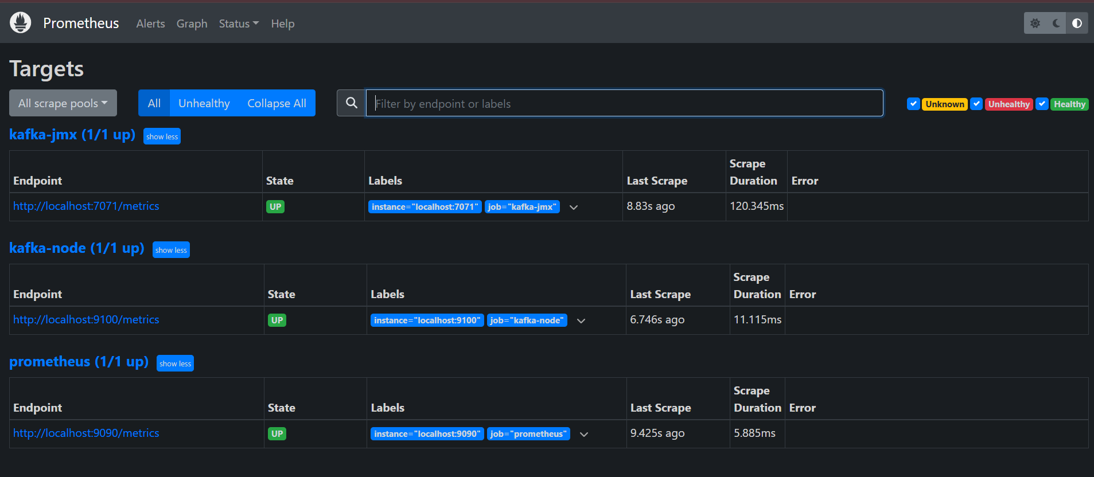

Producer Script (Run on Google Colab)

from kafka import KafkaProducer

import json

import time

import random

from datetime import datetime

# Kafka producer configuration

producer = KafkaProducer(

    bootstrap_servers='100.27.223.212:9092',

    value_serializer=lambda v: json.dumps(v).encode('utf-8'),

    linger_ms=5,

    batch_size=32768,

    compression_type='gzip'

)

print("KafkaProducer initialized successfully!")

topic = "demo_testing2"

try:

    while True:

        messages_to_send = random.randint(100, 200)

        for _ in range(messages_to_send):

            data = {

                "sensor_id": random.randint(1, 100),

                "temperature": round(random.uniform(15.0, 45.0), 2),

                "status": random.choice(["ok", "warn", "fail"]),

                "timestamp": datetime.now().isoformat()

            }

            producer.send(topic, value=data)

        producer.flush()

        print(f"Sent {messages_to_send} messages")

        # Tight loop with minimal delay

        time.sleep(1)

except KeyboardInterrupt:

    print("Producer stopped by user.")

finally:

    producer.flush()

    producer.close()

Consumer Script (Run on Google Colab)

from kafka import KafkaConsumer

import json

# Kafka consumer

consumer = KafkaConsumer(

    'demo_testing2',  # Topic name

    bootstrap_servers='100.27.223.212:9092',  # Kafka broker (EC2 public IP)

    auto_offset_reset='earliest',

    enable_auto_commit=True,

    value_deserializer=lambda v: v.decode('utf-8')  # Decode as plain text first

)

print("Listening for messages on topic 'demo_testing2'...")

for message in consumer:

    try:

        _ = json.loads(message.value)  # Consume and parse JSON

        # No printing or processing, just consuming

    except json.JSONDecodeError:

        # Just consume non-JSON messages silently

        pass

Python Script to log metrics to CSV

import requests

import csv

import time

from datetime import datetime

JMX_URL = "http://100.27.223.212:7071/metrics"

NODE_URL = "http://100.27.223.212:9100/metrics"

CSV_FILE = "stressed_node_metrics.csv"

JMX_METRICS = {

    "bytes_in": "kafka_server_BrokerTopicMetrics_BytesInPerSec_total",

    "bytes_out": "kafka_server_BrokerTopicMetrics_BytesOutPerSec_total"

}

def parse_prometheus_text(text):

    metrics = {}

    for line in text.splitlines():

        if line.startswith("#") or line.strip() == "":

            continue

        parts = line.split()

        if len(parts) == 2:

            key, val = parts

            try:

                metrics[key] = float(val)

            except ValueError:

                continue

    return metrics

def get_jmx_metrics():

    res = requests.get(JMX_URL)

    metrics = parse_prometheus_text(res.text)

    return {k: metrics.get(v, 0.0) for k, v in JMX_METRICS.items()}

def get_cpu_times(metrics):

    cpu_times = {"idle": 0.0, "total": 0.0}

    for k, v in metrics.items():

        if k.startswith("node_cpu_seconds_total{") and "cpu=" in k:

            cpu_times["total"] += v

            if 'mode="idle"' in k:

                cpu_times["idle"] += v

    return cpu_times

def write_to_csv(timestamp, jmx_data, node_data):

    fieldnames = ["timestamp", "bytes_in", "bytes_out", "cpu_usage"]

    try:

        with open(CSV_FILE, "r"):

            file_exists = True

    except FileNotFoundError:

        file_exists = False

    with open(CSV_FILE, "a", newline="") as csvfile:

        writer = csv.DictWriter(csvfile, fieldnames=fieldnames)

        if not file_exists:

            writer.writeheader()

        row = {

            "timestamp": timestamp,

            **jmx_data,

            **node_data

        }

        writer.writerow(row)

def main():

    prev_cpu = None

    while True:

        try:

            timestamp = datetime.now().strftime("%d-%m-%Y %H:%M:%S")

            # Fetch current metrics

            jmx_data = get_jmx_metrics()

            node_res = requests.get(NODE_URL)

            node_metrics = parse_prometheus_text(node_res.text)

            cpu_times = get_cpu_times(node_metrics)

            # Compute CPU usage from delta

            if prev_cpu:

                idle_delta = cpu_times["idle"] - prev_cpu["idle"]

                total_delta = cpu_times["total"] - prev_cpu["total"]

                if total_delta > 0:

                    cpu_usage = 100 * (1 - idle_delta / total_delta)

                else:

                    cpu_usage = 0.0

            else:

                cpu_usage = 0.0  # First iteration, can't compute

            prev_cpu = cpu_times

            node_data = {"cpu_usage": round(cpu_usage, 2)}

            write_to_csv(timestamp, jmx_data, node_data)

            print(f"[{timestamp}] Metrics recorded: bytes_in={jmx_data['bytes_in']}, bytes_out={jmx_data['bytes_out']}, cpu_usage={node_data['cpu_usage']}")

        except Exception as e:

            print(f"Error: {e}")

        time.sleep(4)

if __name__ == "__main__":

    main()

Stressing the CPU Load:

To **gradually increase CPU load from 0% to 100% over 10 minutes using** stress-ng first

1) Make sure stress-ng is installed:

sudo apt update

sudo apt install stress-ng

2) Save the script as gradual_cpu_load.sh

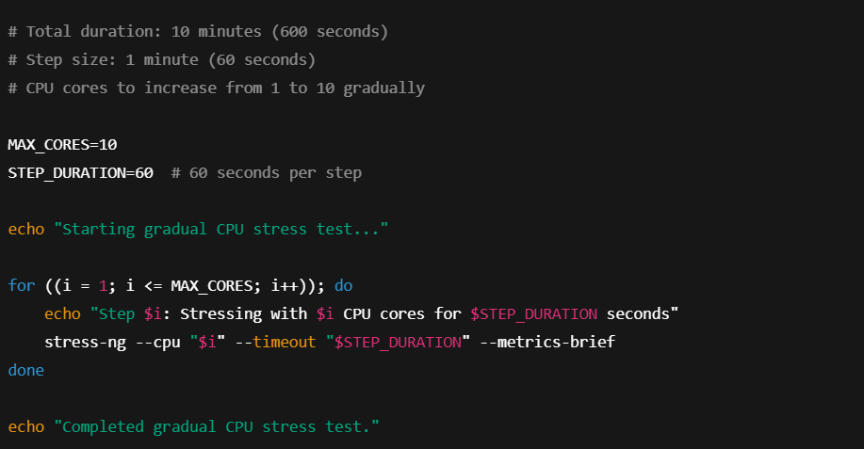

3) Make it executable:

chmod +x gradual_cpu_load.sh

4) Run it:

./gradual_cpu_load.sh