1. **Introduction to DBMS**

**E-R Model**

Analyze the problem carefully and come up with entities in it. Identify what date has to be persisted in the database. This contains the entities, attributes etc.

Identify the primary keys for all the entities. Identify the other keys like candidate keys, partial keys, if any.

**Definitions:**

**Entity:** the object in the **ER** Model represents is an entity which is thing in the real world with an independent existence.

Eg:



**ER-Model:**

Describes data as entities, relationships and attributes .The ER-Model is important preliminary for its role in database design. ER Model is usually shown pictorially using entity relationship diagrams.

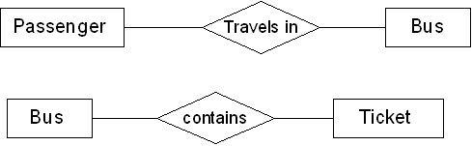

**Attributes:**

The properties that characterize an entity set are called its attributes. An attribute is referred to by the terms data items, data element, data field item.

Ex: attributes for bus entity and ticket entity.

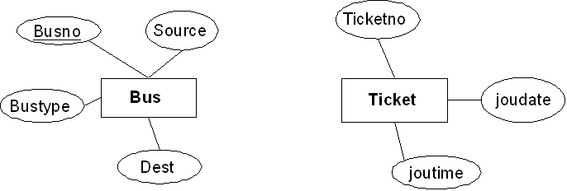

**Candidate key:**

It can be defined as minimal super key or irreducible super key. In other words an attribute or combination of attributes that identifies the record uniquely but none of its proper subsets can identify the record uniquely.

|  |  |  |  |  |  |  |  |
| --- | --- | --- | --- | --- | --- | --- | --- |
| Busno | serviceno | source | destination | deptime | retime | bustype | noofseats |

Busno,serviceno--------------->candidate key

**Primary key:**

A candidate key that is used by the database designer for unique identification of each row in a table is known as primary key. A primary key consists of one or more attributes of the table.



**Partial key:**

A weak entity type normally has a partial key which is the set of attributes that can uniquely identify weak entity that are related to the same owner entity.

**The entities in the “Roadway travels” is**

1. Bus 2) Ticket 3) Passenger

**Bus entity:**

Attributes for the bus entity are

Busno, serviceno, source, destination, deptime, retime, bustype, noofseats

**Bus schema:**

|  |  |  |  |  |  |  |  |
| --- | --- | --- | --- | --- | --- | --- | --- |
| **Busno** | **serviceno** | source | destination | deptime | retime | bustype | noofseats |

Busno,serviceno,source -----> super key

Busno,serviceno,bustype-----> super key

Busno,serviceno--------------->candidate key

Busno,serviceno---------------> primary key

**Ticket entity:**

Attributes for the ticket entity are

Ticketno, joudate, joutime, source, destination, seatno, amount, catcard

**Ticket schema:**

|  |  |  |  |  |  |  |  |
| --- | --- | --- | --- | --- | --- | --- | --- |
| **Ticketno** | Joudate | Joutime | Source | Destination | Seatno | Amount | Catcard |

Ticketno, source, destination ------- >Super key

Ticketno, source, seatno --------------> Super key

Ticketno, destination, seatno ---------> Super key

Ticketno-----------> candidate key

Ticketno----------- >primary key

**Passenger entity:**

Attributes for the Passenger entity are

Pnrno, pname, age, sex, ticketno, address, phno, catno

**Passenger schema:**

|  |  |  |  |  |  |  |  |
| --- | --- | --- | --- | --- | --- | --- | --- |
| **Pnrno** | pname | age | sex | ticketno | address | phno | catno |

Pnrno,pname---------- super key

Pnrno,ticketno---------- super key

Pnrno,phno---------- super key

Pnrno ---------- candidate key

Pnrno ----------primary key

**2. Concept design with E – R model**

**Date:**

Relate the entities appropriately. Apply cardinalities for each relationship. Identify strong entities and weak entities (if any). Indicate the type of relationship (total/partial). Try to incorporate generalization, aggregation, specialization etc wherever required.

**Definitions:**

**The cardinality ratio: -** for a binary relationship specifies the maximum number of relationships that an entity can participate in.

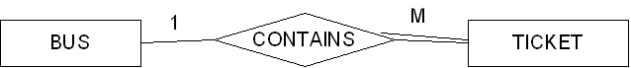

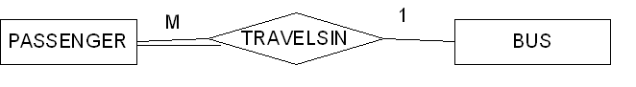

**Relationship: -** it is defined as an association among two or more entities.

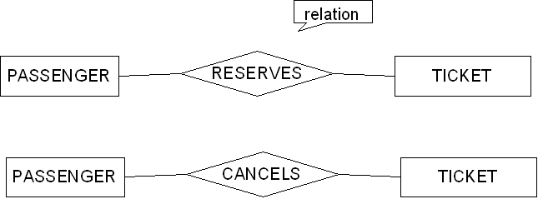

**Weak and strong entity**: - an entity set may not have sufficient attributes to form a primary key. Such an entity set is termed a weak entity set. An entity set that has primary key is termed a strong entity set.

**Total participation:-**

Ex: - if a travel agency states that every passenger must make reservation then every passenger travels in bus. Than a passengers entity can exist only if it participates in atleast one travels relationship instances. Thus the participation of passenger in travel is called total participation meaning that every entity in the “total set” passenger entities must be related to bus via travels relationship.



All passengers travel in one bus so it is total participation

**Partial participation**: a participation that is not total is called as partial participation.



Some passengers cancel ticket so it is partial participation

**Generalization**: consists of identifying some common characteristics of a collection of entity set and creating new entity set that contains entities possessing these common characteristics.

**Aggregation:** allows us to indicate that a relationship set participates in another relationship set.

**Specialization**: in the process of identifying subsets of an entity set (the super set) that share some distinguishing characteristics. This entity type is called the super class of the specialization.

**Relationship between different entities:**

*Relationship between Bus and Ticket entities*

1:M binary relationship



*Relationship between Passenger and Bus entities*

M:1 binary relationship



*Relationship between Passenger and Ticket entities*

M:N binary relationship

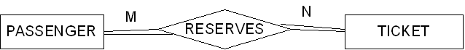

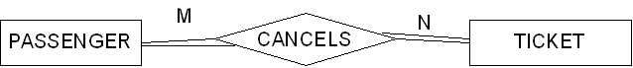

**Entity diagram for *BUS***

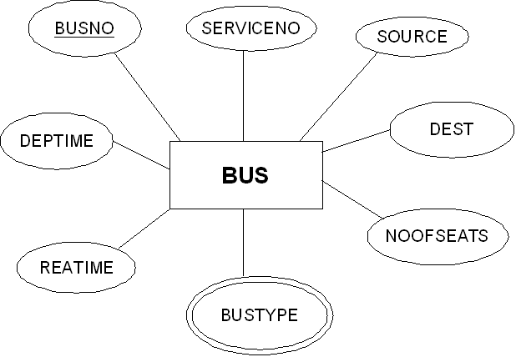

**Entity diagram for *Ticket***

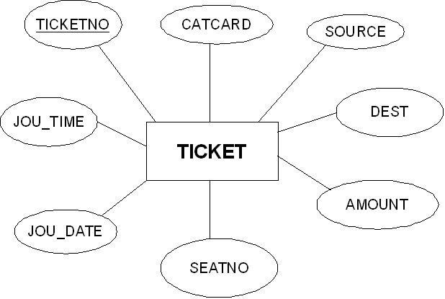

**Entity diagram for *Passenger***

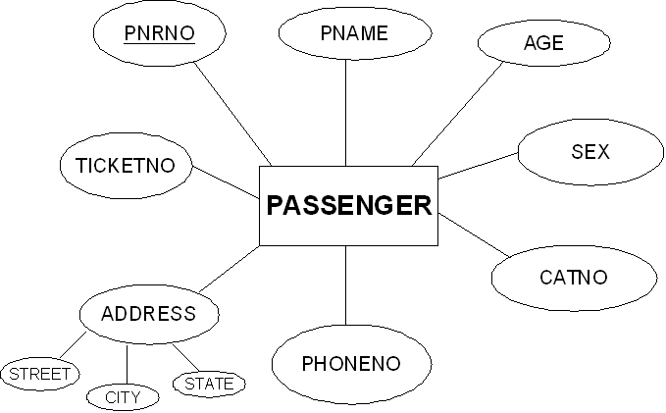

**Generalization:**

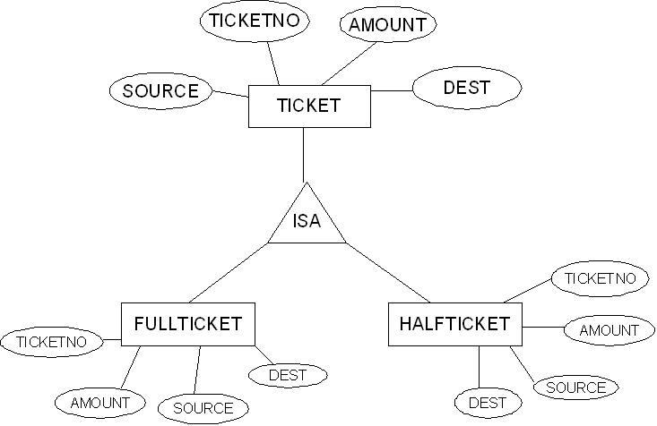

**Aggregation:**

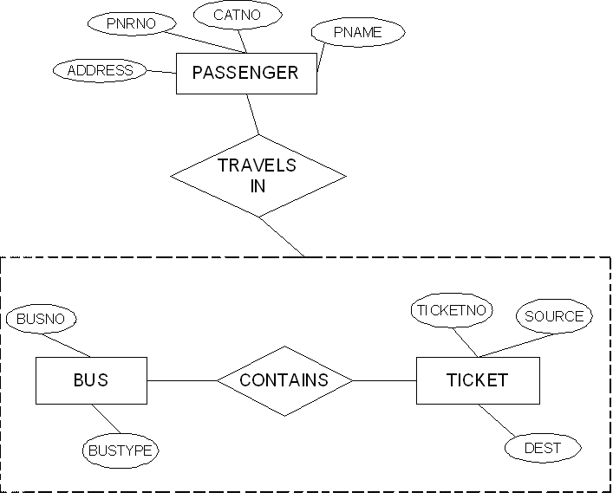

**Specialization:**

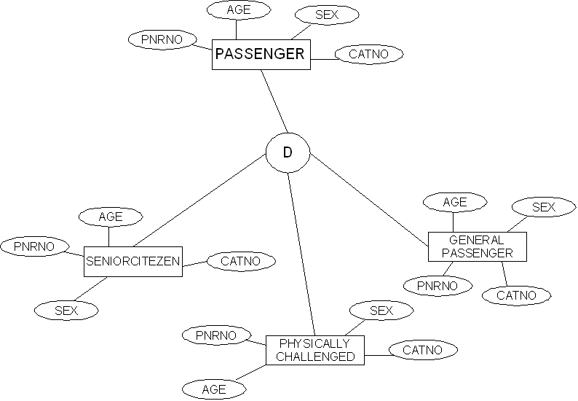

**3. Relational model**

**Date:**

Represent all entities (strong, week) in tabular fashion. Represent relationships in a tabular fashion. There are different ways of representing as tables based on the cardinality. Represent attributes as columns in the tables or as tables based on the requirement. Different types of attributes (composite, multivalued and derived).

**Definitions:**

**Composite attributes**: can be divided into smaller sub parts which represent more basic attributes with independent meaning.

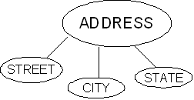

**Multivalued attributes**: for ex the attribute in the Bus entity Bustype can have different types of buses according that the Bustype attribute contains the values as Garuda, Luxury, Express, and Ordinary. This type of attribute is called multivalued attribute and may have lower and upper bounds to constrain the number of values allowed for each individual entity.

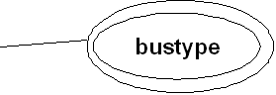

**Derived attributes:**

In some cases, two or more attribute values are related. With the help of one attribute we get the value of another attribute. Age and DOB attributes. With the DOB we get the age of the person to the current date.

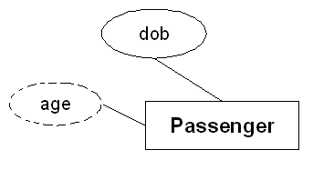

**Entity sets to tables:**

***Relational shema for Bus relation:***

***Bus*(**Busno:numeric, serviceno:numeric, source:varchar(10), destination:varchar(10), deptime:time, retime:time, bustype:varchar(10), noofseats:int)

***Relational shema for Ticket relation:***

***Ticket*(**Ticketno:numeric, joudate:date, joutime:time, source:varchar(10), destination:varchar(10), seatno:int(4), amount:decimal(10,3), catcard:char(3))

***Relational shema for Passenger relation:***

***Passenger*(**Pnrno:numeric, pname:varchar(15), age:int(4), sex:char(3), ticketno:numeric, address:varchar(50), phno:numeric(10), catno:varchar(10))

**Relationship sets to tables:**

***Relational shema for reserve relation:***

***Rserves***(pnrno:numeric,joudate:date,noofseats:int(4),address:varchar(50),contact_no:numeric(10),status:char(3))

***Relational shema for Cancels relation:***

***Cancels***(pnrno:numeric,joudate:date,noofseats:int(4),address:varchar(50),contact_no:numeric(10),status:char(3))

**TABLES:**

***Reserves:***

|  |  |  |  |  |  |
| --- | --- | --- | --- | --- | --- |
| **Pnrno** | **Joudate** | **Noofseats** | **Address** | **Contact_no** | **Status** |
| 1001 | 2010-8-5 | 10 | 5-4,srpt | 9492506282 | Yes |
| 1001 | 2010-8-15 | 5 | 5-4,srpt | 9492506282 | Yes |
| 1002 | 2010-8-5 | 5 | 6-8,hyd | 9949060540 | Yes |
| 1003 | 2010-8-15 | 6 | h/7,vij | 9704054050 | Yes |
| 1004 | 2010-8-18 | 8 | 8-9,hyd | 9704613151 | Yes |
| 1005 | 2010-8-5 | 9 | 9-11,hyd | 9848354941 | No |
| 1005 | 2010-8-6 | 5 | 9-11,hyd | 9848354941 | Yes |

***Cancels:***

|  |  |  |  |  |  |
| --- | --- | --- | --- | --- | --- |
| **Pnrno** | **Joudate** | **Noofseats** | **Address** | **Contact_no** | **Status** |
| 1001 | 2010-8-5 | 5 | 5-4,srpt | 9492506282 | Yes |
| 1002 | 2010-8-5 | 2 | 6-8,hyd | 9949060540 | No |
| 1003 | 2010-8-15 | 2 | h/7,vij | 9704054050 | Yes |
| 1004 | 2010-8-18 | 5 | 8-9,hyd | 9704613151 | Yes |
| 1005 | 2010-8-6 | 4 | 9-11,hyd | 9848354941 | Yes |

***Bus:***

|  |  |  |  |  |  |  |  |
| --- | --- | --- | --- | --- | --- | --- | --- |
| **Busno** | **serviceno** | **source** | **destination** | **deptime** | **retime** | **bustype** | **Noofseats** |
| Ap555 | 3889 | Srpt | Hyd | 9:00:00 | 19:15:00 | Ac | 36 |
| Ap501 | 3891 | Srpt | Hyd | 10:00:15 | 20:15:00 | Ac | 36 |
| Ap444 | 3601 | Hyd | Srpt | 9:00:00 | 19:30:00 | Nonac | 52 |
| Ap891 | 3555 | Hyd | Srpt | 9:30:00 | 20:30:00 | Nonac | 52 |
| Ap8830 | 3239 | Hyd | Vij | 9:00:00 | 22:30:00 | Metro | 45 |

***Ticket:***

|  |  |  |  |  |  |  |  |
| --- | --- | --- | --- | --- | --- | --- | --- |
| **Ticketno** | **Joudate** | **Joutime** | **Source** | **Destination** | **Seatno** | **Amount** | **Catcard** |
| 1111 | 2010-8-5 | 9:00:00 | Srpt | Hyd | 5 | 96 | No |
| 2222 | 2010-8-5 | 10:00:15 | Srpt | Hyd | 10 | 88 | Yes |
| 3333 | 2010-8-15 | 9:00:00 | Hyd | Srpt | 15 | 88 | Yes |
| 4444 | 2010-8-18 | 9:30:00 | Hyd | Srpt | 20 | 96 | No |
| 5555 | 2010-8-6 | 9:00:00 | Hyd | Vij | 18 | 172 | Yes |

***Passenger:***

|  |  |  |  |  |  |  |  |
| --- | --- | --- | --- | --- | --- | --- | --- |
| **Pnrno** | **pname** | **age** | **sex** | **ticketno** | **address** | **phno** | **Catno** |
| 1001 | Subbu | 31 | M | 1111 | 5-4,srpt | 9492506282 | Cap5112 |
| 1002 | Achaith | 22 | M | 2222 | 6-8,hyd | 9949060540 | Cap6900 |
| 1003 | Padma | 25 | F | 3333 | h/7,vij | 9704054050 | Cap5772 |
| 1004 | Ravi | 23 | M | 4444 | 8-9,hyd | 9704613151 | Cap6132 |
| 1005 | Satyam | 42 | F | 5555 | 9-11,hyd | 9848354941 | Cap6732 |

**4 Normalization**

**Date:**

**Database normalization is a technique for designing relational database tables to minimize duplication of information and, in doing so , to safeguard the database against certain types of logical or structural problems namely data anomalies.**

**The normalization forms are:**

1. **First Normal Form**: 1NF requires that the values in each column of a table are atomic. By atomic we mean that there are no sets of values within a column.
2. **Second Normal Form**: where the 1NF deals with atomicity of data, the 2NF deals with relationships between composite key columns and non-key columns. To achieve 2NF the tables should be in 1NF. The 2NF any non-key columns must depend on the entire primary key. In case of a composite primary key, this means that non-key column can’t depend on only part of the composite key.
3. **Third Normal Form**: 3NF requires that all columns depend directly on the primary key. Tables violate the third normal form when one column depends an another column, which in turn depends on the primary key(transitive dependency). One way to identify transitive dependency is to look at your tables and see if any columns would require updating if another column in the table was updated. If such a column exists, it probably violates 3NF.

**Let’s normalize our entities:**

**Normalization of Passenger entity:**

In the passenger entity there exists a passenger with two phone numbers, but atomic values should be there. So we normalize the relation as follows.

***Passenger:***

|  |  |  |  |  |  |  |  |
| --- | --- | --- | --- | --- | --- | --- | --- |
| **Pnrno** | **pname** | **age** | **sex** | **ticketno** | **address** | **phno** | **Catno** |
| 1001 | Subbu | 31 | M | 1111 | 5-4,srpt | 9492506282,  9848845985 | Cap5112 |
| 1002 | Achaith | 22 | M | 2222 | 6-8,hyd | 9949060540 | Cap6900 |
| 1003 | Padma | 25 | F | 3333 | h/7,vij | 9704054050 | Cap5772 |
| 1004 | Ravi | 23 | M | 4444 | 8-9,hyd | 9704613151 | Cap6132 |
| 1005 | Satyam | 42 | F | 5555 | 9-11,hyd | 9848354941 | Cap6732 |

|  |  |  |  |  |  |  |  |
| --- | --- | --- | --- | --- | --- | --- | --- |
| **Pnrno** | **pname** | **age** | **sex** | **ticketno** | **address** | **phno** | **Catno** |
| 1001 | Subbu | 31 | M | 1111 | 5-4,srpt | 9492506282 | Cap5112 |
| 1001 | Subbu | 31 | M | 1111 | 5-4,srpt | 9848845985 | Cap5112 |
| 1002 | Achaith | 22 | M | 2222 | 6-8,hyd | 9949060540 | Cap6900 |
| 1003 | Padma | 25 | F | 3333 | h/7,vij | 9704054050 | Cap5772 |
| 1004 | Ravi | 23 | M | 4444 | 8-9,hyd | 9704613151 | Cap6132 |
| 1005 | Satyam | 42 | F | 5555 | 9-11,hyd | 9848354941 | Cap6732 |

The above relation is now in 1NF and the relation is 2NF as there are no partial functional dependencies and the relation is also in 3NF as there are no transitive dependencies.

**Normalization of Bus entity:**

***Bus:***

|  |  |  |  |  |  |  |  |
| --- | --- | --- | --- | --- | --- | --- | --- |
| **Busno** | **serviceno** | **source** | **destination** | **deptime** | **retime** | **bustype** | **Noofseats** |
| Ap555 | 3889 | Srpt | Hyd | 9:00:00 | 19:15:00 | Ac | 36 |
| Ap501 | 3891 | Srpt | Hyd | 10:00:15 | 20:15:00 | Ac | 36 |
| Ap444 | 3601 | Hyd | Srpt | 9:00:00 | 19:30:00 | Nonac | 52 |
| Ap891 | 3555 | Hyd | Srpt | 9:30:00 | 20:30:00 | Nonac | 52 |
| Ap8830 | 3239 | Hyd | Vij | 9:00:00 | 22:30:00 | Metro | 45 |

In this relation the values in each column are atomic so it is already in 1NF.

In the Bus entity **Busno+serviceno** is the primary key.

There exists following partial dependencies.

Busno ----> Bustype,Noofseats

Serviceno---->Source,Dest

So the relation will be in 2NF as follows.

|  |  |  |  |
| --- | --- | --- | --- |
| **Busno** | **serviceno** | **deptime** | **retime** |
| Ap555 | 3889 | 9:00:00 | 19:15:00 |
| Ap501 | 3891 | 10:00:15 | 20:15:00 |
| Ap444 | 3601 | 9:00:00 | 19:30:00 |
| Ap891 | 3555 | 9:30:00 | 20:30:00 |
| Ap8830 | 3239 | 9:00:00 | 22:30:00 |

|  |  |  |
| --- | --- | --- |
| **Busno** | **bustype** | **Noofseats** |
| Ap555 | Ac | 36 |
| Ap501 | Ac | 36 |
| Ap444 | Nonac | 52 |
| Ap891 | Nonac | 52 |
| Ap8830 | Metro | 45 |

|  |  |  |
| --- | --- | --- |
| **serviceno** | **source** | **destination** |
| 3889 | Srpt | Hyd |
| 3891 | Srpt | Hyd |
| 3601 | Hyd | Srpt |
| 3555 | Hyd | Srpt |
| 3239 | Hyd | Vij |

The above relation is 2NF. And all columns directly depend on primary key. So there is no transitive dependency and the relation is 3NF.

**Normalization of Ticket entity:**

|  |  |  |  |  |  |  |  |
| --- | --- | --- | --- | --- | --- | --- | --- |
| **Ticketno** | **Joudate** | **Joutime** | **Source** | **Destination** | **Seatno** | **Amount** | **Catcard** |
| 1111 | 2010-8-5 | 9:00:00 | Srpt | Hyd | 5 | 96 | No |
| 2222 | 2010-8-5 | 10:00:15 | Srpt | Hyd | 10 | 88 | Yes |
| 3333 | 2010-8-15 | 9:00:00 | Hyd | Srpt | 15 | 88 | Yes |
| 4444 | 2010-8-18 | 9:30:00 | Hyd | Srpt | 20 | 96 | No |
| 5555 | 2010-8-6 | 9:00:00 | Hyd | Vij | 18 | 172 | Yes |

In this relation the values in each column are atomic so it is already in 1NF.

In the above relation there are no partial functional dependencies so the relation is in 2NF.

The ticket entity might face the following transitive dependency

Ticketno-------> catcard

Catcard--------->amount

So the relation is in 3NF.

|  |  |  |  |  |  |  |
| --- | --- | --- | --- | --- | --- | --- |
| **Ticketno** | **Joudate** | **Joutime** | **Source** | **Destination** | **Seatno** | **Catcard** |
| 1111 | 2010-8-5 | 9:00:00 | Srpt | Hyd | 5 | No |
| 2222 | 2010-8-5 | 10:00:15 | Srpt | Hyd | 10 | Yes |
| 3333 | 2010-8-15 | 9:00:00 | Hyd | Srpt | 15 | Yes |
| 4444 | 2010-8-18 | 9:30:00 | Hyd | Srpt | 20 | No |
| 5555 | 2010-8-6 | 9:00:00 | Hyd | Vij | 18 | Yes |

Put the catcard and amount attributes in a separate table. Then the relation should be in 3NF.

|  |  |
| --- | --- |
| **Catcard** | **Amount** |
| No | 96 |
| Yes | 88 |
| Yes | 88 |
| No | 96 |
| Yes | 172 |

The above relation is 3NF as we have eliminated the transitive dependencies.

Finally all the tables are normalized and free from data redundancy, partial functional dependencies and transitive dependencies.

**5: PRACTICING DDL COMMANDS**

**Creation of databases:**

mysql> show databases;

+--------------------+

| Database |

+--------------------+

| information_schema |

| mysql |

| test |

+--------------------+

3 rows in set (0.09 sec)

mysql> create database groupa;

Query OK, 1 row affected (0.01 sec)

mysql> use groupa;

Database changed

**Creation of tables:**

mysql> create table groupamem(rollno numeric(10),name varchar(15),phone numeric(

10),branch varchar(10));

Query OK, 0 rows affected (0.42 sec)

mysql> desc groupamem;

+--------+---------------+------+-----+---------+-------+

| Field | Type | Null | Key | Default | Extra |

+--------+---------------+------+-----+---------+-------+

| rollno | decimal(10,0) | YES | | NULL | |

| name | varchar(15) | YES | | NULL | |

| phone | decimal(10,0) | YES | | NULL | |

| branch | varchar(10) | YES | | NULL | |

+--------+---------------+------+-----+---------+-------+

4 rows in set (0.03 sec)

**Altering the table:**

mysql> alter table groupamem add gender char(3);

Query OK, 0 rows affected (0.36 sec)

Records: 0 Duplicates: 0 Warnings: 0

mysql> desc groupamem;

+--------+---------------+------+-----+---------+-------+

| Field | Type | Null | Key | Default | Extra |

+--------+---------------+------+-----+---------+-------+

| rollno | decimal(10,0) | YES | | NULL | |

| name | varchar(15) | YES | | NULL | |

| phone | decimal(10,0) | YES | | NULL | |

| branch | varchar(10) | YES | | NULL | |

| gender | char(3) | YES | | NULL | |

+--------+---------------+------+-----+---------+-------+

5 rows in set (0.00 sec)

**Dropping the table:**

mysql> create table dd(name varchar(10));

Query OK, 0 rows affected (0.09 sec)

mysql> show tables;

+------------------+

| Tables_in_groupa |

+------------------+

| dd |

| groupamem |

+------------------+

2 rows in set (0.00 sec)

mysql> drop table dd;

Query OK, 0 rows affected (0.06 sec)

**Dropping the database:**

mysql> create database dbl;

Query OK, 1 row affected (0.01 sec)

mysql> show databases;

+--------------------+

| Database |

+--------------------+

| information_schema |

| dbl |

| groupa |

| mysql |

| test |

+--------------------+

6 rows in set (0.01 sec)

mysql> drop database dbl;

Query OK, 0 rows affected (0.00 sec)

mysql> show databases;

+--------------------+

| Database |

+--------------------+

| information_schema |

| groupa |

| mysql |

| test |

+--------------------+

5 rows in set (0.00 sec)

**Rename the tables:**

mysql> rename table groupamem to ga;

Query OK, 0 rows affected (0.03 sec)

mysql> show tables;

+------------------+

| Tables_in_groupa |

+------------------+

| ga |

+------------------+

1 row in set (0.00 sec)

**Truncate the table:**

mysql> insert into ga values(1111,'ram',9885321456,'mbbs','m');

Query OK, 1 row affected (0.06 sec)

mysql> select * from ga;

+--------+------+------------+--------+--------+

| rollno | name | phone | branch | gender |

+--------+------+------------+--------+--------+

| 1111 | ram | 9885321456 | mbbs | m |

+--------+------+------------+--------+--------+

1 row in set (0.01 sec)

mysql> truncate table ga;

Query OK, 1 row affected (0.09 sec)

mysql> select * from ga;

Empty set (0.00 sec)

***Creation of tables for Roadway Travels:***

**Bus**

mysql> create table bus555(busno varchar(10),bustype varchar(10),primary key(bus

no));

Query OK, 0 rows affected (0.17 sec)

**Ticket**

mysql> create table ticket555(tic_no numeric(10),joudate date,source varchar(10)

,dest varchar(10),deptime time,reatime time,busnumber varchar(10),primary key(ti

c_no));

Query OK, 0 rows affected (0.08 sec)

mysql> alter table ticket555 add constraint tic_fk foreign key(busnumber) refere

nces bus555(busno);

Query OK, 0 rows affected (0.16 sec)

Records: 0 Duplicates: 0 Warnings: 0

**Passenger**

mysql> create table passenger(pnrno numeric(10),ticnumber numeric(10),pname varc

har(15),age int(4),sex char(10),ppno varchar(15),primary key(pnrno));

Query OK, 0 rows affected (0.06 sec)

mysql> alter table passenger add constraint pas_fk foreign key(ticnumber) refere

nces ticket555(tic_no);

Query OK, 0 rows affected (0.14 sec)

Records: 0 Duplicates: 0 Warnings: 0

**Reserve**

mysql> create table reserve(pnrnumber numeric(10),noofseats int(8),address varch

ar(50),phno numeric(10),status char(3));

Query OK, 0 rows affected (0.16 sec)

mysql> alter table reserve add constraint res_fk foreign key(pnrnumber) referenc

es passenger(pnrno);

Query OK, 0 rows affected (0.17 sec)

Records: 0 Duplicates: 0 Warnings: 0

**Cancel**

mysql> create table cancel(pnrnumber numeric(10),noofseats int(8),address varcha

r(50),phno numeric(10),status char(3));

Query OK, 0 rows affected (0.06 sec)

mysql> alter table cancel add constraint can_fk foreign key(pnrnumber) reference

s passenger(pnrno);

Query OK, 0 rows affected (0.14 sec)

Records: 0 Duplicates: 0 Warnings: 0

**6. Practicing DML commands**

**Date:**

DML commands are used to for managing data within the schema objects.

**Use of insert command:**

**Inserting values into *Bus* table:**

mysql> insert into bus555 values('ap555','ac');

Query OK, 1 row affected (0.03 sec)

mysql> insert into bus555 values('ap501','ac');

Query OK, 1 row affected (0.03 sec)

mysql> insert into bus555 values('ap444','nonac');

Query OK, 1 row affected (0.03 sec)

mysql> insert into bus555 values('ap891','nonac');

Query OK, 1 row affected (0.03 sec)

mysql> insert into bus555 values('ap8830','metro');

Query OK, 1 row affected (0.03 sec)

**Inserting values into *Ticket* table:**

mysql> insert into ticket555 values(1111,'2010-08-05','srpt','hyd','09:00:05','1

9:15:00','ap555');

Query OK, 1 row affected (0.03 sec)

mysql> insert into ticket555 values(2222,'2010-08-05','srpt','hyd','10:00:05','2

0:15:00','ap501');

Query OK, 1 row affected (0.03 sec)

mysql> insert into ticket555 values(3333,'2010-08-15','hyd','srpt','09:00:05','2

0:15:00','ap444');

Query OK, 1 row affected (0.03 sec)

mysql> insert into ticket555 values(4444,'2010-08-18','hyd','srpt','09:30:05','2

0:15:00','ap891');

Query OK, 1 row affected (0.03 sec)

mysql> insert into ticket555 values(5555,'2010-08-8','hyd','vij','09:10:05','22:

15:00','ap8830');

Query OK, 1 row affected (0.03 sec)

**Inserting values into *Passenger* table:**

mysql> insert into passenger values(1001,1111,'subbu',31,'m','pp555');

Query OK, 1 row affected (0.05 sec)

mysql> insert into passenger values(1002,2222,'achaith',22,'m','pp8830');

Query OK, 1 row affected (0.03 sec)

mysql> insert into passenger values(1003,3333,'padma',25,'f','pp333');

Query OK, 1 row affected (0.05 sec)

mysql> insert into passenger values(1004,4444,'ravi',23,'m','pp444');

Query OK, 1 row affected (0.01 sec)

mysql> insert into passenger values(1005,5555,'nirma',42,'f','pp666');

Query OK, 1 row affected (0.03 sec)

**Inserting values into *reserve* table:**

mysql> insert into reserve values(1001,10,'hno:5-4,srpt,nlg',9492506282,'yes');

Query OK, 1 row affected (0.05 sec)

mysql> insert into reserve values(1001,5,'hno:5-4,srpt,nlg',9492506282,'yes');

Query OK, 1 row affected (0.03 sec)

mysql> insert into reserve values(1002,5,'hno:15-4,lbngr,hyd',9491653714,'yes');

Query OK, 1 row affected (0.01 sec)

mysql> insert into reserve values(1003,6,'hno:151-4,dsnr,hyd',9704613151,'yes');

Query OK, 1 row affected (0.03 sec)

mysql> insert into reserve values(1004,8,'hno:11-4,dsnr,hyd',9704613111,'yes');

Query OK, 1 row affected (0.02 sec)

mysql> insert into reserve values(1005,8,'hno:41-4,dsnr,hyd',9989503111,'no');

Query OK, 1 row affected (0.03 sec)

mysql> insert into reserve values(1005,5,'hno:41-4,dsnr,hyd',9989503111,'yes');

Query OK, 1 row affected (0.02 sec)

**Inserting values into *cancel* table:**

mysql> insert into cancel values(1001,5,'hno:5-4,srpt,nlg',9492506282,'yes');

Query OK, 1 row affected (0.05 sec)

mysql> insert into cancel values(1001,2,'hno:5-4,srpt,nlg',9492506282,'yes');

Query OK, 1 row affected (0.03 sec)

mysql> insert into cancel values(1002,2,'hno:15-4,lbngr,hyd',9491653714,'no');

Query OK, 1 row affected (0.05 sec)

mysql> insert into cancel values(1003,2,'hno:151-4,dsnr,hyd',9704613151,'yes');

Query OK, 1 row affected (0.01 sec)

mysql> insert into cancel values(1004,5,'hno:11-4,dsnr,hyd',9704613111,'yes');

Query OK, 1 row affected (0.03 sec)

mysql> insert into cancel values(1005,4,'hno:41-4,dsnr,hyd',9989503111,'yes');

Query OK, 1 row affected (0.03 sec)

**Use of select command:**

mysql> select *from bus555;

+--------+---------+

| busno | bustype |

+--------+---------+

| ap444 | nonac |

| ap501 | ac |

| ap555 | ac |

| ap8830 | metro |

| ap891 | nonac |

+--------+---------+

5 rows in set (0.00 sec)

mysql> select *from ticket555;

+--------+------------+--------+------+----------+----------+-----------+

| tic_no | joudate | source | dest | deptime | reatime | busnumber |

+--------+------------+--------+------+----------+----------+-----------+

| 1111 | 2010-08-05 | srpt | hyd | 09:00:05 | 19:15:00 | ap555 |

| 2222 | 2010-08-05 | srpt | hyd | 10:00:05 | 20:15:00 | ap501 |

| 3333 | 2010-08-15 | hyd | srpt | 09:00:05 | 20:15:00 | ap444 |

| 4444 | 2010-08-18 | hyd | srpt | 09:30:05 | 20:15:00 | ap891 |

| 5555 | 2010-08-08 | hyd | vij | 09:10:05 | 22:15:00 | ap8830 |

+--------+------------+--------+------+----------+----------+-----------+

5 rows in set (0.00 sec)set (0.00 sec)

mysql> select *from passenger;

+-------+-----------+---------+------+------+--------+

| pnrno | ticnumber | pname | age | sex | ppno |

+-------+-----------+---------+------+------+--------+

| 1001 | 1111 | subbu | 31 | m | pp555 |

| 1002 | 2222 | achaith | 22 | m | pp8830 |

| 1003 | 3333 | padma | 25 | f | pp333 |

| 1004 | 4444 | ravi | 23 | m | pp444 |

| 1005 | 5555 | nirma | 42 | f | pp666 |

+-------+-----------+---------+------+------+--------+

5 rows in set (0.03 sec)

mysql> select *from reserve;

+-----------+-----------+--------------------+------------+--------+

| pnrnumber | noofseats | address | phno | status |

+-----------+-----------+--------------------+------------+--------+

| 1001 | 10 | hno:5-4,srpt,nlg | 9492506282 | yes |

| 1001 | 5 | hno:5-4,srpt,nlg | 9492506282 | yes |

| 1002 | 5 | hno:15-4,lbngr,hyd | 9491653714 | yes |

| 1003 | 6 | hno:151-4,dsnr,hyd | 9704613151 | yes |

| 1004 | 8 | hno:11-4,dsnr,hyd | 9704613111 | yes |

| 1005 | 8 | hno:41-4,dsnr,hyd | 9989503111 | no |

| 1005 | 5 | hno:41-4,dsnr,hyd | 9989503111 | yes |

+-----------+-----------+--------------------+------------+--------+

7 rows in set (0.02 sec)

mysql> select *from cancel;

+-----------+-----------+--------------------+------------+--------+

| pnrnumber | noofseats | address | phno | status |

+-----------+-----------+--------------------+------------+--------+

| 1001 | 5 | hno:5-4,srpt,nlg | 9492506282 | yes |

| 1001 | 2 | hno:5-4,srpt,nlg | 9492506282 | yes |

| 1002 | 2 | hno:15-4,lbngr,hyd | 9491653714 | no |

| 1003 | 2 | hno:151-4,dsnr,hyd | 9704613151 | yes |

| 1004 | 5 | hno:11-4,dsnr,hyd | 9704613111 | yes |

| 1005 | 4 | hno:41-4,dsnr,hyd | 9989503111 | yes |

+-----------+-----------+--------------------+------------+--------+

6 rows in set (0.00 sec)

**Use of update command**:

mysql> update passenger set ppno=’pp888’ where pnrno=1001;

Query OK, 1 row affected (0.03 sec)

Rows matched: 1 changed: 1 warnings: 0

**Use of DELETE command:**

mysql>delete from cancel where status=’no’;

Query OK, 1 row affected (0.03 sec)

mysql> select *from cancel;

+-----------+-----------+--------------------+------------+--------+

| pnrnumber | noofseats | address | phno | status |

+-----------+-----------+--------------------+------------+--------+

| 1001 | 5 | hno:5-4,srpt,nlg | 9492506282 | yes |

| 1001 | 2 | hno:5-4,srpt,nlg | 9492506282 | yes |

| 1003 | 2 | hno:151-4,dsnr,hyd | 9704613151 | yes |

| 1004 | 5 | hno:11-4,dsnr,hyd | 9704613111 | yes |

| 1005 | 4 | hno:41-4,dsnr,hyd | 9989503111 | yes |

+-----------+-----------+--------------------+------------+--------+

6 rows in set (0.00 sec)

**7. Querying: In this week you are going to practice the queries (along with sub queries) using ANY, ALL, IN, EXISTS, NOT EXISTS, UNION, INTERSECT, Constraints etc.**

**Practice the following queries:**

**1. Display unique PNR_no of all passengers.**

mysql> select distinct pnrno from passenger;

+-------+

| pnrno |

+-------+

| 1001 |

| 1002 |

| 1003 |

| 1004 |

| 1005 |

+-------+

5 rows in set (0.01 sec)

**2. Display all the names of male passengers.**

mysql> select pname from passenger where sex='m';

+---------+

| pname |

+---------+

| subbu |

| achaith |

| ravi |

+---------+

3 rows in set (0.00 sec)

**3. Display ticket numbers and names of all the passengers.**

mysql> select tic_no,pname from ticket555 t,passenger p where t.tic_no=p.ticnumber;

+--------+---------+

| tic_no | pname |

+--------+---------+

| 1111 | subbu |

| 2222 | achaith |

| 3333 | padma |

| 4444 | ravi |

| 5555 | nirma |

+--------+---------+

5 rows in set (0.00 sec)

**4. Display the source and destination having journey time more than 10 hours.**

mysql> select source,dest from ticket555 where hour(timediff(reatime,deptime))>10;

+--------+------+

| source | dest |

+--------+------+

| hyd | srpt |

| hyd | vij |

+--------+------+

2 rows in set (0.00 sec)

**5. Find the ticket numbers of passengers whose name starts with ‘A’ and ends with ‘H’.**

mysql> select tic_no from ticket555 where tic_no=any (select ticnumber from passenger where pname like 'a%h');

+--------+

| tic_no |

+--------+

| 1111 |

| 2222 |

+--------+

2 rows in set (0.02 sec)

**6. Find the name of passengers whose age is between 30 and 45.**

mysql> select pname from passenger where age between 30 and 45;

+-------+

| pname |

+-------+

| subbu |

| nirma |

+-------+

2 rows in set (0.00 sec)

**7. Display all the passengers names beginning with ‘A’.**

mysql> select all pname from passenger where pname like 'a%';

+---------+

| pname |

+---------+

| subbu |

| achaith |

+---------+

2 rows in set (0.00 sec)

**8. Display the sorted list of passengers names.**

mysql> select pname from passenger order by pname;

+---------+

| pname |

+---------+

| subbu |

| achaith |

| nirma |

| padma |

| ravi |

+---------+

5 rows in set (0.02 sec)

**9. Display the Bus numbers that travel on Sunday and Wednesday.**

mysql> select busno from bus555 where busno in(select busnumber from ticket555 where dayofweek(joudate)=1 or dayofweek(joudate)=4);

+--------+

| busno |

+--------+

| ap444 |

| ap8830 |

| ap891 |

+--------+

3 rows in set (0.00 sec)

**10. Display the details of passengers who are traveling either in AC or NON_AC.**

mysql> select pname,pnrno,age,sex from passenger where ticnumber in(select tic_no from ticket555 where busnumber in(select busno from bus555 where bustype='ac' or bustype='nonac'));

+---------+-------+------+------+

| pname | pnrno | age | sex |

+---------+-------+------+------+

| subbu | 1001 | 31 | m |

| achaith | 1002 | 22 | m |

| padma | 1003 | 25 | f |

| ravi | 1004 | 23 | m |

+---------+-------+------+------+

4 rows in set (0.00 sec)

**8. queries using Aggregate functions (COUNT, SUM, AVG, MAX and MIN), GROUP BY, HAVING AND Creation of Views.**

**1. Write a query to display the information present in the Passenger and Cancellation tables.**

mysql> select pnrno from passenger union select pnrnumber from cancel;

+-------+

| pnrno |

+-------+

| 1001 |

| 1002 |

| 1003 |

| 1004 |

| 1005 |

+-------+

5 rows in set (0.00 sec)

**2. Write a query to display the busnumber with source and destination available in Roadway Travels.**

mysql> select busno,source,dest from bus555,ticket555 where busno=busnumber grou

p by busnumber;

+--------+--------+------+

| busno | source | dest |

+--------+--------+------+

| ap444 | hyd | srpt |

| ap501 | srpt | hyd |

| ap555 | srpt | hyd |

| ap8830 | hyd | vij |

| ap891 | hyd | srpt |

+--------+--------+------+

5 rows in set (0.00 sec)

**3. Display the number of days in a week on which AP444 bus is available.**

mysql> select count(joudate) from ticket555 where busnumber in(select busno from

bus555 where busno='ap444') and joudate between '2010-08-14' and '2010-08-20';

+----------------+

| count(joudate) |

+----------------+

| 2 |

+----------------+

1 row in set (0.00 sec)

**4. Find the ticket numbers booked for each PNR_no using Group By clause.**

mysql> select sum(noofseats) as reserved_seats,pnrnumber from reserve where stat

us='yes' group by pnrnumber;

+----------------+-----------+

| reserved_seats | pnrnumber |

+----------------+-----------+

| 15 | 1001 |

| 5 | 1002 |

| 6 | 1003 |

| 8 | 1004 |

| 5 | 1005 |

+----------------+-----------+

5 rows in set (0.33 sec)

**5. Find the distinct PNR numbers that are present.**

mysql> select distinct pnrnumber from reserve;

+-----------+

| pnrnumber |

+-----------+

| 1001 |

| 1002 |

| 1003 |

| 1004 |

| 1005 |

+-----------+

5 rows in set (0.00 sec)

**6. Find the number of tickets booked for each bus with bustype where the number of seats is greater than 1.**

mysql> select busno,bustype,sum(noofseats) as booked_seats from bus555,reserve,t

icket555,passenger where busno=busnumber and tic_no=ticnumber and pnrno=pnrnumbe

r and status='yes'group by tic_no having count(*)>=1;

+--------+---------+--------------+

| busno | bustype | booked_seats |

+--------+---------+--------------+

| ap555 | ac | 15 |

| ap501 | ac | 5 |

| ap444 | nonac | 6 |

| ap891 | nonac | 8 |

| ap8830 | metro | 5 |

+--------+---------+--------------+

5 rows in set (0.00 sec)

**7. Find the total number of cancelled seats.**

mysql> select sum(noofseats) as cancelled_seats from cancel where status='yes';

+-----------------+

| cancelled_seats |

+-----------------+

| 18 |

+-----------------+

1 row in set (0.00 sec)

**8. Write a query to count the number of tickets for the buses which traveled after the date ‘2010-08-06’.**

mysql> select busno,bustype,sum(noofseats) as booked_seats from bus555,reserve,t

icket555,passenger where busno=busnumber and tic_no=ticnumber and pnrno=pnrnumbe

r and status='yes'and joudate>'2010-8-6' group by tic_no having count(*)>=1;

+--------+---------+--------------+

| busno | bustype | booked_seats |

+--------+---------+--------------+

| ap444 | nonac | 6 |

| ap891 | nonac | 8 |

| ap8830 | metro | 5 |

+--------+---------+--------------+

3 rows in set (0.01 sec)

**Creation of Views:**

mysql> create view takes1 as

-> select tic_no,pname from ticket555,passenger where tic_no=ticnumber;

Query OK, 0 rows affected (0.44 sec)

mysql> select tic_no from takes1;

+--------+

| tic_no |

+--------+

| 1111 |

| 2222 |

| 3333 |

| 4444 |

| 5555 |

+--------+

5 rows in set (0.05 sec)

**Dropping of Views:**

mysql> drop view takes1;

Query OK, 0 rows affected (0.00 sec)

**9: TRIGGERS**

**Date:**

**Creation of insert trigger, delete trigger, update trigger. Practice triggers using above database.**

**A Trigger** is a named database object which defines some action that the database should take when some databases related event occurs. Triggers are executed when you issues a data manipulation command like INSERT, DELETE, UPDATE on a table for which the trigger has been created. They are automatically executed and also transparent to the user. But for creating the trigger the user must have the CREATE TRIGGER privilege. In this section we will describe you about the syntax to create and drop the triggers and describe you some examples of how to use them.

CREATE TRIGGER

The general syntax of CREATE TRIGGER is :  
        CREATE TRIGGER trigger_name trigger_time trigger_event ON tbl_name FOR EACH ROW trigger_statement

By using above statement we can create the new trigger. The trigger can associate only with the table name and that must be refer to a permanent table. Trigger_time means trigger action time. It can be BEFORE or AFTER. It is used to define that the trigger fires before or after the statement that executed it. Trigger_event specifies the statement that executes the trigger. The trigger_event can be any of the DML Statement : INSERT, UPDATE, DELETE.  
  
We can not have the two trigger for a given table, which have the same trigger action time and event. For Instance : we cannot have two BEFORE INSERT triggers for same table. But we can have a BEFORE INSERT and BEFORE UPDATE trigger for a same table.  
  
Trigger_statement have the statement that executes when the trigger fires but if you want to execute multiple statement the you have to use the BEGIN…END compound statement.

We can refer the columns of the table that associated with trigger by using the OLD and NEW[keyword](http://www.roseindia.net/mysql/mysql5/triggers.shtml##). OLD.column_name is used to refer the column of an existing row before it is deleted or updated and NEW.column_name is used to refer the column of a new row that is inserted or after updated existing row.  
  
In INSERT trigger we can use only NEW.column_name because there is no old row and in a DELETE trigger we can use only OLD.column_name because there is no new row. But in UPDATE trigger we can use both, OLD.column_name is used to refer the columns of a row before it is updated and NEW.Column_name is used to refer the column of the row after it is updated.

**Update Trigger:**

mysql> create trigger t1 before update on reserve

-> for each row

-> begin

-> if new.noofseats>30 then

-> set new.noofseats=old.noofseats;

-> else

-> set new.noofseats=new.noofseats;

-> end if;

-> end//

Query OK, 0 rows affected (0.03 sec)

mysql> update reserve set noofseats=12 where pnrnumber=1004;

-> //

Query OK, 1 row affected (0.01 sec)

Rows matched: 1 Changed: 1 Warnings: 0

mysql> select *from reserve;

-> //

+-----------+-----------+--------------------+------------+--------+

| pnrnumber | noofseats | address | phno | status |

+-----------+-----------+--------------------+------------+--------+

| 1001 | 10 | hno:5-4,srpt,nlg | 9492506282 | yes |

| 1001 | 5 | hno:5-4,srpt,nlg | 9492506282 | yes |

| 1002 | 20 | hno:15-4,lbngr,hyd | 9491653714 | yes |

| 1003 | 6 | hno:151-4,dsnr,hyd | 9704613151 | yes |

| 1004 | 12 | hno:11-4,dsnr,hyd | 9704613111 | yes |

| 1005 | 8 | hno:41-4,dsnr,hyd | 9989503111 | no |

| 1005 | 5 | hno:41-4,dsnr,hyd | 9989503111 | yes |

+-----------+-----------+--------------------+------------+--------+

7 rows in set (0.00 sec)

mysql> update reserve set noofseats=32 where pnrnumber=1004//

Query OK, 0 rows affected (0.00 sec)

Rows matched: 1 Changed: 0 Warnings: 0

mysql> select *from reserve//

+-----------+-----------+--------------------+------------+--------+

| pnrnumber | noofseats | address | phno | status |

+-----------+-----------+--------------------+------------+--------+

| 1001 | 10 | hno:5-4,srpt,nlg | 9492506282 | yes |

| 1001 | 5 | hno:5-4,srpt,nlg | 9492506282 | yes |

| 1002 | 20 | hno:15-4,lbngr,hyd | 9491653714 | yes |

| 1003 | 6 | hno:151-4,dsnr,hyd | 9704613151 | yes |

| 1004 | 12 | hno:11-4,dsnr,hyd | 9704613111 | yes |

| 1005 | 8 | hno:41-4,dsnr,hyd | 9989503111 | no |

| 1005 | 5 | hno:41-4,dsnr,hyd | 9989503111 | yes |

+-----------+-----------+--------------------+------------+--------+

**Insert Trigger:**

mysql> create trigger t3

-> before insert on passenger

-> for each row

-> begin

-> if new.age>18 then

-> set new.ppno='pp8630';

-> else

-> set new.ppno='';

-> end if;

-> end//

Query OK, 0 rows affected (0.06 sec)

mysql> insert into passenger values(1009,5555,'mm','17','m','99')//

Query OK, 1 row affected (0.03 sec)

mysql> select * from passenger//

+-------+-----------+---------+------+------+--------+

| pnrno | ticnumber | pname | age | sex | ppno |

+-------+-----------+---------+------+------+--------+

| 1001 | 1111 | subbu | 31 | m | pp555 |

| 1002 | 2222 | achaith | 22 | m | pp8830 |

| 1003 | 3333 | padma | 25 | f | pp333 |

| 1004 | 4444 | ravi | 23 | m | pp444 |

| 1005 | 5555 | nirma | 42 | f | pp666 |

| 1009 | 5555 | mm | 17 | m | |

+-------+-----------+---------+------+------+--------+

6 rows in set (0.00 sec)

**Delete Trigger:**

mysql> delimiter //

mysql> create trigger rc before delete on cancel

-> for each row

-> begin

-> insert into reserve values(old.pnrnumber,old.noofseats,old.address,old.phno,old.status);

-> end//

Query OK, 0 rows affected (0.05 sec)

mysql> delete from cancel where pnrnumber=1003//

Query OK, 1 row affected (0.08 sec)

mysql> select *from reserve//

+-----------+-----------+--------------------+------------+--------+

| pnrnumber | noofseats | address | phno | status |

+-----------+-----------+--------------------+------------+--------+

| 1001 | 10 | hno:5-4,srpt,nlg | 9492506282 | yes |

| 1001 | 5 | hno:5-4,srpt,nlg | 9492506282 | yes |

| 1002 | 20 | hno:15-4,lbngr,hyd | 9491653714 | yes |

| 1003 | 6 | hno:151-4,dsnr,hyd | 9704613151 | yes |

| 1004 | 29 | hno:11-4,dsnr,hyd | 9704613111 | yes |

| 1005 | 8 | hno:41-4,dsnr,hyd | 9989503111 | no |

| 1005 | 5 | hno:41-4,dsnr,hyd | 9989503111 | yes |

| 1003 | 2 | hno:151-4,dsnr,hyd | 9704613151 | yes |

+-----------+-----------+--------------------+------------+--------+

8 rows in set (0.00 sec)

mysql> select *from cancel//

+-----------+-----------+-------------------+------------+--------+

| pnrnumber | noofseats | address | phno | status |

+-----------+-----------+-------------------+------------+--------+

| 1001 | 5 | hno:5-4,srpt,nlg | 9492506282 | yes |

| 1001 | 2 | hno:5-4,srpt,nlg | 9492506282 | yes |

| 1004 | 5 | hno:11-4,dsnr,hyd | 9704613111 | yes |

| 1002 | 2 | hno:15-4,lbnr,hyd | 9491653714 | no |

| 1005 | 2 | hno:41-4,dsnr,hyd | 9989503111 | yes |

+-----------+-----------+-------------------+------------+--------+

5 rows in set (0.00 sec)

**10: Procedures**

**Date:**

**In this session you are going to learn Creation of stored procedures, execution of procedure and modification of procedures. Practice the procedures using above database.**

A stored procedure is a procedure (like a subprogram in a regular computing language) that is stored (in the database). Correctly speaking, MySQL supports "routines" and there are two kinds of routines: stored procedures which you call, or functions whose return values you use in other SQL statements the same way that you use pre-installed MySQL functions like pi(). I'll use the word "stored procedures" more frequently than "routines" because it's what we've used in the past, and what people expect us to use.

mysql> create procedure p2(p_age int)

-> begin

-> select pname,ticnumber,sex from passenger where age>p_age;

-> end//

Query OK, 0 rows affected (0.00 sec)

mysql> call p2(30)//

+-------+-----------+------+

| pname | ticnumber | sex |

+-------+-----------+------+

| subbu | 1111 | m |

| nirma | 5555 | f |

+-------+-----------+------+

2 rows in set (0.00 sec)

mysql> call p2(24)//

+-------+-----------+------+

| pname | ticnumber | sex |

+-------+-----------+------+

| subbu | 1111 | m |

| padma | 3333 | f |

| nirma | 5555 | f |

+-------+-----------+------+

3 rows in set (0.00 sec)

Query OK, 0 rows affected (0.00 sec)

mysql> create procedure p3()

-> begin

-> select source,dest from ticket555 where hour(timediff(reatime,deptime))>10;

-> end//

Query OK, 0 rows affected (0.02 sec)

mysql> call p3()//

+--------+------+

| source | dest |

+--------+------+

| hyd | srpt |

| hyd | vij |

+--------+------+

2 rows in set (0.00 sec)

Query OK, 0 rows affected (0.00 sec)

**11: Cursors**

**Date:**

**Declare the cursor that defines the result set. Open the cursor to establish the result set. Fetch the data into local variables as needed from the cursor, one row at a time. Close the cursor when done.**

Cursors are used when the SQL Select statement is expected to return more than one row. Cursors are supported inside procedures and functions. Cursors must be declared and its definition contains the query. The cursor must be defined in the DECLARE section of the program. A cursor must be opened before processing and close after processing.  
  
Syntax to declare the cursor:  
        DECLARE <cursor_name> CURSOR FOR <select_statement>

Multiple cursors can be declared in the procedures and functions but each cursor must have a unique name. And in defining the cursor the select_statement cannot have INTO clause.  
  
Syntax to open the cursor :  
        OPEN <cursor_name>

By this statement we can open the previously declared cursor.  
  
Syntax to store data in the cursor :  
        FETCH <cursor_name> INTO <var1>,<var2>…….

The above statement is used to fetch the next row if a row exists by using the defined open cursor.  
  
Syntax to close the cursor :  
        CLOSE <cursor_name>

By this statement we can close the previously opened cursor. If it is not closed explicitly then a cursor is closed at the end of compound statement in which that was declared.

mysql> create procedure mycur1(pa_id int)

-> begin

-> declare v_id int;

-> declare v_name varchar(30);

-> declare c1 cursor for select pnrno,pname from passenger where pnrno=pa_id;

-> open c1;

-> fetch c1 into v_id,v_name;

-> select v_id,v_name;

-> close c1;

-> end//

Query OK, 0 rows affected (0.00 sec)

mysql> call mycur1(1001)//

+------+--------+

| v_id | v_name |

+------+--------+

| 1001 | subbu |

+------+--------+

1 row in set (0.01 sec)

Query OK, 0 rows affected (0.01 sec)

mysql> create procedure mycur5(ti_id int)

-> begin

-> declare x_no int;

-> declare x_src varchar(30);

-> declare x_dst varchar(30);

-> declare c2 cursor for select tic_no,source,dest from ticket555 where tic_

no=ti_id;

-> open c2;

-> fetch c2 into x_no,x_src,x_dst;

-> select x_no,x_src,x_dst;

-> close c2;

-> end//

Query OK, 0 rows affected (0.00 sec)

mysql> call mycur5(1111)//

+------+-------+-------+

| x_no | x_src | x_dst |

+------+-------+-------+

| 1111 | srpt | hyd |

+------+-------+-------+

1 row in set (0.00 sec)

Query OK, 0 rows affected (0.01 sec)