BTEC Level 3 Computing
Unit FC308: Information Technology

Practical Assignment – Programming Assignment Part 2

Health and Fitness Tracker Application

Student Name:
Teacher: Akila Rangoda

Table of Contents

Table of Contents 2
1. Analysis 3
1.1 Problem Description 3
1.2 Key Challenges 3
1.3 Success Criteria 3
1.4 Scope and Limitations 3
2. Design 4
2.1 Overview of the Algorithm Design 4
2.2 Pseudocode 6
2.3 Design Decisions 8
2.3 Screenshots 8
3. Technical Overview 10
3.1 Programming Language and Library 10
3.2 Data Structures Used 10
3.3 Programming Techniques Used 10
3.4 Why These Choices Were Made 11
4. Coded Solution 12
4.1 Annotated Python Code 12
5. Testing 17
5.1 Testing Approach 17
5.2 Changes Made After Testing 19
6. Evaluation 20
6.1 How Well the Program Meets the Success Criteria 20
6.2 Strengths of the Solution 20
6.3 Weaknesses and Future Improvements 20
7. References 21

1. Analysis

1.1 Problem Description
The scenario involves a person called Tom who works for a health and wellness company. His company wants him to build a simple fitness tracking application that people can use to record their exercise and food intake. The app needs to work for all kinds of users, from beginners to more experienced athletes.
The main problem is that people often forget to keep track of how much they exercise and what they eat. Without tracking this information it is hard to know if you are making progress towards your fitness goals. Tom needs to create a program that makes it easy to log this data and view it later.

1.2 Key Challenges
When I was thinking about how to build this program, I identified several key challenges:
- User accounts: The program needs to let different users register and log in separately so their data does not get mixed up with other people.
- Data storage: The program needs to save fitness and food data to a file so it is not lost when the program is closed.
- Input validation: The program must check that the user has filled in all the fields before saving anything, so no incomplete records are stored.
- Showing the right data: When a user views their progress, the program should only show their own data, not data from other users.
- Simple interface: The GUI needs to be easy to understand so all types of users can use it without being confused.

1.3 Success Criteria
For this program to be considered successful, it needs to meet the following criteria:
- Users can register a new account with a username and password.
- Users can log in with their username and password and be taken to the main menu.
- Users can save fitness activities including the activity type, duration, and intensity.
- Users can log food intake by entering food name and calories.
- Users can view only their own saved activity and food data.
- The program handles empty inputs and shows an appropriate error message.
- All data is saved to text files so it persists between sessions.

1.4 Scope and Limitations
The scope of this program is to provide a basic fitness tracker with user login, activity logging, food logging, and data viewing. It is a simple version of what a real fitness app might look like.
There are some limitations. The login system is not very secure because it checks if the username and password appear anywhere in the file, which could cause problems if one username is a part of another. The program also does not validate that calories are a number, so a user could accidentally type letters and the program would still save it. These are things that could be improved in the future.

2. Design

2.1 Overview of the Algorithm Design
Because this is Akila's report, pseudocode is used to represent the algorithms and flowcharts. Pseudocode describes the logic of the program in plain English-like steps which makes it easier to plan before writing the actual code.
The program has five main functions: registerNOW, loginNOW, saveAct, saveFoodNOW, and showDataNOW. Each function is described below in pseudocode.

Startup, Login & Registration
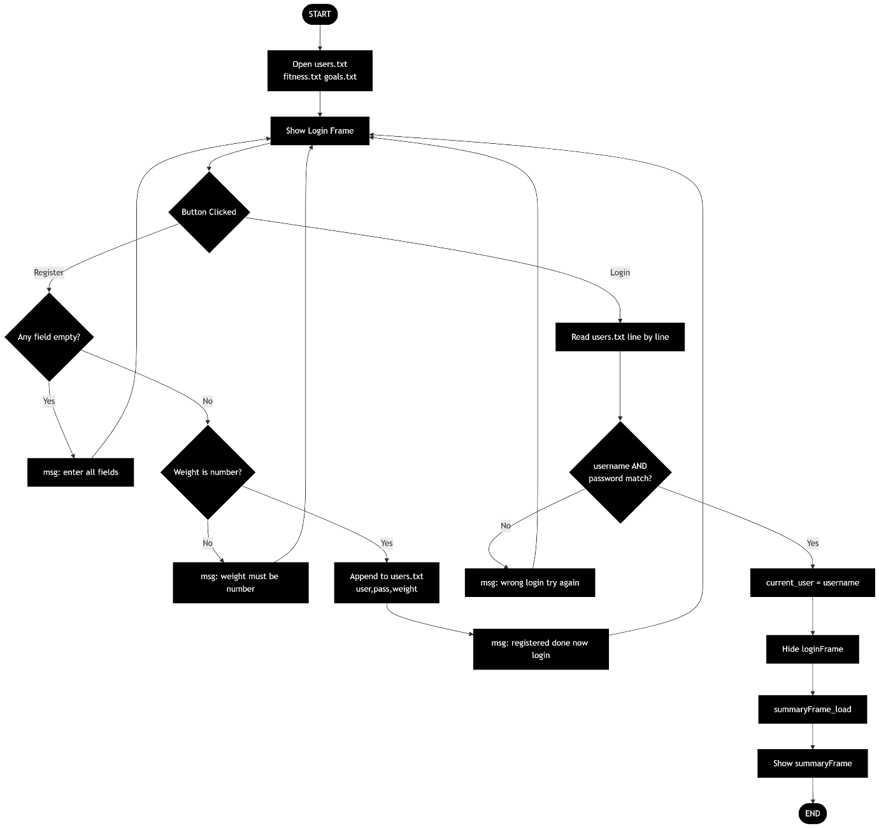

Log Activity & Log Food
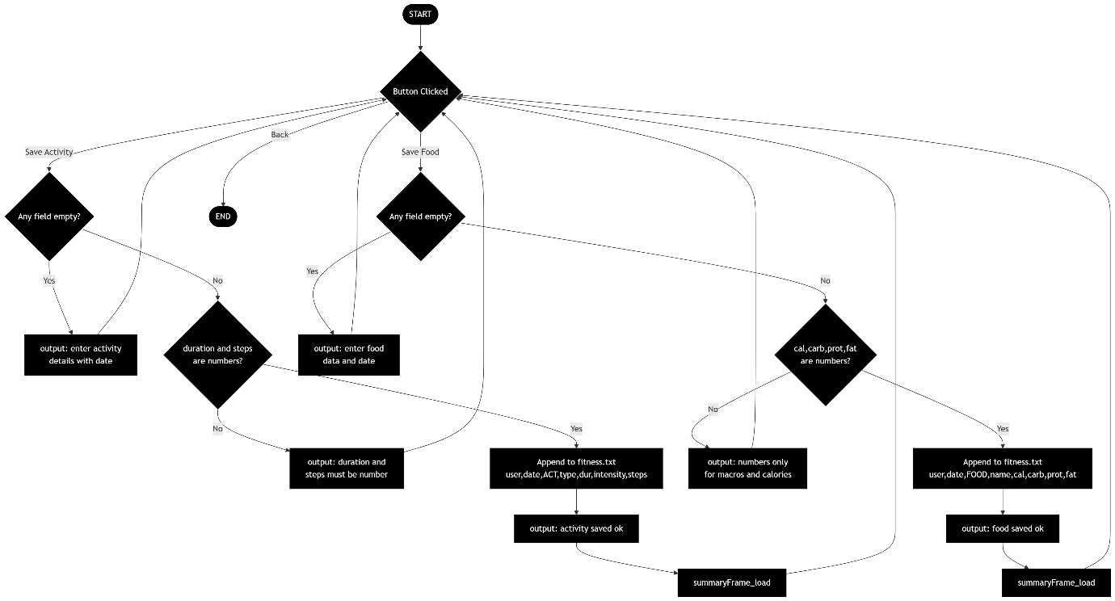

Goals, Summary & Plans
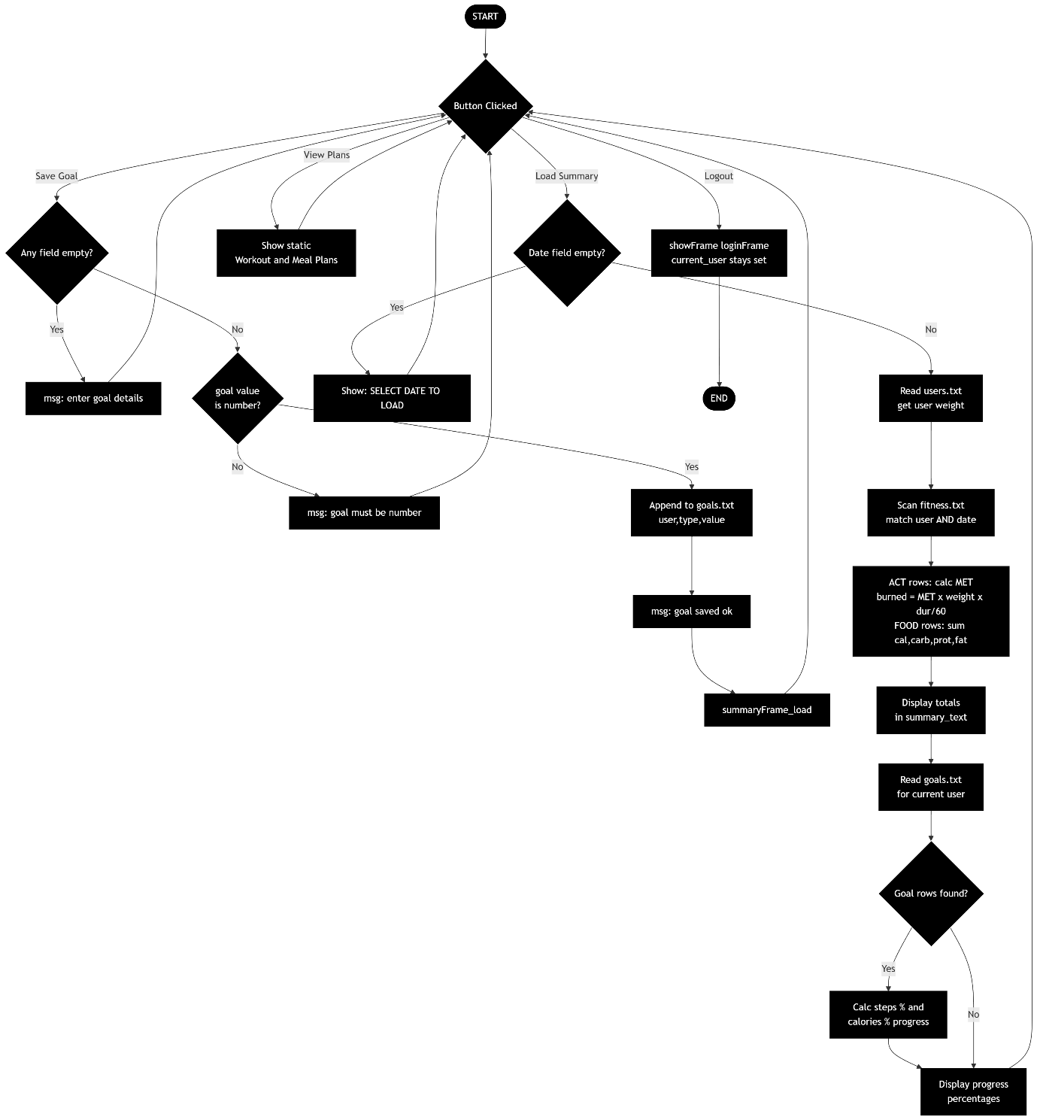
Flowcharts for the Health and Fitness Tracker application

2.2 Pseudocode

BEGIN FitnessTrackerApp
SET user_file = 'users.txt'
SET data_file = 'fitness.txt'
SET current_user = ''

DISPLAY login window (username field, password field, login button, register button)

FUNCTION registerNOW:
GET username and password from fields
IF username is empty OR password is empty THEN
DISPLAY 'enter all fields pls'
RETURN
END IF
OPEN user_file in append mode
WRITE username + ',' + password to file
CLOSE file
DISPLAY 'registered done now login'
END FUNCTION

FUNCTION loginNOW:
GET username and password from fields
OPEN user_file in read mode
READ all data
IF username in data AND password in data THEN
SET current_user = username
HIDE login frame
SHOW menu frame
ELSE
DISPLAY 'wrong login try again'
END IF
END FUNCTION

FUNCTION saveAct:
GET activity, duration, intensity from fields
IF any field is empty THEN
DISPLAY 'enter activity full'
RETURN
END IF
OPEN data_file in append mode
WRITE current_user + ',ACT,' + activity + ',' + duration + ',' + intensity
CLOSE file
DISPLAY 'activity saved ok'
END FUNCTION

FUNCTION saveFoodNOW:
GET food name and calories from fields
IF any field is empty THEN
DISPLAY 'enter food data'
RETURN
END IF
OPEN data_file in append mode
WRITE current_user + ',FOOD,' + food + ',' + calories
CLOSE file
DISPLAY 'food saved ok'
END FUNCTION

FUNCTION showDataNOW:
CLEAR output box
OPEN data_file in read mode
IF file not found THEN
DISPLAY 'file missing'
RETURN
END IF
READ all lines
FOR EACH line:
IF current_user is in line THEN
DISPLAY line in output box
END IF
END FOR
END FUNCTION

END FitnessTrackerApp

Figure 2: Pseudocode for the Health and Fitness Tracker application

2.3 Design Decisions
I decided to split the program into two frames: a login frame and a menu frame. The login frame is shown when the program starts and the menu frame is hidden. Once the user logs in successfully, the login frame disappears and the menu frame appears. This approach is simple and works well with Tkinter.
I also decided to use two separate text files to store data. One file (users.txt) stores the usernames and passwords. The other file (fitness.txt) stores the fitness and food records. Keeping them separate makes it easier to manage.

2.3 Screenshots
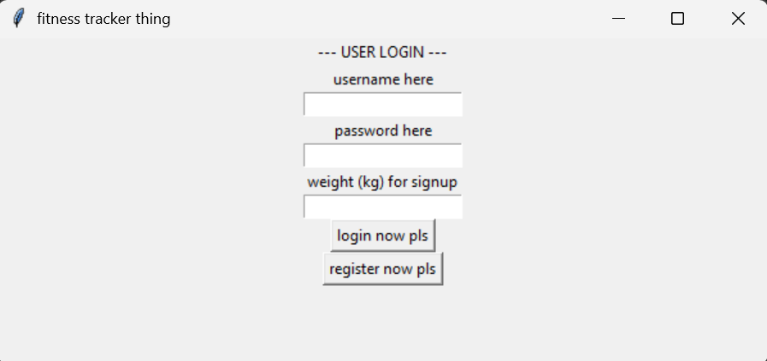
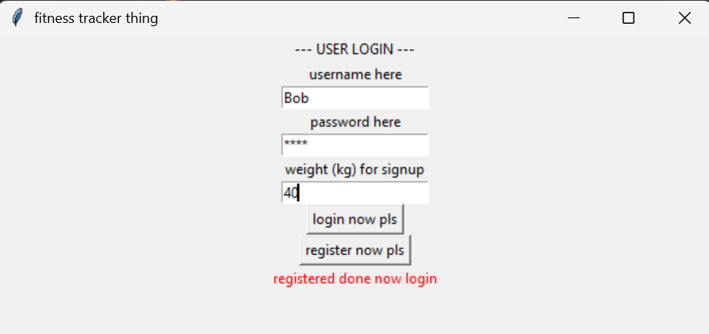
Screenshot 1: Login and register page

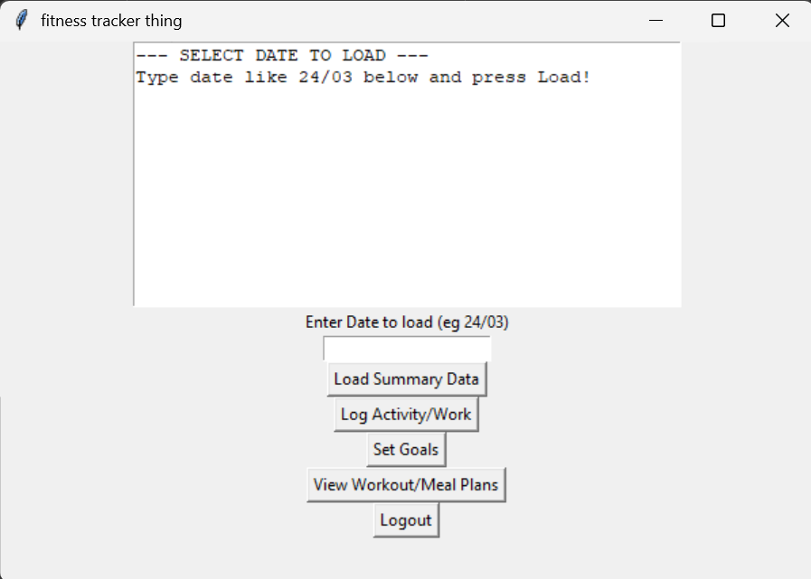
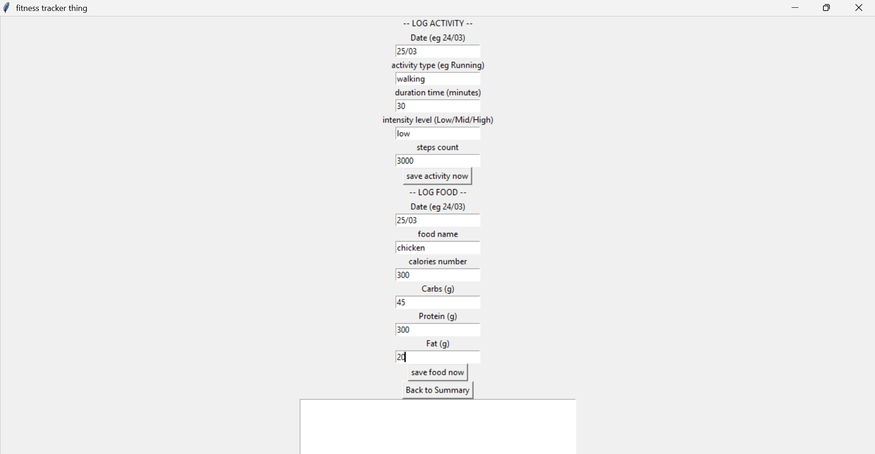

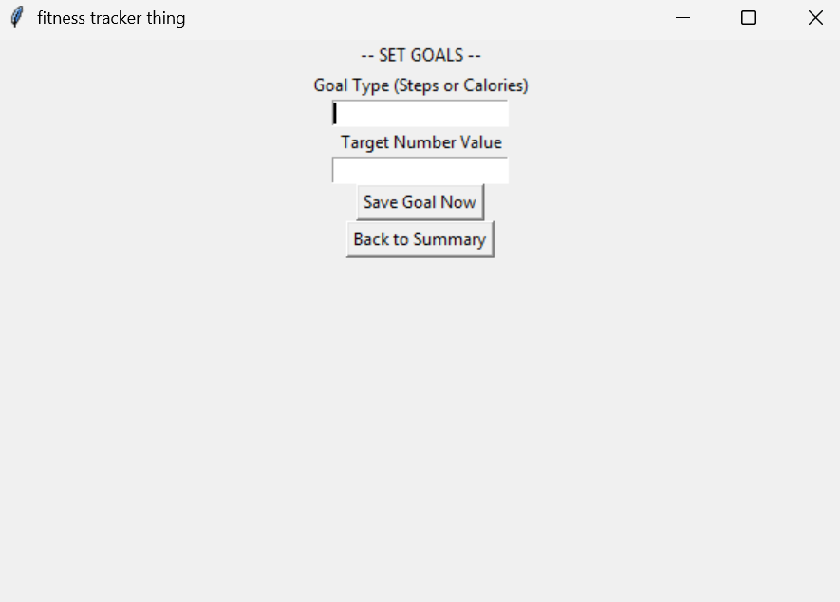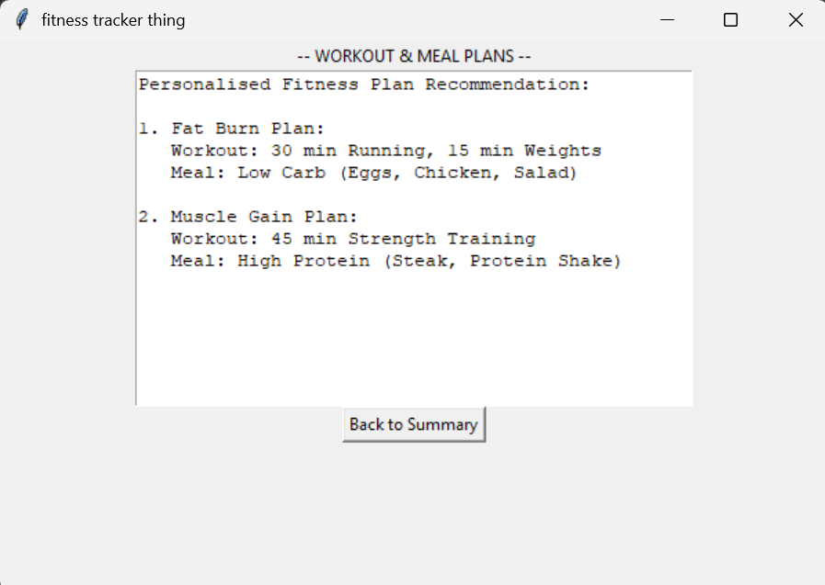
Screenshot 2: Main menu pages

3. Technical Overview

3.1 Programming Language and Library
The program was written in Python 3. Python is a good choice for this kind of program because it is easy to read and write, and it has a built-in library called Tkinter for making GUI applications (Gaddis, 2021). Tkinter does not need to be installed separately as it comes with Python.

3.2 Data Structures Used
The program uses the following data structures:
- String variables: Used to store things like the username (current_user_value), file names, and the data read from files. Strings are used because all the data in this program is text-based.
- List: The showDataNOW function splits the file content into a list called 'lines' using the split() method. This allows the program to loop through each line one at a time and check if it belongs to the current user.
- Files (text files): Two text files are used as simple databases. users.txt stores account information and fitness.txt stores activity and food records. Text files were chosen because they are easy to read and write in Python and do not require any extra libraries.

3.3 Programming Techniques Used
- Functions: Each main action in the program is put inside its own function (loginNOW, registerNOW, saveAct, saveFoodNOW, showDataNOW). This makes the code easier to read and each part does one specific job (Lutz, 2013).
- Global variable: The variable current_user_value is declared as global inside the loginNOW function. This is needed because the function needs to change the value of a variable that is defined outside the function. Without the global keyword, Python would treat it as a new local variable.
- File handling: The program uses Python's open() function in different modes. 'r' mode is used to read files and 'a' mode (append) is used to add new data without deleting existing content. try/except blocks are used around file reading operations to prevent the program from crashing if a file does not exist yet.
- Input validation: Before saving any data, each function checks that the input fields are not empty. The strip() method is used to remove spaces from the beginning and end of input, so a user cannot just press the spacebar and submit an empty entry.
- Tkinter Frames: Two Frame widgets are used to switch between the login screen and the menu screen. pack_forget() is used to hide the login frame and pack() is used to show the menu frame when login is successful.
- while loop: In the showDataNOW function, a while loop is used to go through each line of the fitness file one by one to check if it belongs to the logged-in user.

3.4 Why These Choices Were Made
I chose to use Tkinter because it is the most straightforward way to create a GUI in Python without installing anything extra. It comes built into Python which means anyone can run the program easily (Python Software Foundation, 2024).
I used text files instead of a database because this is a beginner-level project and text files are much simpler to work with. For a more advanced version, a database like SQLite would be a better choice because it would allow more reliable searching and better data security.
I used the global keyword for current_user_value because it needs to be shared between the login function and all the other functions that need to know who is logged in. This is one of the simplest ways to share data between functions in Python, though in a larger program it would be better to use a class or pass the value as a parameter.

4. Coded Solution

4.1 Annotated Python Code
The following is the complete annotated code for the Health and Fitness Tracker. Comments have been added throughout to explain each section of the code:

from tkinter import *

# making window
WinMainAPP = Tk()
WinMainAPP.title("fitness tracker thing")

# global user
current_user_value = ""

# login function
def loginNOW():

global current_user_value

u = user_input_box.get().strip()
p = pass_input_box.get().strip()

try:
# open users file to read credentials
f = open("users.txt" , "r")
data = f.read().strip()
f.close()

# simple check (not perfect but ok)
if u in data and p in data:
current_user_value = u
loginFrame.pack_forget()
menuFrame.pack()
else:
msg_label.config(text="wrong login try again")

except:
msg_label.config(text="file not found")

# register
def registerNOW():
"""registering new user"""
u = user_input_box.get().strip()
p = pass_input_box.get().strip()

if u == "" or p == "":
msg_label.config(text="enter all fields pls")
return

f = open("users.txt","a")

# saving user
f.write(u + "," + p + "\n")

f.close()

msg_label.config(text="registered done now login")

# save activity
def saveAct():

act_val = act_box.get().strip()
dur_val = dur_box.get().strip()
int_val = int_box.get().strip()

if act_val == "" or dur_val == "" or int_val == "":
output_box.insert(END,"\nenter activity full\n")
return

f = open("fitness.txt","a")

f.write(current_user_value + ",ACT," + act_val + "," + dur_val + "," + int_val + "\n")

f.close()

output_box.insert(END,"\nactivity saved ok\n")

# save food
def saveFoodNOW():

food_val = food_box.get().strip()
cal_val = cal_box.get().strip()

if food_val == "" or cal_val == "":
output_box.insert(END,"\nenter food data\n")
return

f = open("fitness.txt","a")

f.write(current_user_value + ",FOOD," + food_val + "," + cal_val + "\n")

f.close()

output_box.insert(END,"\nfood saved ok\n")

# view data
def showDataNOW():

output_box.delete(1.0 , END)

try:
f = open("fitness.txt","r")
data_all = f.read().strip()
f.close()

if data_all == "":
output_box.insert(END,"no data yet")
return
"""viewing data"""
lines = data_all.split("\n")

i = 0

while i < len(lines):

# checking current user
if current_user_value in lines[i]:
output_box.insert(END , lines[i] + "\n")

i = i + 1

except:
output_box.insert(END,"file missing")

# LOGIN
loginFrame = Frame(WinMainAPP)
loginFrame.pack()

"""login screen"""
Label(loginFrame , text="username here").pack()
user_input_box = Entry(loginFrame)
user_input_box.pack()

"""password screen"""
Label(loginFrame , text="password here").pack()
pass_input_box = Entry(loginFrame)
pass_input_box.pack()

"""login button"""
Button(loginFrame , text="login now pls", command=loginNOW).pack()

"""register button"""
Button(loginFrame , text="register now pls", command=registerNOW).pack()

"""message label"""
msg_label = Label(loginFrame , text="")
msg_label.pack()

# MENU
menuFrame = Frame(WinMainAPP)

"""activity type"""
Label(menuFrame , text="activity type").pack()
act_box = Entry(menuFrame)
act_box.pack()

"""duration time"""
Label(menuFrame , text="duration time").pack()
dur_box = Entry(menuFrame)
dur_box.pack()

Label(menuFrame , text="intensity level").pack()
int_box = Entry(menuFrame)
int_box.pack()

Button(menuFrame , text="save activity now", command=saveAct).pack()

Label(menuFrame , text="food name").pack()
food_box = Entry(menuFrame)
food_box.pack()

# calories number
Label(menuFrame , text="calories number").pack()
cal_box = Entry(menuFrame)
cal_box.pack()

Button(menuFrame , text="save food now", command=saveFoodNOW).pack()

Button(menuFrame , text="view progress data", command=showDataNOW).pack()

output_box = Text(menuFrame , height=15 , width=50)
output_box.pack()

if __name__ == "__main__":
WinMainAPP.mainloop()

Figure 3: Complete annotated source code for the Health and Fitness Tracker

5. Testing

5.1 Testing Approach
I tested the program by running it and entering different kinds of data to see how it responded. I tested valid data to make sure it was accepted, invalid data (like empty fields) to make sure error messages appeared, extreme data (very long text) to see if it caused any crashes, and erroneous data (wrong data types) to check for any problems.
The results of the testing are recorded in four tables below. Each table covers a different part of the program.

Testing Table 1: Login and Register Tests

Test No. | Item to Test | Test Description (with example data) | Expected Result | Actual Result | Comments / Actions
1 | Register | Valid: username='tom', password='pass1' | Registered ok, message shown | Message: 'registered done now login' | No action required
2 | Register | Empty username, password='abc' | Error: fill all fields | Error message shown | No action required
3 | Register | Empty both fields | Error: fill all fields | Error message shown | No action required
4 | Login | Correct username and password | Login frame hides, menu frame shows | Menu appears correctly | No action required
5 | Login | Wrong password entered | Error: wrong login | Error message shown | No action required
6 | Login | No users.txt file present | Error: file not found | Correct error shown | No action required

Table 1: Login and Register validation testing

Testing Table 2: Save Activity Tests

Test No. | Item to Test | Test Description (with example data) | Expected Result | Actual Result | Comments / Actions
1 | Save Activity | Valid: activity='running', dur='30', int='high' | Activity saved to file | 'activity saved ok' shown | No action required
2 | Save Activity | Empty activity field | Error shown in output box | Error message displayed | No action required
3 | Save Activity | Empty duration field | Error shown in output box | Error shown correctly | No action required
4 | Save Activity | All fields empty | Error shown | Error message displayed | No action required
5 | Save Activity | Numbers as activity name (e.g. '123') | Accepted and saved | Saved without errors | No action required
6 | Save Activity | Very long activity text (100+ chars) | Accepted and saved | Saved to file correctly | No action required

Table 2: Save Activity validation testing

Testing Table 3: Save Food Tests

Test No. | Item to Test | Test Description (with example data) | Expected Result | Actual Result | Comments / Actions
1 | Save Food | Valid: food='apple', cal='95' | Food saved to file | 'food saved ok' shown | No action required
2 | Save Food | Empty food name | Error shown | Error message displayed | No action required
3 | Save Food | Empty calories field | Error shown | Error message displayed | No action required
4 | Save Food | Letters as calories (e.g. 'abc') | Accepted as string (no validation) | Saved as text to file | Could improve with number check
5 | Save Food | Negative calorie value ('-50') | Accepted as string (no validation) | Saved as text to file | Could improve with value check
6 | Save Food | Both fields have only spaces | Error shown due to .strip() | Error message shown | No action required

Table 3: Save Food validation testing

Testing Table 4: View Data and Boundary Tests

Test No. | Item to Test | Test Description (with example data) | Expected Result | Actual Result | Comments / Actions
1 | View Data | One activity and one food saved | Shows only current user data | User data displayed correctly | No action required
2 | View Data | fitness.txt does not exist | Error: file missing | 'file missing' shown in output box | No action required
3 | View Data | fitness.txt empty | 'no data yet' shown | Message displayed correctly | No action required
4 | View Data | Data saved by two different users | Only shows logged-in user's data | Correct filtering working | No action required
5 | Boundary | Username that is a substring of another user (e.g. 'tom' vs 'tommy') | May show both users' data | Bug: substring match causes incorrect display | Known limitation of simple check
6 | Boundary | Multiple activities saved in a row | All shown in output box | All entries displayed | No action required

Table 4: View Data and boundary/edge case testing

5.2 Changes Made After Testing
After testing I noticed that the login check was not very secure. If one username was contained inside another (for example 'tom' inside 'tommy') the login could incorrectly accept the wrong user. This is a known limitation of the simple 'in' check. In the future I would change this to check line by line and split each line by the comma to compare username and password separately.
I also noticed that the calories field accepts text, which means a user could type letters instead of a number and the program would still save it. This could be fixed by adding a check using the isdigit() method before saving.

6. Evaluation

6.1 How Well the Program Meets the Success Criteria
Looking back at the success criteria I set in Section 1, I can evaluate how well the program has met each one:
- Users can register: Yes, the registerNOW function allows new users to create an account and it saves the username and password to a file.
- Users can log in: Yes, the loginNOW function reads from the file and checks if the username and password exist. If they do, the menu appears.
- Users can save fitness activities: Yes, the saveAct function saves activity type, duration, and intensity to the fitness file.
- Users can log food intake: Yes, the saveFoodNOW function saves food name and calories to the same fitness file.
- Users can view their own data: Mostly yes. The showDataNOW function filters lines to only show the logged-in user's data. However, there is a bug with usernames that are substrings of each other.
- Input validation works: Yes, empty fields are caught and error messages are shown in most cases. Calorie validation is missing.
- Data persists between sessions: Yes, text files are used so data is saved even when the program is closed.

6.2 Strengths of the Solution
The main strengths of the program are that it is simple and easy to use. The GUI is clear with labels on each input field. The frame switching between login and menu works smoothly. The file handling keeps data saved between sessions which meets one of the most important requirements.
The code is also well-organised with each task in its own function, making it easier to read and maintain (Dawson, 2010).

6.3 Weaknesses and Future Improvements
The biggest weakness is the login security. The current check just looks for whether the username and password appear anywhere in the file text, which is not reliable. A better approach would be to read the file line by line, split each line by comma, and compare each part individually.
Another weakness is that calorie input is not validated as a number. A user could type anything and it would be saved. Adding a try/except block around float() conversion would fix this.
In the future I would also like to add a logout button so users can switch accounts, and a delete function so users can remove incorrect entries. A summary feature that adds up total calories or exercise time for the week would also make the app much more useful.

7. References
Dawson, M. (2010) Python Programming for the Absolute Beginner. 3rd edn. Course Technology.

Gaddis, T. (2021) Starting Out with Python. 5th edn. Pearson Education.

Lutz, M. (2013) Learning Python. 5th edn. O'Reilly Media.

Python Software Foundation (2024) The Python Standard Library – tkinter. Available at: https://docs.python.org/3/library/tkinter.html

Python Software Foundation (2024) Python 3 Documentation. Available at: https://docs.python.org/3/

Summerfield, M. (2007) Programming in Python 3. Addison-Wesley Professional.

W3Schools (2024) Python File Handling. Available at: https://www.w3schools.com/python/python_file_handling.asp

GeeksforGeeks (2024) Python Tkinter – Introduction to GUI Programming. Available at: https://www.geeksforgeeks.org/python-gui-tkinter/

