Basic Fit Tracker
A Tkinter-Based Personal Fitness Tracking Application
TABLE OF CONTENTS
Table of Contents
1. Analysis 3
1.1 Problem Description 3
1.2 Use of the datetime Library 3
1.3 Why Steps Minimum is 1,000 and Calories Minimum is 500 3
1.4 Key Challenges 4
1.5 Success Criteria 4
2. Design 5
2.1 Pseudocode Algorithm 5
2.2 Flowcharts 6
Flowchart (Startup, Login and Registration) 6
Flowchart 2 (Add Activity and Add Food) 7
Flowchart 3 (Save Goals, Refresh Summary and Logout) 7
3. Technical Overview 8
3.1 Tkinter GUI Framework 8
3.2 File Storage and the Pipe Delimiter 8
3.3 MET-Based Calorie Burn Calculation 8
3.4 Custom Number Validation 8
3.5 Data Structures 8
4. Coded Solution 10
5. Application Screenshots 22
6. Testing 25
6.1 Testing Approach 25
6.2 Test Results 25
7. Evaluation 27
7.1 Assessment Against Success Criteria 27
7.2 Strengths 27
7.3 Limitations 27
7.4 Future Improvements 27
8. References 29

1. Analysis

1.1 Problem Description
The scenario for this assignment centres on Tom, an employee at a health and wellness technology company, who has been tasked with developing a desktop fitness tracking application. The intended users are members of the general public who want a simple, accessible tool to monitor their daily physical activity, log the food they eat, and track their progress towards personal health goals. The application must support multiple users on the same machine without any one user being able to see another's data.
The solution produced here, titled Basic Fit Tracker, is a graphical desktop application built in Python using the tkinter library. Unlike the command-line solutions used in previous assignments, this application presents a fully interactive window with labelled entry fields, buttons, and live text output panels, making it accessible to users who are not comfortable with a terminal.
All data is stored in three plain text files on the local machine: ft_users.txt for account credentials and body weight, ft_logs.txt for all activity and food entries, and ft_goals.txt for each user's personal step and calorie targets. No external database or internet connection is required.

1.2 Use of the datetime Library
The datetime library is imported at the top of the program with the line: from datetime import date. Specifically, the date class from this library is used.
Its single usage point is the global constant TODAY, which is set at program startup using str(date.today()). This converts the current calendar date into an ISO 8601 string in the format YYYY-MM-DD, for example 2026-03-25.
TODAY is then used in two critical places throughout the application. First, every row written to ft_logs.txt (both activity rows beginning with A| and food rows beginning with F|) includes TODAY as the third pipe-separated field. This timestamps each entry so it can be matched back to the day it was created. Second, in get_today_data(), every row read from ft_logs.txt is filtered by comparing the stored date field against TODAY. Only rows where the date field exactly matches TODAY are included in the totals displayed in the summary and log panels. This means the summary always reflects today's data only, regardless of how many historical entries exist in the file.
Without the datetime library, the application would have no way of knowing the current date without asking the user to type it, which would be error-prone and inconvenient. By obtaining the date automatically from the operating system at startup, the tracking is always accurate and requires no manual input from the user (Python Software Foundation, 2024c).

1.3 Why Steps Minimum is 1,000 and Calories Minimum is 500
The save_goal_click function enforces a minimum of 1,000 for the daily step goal and a minimum of 500 for the daily calorie goal. These thresholds were chosen deliberately based on established health and nutrition guidelines, not as arbitrary technical constraints.
The 1,000-step minimum for the step goal exists because setting a daily step target below 1,000 steps would not constitute a meaningful physical activity goal. The NHS recommends that adults aim for at least 10,000 steps per day as a general health benchmark (NHS, 2024). A goal of fewer than 1,000 steps would be so low that it provides no health benefit and is almost certainly a data entry error — for example, a user accidentally typing 100 instead of 10,000. The minimum prevents the progress percentage displayed in the summary from showing misleadingly inflated values such as 3,500% because the user set a goal of 100 steps.
The 500-calorie minimum for the daily calorie goal is grounded in nutritional safety. The British Dietetic Association and NHS guidance both caution that very low-calorie diets (generally defined as under 800 kcal per day) should only be undertaken under medical supervision (NHS, 2024). Setting the floor at 500 kcal prevents a user from entering an unrealistically low-calorie target that could encourage dangerously restrictive eating behaviour. At the same time, 500 kcal is deliberately set below the medically supervised threshold so that users with genuine low-calorie clinical targets can still use the application. A goal of fewer than 500 kcal per day is almost certainly a typing error and the validation protects data quality as well as user wellbeing.

1.4 Key Challenges
- Multi-user data isolation: all three files store data from every registered user. Every read operation must filter rows by matching the stored username field against current_user to ensure users see only their own data.
- Custom number validation without external libraries: because no modules such as csv or re are permitted, a manual character-by-character number checker (number_text) was written from scratch. It supports integers and decimals with a maximum of one dot.
- MET-based calorie burn calculation: estimating calories burned from an activity requires the user's body weight, the duration of the activity, and a MET (Metabolic Equivalent of Task) value for the effort level. The three intensity levels low (MET 3), medium (MET 5), and high (MET 8) were chosen as broadly representative of light, moderate, and vigorous physical activity respectively (Ainsworth et al., 2011).
- Tkinter widget layout: the application uses both pack() and grid() layout managers, but never mixes them within the same frame. The login_frame uses pack() because its simple vertical stack suits that approach, while app_frame uses grid() to achieve the two-column form layout required for the data entry fields.
- File delimiter collision: the pipe character | was chosen as the field delimiter instead of a comma because food names and activity types might legitimately contain commas. The bad_text() function rejects any user input that contains a pipe character to prevent delimiter injection into the stored files.

1.5 Success Criteria
- A user can register a new account with a unique username, a password of at least four characters, and a body weight between 25 and 250 kg.
- A registered user can sign in and the application shows their data and hides that of all other users.
- A user can log a physical activity by specifying type, duration in minutes, intensity (low/medium/high), and step count. Calorie burn is calculated automatically using the MET formula.
- A user can log a food entry with name, calories, and full macro breakdown (carbohydrates, protein, fat). All values are validated as non-negative numbers.
- A user can set daily goals for steps and calories. The step goal must be at least 1,000 and the calorie goal at least 500.
- The summary panel shows today's totals for steps, calories burned, calories eaten, net balance, and all macros, and displays goal progress as a percentage.
- A contextual plan message is shown based on the net calorie balance.
- All data persists between sessions through the three text files.

2. Design

2.1 Pseudocode Algorithm
The pseudocode below describes the complete logic of the Basic Fit Tracker from startup to shutdown. It is presented in a structured style using numbered steps to describe each major operation.

- The program starts.
- Call make_files(). Open ft_users.txt, ft_logs.txt, and ft_goals.txt each in append mode. If any file does not exist, the append-mode open creates it automatically. If it already exists, no data is changed.
- Set TODAY = str(date.today()). This captures the current date once at startup. Every activity and food entry logged in this session will use this value as their date stamp.
- Set current_user to an empty string. This variable tracks who is signed in; empty means no one is signed in.
- Create the Tkinter root window (760 x 760). Build and display the login_frame with entry fields for username, password, and weight, plus Login and Register buttons.
- User clicks Register. Call register_click(). Read username, password, and weight from the entry fields. IF username or password contain a pipe character or are blank, show 'username/password invalid'. IF password length is less than 4, show 'password too short'. IF weight is not a valid number, show 'weight must be number'. IF weight is outside 25 to 250, show 'weight out of range'. IF username already exists in ft_users.txt, show 'username already taken'. IF all checks pass, call write_user_map() to append the new account to ft_users.txt and show 'register done, now login'.
- User clicks Login. Call login_click(). Read username and password. Call read_user_map() to load ft_users.txt into a dictionary. IF the username exists in the dictionary AND the stored password matches, set current_user to the username, hide the login_frame, show the app_frame, and call refresh_summary_action(). IF the check fails, show 'wrong username or password'.
- The app_frame is now visible. The user sees form fields for activity, food, and goals, plus a Refresh Summary button and two output text panels.
- User fills in the activity fields and clicks Add Activity. Call add_activity_click(). Validate: type must not be blank or contain |; duration and steps must be valid numbers; duration must be greater than 0; steps must be at least 1; intensity must be exactly low, medium, or high. IF any check fails, show an error message. IF all pass, call append_activity_row() to write one A| row to ft_logs.txt. Clear the entry fields and call refresh_summary_action().
- User fills in the food fields and clicks Add Food. Call add_food_click(). Validate: name must not be blank or contain |; all numeric fields must be valid numbers; calories must be greater than 0; carbs, protein, and fat must each be 0 or above. IF any check fails, show an error. IF all pass, call append_food_row() to write one F| row to ft_logs.txt. Clear the fields and call refresh_summary_action().
- User enters step and calorie goals and clicks Save Goals. Call save_goal_click(). Validate: both values must be valid numbers; steps must be at least 1,000 (see Section 1.3); calories must be at least 500 (see Section 1.3). IF any check fails, show the relevant error message. IF all pass, call read_goal_map() to load the current goals dictionary, update the entry for current_user, and call write_goal_map() to rewrite ft_goals.txt. Call refresh_summary_action().
- refresh_summary_action() is called (by any button that saves data, or directly). IF current_user is empty, show 'login first' and return. Otherwise call get_today_data(current_user). Inside get_today_data: clear both text panels; open ft_logs.txt and scan every line; for each A| row where username equals current_user and date equals TODAY, add the step count to total_steps and calculate calories burned using: burned = MET x weight x (duration / 60). MET values: low = 3.0, medium = 5.0, high = 8.0. For each F| row where username and date match, sum calories eaten and all macro totals. After scanning, compute net = eaten minus burned. Display all totals in the summary_text widget. Call read_goal_map() and if a goal row exists for current_user, calculate and display step and calorie progress percentages. Finally call simple_plan_text(net) to generate and display a plan message.
- simple_plan_text(net): IF net is greater than 300, return 'reduce snacks and add walk'. IF net is less than -300, return 'eat enough and recover'. Otherwise return 'keep same routine'.
- User clicks Logout. Call logout_click(). Set current_user to empty string. Hide app_frame and show login_frame again.
- The program continues running in the Tkinter event loop until the user closes the window. root.mainloop() manages all widget events.

2.2 Flowcharts

Flowchart (Startup, Login and Registration)
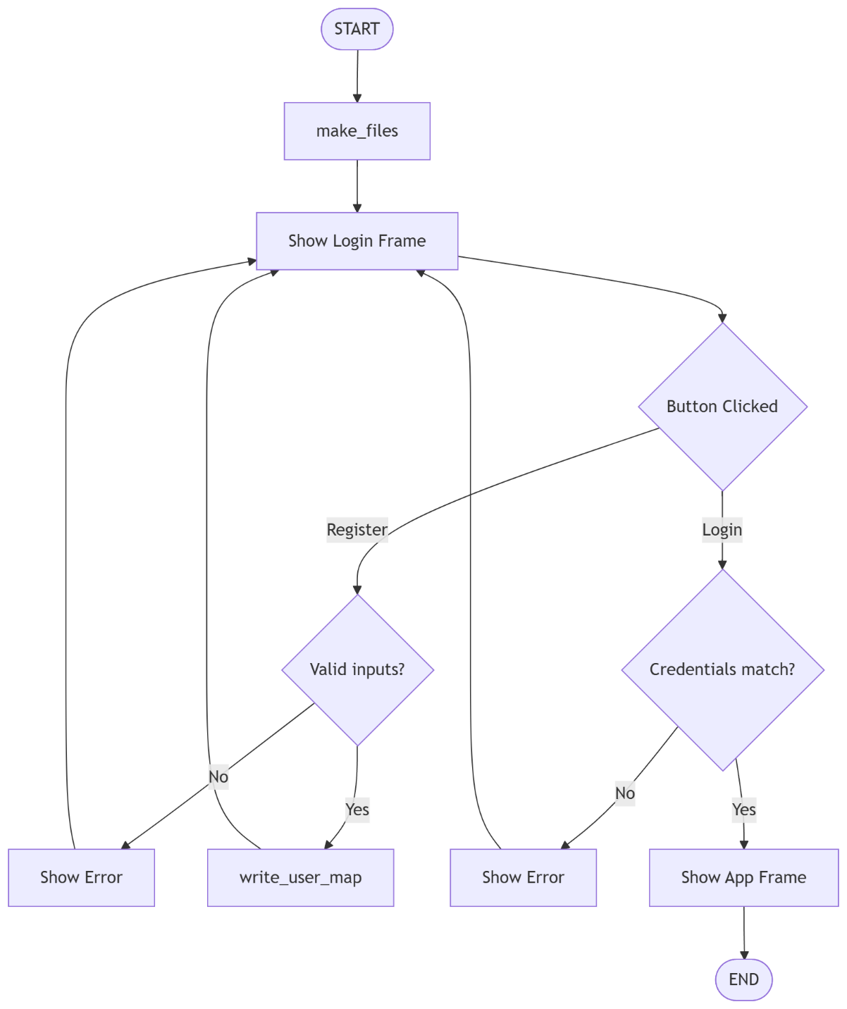
Figure 1. Application startup, login and account registration

Flowchart 2 (Add Activity and Add Food)
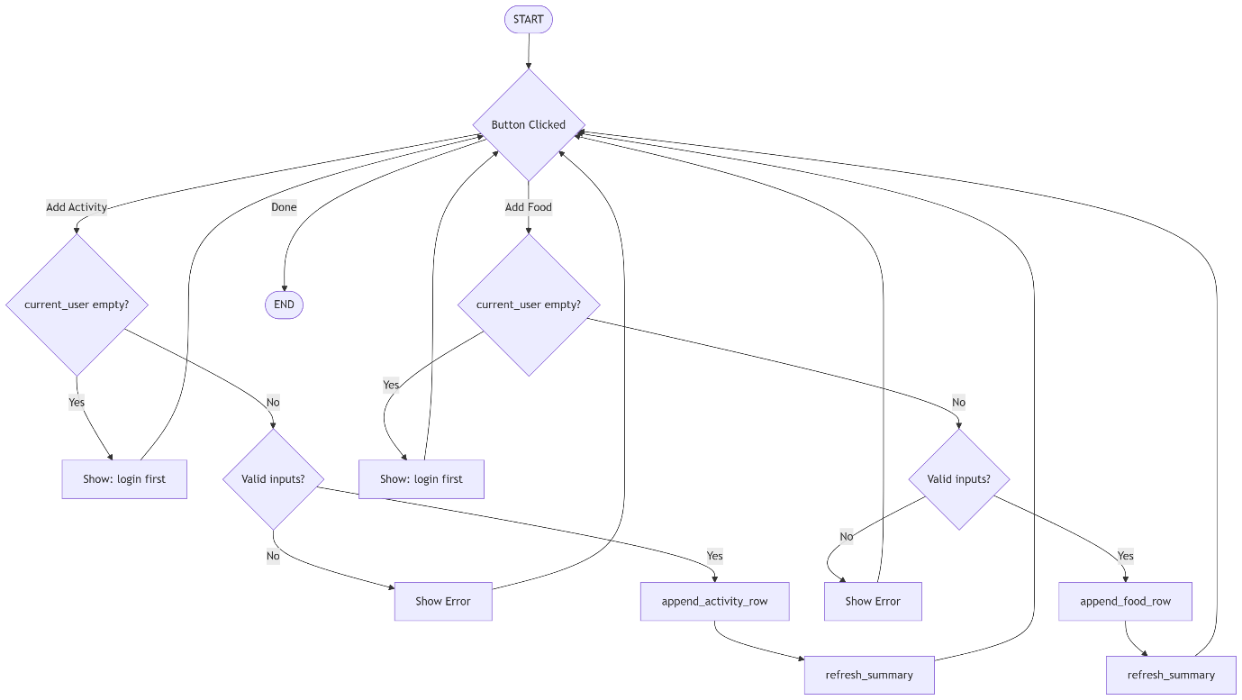
Figure 2. Add activity and add food with full validation

Flowchart 3 (Save Goals, Refresh Summary and Logout)
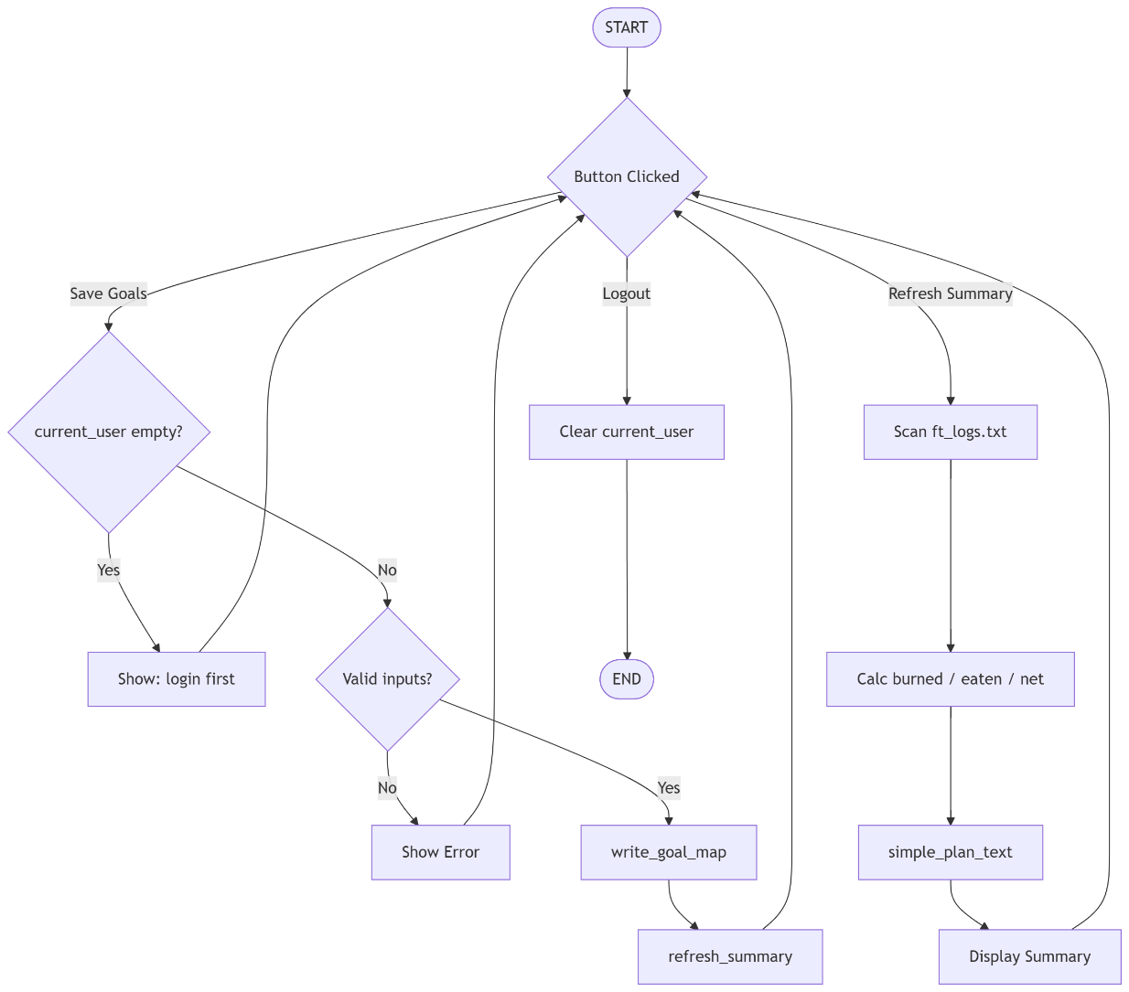
Figure 3. Save goals, refresh summary calculations and logout

3. Technical Overview

3.1 Tkinter GUI Framework
The application uses tkinter, Python's standard built-in library for creating graphical user interfaces. Tkinter wraps the Tcl/Tk toolkit and requires no installation beyond a standard Python environment. Two layout managers are used in the application. The login_frame uses pack() which stacks widgets vertically in the order they are added this suits the simple linear form layout of the login screen. The app_frame uses grid() which places widgets in a row/column coordinate system this allows the two-column form design where labels appear in column 0 and entry fields appear in column 1
Key tkinter widgets used in this application include: Label for displaying static text and dynamic status messages; Entry for single-line text input fields; Button which calls a Python function via its command parameter when clicked; Text for the multi-line scrollable output panels that display the summary and log data; and Frame which acts as a container to group related widgets together and allow the entire group to be shown or hidden at once using pack() and pack_forget().

3.2 File Storage and the Pipe Delimiter
Three plain text files store all persistent data. The pipe character | was chosen as the column delimiter rather than a comma because food descriptions and activity type names may legitimately contain commas, which would corrupt a comma-delimited file. The bad_text() function rejects any user input containing a | character to prevent deliberate or accidental injection of extra delimiter characters into a stored row.
Each file uses a simple flat-row structure with no header line. ft_users.txt stores one row per registered user in the format username | password | weight. ft_logs.txt stores one row per logged entry; activity rows are prefixed with A| and food rows with F|. ft_goals.txt stores one row per user in the format username | steps | calories. When goals are updated, the entire file is rewritten from the in-memory dictionary using write_goal_map(), which is the same overwrite-and-rewrite pattern used for users. Activity and food logs use append mode only; they are never rewritten because historical data must be preserved.

3.3 MET-Based Calorie Burn Calculation
Calories burned during physical activity are estimated using the Metabolic Equivalent of Task (MET) formula: calories burned = MET x body weight in kg x duration in hours. This is a widely used approximation documented in the Compendium of Physical Activities (Ainsworth et al., 2011). In this application, duration is stored in minutes, so the formula is implemented as: total_burned = MET x weight x (duration / 60.0).
Three intensity levels map to fixed MET values: low maps to 3.0 (representative of light activity such as leisurely walking), medium maps to 5.0 (representative of moderate activity such as brisk walking or cycling), and high maps to 8.0 (representative of vigorous activity such as running or HIIT). The user's body weight in kg is retrieved from ft_users.txt via get_weight_for_user() each time a summary is refreshed, so if the user updates their weight in a future session, subsequent calorie calculations will use the updated value.

3.4 Custom Number Validation
Number validation is performed by the custom function number_text(). This function iterates through every character in the input string using a while loop. It returns False if the string is empty, if it contains any character outside the range '0' to '9', or if it contains more than one dot. The dot check uses a counter (dots) that increments for each dot found; if the counter exceeds 1, the function returns False immediately. This approach correctly validates both integers (such as '3500') and decimal numbers (such as '72.5') without relying on try/except conversion.

3.5 Data Structures
Two Python dictionaries are used as the primary in-memory data structures. The users dictionary (returned by read_user_map()) maps each username string to a nested dictionary containing two keys: 'password' and 'weight'. The goals dictionary (returned by read_goal_map()) maps each username to a nested dictionary with keys 'steps' and 'calories'. Dictionaries were chosen because they allow O(1) lookup by username when checking whether a username already exists during registration, or when retrieving a user's goal values during a summary refresh, the check is a single dictionary key lookup rather than a linear scan of a list.

4. Coded Solution
The annotated source code below covers the complete application. Comments explain the purpose of every function and the logic of key blocks.

Code: main.py

from tkinter import *
from datetime import date

# simple files for this basic tracker
# i make some files here to save data
FILE_USERS = "ft_users.txt"
FILE_LOGS = "ft_logs.txt"
FILE_GOALS = "ft_goals.txt"

# todays date auto text
# get the date from system
TODAY = str(date.today())

# current session user
# who is using the app now
current_user = ""

# system setup and config finished
def make_files():
# create files if not there
# if files not exist then make them empty
f1 = open(FILE_USERS, "a")
f1.close()

f2 = open(FILE_LOGS, "a")
f2.close()

f3 = open(FILE_GOALS, "a")
f3.close()

# helper tools for validating inputs
def bad_text(v):
# bad means empty or storage separators
# check if user put weird symbols or nothing
# reject empty string inputs
if len(v) == 0:
return True
# prevent breaking pipe separated logs structure
if "|" in v:
return True
if "\n" in v:
return True
return False

# check if we have a valid float number
def number_text(v):
# simple number checker with max one dot
# this function check if string is a number or not
if len(v) == 0:
return False

i = 0
dots = 0
while i < len(v):
ch = v[i]
if ch == ".":
dots = dots + 1
if dots > 1:
return False
elif ch < "0" or ch > "9":
return False
i = i + 1

return True

# functions to read and write from files
def read_user_map():
# output: user -> {password, weight}
# get all users from the file into a list or dict
users = {}

f = open(FILE_USERS, "r")
lines = f.readlines()
f.close()

i = 0
while i < len(lines):
line = lines[i].strip()
p = line.split("|")
if len(p) >= 3:
u = p[0]
pw = p[1]
w = p[2]
if number_text(w):
users[u] = {"password": pw, "weight": float(w)}
i = i + 1

return users

# update user file with new map data
def write_user_map(users):
# rewrite full user file from dict
# save the user data back to the disk
f = open(FILE_USERS, "w")

for uname in users:
info = users[uname]
row = uname + "|" + info["password"] + "|" + str(info["weight"]) + "\n"
f.write(row)

f.close()

# operations relating to goals fit tracker
def read_goal_map():
# output: user -> {steps, calories}
# read the goal file so we know what they want reach
goals = {}

f = open(FILE_GOALS, "r")
lines = f.readlines()
f.close()

i = 0
while i < len(lines):
line = lines[i].strip()
p = line.split("|")
if len(p) >= 3:
u = p[0]
s = p[1]
c = p[2]
if number_text(s) and number_text(c):
goals[u] = {"steps": float(s), "calories": float(c)}
i = i + 1

return goals

# write goals map back into memory disk
def write_goal_map(goals):
# rewrite full goal file from dict
# put the goals into the txt file
f = open(FILE_GOALS, "w")

for uname in goals:
info = goals[uname]
row = uname + "|" + str(info["steps"]) + "|" + str(info["calories"]) + "\n"
f.write(row)

f.close()

# row appenders for history logging
def append_activity_row(user_name, day_text, act_type, dur_text, intensity_text, steps_text):
# A row format: A|user|date|type|duration|intensity|steps
# just add one newline for new activity
# open in append mode to preserve previous logs history
f = open(FILE_LOGS, "a")
row = "A|" + user_name + "|" + day_text + "|" + act_type + "|" + dur_text + "|" + intensity_text + "|" + steps_text + "\n"
f.write(row)
f.close()

# write food row into log structure
def append_food_row(user_name, day_text, food_name, cal_text, carb_text, prot_text, fat_text):
# F row format: F|user|date|name|cal|carb|prot|fat
# write food into log file
f = open(FILE_LOGS, "a")
row = "F|" + user_name + "|" + day_text + "|" + food_name + "|" + cal_text + "|" + carb_text + "|" + prot_text + "|" + fat_text + "\n"
f.write(row)
f.close()

# retrieval functions for user info
def get_weight_for_user(user_name):
# read weight for calories burned math
# i need weight or i cant calcuclate calories
users = read_user_map()
if user_name in users:
return users[user_name]["weight"]
return 70.0

# aggregate numbers for the main dashboard view
def get_today_data(user_name):
# collect all today totals from log file
# this loop look for everything user did today
total_steps = 0.0
total_burned = 0.0
total_eaten = 0.0
total_carb = 0.0
total_prot = 0.0
total_fat = 0.0

weight = get_weight_for_user(user_name)

log_text.delete("1.0", END)
log_text.insert(END, "today entries\n")
log_text.insert(END, "------------------------------\n")

f = open(FILE_LOGS, "r")
lines = f.readlines()
f.close()

show_count = 0
i = 0
while i < len(lines):
line = lines[i].strip()
p = line.split("|")

if len(p) >= 4:
kind = p[0]
uname = p[1]
day = p[2]

if uname == user_name and day == TODAY:
if kind == "A" and len(p) >= 7:
act_type = p[3]
dur = p[4]
inten = p[5]
st = p[6]

if number_text(dur) and number_text(st):
dval = float(dur)
sval = float(st)
total_steps = total_steps + sval

# Metabolic Equivalent of Task rates
# higher intensity burns significantly more energy per minute
met = 3.0
if inten == "medium":
met = 5.0
elif inten == "high":
met = 8.0

# formula: MET * weight * duration_in_hours = calories burned
total_burned = total_burned + (met * weight * (dval / 60.0))

log_text.insert(END, "ACT " + act_type + " " + str(dval) + " min " + inten + " " + str(int(sval)) + " steps\n")
show_count = show_count + 1

elif kind == "F" and len(p) >= 8:
# unpack food macros index map from row variables
fname = p[3]
cal = p[4]
carb = p[5]
prot = p[6]
fat = p[7]

if number_text(cal) and number_text(carb) and number_text(prot) and number_text(fat):
cval = float(cal)
carbv = float(carb)
protv = float(prot)
fatv = float(fat)

total_eaten = total_eaten + cval
total_carb = total_carb + carbv
total_prot = total_prot + protv
total_fat = total_fat + fatv

log_text.insert(END, "FOOD " + fname + " " + str(cval) + " kcal C" + str(carbv) + " P" + str(protv) + " F" + str(fatv) + "\n")
show_count = show_count + 1

i = i + 1

if show_count == 0:
log_text.insert(END, "no entries today\n")

return total_steps, total_burned, total_eaten, total_carb, total_prot, total_fat

# main trigger for refreshing the app text boxes
def refresh_summary_action():
# update summary text and goals progress
# clear the text box and put new numbers inside
if len(current_user) == 0:
summary_text.delete("1.0", END)
summary_text.insert(END, "login first")
return

welcome_label.config(text="logged user: " + current_user)

t_steps, t_burn, t_eat, t_carb, t_prot, t_fat = get_today_data(current_user)
# calculate total balance (consumed minus spent)
net = t_eat - t_burn

summary_text.delete("1.0", END)
summary_text.insert(END, "today: " + TODAY + "\n")
summary_text.insert(END, "steps: " + str(int(t_steps)) + "\n")
summary_text.insert(END, "burned kcal: " + str(round(t_burn, 1)) + "\n")
summary_text.insert(END, "eaten kcal: " + str(round(t_eat, 1)) + "\n")
summary_text.insert(END, "net kcal: " + str(round(net, 1)) + "\n")
summary_text.insert(END, "carbs: " + str(round(t_carb, 1)) + " g\n")
summary_text.insert(END, "protein: " + str(round(t_prot, 1)) + " g\n")
summary_text.insert(END, "fat: " + str(round(t_fat, 1)) + " g\n")

goals = read_goal_map()
if current_user in goals:
gs = goals[current_user]["steps"]
gc = goals[current_user]["calories"]

# percentage of goal reached for today
step_p = 0.0
cal_p = 0.0
if gs > 0:
step_p = (t_steps / gs) * 100.0
if gc > 0:
cal_p = (t_eat / gc) * 100.0

summary_text.insert(END, "\n")
summary_text.insert(END, "goal steps: " + str(int(gs)) + " progress: " + str(int(step_p)) + "%\n")
summary_text.insert(END, "goal calories: " + str(int(gc)) + " progress: " + str(int(cal_p)) + "%\n")
else:
summary_text.insert(END, "\n")
summary_text.insert(END, "goals not set yet\n")

summary_text.insert(END, "\n")
summary_text.insert(END, simple_plan_text(net))

def simple_plan_text(net_kcal):
# simple static-like advice text
# some advice based on calories balance
if net_kcal > 300:
return "plan: reduce snacks and add walk"
if net_kcal < -300:
return "plan: eat enough and recover"
return "plan: keep same routine"

def login_click():
# login existing account
# check if user and pass match
global current_user

# pull strings and clean accidental spaces
u = login_user_entry.get().strip()
p = login_pass_entry.get().strip()

users = read_user_map()
if u in users and users[u]["password"] == p:
current_user = u
login_msg.config(text="")
login_frame.pack_forget()
app_frame.pack(padx=8, pady=8)
refresh_summary_action()
else:
login_msg.config(text="wrong username or password")

def register_click():
# create new account
# make a new user if not already there
u = login_user_entry.get().strip()
p = login_pass_entry.get().strip()
w = login_weight_entry.get().strip()

if bad_text(u) or bad_text(p):
login_msg.config(text="username/password invalid")
return

if len(p) < 4:
login_msg.config(text="password too short")
return

if not number_text(w):
login_msg.config(text="weight must be number")
return

wv = float(w)
# validate that body weight is within human thresholds
if wv < 25 or wv > 250:
login_msg.config(text="weight out of range")
return

users = read_user_map()
if u in users:
login_msg.config(text="username already taken")
return

users[u] = {"password": p, "weight": wv}
write_user_map(users)
login_msg.config(text="register done, now login")

def logout_click():
# logout and back to login panel
# go back to start page
global current_user
current_user = ""
app_frame.pack_forget()
login_frame.pack(padx=8, pady=8)
login_msg.config(text="logged out")

def add_activity_click():
# save one activity row
# button for adding exercise
if len(current_user) == 0:
action_msg.config(text="login first")
return

t = act_type_entry.get().strip()
d = act_duration_entry.get().strip()
n = act_intensity_entry.get().strip().lower()
s = act_steps_entry.get().strip()

if bad_text(t):
action_msg.config(text="activity type needed")
return

if not number_text(d) or not number_text(s):
action_msg.config(text="duration and steps must be numbers")
return

dv = float(d)
sv = float(s)

if dv <= 0:
action_msg.config(text="duration must be > 0")
return

if sv < 1:
action_msg.config(text="steps must be >= 1")
return

if n != "low" and n != "medium" and n != "high":
action_msg.config(text="intensity: low/medium/high")
return

append_activity_row(current_user, TODAY, t, d, n, s)
action_msg.config(text="activity saved")

act_type_entry.delete(0, END)
act_duration_entry.delete(0, END)
act_intensity_entry.delete(0, END)
act_steps_entry.delete(0, END)

refresh_summary_action()

def add_food_click():
# save one food row
# store what i eat today
if len(current_user) == 0:
action_msg.config(text="login first")
return

n = food_name_entry.get().strip()
c = food_cal_entry.get().strip()
carb = food_carb_entry.get().strip()
prot = food_prot_entry.get().strip()
fat = food_fat_entry.get().strip()

if bad_text(n):
action_msg.config(text="food name needed")
return

if not number_text(c) or not number_text(carb) or not number_text(prot) or not number_text(fat):
action_msg.config(text="food numbers are invalid")
return

cv = float(c)
carbv = float(carb)
protv = float(prot)
fatv = float(fat)

if cv <= 0:
action_msg.config(text="calories must be > 0")
return

if carbv < 0 or protv < 0 or fatv < 0:
action_msg.config(text="macro values cannot be negative")
return

append_food_row(current_user, TODAY, n, c, carb, prot, fat)
action_msg.config(text="food saved")

food_name_entry.delete(0, END)
food_cal_entry.delete(0, END)
food_carb_entry.delete(0, END)
food_prot_entry.delete(0, END)
food_fat_entry.delete(0, END)

refresh_summary_action()

def save_goal_click():
# save daily goals
# update the goals for user
if len(current_user) == 0:
action_msg.config(text="login first")
return

s = goal_steps_entry.get().strip()
c = goal_cal_entry.get().strip()

if not number_text(s) or not number_text(c):
action_msg.config(text="goal values must be numbers")
return

sv = float(s)
cv = float(c)

if sv < 1000:
action_msg.config(text="steps goal too low")
return

if cv < 500:
action_msg.config(text="calorie goal too low")
return

goals = read_goal_map()
goals[current_user] = {"steps": sv, "calories": cv}
write_goal_map(goals)

action_msg.config(text="goals saved")
refresh_summary_action()

# start of script
make_files()

root = Tk()
root.title("Basic Fit Tracker")
root.geometry("760x760")

# login frame
# first screen for login or register
login_frame = Frame(root)
login_frame.pack(padx=8, pady=8)

Label(login_frame, text="basic fit tracker", font=("Arial", 16, "bold")).pack(pady=4)
Label(login_frame, text="username").pack(anchor=W)
# text box for entering username
login_user_entry = Entry(login_frame, width=30)
login_user_entry.pack()

Label(login_frame, text="password").pack(anchor=W)
# security entry hiding typed characters
login_pass_entry = Entry(login_frame, width=30, show="*")
login_pass_entry.pack()

Label(login_frame, text="weight kg (only for register)").pack(anchor=W)
# needed to compute how many calories you burn
login_weight_entry = Entry(login_frame, width=30)
login_weight_entry.pack()

Button(login_frame, text="login", width=16, command=login_click).pack(pady=2)
Button(login_frame, text="register", width=16, command=register_click).pack(pady=2)

login_msg = Label(login_frame, text="")
login_msg.pack()

# app frame
# main screen with all data fields
app_frame = Frame(root)

welcome_label = Label(app_frame, text="logged user:")
welcome_label.grid(row=0, column=0, columnspan=2, sticky=W)

Button(app_frame, text="logout", width=12, command=logout_click).grid(row=0, column=2, sticky=E)

Label(app_frame, text="today date: " + TODAY).grid(row=1, column=0, columnspan=3, sticky=W, pady=2)

# activity area
# part for entering exercise
Label(app_frame, text="activity type").grid(row=2, column=0, sticky=W)
# e.g. walk, run, gym
act_type_entry = Entry(app_frame, width=24)
act_type_entry.grid(row=2, column=1, sticky=W)

Label(app_frame, text="duration min").grid(row=3, column=0, sticky=W)
# total minutes spent exercising
act_duration_entry = Entry(app_frame, width=24)
act_duration_entry.grid(row=3, column=1, sticky=W)

Label(app_frame, text="intensity low/medium/high").grid(row=4, column=0, sticky=W)
# allowed keywords only: low, medium, high
act_intensity_entry = Entry(app_frame, width=24)
act_intensity_entry.grid(row=4, column=1, sticky=W)

Label(app_frame, text="steps").grid(row=5, column=0, sticky=W)
# total steps from pedometer counts
act_steps_entry = Entry(app_frame, width=24)
act_steps_entry.grid(row=5, column=1, sticky=W)

Button(app_frame, text="add activity", width=14, command=add_activity_click).grid(row=6, column=1, sticky=W, pady=2)

# food area
# part for entering food
Label(app_frame, text="food name").grid(row=7, column=0, sticky=W)
# what did you eat today
food_name_entry = Entry(app_frame, width=24)
food_name_entry.grid(row=7, column=1, sticky=W)

Label(app_frame, text="food calories").grid(row=8, column=0, sticky=W)
# energy value of the food in kcal
food_cal_entry = Entry(app_frame, width=24)
food_cal_entry.grid(row=8, column=1, sticky=W)

Label(app_frame, text="carbs g").grid(row=9, column=0, sticky=W)
food_carb_entry = Entry(app_frame, width=24)
food_carb_entry.grid(row=9, column=1, sticky=W)

Label(app_frame, text="protein g").grid(row=10, column=0, sticky=W)
food_prot_entry = Entry(app_frame, width=24)
food_prot_entry.grid(row=10, column=1, sticky=W)

Label(app_frame, text="fat g").grid(row=11, column=0, sticky=W)
food_fat_entry = Entry(app_frame, width=24)
food_fat_entry.grid(row=11, column=1, sticky=W)

Button(app_frame, text="add food", width=14, command=add_food_click).grid(row=12, column=1, sticky=W, pady=2)

# goals area
# part for changing goals
Label(app_frame, text="goal steps").grid(row=13, column=0, sticky=W)
# target steps for daily health goal
goal_steps_entry = Entry(app_frame, width=24)
goal_steps_entry.grid(row=13, column=1, sticky=W)

goal_steps_entry.insert(0, "8000")

Label(app_frame, text="goal calories").grid(row=14, column=0, sticky=W)
goal_cal_entry = Entry(app_frame, width=24)
goal_cal_entry.grid(row=14, column=1, sticky=W)

goal_cal_entry.insert(0, "2000")

Button(app_frame, text="save goals", width=14, command=save_goal_click).grid(row=15, column=1, sticky=W, pady=2)

# utility buttons
Button(app_frame, text="refresh summary", width=14, command=refresh_summary_action).grid(row=16, column=0, sticky=W, pady=2)

action_msg = Label(app_frame, text="")
action_msg.grid(row=16, column=1, sticky=W)

# output boxes
# view everything here
Label(app_frame, text="summary").grid(row=17, column=0, sticky=W, pady=2)
summary_text = Text(app_frame, width=44, height=13)
summary_text.grid(row=18, column=0, columnspan=2, sticky=W)

Label(app_frame, text="today log lines").grid(row=17, column=2, sticky=W, pady=2)
log_text = Text(app_frame, width=42, height=13)
log_text.grid(row=18, column=2, sticky=W)

root.mainloop()

5. Application Screenshots
The five screenshots below were captured from the running application and demonstrate the key screens and validation behaviours.
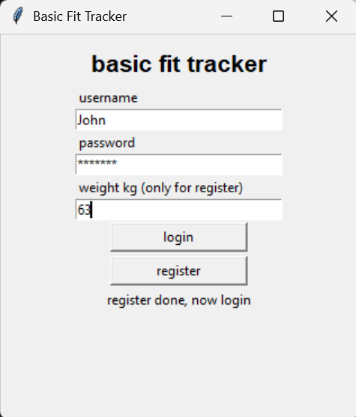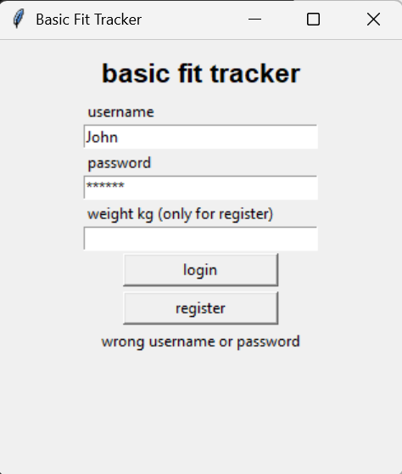

Figure 4. Screenshot (Login screen showing the login error message when incorrect credentials are entered)
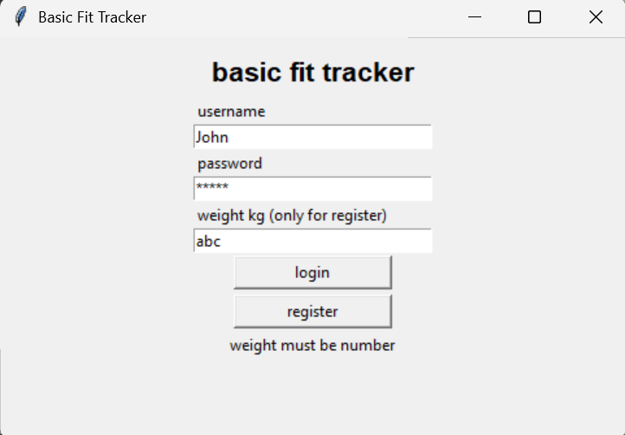
Figure 5. Screenshot 2 (Registration screen showing the validation error when a non-numeric weight is entered)

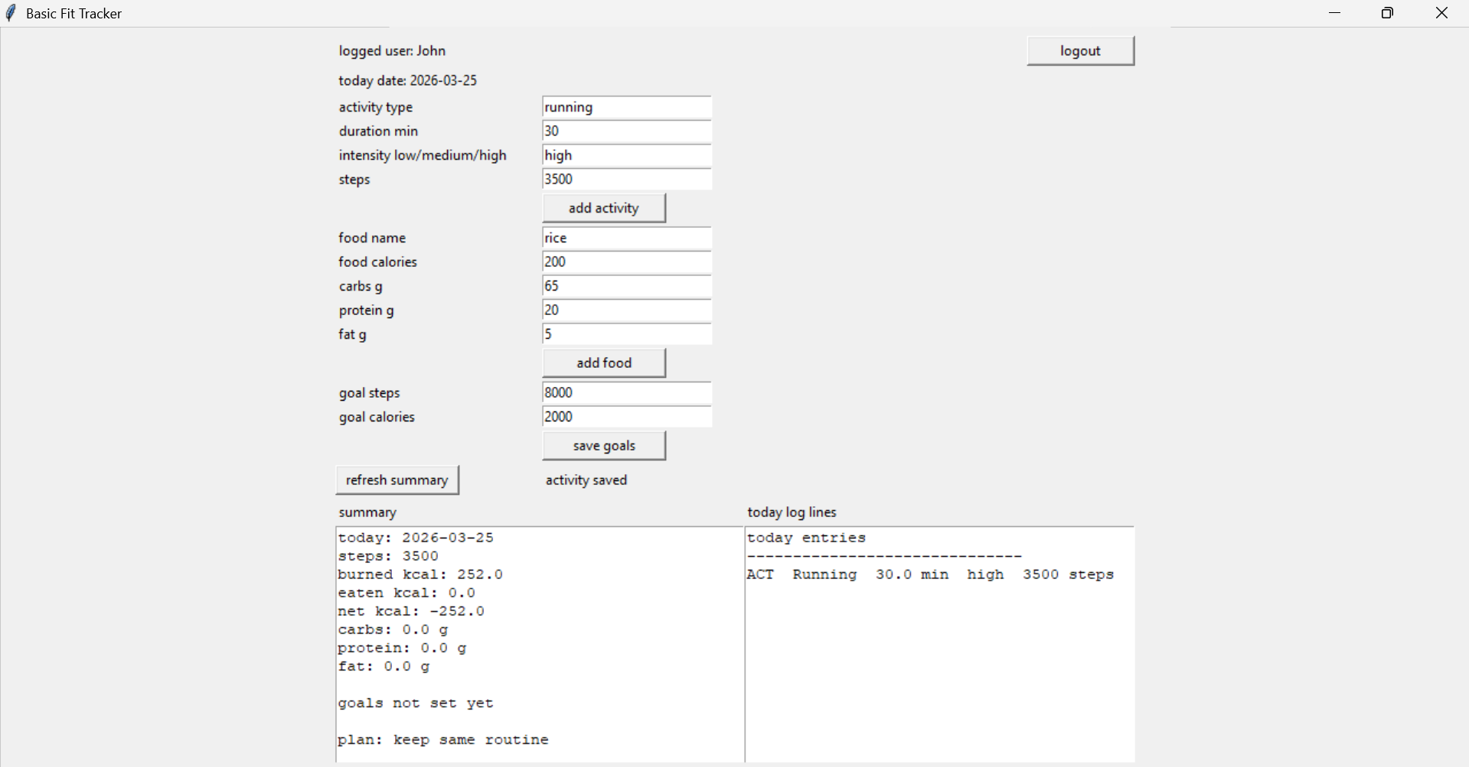
Figure 6. Screenshot 3(Main application screen after login, showing activity entry fields populated with a Running session)

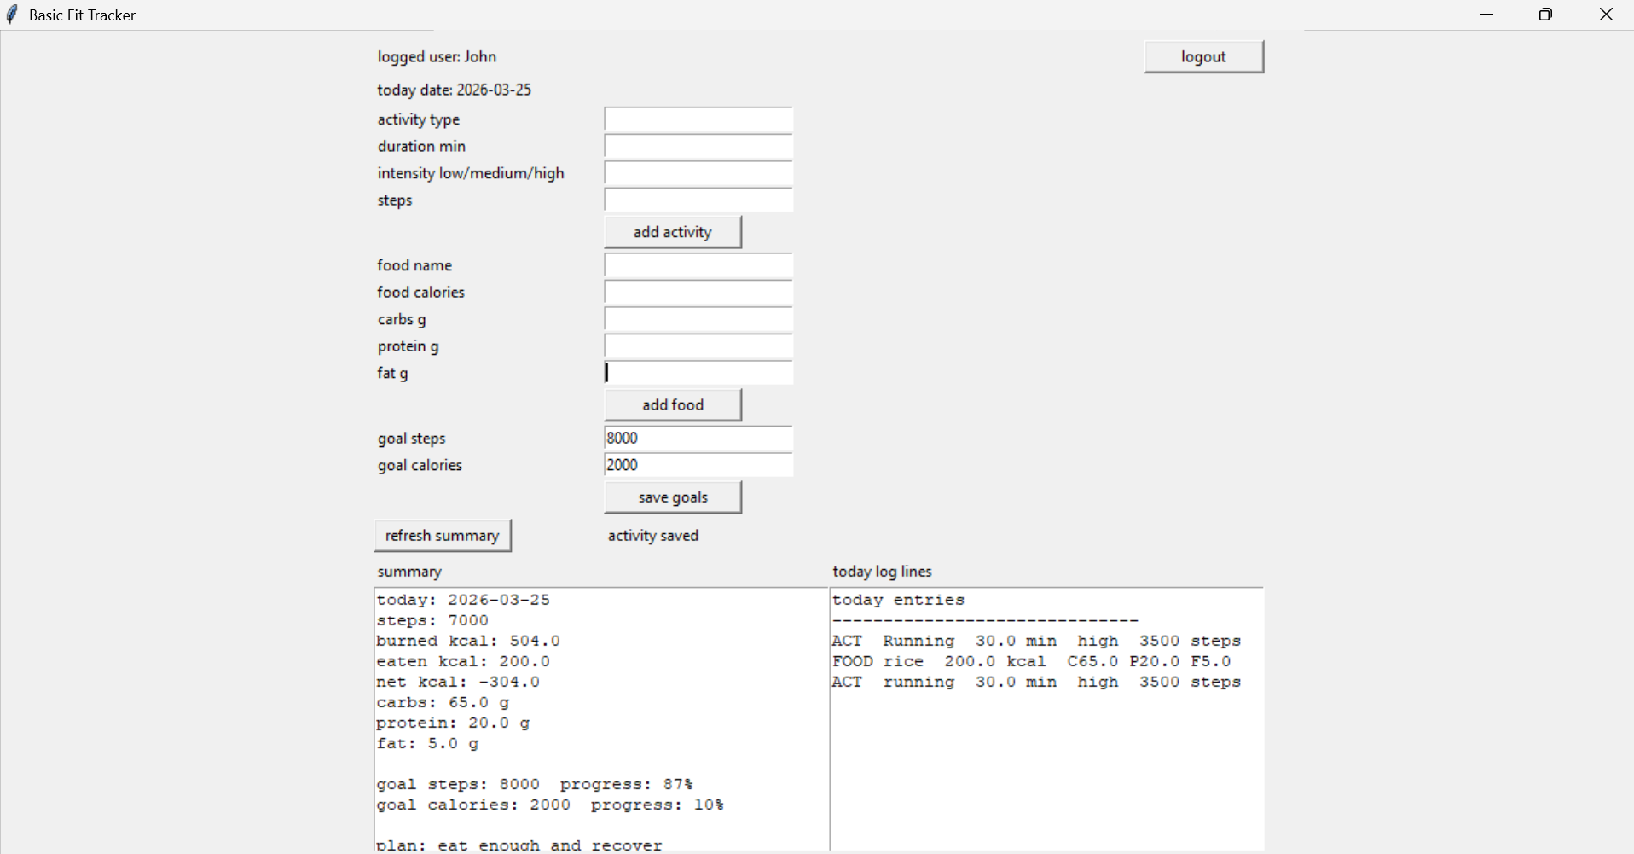
Figure 7. Screenshot 4 (Main application screen showing the Summary and Today Log panels after one activity and one food entry have been saved)

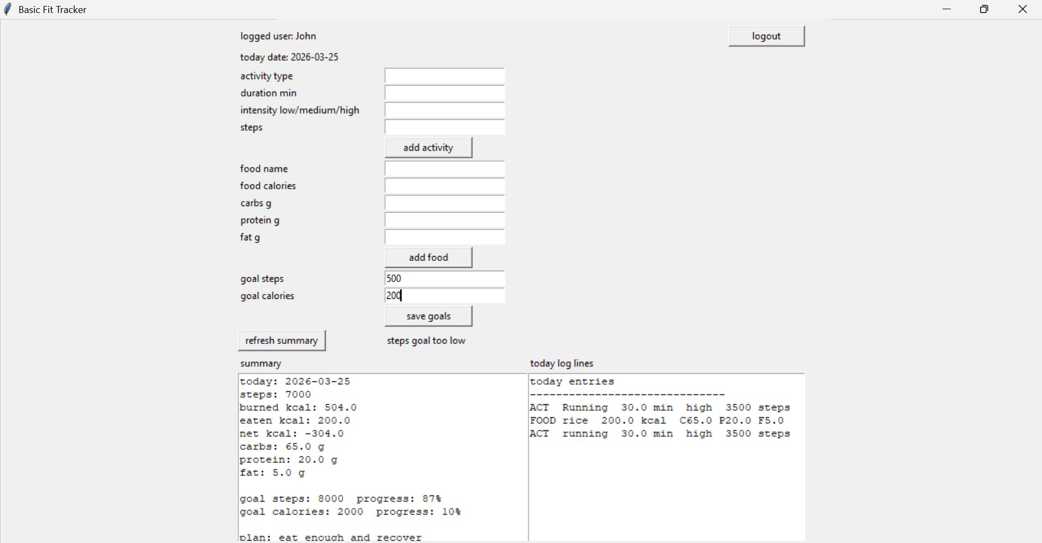
Figure 8. Screenshot 5 (Goal validation error shown when the user enters a steps goal below the minimum threshold of 1,000)

6. Testing

6.1 Testing Approach
All testing was performed manually by running the application, interacting with the GUI, and observing the feedback messages and stored file contents. The test table below follows the format shown in the assignment sample: Test No., Item to Test, Test Description (with example data), Expected Result, Actual Result, and Comments/Actions. Both normal, boundary, and erroneous input cases are included for all major functions.

6.2 Test Results

Test | Item to Test | Test Description (with example data) | Expected Result | Actual Result | Comments/Actions
A | register_click | Typical valid data (username: alika, pw: pass1, weight: 72) | No prior account | Account saved to ft_users.txt login_msg = register done now login | No actions required
B | register_click | Extreme valid weight (250) | No prior account | Account saved successfully | No actions required
C | register_click | Invalid weight (string: hello) | N/A | login_msg = weight must be number account not saved | No actions required
D | register_click | Invalid extreme weight (-5) | N/A | login_msg = weight out of range account not saved | No actions required
E | register_click | Erroneous password (char: ab) | N/A | login_msg = password too short account not saved | No actions required
F | login_click | Correct username and password | Valid account in file | current_user set app_frame shown summary loaded | No actions required
G | login_click | Wrong password | Account exists | login_msg = wrong username or password | No actions required
H | add_activity_click | Valid activity (Running 30 high 3500) | User logged in | Row appended to ft_logs.txt action_msg = activity saved | No actions required
I | add_activity_click | Duration = 0 | User logged in | action_msg = duration must be > 0 no row saved | No actions required
J | add_activity_click | Intensity = extreme | User logged in | action_msg = intensity: low/medium/high no row saved | No actions required
K | add_food_click | Valid food (Rice 350 kcal C70 P8 F2) | User logged in | Row appended action_msg = food saved | No actions required
L | add_food_click | Calories = 0 | User logged in | action_msg = calories must be > 0 no row saved | No actions required
M | add_food_click | Negative fat (-3) | User logged in | action_msg = macro values cannot be negative no row saved | No actions required
N | save_goal_click | Valid goals (steps 8000 cal 2000) | User logged in | Goals saved summary updated with progress % | No actions required
O | save_goal_click | Steps goal too low (500) | User logged in | action_msg = steps goal too low nothing saved | No actions required
P | save_goal_click | Calorie goal too low (200) | User logged in | action_msg = calorie goal too low nothing saved | No actions required
Q | refresh_summary_action | Called when no user logged in | current_user empty | summary_text = login first | No actions required
r | refresh_summary_action | Called after activity + food logged today | Entries in ft_logs for today | Correct totals: steps burned eaten net carbs protein fat shown | No actions required
S | number_text | Input string hello | N/A | Returns False field rejected | No actions required
t | bad_text | Input contains pipe char (a|b) | N/A | Returns True input rejected | No actions required
Table 1. Test results

7. Evaluation

7.1 Assessment Against Success Criteria
- Registration and login: the application correctly validates all registration inputs (blank username, short password, non-numeric weight, weight out of range, duplicate username) and grants access only when stored credentials match. Success criterion met.
- Activity logging: all five input validations (blank type, non-numeric duration/steps, zero duration, steps below 1, invalid intensity) function correctly. The MET calculation produces values consistent with published activity energy expenditure data. Success criterion met.
- Food logging: all validations pass (blank name, non-numeric macros, zero calories, negative macros). Entries appear immediately in the log panel after saving. Success criterion met.
- Goal setting with minimum thresholds: steps and calorie minimums of 1,000 and 500 respectively are enforced with clear error messages. Valid goals are saved and displayed with progress percentages in the summary. Success criterion met.
- Daily summary: steps, calories burned, calories eaten, net balance, all macros, and goal progress percentages are calculated correctly and update in real time after every save action. Success criterion met.
- Plan message: the three-state plan text appears correctly based on the net balance value. Success criterion met.
- Data persistence: all three files are created on first run and correctly reloaded in subsequent sessions. Success criterion met.

7.2 Strengths
- The graphical interface removes the barrier to entry that a command-line application presents. All interactions are through clearly labelled buttons and entry fields.
- The custom number_text() validator handles both integers and decimals correctly without requiring the csv or re modules, demonstrating manual string processing.
- Using the pipe | character as a file delimiter and rejecting it in user input via bad_text() makes the file format robust against common data entry mistakes.
- The MET-based calorie calculation adapts to the individual user's body weight, making burn estimates more personalised than a flat kcal-per-minute rate.

7.3 Limitations
- Passwords are stored in plain text. In a production application these would be hashed before being written to disk (Sweigart, 2019).
- The application window uses fixed pixel geometry (760 x 760) and does not resize gracefully on high-resolution or small displays.
- The summary always shows today's totals only. There is no history view showing previous days' data.
- Step counts are entered manually by the user rather than read from a device, which introduces the risk of inaccurate self-reported data.

7.4 Future Improvements
- A date-range history view that lets users browse past weeks would significantly increase the long-term usefulness of the application (World Health Organization, 2020).
- Replacing plain-text password storage with hashlib-based hashing would bring the application in line with basic security best practices (Python Software Foundation, 2024b).
- Adding progress bars (tkinter.ttk.Progressbar) for the step and calorie goals would provide a more visual and motivating display of progress (Python Software Foundation, 2024e).
- A body weight history log would allow the application to show weight change over time, one of the most commonly desired fitness metrics.

8. References
Python Software Foundation Built-in Functions. Available at: https://docs.python.org/3/library/functions.html
Python Software Foundation datetime Basic date and time types. Available at: https://docs.python.org/3/library/datetime.html
Python Software Foundation Exceptions Built-in Exceptions. Available at: https://docs.python.org/3/library/exceptions.html (Accessed: 16 March 2026).
Python Software Foundation Reading and Writing Files. Available at: https://docs.python.org/3/tutorial/inputoutput.html#reading-and-writing-files (Accessed: 15 March 2026).
Python Software Foundation String Methods. Available at: https://docs.python.org/3/library/stdtypes.html#string-methods
Python Software Foundation tkinter Python interface to Tcl/Tk. Available at: https://docs.python.org/3/library/tkinter.html
Python Software Foundation tkinter.ttk Tk themed widgets. Available at: https://docs.python.org/3/library/tkinter.ttk.html.
Shipman, J. Tkinter 8.5 Reference: a GUI for Python. New Mexico Tech Computer Center. Available at: https://anzeljg.github.io/rin2/book2/2405/docs/tkinter/index.html.
Zelle, J.M. Python Programming: An Introduction to Computer Science. 3rd edn. Wilsonville: Franklin, Beedle and Associates.

