Health and Fitness Tracker
FC308 Information Technology | Programming Assignment Part 2

1. Analysis

1.1 Problem Description
Tom works for a health and wellness company and has been tasked with building a simple fitness tracking application. The application must help users monitor their daily physical activity, record their nutritional intake, and track their progress towards personal fitness goals. It is intended for users of all fitness levels and must be straightforward enough for people with limited technical experience.
Three core requirements drive the design: tracking workouts, recording food and calorie intake, and measuring progress against a personalised fitness plan. Crucially, all data must be saved between sessions so the user can return the next day and continue building their records.

1.2 Key Challenges
- User authentication: ensuring each user has their own private account protected by a password, preventing one user from seeing another user's data.
- Data persistence without a database module: all data must be stored in plain text files using manual read and write operations, without relying on the csv or os modules.
- Input validation: preventing the program from crashing when a user accidentally types text instead of a number, or enters a negative value.
- Progress calculation: computing meaningful figures such as percentage of a goal achieved and estimated calories burned from the raw data that has been logged.
- Accessibility: keeping the interface simple enough for users of any technical background, using numbered menus and clear confirmation messages.

1.3 Success Criteria
- A user can register an account and log in using a username and password.
- A user can log one or more physical activities, each with a type, duration in minutes, and intensity level.
- A user can record their daily calorie and macronutrient intake.
- A user can set a fitness goal and view their progress as a percentage with a text progress bar.
- A fitness summary displays today's estimated calories burned, calories consumed, and net balance.
- All data is saved to text files and correctly reloaded the next time the user logs in.
- Invalid inputs (letters instead of numbers, negative values, out-of-range menu choices) are handled gracefully without crashing the program.

1.4 Scope and Limitations
The program is console-based and stores all data locally in four plain text files. No internet connection, database system, or graphical interface is used. Passwords are stored in plain text, which is acceptable for a prototype but would require hashing in a production system. The calorie burn estimate uses fixed rates per intensity level (Low = 5 kcal/min, Medium = 8 kcal/min, High = 11 kcal/min) adapted from the Compendium of Physical Activities (Ainsworth et al., 2011). Running distance is estimated from duration and may not match GPS measurements. Weight-loss progress must be updated manually as the program cannot interface with a scale.

1.5 User Experience Considerations
All menus use single-digit numbered options to minimise typing. Input validation loops re-prompt the user with a helpful error message rather than crashing silently. Every successful action is confirmed with a printed message. The main menu displays the logged-in username at all times so the user always knows which account is active.

2. Design
This section presents the algorithms that describe how each major part of the program works. An algorithm is a precise, step-by-step set of instructions for solving a problem. Each algorithm below is written in plain numbered English steps, with decision points (IF) and repetition (REPEAT / FOR EACH) described clearly so that the logic can be followed without needing to know Python syntax.

2.1 Algorithm & Flowchart - Program Start-Up and Authentication Loop

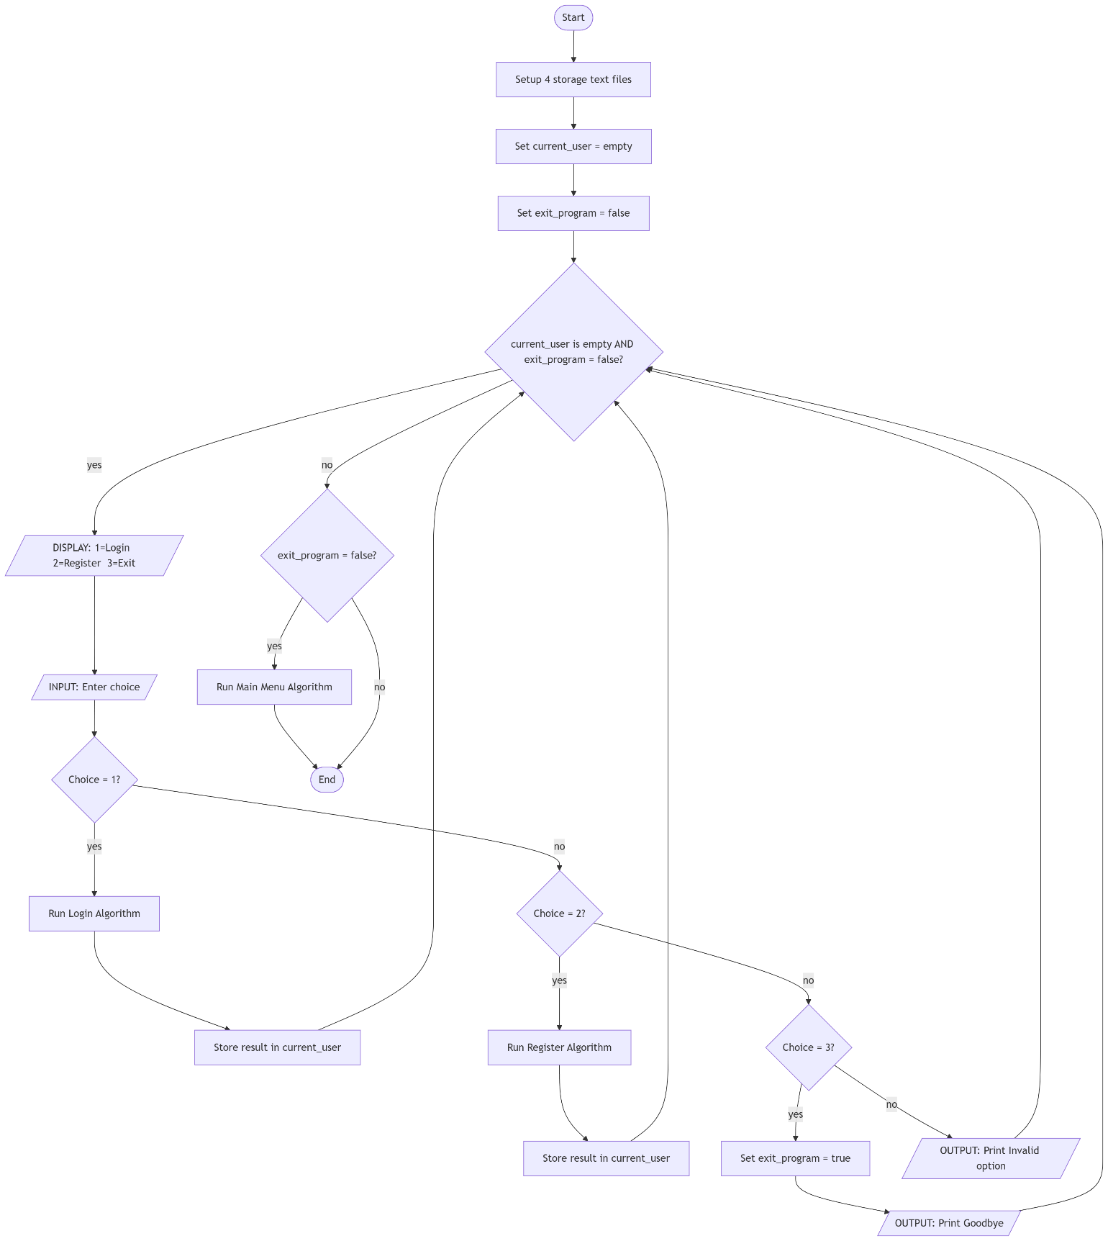

This algorithm covers the very beginning of the program: setting up storage files and showing the login or register menu until a user successfully signs in.

Step 1. The program starts.
Step 2. Check whether each of the four storage files (users.txt, activities.txt, nutrition.txt, goals.txt) exists on disk.
Step 3. For any file that does not exist, create it and write a header line as the first row.
Step 4. Display a welcome message on the screen.
Step 5. Set the variable current_user to empty (no one is logged in yet).
Step 6. Display the start menu: option 1 = Login, option 2 = Register, option 3 = Exit.
Step 7. Ask the user to enter a choice.
Step 8. IF the user enters 1, run the Login Algorithm (Algorithm 2) and store the result in current_user.
Step 9. IF the user enters 2, run the Register Algorithm (Algorithm 3) and store the result in current_user.
Step 10. IF the user enters 3, print a goodbye message and stop the program.
Step 11. IF the user enters anything else, print 'Invalid option' and go back to Step 6.
Step 12. IF current_user is still empty after Step 8 or Step 9 (meaning login or registration failed), go back to Step 6.
Step 13. IF current_user now contains a username, proceed to the Main Menu Algorithm (Algorithm 4).

2.2 Algorithm & Flowchart - Login

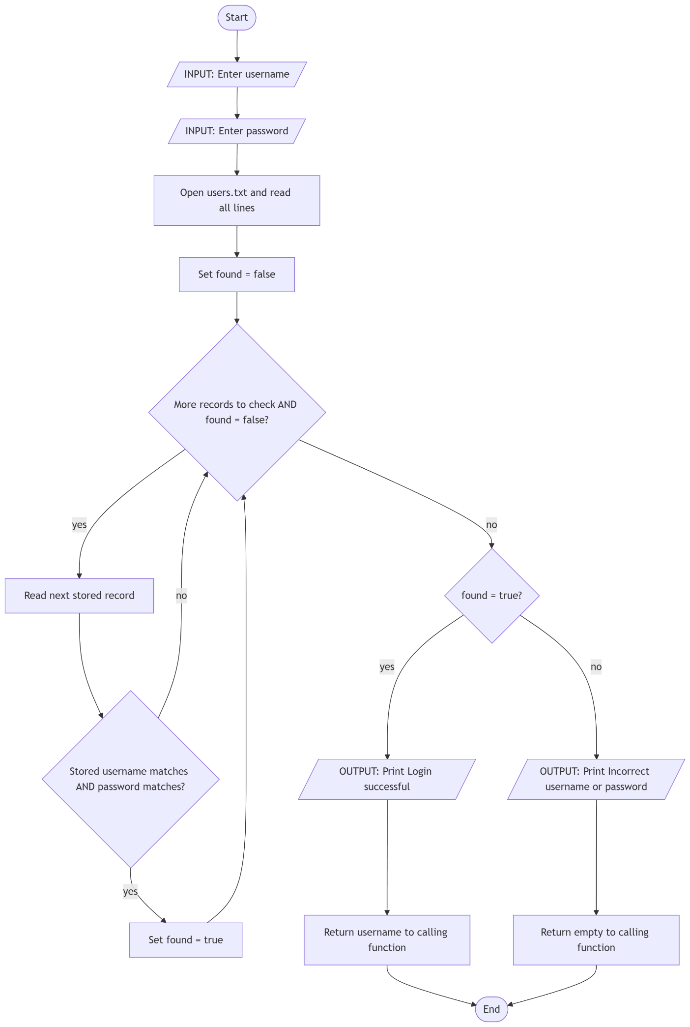

This algorithm checks whether a username and password entered by the user match a stored account record.

Step 1. Ask the user to type their username.
Step 2. Ask the user to type their password.
Step 3. Open users.txt and read all lines into memory.
Step 4. For each line in the file (ignoring the header line):
Split the line by the comma separator to get the stored username and stored password.
IF the stored username matches the entered username AND the stored password matches the entered password:
Print 'Login successful'.
Return the username to the calling function — login has succeeded.
Step 5. If the loop in Step 4 finishes without finding a match, print 'Incorrect username or password'.
Step 6. Return empty (None) to the calling function — login has failed.

2.3 Algorithm & Flowchart - Register

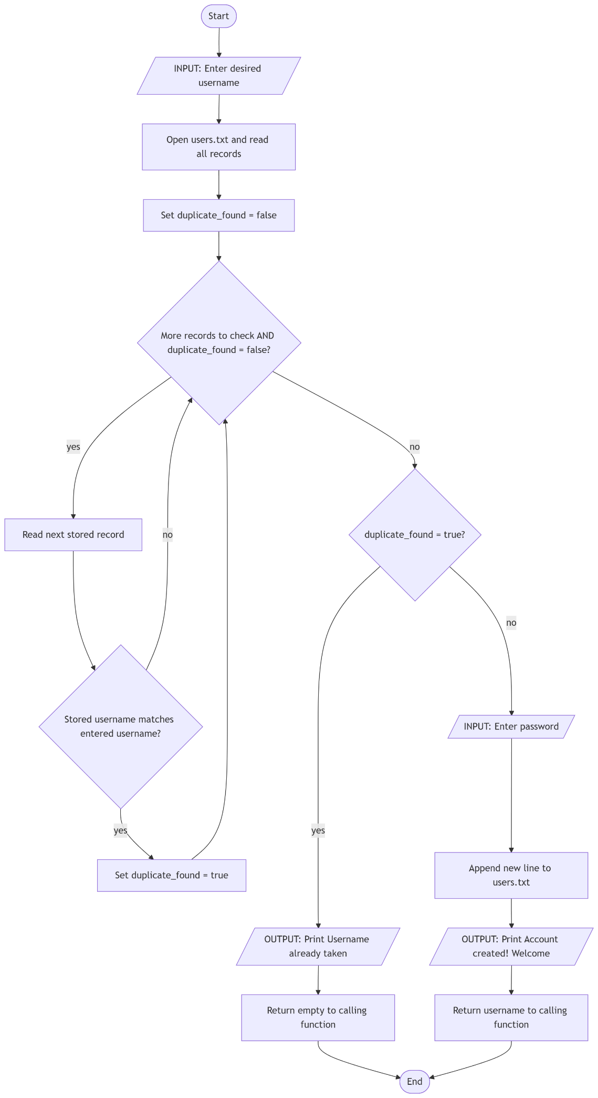

This algorithm creates a new user account, first checking that the chosen username is not already taken.

Step 1. Ask the user to type a desired username.
Step 2. Open users.txt and read all existing user records.
Step 3. For each existing record:
IF the stored username exactly matches the entered username:
Print 'That username is already taken'.
Return empty (None) — registration has failed.
Step 4. If the loop finishes without a match, the username is available.
Step 5. Ask the user to type a password.
Step 6. Open users.txt in append mode and write a new line containing: username, password.
Step 7. Print 'Account created! Welcome, [username]'.
Step 8. Return the username to the calling function — registration has succeeded.

2.4 Algorithm & Flowchart - Main Menu

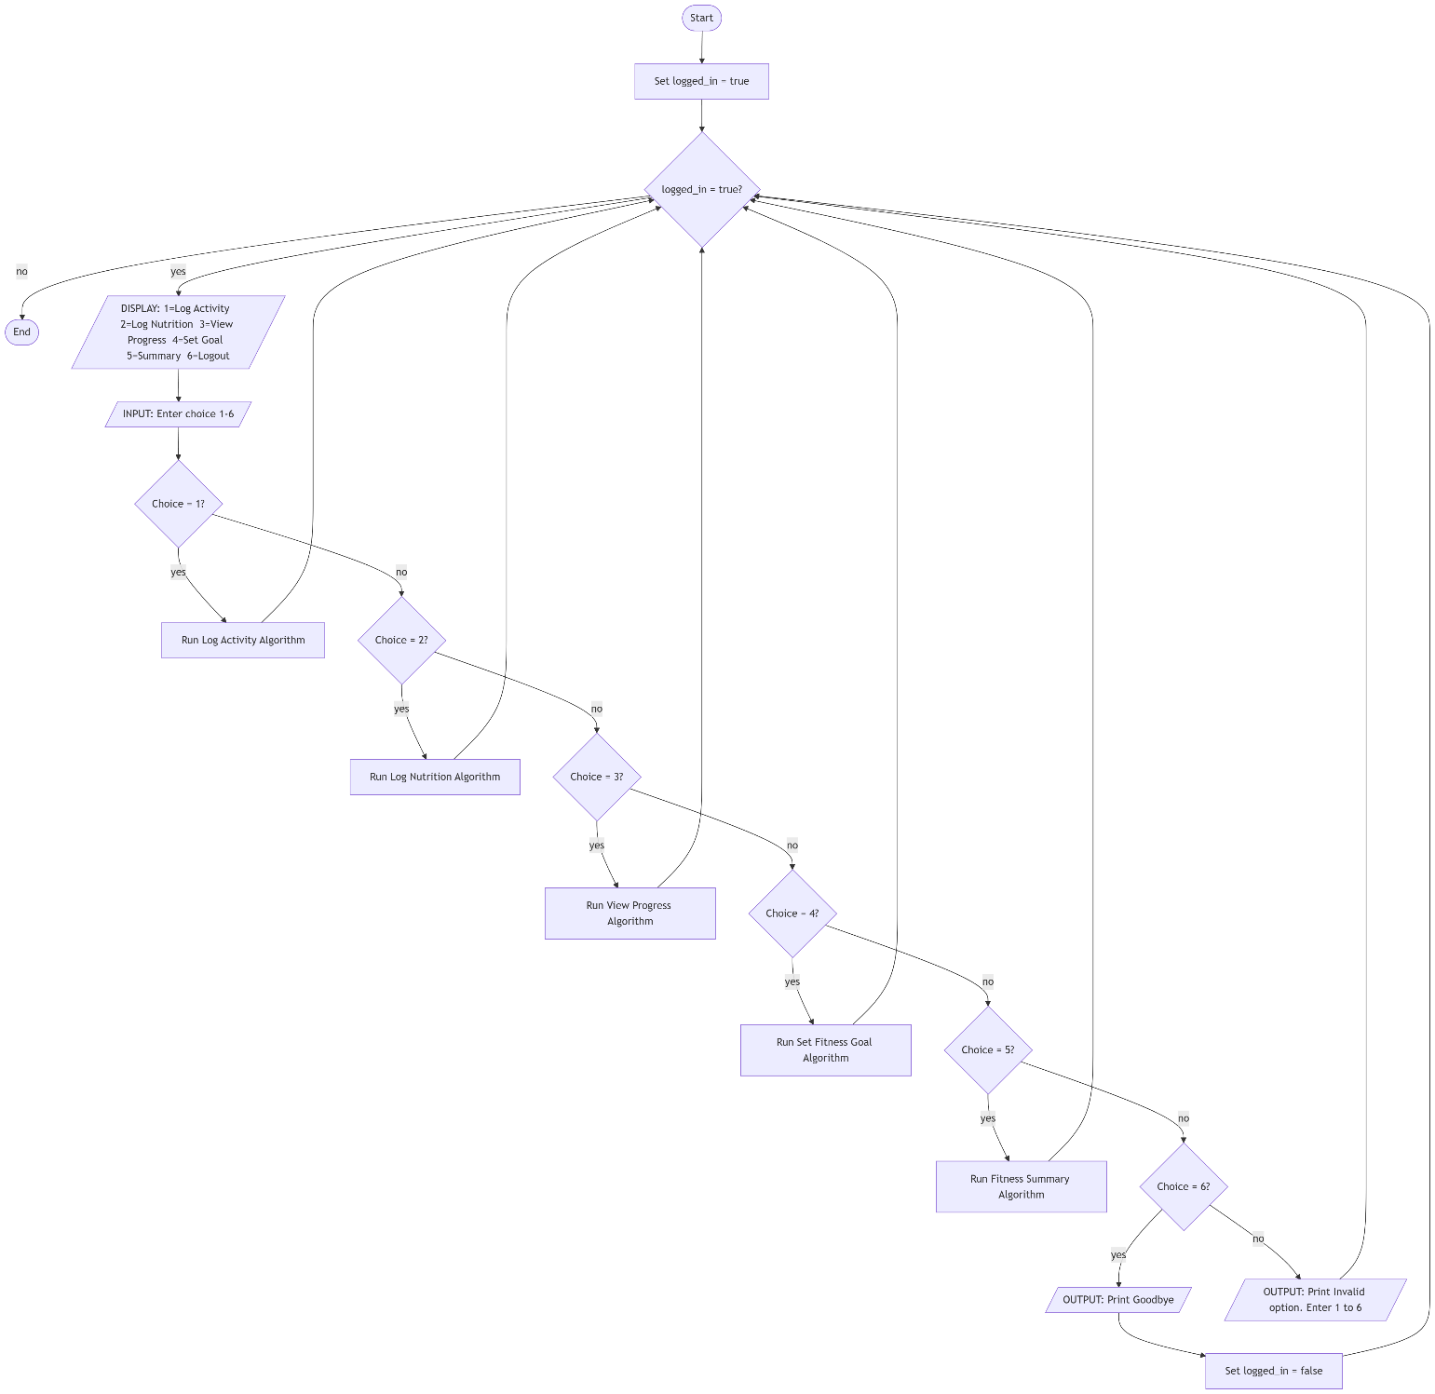

This algorithm displays the main navigation menu and sends the user to the correct feature based on their choice. It repeats until the user logs out.

Step 1. Display the menu: 1 = Log Activity, 2 = Log Nutrition, 3 = View Progress, 4 = Set Goal, 5 = Summary, 6 = Logout.
Step 2. Ask the user to enter a number between 1 and 6.
Step 3. IF the user enters 1, run Algorithm 5 (Log Physical Activity).
Step 4. IF the user enters 2, run Algorithm 6 (Log Nutrition).
Step 5. IF the user enters 3, run Algorithm 7 (View Progress).
Step 6. IF the user enters 4, run Algorithm 8 (Set Fitness Goal).
Step 7. IF the user enters 5, run Algorithm 9 (Fitness Summary).
Step 8. IF the user enters 6, print a goodbye message and end the menu loop — the user is logged out.
Step 9. IF the user enters anything else, print 'Invalid option. Please enter 1 to 6'.
Step 10. Go back to Step 1 (unless the user has logged out in Step 8).

2.5 Algorithm & Flowchart - Log Physical Activity

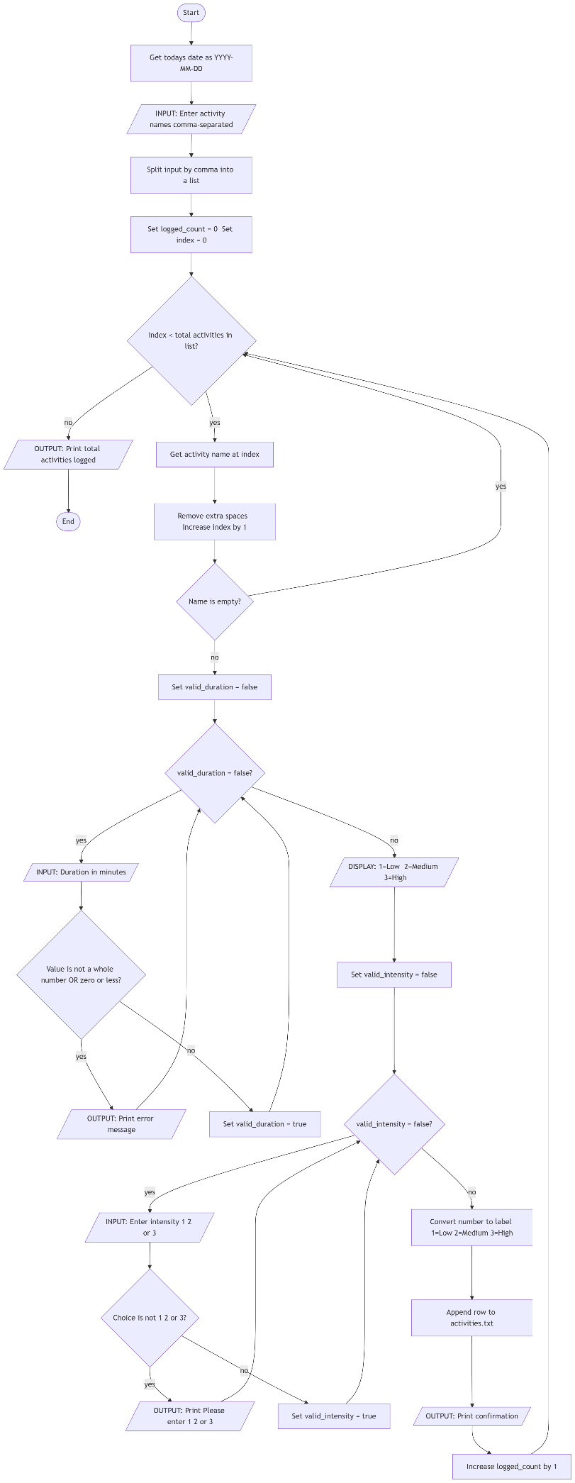

This algorithm records one or more physical activities for the current day, collecting the type, duration, and intensity for each.

Step 1. Get today's date as a text string in YYYY-MM-DD format.
Step 2. Ask the user to enter one or more activity names, separated by commas.
Step 3. Split the entered text by the comma character to produce a list of activity names.
Step 4. For each activity name in the list:
Step 4a. Remove any extra spaces from the name.
Step 4b. IF the name is empty (e.g. from a trailing comma), skip it and move to the next.
Step 4c. Ask the user to enter the duration in minutes.
Step 4d. IF the entered value is not a whole number, print an error and repeat Step 4c.
Step 4e. IF the duration is zero or less, print an error and repeat Step 4c.
Step 4f. Show the intensity options: 1 = Low, 2 = Medium, 3 = High.
Step 4g. Ask the user to enter 1, 2, or 3.
Step 4h. IF the choice is not 1, 2, or 3, print an error and repeat Step 4g.
Step 4i. Convert the number to a label: 1 = Low, 2 = Medium, 3 = High.
Step 4j. Write a new line to activities.txt containing: username, today's date, activity name, duration, intensity.
Step 4k. Print a confirmation message for this activity.
Step 5. After processing all activities, print how many were successfully logged.

2.6 Algorithm & Flowchart - Log Nutrition

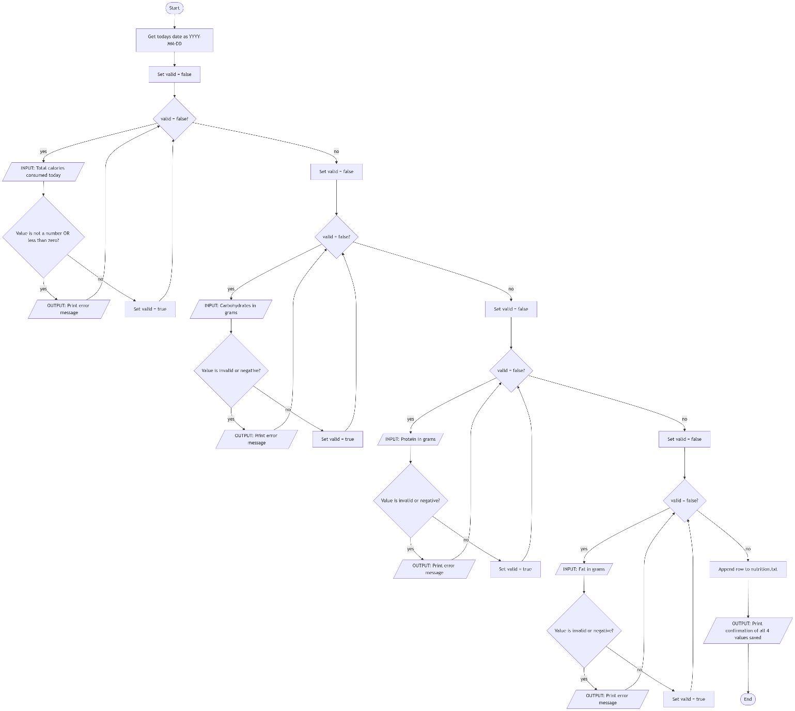

This algorithm records the user's calorie and macronutrient intake for the current day.

Step 1. Get today's date as a text string.
Step 2. Ask the user to enter the total calories consumed today.
Step 3. IF the value entered is not a number, print an error and repeat Step 2.
Step 4. IF the value is less than zero, print an error and repeat Step 2.
Step 5. Repeat Steps 2 to 4 for carbohydrates in grams, protein in grams, and fat in grams.
Step 6. Write a new line to nutrition.txt containing: username, today's date, calories, carbs, protein, fat.
Step 7. Print a confirmation showing all four values that were saved.

2.7 Algorithm 7 & Flowchart - View Progress Towards Goals

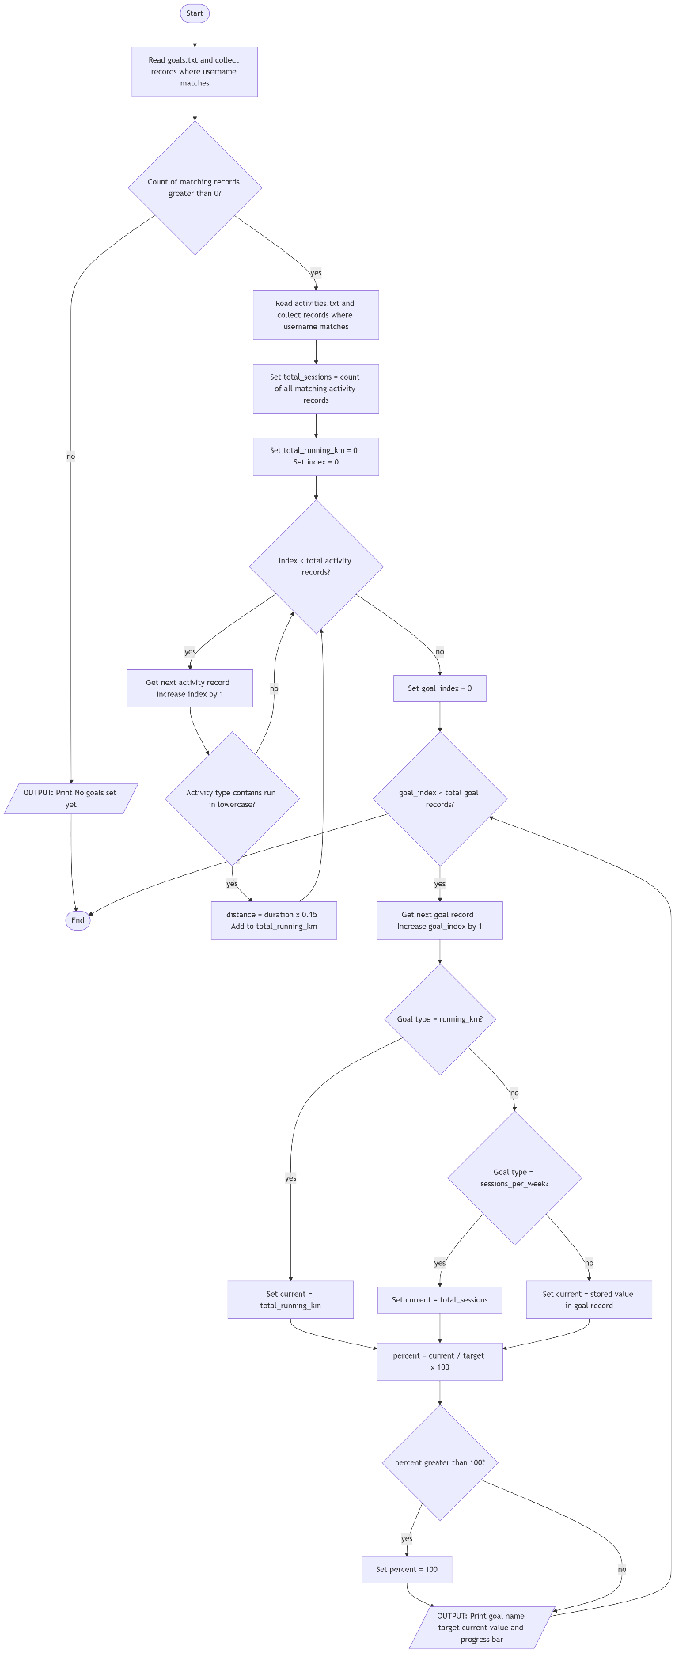

This algorithm reads the user's saved goals and calculates how far they have progressed toward each one.

Step 1. Read goals.txt and collect all rows where the username column matches the logged-in user.
Step 2. IF no matching rows are found, print 'No goals set yet' and stop this algorithm.
Step 3. Read activities.txt and collect all rows where the username matches.
Step 4. Count the total number of activity rows found — this is the total session count.
Step 5. Set the total running distance to zero.
Step 6. For each activity row:
IF the word 'run' appears anywhere in the activity type (checked in lowercase):
Multiply the duration in minutes by 0.15 to estimate kilometres covered.
Add this distance to the total running distance.
Step 7. For each goal row belonging to the user:
IF the goal type is 'running_km', set the current value to the total running distance.
IF the goal type is 'sessions_per_week', set the current value to the total session count.
IF the goal type is 'weight_loss_kg', read the current value stored in the goal record.
Divide the current value by the target value and multiply by 100 to get a percentage.
IF the percentage is greater than 100, set it to 100.
Print the goal name, target, current value, and a text progress bar.

2.8 Algorithm & Flowchart - Set Fitness Goal

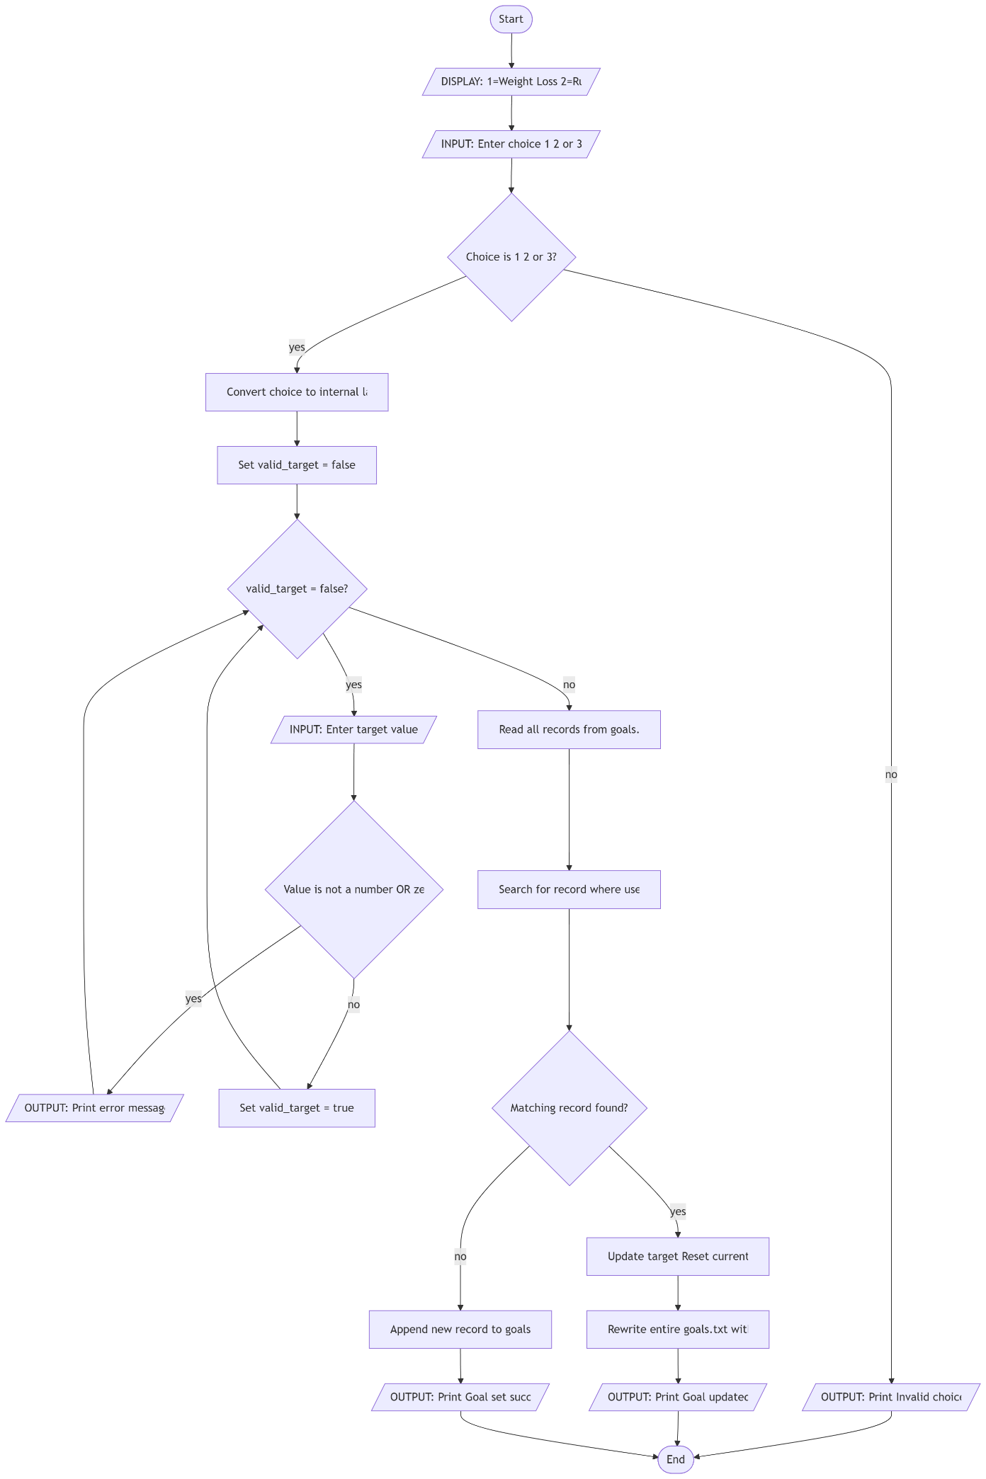

This algorithm allows the user to set a new fitness goal or update an existing one of the same type.

Step 1. Display three goal options: 1 = Weight Loss, 2 = Running Distance, 3 = Workout Sessions.
Step 2. Ask the user to enter 1, 2, or 3.
Step 3. IF the choice is not 1, 2, or 3, print an error and stop this algorithm.
Step 4. Convert the number to an internal label: 1 = weight_loss_kg, 2 = running_km, 3 = sessions_per_week.
Step 5. Ask the user to enter the target value.
Step 6. IF the value is not a number or is zero or less, print an error and repeat Step 5.
Step 7. Read goals.txt and search for an existing row where both the username and goal type match.
Step 8. IF a matching row is found:
Update its target value to the new value.
Reset the current value to zero.
Rewrite the entire goals.txt file with the updated data.
Print 'Goal updated'.
Step 9. IF no matching row is found, write a new line to goals.txt containing: username, goal type, target, 0.
Step 10. Print 'Goal set successfully'.

2.9 Algorithm & Flowchart - Fitness Summary

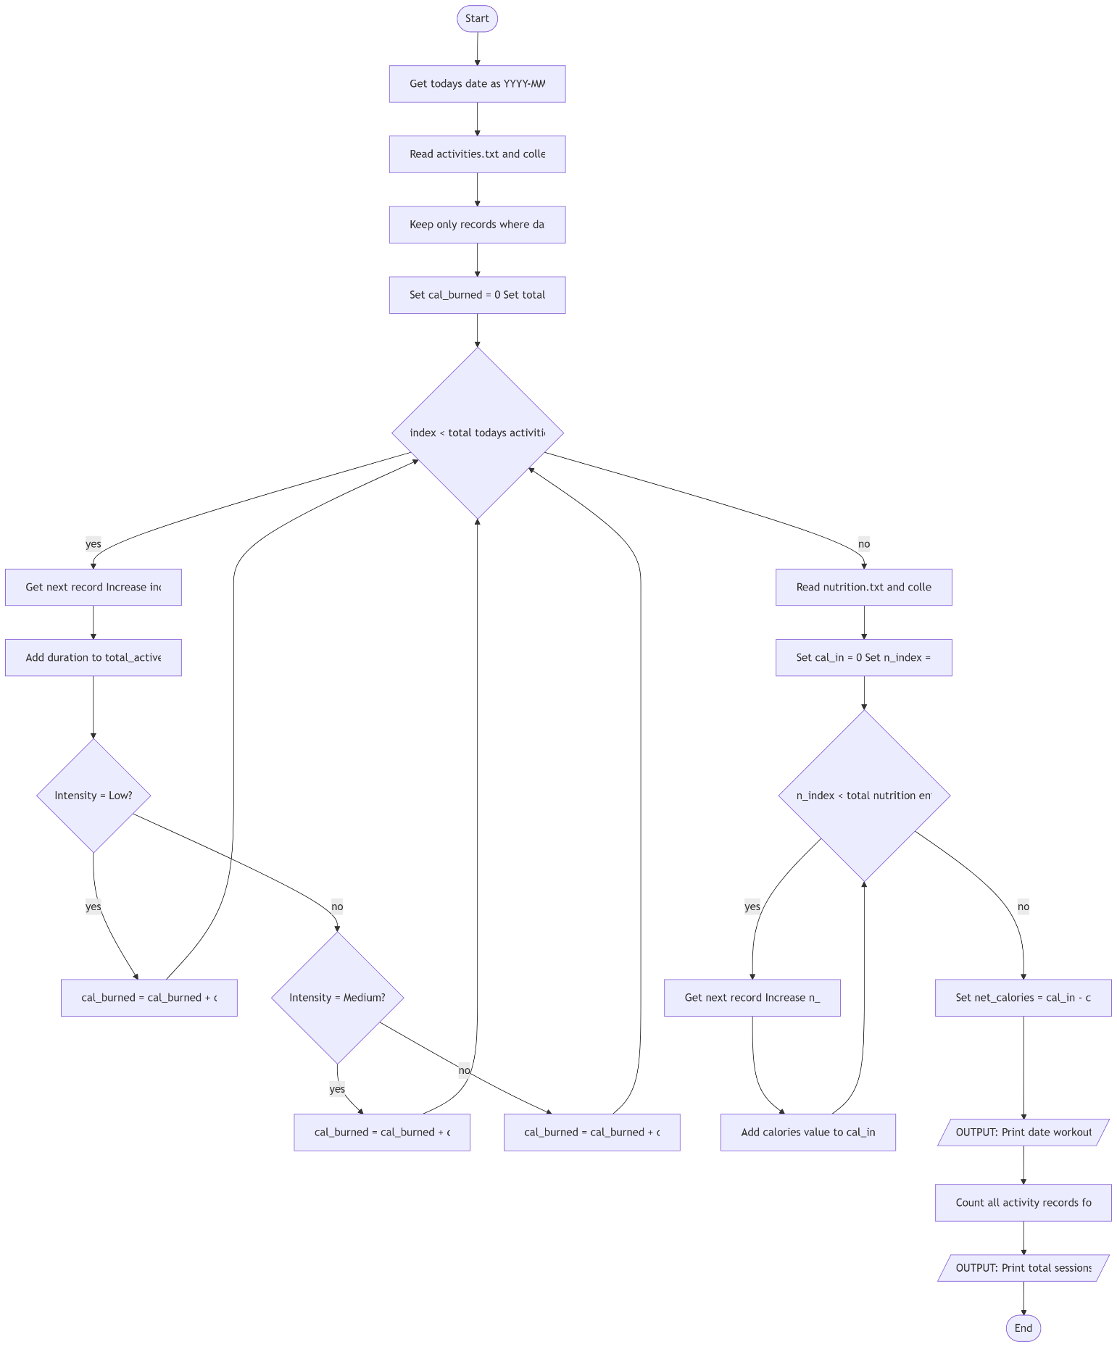

This algorithm calculates and displays the user's daily calorie balance and all-time activity totals.

Step 1. Get today's date as a text string.
Step 2. Read activities.txt and collect all rows where the username matches.
Step 3. From those rows, keep only the ones where the date column equals today's date.
Step 4. Set calories burned to zero and total active minutes to zero.
Step 5. For each of today's activity rows:
Add the duration in minutes to the total active minutes.
IF the intensity is Low, multiply duration by 5 and add to calories burned.
IF the intensity is Medium, multiply duration by 8 and add to calories burned.
IF the intensity is High, multiply duration by 11 and add to calories burned.
Step 6. Read nutrition.txt and collect rows where both the username and date equal today.
Step 7. Add up all calories values from those rows to get total calories consumed.
Step 8. Subtract calories burned from calories consumed to calculate the net calorie balance.
Step 9. Print today's date, number of workouts, total active minutes, calories burned, calories consumed, and net calories.
Step 10. Add up the duration of all activity rows (not just today) to get the all-time active time.
Step 11. Print the total number of sessions and total active minutes across all time.

3. Technical Overview

3.1 Data Structures
The program uses Python's two most fundamental built-in data structures: lists and dictionaries. When a data file is read, the read_file() function returns a list, where each item is a dictionary representing one row of data. The dictionary keys come from the header line of the file. For example, after reading the users file, each row dictionary looks like: {"username": "tom", "password": "pass123"}. This approach was chosen because lists and dictionaries are covered in the first year of most computing courses and require no additional modules.
Strings store names, dates, activity types, and intensity levels. Integers store duration values in minutes. Floats store calorie and macronutrient amounts. Boolean logic is expressed through comparisons in if/elif conditions.

3.2 File Storage
All data is stored in four plain text files. Each file has a header as its first line, with column names separated by commas. Each subsequent line is one record. This approach deliberately avoids the csv module by manually splitting lines on commas using .split(",") and building output lines through string concatenation with the + operator (Sweigart, 2019). File existence is checked using try/except around open() in read mode rather than os.path.exists(), so the os module is also not needed.

File | Columns Stored
users.txt | username, password
activities.txt | username, date, type, duration_mins, intensity
nutrition.txt | username, date, calories, carbs_g, protein_g, fat_g
goals.txt | username, goal_type, target, current

3.3 Programming Techniques Used
- Functions: every feature (login, register, log_activity, log_nutrition, set_fitness_plan, view_progress, fitness_summary) is a separate named function. This keeps the code organised, avoids repetition, and makes individual features straightforward to test.
- While loops: used for menu navigation and input validation. The loop repeats until the user enters a valid value or selects an exit option.
- For loops with range(): used to iterate over every row in a file list (e.g. to find a matching user or to total up today's calories) and to build strings character by character.
- Conditionals (if / elif / else): used to check menu choices, match goal types to their current calculated values, and select the correct calorie burn rate per intensity level.
- Try / except with ValueError: wraps integer and float conversions of user input to catch the error raised when text or symbols are typed instead of a number, preventing the program from crashing.
- String methods (.strip(), .split(), .lower()): .strip() removes accidental spaces from all user input; .split(',') breaks a comma-separated string into a list; .lower() ensures the 'run' activity type check is case-insensitive.
- String concatenation with +: all output messages and file lines are built by joining string parts with the + operator and str() conversions. f-strings are deliberately not used so the syntax stays as basic as possible.

3.4 Key Algorithms
Calorie burn estimation: the program assigns an approximate burn rate per minute based on the intensity level. Low intensity = 5 kcal/min, Medium = 8 kcal/min, High = 11 kcal/min. These values are adapted from MET (Metabolic Equivalent of Task) figures published in the Compendium of Physical Activities (Ainsworth et al., 2011). Estimated calories burned = duration x rate.
Running distance estimation: when an activity type string contains 'run' (after calling .lower()), the program estimates distance as duration multiplied by 0.15 km/min, equivalent to approximately 9 km/h. This is a moderate jogging pace widely cited in fitness literature (NHS, 2023).
Progress percentage: calculated as (current / target) * 100, rounded to one decimal place and capped at 100. The draw_progress_bar() function converts this to a 20-character text bar. Each '#' represents 5 percentage points; the filled count is calculated as int(percent / 5). The bar is assembled character by character using concatenation inside a for loop.
File existence check: instead of os.path.exists(), the program tries to open the file in read mode inside a try block. Python raises FileNotFoundError if the file does not exist; the except block catches this and creates the file. This technique is described in the Python documentation (Python Software Foundation, 2024b).
Duplicate username check: before accepting a new registration, the program reads all existing user rows and loops through them. If any row's username field equals the new input, registration is rejected with an error message and the function returns None.

4. Coded Solution
The complete Python program is shown below
# importing date from datetime so we can get today's date
from datetime import date

# these are the file names where we save all the data
# i am using variables so i don't have to type the names again and again
USERS_FILE = "users.txt" # this file stores usernames and passwords
ACTIVITIES_FILE = "activities.txt" # this file stores all the workouts
NUTRITION_FILE = "nutrition.txt" # this file stores food/calorie info
GOALS_FILE = "goals.txt" # this file stores the fitness goals

# this function checks if a file exists
# if it doesn't exist, it creates a new one with a header line
def create_file_if_not_exists(filename, header):

try:
# try to open the file to see if it already exists
f = open(filename, "r")
f.close() # close it if it opened successfully, we don't need to do anything

except FileNotFoundError:
# if file not found, we create a new one and write the header
f = open(filename, "w")
f.write(header + "\n") # write the header and go to next line
f.close()

# this function sets up all 4 files at the start of the program
# it calls the above function 4 times, one for each file
def setup_files():
create_file_if_not_exists(USERS_FILE, "username,password")
create_file_if_not_exists(ACTIVITIES_FILE, "username,date,type,duration_mins,intensity")
create_file_if_not_exists(NUTRITION_FILE, "username,date,calories,carbs_g,protein_g,fat_g")
create_file_if_not_exists(GOALS_FILE, "username,goal_type,target,current")

# this function reads a file and gives back all the rows as a list of dictionaries
# dictionary is like key = column name, value = actual data
def read_file(filename):
result = [] # empty list, we will add rows here

# open file and read everything
f = open(filename, "r")
all_lines = f.readlines() # readlines() gives each line as item in a list
f.close()

# if file has only header or is empty, return empty list
if len(all_lines) < 2:
return result

# first line is the header (like "username,password")
header_line = all_lines[0].strip() # strip() removes spaces and newlines
headers = header_line.split(",") # split by comma to get list of column names

# now loop through all other lines (skip line 0 because that's the header)
for i in range(1, len(all_lines)):
line = all_lines[i].strip() # remove extra whitespace
if line == "":
continue # skip empty lines
values = line.split(",") # split the line by comma

# create a dictionary for this row
row = {}
for j in range(len(headers)):
if j < len(values):
row[headers[j]] = values[j] # match column name to value
else:
row[headers[j]] = "" # if value is missing, put empty string
result.append(row) # add this row to our list

return result # give back the full list of rows

# this function adds a new row at the bottom of a file
# values is a list like [username, date, calories, ...]
def append_to_file(filename, values):
# join all values with comma to make one line
line = ""
for i in range(len(values)):
if i == 0:
line = str(values[i]) # first value, no comma before it
else:
line = line + "," + str(values[i]) # add comma before other values

# open file in append mode ("a" means add at the end, not overwrite)
f = open(filename, "a")
f.write(line + "\n") # write the line and go to next line
f.close()

# this function re-writes the whole file from scratch
# we use this when we need to update/edit a row (like changing a goal)
def overwrite_file(filename, header, rows):
# open in write mode ("w") which clears the file first
f = open(filename, "w")
f.write(header + "\n") # write the header first
headers = header.split(",") # get list of column names

# write each row one by one
for row in rows:
line = ""
for i in range(len(headers)):
col = headers[i]
if i == 0:
line = str(row[col]) # first column
else:
line = line + "," + str(row[col]) # rest of columns
f.write(line + "\n") # write the row

f.close()

# this function lets a new user create an account
# returns the username if successful, otherwise returns None
def register():
print("\n--- Register New Account ---")
username = input("Choose a username: ").strip()

# check if username is already taken
users = read_file(USERS_FILE)
for user in users:
if user["username"] == username:
print("That username is already taken. Please try a different one.")
return None # stop here and return nothing

# get password from user
password = input("Choose a password: ").strip()

# save new user to file
append_to_file(USERS_FILE, [username, password])
print("Account created! Welcome, " + username + ".")
return username # return username so we know who is logged in

# this function lets an existing user login
# returns the username if login is correct, otherwise returns None
def login():
print("\n--- Login ---")
username = input("Username: ").strip()
password = input("Password: ").strip()

# read all users from the file
users = read_file(USERS_FILE)

# check if username and password match any user in the file
for user in users:
if user["username"] == username and user["password"] == password:
print("Login successful! Welcome back, " + username + ".")
return username # login success!

# if we get here, no match was found
print("Incorrect username or password. Please try again.")
return None

# this function lets the user log their physical activity for today
def log_activity(username):
print("\n--- Log Physical Activity ---")
today = str(date.today()) # get today's date as a string like "2024-01-15"

# user can enter multiple activities at once, separated by commas
activity_input = input("Activity type(s), separated by commas (e.g. running, cycling): ").strip()
activity_list = activity_input.split(",") # split into individual activities
logged_count = 0 # keep track of how many we logged

# loop through each activity
for i in range(len(activity_list)):
activity_type = activity_list[i].strip() # remove spaces around name
if activity_type == "":
continue # skip if empty (user put two commas maybe)

print("\nDetails for: " + activity_type)

# keep asking for duration until user gives a valid positive number
while True:
try:
duration = int(input(" Duration (in minutes): "))
if duration > 0:
break # good input, exit the loop
else:
print(" Please enter a positive number greater than zero.")
except ValueError:
# ValueError happens when user types letters instead of a number
print(" Please enter a whole number (e.g. 30).")

# ask for intensity level
print(" Intensity levels: 1 = Low 2 = Medium 3 = High")
while True:
intensity_choice = input(" Select intensity (1/2/3): ").strip()
if intensity_choice == "1":
intensity = "Low"
break
elif intensity_choice == "2":
intensity = "Medium"
break
elif intensity_choice == "3":
intensity = "High"
break
else:
print(" Invalid selection. Please enter 1, 2, or 3.")

# save this activity to the file
append_to_file(ACTIVITIES_FILE, [username, today, activity_type, duration, intensity])

print(" Logged: " + activity_type + " for " + str(duration) + " mins at " + intensity + " intensity.")
logged_count = logged_count + 1 # increase counter by 1

print("\n" + str(logged_count) + " activity/activities logged successfully!")

# this is a helper function to get a number from user
# it keeps asking until user enters a valid number that is 0 or more
def get_positive_number(prompt):
while True:
try:
value = float(input(prompt)) # float() allows decimals like 65.5
if value >= 0:
return value # valid number, return it
else:
print("Please enter a positive number (0 or more).")
except ValueError:
# user typed something that is not a number
print("Please enter a valid number (e.g. 1800 or 65.5).")

# this function lets user log what they ate today
def log_nutrition(username):
print("\n--- Log Nutrition / Calorie Intake ---")
today = str(date.today()) # get today's date

# ask for each nutrition value using our helper function
calories = get_positive_number("Total calories consumed today: ")
carbs = get_positive_number("Carbohydrates (grams): ")
protein = get_positive_number("Protein (grams): ")
fat = get_positive_number("Fat (grams): ")

# save nutrition data to file
append_to_file(NUTRITION_FILE, [username, today, calories, carbs, protein, fat])
print("Nutrition logged: " + str(calories) + " kcal | " + str(carbs) + "g carbs | " + str(protein) + "g protein | " + str(fat) + "g fat.")

# this function lets user set a fitness goal
def set_fitness_plan(username):
print("\n--- Set Fitness Goal ---")
print(" 1. Weight loss (target kg to lose)")
print(" 2. Running distance (target total km)")
print(" 3. Workout sessions (target sessions per week)")

choice = input("Select goal type (1/2/3): ").strip()

# convert user choice to a goal type name
if choice == "1":
goal_type = "weight_loss_kg"
elif choice == "2":
goal_type = "running_km"
elif choice == "3":
goal_type = "sessions_per_week"
else:
print("Invalid choice. Please enter 1, 2, or 3.")
return # exit the function early if invalid

# ask for the target value
while True:
try:
target = float(input("Enter your target value: "))
if target > 0:
break # valid target, exit loop
else:
print("Target must be greater than zero.")
except ValueError:
print("Please enter a valid number.")

# check if user already has this goal type saved
goals = read_file(GOALS_FILE)
goal_found = False
for goal in goals:
if goal["username"] == username and goal["goal_type"] == goal_type:
# update existing goal instead of adding a new one
goal["target"] = str(target)
goal["current"] = "0" # reset progress to 0
goal_found = True
break

if goal_found:
# if goal existed, overwrite the file with the updated version
overwrite_file(GOALS_FILE, "username,goal_type,target,current", goals)
print("Goal updated successfully!")
else:
# if goal is new, just append it to the file
append_to_file(GOALS_FILE, [username, goal_type, target, 0])
print("Goal set successfully!")

# this function draws a simple text progress bar
# like [################----] 80%
def draw_progress_bar(percent):
# figure out how many # symbols to show (max is 20)
filled_count = int(percent / 5)
if filled_count > 20:
filled_count = 20 # can't go more than 20 #'s

empty_count = 20 - filled_count # rest are dashes

# build the bar string character by character
bar = ""
for i in range(filled_count):
bar = bar + "#" # filled part
for i in range(empty_count):
bar = bar + "-" # empty part

return "[" + bar + "] " + str(percent) + "%"

# this helper function converts goal_type code to a readable label
def get_goal_label(goal_type):
if goal_type == "weight_loss_kg":
return "Weight Loss (kg)"
elif goal_type == "running_km":
return "Running Distance (km)"
elif goal_type == "sessions_per_week":
return "Workout Sessions Per Week"
else:
return goal_type # if unknown type, just return it as is

# this function shows the user how close they are to their goals
def view_progress(username):
print("\n--- Progress Towards Fitness Goals ---")

# read all goals and filter only this user's goals
goals = read_file(GOALS_FILE)
user_goals = []
for goal in goals:
if goal["username"] == username:
user_goals.append(goal)

# if user has no goals yet, tell them to set one
if len(user_goals) == 0:
print("You have no goals set yet.")
print("Select option 4 from the main menu to set a fitness goal.")
return

# read activity data to calculate running km and total sessions
activities = read_file(ACTIVITIES_FILE)
user_activities = []
for activity in activities:
if activity["username"] == username:
user_activities.append(activity)

# count total number of workout sessions
total_sessions = len(user_activities)

# estimate running distance: assume 0.15 km per minute of running
total_running_km = 0
for a in user_activities:
activity_lower = a["type"].lower() # lowercase so "Running" and "running" both work
if "run" in activity_lower:
distance = int(a["duration_mins"]) * 0.15 # 0.15 km per minute is the estimate
total_running_km = total_running_km + distance
total_running_km = round(total_running_km, 2) # round to 2 decimal places

# now show progress for each goal
for goal in user_goals:
target = float(goal["target"]) # what the user wants to reach
goal_type = goal["goal_type"] # what type of goal it is

# figure out current progress based on goal type
if goal_type == "running_km":
current = total_running_km # use calculated running distance
elif goal_type == "sessions_per_week":
current = total_sessions # use total session count
else:
current = float(goal["current"]) # for weight loss, use saved value

# calculate percentage done (how far are they from the goal)
if target > 0:
percent = round((current / target) * 100, 1)
if percent > 100:
percent = 100 # cap at 100% even if they exceeded target
else:
percent = 0

# print the goal info with a progress bar
label = get_goal_label(goal_type)
print("\nGoal : " + label)
print("Target : " + str(target))
print("Current : " + str(current))
print(draw_progress_bar(percent))

# this function shows a summary of today's activity and all-time stats
def fitness_summary(username):
print("\n--- Fitness Summary ---")
today = str(date.today())

# get all activities for this user
activities = read_file(ACTIVITIES_FILE)
user_activities = []
for a in activities:
if a["username"] == username:
user_activities.append(a)

# filter only today's activities
today_activities = []
for a in user_activities:
if a["date"] == today:
today_activities.append(a)

cal_burned = 0 # total calories burned today
total_active_mins = 0 # total minutes of exercise today

# calculate calories burned based on intensity
for a in today_activities:
mins = int(a["duration_mins"])
total_active_mins = total_active_mins + mins

# different intensities burn different calories per minute
intensity = a["intensity"]
if intensity == "Low":
cal_burned = cal_burned + (mins * 5) # 5 calories per minute
elif intensity == "Medium":
cal_burned = cal_burned + (mins * 8) # 8 calories per minute
elif intensity == "High":
cal_burned = cal_burned + (mins * 11) # 11 calories per minute
else:
cal_burned = cal_burned + (mins * 5) # default to low if unknown

# read nutrition data and get today's entries
nutrition = read_file(NUTRITION_FILE)
today_nutrition = []
for n in nutrition:
if n["username"] == username and n["date"] == today:
today_nutrition.append(n)

# add up all calories consumed today
cal_in = 0
for n in today_nutrition:
cal_in = cal_in + float(n["calories"])

# net calories = calories eaten minus calories burned
net_calories = cal_in - cal_burned

# print today's summary
print("\n Today (" + today + "):")
print(" Workouts completed : " + str(len(today_activities)))
print(" Active time : " + str(total_active_mins) + " minutes")
print(" Calories burned : " + str(cal_burned) + " kcal")
print(" Calories consumed : " + str(cal_in) + " kcal")
print(" Net calories : " + str(net_calories) + " kcal")

# calculate all-time total active minutes
all_time_mins = 0
for a in user_activities:
all_time_mins = all_time_mins + int(a["duration_mins"])

# print all-time totals
print("\n All-time totals:")
print(" Total sessions : " + str(len(user_activities)))
print(" Total active time : " + str(all_time_mins) + " minutes")

# this is the main menu that shows after login
# it keeps running in a loop until user chooses to logout
def main_menu(username):

while True:
# print the menu every time
print("\n=============================")
print(" Health & Fitness Tracker ")
print(" Logged in as: " + username)
print("=============================")
print(" 1. Log Physical Activity")
print(" 2. Log Nutrition / Calories")
print(" 3. View Progress Towards Goals")
print(" 4. Set Fitness Plan / Goals")
print(" 5. View Fitness Summary")
print(" 6. Logout")
print("-----------------------------")

choice = input("Select an option (1-6): ").strip()

# call the right function based on user's choice
if choice == "1":
log_activity(username)
elif choice == "2":
log_nutrition(username)
elif choice == "3":
view_progress(username)
elif choice == "4":
set_fitness_plan(username)
elif choice == "5":
fitness_summary(username)
elif choice == "6":
# logout means we break out of the while loop
print("\nGoodbye, " + username + "! Keep up the great work!")
break
else:
print("Invalid option. Please enter a number between 1 and 6.")

# this is the starting function that runs first
# it shows login/register screen before anything else
def main():
setup_files() # make sure all files exist before we start

# welcome message
print("=================================")
print(" Welcome to Health and Fitness Tracker")
print("=================================")

current_user = None # no one is logged in at start

# keep showing login/register until someone logs in
while current_user is None:
print("\n 1. Login")
print(" 2. Register")
print(" 3. Exit")

choice = input("Select an option (1-3): ").strip()

if choice == "1":
current_user = login() # login() returns username or None
elif choice == "2":
current_user = register() # register() returns username or None
elif choice == "3":
print("Goodbye!")
return # exit the whole program
else:
print("Invalid option. Please enter 1, 2, or 3.")

# once logged in, go to the main menu
main_menu(current_user)

# this is the standard Python thing to run main() when we run this file
# if someone imports this file, main() won't run automatically
if __name__ == "__main__":
main()

5. Testing
All tests were carried out manually by running fitness_tracker.py from the command line and typing inputs directly at the prompts. After each test, the relevant text file was opened in a text editor to verify that data was saved correctly.

Test ID | Description | Input Given | Expected Result | Actual Result / Notes
T01 | Register a new account | username: tom | password: pass123 | Account created; return to main menu | Pass - users.txt updated correctly
T02 | Register with duplicate username | username: tom (exists already) | Error: username taken; return None | Pass - rejected with message
T03 | Login with correct credentials | tom / pass123 | Login successful; enter main menu | Pass
T04 | Login with wrong password | tom / wrongpass | Error: incorrect credentials | Pass - login refused
T05 | Log a single activity - valid input | running, 30 mins, Medium | Row appended to activities.txt | Pass - file content verified
T06 | Log two activities in one entry | running, cycling (comma-separated) | Two separate rows saved to activities.txt | Pass
T07 | Log activity - letters for duration | abc at duration prompt | Re-prompt: 'Please enter a whole number' | Pass - ValueError caught correctly
T08 | Log activity - invalid intensity | 4 at intensity prompt | Re-prompt until 1, 2, or 3 is entered | Pass - while loop re-prompts
T09 | Log nutrition - valid values | 1800 kcal, 200g carbs, 80g protein, 60g fat | Row saved to nutrition.txt | Pass
T10 | Log nutrition -negative value | -500 for calories | Re-prompt: 'positive number (0 or more)' | Pass - condition >= 0 catches it
T11 | Log nutrition - text for calories | chicken at calories prompt | Re-prompt: 'Please enter a valid number' | Pass - ValueError caught
T12 | Set a running distance goal | type 2, target 50 | Row saved to goals.txt | Pass
T13 | View progress - after 30 min run | 1 running activity of 30 mins logged | Current 4.5 km, ~9% bar displayed | Pass - 30 x 0.15 = 4.5 verified
T14 | View progress - no goals set | (user with no goals) | Message: no goals set yet | Pass
T15 | Fitness summary - activity today | 1 x 30 min Medium activity logged | Burned: 240 kcal (30 x 8) displayed | Pass - calculation confirmed
T16 | Fitness summary – no data today | (new user, nothing logged today) | All values show 0 | Pass
T17 | Logout and re-login | Option 6, then login again | Session ends; all data persists | Pass - files retained all records
T18 | Invalid main menu option | 9 at main menu | Error: enter number between 1 and 6 | Pass
T19 | Exit without logging in | 3 at start menu | Goodbye printed; program ends cleanly | Pass

5.1 Changes Made Following Testing
T10 revealed that the original get_positive_number() function used the condition value > 0, which would have rejected a valid entry of 0 calories (appropriate on a fasting day). The condition was updated to value >= 0 to allow zero values.
T08 revealed that an early draft of log_activity() accepted any non-recognised intensity entry silently and defaulted to Low. A while True loop was added so the program keeps re-prompting until exactly 1, 2, or 3 is entered.
T06 required a change to how activity input is handled. The original version only accepted one activity per log session. The input is now split by comma, and each item is processed separately inside a for loop. Empty items caused by trailing commas are skipped with an if statement checking activity_type == ''.

6. Evaluation
This section evaluates the completed program against each success criterion stated in Section 1.3 of the Analysis. Evidence is drawn from the test results in Section 5.

Success Criterion | Met? | Comment / Evidence
Register and log in with username and password | Yes | register() and login() fully implemented; T01-T04 all pass.
Log physical activity (type, duration, intensity) | Yes | log_activity() collects all three fields with validation; T05-T08 pass.
Support multiple activities in one session | Yes | Comma-separated input; each entry logged individually (T06).
Log daily calorie and macronutrient intake | Yes | log_nutrition() saves calories, carbs, protein, fat; T09-T11 pass.
Set goal and view percentage progress with progress bar | Yes | Three goal types; draw_progress_bar() shows text bar; T12-T14 pass.
Fitness summary with calorie balance | Yes | Today's burned, consumed, and net calories displayed; T15-T16 pass.
Data saved and reloaded between sessions | Yes | All four text files persist; verified in T17.
Invalid inputs handled without crashing | Yes | All numeric inputs use try/except; all menus use while loops (T07-T11, T18).

6.1 Strengths
- All minimal requirements from the assignment scenario are fully met and evidenced with test results.
- Input validation is comprehensive throughout; no tested input caused a program crash.
- The text progress bar provides an immediate visual indicator of goal progress without any graphics library.
- The code is written with extensive comments at every step, making it readable for a first-year student.

6.2 Limitations and Possible Improvements
- Passwords are stored in plain text. A future version should hash passwords using Python's built-in hashlib module (Lutz, 2013).
- The running pace estimate of 0.15 km/min is fixed for all users. A future version could ask the user for their speed or use GPS integration.
- Only three goal types are supported. More types (daily steps, water intake, sleep hours) could be added in future.
- A graphical interface using Python's built-in tkinter module would make the application more accessible to non-technical users.
- The weight-loss goal requires the user to manually enter their current progress value. An automated weigh-in prompt would improve usability.

7. References
Ainsworth, B.E., Haskell, W.L., Herrmann, S.D., Meckes, N., Bassett, D.R., Tudor-Locke, C., Greer, J.L., Vezina, J., Whitt-Glover, M.C. and Leon, A.S. (2011) '2011 Compendium of Physical Activities: a second update of codes and MET values', Medicine and Science in Sports and Exercise, 43(8), pp. 1575-1581.

Lutz, M. (2013) Learning Python. 5th edn. Sebastopol: O'Reilly Media.

NHS (2023) Get running with Couch to 5K. Available at: https://www.nhs.uk/live-well/exercise/running-and-aerobic-exercises/get-running-with-couch-to-5k/ (Accessed: 10 March 2026).

Python Software Foundation (2024a) The Python Tutorial. Available at: https://docs.python.org/3/tutorial/ (Accessed: 9 March 2026).

Python Software Foundation (2024b) Built-in Exceptions. Available at: https://docs.python.org/3/library/exceptions.html (Accessed: 10 March 2026).

Python Software Foundation (2024c) datetime - Basic date and time types. Available at: https://docs.python.org/3/library/datetime.html (Accessed: 10 March 2026).

Sweigart, A. (2019) Automate the Boring Stuff with Python. 2nd edn. San Francisco: No Starch Press. Available at: https://automatetheboringstuff.com (Accessed: 12 March 2026).

Zelle, J.M. (2016) Python Programming: An Introduction to Computer Science. 3rd edn. Wilsonville: Franklin, Beedle and Associates.

