Personal Fitness Tracking Application

FC308 Information Technology | Programming Assignment Part 2

Student: Sam W
March 2026

TABLE OF CONTENTS
Table of Contents
1. Analysis 3
1.1 Problem Description 3
1.2 Key Design Challenges 3
1.3 Success Criteria 3
2. Algorithms and Flowcharts 5
2.1 Function Group 1 - Application Startup, Login and Registration 5
Algorithm 1 - Startup, Login and Registration 5
Flowchart 1 Startup, Login and Registration 5
2.2 Function 2 - add_training 7
Algorithm 2 - add_training 7
Flowchart 2 - add_training 7
2.3 Function 3 - add_food 9
Algorithm 3 - add_food 9
Flowchart 3 - add_food and ask_number 9
2.4 Function Group 4 - set_goal and show_progress 11
Algorithm 4 - set_goal and show_progress 11
Flowchart 4 - set_goal and show_progress 12
2.5 Function 5 - daily_snapshot 15
Algorithm 5 - daily_snapshot 15
Flowchart 5 - daily_snapshot 15
3. Testing 27
3.1 Test Strategy 27
3.2 Test Results 27
4. Evaluation 29
4.1 Strengths 29
4.2 Limitations 29
4.3 Future Improvements 29
5. References 30

1. Analysis

1.1 Problem Description
The development brief describes a scenario in which a software developer named Tom has been asked to build a fitness tracking tool for a health-focused employer. The tool must allow members of the public to track their physical activity, monitor what they eat, set personal fitness goals, and review their progress over time. Because the target users include people who are not technically experienced, the interface must be entirely menu-driven with no command syntax to learn.
The application produced in response to this brief is called FitBuddy. It is a command-line Python program that stores all user data in four plain text files on the local machine. No internet access, external database, or GUI framework is required. The entire application is contained in a single Python file and uses only the standard datetime module.
FitBuddy supports five main features: logging training sessions with a personal best tracker, logging food entries with full macro data, setting and updating fitness goals, viewing goal progress with a text progress bar, and reviewing a daily snapshot of all activity and food logged that day.

1.2 Key Design Challenges
- Personal best tracking: the add_training function must read all previous sessions for the current user and find the longest one before saving the new session. This requires a linear scan of training_sessions.txt on every workout entry.
- Activity burn rate mapping: five different activity types are supported, each with a different kcal-per-minute rate. These must be clearly presented to the user and mapped correctly to the intensity label (Low, Medium, High) and kcal calculation.
- Goal update vs insert: the set_goal function must distinguish between creating a new goal and updating an existing one. The check requires scanning fitness_goals.txt for a row that matches both the username AND the goal type, then either rewriting the file or appending a new row.
- Dictionary-based protein averaging: the show_progress function groups all protein entries by date using a Python dictionary, then divides the sum by the count of unique days to produce a meaningful average. This avoids the inflated figures that would result from simply summing all protein entries.
- Net energy balance: the daily_snapshot function calculates the difference between calories consumed and calories burned, then uses conditional logic to label the result as a deficit, surplus, or balanced day, giving users actionable context.

1.3 Success Criteria
- A user can register a new account and log in on future sessions.
- A user can log a training session by choosing from 5 activity types. Duration is validated between 1 and 240 minutes.
- The system detects and reports a personal best when the logged session is the user's longest ever.
- A user can log a food entry with calorie and macro breakdown (carbs, protein, fat).
- A user can set one of three fitness goals: total sessions, total calories burned, or average daily protein.
- The progress screen shows a 20-character equals-sign bar, percentage, and current versus target values for each goal.
- The daily snapshot shows today's workout count, time, calories burned, food entries, macros, and net energy balance with a surplus/deficit/balanced message.
- All data persists between sessions through the four plain text files.

2. Algorithms and Flowcharts
FitBuddy is documented using five separate algorithm-and-flowchart pairs. Each pair covers a distinct functional area of the application. This approach makes it easier to understand and review each part of the system in isolation.

2.1 Function Group 1 - Application Startup, Login and Registration
This group covers the launch function (entry point), prep_all_files (file initialisation), do_login (sign-in), do_register (account creation), and run_menu (main menu dispatch loop). These functions form the outer shell of the application that all other features sit inside.

Algorithm 1 - Startup, Login and Registration
- Call launch().
- Inside launch, call prep_all_files(). For each of the four files, call create_if_missing(). Inside create_if_missing: attempt to open the file in read mode. If a FileNotFoundError is raised, open the file in write mode and write the column header row.
- Display the FitBuddy welcome banner.
- Set active to True. Enter the startup while loop.
- Display the startup menu: 1 Log in, 2 Register, 3 Quit.
- Read the user's choice.
- IF choice is 1: Call do_login(). Prompt for username and password. Call get_all_rows(MEMBERS) to load member_list.txt. For each row, split by comma and compare both fields. IF username and password both match, print 'Logged in' and return the username. IF the loop ends without a match, print 'Wrong username or password' and return None.
- IF choice is 2: Call do_register(). Prompt for a username. If blank, print error and return None. Call get_all_rows(MEMBERS) and scan for a duplicate username. If found, print 'already taken' and return None. Prompt for a password. If blank, print error and return None. Call save_row(MEMBERS, row) to write the new account. Print 'Registered' and return the username.
- If do_login or do_register returned a username (not None), call run_menu(that_username).
- Inside run_menu, set going to True. Display the 6-option main menu. Read the choice and dispatch to: add_training (1), add_food (2), set_goal (3), show_progress (4), daily_snapshot (5), or logout (6). Any other input prints 'Invalid. Enter 1-6.' Loop continues until option 6 is selected.
- IF choice is 3 in the startup menu: print 'Goodbye!' and set active to False. The program ends.

Flowchart 1 Startup, Login and Registration
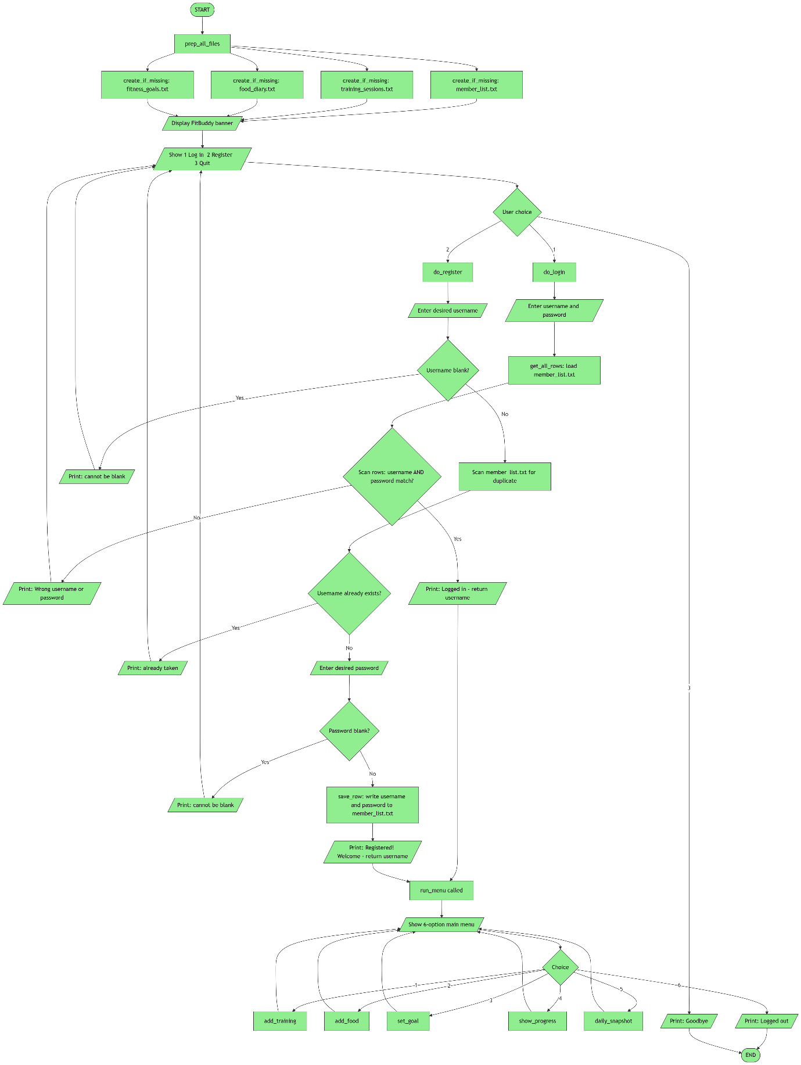

2.2 Function 2 - add_training
This function handles the complete workflow for logging a training session. It presents a 5-option activity menu, validates duration, maps the selection to a burn rate and intensity label, computes calories burned, scans the training history for a personal best, saves the session, and prints a personal best notification.

Algorithm 2 - add_training
- Call add_training(current_user).
- Get today's date using date.today().
- Display the 5-option activity menu: 1 = Light cardio (4 kcal/min), 2 = Moderate cardio (7 kcal/min), 3 = Hard cardio (10 kcal/min), 4 = Strength (5 kcal/min), 5 = HIIT (13 kcal/min). Loop until a valid number from 1 to 5 is entered. Store the activity name in aname and the burn rate in burn.
- Call ask_number() to get duration in minutes. The value must be a whole number between 1 and 240. ask_number loops internally until a valid value is entered.
- Set intensity label: IF burn <= 5 THEN 'Low'. IF burn <= 8 THEN 'Medium'. ELSE 'High'.
- Calculate kcal = duration x burn.
- Call get_all_rows(TRAINING) to load training_sessions.txt. For each row, check if the username matches current_user. If it does, read the duration field and update pb (personal best) if the value is greater than the current pb. At this point pb holds the longest session the user has ever completed.
- Call save_row(TRAINING, row) to append the new session with fields: current_user, today, aname, duration, intensity, kcal.
- Print 'Session saved. Burned approx X kcal.'
- IF duration > pb THEN print 'NEW PERSONAL BEST!' with the new duration. ELSE print the existing personal best value and an encouragement message.

Flowchart 2 - add_training
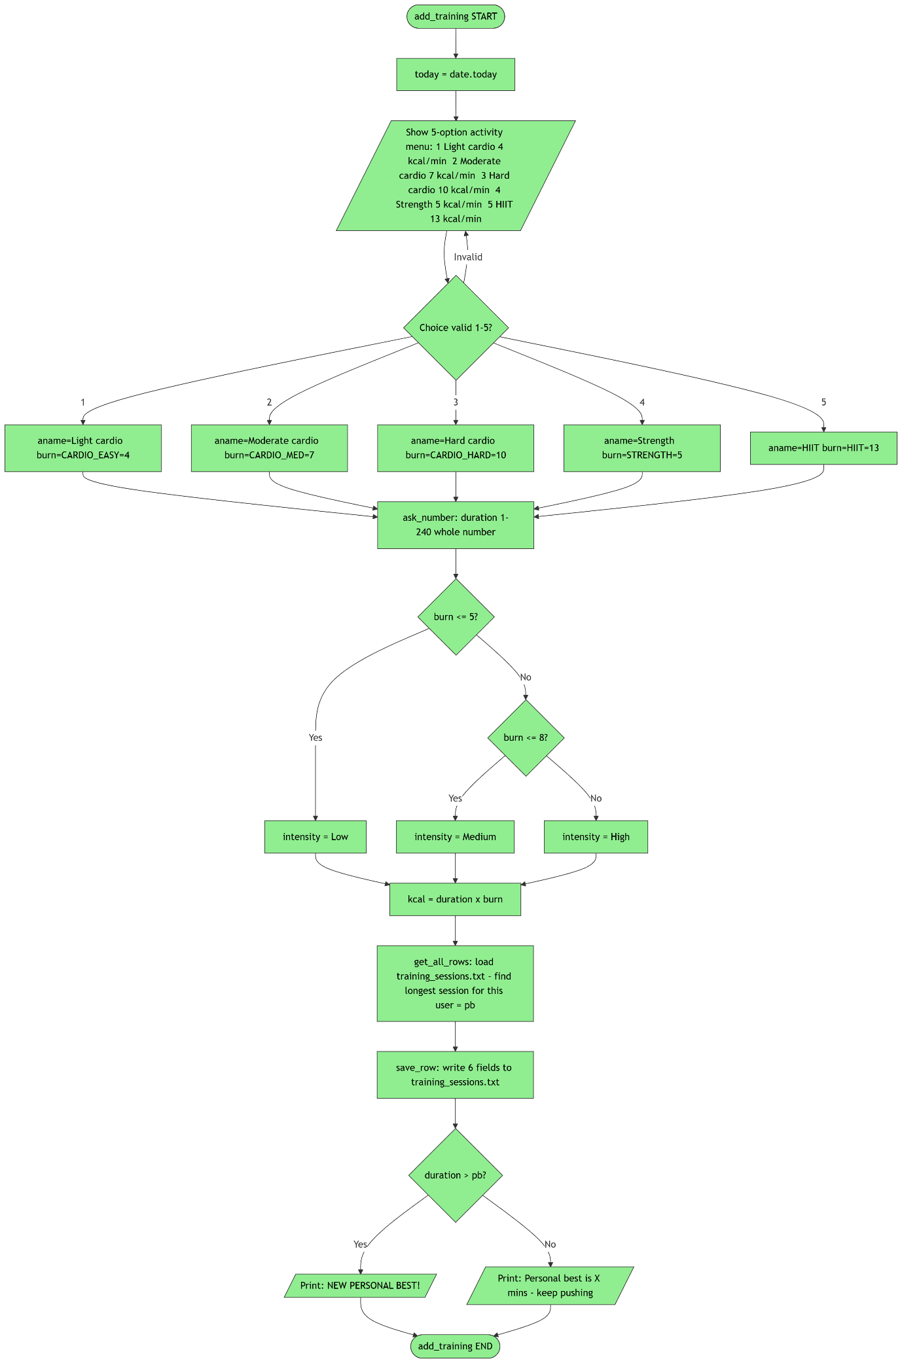

2.3 Function 3 - add_food
This function collects a food entry from the user and saves it to the food diary. It includes a subgraph showing the internal behaviour of the ask_number validation helper, which is called four times inside add_food.

Algorithm 3 - add_food
- Call add_food(current_user).
- Get today's date.
- Prompt for a food description. If the user presses Enter without typing, store 'Unspecified' as the default.
- Call ask_number() four times in sequence, one for each field: calories in kcal, carbohydrates in g, protein in g, and fat in g. For each call, the minimum accepted value is 0 (zero is allowed because some entries such as water have zero macros). There is no upper limit. Decimals are accepted.
- Inside ask_number (called for each field): read the raw input. Attempt to convert to float. If the conversion raises a ValueError, print 'Please enter a valid number' and re-prompt. If the value is below the minimum, print 'Minimum is X' and re-prompt. If a maximum is set and the value exceeds it, print 'Maximum is X' and re-prompt. Otherwise return the validated float.
- Build the data row: current_user + today + description + kcal + carbs + protein + fat (7 fields total).
- Call save_row(FOOD, row) to append the row to food_diary.txt.
- Print 'Food entry saved.'

Flowchart 3 - add_food and ask_number
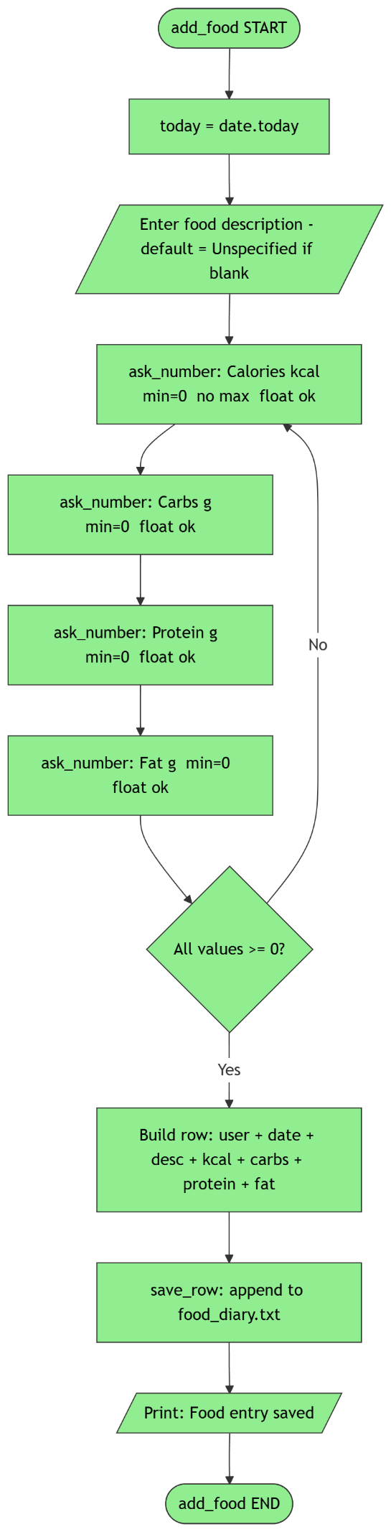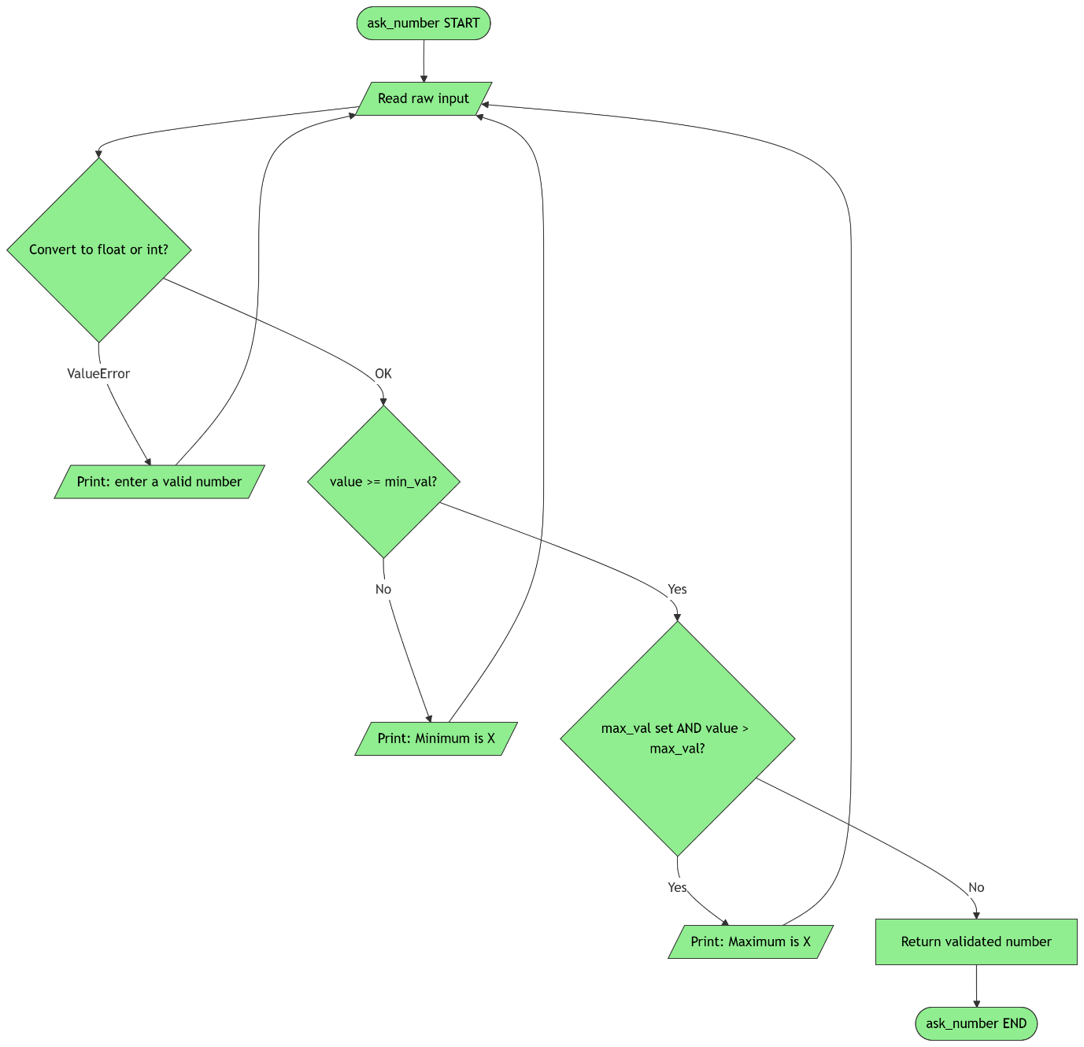

2.4 Function Group 4 - set_goal and show_progress
These two functions work together: set_goal allows the user to define or update a fitness target, and show_progress reads those targets and displays live progress against them. They are documented together because show_progress depends directly on the structure of data written by set_goal.

Algorithm 4 - set_goal and show_progress
SET_GOAL
- Call set_goal(current_user).
- Display the 3 goal types: 1 = sessions_target, 2 = kcal_burn_target, 3 = protein_goal_g. Loop until a valid choice is entered. Store the code in gcode.
- Call ask_number() to get the target value. The value must be greater than 0.
- Call get_all_rows(GOALS) to load fitness_goals.txt. Iterate through each row. For each row, split by comma. IF columns 0 (user) and 1 (goal type) both match current_user and gcode: build a replacement row with the updated target value but keeping the old logged_value from column 3. Add the replacement to new_rows and set updated = True. Otherwise add the row unchanged to new_rows.
- IF updated is True: call replace_file(GOALS, header, new_rows) to rewrite the file. Print 'Goal updated.'
- IF updated is False: call save_row(GOALS, new row with logged_value = 0). Print 'Goal saved.'

SHOW_PROGRESS
- Call show_progress(current_user).
- Load fitness_goals.txt and filter rows for current_user. If no goals exist, print 'No goals set' and return.
- Load training_sessions.txt. Count total_sessions and sum total_kcal_out for current_user.
- Load food_diary.txt. Build a dictionary protein_totals keyed by date. For each food entry belonging to current_user, add the protein value to that date's total. After scanning all rows, calculate avg_protein as the sum of all daily totals divided by the number of unique days.
- For each goal: IF gcode = sessions_target, current = total_sessions. IF kcal_burn_target, current = total_kcal_out. IF protein_goal_g, current = avg_protein.
- Calculate pct = (current / target) x 100. If pct exceeds 100, cap it at 100.
- Call build_progress_bar(pct): build a 20-character bar where filled positions use '=' and empty positions use a space. Return the bar string enclosed in square brackets.
- Print the goal name (from goal_name()), the bar, the percentage, and the current versus target values.

Flowchart 4 - set_goal and show_progress
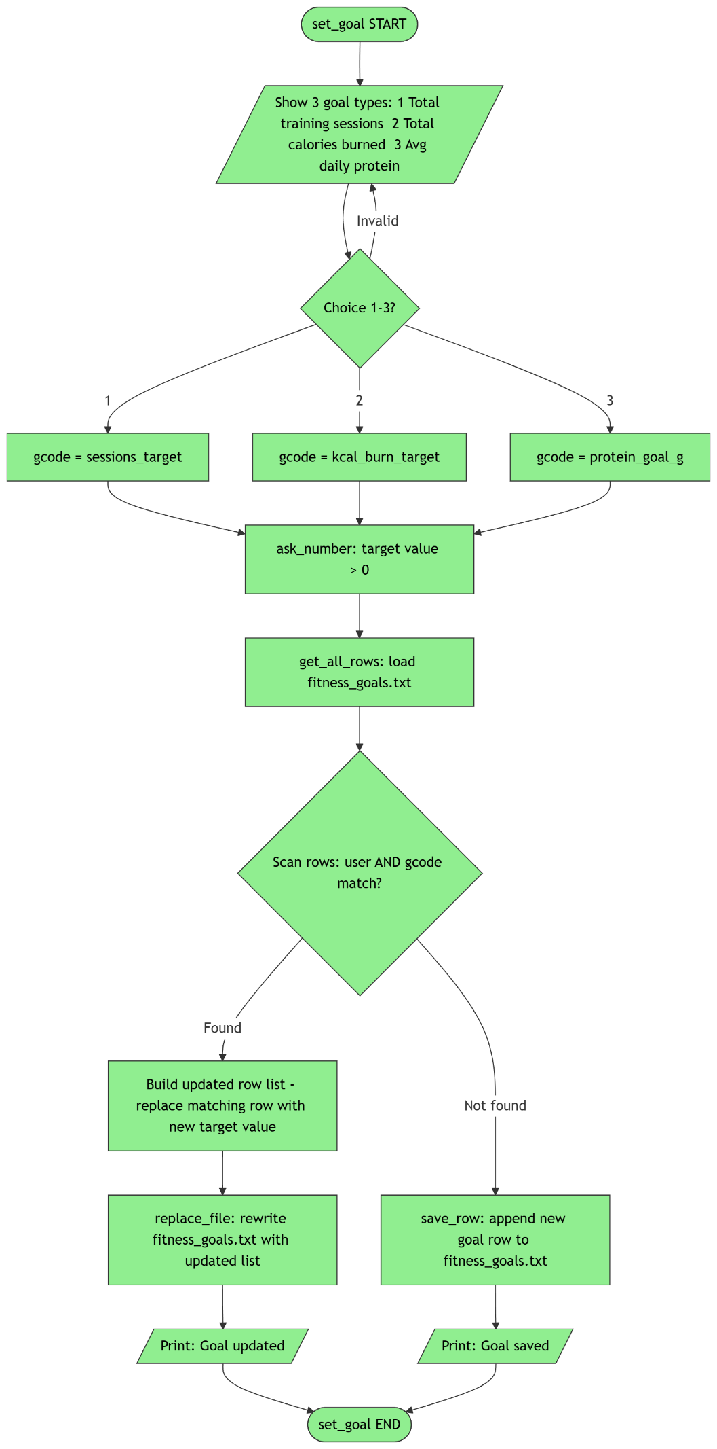
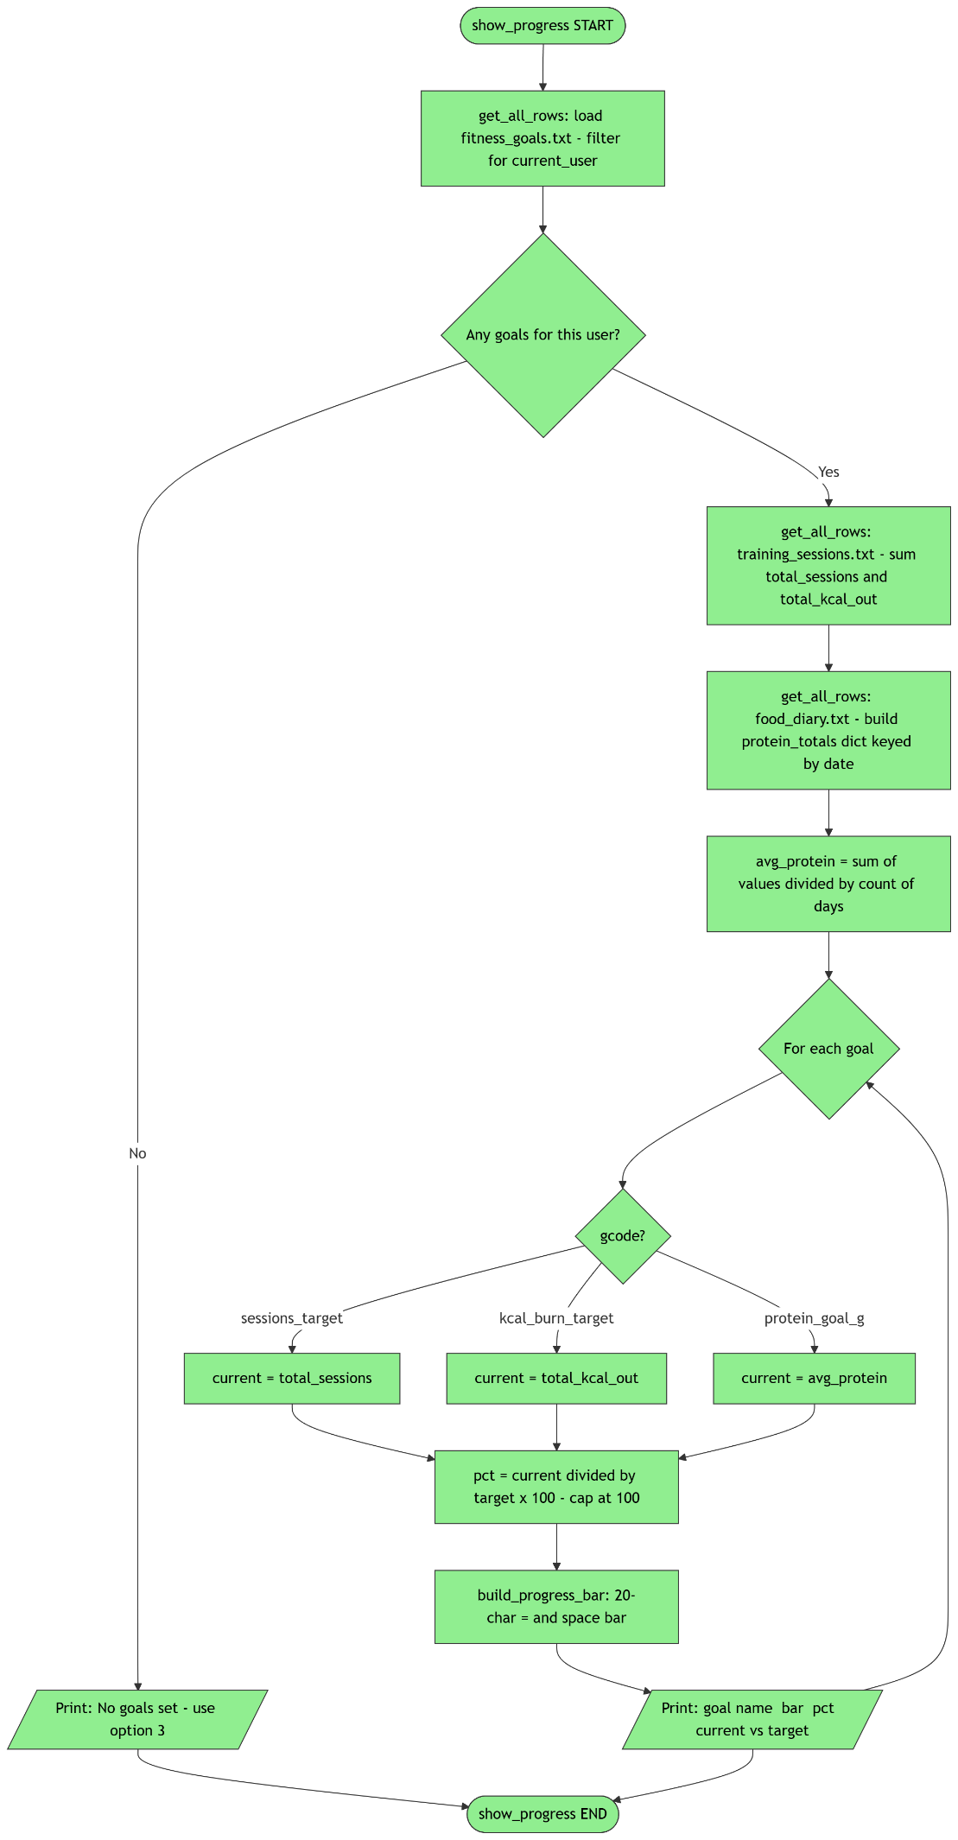

2.5 Function 5 - daily_snapshot
This function produces a complete view of a single day's activity and nutrition. It filters both the training and food files for the current user and today's date, sums all relevant fields, calculates a net energy balance, and prints a contextual surplus, deficit, or balanced message.

Algorithm 5 - daily_snapshot
- Call daily_snapshot(current_user).
- Get today's date as a string using str(date.today()).
- Call get_all_rows(TRAINING). For each row, check if column 0 (user) equals current_user AND column 1 (date) equals today. If both match, increment t_count by 1, add the duration value (column 3) to t_mins, and add the kcal_burned value (column 5) to t_kcal.
- Call get_all_rows(FOOD). For each row, check if column 0 (user) equals current_user AND column 1 (date) equals today. If both match, increment f_count by 1, and add each macro field to the running totals: f_kcal, f_carbs, f_protein, f_fat.
- Calculate net = f_kcal minus t_kcal.
- Print the training section: session count, total active minutes, total calories burned.
- Print the food section: entry count, calories in, carbohydrates, protein, fat.
- Print the net balance value.
- IF net < 0 THEN print 'Deficit! Good for fat loss.' ELSE IF net > 0 THEN print 'Surplus. Good for muscle building.' ELSE print 'Balanced day.'

Flowchart 5 - daily_snapshot
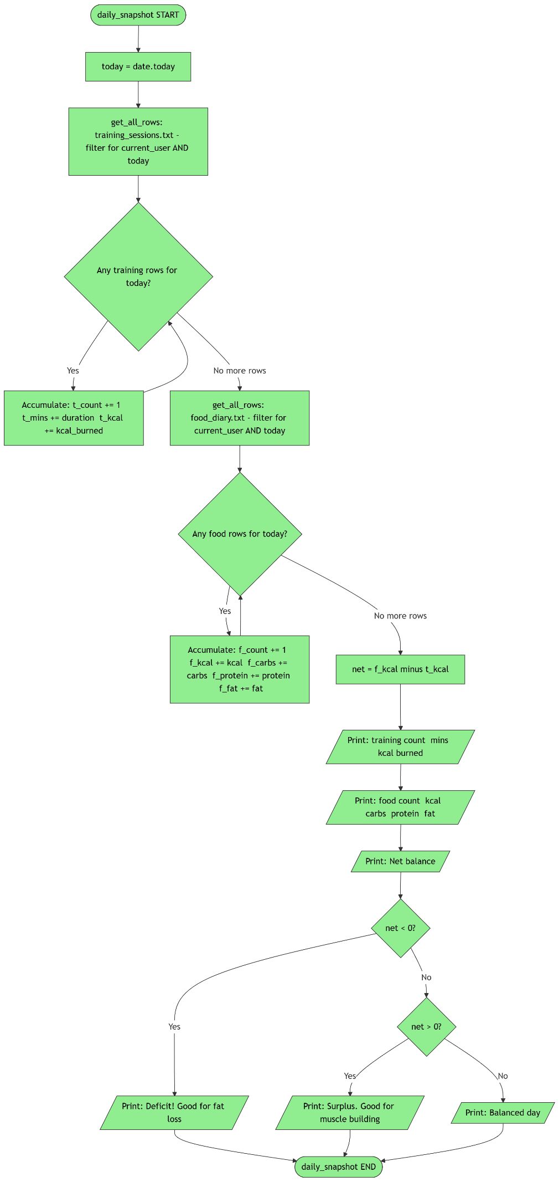
Code:
# -------------------------------------------------------
# FitBuddy - FC308 Programming Assignment 2
# Student:
# -------------------------------------------------------
# A fitness tracking app that logs training, food, and goals.
# Stores everything in plain .txt files -- no imports except date.
# -------------------------------------------------------

from datetime import date

# using short names so they're easy to type
MEMBERS="member_list.txt" # username + password
TRAINING="training_sessions.txt" # workout records
FOOD="food_diary.txt" # food and kcal
GOALS="fitness_goals.txt" # user goals

# different activities burn at very different rates
# using WHO and NHS activity guidelines as reference
CARDIO_EASY= 4 # light cardio e.g. walking
CARDIO_MED= 7 # medium e.g. cycling
CARDIO_HARD= 10 # hard e.g. running
STRENGTH= 5 # weight training, average
HIIT= 13 # high intensity interval training

def prep_all_files():
# make sure every file exists before we try to read it
create_if_missing(MEMBERS,"username,password")
create_if_missing(TRAINING,"user,date,activity,duration,intensity,kcal_burned")
create_if_missing(FOOD,"user,date,description,kcal,carbs,protein,fat")
create_if_missing(GOALS,"user,goal_type,goal_target,logged_value")

def create_if_missing(fname, header):
# try to open for reading -- only fails if file doesn't exist
try:
f = open(fname, "r")
f.close()
# file exists, nothing needed
except FileNotFoundError:
# create the file with a header row
f = open(fname, "w")
f.write(header + "\n")
f.close()

def get_all_rows(fname):
# returns list of raw strings, skips the header row
f = open(fname, "r")
lines = f.readlines()
f.close()

rows = []
i = 0
for line in lines:
if i == 0:
# skip header
i = i + 1
continue
clean = line.strip()
if clean != "":
rows.append(clean)
i = i + 1
return rows

def save_row(fname, row_data):
# appends one row to the end of a file
f = open(fname, "a")
f.write(row_data + "\n")
f.close()

def replace_file(fname, header, new_rows):
# completely rewrites a file -- used for goal updates
f = open(fname, "w")
f.write(header + "\n")
for r in new_rows:
f.write(r + "\n")
f.close()

def do_login():
# asks for username + password, checks against member_list
# returns the username if correct, None if wrong
print("\n[ Sign In ]")
uname = input("Username: ").strip()
pword = input("Password: ").strip()
rows = get_all_rows(MEMBERS)
for row in rows:
cols = row.split(",")
if len(cols) >= 2:
if cols[0].strip() == uname and cols[1].strip() == pword:
print(" Logged in as " + uname)
return uname
print("Wrong username or password.")
return None

def do_register():
# lets a new user pick a username and password
# returns username on success, None if taken or blank
print("\n[ Register ]")
uname = input("Pick a username: ").strip()
if uname == "":
print("Username can't be blank.")
return None
# make sure this name isn't already used
rows = get_all_rows(MEMBERS)
for row in rows:
cols = row.split(",")
if len(cols) >= 1:
if cols[0].strip() == uname:
print(" That username is taken.")
return None
pword = input(" Pick a password: ").strip()
if pword == "":
print(" Password can't be blank.")
return None
save_row(MEMBERS, uname + "," + pword)
print(" Registered! Welcome " + uname)
return uname

def ask_number(msg, must_be_int, min_val, max_val):
# loops until the user enters a valid number
# must_be_int=True means whole numbers only
# max_val=-1 means no upper limit
while True:
raw = input(msg).strip()
ok = True
num = 0
try:
if must_be_int:
num = int(raw)
else:
num = float(raw)
except ValueError:
ok = False

if not ok:
print(" Please enter a valid number.")
continue

if num < min_val:
print(" Minimum is " + str(min_val))
continue

if max_val != -1 and num > max_val:
print(" Maximum is " + str(max_val))
continue

return num

def add_training(current_user):
# records a workout session
# shows 5 activity types with kcal/min rates
# also checks for a personal best (longest session ever)
print("\n[ Log Training Session ]")
today = str(date.today())

# show activity menu
print("Activity type:")
print("1. Light cardio(4 kcal/min)")
print("2. Moderate cardio(7 kcal/min)")
print("3. Hard cardio(10 kcal/min)")
print("4. Strength(5 kcal/min)")
print("5. HIIT(13 kcal/min)")

# pick activity until valid
burn = 0
aname = ""
while True:
pick = input(" Choose (1-5): ").strip()
if pick == "1":
aname = "Light cardio"
burn = CARDIO_EASY
break
elif pick == "2":
aname = "Moderate cardio"
burn = CARDIO_MED
break
elif pick == "3":
aname = "Hard cardio"
burn = CARDIO_HARD
break
elif pick == "4":
aname = "Strength"
burn = STRENGTH
break
elif pick == "5":
aname = "HIIT"
burn = HIIT
break
else:
print(" Enter 1 to 5 only.")

# get duration
mins = int(ask_number(" Duration (mins, 1-240): ", True, 1, 240))

# intensity label
if burn <= 5:
intensity = "Low"
elif burn <= 8:
intensity = "Medium"
else:
intensity = "High"

# calc kcal
kcal = mins * burn

# check personal best (longest session for this user)
pb = 0
old_rows = get_all_rows(TRAINING)
for row in old_rows:
cols = row.split(",")
if len(cols) >= 4:
if cols[0].strip() == current_user:
try:
d = int(cols[3].strip())
if d > pb:
pb = d
except ValueError:
pass

# save the session
save_row(TRAINING,
current_user + "," + today + "," + aname + "," +
str(mins) + "," + intensity + "," + str(kcal))

print(" Session saved. Burned approx " + str(kcal) + " kcal.")

# personal best message
if mins > pb:
print(" NEW PERSONAL BEST! Longest session yet: " + str(mins) + " mins.")
else:
print(" Personal best: " + str(pb) + " mins. Keep pushing!")

def add_food(current_user):
# records a food/meal entry with kcal and macros
print("\n[ Log Food Entry ]")
today = str(date.today())

desc = input(" Food description: ").strip()
if desc == "":
desc = "Unspecified"

kcal = ask_number(" Calories (kcal): ", False, 0, -1)
carbs = ask_number(" Carbs (g) : ", False, 0, -1)
protein = ask_number(" Protein (g) : ", False, 0, -1)
fat = ask_number(" Fat (g) : ", False, 0, -1)

save_row(FOOD,
current_user + "," + today + "," + desc + "," +
str(kcal) + "," + str(carbs) + "," + str(protein) + "," + str(fat))

print(" Food entry saved.")

def goal_name(code):
# converts a goal code to a readable name
if code == "sessions_target":
return "Total Training Sessions"
elif code == "kcal_burn_target":
return "Total Calories Burned (kcal)"
elif code == "protein_goal_g":
return "Avg Daily Protein (g)"
else:
return code

def set_goal(current_user):
# lets the user pick and set one of 3 goal types
print("\n[ Set Fitness Goal ]")
print("1. Total training sessions target")
print("2. Total calories burned target (kcal)")
print("3. Average daily protein target (g)")
while True:
g = input(" Choose goal (1-3): ").strip()
if g == "1":
gcode = "sessions_target"
break
elif g == "2":
gcode = "kcal_burn_target"
break
elif g == "3":
gcode = "protein_goal_g"
break
else:
print(" Enter 1, 2, or 3.")

gval = ask_number(" Target value: ", False, 0.01, -1)

# check if goal already exists for this user + type
old_rows= get_all_rows(GOALS)
new_rows= []
updated = False

for row in old_rows:
cols = row.split(",")
if len(cols) >= 2:
if cols[0].strip() == current_user and cols[1].strip() == gcode:
# replace the old goal with updated target
cur_val = "0"
if len(cols) >= 4:
cur_val = cols[3].strip()
new_rows.append(current_user + "," + gcode + "," +
str(gval) + "," + cur_val)
updated = True
continue
new_rows.append(row)

if updated:
replace_file(GOALS, "user,goal_type,goal_target,logged_value", new_rows)
print(" Goal updated.")
else:
save_row(GOALS, current_user + "," + gcode + "," + str(gval) + ",0")
print(" Goal saved.")

def build_progress_bar(pct):
# builds a text bar like [==== ] out of 20 chars
if pct > 100.0:
pct = 100.0
if pct < 0.0:
pct = 0.0

total = 20
filled = int((pct / 100.0) * total)
bar_str = "["
i = 0
while i < total:
if i < filled:
bar_str = bar_str + "="
else:
bar_str = bar_str + " "
i = i + 1
bar_str = bar_str + "]"
return bar_str

def show_progress(current_user):
# shows goal progress with a text bar for each goal
print("\n[ Goal Progress ]")

goal_rows = get_all_rows(GOALS)
user_goals = []
for row in goal_rows:
cols = row.split(",")
if len(cols) >= 3:
if cols[0].strip() == current_user:
user_goals.append(cols)

if len(user_goals) == 0:
print(" No goals set. Use option 3 first.")
return

# compute totals from training and food files
train_rows = get_all_rows(TRAINING)
total_sessions = 0
total_kcal_out = 0.0

for row in train_rows:
cols = row.split(",")
if len(cols) >= 6:
if cols[0].strip() == current_user:
total_sessions = total_sessions + 1
try:
total_kcal_out = total_kcal_out + float(cols[5].strip())
except ValueError:
pass

# avg daily protein
food_rows = get_all_rows(FOOD)
protein_totals = {}
for row in food_rows:
cols = row.split(",")
if len(cols) >= 6:
if cols[0].strip() == current_user:
d = cols[1].strip()
try:
p = float(cols[5].strip())
except ValueError:
p = 0.0
if d in protein_totals:
protein_totals[d] = protein_totals[d] + p
else:
protein_totals[d] = p

avg_protein = 0.0
if len(protein_totals) > 0:
s = 0.0
for k in protein_totals:
s = s + protein_totals[k]
avg_protein = s / len(protein_totals)

# show each goal
for g in user_goals:
gcode = g[1].strip()
try:
gtarget = float(g[2].strip())
except ValueError:
gtarget = 1.0

if gcode == "sessions_target":
current = float(total_sessions)
elif gcode == "kcal_burn_target":
current = total_kcal_out
elif gcode == "protein_goal_g":
current = avg_protein
else:
current = 0.0

if gtarget > 0:
pct = (current / gtarget) * 100.0
else:
pct = 0.0
if pct > 100.0:
pct = 100.0

bar = build_progress_bar(pct)
print("\n " + goal_name(gcode))
print(" " + bar + " " + str(round(pct, 1)) + "%")
print(" " + str(round(current, 1)) + " / " + str(gtarget))

def daily_snapshot(current_user):
# shows everything logged today -- workouts + food + net balance
today = str(date.today())
print("\n[ Daily Snapshot -- " + today + " ]")

# today's training
train_rows = get_all_rows(TRAINING)
t_count = 0
t_mins = 0
t_kcal = 0.0

for row in train_rows:
cols = row.split(",")
if len(cols) >= 6:
if cols[0].strip() == current_user and cols[1].strip() == today:
t_count = t_count + 1
try:
t_mins = t_mins + int(cols[3].strip())
t_kcal = t_kcal + float(cols[5].strip())
except ValueError:
pass

# today's food
food_rows = get_all_rows(FOOD)
f_count = 0
f_kcal = 0.0
f_carbs = 0.0
f_protein = 0.0
f_fat = 0.0

for row in food_rows:
cols = row.split(",")
if len(cols) >= 7:
if cols[0].strip() == current_user and cols[1].strip() == today:
f_count = f_count + 1
try:
f_kcal = f_kcal + float(cols[3].strip())
f_carbs = f_carbs + float(cols[4].strip())
f_protein = f_protein + float(cols[5].strip())
f_fat = f_fat + float(cols[6].strip())
except ValueError:
pass

net = f_kcal - t_kcal

print("\n Training: " + str(t_count) + " session(s)")
print(" Time: " + str(t_mins) + " mins")
print(" Burned: " + str(round(t_kcal, 1)) + " kcal")

print("\n Food: " + str(f_count) + " entry/entries")
print(" Eaten: " + str(round(f_kcal, 1)) + " kcal")
print(" Carbs: " + str(round(f_carbs, 1)) + " g")
print(" Protein: " + str(round(f_protein, 1)) + " g")
print(" Fat: " + str(round(f_fat, 1)) + " g")

print("\n Net balance: " + str(round(net, 1)) + " kcal")

if net < 0:
print(" Deficit! Good for fat loss.")
elif net > 0:
print(" Surplus. Good for muscle building.")
else:
print(" Balanced day.")

def run_menu(current_user):
# main menu loop -- runs until user logs out
going = True
while going:
print("\n-------------------------------")
print(" FitBuddy | " + current_user)
print("------------------------------")
print(" 1. Log training session")
print(" 2. Log food")
print(" 3. Set fitness goal")
print(" 4. View goal progress")
print(" 5. Daily snapshot")
print(" 6. Log out")

opt = input(" Option: ").strip()

if opt == "1":
add_training(current_user)
elif opt == "2":
add_food(current_user)
elif opt == "3":
set_goal(current_user)
elif opt == "4":
show_progress(current_user)
elif opt == "5":
daily_snapshot(current_user)
elif opt == "6":
print(" Logged out. Bye " + current_user + "!")
going = False
else:
print(" Invalid. Enter 1-6.")

def launch():
# entry point -- sets up files, shows login screen
prep_all_files()

print(" FitBuddy")
print(" FC308 Assignment 2")

active = True
while active:
print("\n 1. Log in")
print(" 2. Register")
print(" 3. Quit")
choice = input(" Choice: ").strip()

if choice == "1":
logged_in_as = do_login()
if logged_in_as is not None:
run_menu(logged_in_as)

elif choice == "2":
new_user = do_register()
if new_user is not None:
run_menu(new_user)

elif choice == "3":
print(" Goodbye!")
active = False

else:
print(" Enter 1, 2, or 3.")

launch()

3. Testing

3.1 Test Strategy
Testing was carried out manually on a Windows machine using the command line. Each test was executed by running the application, navigating to the relevant menu option, and observing the output. For tests involving specific file states, the text files were manually edited or deleted before the test run. The table below records each test case with its identifier, the function under test, the input or condition used, any preconditions, the expected outcome, and whether the actual result matched.

3.2 Test Results

ID | Function | Input / Condition | Pre-condition | Expected Result | Outcome
TC01 | launch / prep_all_files | Start app with no files on disk | No files exist | 4 files created with correct headers | Pass
TC02 | create_if_missing | File already exists | File on disk | File unchanged, no error raised | Pass
TC03 | do_login | Correct username and password | Valid row in member_list.txt | Prints 'Logged in', returns username | Pass
TC04 | do_login | Correct username, wrong password | Row present but password differs | Prints 'Wrong username or password', returns None | Pass
TC05 | do_login | Username not in file | Empty member_list | Prints error, returns None | Pass
TC06 | do_register | Blank username submitted | N/A | Prints 'cannot be blank', returns None | Pass
TC07 | do_register | Username already taken | Duplicate row in file | Prints 'already taken', returns None | Pass
TC08 | do_register | Valid unique username and password | No duplicate | Row saved, returns username | Pass
TC09 | ask_number | Enter a word instead of a number | N/A | Prints error, re-prompts | Pass
TC10 | ask_number | Enter -5 when minimum is 0 | N/A | Prints 'Minimum is 0', re-prompts | Pass
TC11 | add_training | Choose HIIT (option 5), 20 mins | User logged in | kcal = 260, row saved, burn shown | Pass
TC12 | add_training | Duration of 241 minutes entered | N/A | ask_number rejects >240, re-prompts | Pass
TC13 | add_training | First ever session logged | No prior rows | Personal best message printed | Pass
TC14 | add_food | Valid description and all macro values | User logged in | Row saved to food_diary.txt | Pass
TC15 | set_goal | Set sessions_target, no existing goal | No prior goals | New row appended to fitness_goals.txt | Pass
TC16 | set_goal | Update kcal_burn_target already set | Existing row present | replace_file called, target updated | Pass
TC17 | show_progress | No goals set for user | fitness_goals.txt empty for user | Prints 'No goals set. Use option 3.' | Pass
TC18 | daily_snapshot | No entries at all for today | Files empty for today | All totals show 0.0, balanced message shown | Pass
TC19 | daily_snapshot | Log one HIIT session and one meal then view | Entries for today | Correct net balance and message displayed | Pass

4. Evaluation

4.1 Strengths
- The personal best feature inside add_training adds engagement value with minimal code complexity. It reads the existing session history, finds the maximum duration, and compares it to the new entry. This gives users a concrete motivational signal every time they train.
- Separating file operations into three dedicated functions — get_all_rows, save_row, and replace_file — means the rest of the application never touches a file handle directly. This improves maintainability, as the storage format could be changed by editing only those three functions.
- The activity type menu with five options and printed burn rates (e.g. 'HIIT -- 13 kcal/min') is transparent to the user: they can see how their calorie estimate will be calculated before they confirm, which improves trust in the results.
- The three intensity labels (Low, Medium, High) are calculated programmatically from the burn rate rather than being entered by the user, ensuring the label in the stored record is always consistent with the actual burn rate used.
- The ask_number function provides clear, contextual error messages for each failure mode (not a number, below minimum, above maximum), making it easy for users to understand and correct their input.

4.2 Limitations
- Credentials are stored in plain text, which is insecure. A production version of FitBuddy would need to hash passwords before writing them to disk (Hunt and Thomas, 2019).
- The personal best check only compares duration in minutes. A more meaningful comparison would consider the combination of duration and intensity, since a 30-minute HIIT session is a greater achievement than a 30-minute walk.
- Calorie burn estimates assume a fixed body weight of approximately 70 kg. Users who are significantly lighter or heavier than this average will see systematically inaccurate kcal values (Ainsworth et al., 2011).
- Only three goal types are supported. Real fitness apps typically allow a wider range of goals such as target body weight, step count, or distance targets.
- There is no edit or delete function. A user who logs a session with the wrong values cannot remove or correct it without manually editing the text file.

4.3 Future Improvements
- Adding a body weight input field to the registration screen and using it in the burn rate formula would make calorie estimates significantly more accurate (WHO, 2020).
- A weekly summary function that aggregates totals over the previous 7 days and shows day-by-day bar charts in the terminal would help users identify patterns in their training and eating behaviour (Fox and Duggan, 2013).
- A data export option that writes a CSV summary to a user-chosen location would allow users to share their data with a nutritionist, personal trainer, or healthcare provider.
- The personal best system could be extended to track the most kcal burned in a single session, the most consecutive days of training, and the highest single-day protein intake.

5. References
NHS (2024) Benefits of exercise. Available at: https://www.nhs.uk/live-well/exercise/exercise-health-benefits.
Python Software Foundation (2024) Built-in functions - open(). Available at: https://docs.python.org/3/library/functions.html#open.
Strava (2024) How Strava calculates calories. Available at: https://support.strava.com/hc/en-us/articles/216917097.

