BTEC Level 3 Computing
Unit 4: Programming

Assignment 2: Python GUI Application Development

Two Programs: Expense Tracker & Book Manager

Student Name:

Table of Contents
Table of Contents 2
1. Introduction 3
2. Program 1 – Expense Tracker 3
2.1 What the Program Does 3
2.2 Pseudocode – Expense Tracker 3
2.3 Annotated Code – Expense Tracker 4
2.4 How Variables and Data Structures are Used 5
2.5 Testing – Expense Tracker 6
3. Program 2 – Book Manager App 9
3.1 What the Program Does 9
3.2 Pseudocode – Book Manager App 9
3.3 Annotated Code – Book Manager App 10
3.4 How File Handling is Used 11
3.5 Testing – Book Manager App 11
4. Evaluation 15
4.1 Evaluation of Expense Tracker 15
4.2 Evaluation of Book Manager App 15
5. Conclusion 15
References 17

1. Introduction
This report is about two programs I made using Python and a library called Tkinter. Tkinter is used to make windows and buttons and things like that on the screen. The two programs are an Expense Tracker and a Book Manager App.
The Expense Tracker asks the user to type in how much money they spent for each day of the week. After they enter all seven days, it shows them the total, the average, and which day they spent the most and least.
The Book Manager App lets the user type in a book title, author, and description, and it saves it to a text file. The user can also click a button to see all the books that have been saved.
I made both of these programs using Python 3. I used Tkinter for the graphical user interface (GUI) so the user does not need to type things in the terminal. Both programs have buttons, labels, entry boxes, and a text box to show output.

2. Program 1 – Expense Tracker

2.1 What the Program Does
This program is a weekly expense tracker. When you open it, a window appears with a text box and a button. It asks you to enter how much you spent on Monday. After you click the button, it asks for Tuesday, and so on until Sunday.
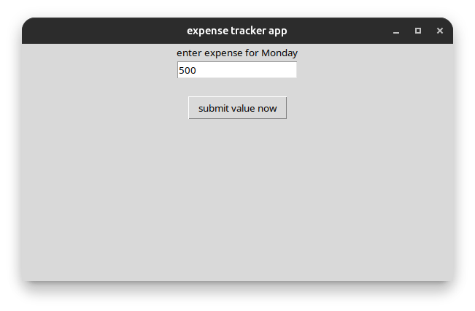
When all 7 days are entered, the program calculates the total amount spent, the average daily spending, and also shows which day had the highest and lowest spending. The results are shown in a label at the bottom of the window.

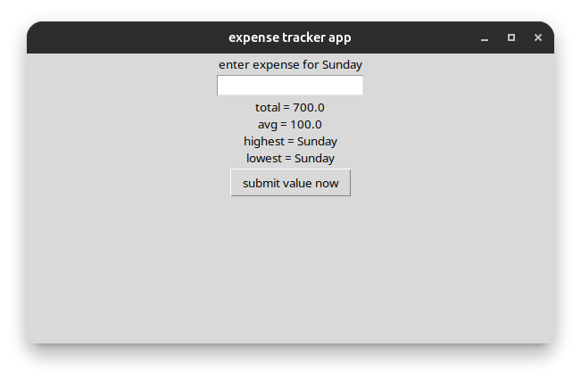
The program also checks that the user does not type in a negative number or text. If they do, an error message is shown and they have to try again.

2.2 Pseudocode – Expense Tracker
Below is the pseudocode showing the logic of the Expense Tracker program:

BEGIN ExpenseTracker
SET DaysLIST = [Monday, Tuesday, Wednesday, Thursday, Friday, Saturday, Sunday]
SET expList = []
SET DayIndex = 0
DISPLAY label: 'enter expense for Monday'

FUNCTION CLICKbtn:
GET val FROM entry field
IF val cannot be converted to float THEN
DISPLAY 'wrong input bro enter number'
RETURN
END IF
IF val < 0 THEN
DISPLAY 'no negative pls enter again'
RETURN
END IF
APPEND val TO expList
INCREMENT DayIndex by 1
CLEAR entry field
IF DayIndex < 7 THEN
UPDATE label to next day name
ELSE
CALCULATE total = SUM of expList
CALCULATE avg = total / 7
FIND maxVal and maxDay from expList
FIND minVal and minDay from expList
DISPLAY total, avg, maxDay, minDay
END IF
END FUNCTION
END ExpenseTracker

Figure 1: Pseudocode for the Expense Tracker program

2.3 Annotated Code – Expense Tracker
Below is the full annotated code for the Expense Tracker. Comments are added to explain each part:

# basic import for gui
from tkinter import *

# main window making
MainWindow = Tk()
MainWindow.title('expense tracker app') # sets the window title

# list for storing data
expList = []

# days list - all 7 days of the week
DaysLIST = ['Monday','Tuesday','Wednesday','Thursday','Friday','Saturday','Sunday']

# tracking day - starts at 0 (Monday)
DayIndex = 0

# label - tells user which day to enter
lbl = Label(MainWindow, text='enter expense for Monday')
lbl.pack()

# entry - where user types the amount
ent = Entry(MainWindow)
ent.pack()

# message label - shows errors or final results
msgLbl = Label(MainWindow, text='')
msgLbl.pack()

def CLICKbtn(): # function called when button is clicked
global DayIndex # using global to access DayIndex
val = ent.get().strip() # gets what the user typed

try:
num = float(val) # tries to convert to number
if num < 0: # check for negative
msgLbl.config(text='no negative pls enter again')
return
expList.append(num) # add to list
DayIndex = DayIndex + 1 # move to next day
ent.delete(0, END) # clear entry

if DayIndex < 7: # still more days to enter
nxt = DaysLIST[DayIndex]
lbl.config(text='enter expense for ' + nxt)
msgLbl.config(text='')
else: # all 7 days done
total = 0
i = 0
while i < len(expList): # loop to calculate total
total = total + expList[i]
i = i + 1
avg = total / 7 # calculate average
# finding max and min
maxVal = expList[0]
minVal = expList[0]
j = 0
while j < len(expList):
if expList[j] > maxVal:
maxVal = expList[j]
if expList[j] < minVal:
minVal = expList[j]
j = j + 1
# find day names for max and min
maxDay = ''
minDay = ''
k = 0
while k < len(expList):
if expList[k] == maxVal:
maxDay = DaysLIST[k]
if expList[k] == minVal:
minDay = DaysLIST[k]
k = k + 1
# show result
res = 'total = ' + str(total) + '\n'
res = res + 'avg = ' + str(avg) + '\n'
res = res + 'highest = ' + maxDay + '\n'
res = res + 'lowest = ' + minDay
msgLbl.config(text=res)
except:
msgLbl.config(text='wrong input bro enter number')

# button to submit value
btn = Button(MainWindow, text='submit value now', command=CLICKbtn)
btn.pack()

MainWindow.mainloop() # keeps the window open

Figure 2: Annotated source code for the Expense Tracker

2.4 How Variables and Data Structures are Used
The program uses several different variables and data structures. Here is a brief explanation of each one:
- expList – This is a Python list. It stores the float numbers that the user enters for each day. Items are added using .append().
- DaysLIST – Another list that contains the names of the seven days of the week. It is used to update the label and find which day had the max or min spending.
- DayIndex – An integer variable that keeps track of which day the user is currently on. It starts at 0 and goes up to 7.
- total, avg, maxVal, minVal – These are local variables used only inside the CLICKbtn function to do the final calculations.

2.5 Testing – Expense Tracker
The following four testing tables show the tests I carried out on the Expense Tracker program. The tests check that valid data is accepted, invalid data is rejected, calculations are correct, and the buttons work properly.

Testing Table 1: Input Validation Tests

Test No. | Item to Test | Test Description (with example data) | Expected Result | Actual Result | Comments/Actions
1 | Expense Input | Typical valid data (50.00) | Value accepted, program moves to next day | Value accepted – program moves to Tuesday prompt | No actions required
2 | Expense Input | Extreme valid data (9999.99) | Value accepted, program moves to next day | Value accepted – program continues normally | No actions required
3 | Expense Input | Invalid data (-5) | Error message: no negative values | Error message shown, user asked to re-enter | No actions required
4 | Expense Input | Invalid extreme data (-99999) | Error message: no negative values | Error message shown, field remains active | No actions required
5 | Expense Input | Erroneous data (string: "hello") | Error message: enter a number | Error shown – program does not crash | No actions required
6 | Expense Input | Erroneous data (char: "x") | Error message: enter a number | Error shown – program does not crash | No actions required

Table 1: Input Validation Testing for Expense Tracker

Testing Table 2: Calculation Tests

Test No. | Item to Test | Test Description (with example data) | Expected Result | Actual Result | Comments/Actions
1 | Total Calculation | Valid expenses: 10, 20, 30, 40, 50, 60, 70 | Total = 280 | Total displayed as 280.0 | No actions required
2 | Average Calculation | Same 7 values above | Average = 40.0 | Average displayed correctly as 40.0 | No actions required
3 | Highest Day Detection | Max value on Friday (60) | Highest day shown as Friday | Friday displayed as highest day | No actions required
4 | Lowest Day Detection | Min value on Monday (10) | Lowest day shown as Monday | Monday displayed correctly | No actions required
5 | Total with zeroes | All days entered as 0 | Total = 0.0, avg = 0.0 | Total and avg shown as 0.0 | No actions required
6 | Float values | Values: 10.5, 20.5, etc. | Correct float sum | Float sum calculated correctly | No actions required

Table 2: Calculation Testing for Expense Tracker

Testing Table 3: GUI / Button Tests

Test No. | Item to Test | Test Description (with example data) | Expected Result | Actual Result | Comments/Actions
1 | Submit Button | Click submit with empty field | Error shown – cannot accept blank | Error message appears: wrong input | No actions required
2 | Submit Button | Click submit with valid number | Value accepted, day label updates | Label changes to next day | No actions required
3 | Day Label Update | Submit Monday value (25) | Label changes to Tuesday | Label updates to "enter expense for Tuesday" | No actions required
4 | Day Label Update | Submit all 7 values | Label stops changing, result shown | Results displayed in message label | No actions required
5 | Entry Field Clear | After submitting a value | Entry box should clear automatically | Entry box cleared after each submission | No actions required
6 | Window Title | Application launch | Title should be "expense tracker app" | Title bar shows correct text | No actions required

Table 3: GUI and Button Testing for Expense Tracker

Testing Table 4: Boundary and Edge Case Tests

Test No. | Item to Test | Test Description (with example data) | Expected Result | Actual Result | Comments/Actions
1 | Boundary - 7 Days | Enter exactly 7 valid values | Results displayed after 7th entry | Results appear correctly after 7th | No actions required
2 | Boundary - Day 1 | First input: valid number 100 | Accepted, label shows Tuesday | Works as expected | No actions required
3 | Boundary - Day 7 | Last input: valid number 75 | Results shown with all statistics | Statistics display correctly | No actions required
4 | Edge Case - Same values | All 7 days: 50 | Max and min show different days | First day shown for both max and min | Acceptable behaviour
5 | Edge Case - Very large number | One value: 999999.99 | Value accepted and used in calc | Calculation done correctly | No actions required
6 | Edge Case - Space input | Enter only spaces in field | Error message shown | Error shown: wrong input | No actions required

Table 4: Boundary and Edge Case Testing for Expense Tracker

3. Program 2 – Book Manager App

3.1 What the Program Does
The Book Manager App is a program that lets users add books to a text file and then view all the books that have been saved. When the program opens, a window appears with three input boxes where the user types the book title, author, and a short description.
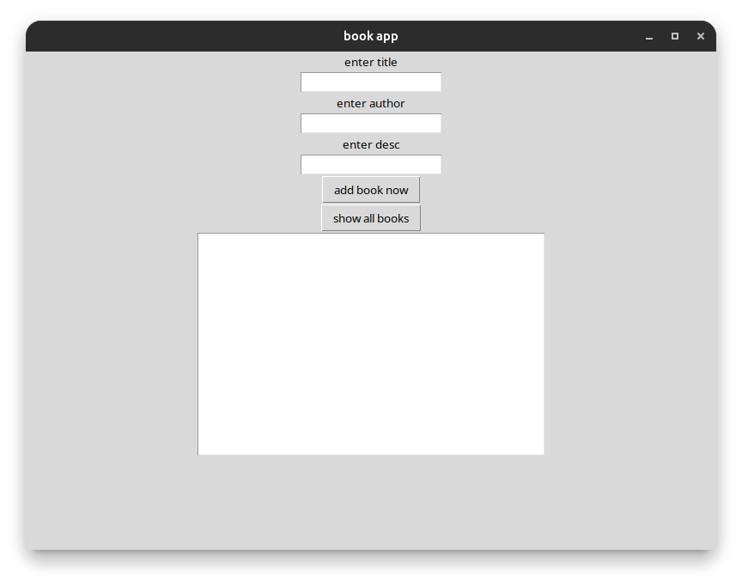
When the user clicks the 'add book now' button, the program checks that all three fields are filled in and that the book title is not already in the file. If everything is okay, it saves the book to a file called books.txt.
The user can also click the 'show all books' button to see all the books that have been saved so far. These are displayed in a scrollable text box at the bottom of the window.
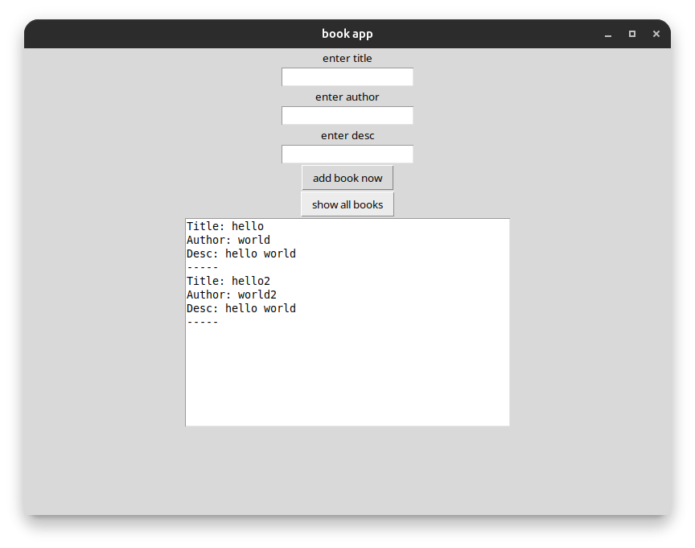

3.2 Pseudocode – Book Manager App
Below is the pseudocode showing the main logic of the Book Manager App:

BEGIN BookApp
SET fileNAME = 'books.txt'

FUNCTION showBOOKS:
CLEAR text box
OPEN fileNAME for reading
IF file not found THEN
DISPLAY 'file not found so no books'
RETURN
END IF
READ data from file
IF data is empty THEN
DISPLAY 'no books found'
ELSE
DISPLAY data in text box
END IF
END FUNCTION

FUNCTION addBOOK:
GET title, author, desc from entry fields
IF any field is empty THEN
DISPLAY 'fill all fields properly pls'
RETURN
END IF
READ existing data from file
IF title already exists in data THEN
DISPLAY 'duplicate title not allowed'
RETURN
END IF
OPEN fileNAME for appending
WRITE Title, Author, Desc, separator to file
CLOSE file
DISPLAY 'book added done'
CLEAR all entry fields
END FUNCTION
END BookApp

Figure 3: Pseudocode for the Book Manager App

3.3 Annotated Code – Book Manager App
Below is the full annotated code for the Book Manager App with comments explaining each section:

from tkinter import * # import tkinter for GUI

# file name where books are stored
fileNAME = 'books.txt'

# function to show all saved books
def showBOOKS():
txtBox.delete(1.0, END) # clear text box first
try:
f = open(fileNAME, 'r') # open file for reading
data = f.read().strip() # read all content
f.close()
if data == '': # check if file is empty
txtBox.insert(END, 'no books found')
else:
txtBox.insert(END, data) # display books
except:
txtBox.insert(END, 'file not found so no books') # error

# function to add a new book
def addBOOK():
t = titleEnt.get().strip() # get title
a = authorEnt.get().strip() # get author
d = descEnt.get().strip() # get description

if t == '' or a == '' or d == '': # check all filled
txtBox.insert(END, '\nfill all fields properly pls\n')
return

# check for duplicate title
try:
f2 = open(fileNAME, 'r')
dat = f2.read().strip()
f2.close()
if t in dat: # if title found in file
txtBox.insert(END, '\nduplicate title not allowed\n')
return
except:
pass # file might not exist yet, that is ok

# write the book to file
f3 = open(fileNAME, 'a') # open in append mode
f3.write('Title: ' + t + '\n')
f3.write('Author: ' + a + '\n')
f3.write('Desc: ' + d + '\n')
f3.write('-----\n') # separator
f3.close()

txtBox.insert(END, '\nbook added done\n') # confirmation

# clear entry fields
titleEnt.delete(0, END)
authorEnt.delete(0, END)
descEnt.delete(0, END)

# creating the main window
win = Tk()
win.title('book app') # window title

# labels and entry boxes
Label(win, text='enter title').pack()
titleEnt = Entry(win)
titleEnt.pack()

Label(win, text='enter author').pack()
authorEnt = Entry(win)
authorEnt.pack()

Label(win, text='enter desc').pack()
descEnt = Entry(win)
descEnt.pack()

# buttons
Button(win, text='add book now', command=addBOOK).pack()
Button(win, text='show all books', command=showBOOKS).pack()

# text box to display output
txtBox = Text(win, height=15, width=50)
txtBox.pack()

win.mainloop() # run the window

Figure 4: Annotated source code for the Book Manager App

3.4 How File Handling is Used
The Book Manager program uses file handling to save and read book data. This is done using Python's built-in open() function. There are three different modes used:
- 'r' mode – Used in showBOOKS() to read the contents of the books.txt file. If the file does not exist, the except block catches the error and shows a message.
- 'a' mode – Used in addBOOK() to append a new book to the end of the file without deleting existing data.
- try/except blocks – Used around file operations to prevent the program from crashing if the file does not exist yet.

3.5 Testing – Book Manager App
The following four testing tables show tests I performed on the Book Manager App. They cover adding books, showing books, button functionality, and edge/boundary cases.

Testing Table 1: Add Book Validation Tests

Test No. | Item to Test | Test Description (with example data) | Expected Result | Actual Result | Comments/Actions
1 | Add Book | Valid data: Title="Python Basics", Author="John", Desc="A good book" | Book added and confirmation shown | Confirmation message: book added done | No actions required
2 | Add Book | All fields filled with max length text | Book saved to file | Book saved without errors | No actions required
3 | Add Book - Empty Title | Title left blank, author and desc filled | Error: fill all fields | Error message shown in text box | No actions required
4 | Add Book - Empty Author | Author left blank, title and desc filled | Error: fill all fields | Error message shown in text box | No actions required
5 | Add Book - All Empty | All three fields left blank | Error: fill all fields properly | Error message displayed | No actions required
6 | Add Book - Spaces only | Fields contain only spaces | Error: fill all fields properly | Error shown due to .strip() logic | No actions required

Table 5: Add Book Validation Testing for Book Manager App

Testing Table 2: Show Books Tests

Test No. | Item to Test | Test Description (with example data) | Expected Result | Actual Result | Comments/Actions
1 | Show Books | At least one book already added | Books displayed in text area | All stored books shown correctly | No actions required
2 | Show Books - Empty File | File exists but empty | Message: no books found | "no books found" shown in text box | No actions required
3 | Show Books - No File | books.txt does not exist yet | Message: file not found so no books | Correct error message shown | No actions required
4 | Show Books - Multiple | Three books added previously | All three books shown | All entries displayed with separators | No actions required
5 | Duplicate Check | Add book with same title twice | Error: duplicate title not allowed | Error message shown, book not added | No actions required
6 | Duplicate Check - Different case | Same title but different capitalisation | May allow (case sensitive check) | Book added (case sensitive behaviour) | Note for improvement

Table 6: Show Books Testing for Book Manager App

Testing Table 3: GUI / Button Tests

Test No. | Item to Test | Test Description (with example data) | Expected Result | Actual Result | Comments/Actions
1 | Text Box - Show | Click show all books button | Previous text cleared, new text shown | Text box refreshed with current data | No actions required
2 | Text Box - Add feedback | Add a book successfully | Confirmation text appears in text box | "book added done" shown | No actions required
3 | Entry Clear after Add | After adding a book | All three entry fields should clear | Fields cleared after successful add | No actions required
4 | Button - Add Book | Click add with valid data | Book written to books.txt | Book found in file after clicking | No actions required
5 | Button - Show Books | Click show all books | Content from file shown in text box | Content displayed correctly | No actions required
6 | Window Title | Application launched | Title should say "book app" | Title bar shows "book app" | No actions required

Table 7: GUI and Button Testing for Book Manager App

Testing Table 4: Boundary and Edge Case Tests

Test No. | Item to Test | Test Description (with example data) | Expected Result | Actual Result | Comments/Actions
1 | Boundary - Long Input | Title with 200 characters | Accepted and saved | Saved without truncation | No actions required
2 | Boundary - Special Characters | Title: "C++ & Python!" | Saved and displayed correctly | Special chars shown correctly | No actions required
3 | Edge Case - Numbers as title | Title: "12345" | Book saved normally | Numeric title accepted | No actions required
4 | Edge Case - Same desc | Two books with same description | Both should be added (only title is checked) | Both books saved, no error | No actions required
5 | File Persistence | Close and reopen app, click show books | Previously added books still shown | Books from file shown on show click | No actions required
6 | Edge Case - Unicode input | Title with emoji or non-ASCII chars | May display or save with encoding issues | Depends on system encoding | Potential improvement area

Table 8: Boundary and Edge Case Testing for Book Manager App

4. Evaluation

4.1 Evaluation of Expense Tracker
I think the Expense Tracker works well for what it is supposed to do. It correctly takes in seven numbers from the user, validates them, and then shows the results at the end. The program handles errors like text input and negative numbers, which is important for making the program more reliable.
One thing I would improve is adding a reset button so the user can start again without closing and reopening the program. Right now, if you want to enter a new week of expenses, you have to close the window and run the program again. This is not very convenient.
Another improvement would be to save the results to a file, so the user can keep a record of their spending over multiple weeks. Currently the results are only shown on screen and are lost when the program closes.
The layout of the window is quite simple and basic. I would make it look better by adding colours, bigger fonts, and maybe a chart to visualise the spending. This would make it more useful for real people to use.

4.2 Evaluation of Book Manager App
The Book Manager App also works as it is supposed to. It can save books to a file, show them on screen, and check for duplicates. The program does not crash if the file does not exist yet, which means it handles errors correctly.
One weakness is that there is no way to delete a book once it has been added. If the user adds a book by mistake, they cannot remove it using the program. They would have to manually edit the books.txt file, which is not user-friendly.
Another issue is that the duplicate check is case-sensitive. For example, 'Python' and 'python' would be treated as different titles. This could cause accidental duplicates. A simple fix would be to convert both the input and the stored data to lowercase before comparing.
I would also like to add a search feature in the future, so the user can search for a book by title or author. This would make the program more useful as more books are added over time.

5. Conclusion
In conclusion, I have successfully created two Python programs using Tkinter. Both programs use a graphical user interface which makes them easier to use compared to command-line programs. I have tested both programs with valid, invalid, extreme, and erroneous data and recorded the results in testing tables.
I have also written pseudocode for both programs which shows the logic before writing the actual code. The programs demonstrate my understanding of key programming concepts including variables, lists, loops, conditional statements, functions, file handling, and exception handling.
Through this assignment I have learned how to use Tkinter to build GUI applications in Python. I have also learned the importance of testing and evaluation in software development. If I was doing this project again, I would plan the design more carefully before starting to code, as I had to make some changes while coding because I had not thought through everything properly at the beginning.

References
Python Software Foundation (2024) Python 3 Documentation. Available at: https://docs.python.org/3/

Python Software Foundation (2023) Tkinter – Python Interface to Tcl/Tk. Available at: https://docs.python.org/3/library/tkinter.html

Gaddis, T. (2021) Starting Out with Python. 5th edn. Pearson Education.

Lutz, M. (2013) Learning Python. 5th edn. O'Reilly Media.

Dawson, M. (2010) Python Programming for the Absolute Beginner. 3rd edn. Course Technology.

Summerfield, M. (2007) Programming in Python 3. Addison-Wesley Professional.

W3Schools (2024) Python Tutorial. Available at: https://www.w3schools.com/python/

GeeksforGeeks (2024) Python Tkinter Tutorial. Available at: https://www.geeksforgeeks.org/python-gui-tkinter/

Index
The following index lists the key terms and topics covered in this report:

- Append (list) – Section 2.4
- Book Manager App – Section 3
- Button widget (Tkinter) – Sections 2, 3
- DayIndex variable – Section 2.4
- Entry widget (Tkinter) – Sections 2, 3
- Error handling / Exception handling – Sections 2.3, 3.4
- Evaluation – Section 4
- Expense Tracker – Section 2
- File handling – Section 3.4
- float() function – Section 2.3
- GUI (Graphical User Interface) – Sections 1, 2, 3
- Input validation – Sections 2.5, 3.5
- Label widget (Tkinter) – Sections 2, 3
- List (Python) – Section 2.4
- open() function – Section 3.4
- Pseudocode – Sections 2.2, 3.2
- Python 3 – Sections 1, 2, 3
- Testing tables – Sections 2.5, 3.5
- Text widget (Tkinter) – Section 3
- Tkinter – Sections 1, 2, 3
- try/except – Sections 2.3, 3.3, 3.4
- while loop – Section 2.3

