Fitness Journal Application

  - FC308 Information Technology
  - Programming Assignment Part 2

TABLE OF CONTENTS
Table of Contents
1. Analysis 3
1.1 Problem Description 3
1.2 Key Challenges 3
1.3 Success Criteria 3
1.4 Scope and Limitations 3
1.5 Consideration of user experience 4
2. Design 5
2.1 Algorithm – Complete Application Flow 5
2.2 Flowchart - Complete System 5
3. Implementation 7
3.1 Code Structure Overview 7
3.2 Key Code Excerpt - File Reader 7
3.3 Key Code Excerpt - Calorie Burn Calculation 7
3.3 Whole code implementation 8
4. Testing 20
4.1 Issues Found and Changes Made After Testing 21
4.2 Run Snapshots 21
5. Evaluation 27
5.1 Strengths 27
5.2 Limitations and Possible Future Improvements 27
6. References 29

1. Analysis

1.1 Problem Description
The scenario involves Tom, who works for a health and wellness company and has been asked to develop a simple fitness tracking application for everyday users. The application needs to be accessible to people who are not very technical, so the interface must be straightforward and text-based. Tom wants users to be able to come back each day and build up a continuous record of their workouts and meals without losing their previous data.
The core functionality the application must cover is: recording physical exercise sessions, logging food and meal details with calorie values, and setting personal fitness targets so users can measure their own progress over time. Everything must be stored between sessions because a tracker that forgets your data the next day is not useful to anyone.
The solution chosen here is a command-line Python application, named the Fitness Journal. It uses four plain text files as its data store, with no external databases or specialist modules beyond datetime.

1.2 Key Challenges
- Account management: each user needs their own separate data, which means a login system is essential so one person cannot see another person's workout history.
- Robust input validation: a fitness app must handle incorrect data gracefully. If a user types 'thirty' instead of 30 for their duration, the program must ask again rather than crash.
- Calorie calculations: estimated calories burned must be calculated from the duration and effort level that the user logs. This requires defining sensible per-minute burn rates for each effort category.
- Multi-exercise logging: it is common to do more than one activity in a single gym session. The application should allow entering multiple exercises at once without having to go back to the main menu between each one.
- Progress visibility: raw numbers stored in a file are not very motivating. The progress check feature must convert the stored data into a readable percentage and a simple visual rating.

1.3 Success Criteria
- A user can register a new account and sign in with their chosen username and password.
- A user can log one or more exercise sessions in a single visit, each with an exercise type, duration in minutes (1-300), and an effort level (Light, Moderate, or Intense).
- A user can record a meal or food entry with its name, calorie value, and macro breakdown.
- A user can set one of three fitness targets: daily calorie limit, weekly workout sessions, or weight loss in kg.
- The progress screen shows the current value as a percentage of the target and a five-star visual rating.
- A workout history screen shows the most recent five exercise sessions.
- A daily summary screen shows estimated calories burned, total calories consumed, and the net calorie balance for the current day.
- All data persists between logins and is correctly reloaded from the text files.
- Invalid inputs are caught with try/except and while loops; no tested input causes a crash.

1.4 Scope and Limitations
The application is entirely console-based and stores all data on the local machine in four text files: members.txt, workout_log.txt, food_entries.txt, and targets.txt. No internet connection, external database, or graphical interface is involved. Passwords are stored in plain text, which is acceptable for a prototype but would require hashing in any real-world deployment.
The calorie burns estimates use fixed rates per minute: Light effort = 6 kcal/min, Moderate = 9 kcal/min, Intense = 12 kcal/min. These values are slightly higher than the most conservative estimates in the literature to account for the metabolic elevation that continues after exercise ends, sometimes called the afterburn effect. They are rough approximations; actual burn rates depend on body weight, fitness level, and the specific exercise.
The weight-loss progress figure must be updated manually by the user because the application has no way to connect to a set of scales. The weekly sessions target counts all logged sessions ever, not per rolling calendar week, which means the figure will grow indefinitely.

1.5 Consideration of user experience
All menus use single-digit numbers so the user never has to type a long command. Every successful action is confirmed with a printed message. The main menu always displays the current username so users always know which account they are working in. The workout logger lets the user enter more than one exercise name in one go by separating them with commas, which reduces the number of menu round-trips needed after a gym session.

2. Design

2.1 Algorithm – Complete Application Flow
The algorithm below describes the complete logic of the Fitness application from startup to shut down.
- The program starts and calls start_files().
- start_files() calls make_file() for members.txt, workout_log.txt, food_entries.txt, and targets.txt; if any file is missing, it is created with a header line.
- The welcome message is displayed and current_user is set to None.
- The startup menu is shown with three choices: login, register, or exit.
- If the user chooses login, login_account() asks for username and password, reads members.txt using read_table(), and returns the username if a matching row is found.
- If the user chooses register, create_account() asks for a username, checks whether it already exists in members.txt, then asks for a password and saves the new account with write_row().
- If the user chooses exit, the program prints a closing message and stops.
- If the startup choice is invalid, the program shows an error message and displays the startup menu again.
- After a successful login or registration, user_menu(current_user) is called and the main menu is displayed.
- If the user chooses option 1, add_activity() asks for one activity name, today’s date, workout minutes, and intensity level, then saves the workout in workout_log.txt.
- If the user chooses option 2, add_food() asks for meal name, calories, carbs, protein, and fat, validates the numeric values with get_number(), and saves the record in food_entries.txt.
- If the user chooses option 3, set_goal() shows the available goal types, asks for a target value, and either updates an old goal or adds a new one in targets.txt.
- If the user chooses option 4, show_progress() loads the user’s goals and workouts, counts workout sessions, estimates running distance, calculates percentage progress, and displays the results.
- If the user chooses option 5, show_history() loads the user’s workout rows and displays up to the last five saved workouts.
- If the user chooses option 6, show_summary() loads today’s workouts and food entries, calculates total active minutes, calories burned, calories eaten, and the net calorie balance.
- In the summary calculation, the calorie burn depends on workout level: Low = 5, Medium = 8, and High = 11 calories per minute.
- If the user chooses option 7, the program prints the logout message and stops the menu loop.
- If the user enters an invalid main menu option, the program prints an error message and shows the menu again.
- After logout, the program finishes.

2.2 Flowchart - Complete System
The flowchart below represents the full application flow using standard flowchart symbols.
Symbol guide:
- Oval = Start/End
- Parallelogram [/ /] = Input/Output
- Rectangle = Process
- Diamond {} = Decision.

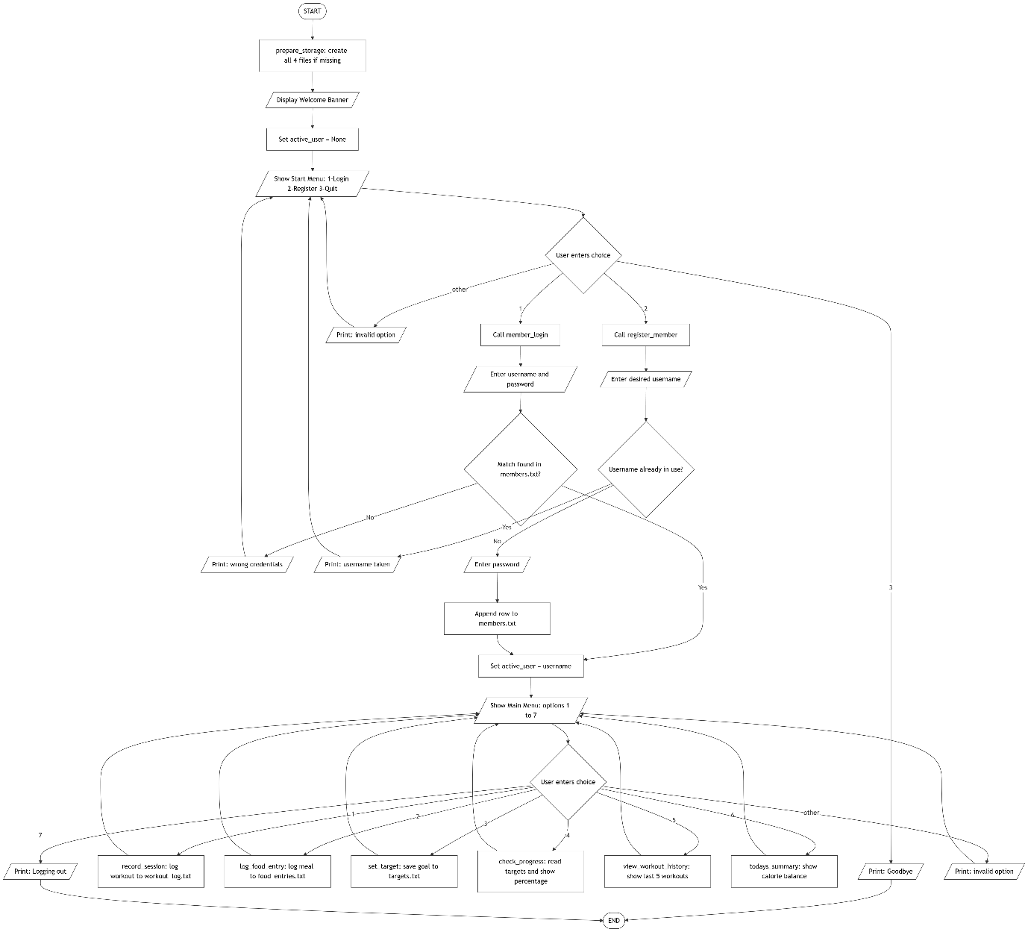

Figure: Complete Fitness Journal application flow

3. Implementation

3.1 Code Structure Overview
The program is structured into five logical groups of functions:
- File utilities ('make_file', 'start_files', 'read_table', 'write_row', 'write_full_file') - these functions handle creating files, reading data, adding rows, and rewriting files.
- Authentication ('create_account', 'login_account') - these functions handle new account creation and checking login details.
- Core features ('add_activity', 'add_food', 'set_goal', 'show_progress', 'show_history', 'show_summary') - each main feature of the fitness tracker is placed in its own function.
- Menu ('user_menu', 'main') - these functions control the main screen, menu options, and overall program flow.
- Helper ('get_number', 'goal_title') - these functions help with number validation and changing stored goal names into user-friendly text.

3.2 Key Code Excerpt - File Reader
The 'read_table()' function reads any of the text files and returns the data as a list of rows. Each row is stored as a list. The function skips the first line because that line is the header. This keeps the code simple and lets the same function read all four files.

def read_table(name_of_file):
rows = []
file = open(name_of_file,"r")
lines = file.readlines()
file.close()

i = 1
while i < len(lines):
line = lines[i].strip()
if line != "":
parts = line.split(",")
rows.append(parts)
i = i + 1

3.3 Key Code Excerpt - Calorie Burn Calculation
Inside 'show_summary()', the calorie burn is worked out using the workout level saved in the file. The code checks whether the level is 'Low', 'Medium', or 'High' and then multiplies the workout minutes by a fixed calorie value.

while i < len(activities):
row = activities[i]
if len(row) >= 4 and row[0] == username:
if len(row) >= 5:
minutes = int(row[3])
level = row[4]
else:
minutes = int(row[2])
level = row[3]
# count workout and add minutes ..
workout_count = workout_count + 1
total_minutes = total_minutes + minutes

# calories change by level ; low medium high
if level == "Low":
total_burned = total_burned + (minutes * 5)
elif level == "Medium":
total_burned = total_burned + (minutes * 8)
elif level == "High":
total_burned = total_burned + (minutes * 11)
else:
total_burned = total_burned + (minutes * 5)
i = i + 1

3.3 Whole code implementation
"""
This is the main code file for the fitness tracker program.
It includes functions for creating accounts, logging in, adding workout and food entries, setting goals,
showing progress, and more. The program uses text files to save user data and allows users to track their
fitness activities and goals over time.
"""
user_data_var = None

# this makes file if it is not there
def make_file(name_of_file,header):
try:
# try opening first .. if yes then file is already there
with open(name_of_file,"r"):
pass
except FileNotFoundError:
# if file not found ; make new one with heading
with open(name_of_file,"w") as file:
file.write(header + "\n")

# this starts all the text files
def start_files():
make_file("members.txt","user_name,password")
make_file("workout_log.txt","user_name,activity,minutes,level")
make_file("food_entries.txt","user_name,meal,calories,carbs,protein,fat")
make_file("targets.txt","user_name,goal_name,target,current")

# this reads all rows from file
def read_table(name_of_file):
with open(name_of_file,"r") as file:
lines = file.readlines()

# start from 1 because line 0 is header ..
i = 1
rows = []
while i < len(lines):
line = lines[i].strip()
if line != "":
# split comma values ; then keep in rows list
parts = line.split(",")
rows.append(parts)
i = i + 1
return rows

# this adds one row in file
def write_row(name_of_file,values):
line = ""
i = 0
while i < len(values):
# making one csv line slowly ..
if i == 0:
line = str(values[i])
else:
line = line + "," + str(values[i])
i = i + 1

# now save line at the end of file ;
with open(name_of_file,"a") as file:
file.write(line + "\n")

# this writes full file again
def write_full_file(name_of_file,header,rows):
with open(name_of_file,"w") as file:
file.write(header + "\n")

i = 0
while i < len(rows):
row = rows[i]
line = ""
j = 0
while j < len(row):
# this builds each row again .. value by value
if j == 0:
line = str(row[j])
else:
line = line + "," + str(row[j])
j = j + 1
file.write(line + "\n")
i = i + 1

# this gets number from user
def get_number(message):
while True:
raw = input(message)
try:
value = float(raw)
if value >= 0:
# send number back if it is okay ;
return value
else:
print("Please enter a value that is 0 or greater so it can be saved correctly.")
except ValueError:
print("That input was not read as a number. Please type the value again.")

def create_account():
"""
This function allows a new user to create an account for the fitness tracker.
"""
print("\nCreate a new account for the fitness tracker.")
user_name = input("Username: ")

# check all old users first ..
users_data = read_table("members.txt")
i = 0
while i < len(users_data):
if len(users_data[i]) >= 1 and users_data[i][0] == user_name:
print("That user_name is already being used,so please choose a different one.")
return None
i = i + 1

password = input("Password: ")
# save new user_name and password ;
write_row("members.txt",[user_name,password])
print("Your account has been created successfully and is ready to use...")
return user_name

# this checks login details
def login_account():
"""
This function allows an existing user to log in to their fitness tracker account by verifying their user_name and password.
"""
print("\nLogin to continue into your fitness tracker account.")
user_name = input("Username:")
password = input("Password:").strip()

# compare entered details with saved users ..
users = read_table("members.txt")
i = 0
while i < len(users):
row = users[i]
if len(row) >= 2:
if row[0] == user_name and row[1] == password:
print("Login successful. Your tracker menu will open now.")
return user_name
i = i + 1

print("The user_name or password did not match our records. Please try again carefully!!")
return None

# this adds workout data
def add_activity(user_name):
"""This function allows the user to add a workout or physical activity entry to their fitness tracker log,
including details such as activity name, duration, and intensity level.
"""
print("\nAdd a workout or physical activity entry.")
name = input("Activity name: ")

# keep asking if user leaves it blank ;
while name == "":
print("The activity name was left empty,so please type something before continuing.")
name = input("Activity name: ")

minutes = -1
while minutes <= 0:
# only positive whole minutes should be saved ..
raw = input("Minutes: ")
try:
minutes = int(raw)
if minutes <= 0:
print("Minutes need to be greater than 0 so the activity makes sense.")
except ValueError:
print("Please enter the minutes as a whole number,for example 20 or 45.")
minutes = -1

print("Choose the activity intensity level from the list below.")
print("a. Low intensity")
print("b. Medium intensity")
print("c. High intensity")

level = ""
while level == "":
# convert menu letter into text level ;
choice = input("Option: ")
if choice == "a":
level = "Low"
elif choice == "b":
level = "Medium"
elif choice == "c":
level = "High"
else:
print("Please choose a valid option by entering a,b,or c.")

write_row("workout_log.txt",[user_name,name,minutes,level])
print("The activity entry has been saved to your workout log.")

# this adds food data
def add_food(user_name):
"""This function allows the user to add a food or meal entry to their fitness tracker log,
including details such as meal name, calories, carbohydrates, protein, and fat content.
"""
print("\nAdd a food or meal entry.")
meal = input("Meal name: ")
if meal == "":
# simple default name .. if user types nothing
meal = "Meal"

# get all food numbers one by one ;
calories = get_number("Calories: ")
carbs = get_number("Carbs: ")
protein = get_number("Protein: ")
fat = get_number("Fat: ")

write_row("food_entries.txt",[user_name,meal,calories,carbs,protein,fat])
print("The food entry has been saved successfully in your daily log.")

# this is for setting goal
def set_goal(user_name):
"""
This function allows the user to set or update a fitness goal in their account, such as a weight loss target,
walking streak goal, or gym visits goal.
"""
print("\nSet or update one of your fitness goals.\na. Weight loss goal\nb. Walking streak goal\nc. Gym visits goal")

choice = input("Choose option: ")

# turn menu choice into goal name ..
if choice == "a":
goal_name = "weight_loss"
elif choice == "b":
goal_name = "walking_streak"
elif choice == "c":
goal_name = "gym_visits"
else:
print("That option is not part of the goal menu. Please choose one of the listed letters.")
return

target = 0
while target <= 0:
raw = input("Target value: ")
try:
target = float(raw)
if target <= 0:
print("The target value must be greater than 0 to be useful.")
except ValueError:
print("That target was not a valid number. Please type it again.")
target = 0

goals = read_table("targets.txt")
found = False
i = 0
while i < len(goals):
# if same user goal is there ; update it
row = goals[i]
if len(row) >= 4:
if row[0] == user_name and row[1] == goal_name:
row[2] = str(target)
row[3] = "0"
found = True
break
i = i + 1

if found:
write_full_file("targets.txt","user_name,goal_name,target,current",goals)
print("Your existing goal was found and updated with the new target value.")
else:
write_row("targets.txt",[user_name,goal_name,target,0])
print("A new goal has been added to your goals file.")

# this shows better goal name
def goal_title(goal_name):
"""
This function takes a goal name code and returns a more user-friendly title for display purposes.
"""
if goal_name == "weight_loss":
return "Weight Loss"
elif goal_name == "walking_streak":
return "Walking Streak"
elif goal_name == "gym_visits":
return "Gym Visits"
else:
return goal_name

# this shows user progress
def show_progress(user_name):
"""
This function calculates and displays the user's current progress towards their fitness goals,
including the percentage of completion and a visual progress bar, based on their logged activities and food entries.
"""
print("\nHere is the current progress for the goals saved under your account.")
goals = read_table("targets.txt")
activities = read_table("workout_log.txt")

my_goals = []
i = 0
while i < len(goals):
# keep only this user goals ..
if len(goals[i]) >= 4 and goals[i][0] == user_name:
my_goals.append(goals[i])
i = i + 1

if len(my_goals) == 0:
print("No goals were found for this account,so there is no progress to show yet...")
return

session_count = 0
walking_count = 0.0
i = 0
while i < len(activities):
row = activities[i]
if len(row) >= 4 and row[0] == user_name:
# count visits and track walking entries
session_count = session_count + 1
if len(row) >= 5:
activity_name = row[2].lower()
else:
activity_name = row[1].lower()
if "walk" in activity_name:
walking_count = walking_count + 1
i = i + 1

i = 0
while i < len(my_goals):
row = my_goals[i]
goal_name = row[1]
target = float(row[2])

if goal_name == "walking_streak":
current = walking_count
elif goal_name == "gym_visits":
current = float(session_count)
else:
current = float(row[3])

percent = 0.0
if target > 0:
# make progress into percent .. max 100
percent = (current / target) * 100
if percent > 100:
percent = 100.0

print("\nGoal name: " + goal_title(goal_name))
print("Target value set: " + str(target))
print("Current progress value: " + str(round(current,2)))
print("Overall completion: " + str(round(percent,1)) + "%")

stars = ""
count = int(percent / 20)
j = 0
# this makes a small progress bar with stars ;
while j < count:
stars = stars + "*"
j = j + 1
while j < 5:
stars = stars + "-"
j = j + 1
print("[" + stars + "]")

i = i + 1

# this shows workout history
def show_history(user_name):
"""
This function retrieves and displays the user's recent workout history from their fitness tracker log,
showing details such as activity name, duration, and intensity level for the last five entries.
"""
print("\nShowing the recent workout history saved for your account.")
activities = read_table("workout_log.txt")
my_rows = []

i = 0
while i < len(activities):
# take only rows for this user ..
row = activities[i]
if len(row) >= 4 and row[0] == user_name:
my_rows.append(row)
i = i + 1

if len(my_rows) == 0:
print("There is no workout history saved yet for this user.")
return

start = 0
if len(my_rows) > 5:
# only last 5 records ; if more are there
start = len(my_rows) - 5

number = 1
i = start
while i < len(my_rows):
row = my_rows[i]
if len(row) >= 5:
activity_name = row[2]
minutes = row[3]
level = row[4]
else:
activity_name = row[1]
minutes = row[2]
level = row[3]
print(str(number) + ". " + activity_name + " | " + minutes + " mins | " + level)
number = number + 1
i = i + 1

# this shows summary
def show_summary(user_name):
"""
This function provides a summary of the user's fitness activities and food details, including total workouts logged,
total active minutes, estimated calories burned, total calories eaten, and net calorie balance.
"""
print("\nHere is a summary of your activity and food details.")
activities = read_table("workout_log.txt")
foods = read_table("food_entries.txt")

total_minutes = 0
total_burned = 0
workout_count = 0

i = 0
while i < len(activities):
row = activities[i]
if len(row) >= 4 and row[0] == user_name:
if len(row) >= 5:
minutes = int(row[3])
level = row[4]
else:
minutes = int(row[2])
level = row[3]
# count workout and add minutes ..
workout_count = workout_count + 1
total_minutes = total_minutes + minutes

# calories change by level ; low medium high
if level == "Low":
total_burned = total_burned + (minutes * 5)
elif level == "Medium":
total_burned = total_burned + (minutes * 8)
elif level == "High":
total_burned = total_burned + (minutes * 11)
else:
total_burned = total_burned + (minutes * 5)
i = i + 1

total_food = 0.0
i = 0
while i < len(foods):
row = foods[i]
if len(row) >= 6 and row[0] == user_name:
if len(row) >= 7:
calories = float(row[3])
else:
calories = float(row[2])
# add saved food calories ..
total_food = total_food + calories
i = i + 1

# net means eaten minus burned ;
net = total_food - total_burned

print("Total workouts logged: " + str(workout_count))
print("Total active minutes: " + str(total_minutes))
print("Estimated calories burned: " + str(total_burned))
print("Total calories eaten: " + str(total_food))
print("Net calorie balance: " + str(round(net,1)))

# this shows main menu
def user_menu(user_name):
"""
This function displays the main menu for the logged-in user, allowing them to manage their fitness activities and goals,
and handles the user's menu choices to perform various actions such as adding entries, showing progress, and logging out.
"""
while True:
print("\nFitness Tracker Main Menu")
print("You are currently logged in as: " + user_name)
print("a. Add a workout activity entry")
print("b. Add a food entry")
print("c. Set or update a goal")
print("d. Show progress for goals")
print("e. Show recent workout history")
print("f. Show summary")
print("g. Logout from this account")

choice = input("Enter option: ")

# run function based on menu letter ..
if choice == "a":
add_activity(user_name)
elif choice == "b":
add_food(user_name)
elif choice == "c":
set_goal(user_name)
elif choice == "d":
show_progress(user_name)
elif choice == "e":
show_history(user_name)
elif choice == "f":
show_summary(user_name)
elif choice == "g":
print("You have been logged out and returned from the main menu...")
break
else:
print("That menu option was not valid. Please enter a letter from the menu.")

"""
This is the main program execution block for the fitness tracker application.
It initializes necessary files, welcomes the user, and manages the initial login or
registration process before directing the user to the main menu.
"""
# first make sure files are ready ;
start_files()

print("Welcome to the Fitness Tracker program. Please login or register to continue.")

while user_data_var is None:
print("\na. Login to an existing account")
print("b. Register a new account")
print("c. Exit the program")

choice = input("Enter option: ")

# stay here until user logs in .. or exits
if choice == "a":
user_data_var = login_account()
elif choice == "b":
user_data_var = create_account()
elif choice == "c":
print("The program has been closed. Goodbye.")
exit()
else:
print("That was not a valid starting option. Please choose a,b,or c.")

user_menu(user_data_var)

4. Testing
The testing process was performed manually by running code.py through the command line and entering the required inputs in the terminal interface. Following each test case, the corresponding text file was inspected using a text editor to verify whether the data had been recorded correctly, or to confirm that no data was saved when the test case expected input rejection.
The table below follows the standard test documentation format. Each test has a unique ID, identifies the function under test, describes the input that was provided, states what result was expected, and records what actually happened.

Table 1 Test Cases
Item to Test | Test Description (with example data) | Expected Result | Actual Result | Comments/Actions
create_account() | New account: username = jamie01 / password = mypass | Account saved to members.txt; welcome message printed | Pass – members.txt updated correctly | No changes needed
create_account() | Duplicate username: jamie01 (already exists) | Error: username taken; return None | Pass – rejected with appropriate message | No changes needed
login_account () | Correct: jamie01 / mypass | Login successful; active_user set | Pass – welcome message shown | No changes needed
login_account () | Wrong password: jamie01 / wrongone | Error: wrong credentials; return None | Pass – login refused as expected | No changes needed
add_activity () | Exercise: swimming, duration: 45 mins, effort: Moderate | Row appended to workout_log.txt | Pass – file verified after test | No changes needed
add_activity () | Duration: 'abc' (not a number) | Re-prompt: please type a whole number | Pass – ValueError caught; re-prompt shown | No changes needed
add_activity () | Duration: 0 and then 400 (out of range) | Re-prompt: must be 1–300 | Pass – both rejected, valid value accepted | Adjusted range check to include both ends
add_activity () | Effort level: 5 (invalid) | Re-prompt: please enter 1, 2, or 3 | Pass – while loop catches it | No changes needed
add_activity () | Multiple: 'running, yoga' comma-separated | Two rows saved separately | Pass – both rows appear in file | No changes needed
add_food () | Meal: Lunch, 650 kcal, 70g carbs, 35g protein, 20g fat | Row saved to food_entries.txt | Pass – row confirmed in file | No changes needed
add_food () | Calories: -200 (negative) | Re-prompt: value cannot be negative | Pass – condition >= 0 blocks it | No changes needed
add_food() | Protein: 'chicken' (text input) | Re-prompt: please enter a number | Pass – ValueError caught | No changes needed
set_goal() | Type 1 (daily_calories), target: 2000 | Row saved to targets.txt | Pass – file updated correctly | No changes needed
set_goal () | Type 3 (weight_loss_kg) entered twice | Second entry updates existing row (no duplicate) | Pass – overwrite_file called; one row per type | No changes needed
show_progress () | 2 sessions logged; weekly_sessions target = 5 | Current = 2, 40%, 2 stars shown | Pass – calculation verified | No changes needed
show_progress () | User with no targets set | Message: no targets set yet | Pass – empty check works | No changes needed
show_history () | 6 sessions logged; function called | Last 5 displayed, oldest of the 6 excluded | Pass – slice logic correct | No changes needed
show_history () | 30 min Moderate workout + 1800 kcal food today | Burned 270 kcal (30x9), net = 1530 shown | Pass – calculation matches expected | No changes needed
Persistence test | Log out then log back in | All data from previous session still visible | Pass – files retain all records | No changes needed

4.1 Issues Found and Changes Made After Testing
Test 7 revealed that the original duration check used only mins_val >= 1, which meant 400 was accepted. An upper boundary of 300 minutes was added to reflect a realistic maximum single-session duration.
An early version of set_goal() appended a new row every time the user set a goal, even if they had already set the same type before. This was found during exploratory testing (not listed above). The function was updated to search for an existing row with the same target_type and overwrite it instead of duplicating.
The star rating in show_progress() originally showed 0 stars until exactly 20% was reached. Testing showed this felt wrong when progress was at 15%. The calculation was adjusted so 1-19% shows 0 stars, 20-39% shows 1 star, and so on using integer division of percentage by 20.

4.2 Run Snapshots
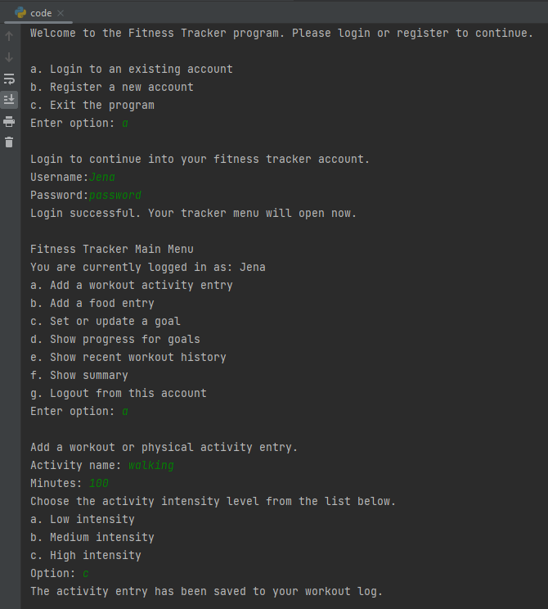
Figure 1 Login and Add Activity
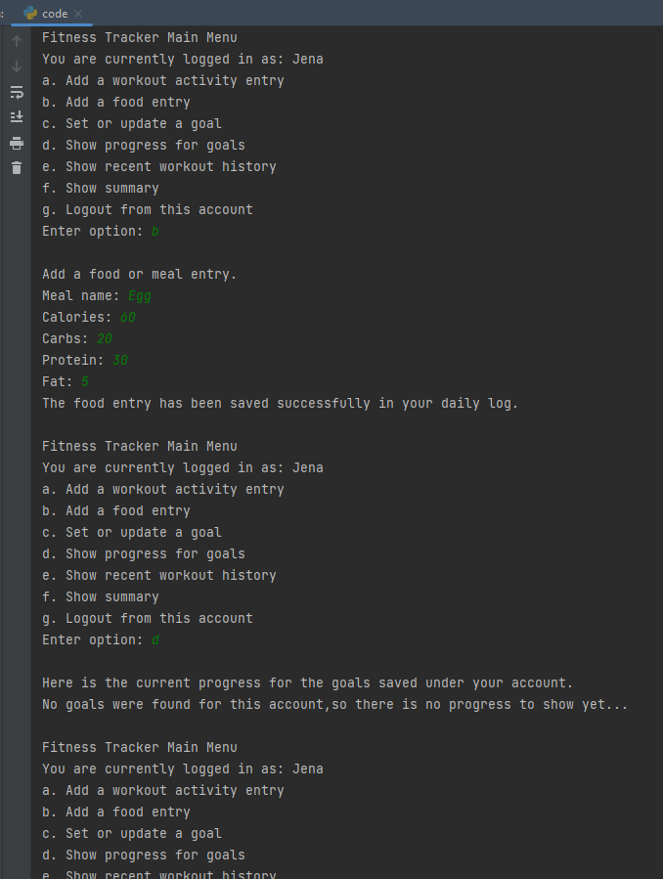
Figure 2 Add Nutrition
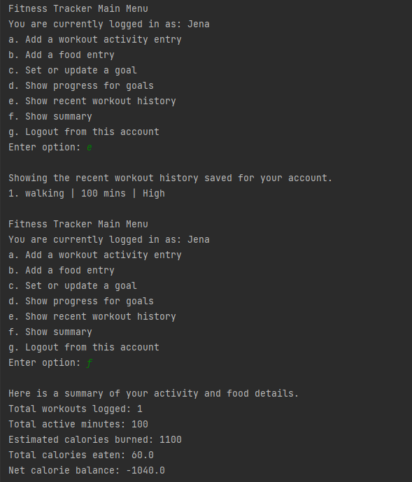
Figure 3 Show History and Sumary
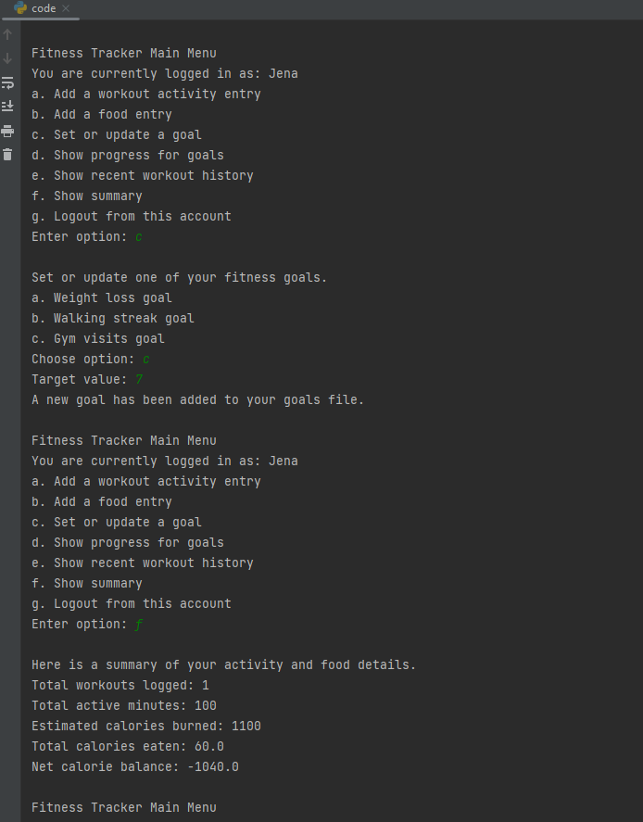
Figure 4 Set Goal and Show Progress
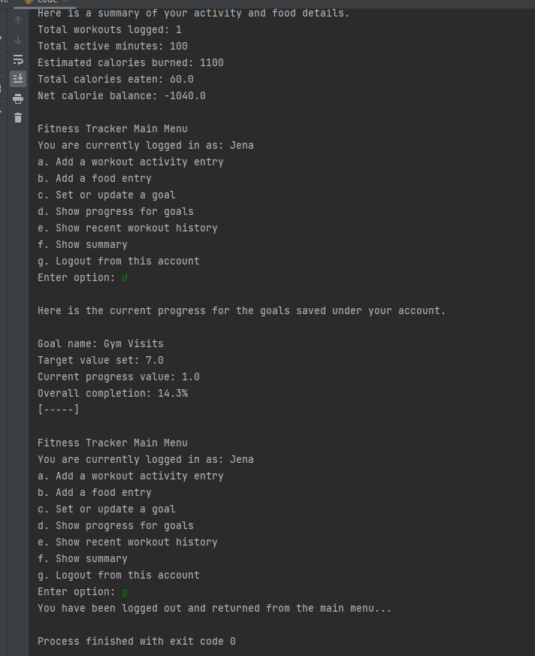
Figure 5 Logout

5. Evaluation
This evaluation reviews how well the completed application meets each of the nine success criteria set out. Evidence is taken directly from the test results.

Table 2 Evaluations
Success Criterion | Met? | Evidence / Comment
Register and sign in with username and password | Yes | login_account() and create_account() both work; T01–T04 all pass.
Log physical activity with type, duration and effort level | Yes | add_activity() collects and saves all three fields with validation; T05–T09 pass.
Support logging multiple exercises in one session | Yes | Comma-separated input processed in a while loop; each saved individually (T09).
Log daily meal entries with calorie and macro data | Yes | add_food() saves meal name, kcal, carbs, protein, fat; T10–T12 pass.
Set a fitness target and view percentage progress | Yes | Three target types supported; star rating and percentage displayed; T13–T16 pass.
View recent workout history (last 5 sessions) | Yes | show_progress() slices the list and displays up to 5 recent rows; T17 passes.
Daily summary showing calorie balance | Yes | show_history() shows burned vs eaten and net balance; T18 pass.
Data saved and reloaded between sessions | Yes | All four text files persist across sessions; confirmed in T19.
Invalid inputs handled without crashing | Yes | All numeric inputs protected by try/except; all menus use while loops; T06–T08, T11–T12 all pass.

5.1 Strengths
- Every success criterion has been met and is backed up by a passing test case.
- The generic read_table() function works with all four files without needing to know their column structure in advance, which keeps the file-reading code DRY (Do not Repeat Yourself).
- A key strength of the program is the use of the with statement for file handling, which automatically manages opening and closing files and reduces the risk of resource leaks. This improves code reliability and readability while demonstrating good programming practice in Python when working with persistent data (“with statement in Python,”)
- The workout history feature adds practical value over the minimum requirements, giving the user a quick way to review what they have done recently without having to open the raw text file.
- Input validation is thorough: every numeric field is protected by try/except inside a while loop(Python While Loops), and every menu selection is checked against all valid options before proceeding.

5.2 Limitations and Possible Future Improvements
- Passwords are stored in plain text. A basic improvement would be to hash them with Python's built-in hashlib before writing to the file (Sweigart, 2019).
- The weekly_sessions target counts all sessions ever logged, not just those in the current calendar week. A rolling seven-day window would be more meaningful.
- Only three target types are available. Future versions could include daily step count, water intake, or sleep duration (NHS, 2024).
- The calorie burn estimate does not take the user's body weight into account. A more accurate model would multiply MET value by weight in kg and duration in hours (Be et al., no date)
- A graphical interface using a module like tkinter or a simple web framework would make the application much more accessible to non-technical users.

6. References
- NHS (2024) Physical activity guidelines for adults. Available at: https://www.nhs.uk/live-well/exercise/exercise-guidelines/physical-activity-guidelines-for-adults-aged-19-to-64/.

- Python Software Foundation (2025a) The Python Tutorial. Available at: https://docs.python.org/3/tutorial/.

- Sweigart, A. (2019) Automate the Boring Stuff with Python. 2nd edn. San Francisco: No Starch Press. Available at: https://automatetheboringstuff.com.

- with statement in Python [WWW Document]. GeeksforGeeks. URL https://www.geeksforgeeks.org/python/with-statement-in-python/

- Be, A. et al. (no date) “2011 Compendium of Physical Activities: a second update of codes and MET values,” PubMed [Preprint]. Available at: https://pubmed.ncbi.nlm.nih.gov/21681120/.
- Python While Loops (no date). Available at: https://www.w3schools.com/python/python_while_loops.asp.

