Git-scm/download

Create github account and then github Repository

In Git bash

Cd /c

Ls – for all files and directories

Clone my repository in git folder

Before cloning we have to

Config git a/c for github repository

1. git config –global user.name “dev23kmr”
2. git config –global user.email [dey23kmr@gmail.com](mailto:dey23kmr@gmail.com)

Now we can clone the repository in git a/c

git clone urlRepository

In order to upload the file we have to first add the file Git by using below command

git add filename.extension

Check status

git status

Before transfering the file to Github we have commit by using command

git commit -m “any message” filename.extension

For transferring the file we use command

git push -u origin master

Branches in Git

We will learn

Creating the branches

**git branch – to see all the branches**

**git branch newbranch – to create new branches**

**git checkout branchname – for switching to another branch**

Merger the branches

Deleting the branches

Why we need branches?

In order to preserve the source code from changes.

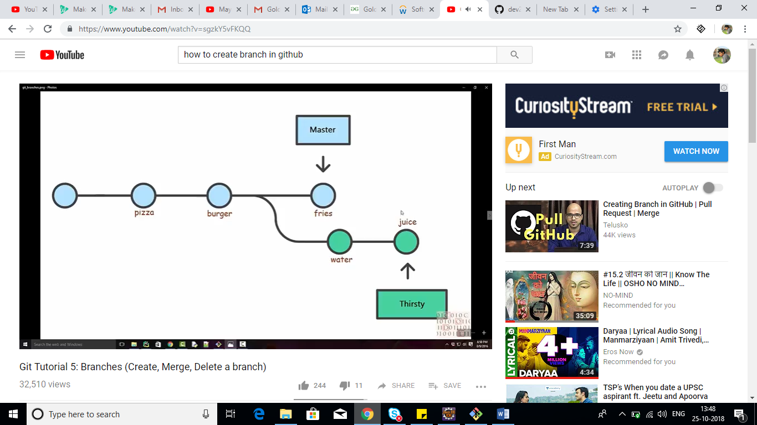

In order to merge first we have to go master branch

**git branch master**

Now, git merge myNew(branch name) – Its says to merge new branch into the active branch

For creating branch in GitHub

**git push --set-upstream origin myNew**

For checking out and creating branch simultaneously

**git checkout -b dummy**

Deleting a branch

**git branch -d dummy**