Redux has a single store which holds the application state. If you want to split your code on the basis of data handling logic, you should start splitting your reducers instead of stores in Redux.
We will discuss how we can split reducers and combine it with store later in this tutorial.
Redux components are as follows −
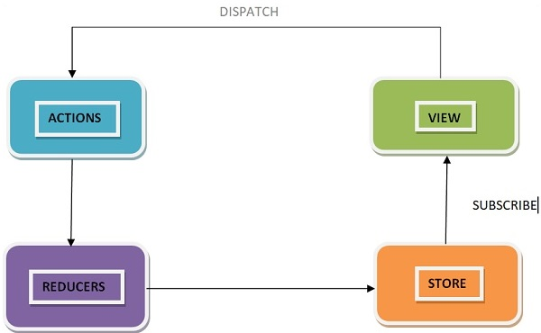

Redux follows the unidirectional data flow. It means that your application data will follow in one-way binding data flow. As the application grows & becomes complex, it is hard to reproduce issues and add new features if you have no control over the state of your application.
Redux reduces the complexity of the code, by enforcing the restriction on how and when state update can happen. This way, managing updated states is easy. We already know about the restrictions as the three principles of Redux. Following diagram will help you understand Redux data flow better −
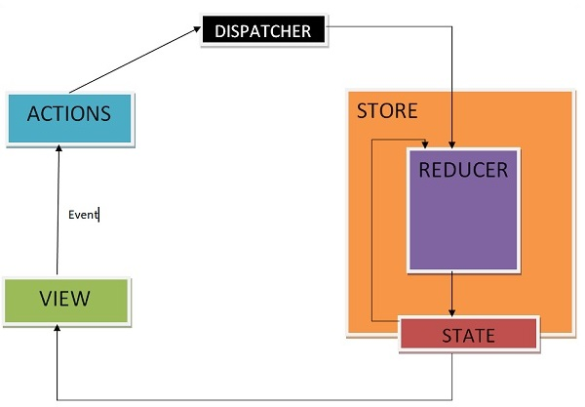
- An action is dispatched when a user interacts with the application.
- The root reducer function is called with the current state and the dispatched action. The root reducer may divide the task among smaller reducer functions, which ultimately returns a new state.
- The store notifies the view by executing their callback functions.
- The view can retrieve updated state and re-render again.
- A store is an immutable object tree in Redux. A store is a state container which holds the application’s state. Redux can have only a single store in your application. Whenever a store is created in Redux, you need to specify the reducer.
- Let us see how we can create a store using the createStore method from Redux. One need to import the createStore package from the Redux library that supports the store creation process as shown below −
- import { createStore } from 'redux';
- import reducer from './reducers/reducer'
- const store = createStore(reducer);
- A createStore function can have three arguments. The following is the syntax −
- createStore(reducer, [preloadedState], [enhancer])
- A reducer is a function that returns the next state of app. A preloadedState is an optional argument and is the initial state of your app. An enhancer is also an optional argument. It will help you enhance store with third-party capabilities.
- A store has three important methods as given below −
- getState
- It helps you retrieve the current state of your Redux store.
- The syntax for getState is as follows −
- store.getState()
- dispatch
- It allows you to dispatch an action to change a state in your application.
- The syntax for dispatch is as follows −
- store.dispatch({type:'ITEMS_REQUEST'})
- subscribe
- It helps you register a callback that Redux store will call when an action has been dispatched. As soon as the Redux state has been updated, the view will re-render automatically.
- The syntax for dispatch is as follows −
- store.subscribe(()=>{ console.log(store.getState());})
- Note that subscribe function returns a function for unsubscribing the listener. To unsubscribe the listener, we can use the below code −
- const unsubscribe = store.subscribe(()=>{console.log(store.getState());});
- unsubscribe();
- Actions are the only source of information for the store as per Redux official documentation. It carries a payload of information from your application to store.
- As discussed earlier, actions are plain JavaScript object that must have a type attribute to indicate the type of action performed. It tells us what had happened. Types should be defined as string constants in your application as given below −
- const ITEMS_REQUEST = 'ITEMS_REQUEST';
- Apart from this type attribute, the structure of an action object is totally up to the developer. It is recommended to keep your action object as light as possible and pass only the necessary information.
- To cause any change in the store, you need to dispatch an action first by using store.dispatch() function. The action object is as follows −
- { type: GET_ORDER_STATUS , payload: {orderId,userId } }
- { type: GET_WISHLIST_ITEMS, payload: userId }
- Actions Creators
- Action creators are the functions that encapsulate the process of creation of an action object. These functions simply return a plain Js object which is an action. It promotes writing clean code and helps to achieve reusability.
- Let us learn about action creator which lets you dispatch an action, ‘ITEMS_REQUEST’ that requests for the product items list data from the server. Meanwhile, the isLoading state is made true in the reducer in ‘ITEMS_REQUEST’ action type to indicate that items are loading, and data is still not received from the server.
- Initially, the isLoading state was false in the initialState object assuming nothing is loading. When data is received at browser, isLoading state will be returned as false in ‘ITEMS_REQUEST_SUCCESS’ action type in the corresponding reducer. This state can be used as a prop in react components to display loader/message on your page while the request for data is on. The action creator is as follows −
- const ITEMS_REQUEST = ‘ITEMS_REQUEST’ ;
- const ITEMS_REQUEST_SUCCESS = ‘ITEMS_REQUEST_SUCCESS’ ;
- export function itemsRequest(bool,startIndex,endIndex) {
- let payload = {
- isLoading: bool,
- startIndex,
- endIndex
- }
- return {
- type: ITEMS_REQUEST,
- payload
- }
- }
- export function itemsRequestSuccess(bool) {
- return {
- type: ITEMS_REQUEST_SUCCESS,
- isLoading: bool,
- }
- }
- To invoke a dispatch function, you need to pass action as an argument to dispatch function.
- dispatch(itemsRequest(true,1, 20));
- dispatch(itemsRequestSuccess(false));
- You can dispatch an action by directly using store.dispatch(). However, it is more likely that you access it with react-Redux helper method called connect(). You can also use bindActionCreators() method to bind many action creators with dispatch function

