
Assignment 6 : Crime Hotspot Prediction in
Washington, DC
Final Project Report
Date: 02-11-2026
Group -1
Lavanya Suresh
Sushmitha Urs A S
Abhishek Singh
Dev Panchal
Professor – Kasun Samarasinghe

1. Introduction and Business Context
Urban crime prevention has shifted from reactive policing to proactive, data-driven strategies. Law enforcement agencies now use predictive analytics to allocate limited resources more effectively. This project builds a machine learning model to predict crime hotspots in Washington, D.C., answering the question: Which ward-time combinations are most likely to experience elevated crime activity? The results can help police departments optimize patrol schedules, guide city administrators in public safety investments, and help community organizations target intervention programs.

Traditional descriptive analysis like counting crimes by ward or plotting trends over time gives useful summaries but cannot make forward-looking predictions. Predictive modeling learns patterns from historical data and applies them to future time periods. This project uses tree-based boosting algorithms to capture the complex interactions between spatial and temporal features that drive crime concentration.

The analysis is built around three research questions: (1) How do crime hotspots vary by time of day, day of the week, and month? (2) Are crime hotspots disproportionately concentrated in specific wards? (3) Which spatiotemporal characteristics are most strongly associated with hotspot classification? These questions guide both the exploratory analysis and the model interpretation stages of the project.

2. Data Description and Data Dictionary

2.1 Data Source
The dataset used in this project is the Crime Incidents in 2025 dataset, obtained from the DC Open Data portal. It contains all reported crime incidents in Washington, D.C. for the calendar year 2025. The data is maintained by the Metropolitan Police Department (MPD) and updated regularly.

2.2 Dataset Overview
The raw dataset contains 24,148 records and 25 columns. Each row represents a single reported crime incident. The features include geographic coordinates (latitude, longitude), temporal information (report date, start date, end date), categorical identifiers (offense type, method, shift, ward, district, PSA, ANC, neighborhood cluster), and additional geographic codes (block group, census tract, voting precinct, BID).

2.3 Data Dictionary
Feature | Description | Type
CCN | Crime case number (unique ID) | Integer
REPORT_DAT | Date the crime was reported | Datetime
START_DATE | Start date/time of incident | Datetime
END_DATE | End date/time of incident | Datetime
OFFENSE | Type of offense (e.g., THEFT, ROBBERY) | Categorical
METHOD | Method of offense (GUN, KNIFE, OTHERS) | Categorical
SHIFT | Police shift (DAY, EVENING, MIDNIGHT) | Categorical
WARD | Ward number (1 through 8) | Categorical
DISTRICT | Police district number | Numeric
PSA | Police Service Area | Numeric
ANC | Advisory Neighborhood Commission | Categorical
NEIGHBORHOOD_CLUSTER | Neighborhood cluster identifier | Categorical
BLOCK | Block address of incident | Categorical
BLOCK_GROUP | Census block group | Categorical
CENSUS_TRACT | Census tract number | Numeric
VOTING_PRECINCT | Voting precinct identifier | Categorical
BID | Business Improvement District | Categorical
LATITUDE | Latitude coordinate | Numeric
LONGITUDE | Longitude coordinate | Numeric
X / Y | Projected coordinates (state plane) | Numeric
XBLOCK / YBLOCK | Block-level projected coordinates | Numeric
OBJECTID | System object identifier | Integer
OCTO_RECORD_ID | OCTO record identifier (100% missing) | Integer

3. Data Preparation and Cleaning

3.1 Missing Data Strategy
The dataset was first inspected for missing values. The OCTO_RECORD_ID column was 100% missing (all 24,148 values null), so it was dropped entirely. BID was missing in approximately 19,342 records and was filled with "Unknown" since it is a categorical variable. Numeric columns DISTRICT, PSA, and CENSUS_TRACT had 32, 32, and 6 missing values respectively, which were filled with 0. BLOCK_GROUP had 6 missing values filled with "Unknown". END_DATE had 1,691 missing values, which were retained as NaT since this field was not used in modeling. Additionally, binary missing-indicator flags were created for columns with missing data to preserve the information signal.

3.2 Duplicate Handling
A check for duplicate rows revealed 0 fully duplicate rows and 3 duplicate CCN (Crime Case Number) values. Since CCN is the unique identifier for each incident, duplicate CCNs were removed using the drop_duplicates function, keeping the first occurrence. This ensured each crime incident appeared exactly once in the dataset.

3.3 Date Parsing
The three date columns (REPORT_DAT, START_DATE, END_DATE) were parsed into proper datetime objects with UTC timezone awareness using pd.to_datetime(). This step was essential for extracting temporal features like hour, day of week, and month for the modeling pipeline.

3.4 Outlier and Sanity Checks
Two sanity checks were performed. First, coordinate validity was checked by filtering rows where latitude was outside the range 37–40 or longitude was outside -79 to -75 (approximate bounds for Washington, D.C.). This check found 0 suspicious coordinate rows, confirming all geographic data was valid. Second, temporal consistency was checked by identifying rows where END_DATE was earlier than START_DATE. One such row was found and corrected by setting the invalid END_DATE to NaT.

4. Exploratory Data Analysis
The EDA phase explored crime patterns from three perspectives aligned with our research questions. Initial EDA was conducted on the raw 2025 incident data, followed by deeper analysis on the aggregated hotspot dataset.

4.1 RQ1: Temporal Patterns
The first research question examines how crime hotspots vary by time of day, day of the week, and month. Four temporal dimensions were analyzed.
Incidents by Month (2025)
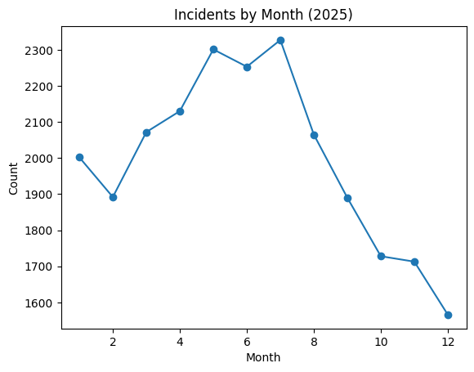
Figure: Monthly incident counts show seasonal variation in 2025.
Monthly crime counts reveal a clear seasonal pattern. Crime incidents tend to increase during warmer months and decrease during colder months. This pattern aligns with well-documented criminological theories about the relationship between temperature, outdoor activity, and crime opportunity.
Incidents by Hour of Day
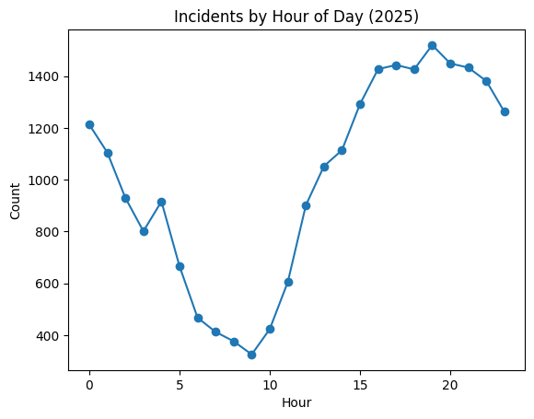
Figure: Hourly distribution of crime incidents in 2025.
The hourly distribution shows that crime activity peaks during afternoon and evening hours, with the highest concentration between 3 PM and 9 PM. Crime drops significantly during early morning hours (2 AM to 6 AM). This pattern reflects the routine activity theory, where crime opportunity increases during periods of high population movement and decreased natural surveillance.
Hotspot Rate by Temporal Dimensions
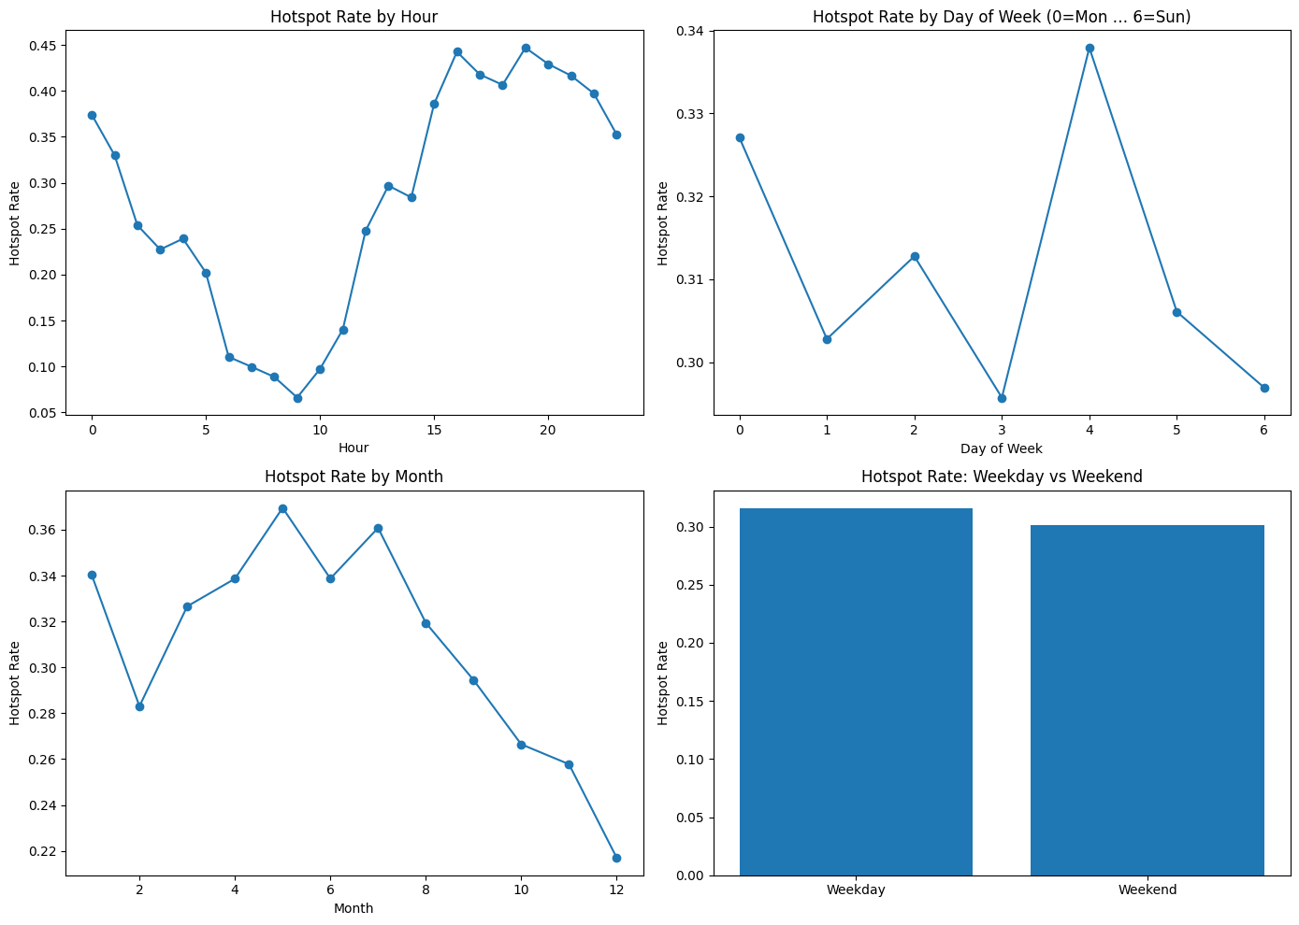
Figure: Hotspot rates by hour, day of week, month, and weekday vs. weekend.
When we examine hotspot rates (proportion of ward-time buckets classified as hotspots), the temporal patterns become clearer. Hotspot rates are highest during late afternoon and evening hours. Weekday and weekend hotspot rates show modest differences, with weekdays having a slightly higher overall rate. Monthly hotspot rates peak during summer months, consistent with the seasonal crime pattern observed in raw counts.

4.2 RQ2: Spatial Concentration
The second research question asks whether crime hotspots are disproportionately concentrated in specific wards.
Incidents by Ward
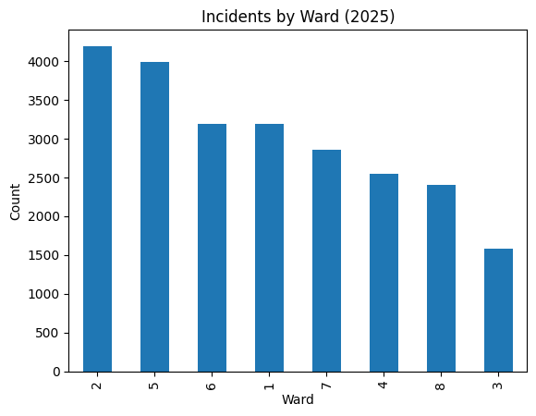
Figure: Total crime incidents by ward in 2025.
Ward-level analysis reveals significant spatial concentration. Certain wards, particularly Ward 2 and Ward 5, consistently record higher crime volumes than others. This concentration persists across time periods, suggesting structural factors such as population density, commercial activity, and socioeconomic conditions drive the spatial distribution of crime.
Hotspot Rate and Volume by Ward
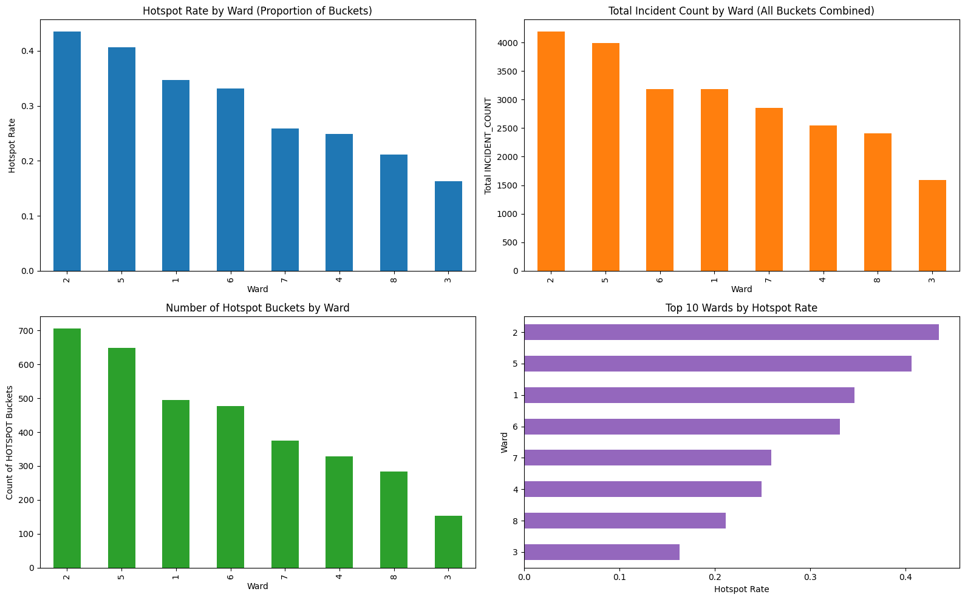
Figure: Hotspot rate, incident volume, and hotspot bucket counts by ward.
The spatial analysis confirms that hotspot classification is strongly driven by ward identity. Some wards have hotspot rates two to three times higher than others. The top wards by hotspot rate also tend to have the highest total incident counts, but the relationship is not perfectly linear. This indicates that while incident volume is a strong driver, the timing and concentration of incidents within specific hours also matter.

4.3 RQ3: Spatiotemporal Hotspot Signals
The third research question investigates which spatiotemporal characteristics are most strongly associated with hotspot classification.
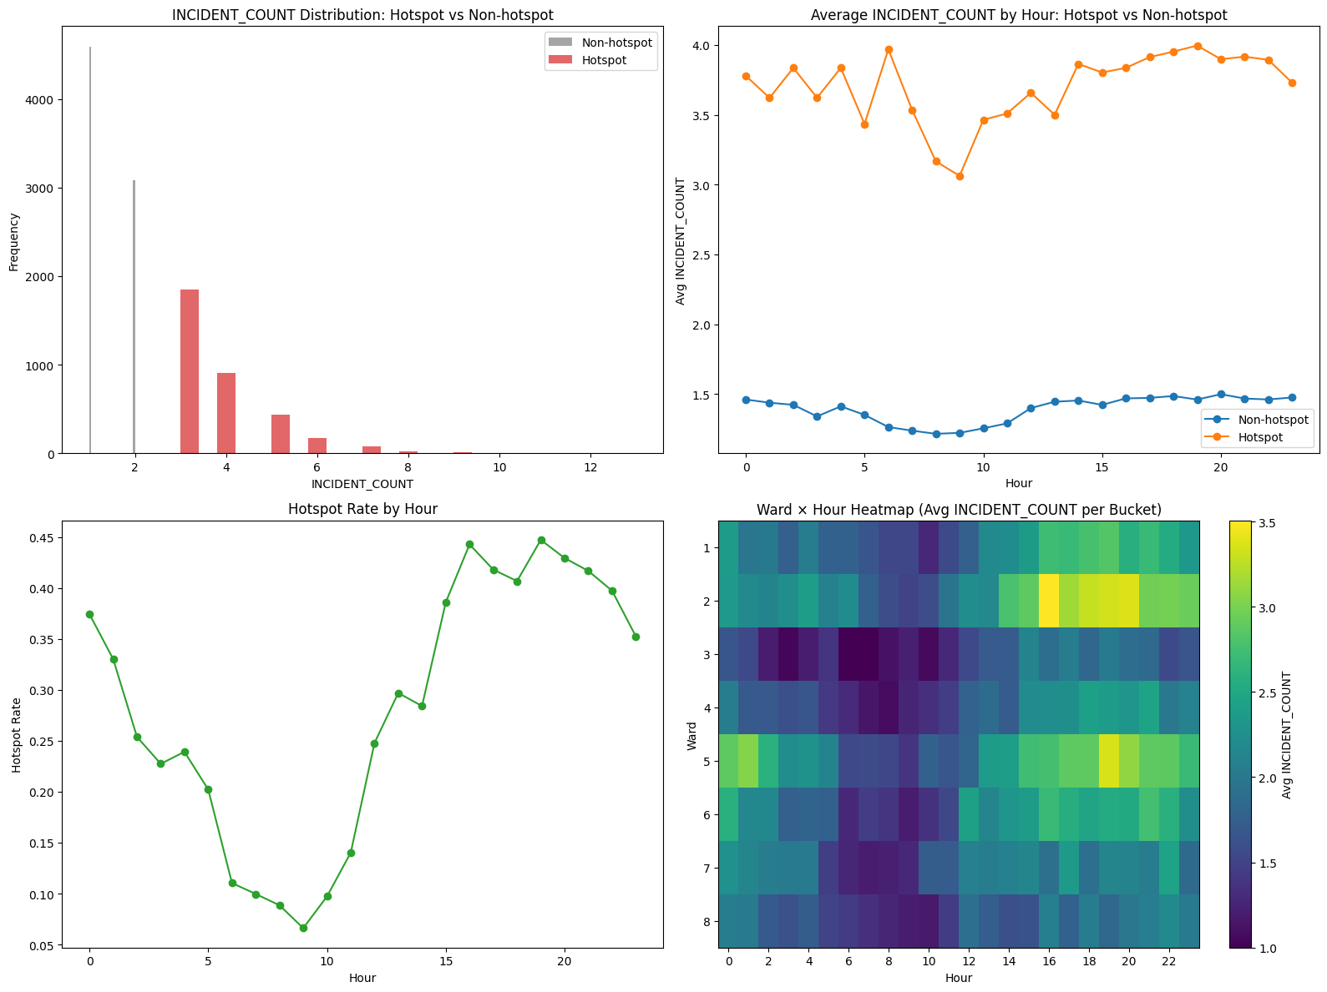
Figure: Spatiotemporal characteristics of hotspot vs. non-hotspot buckets.
Several key findings emerge from this analysis. First, the incident count distribution for hotspot buckets is clearly separated from non-hotspot buckets, which validates our top-quartile threshold approach. Second, hotspot buckets have significantly higher average incident counts at every hour of the day compared to non-hotspot buckets. Third, the Ward-by-Hour heatmap reveals distinct spatiotemporal clusters where certain wards experience elevated crime during specific hours. These clusters represent the primary targets for predictive modeling.
Top Offenses and Methods
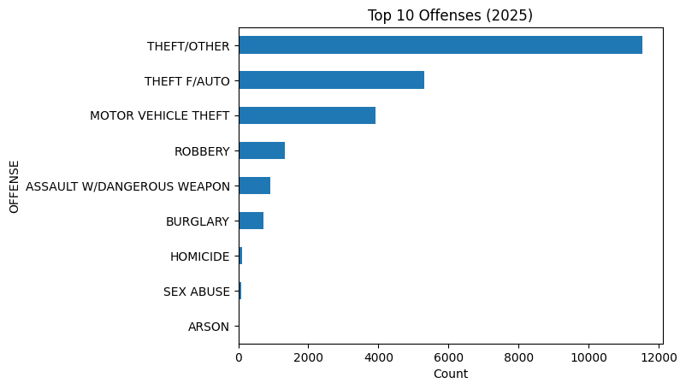
Figure: Top 10 offense types in 2025.
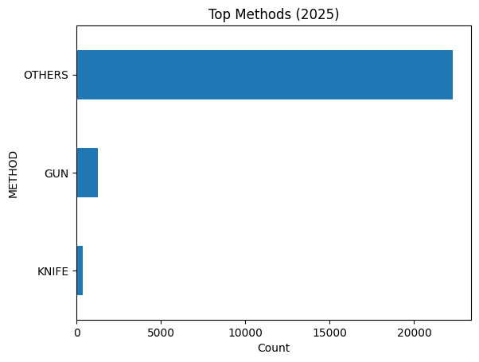
Figure: Crime methods and shift distribution.
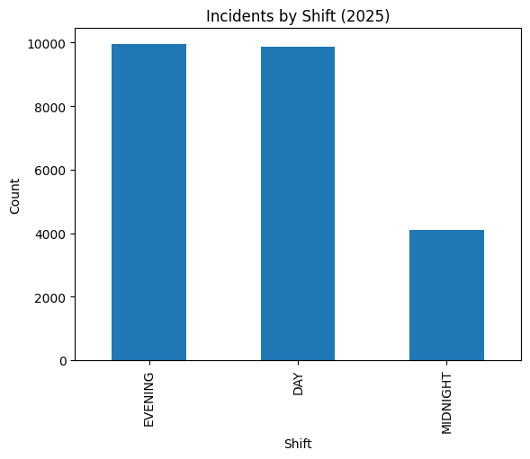
Figure: Incidents by police shift.
Theft is the most common offense type, followed by motor vehicle theft and assault. The majority of crimes are committed using non-weapon methods (classified as "Others"), while gun-related offenses represent a smaller but significant proportion. The evening shift records the highest number of incidents, consistent with the hourly peak pattern observed earlier.

5. Target Variable Definition (Hotspot)

5.1 Aggregation Logic
To convert the raw incident-level data into a supervised learning problem, we aggregated crimes into spatiotemporal buckets. Each bucket is defined by a unique combination of Ward, Month, Day of Week, Hour, and Weekend indicator. The incident count for each bucket was calculated as the number of crimes falling into that combination. This produced a model-ready dataset of 11,140 rows (buckets), where each row represents a specific location-time combination with its associated incident count.

5.2 Top-Quartile Threshold
The binary target variable HOTSPOT was created by labeling buckets with incident counts at or above the 75th percentile of the training data distribution as 1 (hotspot) and all others as 0 (non-hotspot). The 75th percentile threshold was calculated from the training data only (months 1 through 8) to prevent data leakage. The threshold value was 3.0, meaning any bucket with 3 or more incidents was classified as a hotspot.

5.3 Time-Based Split
The data was split chronologically to simulate real-world forecasting. Training data covered January through August 2025 (7,631 buckets), validation data covered September 2025 (910 buckets), and test data covered October through December 2025 (2,599 buckets). This temporal split ensures the model is evaluated on future data relative to the training period, which provides a realistic assessment of predictive performance.

5.4 Class Imbalance
The hotspot class represents approximately 33.5% of training buckets, 29.5% of validation buckets, and 24.7% of test buckets. The decreasing hotspot rate across splits reflects natural seasonal variation (crime tends to decrease in fall and winter). While the class imbalance is moderate, it is significant enough to affect model performance. To address this, we used threshold optimization on the validation set to find the probability cutoff that maximizes F1 score, rather than relying on the default 0.5 threshold.

6. Feature Engineering

6.1 Temporal Features
Several temporal features were extracted from the START_DATE field. HOUR captures the hour of day (0 to 23) and is the most granular temporal feature. DAY_OF_WEEK encodes the day as an integer (0 for Monday through 6 for Sunday). MONTH captures the calendar month (1 to 12). IS_WEEKEND is a binary indicator that equals 1 for Saturday and Sunday and 0 for weekdays. These features allow the model to learn cyclical crime patterns at multiple time scales.

6.2 Spatial Features
The primary spatial feature is WARD, which identifies the geographic ward (1 through 8) where the incident occurred. Ward-level granularity balances interpretability with sufficient data density per bucket. Finer spatial divisions (such as PSA or block group) would create sparse buckets with very few incidents, making classification unreliable.

6.3 Encoding Choices
All categorical features (WARD, MONTH, DAY_OF_WEEK, HOUR) were one-hot encoded using pd.get_dummies(). This produced 48 binary columns in the encoded feature matrix. Encoding was performed separately on training, validation, and test sets. The validation and test sets were then aligned to the training columns using reindex() with fill_value=0, ensuring no information leakage and consistent feature dimensions across splits.

6.4 Excluded Features
Features like OFFENSE, METHOD, SHIFT, geographic coordinates (LATITUDE, LONGITUDE, X, Y), and administrative identifiers (CCN, BLOCK, ANC, NEIGHBORHOOD_CLUSTER, CENSUS_TRACT, VOTING_PRECINCT, BID) were excluded because the aggregation groups incidents by Ward and Time only, and Ward already captures spatial variation. No feature scaling was applied since all models used are tree-based and insensitive to feature magnitude.

7. Modeling Methodology

7.1 Models Evaluated
A total of eight distinct models were evaluated across two phases. In 1st part, four baseline models were trained: Decision Tree (max depth 6), Random Forest (300 estimators), Gradient Boosting Machine (GBM, default parameters), and XGBoost (400 estimators, learning rate 0.05, max depth 4). In Assignment 3, four additional boosting models were introduced: HistGradientBoosting, LightGBM (600 estimators, learning rate 0.05), CatBoost (400 iterations, depth 6), and AdaBoost (200 estimators, learning rate 0.5, base tree depth 3). Hyperparameter tuning via grid search was then performed on GBM, XGBoost, AdaBoost, and CatBoost. Finally, the best AdaBoost model was calibrated using Platt scaling.

7.2 Why Tree-Based and Boosting Models
Tree-based ensemble methods were chosen for several reasons. First, they naturally handle the one-hot encoded categorical features without requiring normalization. Second, boosting algorithms iteratively focus on difficult-to-classify cases, which is valuable for detecting subtle hotspot boundaries. Third, tree-based models provide built-in feature importance measures that support interpretability. Fourth, ensemble methods are more robust to noise and overfitting than single decision trees.

7.3 Evaluation Metrics
Six evaluation metrics were used. Accuracy measures overall correctness but can be misleading with imbalanced classes. Precision measures the proportion of predicted hotspots that are true hotspots (false alarm control). Recall measures the proportion of actual hotspots that the model correctly identifies (coverage). F1 score is the harmonic mean of precision and recall, providing a balanced assessment. ROC-AUC measures the model’s ability to rank positive cases above negative cases across all thresholds. PR-AUC (Average Precision) measures performance specifically on the minority (hotspot) class and is more informative than ROC-AUC under class imbalance.

7.4 Threshold Selection Strategy
Rather than using the default 0.5 probability threshold, we implemented a custom threshold optimization function. The function evaluates 91 threshold values from 0.05 to 0.95 on the validation set and selects the threshold that maximizes F1 score. This approach is critical because the class imbalance means the default threshold often produces poor recall. By tuning the threshold on the validation set (not the test set), we avoid data leakage while still optimizing the precision-recall trade-off.

7.5 Gini vs. Entropy Comparison
A comparison of Decision Tree classifiers using Gini and Entropy impurity criteria was conducted. The Gini-based tree had a root impurity of 0.4457, while the Entropy-based tree had a root impurity of 0.9202.

Model | Accuracy | Precision | Recall | F1 | ROC-AUC | PR-AUC | Threshold
Decision Tree (Entropy) | 0.452866 | 0.292488 | 0.853810 | 0.435714 | 0.589561 | 0.288998 | 0.3
Decision Tree (Gini) | 0.359369 | 0.272889 | 0.954899 | 0.424473 | 0.617336 | 0.319185 | 0.2

The Entropy-based tree achieved a slightly higher F1 score (0.4357 vs. 0.4245) and better precision (0.2925 vs. 0.2729), while the Gini-based tree had higher recall (0.9549 vs. 0.8538) and better ROC-AUC (0.6174 vs. 0.5896). Overall, the differences are small, confirming that the choice of impurity criterion has minimal practical impact for this dataset. Since Gini is computationally simpler and performs comparably, the default Gini criterion was used across all tree-based ensemble models.

8. Models

8.1 Baseline Model Performance
The four baseline models from previous part, we trained and evaluated using optimized thresholds. All models used the same training, validation, and test splits.
Baseline Confusion Matrices
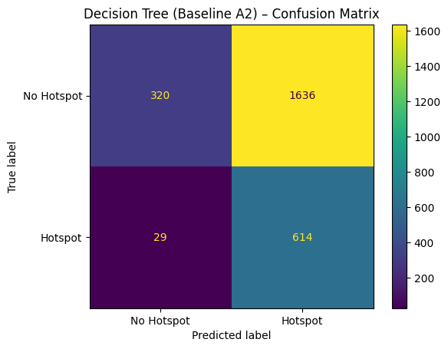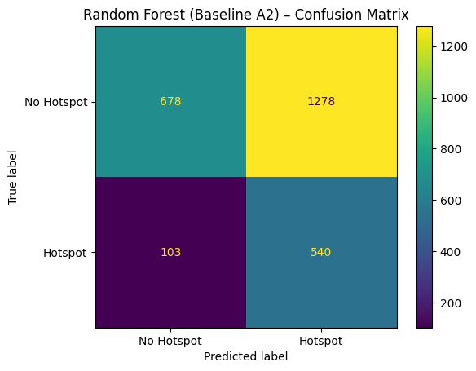

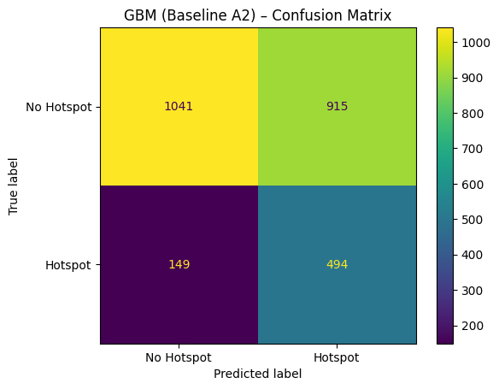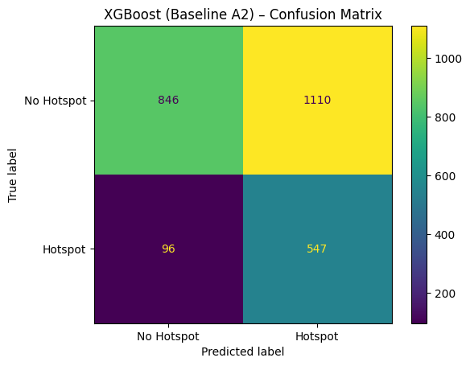

Model | Accuracy | Precision | Recall | F1 | ROC-AUC | PR-AUC | Threshold
Decision Tree | 0.3594 | 0.2729 | 0.9549 | 0.4245 | 0.6173 | 0.3192 | 0.20
Random Forest | 0.4687 | 0.2970 | 0.8398 | 0.4389 | 0.6460 | 0.3403 | 0.20
GBM | 0.5906 | 0.3506 | 0.7683 | 0.4815 | 0.7041 | 0.4036 | 0.33
XGBoost | 0.5360 | 0.3301 | 0.8507 | 0.4757 | 0.7017 | 0.3952 | 0.28
Table: Assignment 2 Baseline Model Results on Test Set
GBM achieved the highest F1 score (0.4815) among baseline models, with a good balance between precision (0.3506) and recall (0.7683). Decision Tree had the highest recall (0.9549) but the lowest precision (0.2729), indicating it over-predicted hotspots. XGBoost performed similarly to GBM with slightly lower F1. Random Forest fell between Decision Tree and the boosting methods.
ROC and Precision-Recall Curves
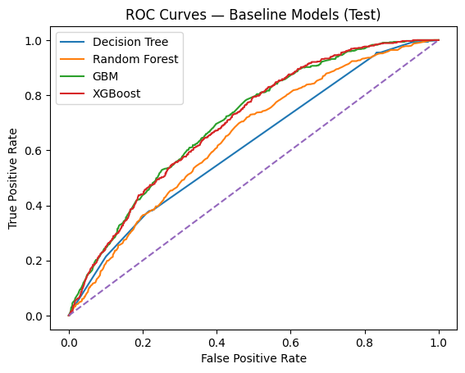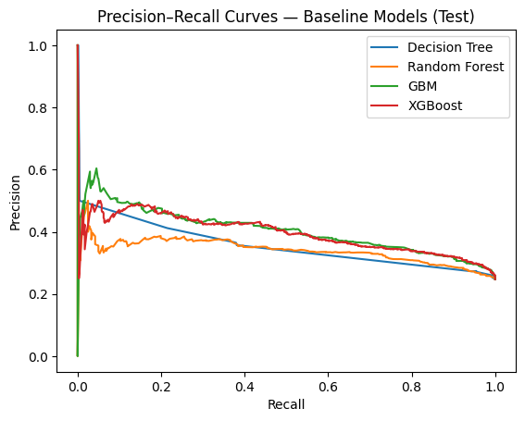
Based on the ROC and PR curves, GBM and XGBoost clearly outperformed Decision Tree and Random Forest, with their curves closest to the top-left corner in the ROC plot and maintaining higher precision across recall levels in the PR plot. Since these two models showed the strongest baseline discrimination ability (ROC-AUC of 0.7041 and 0.7017 respectively), they were selected for hyperparameter tuning to further improve their performance.
Hyperparameter Tuning: GBM and XGBoost

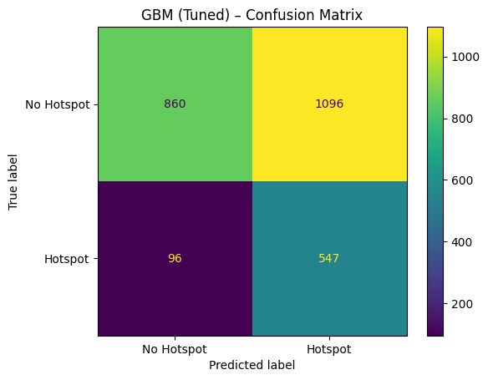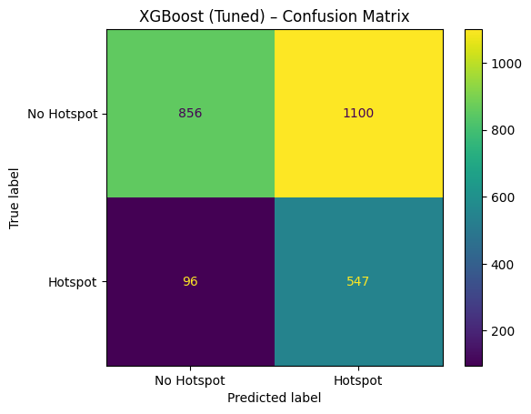
Both tuned models show identical hotspot detection — correctly identifying 547 out of 643 true hotspots (recall = 85.1%) while missing only 96. However, both also produce over 1,000 false positives, meaning they flag many non-hotspot buckets as hotspots. GBM (Tuned) has slightly fewer false positives (1,096 vs. 1,100), giving it a marginal edge in precision.

Model | Accuracy | Precision | Recall | F1 | ROC-AUC | PR-AUC | Threshold
GBM | 0.590612 | 0.350603 | 0.768274 | 0.481481 | 0.704119 | 0.403571 | 0.33
XGBoost | 0.535975 | 0.330115 | 0.850700 | 0.475652 | 0.701686 | 0.395216 | 0.28
GBM (Tuned) | 0.541362 | 0.332928 | 0.850700 | 0.478565 | 0.704085 | 0.400330 | 0.28
XGBoost (Tuned) | 0.539823 | 0.332119 | 0.850700 | 0.477729 | 0.703711 | 0.395542 | 0.28

The comparison table shows that tuning did not significantly improve performance over the baselines. GBM Baseline still leads with the highest F1 (0.4815) and best precision (0.3506). Both tuned models gained higher recall (0.8507) but at the cost of lower precision and accuracy, indicating that the lower thresholds (0.28) made them more aggressive in predicting hotspots. The ROC-AUC values remained nearly identical across all four configurations, suggesting the models reached their performance ceiling with the available features.

8.2 Advanced Boosting Models
In Assignment 3, four additional boosting models were trained with default or lightly configured parameters.
Assignment 3 Confusion Matrices
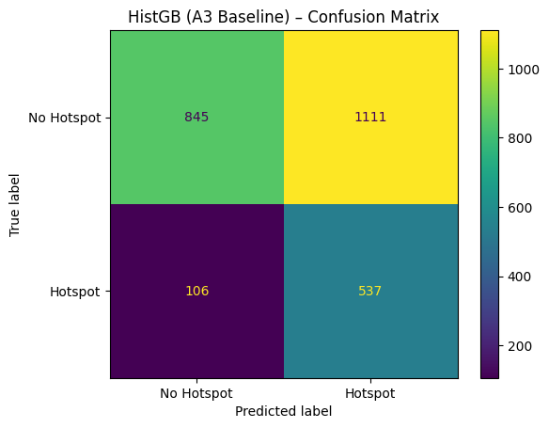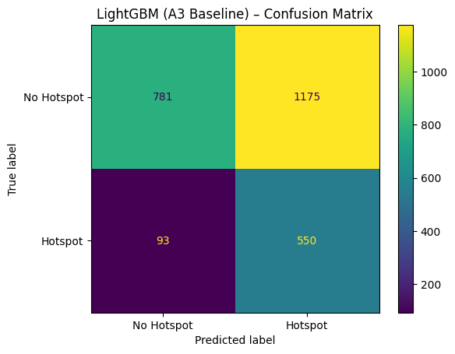
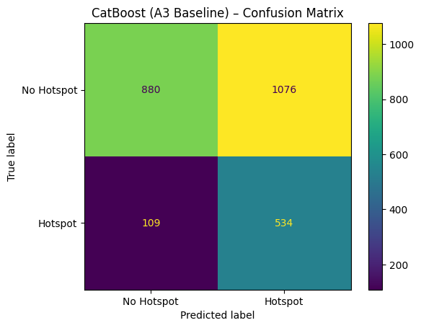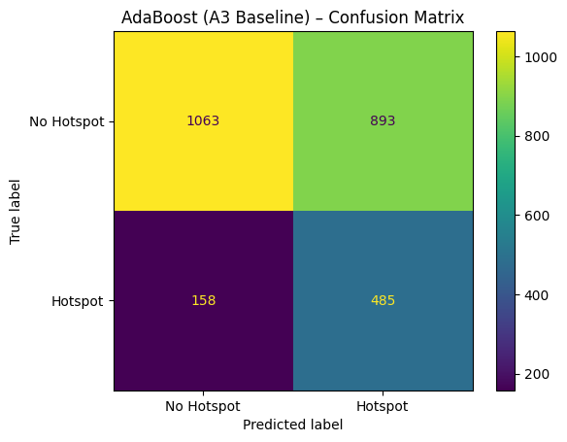

Model | Accuracy | Precision | Recall | F1 | ROC-AUC | PR-AUC | Threshold
HistGB | 0.5317 | 0.3259 | 0.8351 | 0.4689 | 0.6867 | 0.3867 | 0.27
LightGBM | 0.5121 | 0.3188 | 0.8554 | 0.4645 | 0.6765 | 0.3714 | 0.23
CatBoost | 0.5441 | 0.3317 | 0.8305 | 0.4740 | 0.6993 | 0.3904 | 0.29
AdaBoost | 0.5956 | 0.3520 | 0.7543 | 0.4800 | 0.7091 | 0.4083 | 0.44
Table: Assignment 3 Baseline Model Results on Test Set
Based on the A3 baseline results, AdaBoost and CatBoost were selected for hyperparameter tuning because they were the top two performers. AdaBoost led with the highest F1 (0.4800), best ROC-AUC (0.7091), and best PR-AUC (0.4083), showing the strongest overall balance between precision and recall. CatBoost followed closely with the second-best F1 (0.4740) and ROC-AUC (0.6993). HistGB and LightGBM were not tuned because they relied heavily on high recall with weaker precision, and their ROC-AUC and PR-AUC scores lagged behind the top two models.

Hyperparameter Tuning: CatBoost and AdaBoost
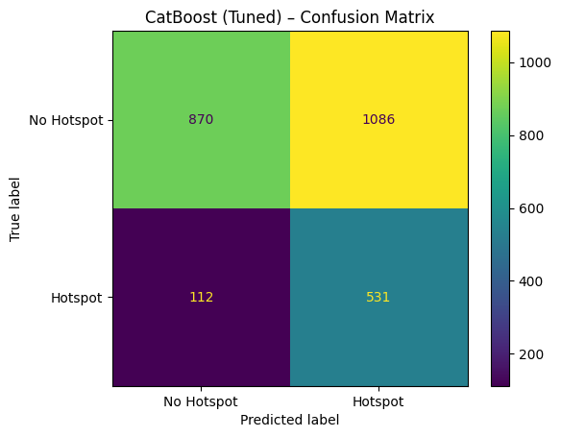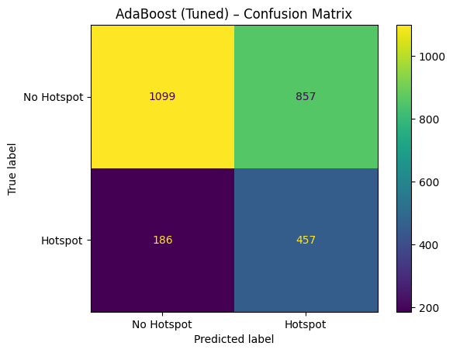
CatBoost (Tuned) maintained high recall, correctly identifying 531 out of 643 hotspots (82.6%) but produced 1,086 false positives, showing an aggressive prediction style similar to the GBM/XGBoost tuned models. AdaBoost (Tuned) took a more conservative approach with fewer false positives (857) and higher accuracy (0.5987), but missed more true hotspots (186 false negatives), resulting in a lower recall of 71.1%. This trade-off made AdaBoost a better candidate for probability calibration, which could improve its recall while preserving its balanced prediction behavior.

9. Final Model Evaluation

9.1 AdaBoost (Tuned + Calibrated) Performance
The final champion model is AdaBoost with tuned hyperparameters (n_estimators=200, learning_rate=1.0, max_depth=3) and Platt scaling calibration applied using the validation set. The calibrated model was evaluated on the test set with a threshold of 0.28 (optimized for F1 on validation).

9.2 Confusion Matrix
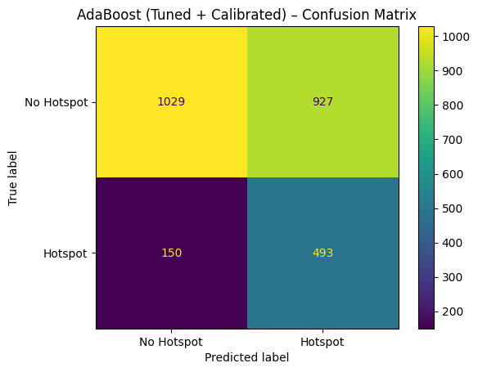
Figure: AdaBoost (Tuned + Calibrated) confusion matrix on test set.
The confusion matrix shows that the model correctly identified 493 out of 643 true hotspot buckets (recall = 76.7%). It also correctly classified 1,029 out of 1,956 non-hotspot buckets as non-hotspots. The model produced 927 false positives (non-hotspot buckets incorrectly predicted as hotspots) and 150 false negatives (missed hotspots). In the context of public safety, false negatives (missing a real hotspot) are generally more costly than false positives (sending extra patrols to a low-risk area), so the high recall of this model is desirable.

9.3 Calibration Analysis
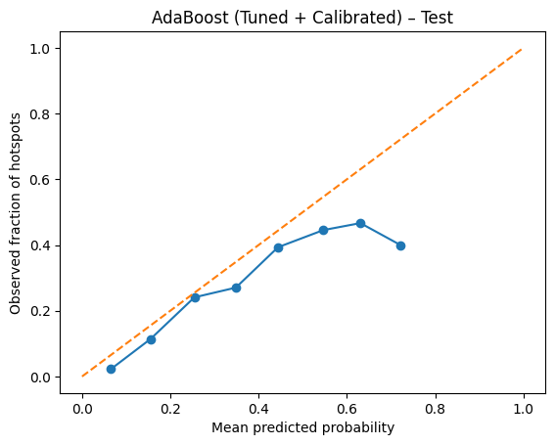
Figure: Calibration curve for AdaBoost (Tuned + Calibrated) on test set.
The calibration curve shows how well the predicted probabilities match the observed hotspot frequencies. After Platt scaling, the calibration curve follows the diagonal line more closely than the uncalibrated model, indicating that the predicted probabilities are more reliable. The Brier score of 0.1725 confirms reasonable calibration quality. This means that when the model predicts a 30% probability of a hotspot, approximately 30% of those cases are actual hotspots.

9.4 Why AdaBoost Was Selected
While GBM Baseline achieved a marginally higher raw F1 (0.4815 vs 0.4779), AdaBoost (Tuned + Calibrated) was selected because it provides calibrated probability estimates for risk-tiered decision-making, maintains strong recall (76.7%) to catch most true hotspots, and is more interpretable for non-technical stakeholders.

9.5 Comprehensive Model Comparison
The final comparison table shows all 13 model configurations ranked by F1 score on the test set.
Stage | Model | Acc. | Prec. | Recall | F1 | ROC | PR-AUC | Thr.
A2 Baseline | GBM | 0.5906 | 0.3506 | 0.7683 | 0.4815 | 0.7041 | 0.4036 | 0.33
A3 Baseline | AdaBoost | 0.5956 | 0.3520 | 0.7543 | 0.4800 | 0.7091 | 0.4083 | 0.44
Tuned | GBM (Tuned) | 0.5414 | 0.3329 | 0.8507 | 0.4786 | 0.7041 | 0.4003 | 0.28
Calibrated | AdaBoost (Cal.) | 0.5856 | 0.3472 | 0.7667 | 0.4779 | 0.7024 | 0.3971 | 0.28
Tuned | XGBoost (Tuned) | 0.5398 | 0.3321 | 0.8507 | 0.4777 | 0.7037 | 0.3955 | 0.28
A2 Baseline | XGBoost | 0.5360 | 0.3301 | 0.8507 | 0.4757 | 0.7017 | 0.3952 | 0.28
A3 Baseline | CatBoost | 0.5441 | 0.3317 | 0.8305 | 0.4740 | 0.6993 | 0.3904 | 0.29
Tuned | CatBoost (Tuned) | 0.5391 | 0.3284 | 0.8258 | 0.4699 | 0.7007 | 0.3960 | 0.29
A3 Baseline | HistGB | 0.5317 | 0.3259 | 0.8351 | 0.4689 | 0.6867 | 0.3867 | 0.27
Tuned | AdaBoost (Tuned) | 0.5987 | 0.3478 | 0.7107 | 0.4670 | 0.7024 | 0.3971 | 0.47
A3 Baseline | LightGBM | 0.5121 | 0.3188 | 0.8554 | 0.4645 | 0.6765 | 0.3714 | 0.23
A2 Baseline | Random Forest | 0.4687 | 0.2970 | 0.8398 | 0.4389 | 0.6460 | 0.3403 | 0.20
A2 Baseline | Decision Tree | 0.3594 | 0.2729 | 0.9549 | 0.4245 | 0.6173 | 0.3192 | 0.20
Table: Complete Model Comparison (Ranked by F1 Score)
The top two models by F1 score are GBM Baseline (0.4815) and AdaBoost Baseline (0.4800). However, when considering the full set of metrics and calibration quality, AdaBoost (Tuned + Calibrated) was selected as the final champion model because it provides well-calibrated probability estimates, achieves a strong recall of 76.7% (capturing over three-quarters of true hotspots), maintains an ROC-AUC of 0.7024, and offers reliable probability outputs that can be used for risk-tiered patrol allocation.

10. Model Interpretability (SHAP Analysis)
SHAP (SHapley Additive exPlanations) values were computed using a KernelExplainer on the tuned AdaBoost model. A background sample of 50 training observations and a test sample of 100 observations were used to generate SHAP explanations for the hotspot class.

10.1 SHAP Summary Bar Plot
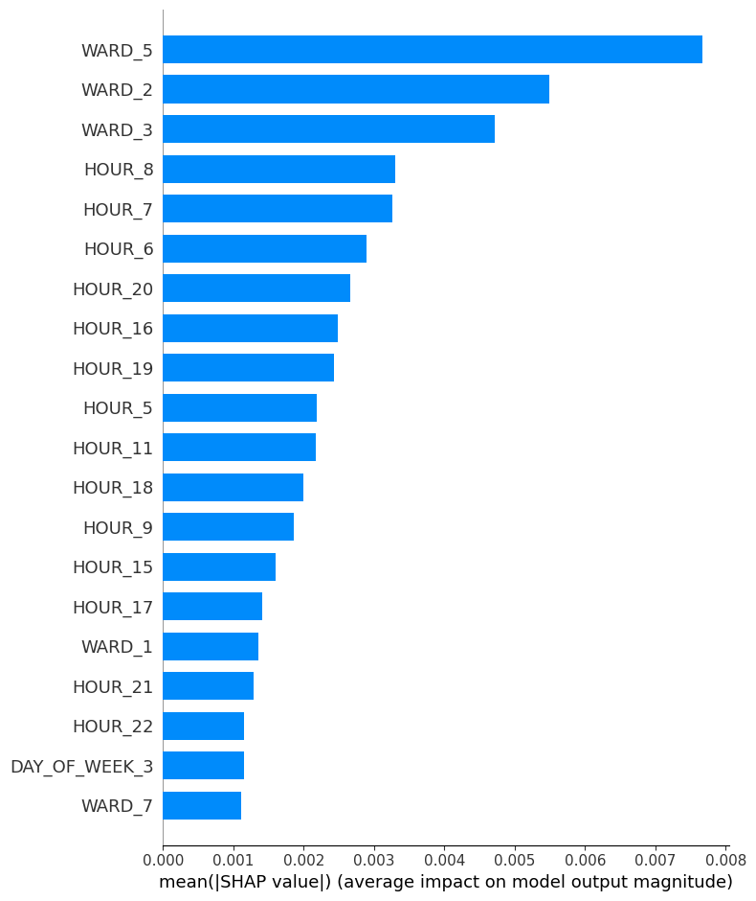
Figure: SHAP feature importance (mean absolute SHAP values).
The bar plot shows the average magnitude of each feature’s impact on model predictions. Ward-level features dominate the top positions, with specific wards (Ward 2, Ward 5, Ward 7) having the highest mean SHAP values. This confirms that spatial location is the single most important factor in determining hotspot classification. Among temporal features, specific hours (afternoon and evening hours) and month indicators contribute meaningfully. The IS_WEEKEND feature has a smaller but non-negligible contribution.

10.2 SHAP Beeswarm Plot
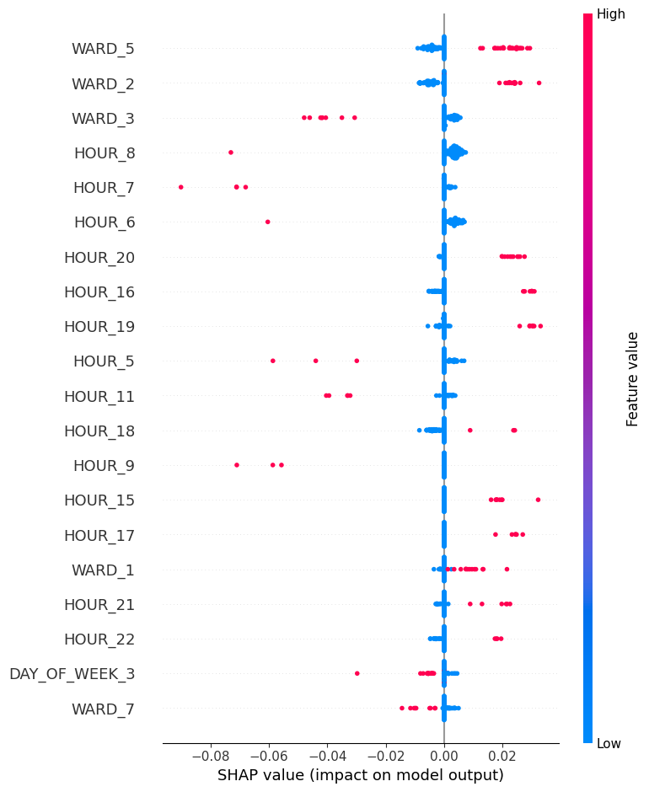
Figure: SHAP beeswarm plot showing feature value direction and impact.
The beeswarm plot provides additional detail by showing both the magnitude and direction of each feature’s effect. Red dots indicate high feature values (feature = 1 for binary indicators) and blue dots indicate low values (feature = 0). For ward features, being in a high-crime ward (feature = 1) pushes predictions toward hotspot classification (positive SHAP values). For hour features, specific afternoon and evening hours have the strongest positive effects. This visualization directly supports our EDA findings: hotspots are concentrated in specific wards during specific hours.

10.3 Waterfall Plot (Single Prediction)
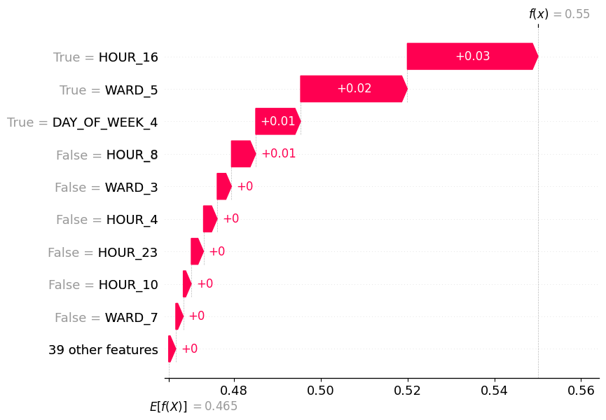
Figure: SHAP waterfall plot for the most hotspot-like prediction.
The waterfall plot explains a single prediction for the most hotspot-like observation in the test sample. Starting from the base value (average prediction across all observations), each feature either pushes the prediction toward hotspot (red) or away from it (blue). In this case, the ward feature provides the largest positive push, followed by the hour feature. This individual explanation demonstrates how the model combines spatial and temporal signals to make its classification decision.

10.4 Connecting SHAP to Research Questions
The SHAP analysis directly ties back to the three research questions. For RQ1 (temporal patterns), SHAP confirms that hour-of-day and month features are significant predictors, with afternoon and evening hours driving hotspot predictions. For RQ2 (spatial concentration), SHAP shows that ward identity is the dominant predictor, with specific wards contributing the most to hotspot classification. For RQ3 (spatiotemporal signals), the combined importance of ward and hour features in SHAP validates the Ward-by-Hour heatmap findings from EDA, confirming that the model has learned the key spatiotemporal interactions that define crime hotspots.

11. Conclusions and Recommendations

11.1 What the Model Learned
The analysis demonstrates that crime hotspots in Washington, D.C. are predictable using ward-level spatial features and time-based temporal features. The model learned that certain wards consistently produce hotspot conditions, and that late afternoon and evening hours represent the highest-risk time periods. The combination of these two dimensions creates distinct spatiotemporal clusters that the boosting algorithm successfully captures.

11.2 How Hotspot Predictions Can Be Used
The calibrated AdaBoost model produces probability scores for each ward-hour-day combination. These scores can be used in several operational ways. Law enforcement agencies can generate daily risk maps that highlight which wards are likely to experience elevated crime during which hours, allowing patrol supervisors to allocate officers accordingly. The probability outputs enable risk-tiered responses: high-probability hotspots (above 60%) receive intensive patrol deployment, medium-probability areas (30–60%) receive increased surveillance, and low-probability areas maintain standard coverage.

11.4 Recommendations for Next Actions
We recommend deploying the calibrated AdaBoost model as a daily hotspot prediction tool integrated with the police department's dispatch systems. A pilot program in the top three highest-risk wards should be conducted to evaluate prediction-guided patrol allocation. Future iterations should incorporate additional data sources like weather, events, and socioeconomic indicators, with quarterly model retraining to capture evolving crime patterns.

12. Limitations and Future Work
- Data Limitations The dataset covers only 2025, limiting long-term trend analysis. It suffers from underreporting bias, ward-level granularity may miss localized hotspots, and it lacks external factors like weather, events, and socioeconomic indicators.
- Modeling Limitations The moderate F1 scores (around 0.48) and precision of approximately 35% mean two-thirds of predicted hotspots are false positives. The class imbalance (only 25% hotspots in test data) makes it difficult to achieve both high precision and high recall simultaneously.
- Suggested Extensions Future work should incorporate multi-year data (2020–2025) with external features like weather and socioeconomic variables, use finer spatial granularity such as census tract or grid-based aggregation, and explore real-time streaming prediction with deep learning approaches like spatiotemporal graph neural networks.

13. References
Washington D.C. Open Data. (2025). Crime Incidents in 2025. Data.gov. https://catalog.data.gov/dataset/crime-incidents-in-2025

