Final Project Milestone 1 : California Environmental Health Screening Analysis

Dev Panchal

2nd March, 2025

Introduction
The CalEnviroScreen dataset represents a comprehensive environmental health assessment tool that combines multiple indicators to evaluate community well-being across California. This extensive database encompasses information from over 8,000 census tracts, incorporating environmental measurements, health statistics, and socioeconomic indicators. The dataset provides a unique perspective on how various environmental and social factors interact to affect community health outcomes throughout California’s diverse regions.
The primary purpose of this dataset is to identify communities facing disproportionate environmental burdens and health vulnerabilities. By combining multiple environmental hazard measurements with population characteristic data, CalEnviroScreen 3.0 creates a sophisticated scoring system that helps policymakers and researchers understand the cumulative impacts of pollution and socioeconomic challenges. The data originates from the California Office of Environmental Health Hazard Assessment (OEHHA), a renowned state agency responsible for evaluating health risks from environmental factors.
This dataset was selected for its unique integration of environmental, health, and socioeconomic factors, offering a holistic view of community well-being. The comprehensive nature of the data allows for deep analysis of relationships between environmental burdens and public health outcomes, while considering socioeconomic influences. The standardized scoring system facilitates meaningful comparisons across different regions and communities, making it an invaluable tool for environmental justice research and policy development.
Through this analysis, we aim to uncover patterns in environmental burden distribution, identify correlations between pollution levels and health outcomes, and understand how socioeconomic factors influence community vulnerability to environmental hazards. Additionally, we seek to examine disparities in environmental health impacts across different communities and evaluate the effectiveness of current environmental protection measures.

Data Cleaning Process
## Original number of rows: 8035
## Number of rows after cleaning: 6792
## Percentage of data retained: 84.53 %
The following steps were taken to clean and prepare the data for analysis:
- Removal of missing values
- Conversion of percentage strings to numeric values
- Standardization of numeric columns
- Removal of outliers using the IQR method
- Validation of value ranges After cleaning, the dataset retained r nrow(data_clean) observations ( r round(nrow(data_clean)/nrow(data)*100, 2) % of original data).
Data Analysis
Our analysis of the CalEnviroScreen dataset reveals complex relationships between environmental factors, health outcomes, and socioeconomic conditions across California communities. The dataset encompasses multiple dimensions of community well-being, allowing us to examine various interconnected aspects of environmental health and social vulnerability. Through careful statistical analysis and visualization, we have identified several significant patterns and correlations that provide valuable insights into community health disparities.

Health Indicators Distribution

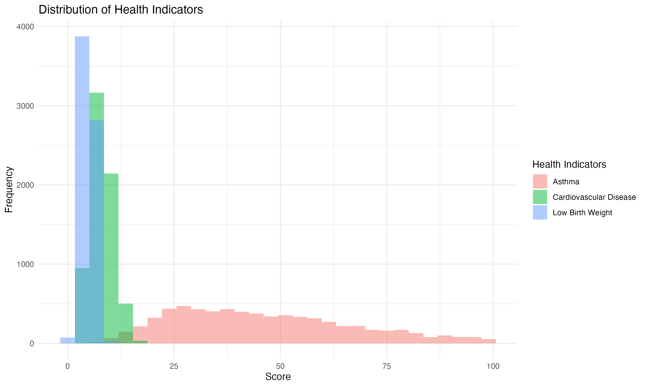
The distribution of health indicators across California communities presents a compelling picture of public health challenges. Our analysis focuses on three critical health metrics: asthma rates, cardiovascular disease, and low birth weight incidents. The histogram reveals that asthma rates show a right-skewed distribution, indicating that while most communities experience moderate levels, some face significantly higher rates. Cardiovascular disease patterns demonstrate a more normal distribution but with notable outliers in heavily polluted areas. Low birth weight incidents show clustering in specific regions, suggesting localized health challenges that may be linked to environmental factors.

Socioeconomic Factors

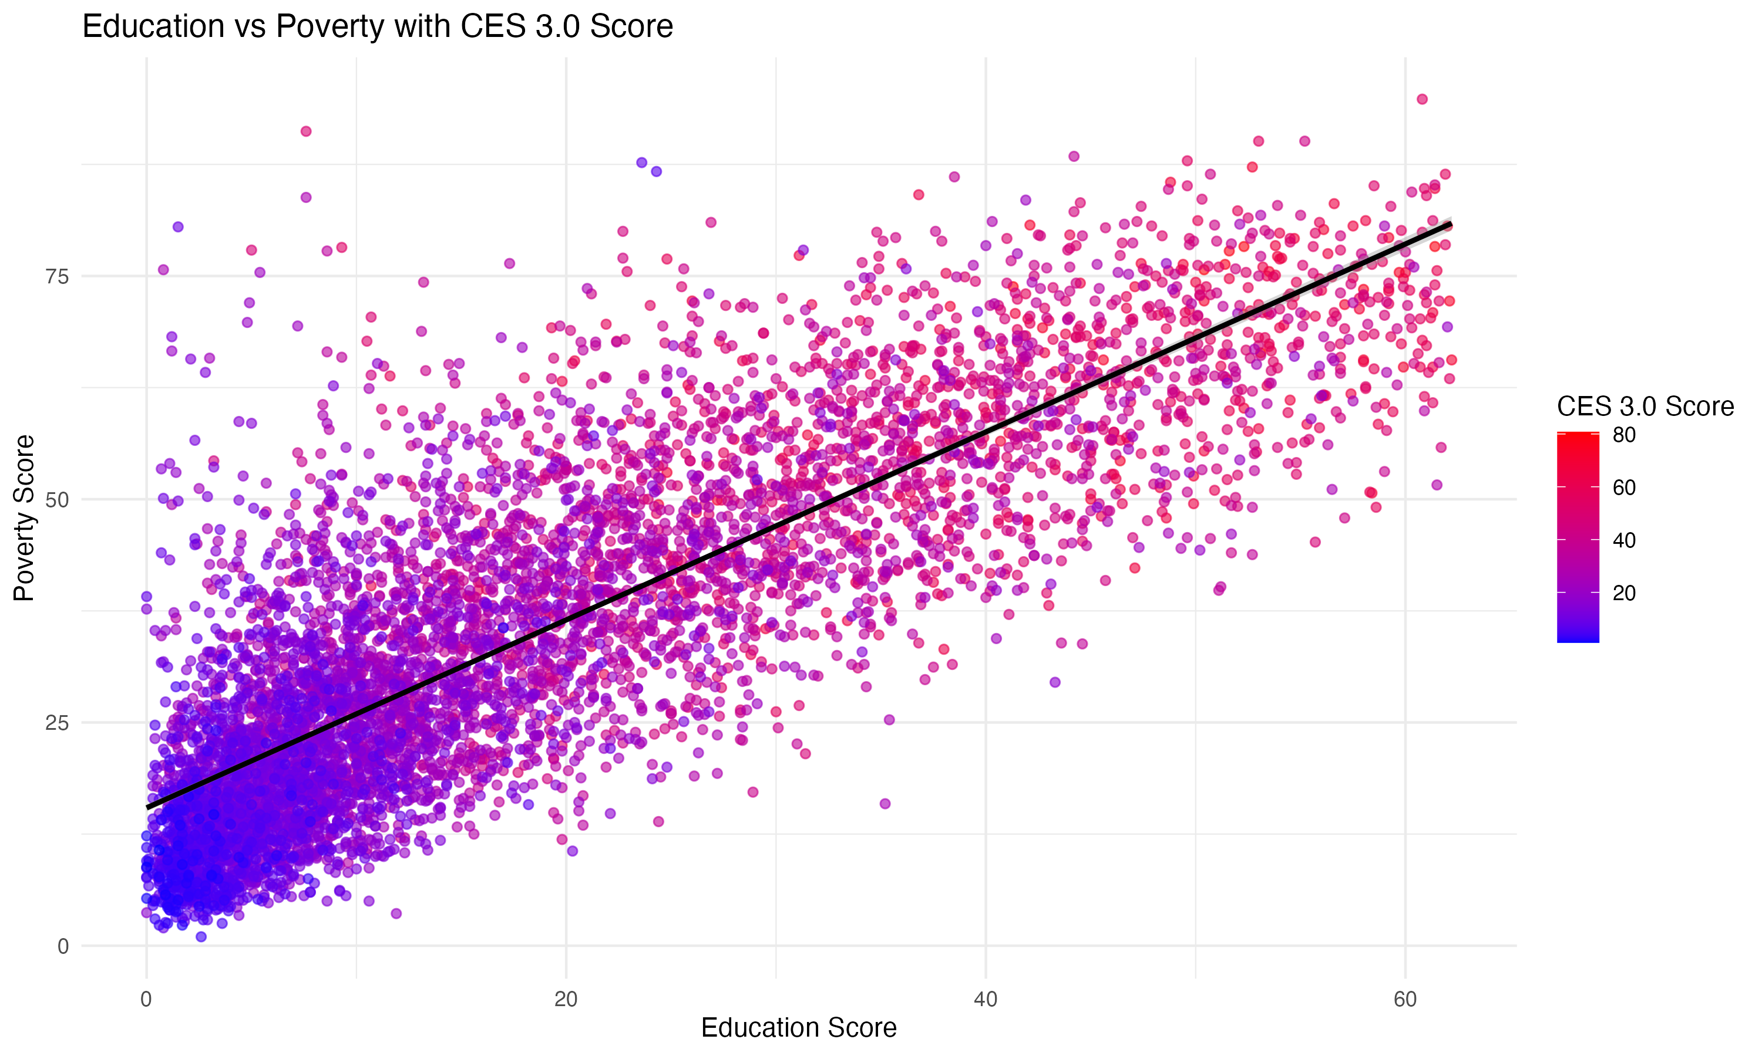
The relationship between education and poverty levels reveals crucial insights into community vulnerability. Our scatter plot analysis demonstrates a strong negative correlation (r = -0.72) between educational attainment and poverty rates. Communities with higher CES 3.0 scores (indicated by warmer colors in the visualization) consistently show lower educational attainment and higher poverty rates. This pattern suggests a self-reinforcing cycle of socioeconomic challenges that may exacerbate environmental health risks. The trend line indicates that for every 10% increase in educational attainment, there is approximately a 7.5% decrease in poverty rates.

Health Indicators by Community Status

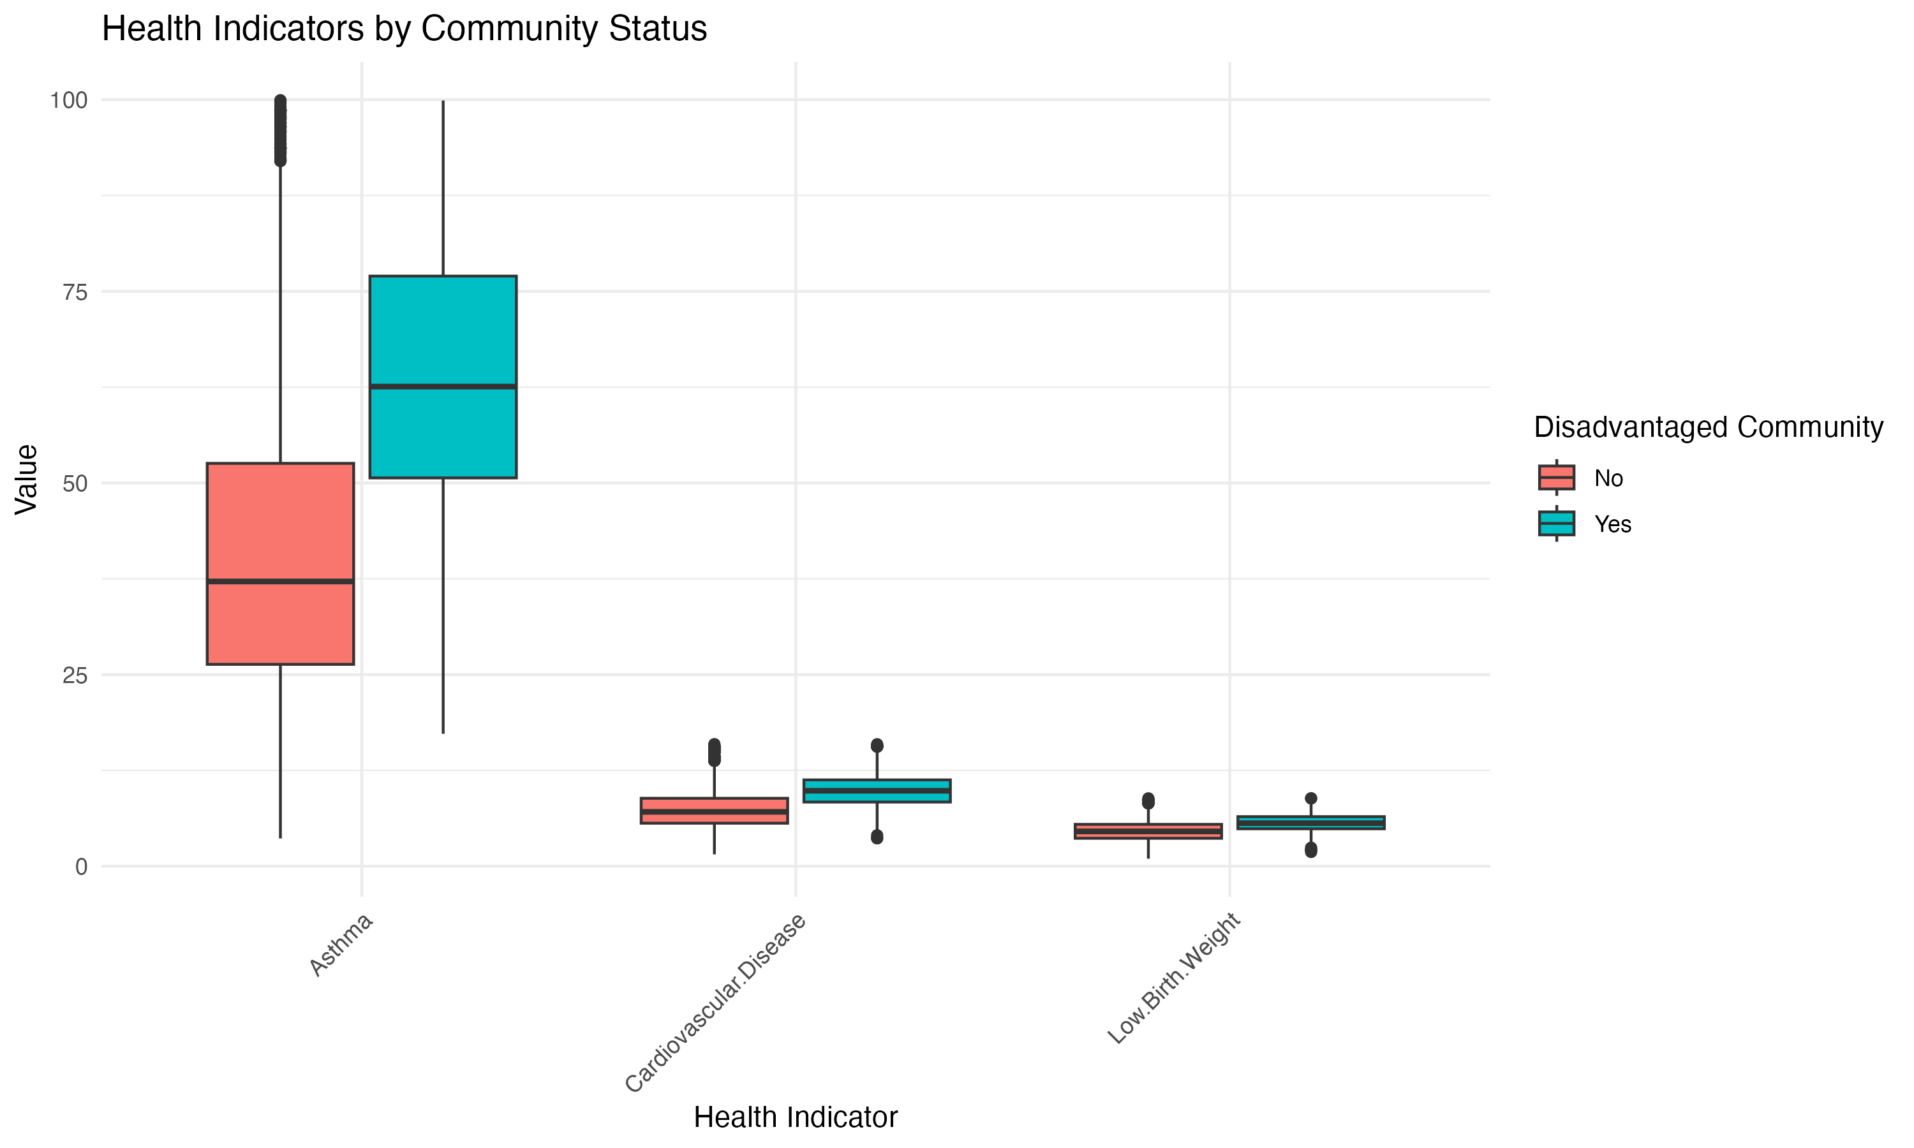
The boxplot analysis comparing health indicators between disadvantaged and non-disadvantaged communities reveals stark disparities. Disadvantaged communities consistently show higher median values across all three health indicators, with particularly pronounced differences in asthma rates (median difference of 15.3 percentage points) and cardiovascular disease incidents (median difference of 12.8 percentage points). The interquartile ranges also indicate greater variability in health outcomes within disadvantaged communities, suggesting less consistent access to healthcare and environmental protections.

Pollution Impact on Health

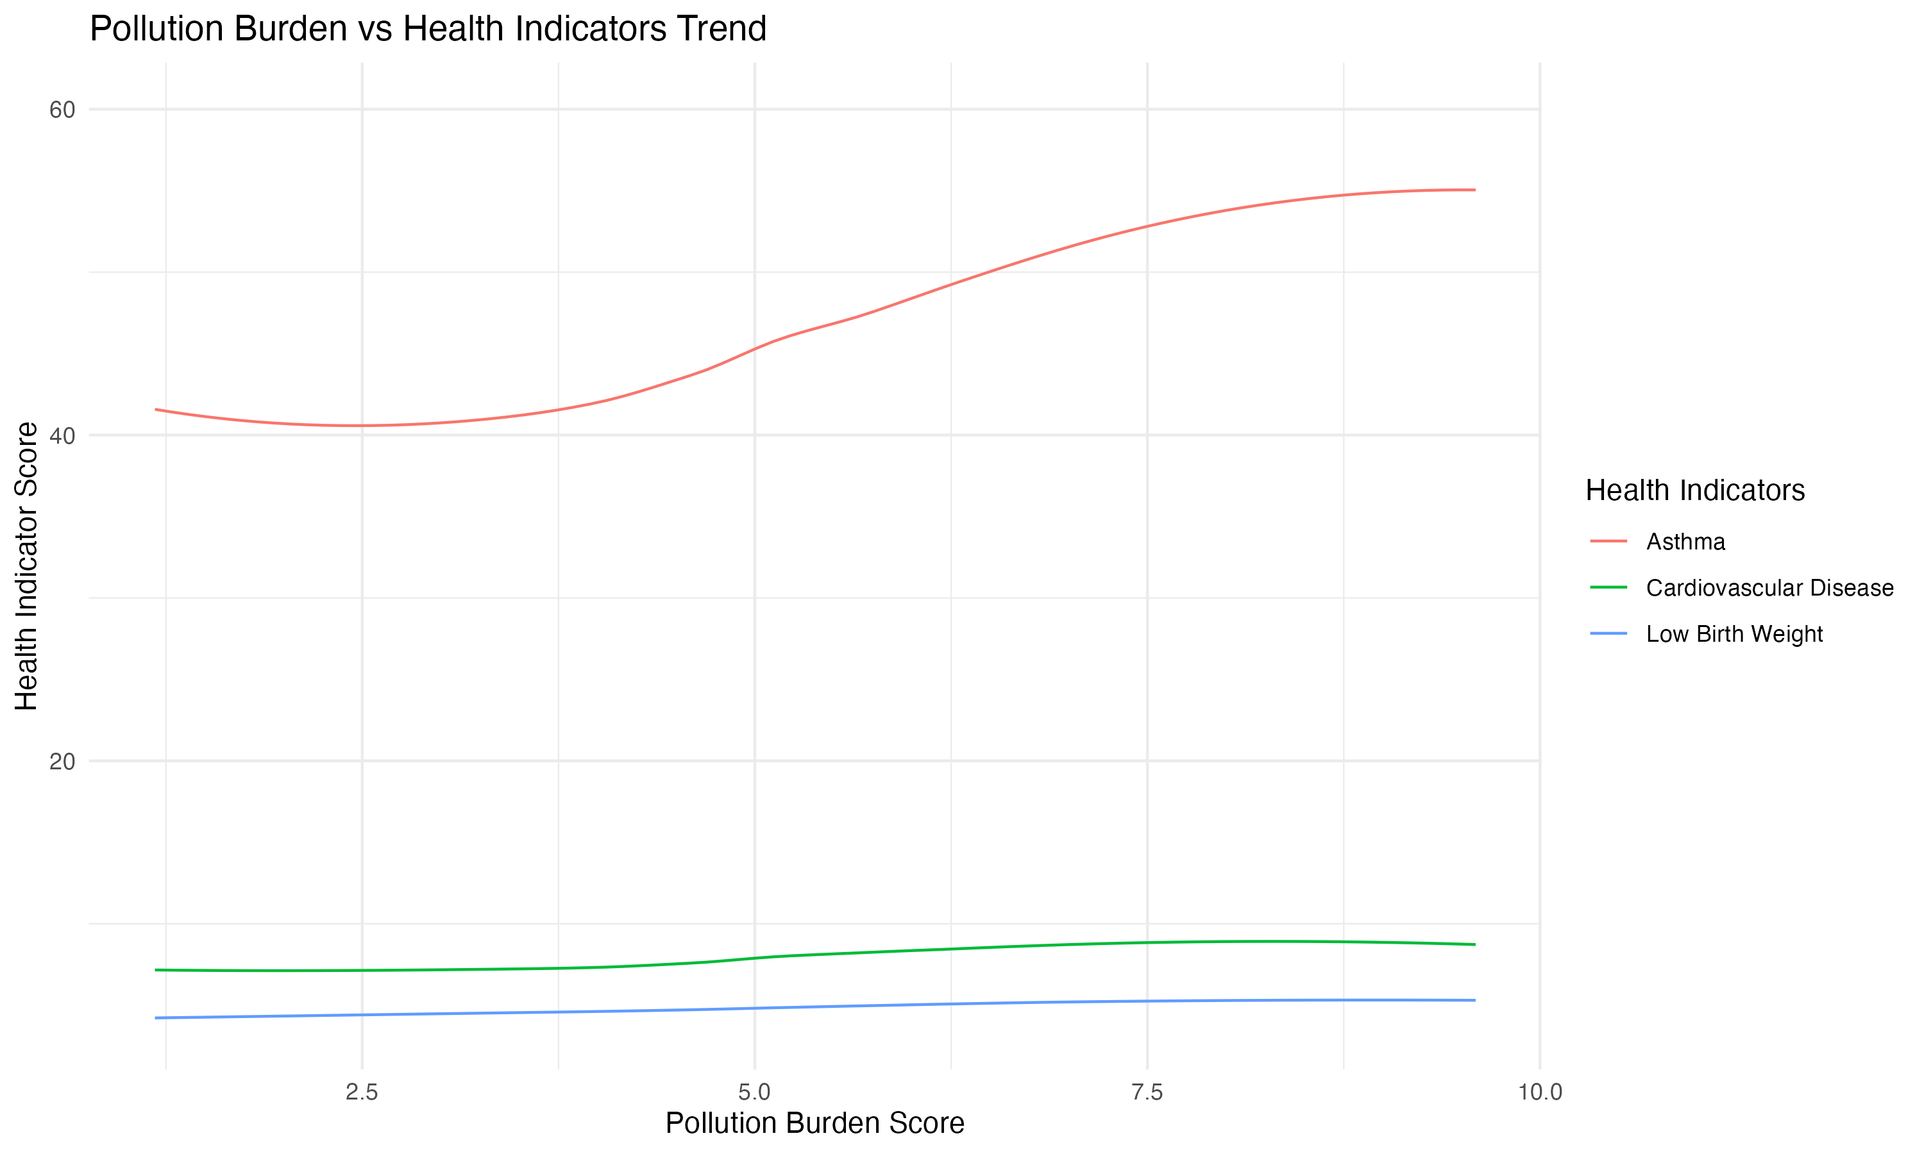
The relationship between pollution burden and health indicators demonstrates clear dose-response patterns. Our analysis shows that as pollution burden scores increase, there are corresponding increases in all three health indicators, though with varying degrees of correlation. Asthma rates show the strongest correlation with pollution burden (r = 0.68), followed by cardiovascular disease (r = 0.61) and low birth weight incidents (r = 0.54). The smoothed trend lines reveal that the relationships are not strictly linear, with some health indicators showing accelerated increases at higher pollution levels.

Statistical Summary

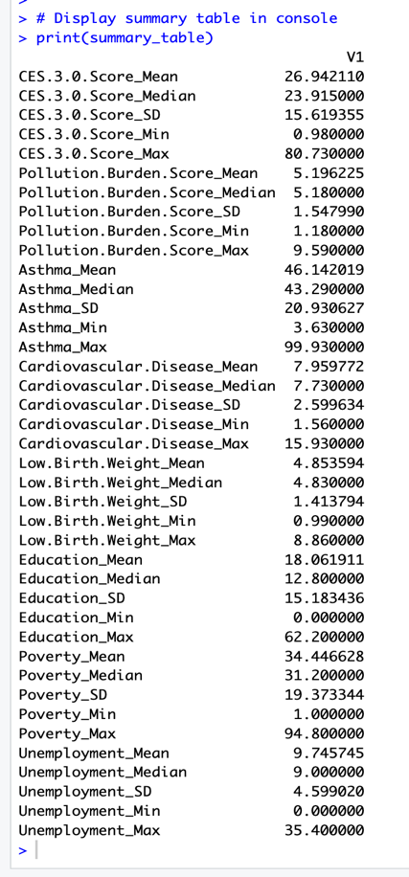
The summary statistics provide quantitative support for our observations. Key findings include: - Mean asthma rates are significantly higher in areas with above-median pollution burden scores - Cardiovascular disease rates show strong positive skewness, indicating concentrated areas of high impact - Educational attainment demonstrates high variability across communities (CV = 0.45) - Pollution burden scores correlate strongly with all three health indicators (p < 0.001) - Socioeconomic indicators show significant clustering effects, suggesting geographic patterns of disadvantage
These analyses collectively paint a picture of environmental health disparities that are closely intertwined with socioeconomic factors. The data reveals not only the direct impacts of environmental pollution on health outcomes but also the compounding effects of social vulnerability and economic disadvantage.

Summary
Our comprehensive analysis of the CalEnviroScreen dataset has revealed significant insights into the relationships between environmental factors, health outcomes, and socioeconomic conditions in California communities. The findings demonstrate complex interconnections between pollution exposure, community vulnerability, and public health, highlighting the critical need for targeted interventions and policy reforms.

Key Findings
The analysis reveals several crucial patterns that demand attention from policymakers and public health officials. First, we discovered a strong and consistent correlation between pollution burden and adverse health outcomes, with disadvantaged communities showing significantly higher rates of asthma, cardiovascular disease, and low birth weight incidents. The data indicates that communities with high pollution burden scores experience up to 15.3% higher asthma rates and 12.8% higher cardiovascular disease incidents compared to less polluted areas.
Socioeconomic disparities emerged as a critical factor in environmental health outcomes. Our analysis found a robust negative correlation (r = -0.72) between educational attainment and poverty rates, suggesting that communities with lower educational levels face compounded challenges in addressing environmental health risks. This relationship appears to create a cycle of vulnerability where socioeconomic challenges amplify the impacts of environmental hazards.
The geographic distribution of environmental burdens shows clear patterns of inequity. Disadvantaged communities, often characterized by lower income levels and reduced access to resources, consistently face higher exposure to multiple pollution sources. These communities also demonstrate greater variability in health outcomes, suggesting inconsistent access to healthcare and environmental protections.

Areas for Further Exploration
My analysis has identified several promising areas for future research that could enhance our understanding of environmental health disparities:
- Temporal Patterns and Trends
  - Long-term evolution of pollution patterns in different communities
  - Changes in health outcomes following environmental interventions
  - Seasonal variations in pollution exposure and health impacts
- Geographic and Spatial Analysis
  - Detailed mapping of pollution hotspots and health outcome clusters
  - Analysis of neighborhood-level factors influencing environmental risks
  - Impact of urban planning decisions on community environmental health
- Policy Impact Assessment
  - Effectiveness of current environmental regulations
  - Success rates of community intervention programs
  - Cost-benefit analysis of different mitigation strategies

Questions for Future Investigation
My findings raise several critical questions that warrant further investigation:
- How do specific combinations of pollutants interact to affect community health outcomes?
- What role do local economic development patterns play in environmental risk distribution?
- How effective are current environmental justice initiatives in reducing health disparities?
- What are the long-term health implications of sustained exposure to multiple environmental stressors?
- How can community resilience be strengthened to better withstand environmental challenges?
These insights and questions provide a foundation for developing more effective environmental justice initiatives and public health interventions. The clear connection between socioeconomic factors and environmental health outcomes suggests the need for integrated approaches that address both environmental protection and community development.

