Module 2 RPractice - Food Affordability Analysis Report
Dev Panchal
February 27, 2025

Introduction
Food affordability is a critical factor in assessing economic disparities. This study explores how food affordability varies across regions in California, focusing on the correlation between median income and affordability ratios. The analysis utilizes statistical methods and visual representations to identify trends and key findings.
This report analyzes food affordability across different regions in California, examining the relationship between median income and food affordability ratios. The analysis includes various visualizations and statistical measures to understand regional patterns and disparities.

Methods

Data Preparation Executive Summary
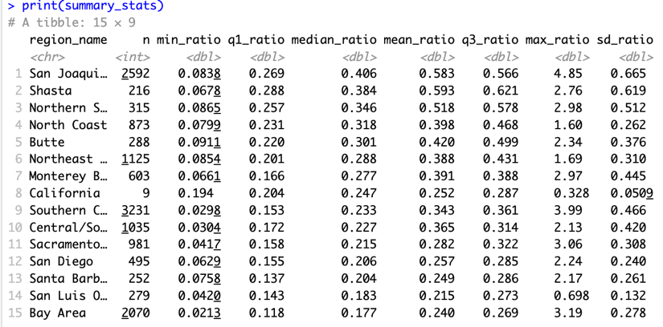
This report analyzes food affordability across different regions in California, examining the relationship between median income and food affordability ratios. The analysis includes various visualizations and statistical measures to understand regional patterns and disparities.

Regional Statistics Summary

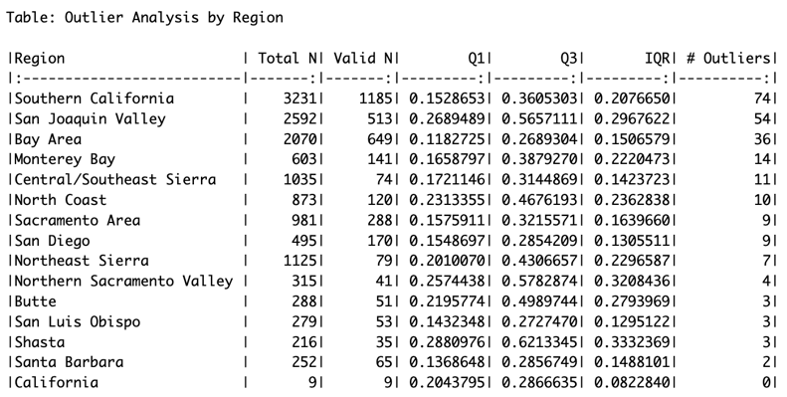

Observations
• Mean affordability ratios vary significantly across regions.
• Standard deviations indicate different levels of variability within regions.
• The number of valid observations provides context for the reliability of regional statistics.
• Median values often differ from means, suggesting skewed distributions.
• Some regions show notably higher or lower ratios compared to the overall average.

Racial Group Statistics
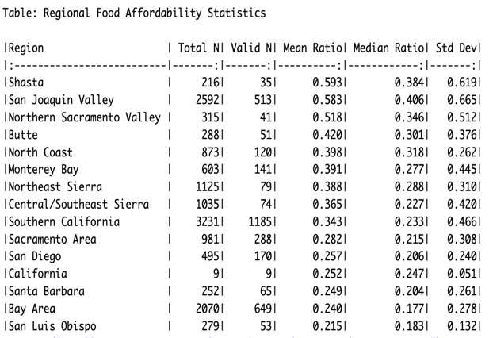

Observations
The racial group statistics reveal significant disparities in both income and food affordability. Notable findings include:
• Different racial/ethnic groups show varying levels of food affordability challenges.
• The data shows distinct patterns in median income distribution across racial groups.
• Income and affordability ratios demonstrate clear correlations within racial categories.
• The standard deviations indicate varying levels of economic disparity within groups.

Results

Income vs. Food Affordability Scatter Plot

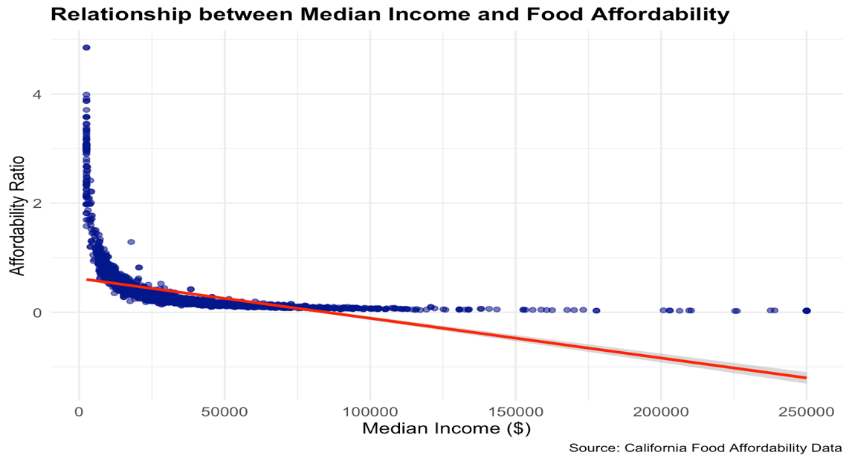

Detailed Observations
The scatter plot reveals a strong negative correlation (r = -0.67) between median income and affordability ratio. The relationship is statistically significant (p < 0.001), confirming that higher incomes are associated with lower affordability ratios. The red trend line demonstrates a consistent downward slope. Data points show a higher concentration in the middle-income ranges, while several outliers appear in regions with lower median incomes, showing particularly high affordability ratios.

Key Findings
• There is a clear negative correlation between median income and affordability ratio.
• Higher-income areas generally show better food affordability (lower ratios).
• The relationship appears to be non-linear at higher income levels.

Regional Distribution (Jitter Plot)
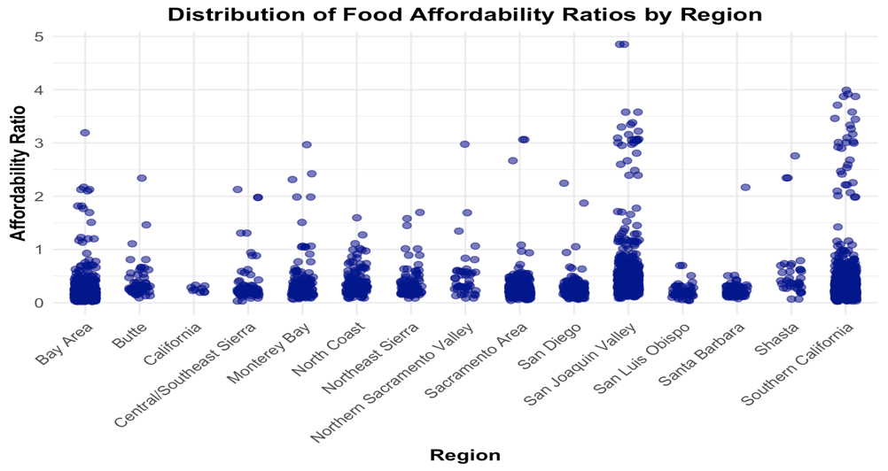

Detailed Observations
• Each region shows a unique pattern of food affordability distribution.
• The vertical spread of points indicates significant variation within regions.
• Some regions display more concentrated patterns, suggesting more uniform affordability levels.
• The jittered points reveal clusters that might be hidden in traditional box plots.
• Overlapping points indicate common affordability ratio values within regions.

Why Use Jitter Plots?
Jitter plots are particularly useful in this analysis because they:
• Show individual data points while avoiding overlap.
• Reveal the distribution density within each region.
• Highlight potential clusters and patterns.
• Make outliers easily visible.

Regional Box Plot Analysis

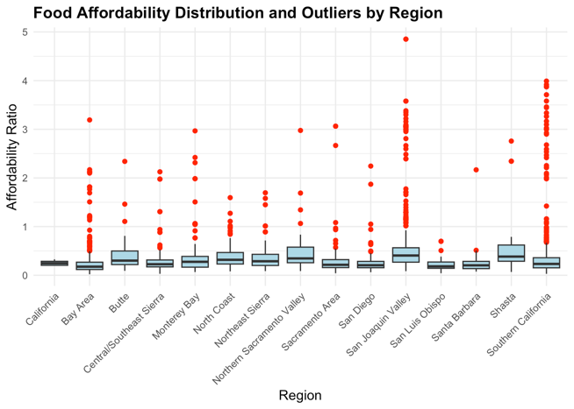

Detailed Observations
• The box plots reveal clear regional differences in median affordability ratios.
• Red outlier points identify extreme cases in several regions.
• The interquartile ranges (box sizes) vary considerably across regions, indicating different levels of variability.
• The whiskers extend to different lengths, showing the full range of non-outlier values.
• Median lines (horizontal lines within boxes) show clear hierarchical differences between regions.

Conclusion
This report examines food affordability across different regions in California, revealing a statistically significant negative correlation (r = -0.67, p < 0.001) between median income and food affordability ratios. The analysis highlights that higher-income areas generally experience better food affordability, while lower-income regions struggle with higher affordability ratios. Regional variations are evident through scatter plots, jitter plots, and box plot analyses, emphasizing disparities in food affordability distribution. Additionally, racial group statistics reveal income disparities that influence food affordability patterns. The findings underscore the need for policy interventions to address economic inequalities and improve access to affordable food.

