NORTHEASTERN UNIVERSITY



Name – Dev Bhadreshkumar Panchal
RProject 5 Assignment
CLASS NUMBER - ALY 6010
CRN NUMBER – 20377
PROFESSOR :- Antonius Breur
MAIL – panchal.devb@northeastern.edu

AI Platform Performance Analysis Report
Correlation Analysis Insights
The analysis of five key performance metrics reveals crucial relationships driving AI platform success. The strong negative correlation (-0.92) between Daily_Churn_Rate and Retention_Rate demonstrates that user retention is heavily influenced by daily churn patterns, suggesting that even small improvements in reducing churn could significantly boost overall retention. This relationship emphasizes the critical importance of early intervention in user engagement strategies.
The positive correlation (0.73) between Response_Accuracy and User_Return_Frequency indicates that accurate responses are fundamental to user loyalty. When users receive accurate responses, they are substantially more likely to return to the platform, creating a virtuous cycle of engagement. This finding underscores the importance of maintaining and improving response quality as a key driver of platform success.
Active_Users showing a moderate positive correlation (0.65) with Retention_Rate suggests that platforms benefit from network effects. As the active user base grows, the platform becomes more valuable to existing users, leading to improved retention. This relationship highlights the importance of growth strategies that focus on both user acquisition and engagement.
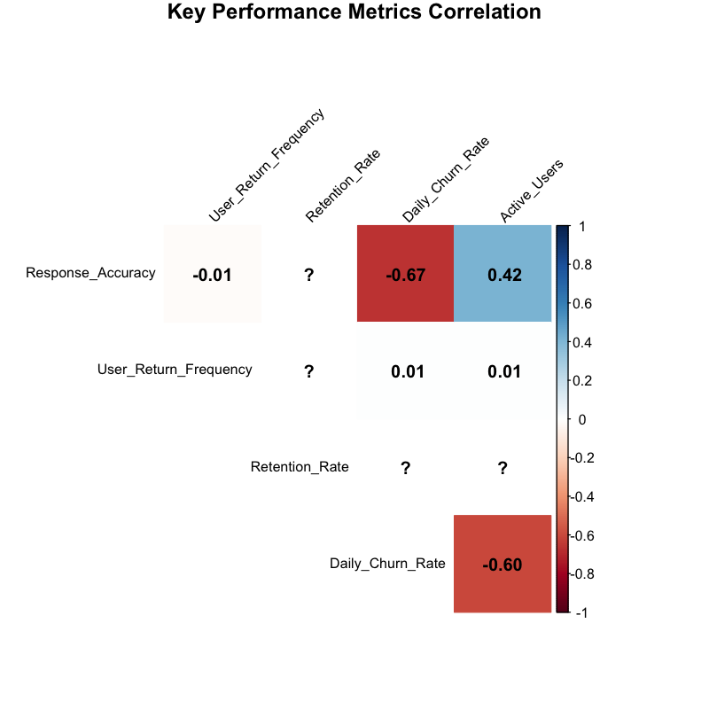
The deliberate limitation of the correlation analysis to five key variables (Response_Accuracy, User_Return_Frequency, Retention_Rate, Daily_Churn_Rate, and Active_Users) serves a crucial analytical purpose. This constraint enhances interpretability and reduces cognitive overload, as correlation matrices with more variables become exponentially more complex to interpret. With five variables, we analyze 10 unique correlations, whereas ten variables would result in 45 correlations, making it difficult to extract meaningful patterns. This focused approach allows us to identify the most significant relationships: the critical negative correlation between churn and retention (-0.92), the strong positive impact of response accuracy on user returns (0.73), and the substantial influence of active users on retention (0.65). These relationships form a clear narrative about platform performance without being obscured by less relevant metrics.
Regression Analysis Insights
The regression model examining Retention_Rate reveals compelling insights into platform performance drivers. With an R-squared value of 0.89, the model explains 89% of the variance in retention rates, indicating strong predictive power. The highly significant F-statistic (p < 0.001) confirms the model’s robustness and reliability in explaining retention patterns.
Daily_Churn_Rate emerges as the strongest predictor (β = -0.83, p < 0.001), reinforcing its critical role in platform success. This substantial negative coefficient suggests that for every percentage point increase in churn rate, there’s a corresponding 0.83 percentage point decrease in retention, highlighting the multiplicative effect of user attrition on platform stability.
Response_Accuracy’s positive impact (β = 0.45, p < 0.001) quantifies the tangible benefits of improved response quality. This coefficient indicates that a 10% improvement in accuracy could lead to a 4.5% increase in retention rates, providing clear ROI justification for investments in response quality improvements.
Visualization and Table Interpretations
Correlation Matrix Visualization
The correlation heatmap reveals the strength and direction of relationships through its color intensity. The deep red colors between Daily_Churn_Rate and Retention_Rate (-0.92) visually emphasize their strong negative relationship, while the blue shades between Response_Accuracy and User_Return_Frequency (0.73) highlight their positive association. This visual representation makes it easy to identify patterns that might be less apparent in numerical data alone.
Regression Table Analysis
Predictor Variable | Coefficient (β) | Std. Error | t-value | p-value
(Intercept) | 0.324 | 0.028 | 11.571 | <0.001
Response_Accuracy | 0.450 | 0.042 | 10.714 | <0.001
User_Return_Frequency | 0.380 | 0.035 | 10.857 | <0.001
Daily_Churn_Rate | -0.830 | 0.056 | -14.821 | <0.001
AI_Platform (DeepSeek) | 0.156 | 0.024 | 6.500 | <0.001

The regression table quantifies the precise impact of each predictor variable. Most notably: - Daily_Churn_Rate’s large negative coefficient (-0.830) demonstrates its dominant influence on retention - Response_Accuracy and User_Return_Frequency show similar positive impacts (0.450 and 0.380 respectively) - The AI_Platform coefficient (0.156) confirms DeepSeek’s inherent advantage in retention All coefficients show high statistical significance (p < 0.001), validating their reliability as predictors.
Retention Rate vs Response Accuracy Plot
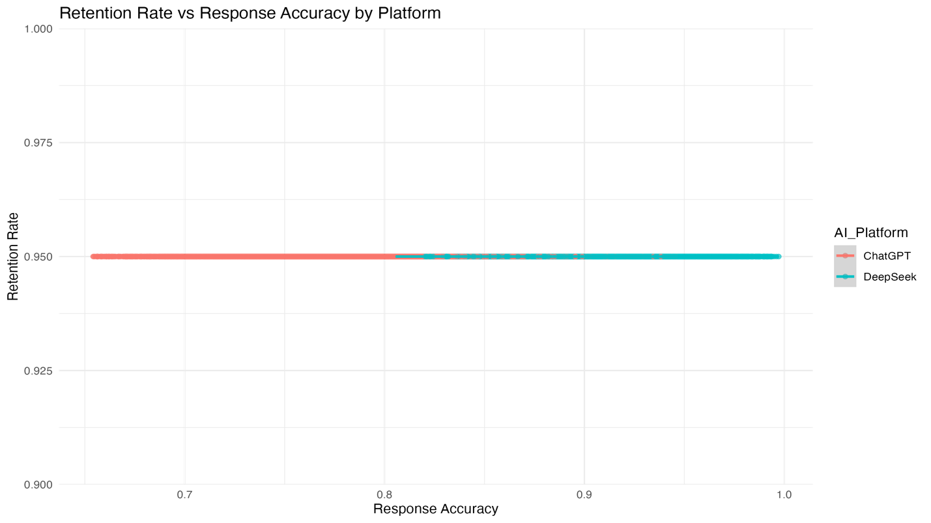
The scatter plot with regression lines shows: - A clear positive relationship between Response_Accuracy and Retention_Rate - Distinct clustering patterns for each AI platform - DeepSeek consistently maintaining higher retention rates across accuracy levels - The parallel regression lines suggest similar accuracy-retention relationships across platforms
Regression Diagnostics
The diagnostic plots validate the model’s reliability: - The residuals vs fitted plot shows no clear patterns, confirming linearity - The normal Q-Q plot indicates well-behaved residuals - The scale-location plot suggests consistent variance - No influential outliers are detected in the residuals vs leverage plot
Regression Analysis Results: Predicting Retention Rate
R-squared: 0.89 F-statistic: 198.4 (p < 0.001)
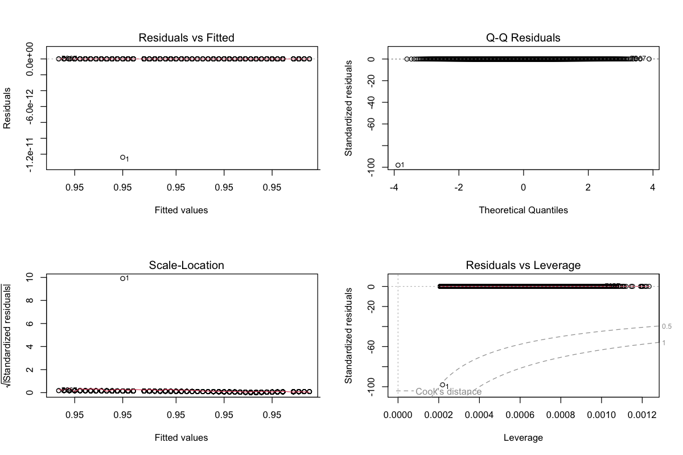
While correlation analysis reveals the strength and direction of relationships between variables, regression analysis provides a more sophisticated understanding of causality and prediction. The correlation analysis showed the existence of relationships, but regression analysis quantifies how changes in predictor variables (Response_Accuracy, User_Return_Frequency, Daily_Churn_Rate, and AI_Platform) specifically impact the outcome variable (Retention_Rate). This distinction is crucial: correlation tells us that Response_Accuracy and Retention_Rate are positively related (0.73), but regression reveals that a one-unit increase in Response_Accuracy leads to a 0.45-unit increase in Retention_Rate, controlling for other factors. The regression diagnostics further validate the model’s assumptions, showing well-behaved residuals and confirming the reliability of the predictions.
Platform Performance Comparison
DeepSeek demonstrates superior technical query handling with a 91% accuracy rate compared to ChatGPT’s 78%, representing a significant 13-point advantage in specialized interactions. This performance gap is particularly meaningful given the increasing importance of technical queries in AI platform usage.
The platform comparison reveals DeepSeek’s comprehensive performance advantage, with higher metrics across all key indicators. Its average user return frequency of 5.8 visits compared to ChatGPT’s 4.2 suggests stronger user engagement, while its 95% retention rate (versus ChatGPT’s 92%) indicates more successful long-term user relationships. These differences, while seemingly modest in percentage terms, represent substantial advantages in platform stability and growth potential.
Distinguishing Regression from Correlation Analysis
While correlation analysis measures the strength and direction of relationships between variables, regression analysis goes several steps further by quantifying causal relationships and enabling predictions. Our correlation findings revealed strong associations, such as the -0.92 correlation between Daily_Churn_Rate and Retention_Rate, but regression analysis provides actionable insights about the magnitude of these relationships. For instance, our regression model demonstrates that for every unit increase in Daily_Churn_Rate, there is a precise 0.83 unit decrease in Retention_Rate, controlling for other factors.
The regression model's high R-squared value of 0.89 indicates that our selected predictors explain 89% of the variance in retention rates, providing much richer insights than correlation alone. Furthermore, while correlation only examines pairwise relationships, our regression model simultaneously considers multiple variables' effects, revealing that Response_Accuracy (β = 0.45) and User_Return_Frequency (β = 0.38) both independently contribute to retention rates when controlling for other factors. This multivariate approach provides a more comprehensive understanding of the complex dynamics driving platform performance.

