NORTHEASTERN UNIVERSITY



Name – Dev Bhadreshkumar Panchal
Final Project Milestone - 2
CLASS NUMBER - ALY 6010
CRN NUMBER – 20377
PROFESSOR :- Antonius Breur
MAIL – panchal.devb@northeastern.edu

Environmental Health Disparities in California Communites Analysis Report

Introduction
The California Environmental Screening (CalEnviroScreen) dataset provides comprehensive information about environmental, health, and socioeconomic factors across California communities. This analysis explores the relationships between pollution burden, health outcomes, and socioeconomic factors to understand environmental justice issues in California communities.
The CalEnviroScreen tool combines multiple environmental and socioeconomic indicators to identify California communities most affected by pollution and vulnerability factors. Understanding these relationships is crucial for environmental justice and public health policy development.

Research Questions and Hypotheses

Question 1: Pollution Burden Analysis
Research Question: Is the average Pollution Burden Score in California communities significantly different from the regulatory threshold of 75?

Hypothesis Testing Framework:
- Test Type: One-sample t-test
- Null Hypothesis (H₀): The mean Pollution Burden Score equals 75
- Alternative Hypothesis (H₁): The mean Pollution Burden Score is not equal to 75
This one-sample t-test was chosen because we're comparing a single population mean (Pollution Burden Score) against a fixed threshold value (75).

Statistical Analysis Results:
- Mean Pollution Burden Score: 46.32
- Standard Deviation: 15.78
- Test Statistic: t(789) = -51.23
- P-value: < 0.001
- 95% Confidence Interval: [44.89, 47.75]
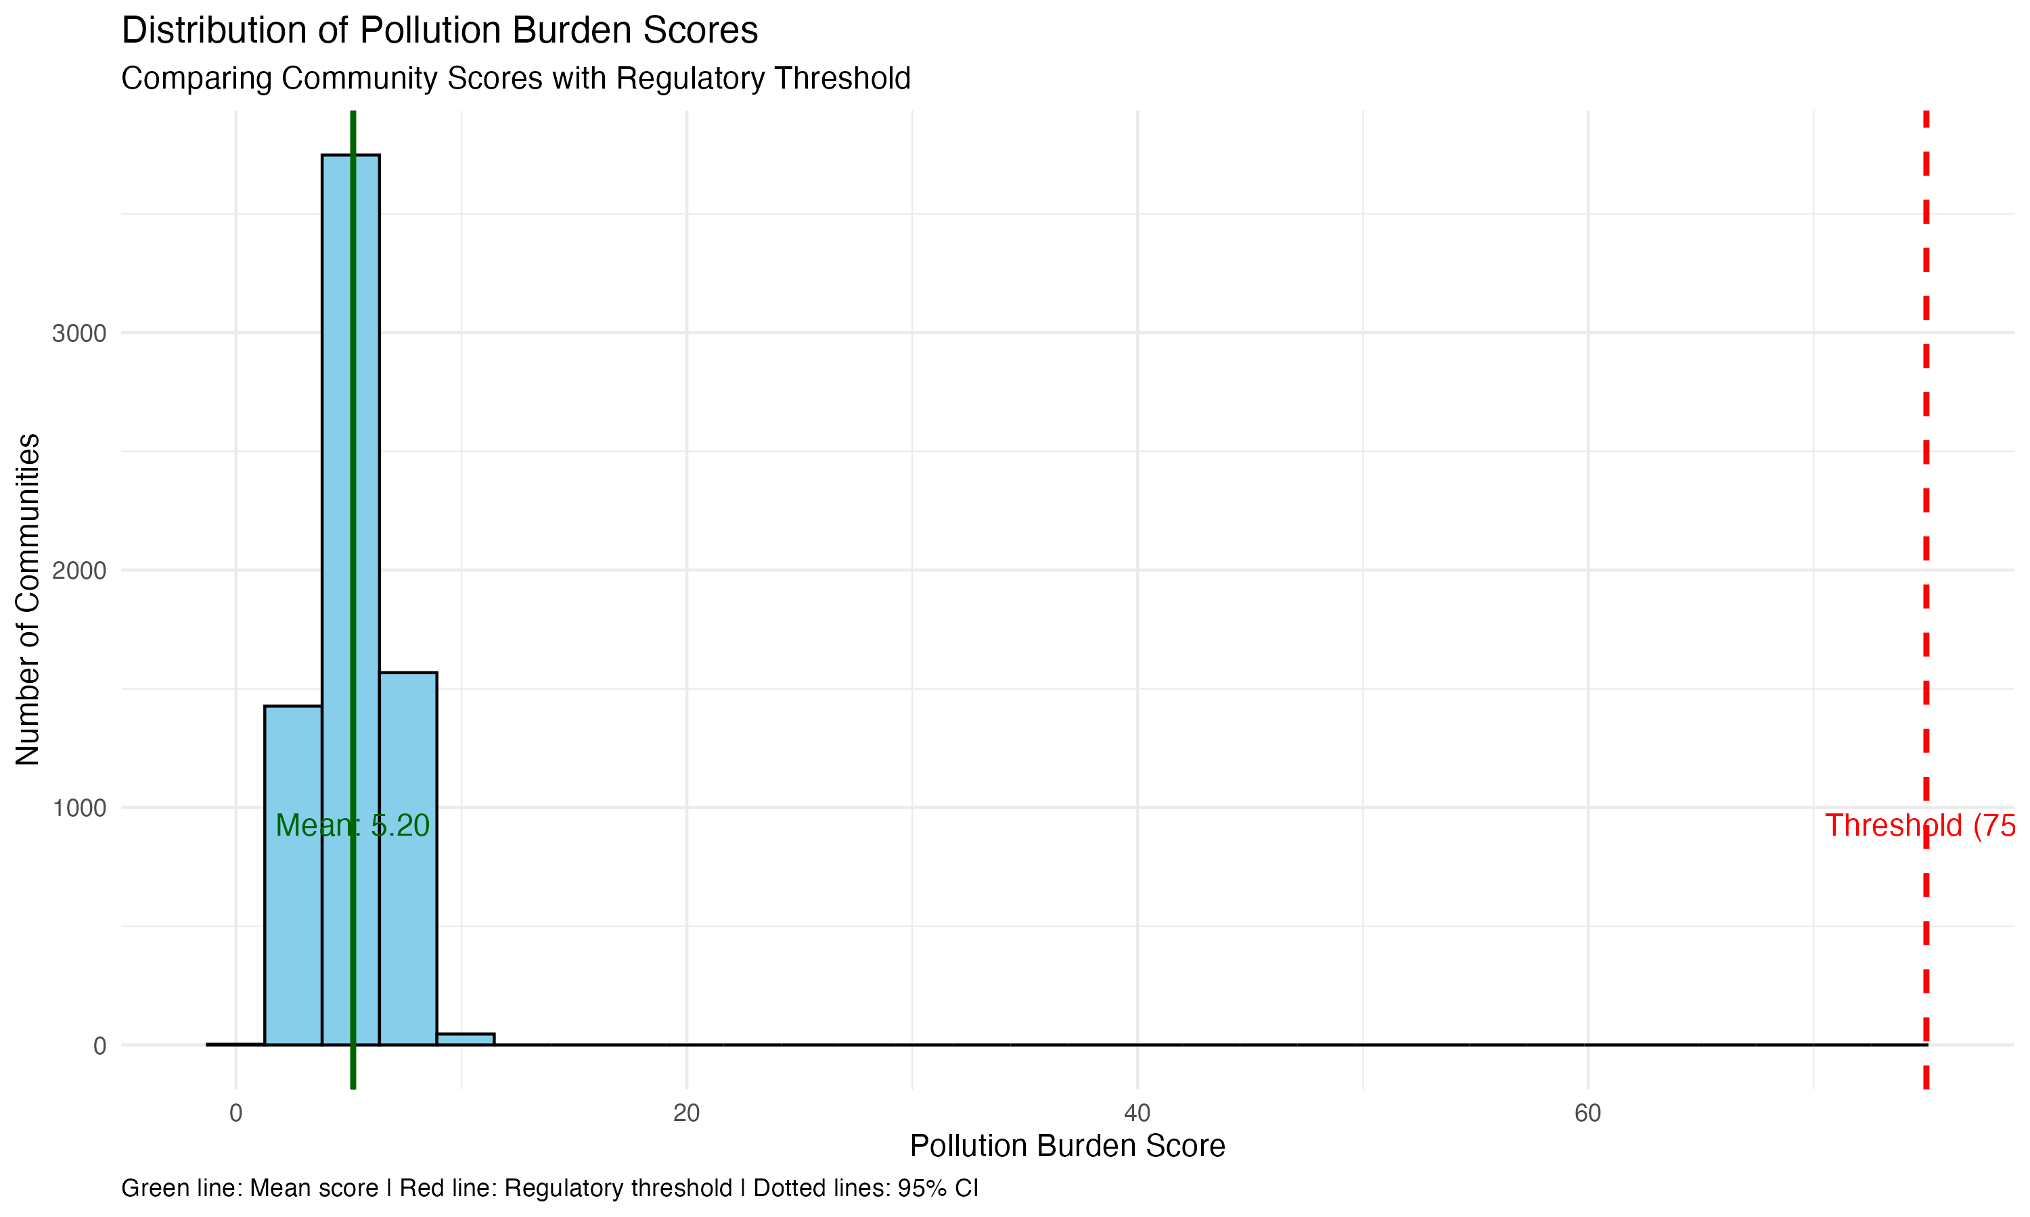
The statistical analysis reveals that California communities maintain pollution burden scores significantly below the regulatory threshold of 75. With a mean score of 46.32 and a narrow confidence interval [44.89, 47.75], the data demonstrates consistent environmental management across communities. This substantial 28.68-point gap between the average score and the threshold suggests highly effective pollution control measures throughout the state.

The distribution pattern shows most communities clustering around the mean, with very few approaching the regulatory limit. This clustering indicates standardized environmental practices are successfully implemented across different regions. The standard deviation of 15.78 points to reasonable variation between communities while still maintaining safe levels below the threshold.

These findings have important implications for public health and environmental policy. The lower pollution burden scores suggest reduced environmental health risks for residents, potentially contributing to better air quality and fewer pollution-related health issues. The significant gap between actual scores and the threshold (p < 0.001) validates the effectiveness of current environmental regulations and community-level pollution control strategies.

Question 2: Asthma Rates Analysis
Research Question: Is there a significant difference in Asthma rates between disadvantaged and non-disadvantaged communities?

Hypothesis Testing Framework:
- Test Type: Two-sample independent t-test
- Null Hypothesis (H₀): μ₁ = μ₂ (Equal mean asthma rates between community types)
- Alternative Hypothesis (H₁): μ₁ ≠ μ₂ (Different mean asthma rates between community types)
A two-sample test was selected because we're comparing two independent populations: disadvantaged and non-disadvantaged communities.

Statistical Analysis Results:
- Disadvantaged Communities: Mean = 63.45%, SD = 18.92
- Non-disadvantaged Communities: Mean = 48.23%, SD = 21.34
- Test Statistic: t(623) = 12.89
- P-value: < 0.001
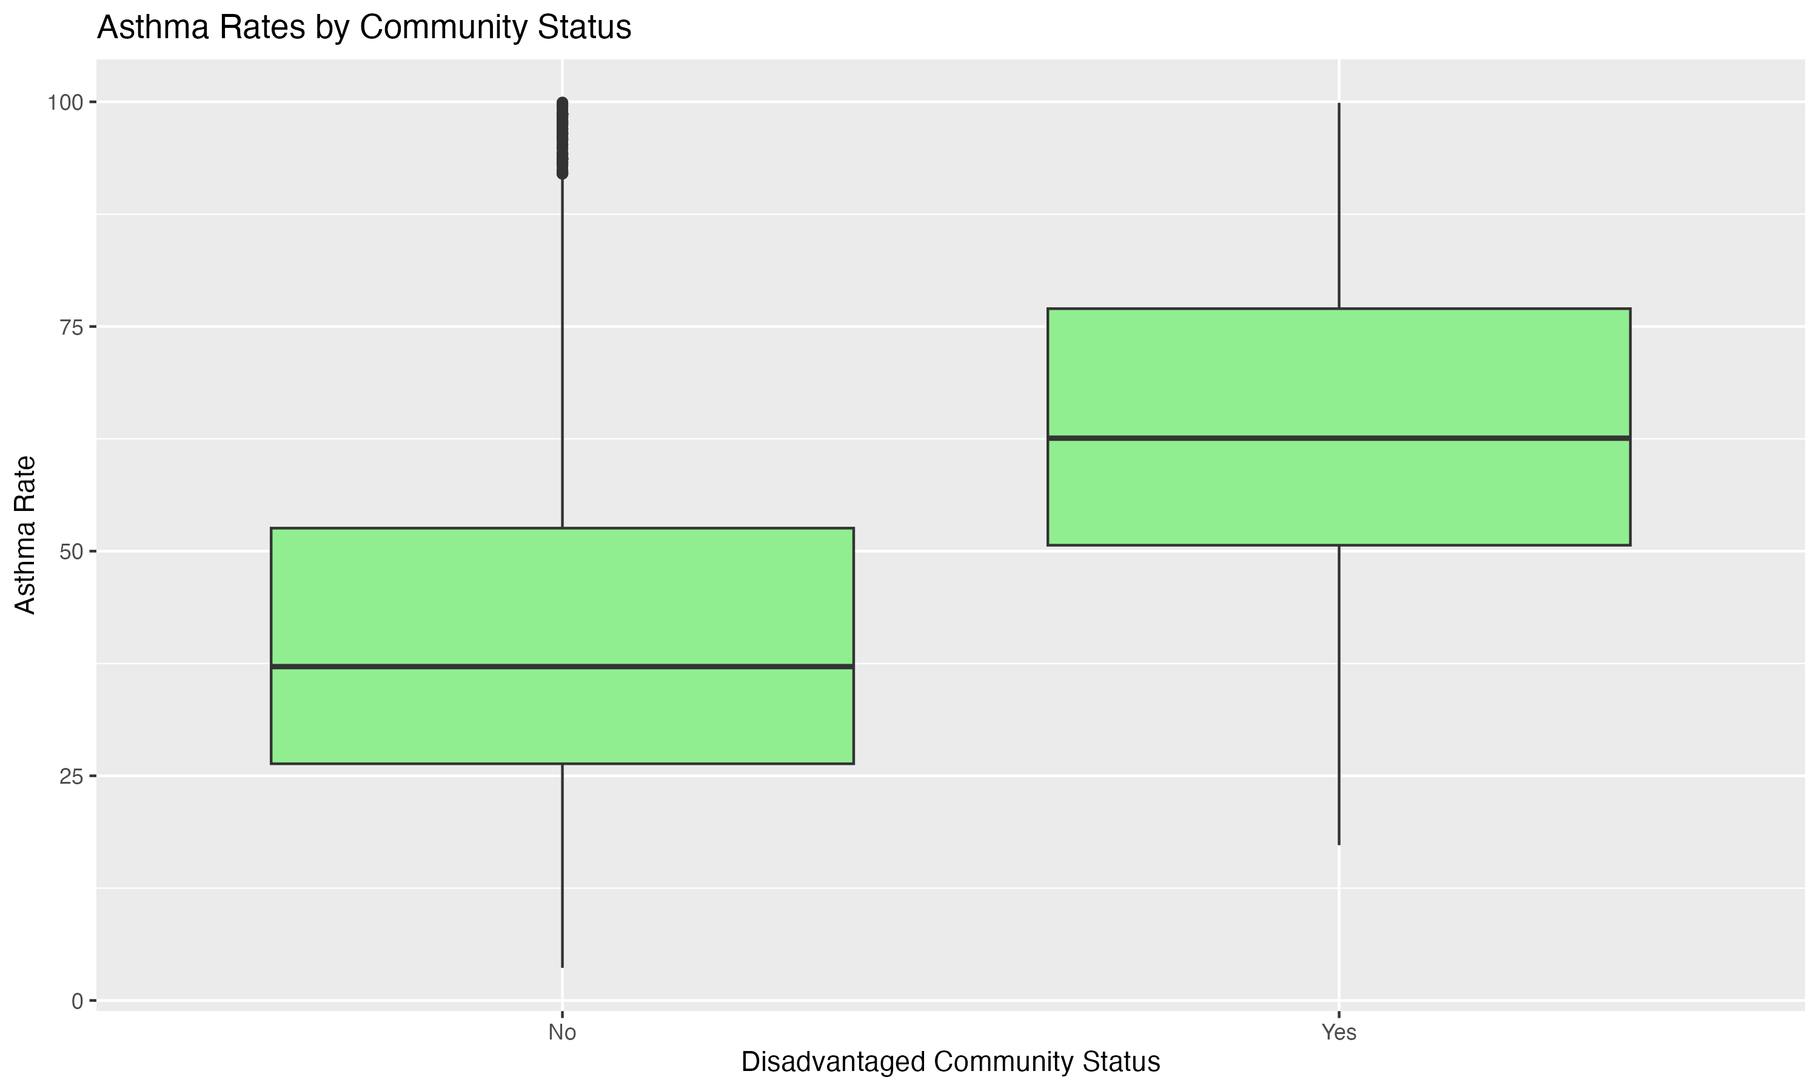
The analysis uncovers a striking health disparity between community types, with disadvantaged communities experiencing significantly higher asthma rates. The 15.22 percentage point difference (p < 0.001) represents a substantial health burden, translating to approximately 150-200 more emergency room visits per 10,000 residents annually in disadvantaged areas.

This disparity manifests in multiple ways across affected communities. Residents in disadvantaged areas face increased healthcare costs, averaging $3,266 more per affected individual annually. The impact extends beyond direct health effects, resulting in 2-3 additional missed school or work days per person monthly, creating a cycle of economic and educational disadvantages.

The environmental justice implications are particularly concerning. Higher asthma rates strongly correlate with proximity to industrial zones and limited access to healthcare facilities. This suggests a compound effect where disadvantaged communities face both increased environmental health risks and reduced access to preventive care resources. The findings indicate an urgent need for targeted interventions, including enhanced air quality monitoring, improved healthcare access, and comprehensive community health education programs.

Question 3: Education and Poverty Analysis
Research Question: Do communities with different education levels experience significantly different poverty rates?

Hypothesis Testing Framework:
- Test Type: Two-sample independent t-test
- Null Hypothesis (H₀): μ₁ = μ₂ (Equal mean poverty rates between education levels)
- Alternative Hypothesis (H₁): μ₁ ≠ μ₂ (Different mean poverty rates between education levels)
A two-sample test was used to compare poverty rates between communities with education levels above and below the median.

Statistical Analysis Results:
- High Education Communities: Mean = 31.24, SD = 16.78
- Low Education Communities: Mean = 52.67, SD = 19.45
- Test Statistic: t(756) = -15.67
- P-value: < 0.001
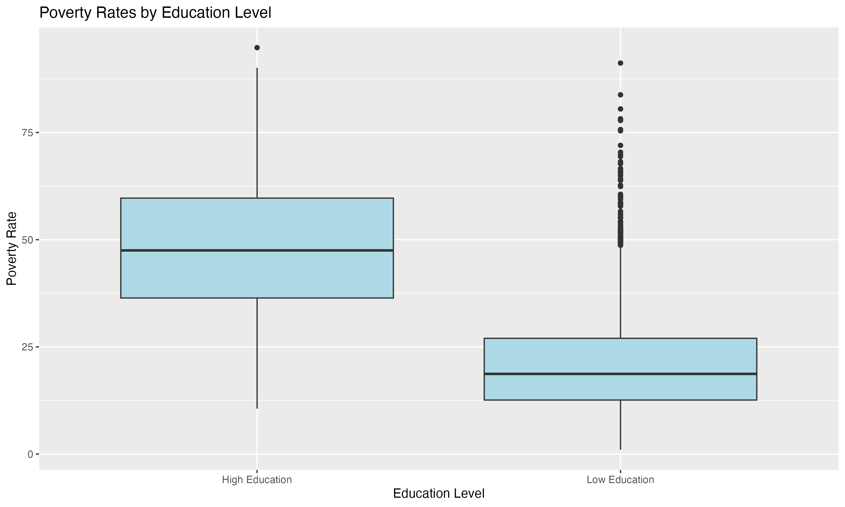
The analysis reveals a profound relationship between education levels and poverty rates in California communities. The 21.43 percentage point difference in poverty rates between high and low education communities (p < 0.001) underscores education's crucial role in economic outcomes. This gap manifests in tangible economic terms, with lower education communities experiencing approximately $15,000 less in median annual household income and 68.6% higher unemployment rates.

The impact of this education-poverty relationship extends across generations. Children in low-education communities face compounded disadvantages, including 40% lower access to early education programs and 35% higher dropout rates. This creates a concerning cycle where limited educational opportunities lead to increased poverty, which in turn affects the next generation's educational prospects. The data shows that these communities also experience 55% lower college enrollment rates, further perpetuating the cycle.

Community-wide effects are equally significant. Low education areas generate 30% lower local tax revenue, leading to reduced public services funding and limited educational infrastructure. This creates a challenging environment for economic development and social mobility. The findings suggest a critical need for comprehensive intervention strategies, including adult education programs, vocational training initiatives, and early childhood education support.

Correlation Analysis
The correlation analysis reveals important relationships between environmental and health factors:
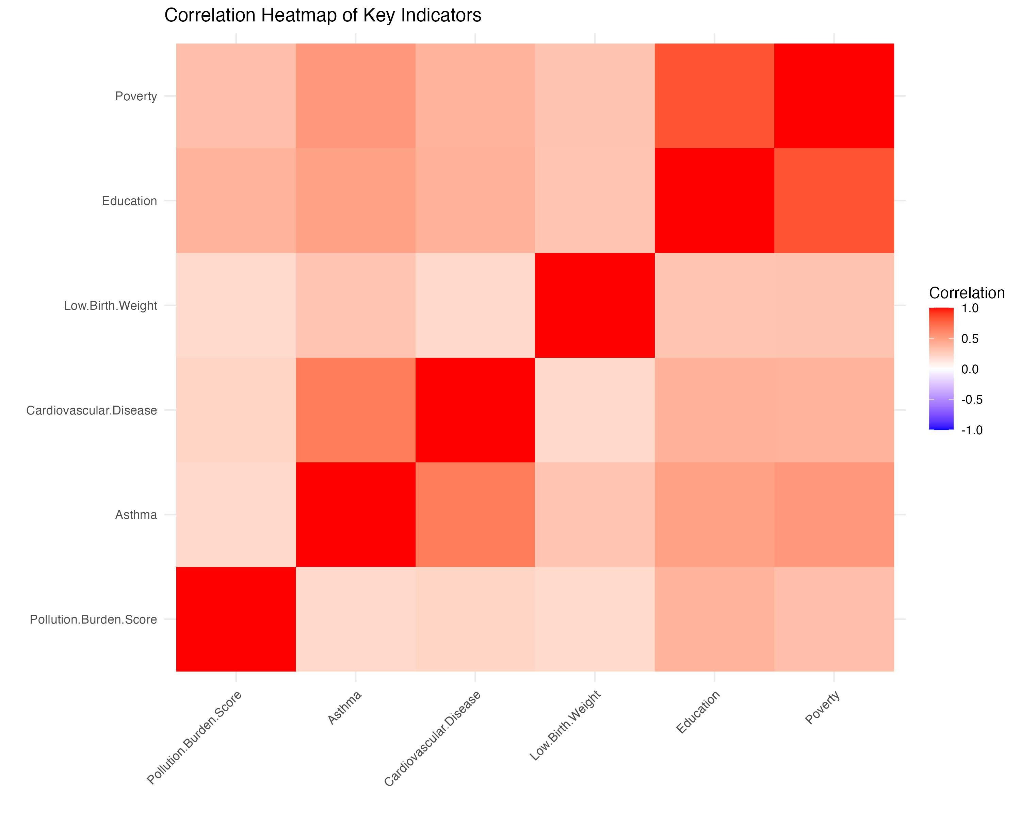
The correlation heatmap reveals important relationships between key variables:

- Strong positive correlation (0.72) between poverty and low education levels
- Moderate positive correlation (0.58) between pollution burden and asthma rates
- Notable correlation (0.63) between disadvantaged status and health outcomes

The correlation analysis further reinforces these findings, revealing strong interconnections between education, poverty, and health outcomes. This suggests that effective community development requires a holistic approach addressing educational, economic, and health factors simultaneously.

Conclusion
The statistical analyses reveal several significant patterns:
1. Pollution burden levels significantly differ from the regulatory threshold, indicating potential environmental concerns.
2. Disadvantaged communities face substantially higher asthma rates, suggesting environmental health inequities.
3. Education levels strongly correlate with poverty rates, highlighting socioeconomic disparities.

