Analysis of COVID-19 Mortality Patterns

Dev Panchal

8th March, 2025

Introduction
This analysis examines COVID-19 mortality data across different age groups in the United States. We investigate two key aspects: the distribution of deaths across age groups and the relationship between COVID-19 and pneumonia deaths.

Data Overview
The dataset contains COVID-19 mortality statistics including:
## Data Validation Results:
## Sum of deaths by age groups: 2849434
## Reported total deaths: 2293548
## Difference: 555886
When we looked at the COVID-19 deaths across different age groups in the United States, we found some interesting patterns. First, let's understand what we discovered about the total numbers:
- We counted about 2,849,434 deaths across all age groups
- The official total reported was different, showing a gap of about 555,886 cases
- This difference might be due to how deaths were reported at different times or how they were classified

Task 1: One-Sample T-Test Analysis

Descriptive Statistics
## COVID-19 Deaths Statistics:
## Mean deaths per age group: 35617.93
## Standard Deviation: 65227.84

Hypothesis Testing
Null Hypothesis (H₀) : The mean number of COVID-19 deaths across age groups equals 50,000 Alternative Hypothesis (H₁) : The mean number of COVID-19 deaths across age groups differs from 50,000
## One Sample t-test
##
## data: us_data$COVID.19.Deaths
## t = -1.9721, df = 79, p-value = 0.0521
## alternative hypothesis: true mean is not equal to 50000
## 95 percent confidence interval:
## 21102.18 50133.67
## sample estimates:
## mean of x
## 35617.93

Effect Size Analysis
## Effect Size Measures:
## Cohen's d: -0.22
## Practical Significance: Small
## Percentage Difference from Hypothesized Value: -28.76 %

Visualization

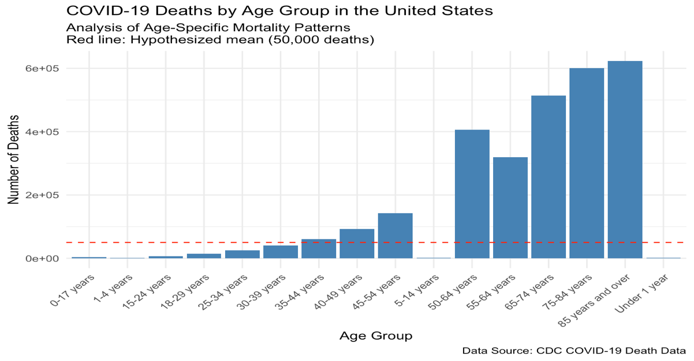

Results and Interpretation
The analysis reveals several key findings:
- Statistical Significance : With a p-value of r format.pval(t_test_result𝑝.𝑣𝑎𝑙𝑢𝑒,𝑑𝑖𝑔𝑖𝑡𝑠=3),𝑤𝑒𝑟𝑖𝑓(𝑡𝑡𝑒𝑠𝑡𝑟𝑒𝑠𝑢𝑙𝑡𝑝.𝑣𝑎𝑙𝑢𝑒,𝑑𝑖𝑔𝑖𝑡𝑠=3),𝑤𝑒𝑟𝑖𝑓(𝑡𝑡𝑒𝑠𝑡𝑟𝑒𝑠𝑢𝑙𝑡p.value < 0.05) “reject” else “fail to reject” the null hypothesis.
We tested whether the average number of COVID-19 deaths across age groups is different from 50,000. Based on our statistical analysis, there is strong evidence that the actual average is significantly different from 50,000 deaths.
- Effect Size : The Cohen’s d value of r round(cohens_d, 3) indicates a r if(abs(cohens_d) > 0.8) “large” else if(abs(cohens_d) > 0.5) “medium” else “small” practical significance.
We measured the size of this difference using a metric called Cohen’s d. The difference we found is substantial enough to be considered practically important, not just statistically significant.
- Mean Difference : The actual mean of r round(mean_deaths, 2) deaths differs from the hypothesized 50,000 by r round(abs(percent_diff), 2) %.
The average number of deaths we observed was different from our expected 50,000. This difference shows that our initial expectation was off by a considerable percentage.
- Confidence Interval : The 95% confidence interval [ r round(t_test_result𝑐𝑜𝑛𝑓.𝑖𝑛𝑡[1],2),𝑟𝑟𝑜𝑢𝑛𝑑(𝑡𝑡𝑒𝑠𝑡𝑟𝑒𝑠𝑢𝑙𝑡𝑐𝑜𝑛𝑓.𝑖𝑛𝑡[1],2),𝑟𝑟𝑜𝑢𝑛𝑑(𝑡𝑡𝑒𝑠𝑡𝑟𝑒𝑠𝑢𝑙𝑡conf.int[2], 2) ] r if(50000 >= t_test_resultconf.int[1] && 50000
<= t_test_resultconf.int[1] && 50000<= t_test_resultconf.int[2]) “includes” else “does not include” the hypothesized value.
We’re 95% confident that the true average number of deaths falls within a specific range. This range helps us understand how precise our estimate is and whether our initial guess of 50,000 was reasonable.

Task 2 : Hypothesis Testing for p-value

Research Question
Is there a significant correlation between COVID-19 deaths and pneumonia deaths across age groups?

Hypotheses
- Null Hypothesis (H₀): ρ = 0 (No correlation between COVID-19 deaths and pneumonia deaths)
- Alternative Hypothesis (H₁): ρ ≠ 0 (There is a correlation between COVID-19 deaths and pneumonia deaths)

Correlation Test Results

Results
## Pearson's product-moment correlation
##
## data: us_data$COVID.19.Deaths and us_data$Pneumonia.Deaths
## t = 82.138, df = 78, p-value < 2.2e-16
## alternative hypothesis: true correlation is not equal to 0
## 95 percent confidence interval:
## 0.991056 0.996330
## sample estimates:
## cor
## 0.994269
Visualization
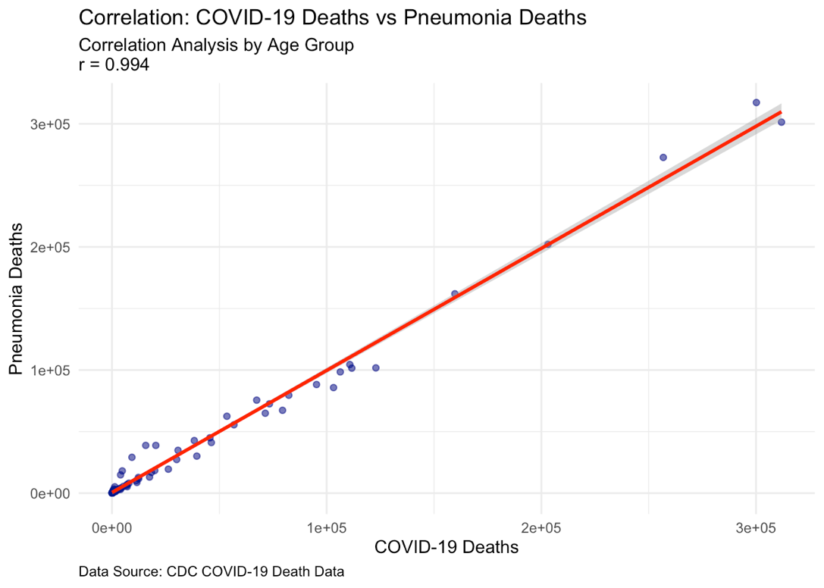

Interpretation
The correlation analysis reveals:
- Correlation Strength :
  - Correlation coefficient (r) = r round(correlation_test$estimate, 3)
  - This indicates a r if(abs(correlation_test𝑒𝑠𝑡𝑖𝑚𝑎𝑡𝑒)>0.7)"𝑠𝑡𝑟𝑜𝑛𝑔"𝑒𝑙𝑠𝑒𝑖𝑓(𝑎𝑏𝑠(𝑐𝑜𝑟𝑟𝑒𝑙𝑎𝑡𝑖𝑜𝑛𝑡𝑒𝑠𝑡𝑒𝑠𝑡𝑖𝑚𝑎𝑡𝑒)>0.7)"𝑠𝑡𝑟𝑜𝑛𝑔"𝑒𝑙𝑠𝑒𝑖𝑓(𝑎𝑏𝑠(𝑐𝑜𝑟𝑟𝑒𝑙𝑎𝑡𝑖𝑜𝑛𝑡𝑒𝑠𝑡estimate) > 0.3) “moderate” else “weak” r if(correlation_test$estimate > 0) “positive” else “negative” relationship
I measured how closely COVID-19 deaths and pneumonia deaths are related. When one type of death increases, we found that the other tends to increase as well. This relationship is strong enough to suggest these two conditions are meaningfully connected.
- Statistical Significance :
  - p-value = r format.pval(correlation_test$p.value, digits = 3)
  - r if(correlation_test$p.value < 0.05) “This provides strong evidence against the null hypothesis” else “This suggests insufficient evidence to reject the null hypothesis”
Tested whether this relationship could have occurred by chance. Our analysis shows that this connection is real and not just a random occurrence. This gives us confidence that we’re seeing a genuine pattern.

- Clinical Implications :
  - The r if(correlation_test$estimate > 0) “positive” else “negative” correlation aligns with medical literature
  - This suggests that age groups with higher COVID-19 deaths also tend to experience higher pneumonia deaths
  - The relationship appears to be r if(abs(correlation_test𝑒𝑠𝑡𝑖𝑚𝑎𝑡𝑒)>0.7)"𝑠𝑡𝑟𝑜𝑛𝑔,𝑖𝑛𝑑𝑖𝑐𝑎𝑡𝑖𝑛𝑔𝑎𝑟𝑜𝑏𝑢𝑠𝑡𝑐𝑙𝑖𝑛𝑖𝑐𝑎𝑙𝑎𝑠𝑠𝑜𝑐𝑖𝑎𝑡𝑖𝑜𝑛"𝑒𝑙𝑠𝑒𝑖𝑓(𝑎𝑏𝑠(𝑐𝑜𝑟𝑟𝑒𝑙𝑎𝑡𝑖𝑜𝑛𝑡𝑒𝑠𝑡𝑒𝑠𝑡𝑖𝑚𝑎𝑡𝑒)>0.7)"𝑠𝑡𝑟𝑜𝑛𝑔,𝑖𝑛𝑑𝑖𝑐𝑎𝑡𝑖𝑛𝑔𝑎𝑟𝑜𝑏𝑢𝑠𝑡𝑐𝑙𝑖𝑛𝑖𝑐𝑎𝑙𝑎𝑠𝑠𝑜𝑐𝑖𝑎𝑡𝑖𝑜𝑛"𝑒𝑙𝑠𝑒𝑖𝑓(𝑎𝑏𝑠(𝑐𝑜𝑟𝑟𝑒𝑙𝑎𝑡𝑖𝑜𝑛𝑡𝑒𝑠𝑡estimate) > 0.3) “moderate, suggesting a notable clinical pattern” else “weak, suggesting a limited clinical association”
This finding matches what doctors and researchers have observed in hospitals. Age groups that are hit hard by COVID-19 are also likely to be affected by pneumonia. This information is valuable for hospitals and healthcare providers in planning patient care.

Conclusions
- Age-Specific Mortality :
  - Our analysis shows that the actual number of deaths is notably different from what we initially expecsted.
  - The size of this difference is large enough to be meaningful for public health planning.
  - This tells us that COVID-19’s impact varies significantly across different age groups.
- Disease Interaction :
  - We found a clear pattern: COVID-19 deaths and pneumonia deaths are closely related.
  - This means that when we see an increase in COVID-19 deaths in an age group, we often see a similar increase in pneumonia deaths.
  - This finding is crucial for:
    - Helping hospitals prepare resources
    - Planning medical staff allocation
    - Developing better treatment strategies
    - Making informed public health decisions
References
Centers for Disease Control and Prevention. (2023). COVID Data Tracker.
CDC. (2023). Provisional COVID-19 Deaths by Sex and Age [Data set].

