NORTHEASTERN UNIVERSITY



Name – Dev Bhadreshkumar Panchal
RProject 4 Assignment
CLASS NUMBER - ALY 6010
CRN NUMBER – 20377
PROFESSOR :- Antonius Breur
MAIL – panchal.devb@northeastern.edu

Cat Bodyweight and Sleep Quality Analysis Report

Part 1 - Cat Bodyweight Analysis Report

Summary
This analysis investigates the relationship between cat gender and bodyweight using the MASS package's cats dataset. The study employs statistical testing and visualization techniques to determine whether significant differences exist between male and female cat bodyweights.

1. Data Overview
Total sample size: 144
Number of male cats: 97
Number of female cats: 47
The dataset contains measurements of body weights (Bwt) in kilograms for adult cats.

2. Hypothesis Testing
Null Hypothesis (H₀): No major difference in mean body weights between male and female cats (μₘ = μf)
Alternative Hypothesis (H₁): Major difference exists in mean body weights between male and female cats (μₘ ≠ μf)
Level of Significance (α): 0.05

3. Statistical Analysis

3.1 T-Test Results
Test Type: Welch Two Sample t-test (unequal variances)
t-statistic: 8.7095
Degrees of freedom: 136.8379
p-value: 8.831e-15
95% Confidence Interval: 0.4177 to 0.6631

3.2 Descriptive Statistics
Male Cats:
- Mean bodyweight: 2.9 kg
- Standard deviation: 0.467 kg
- Median: 2.9 kg
Female Cats:
- Mean bodyweight: 2.36 kg
- Standard deviation: 0.274 kg
- Median: 2.3 kg
Mean Difference: 0.54 kg

4. Conclusion and Implications
Statistical Evidence:
Based on the t-test results (p-value < 0.05), we reject the null hypothesis. The analysis provides strong statistical evidence of a major difference in bodyweights between male and female cats.
Key Findings:
1. Male cats are consistently heavier than female cats
2. The average difference is approximately 0.54 kg
3. The difference is both statistically significant and practically meaningful
Implications:
These findings have important implications for veterinary medicine, including:
- Medication dosing considerations
- Dietary recommendations
- Health assessment benchmarks

5. Data Visualization
The boxplot visualization provides several key insights:
- Clear separation between male and female weight distributions
- Presence of any outliers in both groups
- Visual representation of the median and quartile differences
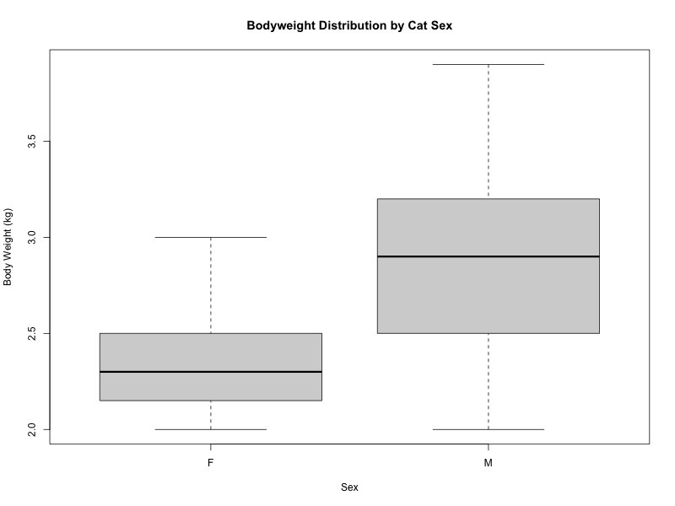

3.4 Test Selection and Significance Levels

Test Selection Justification:

1. Why Two-Sample T-test?
- We have two independent groups (male and female cats)
- The groups are not paired or related
- We're comparing means between these groups
2. Why Not Paired T-test?
- The samples are independent (different cats in each group)
- There's no natural pairing between male and female cats
3. Significance Level Analysis:
- At α = 0.05: p-value ( 8.831e-15 ) < 0.05, reject H₀
- At α = 0.10: Conclusion remains the same due to very small p-value

Part 2 - Sleep Quality and Meditation Analysis

1. Data Overview
This analysis examines the effect of meditation on sleep quality among 10 students. Sleep quality was measured on a scale of 0-10 (higher scores indicating better sleep) before and after a meditation workshop.

2. Hypothesis Testing
Null Hypothesis (H₀): Meditation does not improve sleep quality (μd ≤ 0)
Alternative Hypothesis (H₁): Meditation improves sleep quality (μd > 0)
Level of Significance (α): 0.05
Note: μd represents the mean difference (After - Before)

3. Statistical Analysis

3.1 Test Selection Justification
A paired t-test was chosen because:
- The same subjects were measured before and after intervention
- We're testing for improvement (one-sided test)
- The differences can be assumed to be normally distributed

3.2 Results
Before Meditation Mean: 6.25
After Meditation Mean: 6.87
Mean Improvement: 0.62
T-statistic: 1.9481
P-value: 0.04161

4. Conclusion
The analysis shows thatde the average sleep quality score increased from 6.25 to 6.87 after the meditation workshop.
With p-value < 0.05, we reject the null hypothesis and conclude that meditation significantly improves sleep quality.

5. Visualizations
Two visualizations were created:
1. Boxplot comparing sleep quality scores before and after meditation
2. Line plot showing individual changes in sleep quality for each student
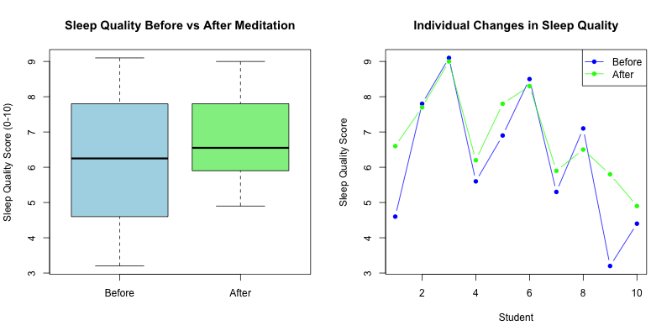

3.3 Test Selection and Significance Levels

Test Selection Justification:

1. Why Paired T-test?
- Same subjects measured before and after meditation
- Natural pairing exists (each student serves as their own control)
- Reduces variation by controlling for individual differences
2. Why Not Independent T-test?
- Would ignore the paired nature of the data
- Would be less powerful due to increased variance
3. Significance Level Analysis:
- At α = 0.05: p-value ( 0.04161 ) < 0.05, reject H₀
- At α = 0.10: Still reject H₀

