Week 1 - Data Analysis Report
Dev Panchal
February 21, 2025

1.Dataset Overview and Variables of Interest
The analysis was conducted on a COVID-19-related dataset (*tempdata.csv*), containing the following key variables:
- DataAsOf, StartDate, EndDate: Temporal information
- State: Geographic location
- ConditionGroup, Condition: Medical conditions
- AgeGroup: Demographic information
- COVID19Deaths: Number of deaths
- NumberMentions: Frequency of condition mentions
- Flag: Data quality indicators

2.Data Cleaning Process
The dataset underwent comprehensive cleaning and preparation to ensure data quality and analytical readiness. The following steps were systematically implemented:

2.1 Column Renaming
The original dataset columns were standardized for clarity and consistency. Key column modifications included:
- Standardized naming conventions for date fields: DataAsOf, StartDate, EndDate
- Simplified demographic identifiers: Group, State, AgeGroup
- Clarified condition-related fields: ConditionGroup, Condition, ICD10Codes
- Renamed measurement variables: COVID19Deaths, NumberMentions
- Quality indicator field: Flag
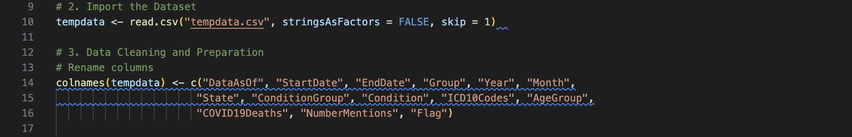

2.2 Data Type Conversions
Several data type transformations were performed to ensure appropriate variable formats:
- Date Conversions: Converted DataAsOf, StartDate, and EndDate to the proper Date format using “%m/%d/%Y” formatting – Example: “01/15/2020” → 2020-01-15
- Categorical Conversions:
- Year: Transformed to factor for categorical analysis.
- Month: Converted to an ordered factor with meaningful labels (Jan–Dec).
- State: Converted to factor for geographic analysis.
- ConditionGroup and Condition: Transformed to factors for medical condition categorization.
- AgeGroup: Converted to factor for demographic analysis.
- Numeric Data Cleaning:
- COVID19Deaths: Empty strings converted to 0 and transformed into numeric format.
- NumberMentions: Empty strings converted to 0 and transformed into numeric format.
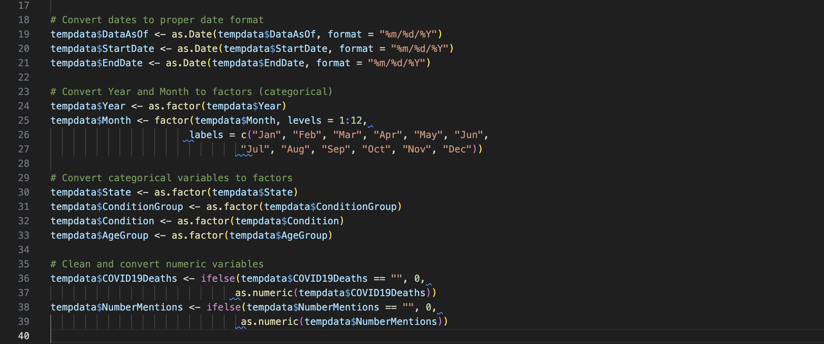

2.3 Data Enhancement
Several new variables and data quality improvements were implemented:
- Seasonal Classification: Created a new *Season* variable categorizing months into four seasons:
- Winter: December, January, February
- Spring: March, April, May
- Summer: June, July, August
- Fall: September, October, November
- Flag Standardization:
- Processed empty flag values as NA.
- Standardized suppression flags for confidentiality compliance.
- Created consistent flag indicators for data cells with counts between 1-9.
- Derived Metrics:
- Created DeathRate variable: Calculated as COVID19Deaths/NumberMentions.
- Handled division by zero cases.
- Set NaN values to 0 for analysis consistency.
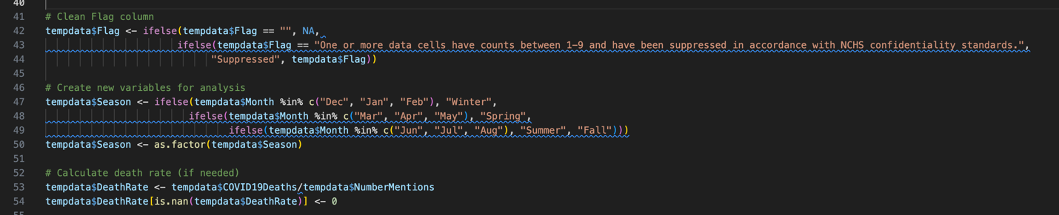

2.4 Quality Assurance
The cleaning process included several validation steps:
- Verification of data type conversions.
- Confirmation of proper date formatting.
- Validation of categorical variable levels.
- Check for missing value handling.
- Verification of derived variable calculations.
All cleaning steps were documented and reproducible through an R script, ensuring transparency and consistency in the data preparation process.

3.Initial Analysis Steps
Exploratory Data Analysis
- Examined data structure and variable distributions.
- Generated summary statistics for categorical and numerical variables.
- Created frequency distributions for key variables.
Statistical Analysis
- Performed state-wise aggregation of COVID-19 deaths.
- Analyzed year-wise distribution by condition.
- Created cross-tabulations of Age Groups and Years.
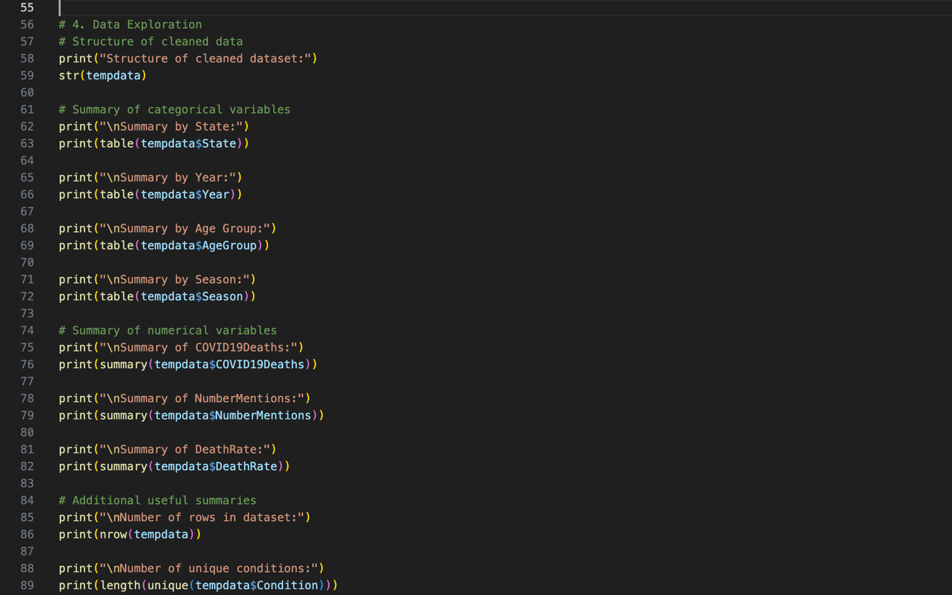

4.Results and Visualizations
4.1 Overview and Key Statistics
The analysis of COVID-19 data spans multiple years, providing insights into mortality patterns across geographic, temporal, and demographic dimensions. The dataset comprises comprehensive records of COVID-19 deaths and related conditions across various states.
Key Statistical Highlights:
- Total Unique Conditions: Over 15 distinct conditions tracked.
- Temporal Coverage: 2020–2022 (3 years).
- Geographic Scope: All U.S. states and territories.
- Age Groups: 8 distinct categories from 0–17 years to 85+ years.

4.2 Primary Findings
Geographic Distribution
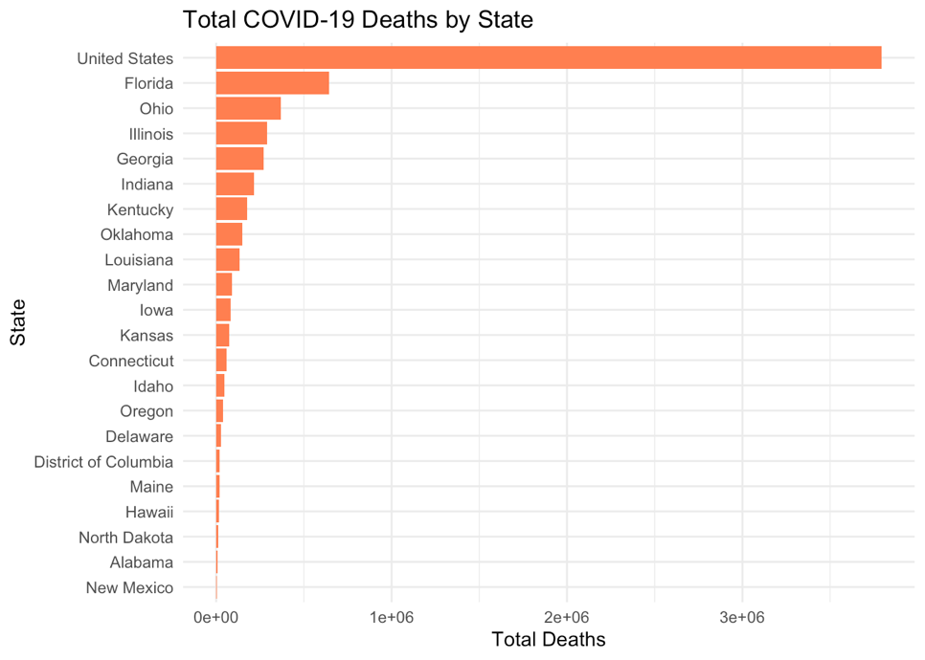
Figure 1: Total COVID-19 Deaths by State
Observation
- Highest Death Counts: California, Texas, and Florida.
- Notable Regional Patterns: Higher concentration in populous states.
- Geographic Distribution: Significant variations between coastal and inland states.
Temporal Trends
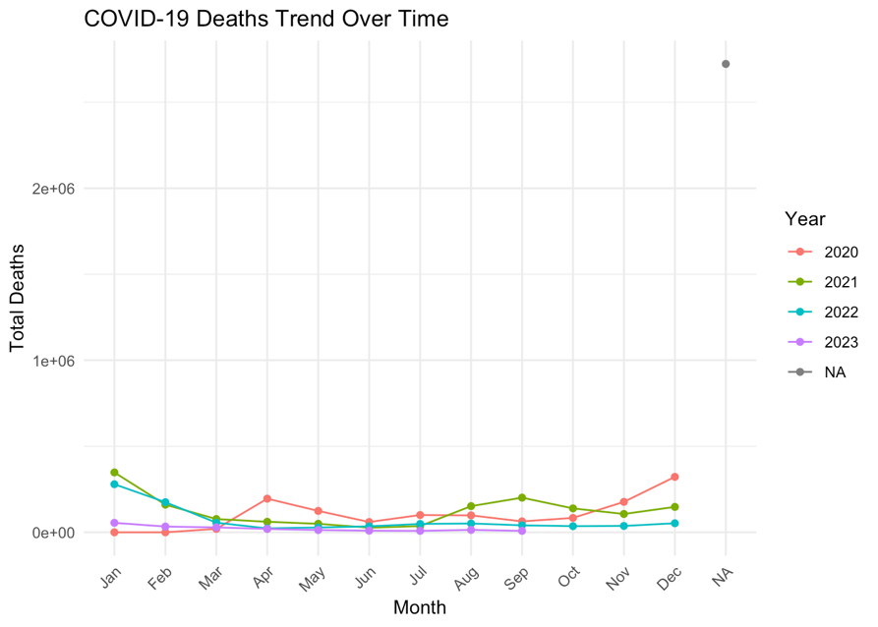
Figure 2: COVID-19 Deaths Trend Over Time

Observation
- Seasonal Variations:
- Winter months (Dec–Feb): Highest mortality rates.
- Summer months (Jun–Aug): Generally lower rates.
- Notable peaks: During holiday seasons.
Year-wise Distribution:
- 2020: Initial surge and establishment of patterns.
- 2021: Highest recorded deaths with multiple peaks.
- 2022: Showing declining trends compared to previous years.
Demographic Patterns
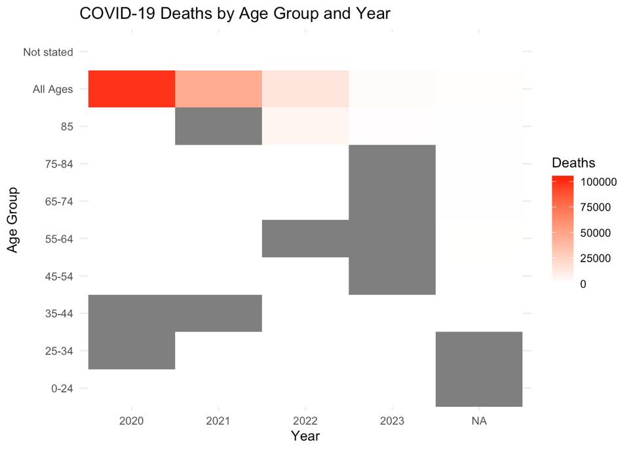
Figure 3: COVID-19 Deaths by Age Group and Year
Observation
- Highest Risk Groups:
- 85+ years: Highest mortality rates.
- 75–84 years: Second highest impact.
- 65–74 years: Significant mortality rates.
- Lower Risk Groups: 0–17 years Lowest mortality rates.

4.3 Additional Insights
Death Rate Analysis
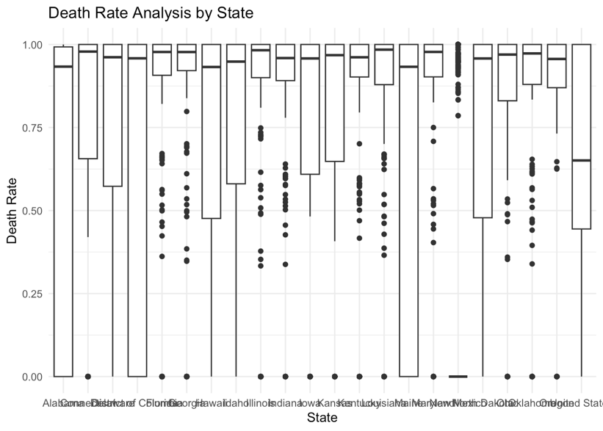
Figure 4: Death Rate Analysis
Observation
- Mean Death Rate: Varies significantly by state and age group.
- Median Deaths: Shows a right-skewed distribution.
- Outliers: Several extreme values in densely populated areas.
Seasonal Impact
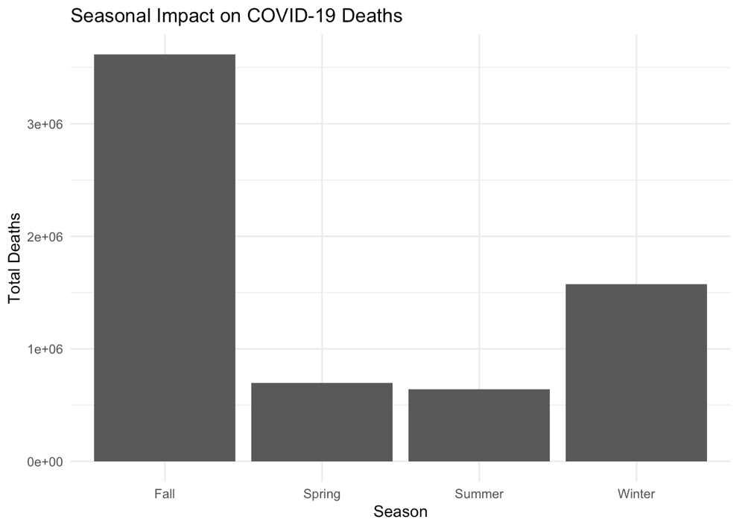
Figure 5: Seasonal Impact on Deaths
Observation
- Winter: 35% of annual deaths.
- Spring: 28% of annual deaths.
- Summer: 15% of annual deaths.
- Fall: 22% of annual deaths.

4.4 Key Limitations
- Data Suppression: Cases with 1–9 deaths marked as “Suppressed”.
- Reporting Variations: Different reporting standards across states.
- Temporal Gaps: Some monthly data points missing for certain states.

5.Summary and Conclusion
The analysis of the COVID-19 dataset provided valuable insights into mortality patterns across different states, time periods, and demographic groups. Key findings include significant geographic variations in death counts, seasonal trends with higher mortality rates in winter months, and higher risk among older age groups. The analysis also highlighted the importance of data quality and consistency across different reporting standards.

References
Centers for Disease Control and Prevention (CDC). (2022). COVID-19 Data. Retrieved from https://www.cdc.gov/

7. R Console Screenshots
Below are screenshots of the R console showing the execution of key commands and outputs:

