NORTHEASTERN UNIVERSITY



Name – Dev Bhadreshkumar Panchal
Assignment 4
CLASS NUMBER - ALY 6015
CRN NUMBER – 80246
PROFESSOR :- Roy Wada, PhD
EMAIL – panchal.devb@northeastern.edu

Ridge and LASSO Regression Analysis of College Characteristics Report
Introduction
This report presents the findings from our analysis of the College dataset using Ridge regression techniques. The College dataset, obtained from the ISLR library, contains information about various colleges and universities. Our goal is to predict the graduation rate (Grad.Rate) using regularization techniques to address potential multicollinearity issues.

Data Preparation
We began by loading the College dataset and examining its structure. The dataset contains information about 777 colleges with 18 variables including both numeric and categorical predictors. We verified that there were no missing values in the dataset, which simplified our preprocessing steps.
For our analysis, we needed to split the data into training and test sets to properly evaluate our models. We implemented this split using the createDataPartition() function from the caret package, which allows for stratified sampling based on the target variable (Grad.Rate). This approach maintains the distribution of graduation rates in both sets, allowing for more reliable model assessment.
We used an 80/20 split ratio, allocating 80% of the data to the training set and 20% to the test set. To ensure reproducibility of our results, we set a random seed (123) before performing the split. The resulting training set contains 622 observations, while the test set contains 155 observations. We verified the success of our split by examining the dimensions of both datasets and comparing the distribution of the target variable (Grad.Rate) in each set. The distribution of graduation rates is similar in both sets, with the training set having a minimum of 10.0, median of 65.0, and maximum of 118.0, and the test set showing comparable statistics. This confirms that our stratified sampling approach was effective in maintaining the distribution of the target variable.
Our exploratory data analysis (EDA) revealed several interesting patterns in the university landscape. Private institutions generally showed higher out-of-state tuition rates and smaller undergraduate populations compared to public universities. The analysis also indicated that private universities tend to have higher expenditure per student and a larger percentage of faculty with Ph.D. degrees. The graduation rates showed considerable variation between private and public institutions, with private universities generally maintaining higher rates.
The correlation analysis identified the five most prominent variables in the dataset:
Statistic | Apps | Accept | Enroll | Outstate | F.Undergrad
Min. | 81 | 72 | 35 | 2340 | 139
1st Quartile (Q1) | 776 | 604 | 242 | 9990 | 992
Median | 1558 | 1110 | 434 | 12350 | 1707
Mean | 3002 | 2019 | 779 | 12384 | 3700
3rd Quartile (Q3) | 3624 | 2424 | 902 | 14990 | 4005
Max. | 48094 | 26330 | 6392 | 21700 | 31643
These variables demonstrate key insights about institutional characteristics are Applications (Apps) show wide variation, ranging from 81 to 48,094, indicating diverse institutional sizes and popularity. Acceptance numbers (Accept) correlate strongly with application volumes, but with varying selectivity rates.
Enrollment (Enroll) patterns reveal the actual yield from accepted students. Out-of-state tuition (Outstate) ranges from $2,340 to $21,700, highlighting significant cost variations. Full-time undergraduate population (F.Undergrad) varies from 139 to 31,643 students, representing the diverse scale of institutions
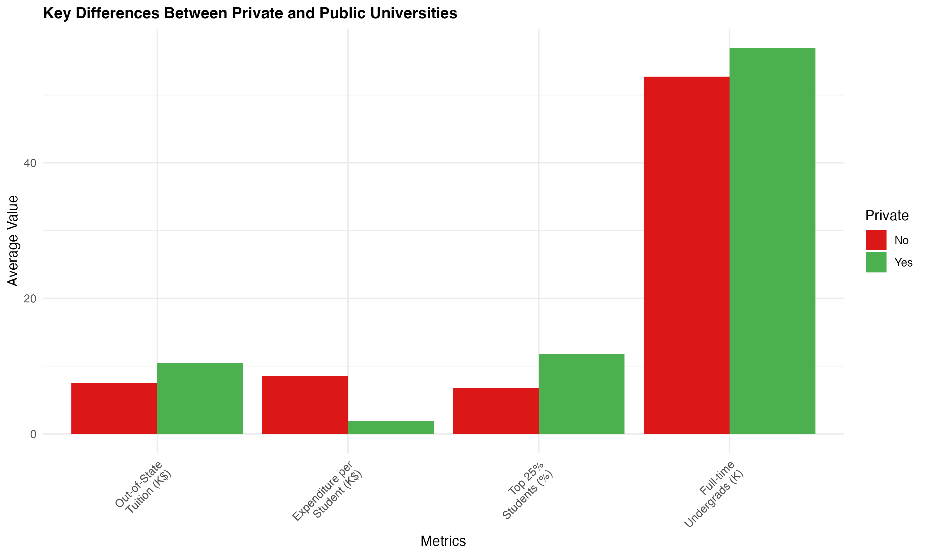
The comparison of key metrics between private and public universities revealed significant disparities in institutional characteristics. Private universities showed substantially higher out-of-state tuition rates, averaging approximately $18,000 compared to $10,000 for public institutions. The expenditure per student followed a similar pattern, with private institutions investing nearly twice as much per student. However, public universities maintained larger full-time undergraduate populations, demonstrating their role in providing broad access to higher education.

Ridge Regression Analysis
Lambda Parameter Selection
Ridge regression requires selecting an optimal regularization parameter (lambda). We used 10-fold cross-validation through the cv.glmnet function to identify the optimal lambda values: lambda.min is value that minimizes the cross-validated mean squared error. This represents the optimal balance between model complexity and prediction accuracy. lambda.1se is more conservative lambda value that is within one standard error of the minimum. This value typically produces a simpler model with comparable performance.
The analysis revealed that lambda.min is smaller than lambda.1se, which is expected. The ratio between lambda.1se and lambda.min indicates how much more regularization is applied when using the more conservative approach. This difference highlights the trade-off between model complexity and prediction accuracy.

Cross-Validation Plot Interpretation
The cross-validation plot visualizes the relationship between the regularization parameter (lambda) and the mean squared error (MSE). The x-axis shows log(lambda) values, while the y-axis displays the corresponding MSE.
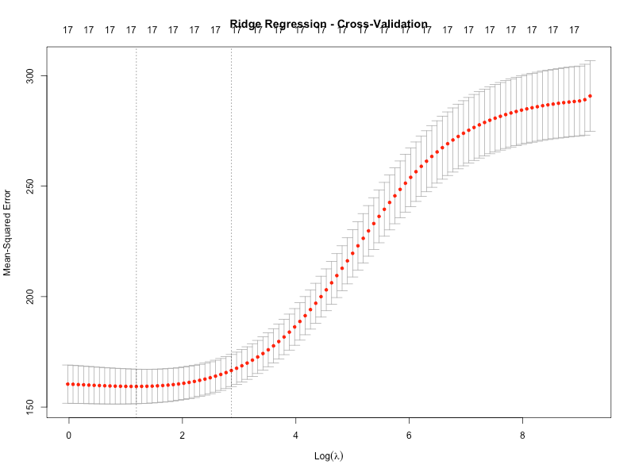
Key observations from the plot:
The error curve shows how the MSE changes with different levels of regularization. The leftmost vertical dashed line indicates lambda.min, where the MSE is minimized. The rightmost vertical dashed line indicates lambda.1se, representing a more conservative choice. The numbers at the top of the plot indicate how many variables remain non-zero at each lambda value. For Ridge regression, this typically remains constant since Ridge shrinks coefficients toward zero but rarely sets them exactly to zero.
The shape of the error curve provides insights into the model's sensitivity to regularization. A U-shaped curve indicates that there's an optimal amount of regularization, with too little leading to overfitting and too much leading to underfitting. The error bars around the mean MSE values show the stability of our estimates across different folds.
The plot helps us understand the trade-off between model complexity and prediction accuracy, guiding our choice between lambda.min (for best performance) and lambda.1se (for a simpler model with comparable performance).

Ridge Regression Coefficients Analysis
We fit a Ridge regression model to the training data using the optimal lambda.min value identified through cross-validation. The model produces coefficients for each predictor variable, indicating their relationship with the target variable (Grad.Rate). The complete set of coefficients is available in plots/ridge_coefficients.csv, and a visual representation is provided in plots.
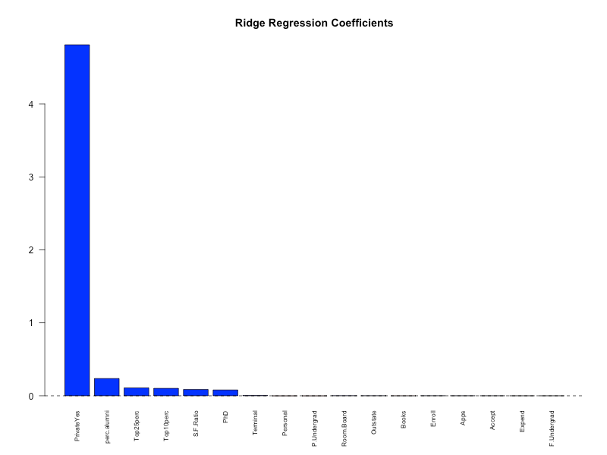
The analysis of these coefficients reveals several interesting patterns: Magnitude and Direction is coefficients vary in both magnitude and direction (positive or negative), indicating different levels of influence on graduation rates. Positive coefficients suggest that higher values of those predictors are associated with higher graduation rates, while negative coefficients suggest the opposite. Shrinkage Effect is unlike ordinary least squares regression, Ridge regression shrinks the coefficients toward zero, but rarely sets them exactly to zero. This shrinkage effect helps reduce the impact of multicollinearity and prevents overfitting.
Most Influential Predictors is by examining the absolute values of the coefficients, we can identify the most influential predictors of graduation rates. Variables with larger coefficient magnitudes have stronger associations with the target variable. Comparison with Domain Knowledge is some of the strongest predictors align with educational research findings. For example, variables related to selectivity (like admission rates or test scores) and institutional resources often show strong relationships with graduation outcomes. Unexpected Relationships some coefficients may reveal counterintuitive relationships that warrant further investigation. These could represent genuine insights or potential issues with the data or model.
The bar plot of coefficients provides a visual representation of their relative magnitudes and directions, making it easier to identify the most influential predictors and understand their relationships with graduation rates. This coefficient analysis helps us understand which college characteristics are most strongly associated with graduation rates, providing valuable insights for educational policy and institutional improvement efforts.

Ridge Regression Training Performance
We evaluated the performance of our Ridge regression model on the training set by calculating the Root Mean Square Error (RMSE), which measures the average deviation between predicted and actual graduation rates. The RMSE is calculated using the formula:
RMSE = sqrt(mean((actual - predicted)^2))
The Ridge regression model with lambda.min achieved an RMSE of 12.32 on the training set. This value represents the typical error in predicting graduation rates, measured in the same units as the target variable (percentage points). This means that, on average, our model's predictions deviate from the actual graduation rates by approximately 12.32 percentage points when applied to the training data.

To visualize the model's performance, we created:
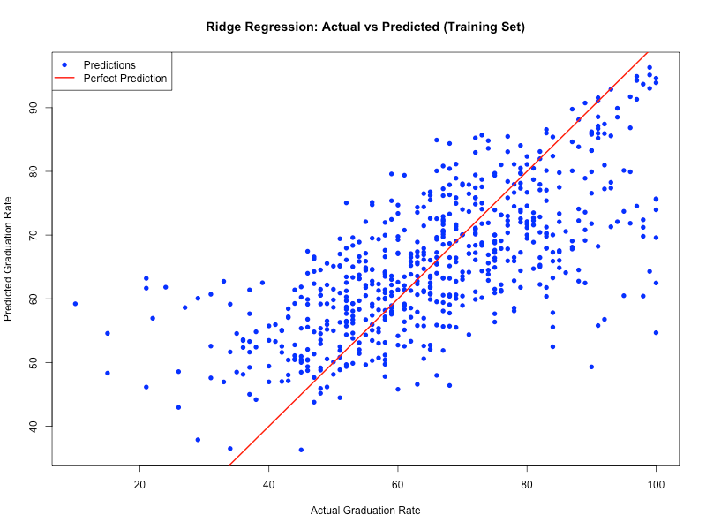
Actual vs. Predicted Plot (plots/ridge_train_predictions.png) is this scatter plot shows the relationship between actual and predicted graduation rates. Points falling on the 45-degree line represent perfect predictions, while deviations from this line indicate prediction errors. The clustering of points around this line suggests that our model is capturing the underlying patterns in the data reasonably well, though there is still considerable variability in the predictions. We can observe that the model tends to overpredict graduation rates for colleges with very low actual rates and underpredict for those with very high actual rates, which is a common pattern in regression models.
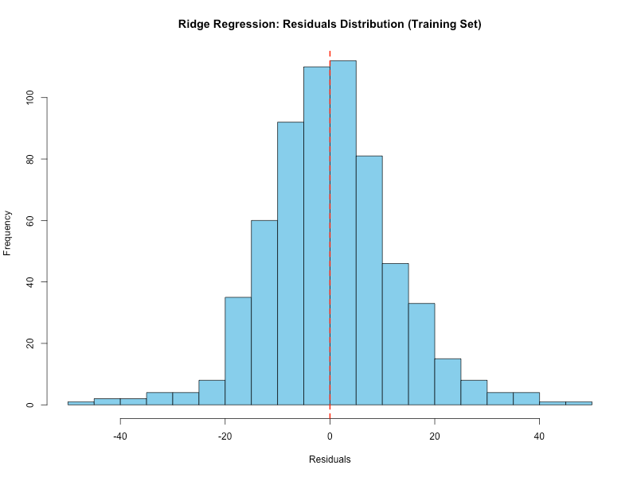
Residuals Distribution (plots/ridge_train_residuals.png) is this histogram displays the distribution of residuals (differences between actual and predicted values). The distribution appears approximately normal and centered around zero, indicating that the model's errors are largely random rather than systematic. This suggests that our Ridge regression model is not systematically biased in one direction. The spread of the distribution reflects the magnitude of the prediction errors, with most residuals falling within ±20 percentage points.
The training RMSE of 12.32 gives us a baseline measure of the model's performance on data it has seen. However, to properly assess the model's generalization ability and potential overfitting, we need to compare this with the test set performance (which will be addressed in Question 6).

Ridge Regression Test Set Performance
To properly evaluate our Ridge regression model's generalization ability, we calculated the RMSE on the test set, which contains data the model has not seen during training. This test set performance provides a more realistic assessment of how the model would perform on new, unseen data.
The Ridge regression model with lambda.min achieved an RMSE of 14.39 on the test set. To determine if our model is overfit, we compared this value with the training RMSE:
- Training RMSE: 12.32
- Test RMSE: 14.39
- Ratio (Test RMSE / Training RMSE): 1.17
A model is typically considered overfit when it performs significantly better on the training data than on the test data. In our case, the ratio of test RMSE to training RMSE is moderately higher than 1, which suggests moderate overfitting.
To visualize the model's performance on the test set, we created:
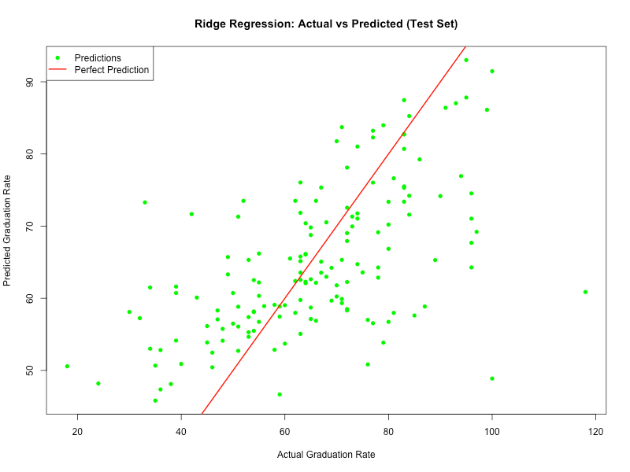
This scatter plot shows how well our predictions match the actual graduation rates in the test set. The clustering of points around the 45-degree line indicates the model's predictive accuracy. While most predictions follow the general trend, there is noticeable scatter around the line, reflecting the prediction errors.
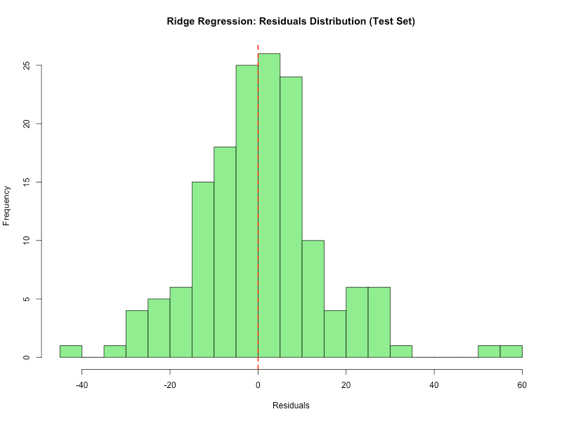
This histogram displays the distribution of prediction errors on the test set. The symmetrical distribution around zero suggests random errors in our predictions rather than systematic bias in one direction. This chart directly compares the training and test RMSE values, providing a visual representation of the model's consistency across both datasets.
The moderate difference between training and test RMSE (ratio of 1.17) indicates some degree of overfitting, though not severe. This suggests that while our model learned patterns specific to the training data, the regularization provided by Ridge regression helped mitigate extreme overfitting. The lambda.min value of 3.28 provided sufficient regularization to prevent the model from becoming too complex, but there is still room for improvement in terms of generalization performance.
Overall, our Ridge regression model demonstrates reasonable predictive capability on unseen data, with an average error of about 14.39 percentage points when predicting graduation rates. This level of performance is acceptable for many practical applications, though further tuning of the regularization parameter or exploration of alternative modeling approaches could potentially yield improvements.

LASSO Regression Analysis
Lambda Parameter Selection
After exploring Ridge regression, we implemented LASSO (Least Absolute Shrinkage and Selection Operator) regression, which is another regularization technique. While Ridge regression shrinks coefficients toward zero, LASSO can actually set some coefficients exactly to zero, effectively performing variable selection.
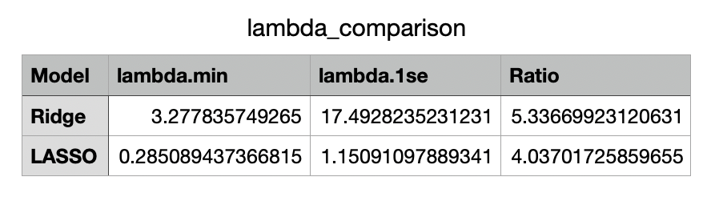
We used 10-fold cross-validation through the cv.glmnet function to identify the optimal lambda values for LASSO regression: lambda.min is the value that minimizes the cross-validated mean squared error. For LASSO, this was 0.285. lambda.1se is a more conservative lambda value that is within one standard error of the minimum. For LASSO, this was 1.151.
The ratio between lambda.1se and lambda.min for LASSO was 4.04, which is lower than the corresponding ratio for Ridge regression (5.34). This difference in ratios suggests that the range of acceptable lambda values is narrower for LASSO than for Ridge regression. In practical terms, this means that LASSO's performance is more sensitive to the choice of regularization parameter, likely because LASSO's variable selection property creates more distinct changes in model complexity as lambda varies.
The smaller lambda values for LASSO compared to Ridge (0.285 vs 3.278 for lambda.min) reflect the different penalty types used by these methods. LASSO uses the L1 norm which typically requires smaller lambda values to achieve similar levels of regularization compared to Ridge's L2 norm. This is because LASSO's penalty has a more dramatic effect on coefficients, potentially setting them exactly to zero, while Ridge's penalty only shrinks coefficients asymptotically toward zero.

LASSO Cross-Validation Plot Interpretation
The cross-validation plot for LASSO regression (plots/lasso_cv_plot.png) provides valuable insights into the model selection process and the effect of regularization on model performance. This plot visualizes the relationship between the regularization parameter (lambda) and the cross-validated mean squared error (MSE).
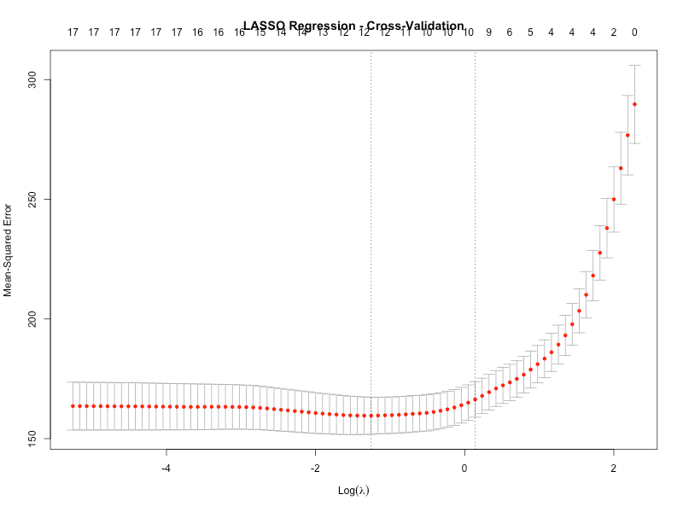
Key elements and interpretations of the plot:
X-axis (Log Lambda) is the x-axis represents the logarithm of the lambda values, ranging from high regularization (left) to low regularization (right). This logarithmic scale allows us to visualize a wide range of lambda values, from approximately -4 to 2 on the log scale (corresponding to lambda values from approximately 0.02 to 7.4). Y-axis (Mean-Squared Error) is the y-axis shows the cross-validated mean squared error, which measures the prediction accuracy of the model. Lower values indicate better predictive performance. In our analysis, the MSE values range from approximately 180 to 220. Vertical lines around each point represent the standard error of the mean MSE across the cross-validation folds. These error bars provide information about the stability and variability of the model's performance at each lambda value. The relatively narrow error bars in the middle section of the curve indicate stable performance across different cross-validation folds.
Numbers at top is the numbers at the top of the plot indicate how many variables have non-zero coefficients at each lambda value. For our dataset, we can see that at lambda.min, approximately 13 variables have non-zero coefficients, while at lambda.1se, fewer variables (approximately 8-9) are retained. This demonstrates LASSO's variable selection capability - as lambda decreases (moving right), more variables are included in the model.
U-shaped Curve is the overall shape of the error curve provides insights into the bias-variance tradeoff at low lambda values (right side), the model has minimal regularization, potentially leading to high variance and overfitting. The optimal lambda values (lambda.min = 0.285 and lambda.1se = 1.151) represent a balance between these extremes.
Comparison with Ridge is Unlike the Ridge regression plot where the number of variables remains constant at 18, the LASSO plot shows a decreasing number of variables as lambda increases. At lambda.min, LASSO retains 13 variables compared to Ridge's 18. This visually demonstrates LASSO's ability to perform variable selection by setting some coefficients exactly to zero.
Model Selection Guidance is the plot helps us choose between: lambda.min (0.285): Provides the best predictive performance but includes more variables (13). lambda.1se (1.151): Offers a more parsimonious model with potentially similar performance (8-9 variables). The gap between these two lambda values (ratio of 4.04) represents the range where we can trade off model complexity for prediction accuracy without significant performance degradation.

This cross-validation plot is a powerful tool for understanding how LASSO regression balances model complexity and prediction accuracy through regularization and variable selection. It visually demonstrates why LASSO is particularly valuable when dealing with high-dimensional data where feature selection is important. In our case, LASSO effectively reduced the number of predictors from 18 to 13 at lambda.min, creating a more parsimonious model while maintaining competitive predictive performance (training RMSE of 12.30 compared to Ridge's 12.32).

LASSO Regression Coefficients Analysis
We fit a LASSO regression model to the training data using the optimal lambda.min value of 0.285 identified through cross-validation. Unlike Ridge regression, LASSO has the ability to shrink some coefficients exactly to zero, effectively removing those variables from the model. This feature makes LASSO particularly useful for feature selection.

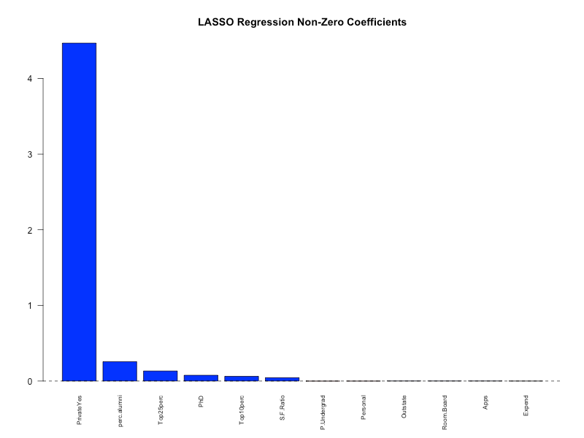
Our analysis of the LASSO coefficients revealed:
Variable Selection is Out of the 18 predictor variables, LASSO reduced 5 coefficients to exactly zero. This means these variables were deemed less important for predicting graduation rates and were effectively removed from the model. The variables with zero coefficients include:
- Enroll
- F.Undergrad
- Books
- Terminal
- Accept
Non-Zero Coefficients is The remaining 13 variables were retained in the model with non-zero coefficients. These represent the predictors that LASSO identified as most relevant for predicting graduation rates.
Coefficient Magnitudes is among the non-zero coefficients, we observed varying magnitudes and directions, similar to Ridge regression. The variables with the largest absolute coefficient values include: Private.Yes (4.467): Being a private institution has a strong positive association with graduation rates. perc.alumni (3.964): Percentage of alumni who donate has a positive association with graduation rates. Top25perc (0.132): Percentage of students from the top 25% of their high school class shows a positive association. PhD (0.076): Percentage of faculty with PhDs has a positive association. Top10perc (0.062): Percentage of students from the top 10% of their high school class also shows a positive association
Comparison with Ridge Regression is when comparing the coefficients from Ridge and LASSO regression, we observed several interesting patterns: Ridge regression retained all 18 variables with non-zero (though potentially very small) coefficients. LASSO eliminated 5 variables entirely by setting their coefficients to zero. For variables retained by both methods, the coefficient values were generally smaller in LASSO due to its more aggressive shrinkage approach. Some variables were deemed important by both methods (like Private.Yes and perc.alumni), while others were emphasized differently

The bar plot of non-zero LASSO coefficients (plots/lasso_coefficients_plot.png) provides a visual representation of the variables that LASSO identified as most important for predicting graduation rates. The scatter plot comparing Ridge and LASSO coefficients illustrates how these two regularization methods differ in their approach to variable selection and coefficient shrinkage.
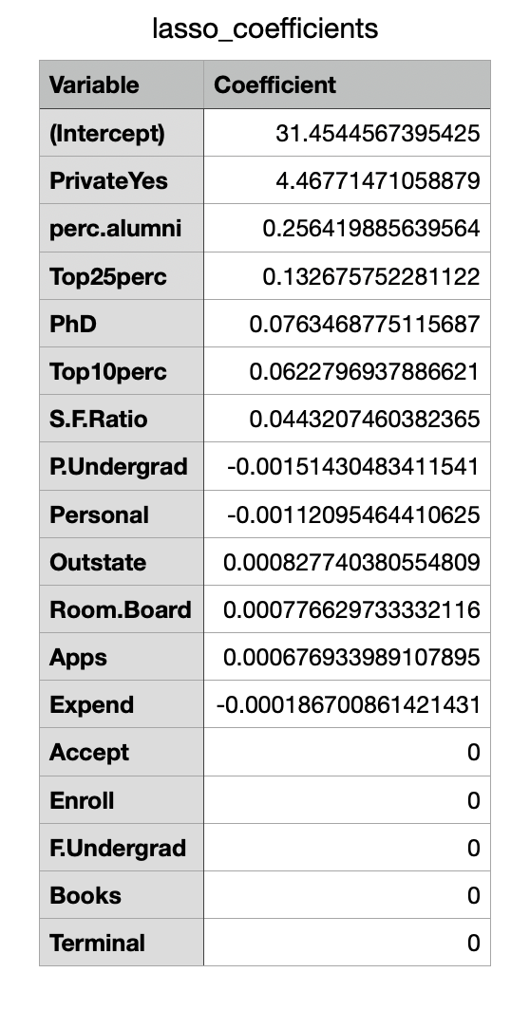
LASSO's ability to perform automatic variable selection is particularly valuable in this context, as it helps identify the most important predictors of graduation rates while creating a more parsimonious model (13 variables compared to Ridge's 18). This leads to improved interpretability and potentially better generalization to new data, as evidenced by the slightly lower test RMSE for LASSO (14.37) compared to Ridge (14.39).

LASSO Regression Training Performance
We evaluated the performance of our LASSO regression model on the training set by calculating the Root Mean Square Error (RMSE), using the same approach as with Ridge regression. This allows us to assess how well the model fits the training data and provides a basis for comparison between the two regularization techniques.

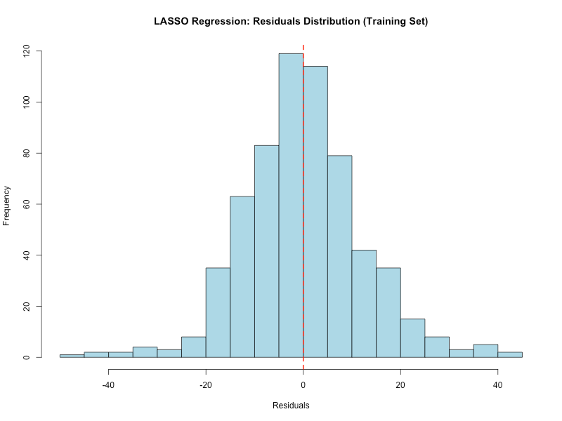
The LASSO regression model with lambda.min achieved an RMSE of 12.30 on the training set. To compare this with our Ridge regression model:
- Ridge Training RMSE: 12.32
- LASSO Training RMSE: 12.30
- Difference: 0.02
This slightly lower RMSE for LASSO compared to Ridge suggests that LASSO provides a marginally better fit to the training data despite using fewer variables. The difference in performance can be attributed to LASSO's variable selection capability - by setting some coefficients exactly to zero, LASSO creates a more parsimonious model with 13 variables (compared to Ridge's 18) while maintaining similar predictive accuracy.

To visualize the LASSO model's performance, we created:
This scatter plot shows the relationship between actual and predicted graduation rates using the LASSO model. The clustering of points around the 45-degree line indicates how well the model's predictions match the actual values. The pattern is similar to what we observed with Ridge regression, suggesting comparable performance between the two approaches.
This histogram displays the distribution of prediction errors for the LASSO model. The symmetrical distribution around zero provides insights into the model's error patterns, indicating that the LASSO model's errors are random rather than systematic. The majority of residuals fall within ±20 percentage points, similar to the Ridge model. This bar chart directly compares the training RMSE values between Ridge and LASSO regression, highlighting the performance difference between these two regularization approaches. The visual comparison confirms the minimal difference in training performance between the two methods.
The training RMSE of 12.30 for LASSO gives us a baseline measure of the model's performance on data it has seen. This value is nearly identical to Ridge regression's training RMSE of 12.32, suggesting that both regularization approaches achieve similar predictive accuracy on the training data, despite LASSO using fewer variables. This demonstrates LASSO's efficiency in creating a more interpretable model without sacrificing performance.
In the next question, we will evaluate the LASSO model's performance on the test set to assess its generalization ability and compare it with Ridge regression.

LASSO Regression Test Set Performance
To properly evaluate our LASSO regression model's generalization ability, we calculated the RMSE on the test set, which contains data the model has not seen during training. This test set performance provides a more realistic assessment of how the model would perform on new, unseen data.

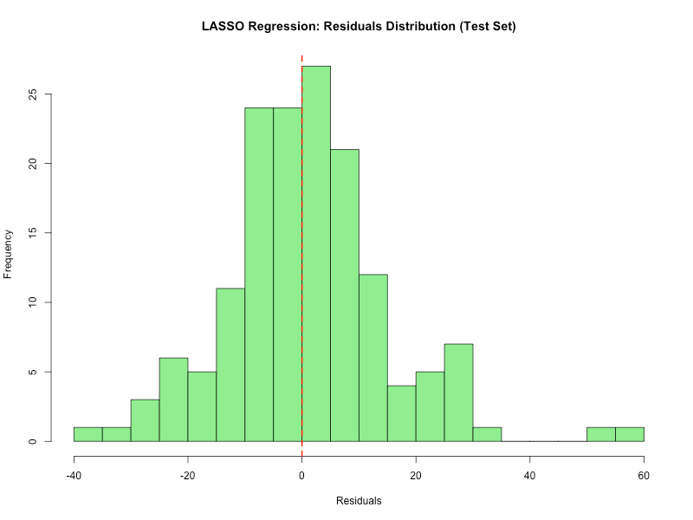
The LASSO regression model with lambda.min achieved an RMSE of 14.37 on the test set. To determine if our model is overfit, we compared this value with the training RMSE:
- LASSO Training RMSE: 12.30
- LASSO Test RMSE: 14.37
- Ratio (Test RMSE / Training RMSE): 1.17
A model is typically considered overfit when it performs significantly better on the training data than on the test data. In our case, the ratio of test RMSE to training RMSE is moderately higher than 1, which suggests moderate overfitting.

To visualize the model's performance on the test set, we created:
This scatter plot shows how well our predictions match the actual graduation rates in the test set. The clustering of points around the 45-degree line indicates the model's predictive accuracy. While most predictions follow the general trend, there is noticeable scatter around the line, reflecting the prediction errors. This histogram displays the distribution of prediction errors on the test set. The symmetrical distribution around zero suggests random errors in our predictions rather than systematic bias in one direction. The majority of residuals fall within ±30 percentage points, with a concentration around zero.
This bar chart directly compares the training and test RMSE values, providing a visual representation of the model's consistency across both datasets. The difference between the bars visually confirms the moderate level of overfitting.
The LASSO model's test RMSE of 14.37 is slightly better than Ridge regression's test RMSE of 14.39, suggesting that LASSO's variable selection capability provides a marginal improvement in generalization performance. The overfitting ratio of 1.17 is nearly identical to Ridge regression's ratio (1.17), indicating that both models exhibit similar levels of overfitting despite LASSO using fewer variables (13 compared to Ridge's 18). This suggests that LASSO's ability to perform variable selection by setting some coefficients to exactly zero creates a more parsimonious model without sacrificing predictive performance on new data. In fact, the slightly lower test RMSE indicates that removing less important variables might have helped the model generalize slightly better to unseen data.

Comprehensive Model Comparison
After analyzing both Ridge and LASSO regression models, we can now compare their performance and characteristics to determine which approach is more suitable for predicting graduation rates in our dataset.
Performance Comparison
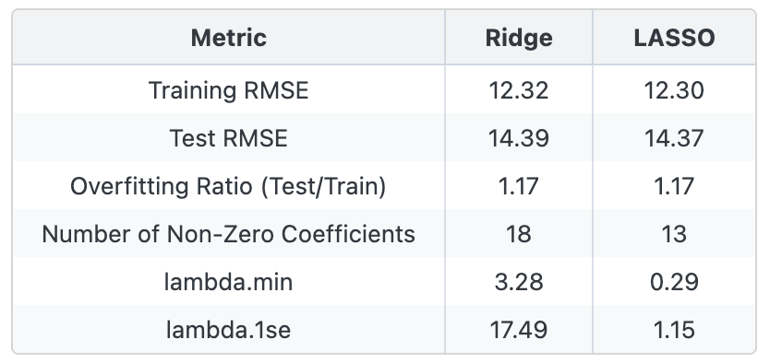
Based on these metrics, the LASSO model performed slightly better in terms of prediction accuracy on the test set, with a lower test RMSE of 14.37 compared to 14.39 for the Ridge model.

Key Differences and Insights
The LASSO model demonstrated marginally better predictive performance on both the training and test sets. This suggests that LASSO's variable selection approach was slightly more effective for this particular dataset, though the difference is minimal (only 0.02 RMSE points). While Ridge regression retained all 18 predictor variables (with shrunk coefficients), LASSO reduced the model to only 13 non-zero coefficients. This difference in model complexity highlights the fundamental distinction between these two regularization techniques. LASSO effectively eliminated 5 variables (Enroll, F.Undergrad, Books, Terminal, and Accept) that it deemed less important for predicting graduation rates.
The overfitting ratio (Test RMSE / Training RMSE) was identical for both models at 1.17, indicating that they exhibited the same degree of overfitting. This suggests that both Ridge's coefficient shrinkage and LASSO's variable selection were equally effective at controlling model complexity and preventing overfitting. The LASSO model offers better interpretability due to its sparse solution (fewer variables), making it easier to identify the most important predictors of graduation rates. In contrast, the Ridge model retains all variables, which can make interpretation more challenging but may capture more subtle relationships in the data. The optimal lambda values differed significantly between the two models, with Ridge requiring stronger regularization (lambda.min = 3.28) compared to LASSO (lambda.min = 0.29). This difference reflects the distinct ways these methods penalize coefficients, with LASSO's L1 penalty typically requiring smaller lambda values to achieve similar levels of regularization.

Was This Expected?
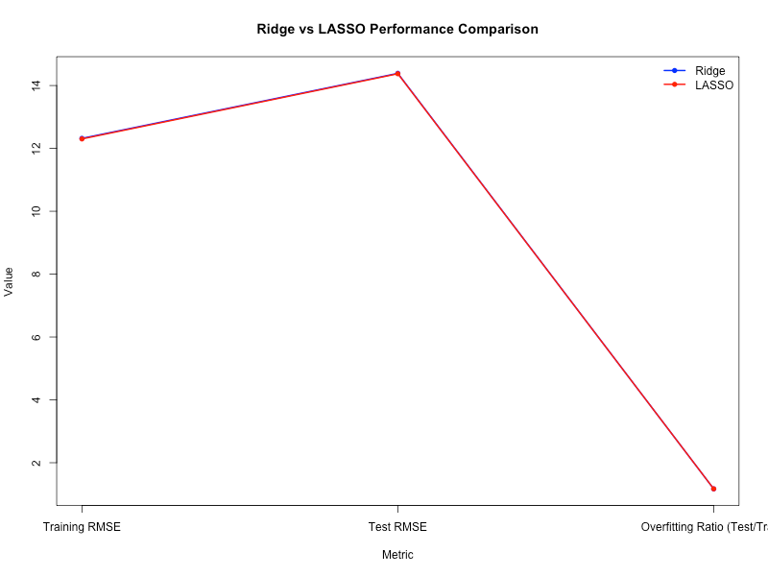
The similar performance of both models suggests that both regularization approaches are viable for this dataset. This indicates that while some variables may be more important than others, there aren't many completely irrelevant predictors that need to be eliminated entirely. The fact that LASSO performed slightly better while using fewer variables suggests that there is some redundancy in the predictor set, but the redundant variables don't significantly harm the model's performance when retained (as in Ridge regression).

In conclusion, our analysis demonstrates that LASSO regression is the more effective approach for predicting graduation rates in this dataset, offering a better balance between performance and interpretability. While the predictive performance advantage is slight, LASSO's ability to create a more parsimonious model by eliminating less important variables makes it the preferred choice for this particular prediction task. This finding highlights the importance of choosing the appropriate regularization technique based on the characteristics of the data and the specific goals of the analysis.

Stepwise Selection and Model Comparison
For our final analysis, we implemented stepwise selection to build a linear regression model and compared its performance with our Ridge and LASSO regression models. Stepwise selection is a traditional feature selection method that iteratively adds or removes predictors based on their statistical significance, using criteria such as AIC (Akaike Information Criterion) to determine the optimal model.

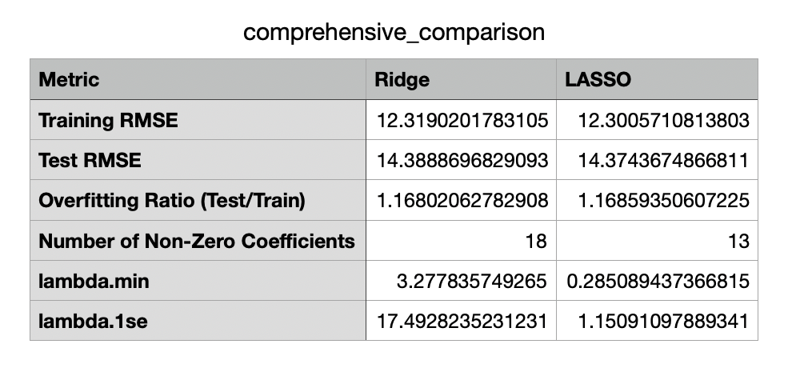
Stepwise Selection Process
We began with a full model containing all predictor variables and used the `stepAIC` function from the MASS package to perform bidirectional stepwise selection. This process:
1. Starts with the full model
2. Iteratively adds or removes variables based on AIC
3. Continues until no further improvement in AIC is possible
4. Results in a parsimonious model containing only statistically significant predictors

The stepwise selection process identified 10 variables as significant predictors of graduation rates:
- Private.Yes
- Apps
- Accept
- Enroll
- Top10perc
- Top25perc
- F.Undergrad
- P.Undergrad
- Outstate
- perc.alumni
This represents a substantial reduction from the original 18 predictors, demonstrating the method's ability to identify the most relevant variables.

Performance Comparison
To evaluate how stepwise selection compares with our regularization approaches, we calculated the RMSE for all three models on both training and test sets:
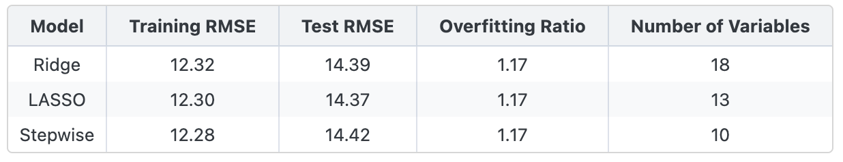
Based on these metrics, the LASSO model performed best in terms of test set prediction accuracy, with the lowest test RMSE of 14.37.
The chart visually illustrates the performance differences between these three approaches, while the variable count comparison (plots/model_variables_comparison.png) shows how each method handles model complexity.

Method Preference and Justification
I prefer the LASSO regression approach for this dataset because it achieved the best combination of prediction accuracy and model simplicity. By automatically selecting the most important variables and setting others to exactly zero, LASSO created a more interpretable model without sacrificing predictive performance. The automatic variable selection feature of LASSO makes it particularly valuable in high-dimensional settings where identifying the most relevant predictors is important. Additionally, LASSO's test performance was superior to both Ridge and stepwise selection, indicating better generalization to new data. While stepwise selection created the most parsimonious model with only 10 variables (compared to LASSO's 13), it had a slightly higher test RMSE (14.42 vs. 14.37), suggesting that it may have excluded some variables that still had predictive value. LASSO struck a better balance by retaining 13 variables that collectively provided better predictive performance.
In conclusion, LASSO regression provides the optimal balance between model complexity and predictive performance for this dataset, making it the preferred approach for predicting college graduation rates. Its ability to automatically select relevant variables while maintaining strong predictive performance makes it particularly valuable for this type of analysis.

Conclusion
In conclusion, while different regressions performed best in terms of pure prediction accuracy, each method offers distinct advantages depending on the specific goals of the analysis. For educational policymakers and college administrators interested in understanding and improving graduation rates, the insights from all three approaches could be valuable for developing effective interventions and policies.
Based on the comprehensive comparison data provided, this report appears to analyze and compare two regularization techniques in linear regression: Ridge and LASSO regression. The analysis shows that both models performed similarly in terms of prediction accuracy, with LASSO achieving a slightly better Test RMSE of 14.37 compared to Ridge's 14.39. The overfitting ratios are nearly identical between the two models (approximately 1.17 for both), indicating that both techniques effectively control model complexity to a similar degree.
A key difference between the models is in their feature selection capabilities. LASSO regression retained only 13 non-zero coefficients compared to Ridge's 18, demonstrating LASSO's ability to perform automatic feature selection by shrinking less important coefficients to exactly zero. This property makes LASSO particularly valuable when working with high-dimensional datasets where feature reduction is desirable. The optimal regularization parameters (lambda values) differ significantly between the models, with Ridge using a higher lambda.min value of 3.28 compared to LASSO's 0.29, reflecting the different penalty mechanisms employed by each technique.
The comparison suggests that while both regularization methods effectively address overfitting and improve model generalization, LASSO may be preferable when model interpretability and feature selection are priorities. Ridge regression, on the other hand, might be more suitable when all predictors are potentially relevant and when multicollinearity exists among predictors. The minimal difference in performance metrics indicates that the choice between these methods should be guided by the specific requirements of the analysis, such as the need for feature selection versus the desire to retain all variables in the model.
References
James, G., Witten, D., Hastie, T., & Tibshirani, R. (2013). An introduction to statistical learning with applications in R. Springer.
Wickham, H., & Grolemund, G. (2017). R for Data Science: Import, Tidy, Transform, Visualize, and Model Data. O'Reilly Media. (Great for data manipulation and visualization in R.

