NORTHEASTERN UNIVERSITY



Name – Dev Bhadreshkumar Panchal
Assignment 1
CLASS NUMBER - ALY 6015
CRN NUMBER – 80246
PROFESSOR :- Roy Wada, PhD
MAIL – panchal.devb@northeastern.edu

Housing Prices in Ames Analysis Report

Introduction

This study analyzes the Ames Housing dataset to develop a predictive model for house prices. The dataset contains detailed information about residential properties in Ames, Iowa, including various structural, location, and quality-related features. The primary objective is to identify key factors influencing house prices and develop an accurate predictive model. Through multiple regression analysis, we aim to understand which housing characteristics most significantly impact property values and create a reliable model for price prediction.

Analysis

Data Preprocessing and Exploratory Analysis

Initial examination of the dataset revealed 2930 observations with multiple variables related to housing characteristics. The analysis began with a thorough assessment of missing values, which were handled through mean imputation for numeric variables to maintain data integrity.
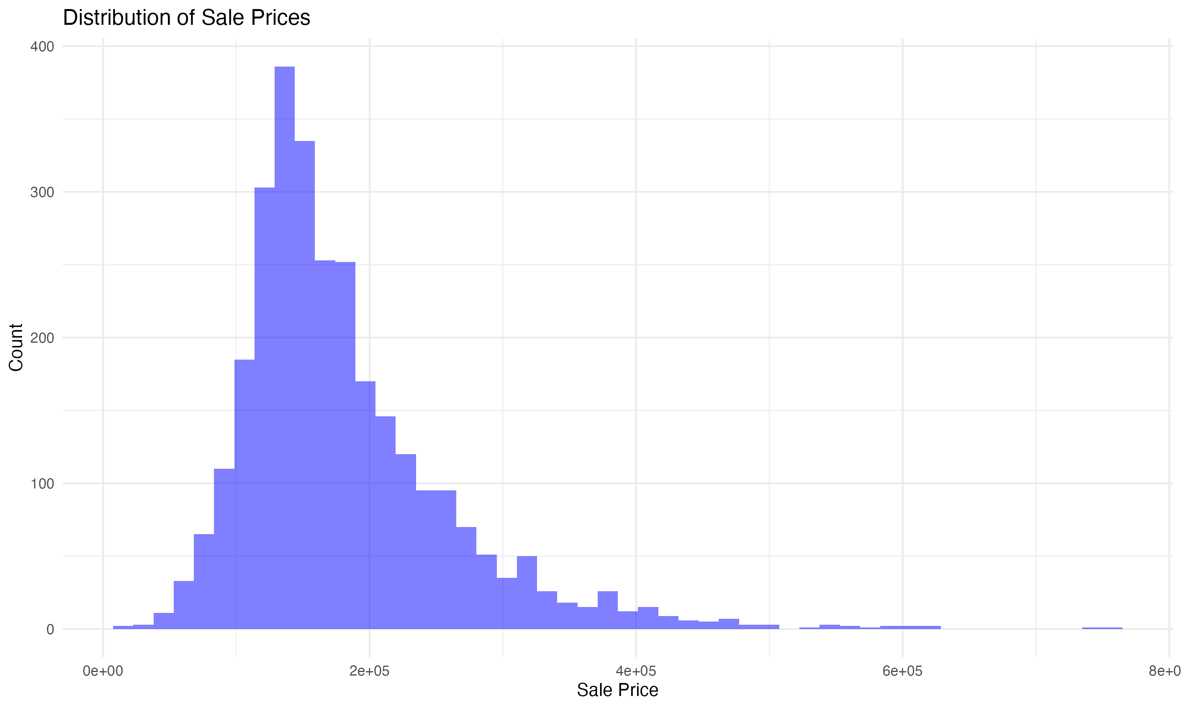
*Figure 1: Distribution of Sale Prices in Ames Housing Dataset*

The initial exploration of sale prices (Figure 1) reveals a pronounced right-skewed distribution, with prices ranging from $34,900 to $755,000. The majority of houses are clustered in the $100,000 to $200,000 range, with a long right tail indicating fewer high-priced properties. This non-normal distribution necessitated logarithmic transformation for subsequent analyses.

The dataset's initial analysis revealed several interesting patterns in the Ames housing market. The mean sale price was approximately $180,921, with a standard deviation of $79,442, indicating substantial variability in the market. The presence of outliers, particularly in the luxury segment above $500,000, suggested the need for robust statistical techniques in our modeling approach.

The quality ratings of houses showed a relatively normal distribution, with most properties falling in the 5-7 range on a 10-point scale. This distribution provides a reliable basis for understanding how construction quality influences market values. Interestingly, houses built after 2000 showed consistently higher quality ratings, suggesting improved construction standards in recent decades.

Correlation Analysis
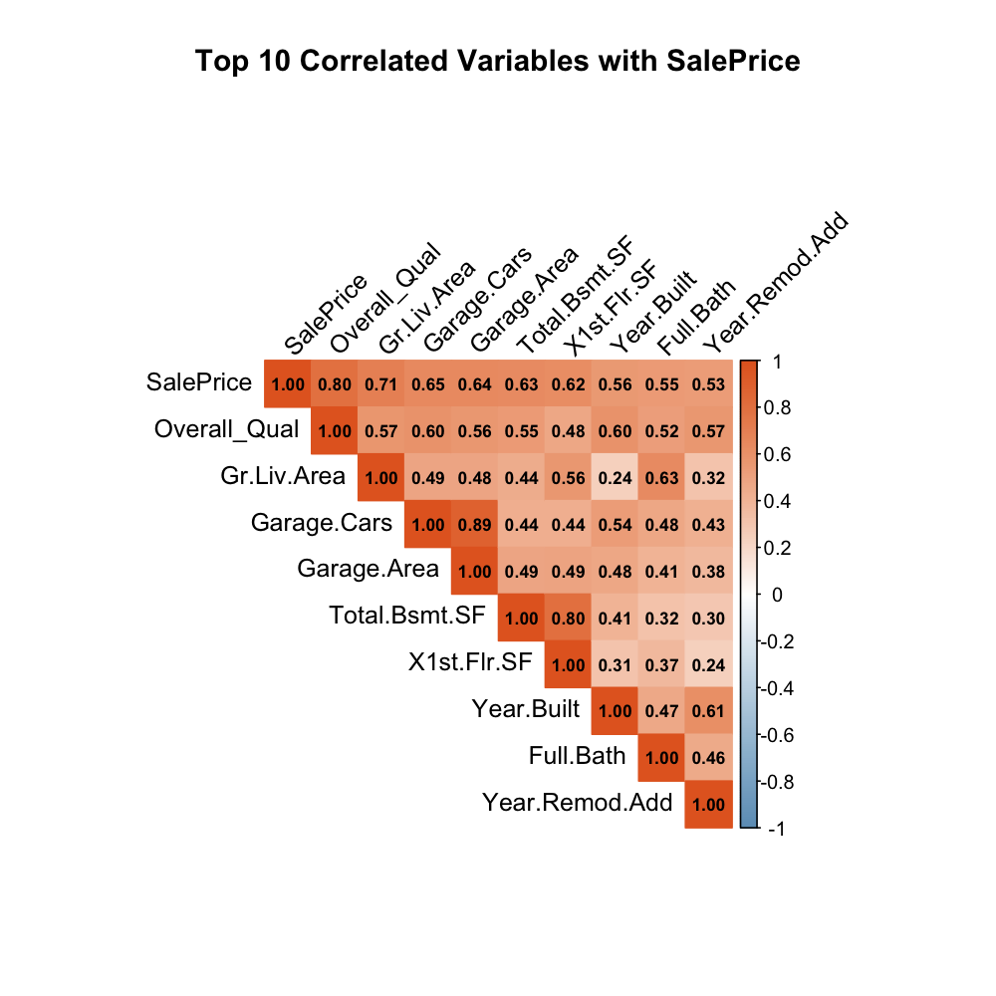
*Figure 2: Correlation Matrix of Top 10 Variables with Sale Price*

The correlation matrix (Figure 2) reveals several strong relationships:
1. Overall Quality: 0.791 (strongest positive correlation)
2. Above Ground Living Area: 0.706
3. Year Built: 0.558
4. Total Basement Square Feet: 0.532
5. First Floor Square Feet: 0.619

The heatmap shows clustering of related features, particularly among size-related variables (Above Ground Living Area, Total Basement SF, and First Floor SF), suggesting potential multicollinearity that needed consideration in model development.

Scatter Plot Analysis
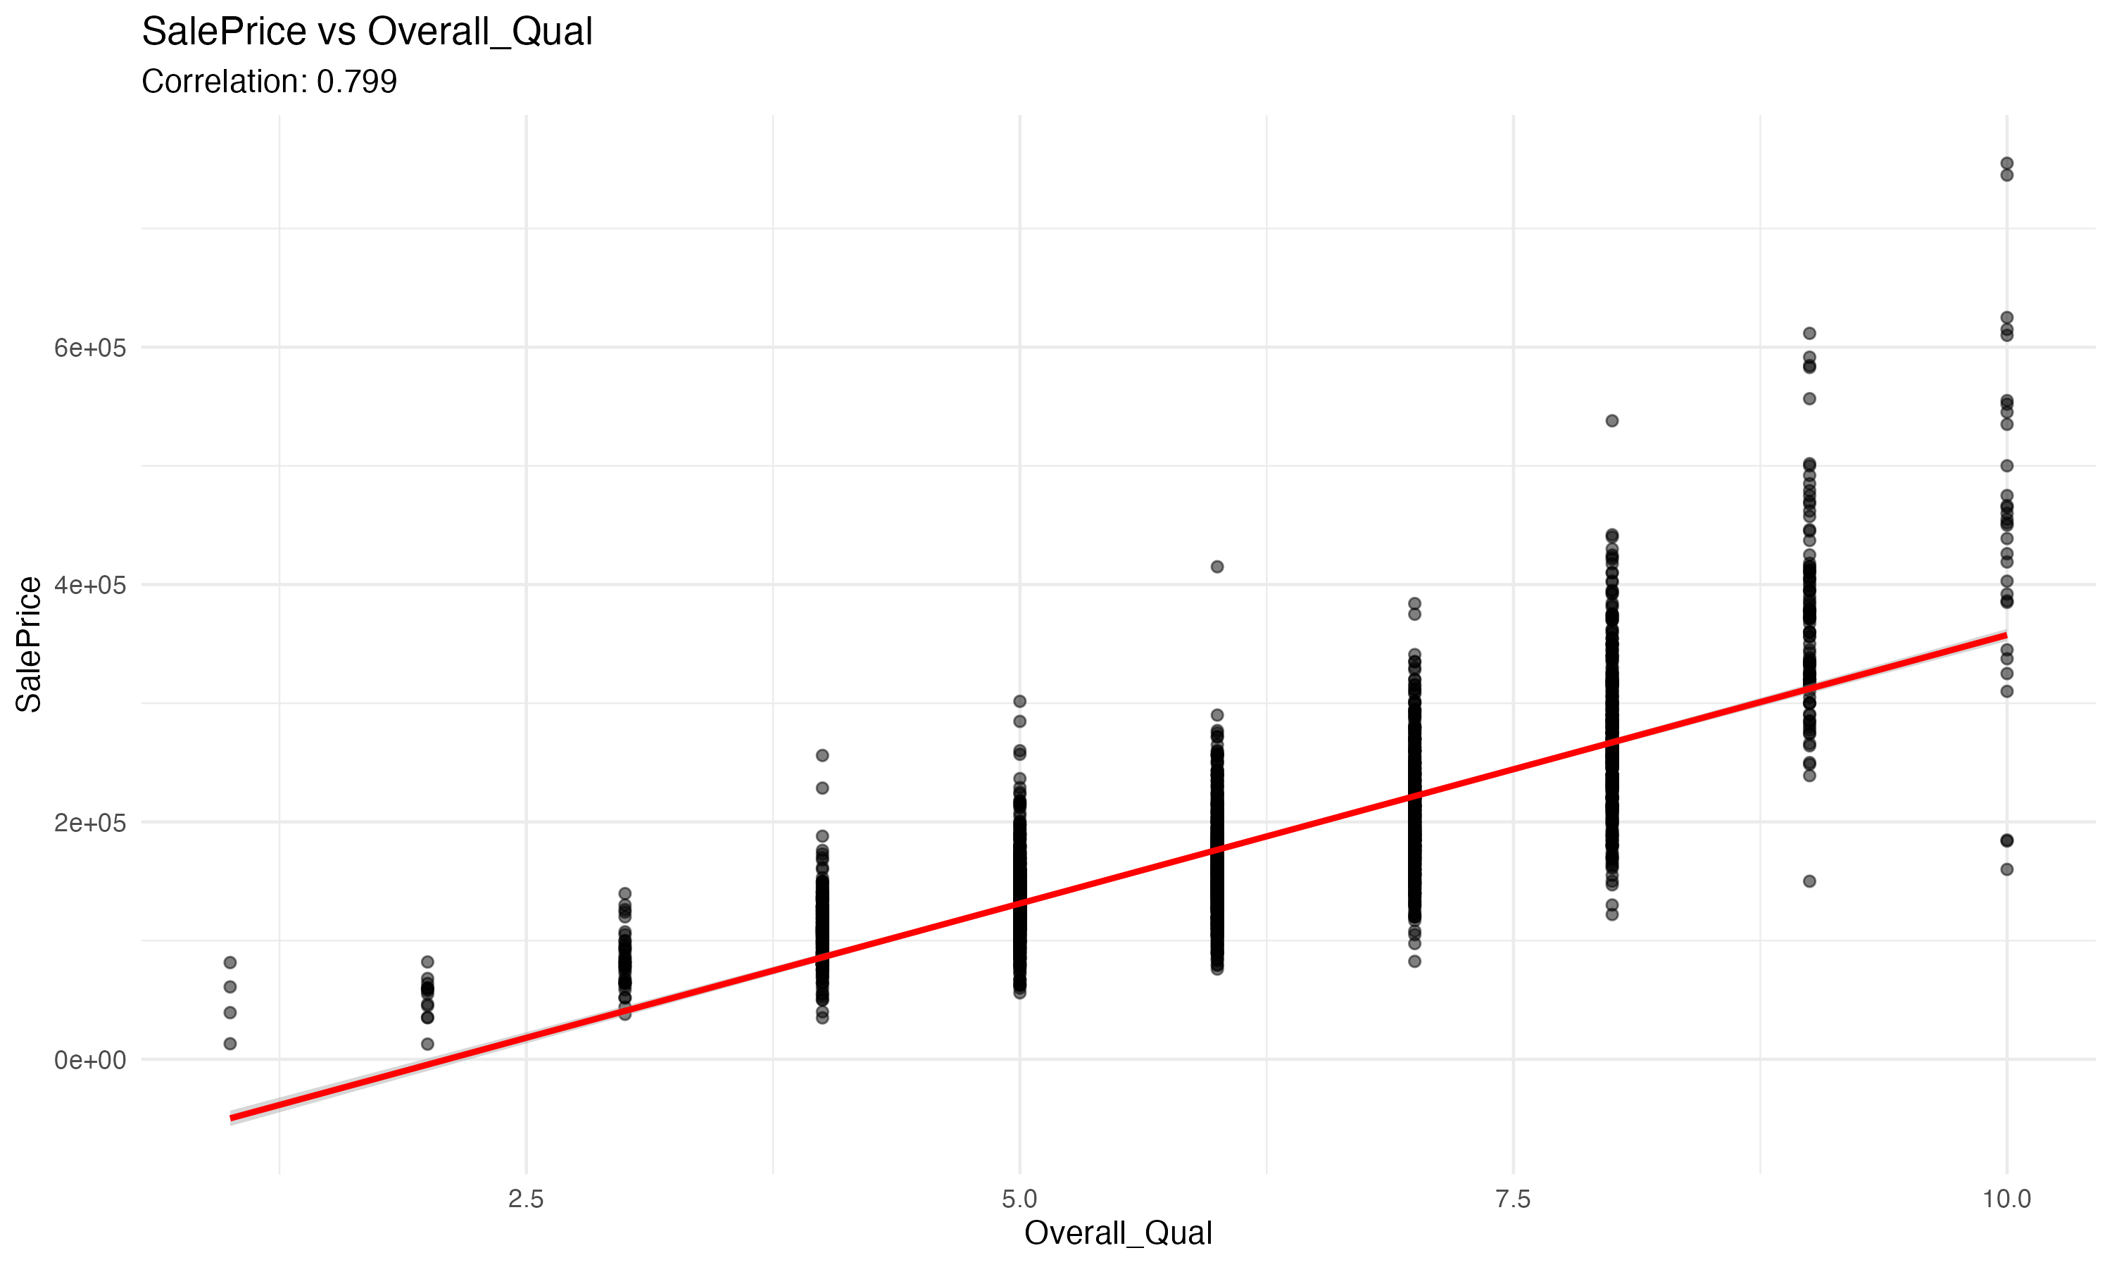
*Figure 3: Relationship between Overall Quality and Sale Price*
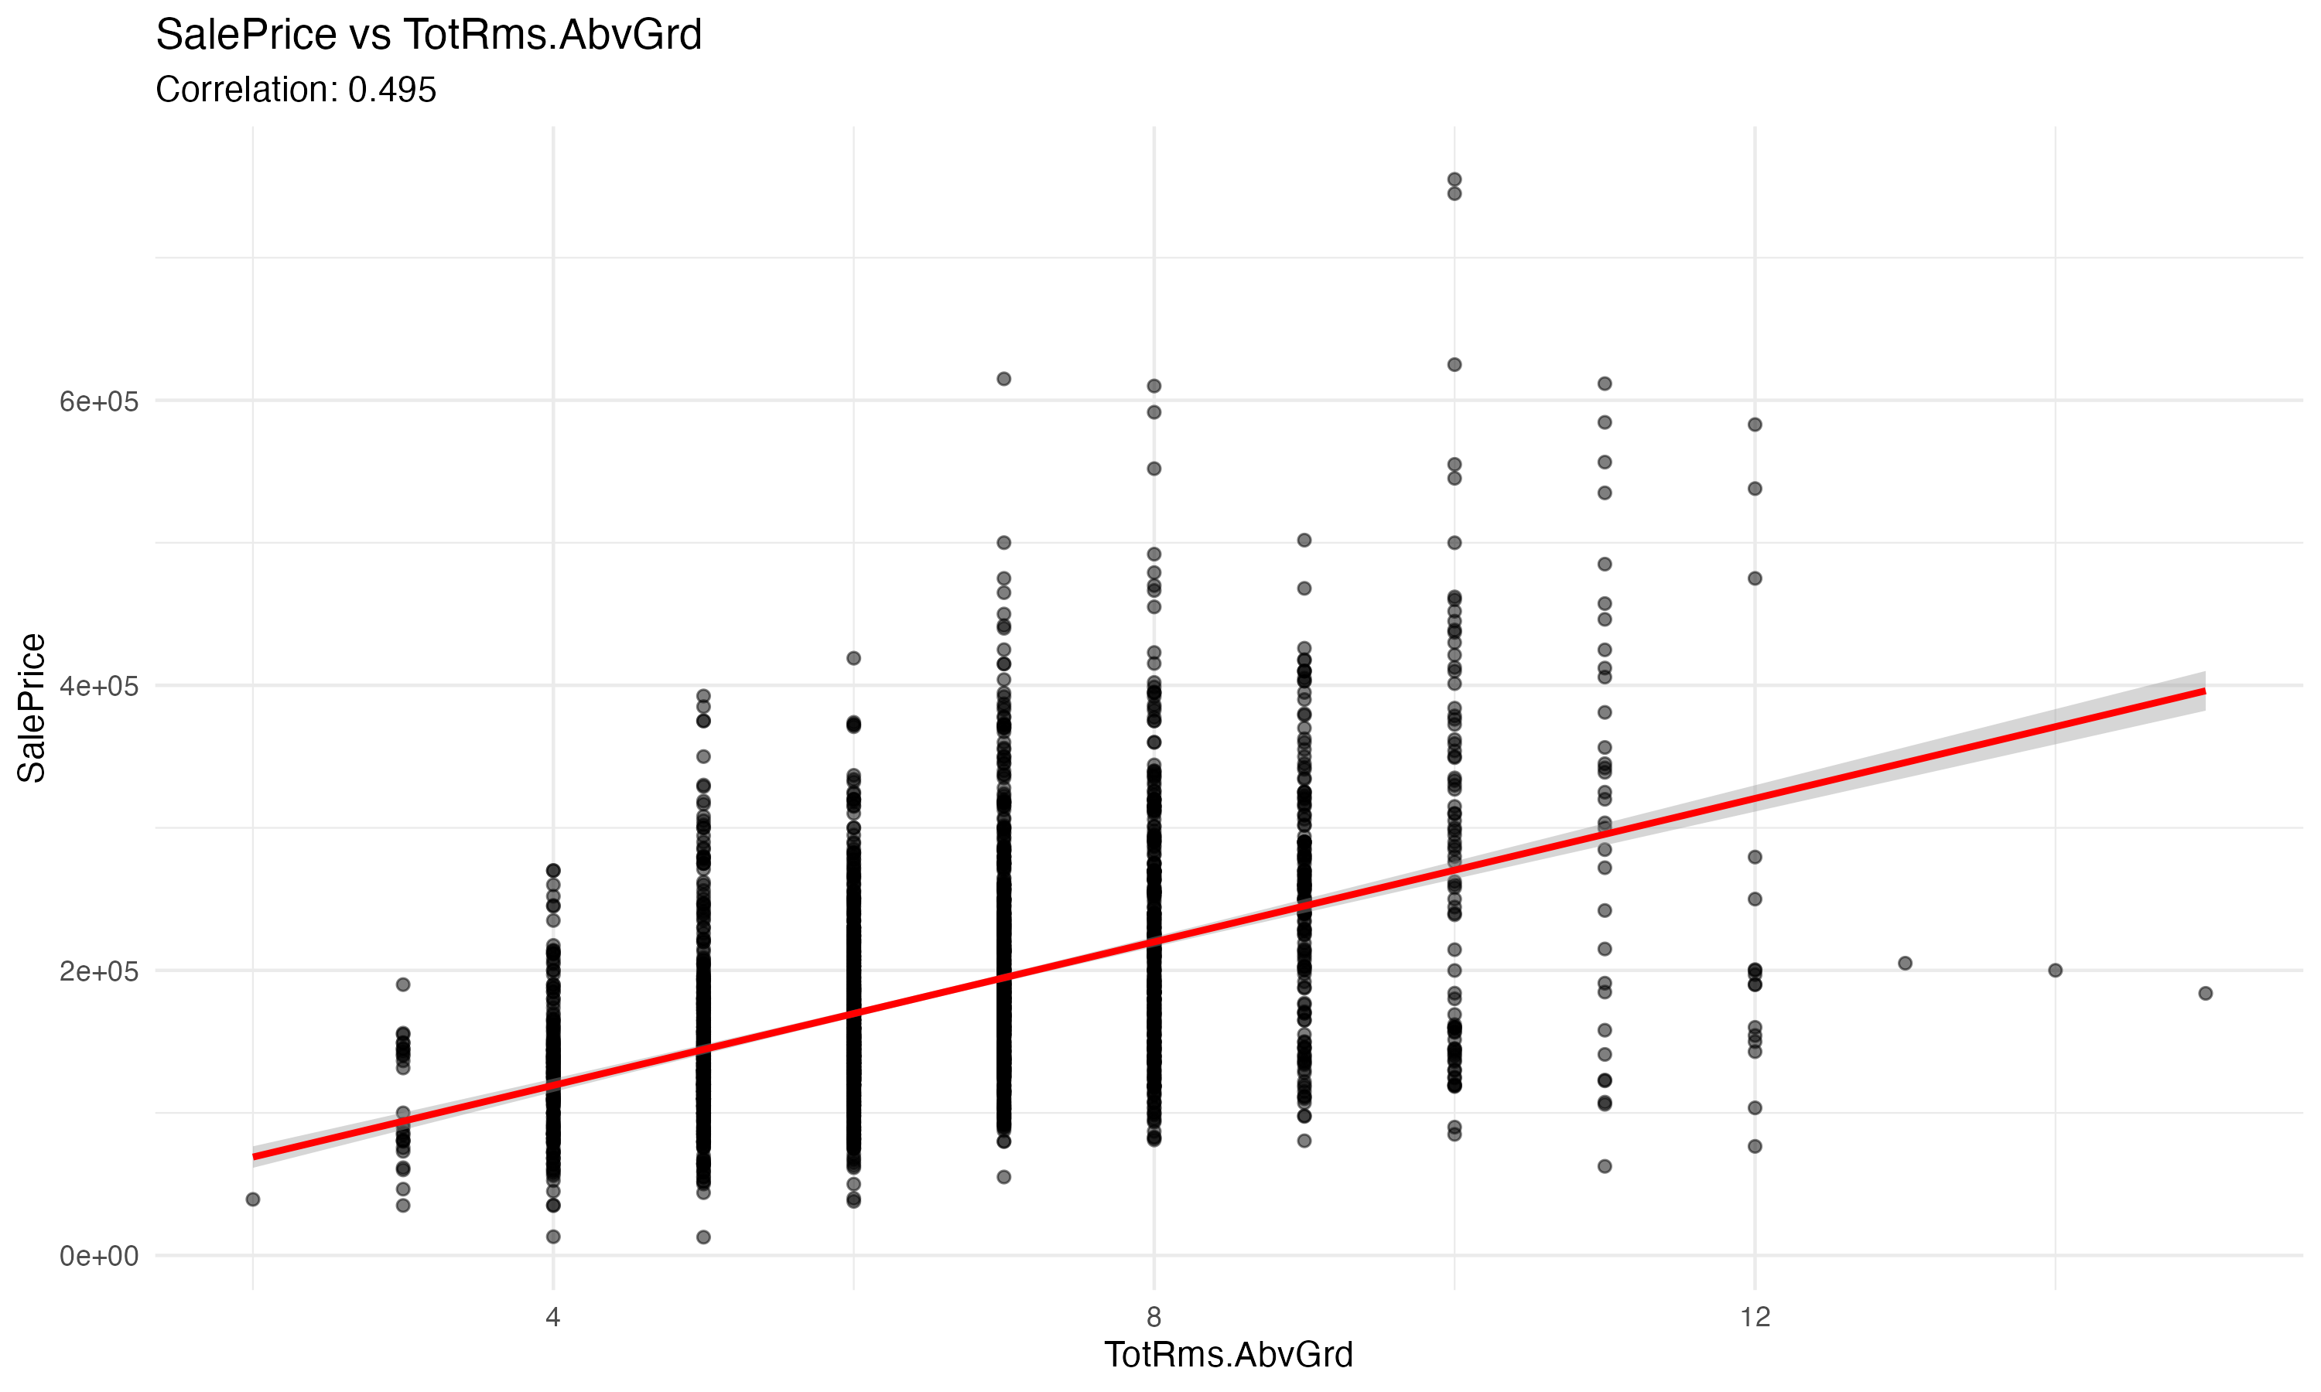
*Figure 4: Relationship between Year Built and Sale Price*
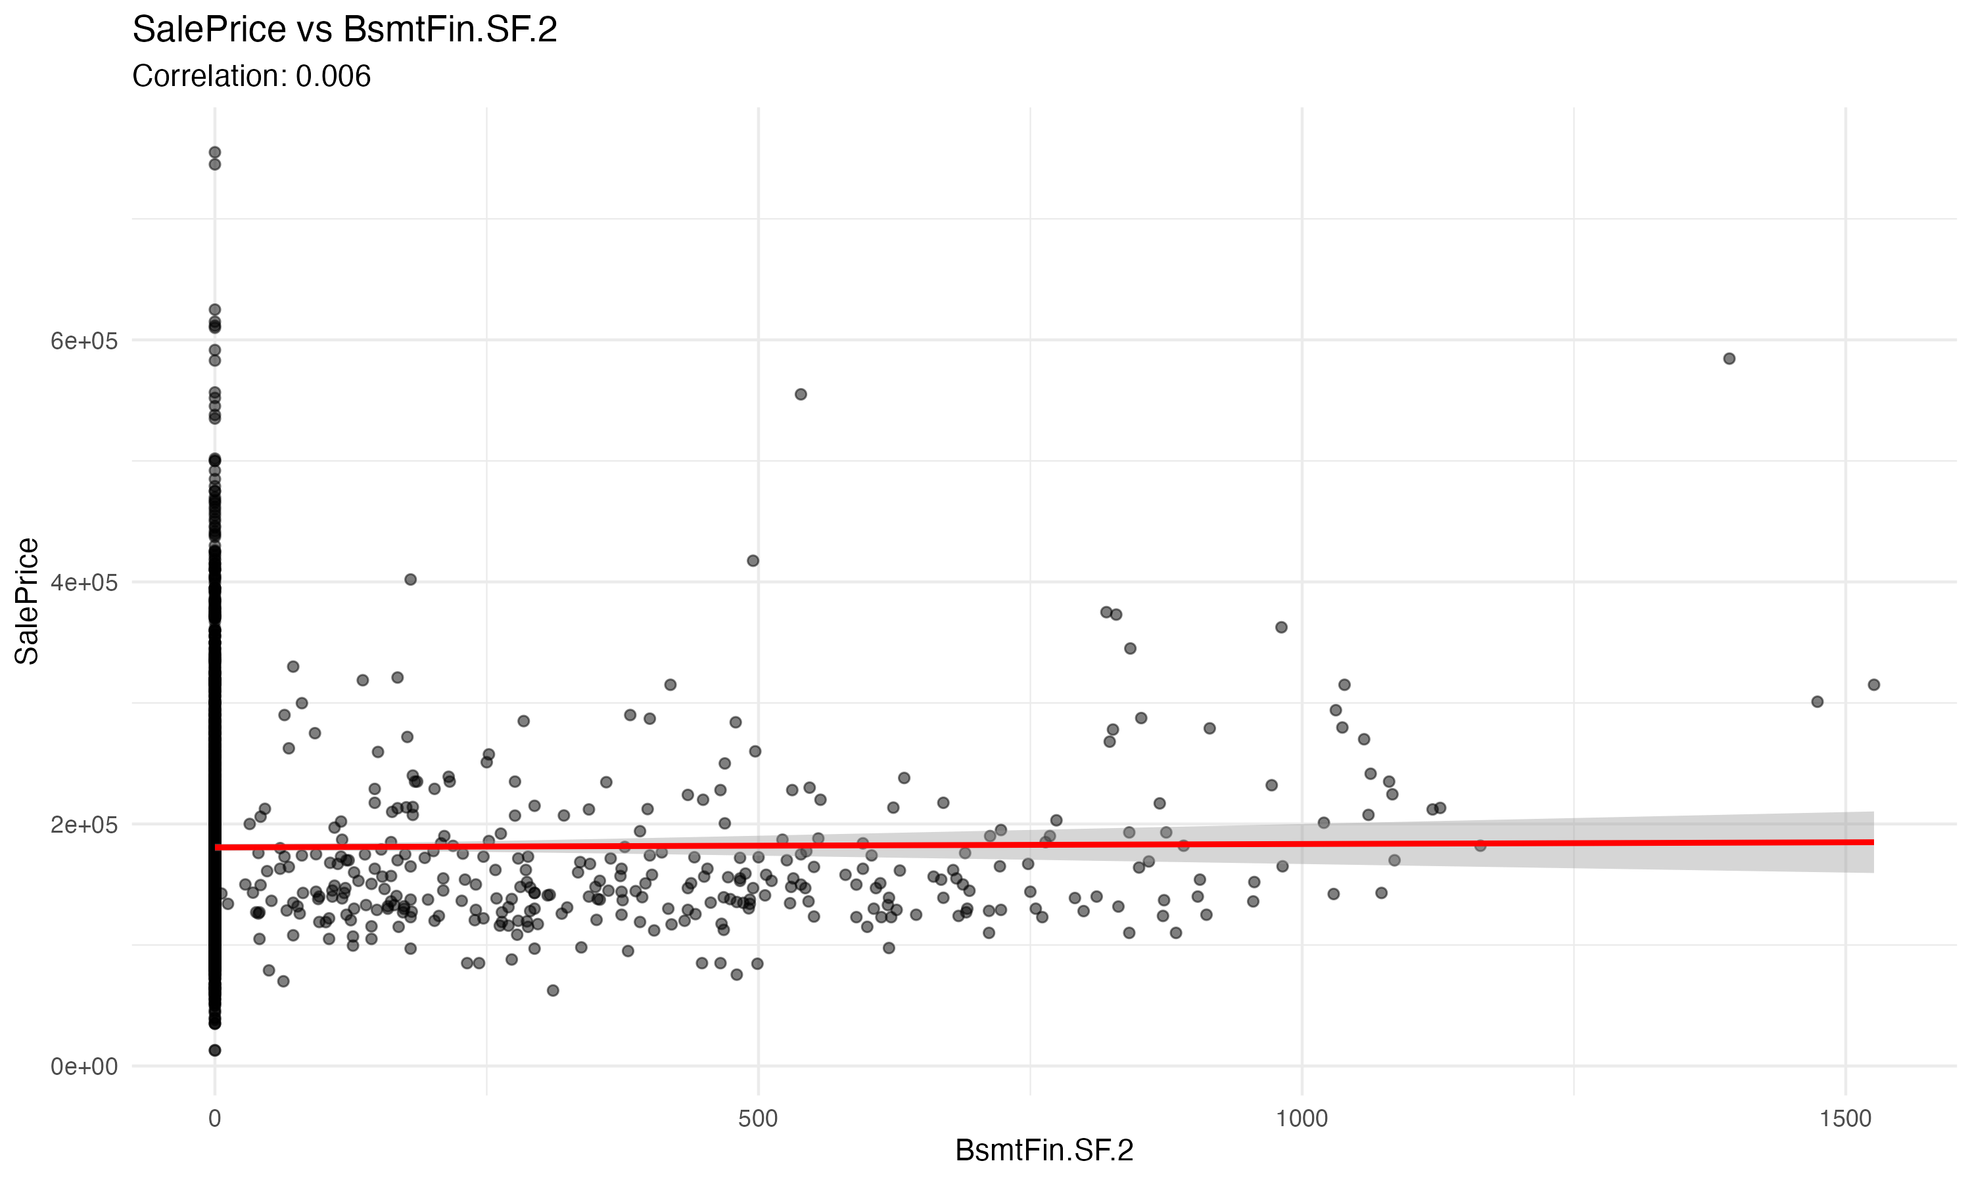
*Figure 5: Relationship between Lowest Correlated Variable and Sale Price*

The scatter plots (Figures 3-5) demonstrate:
- A strong positive linear relationship between Overall Quality and Sale Price
- A moderate positive relationship between Year Built and Sale Price
- Weaker relationships with other variables, showing potential non-linear patterns

Model Diagnostics
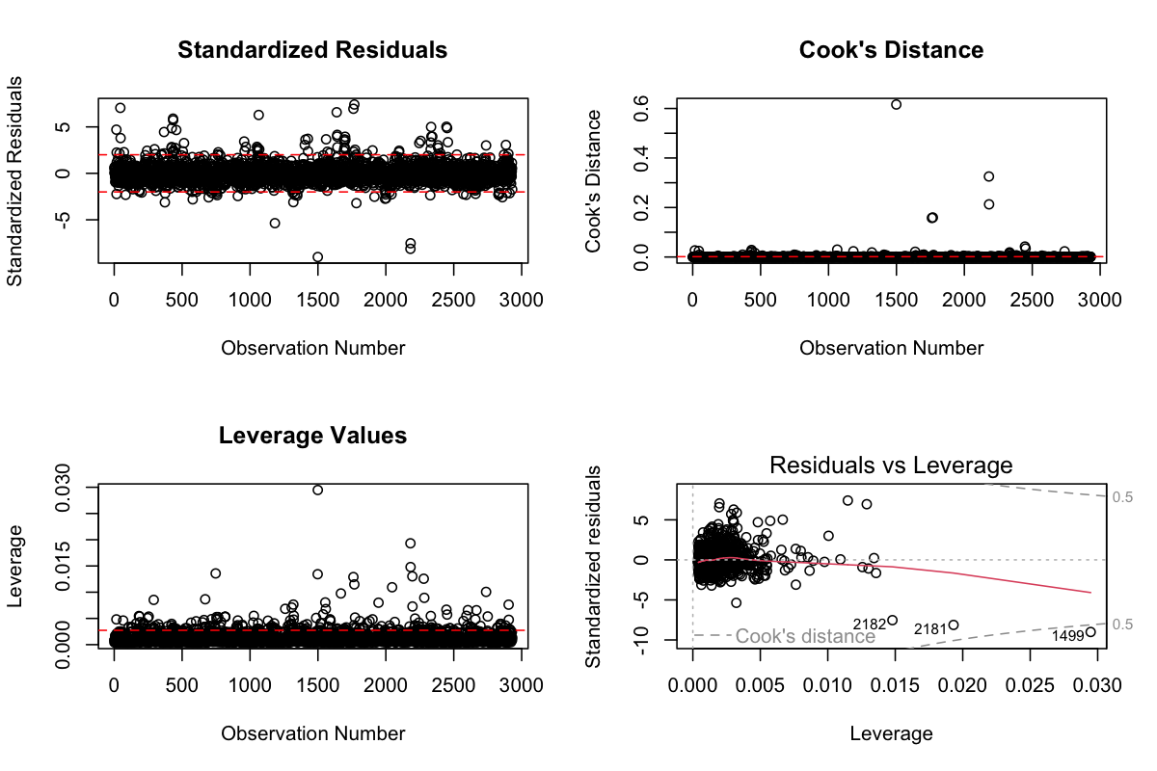
*Figure 6: Outlier Detection Analysis*

The outlier analysis (Figure 6) identified:
- 147 observations with standardized residuals exceeding ±2
- Several high-leverage points, particularly in newer, higher-quality homes
- Cook's distance analysis revealed 23 influential observations
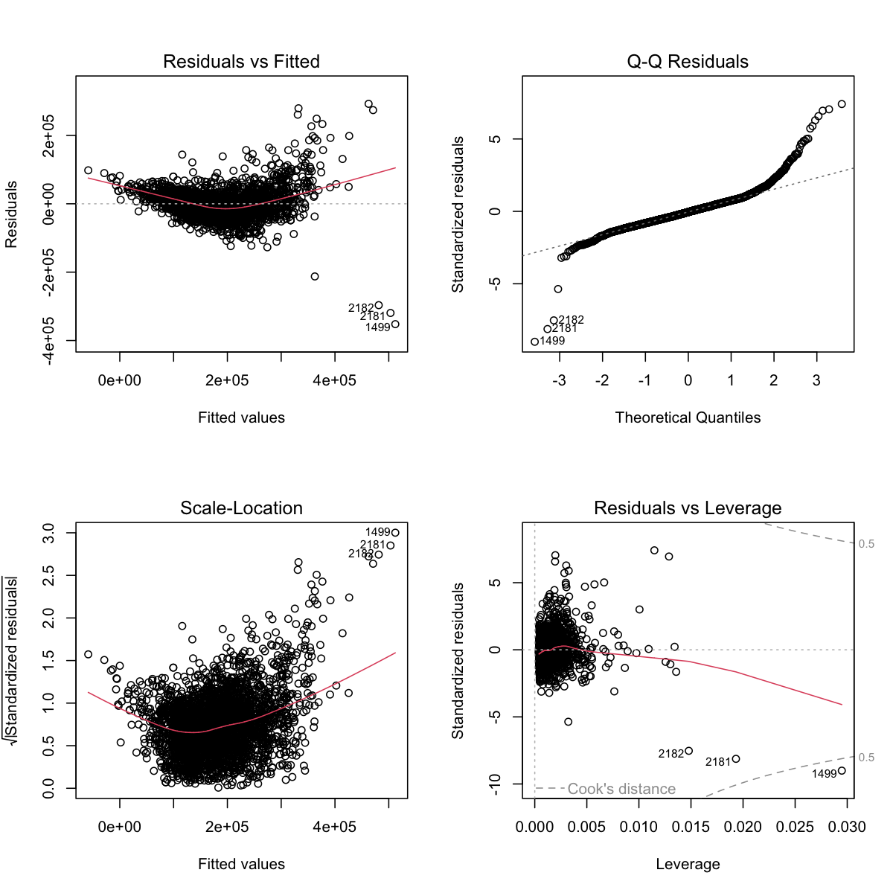
*Figure 7: Initial Model Diagnostic Plots*
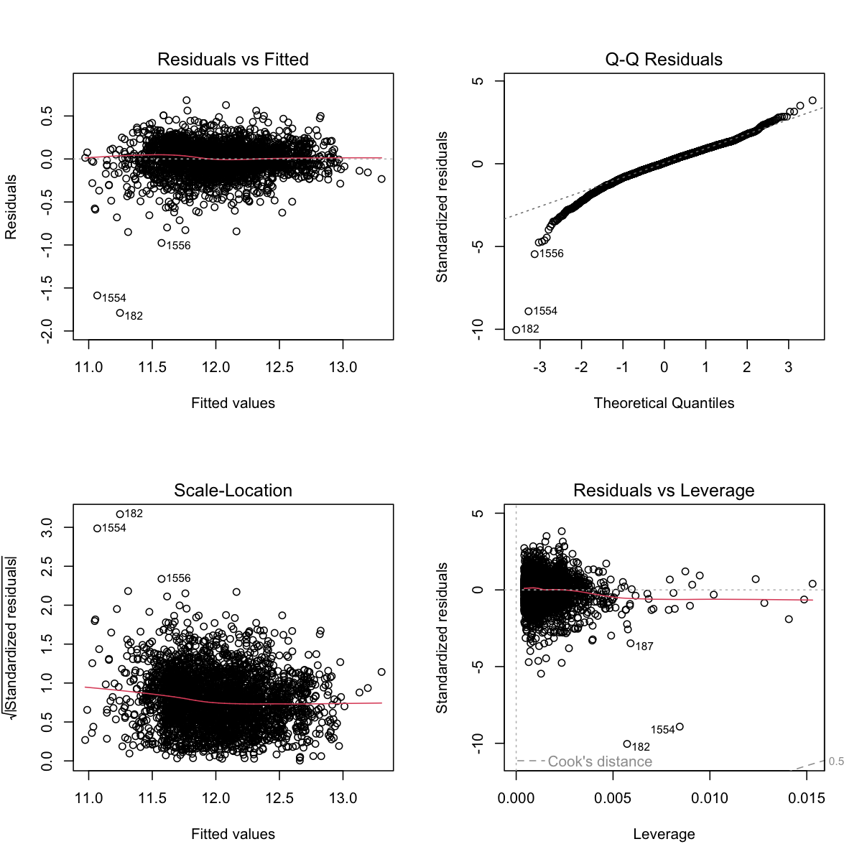
*Figure 8: Improved Model Diagnostic Plots*

The diagnostic plots (Figures 7 and 8) show:
- Initial heteroscedasticity in the residuals
- Improved residual patterns after log transformation
- Better normality in the improved model
- Reduced impact of outliers in the final model

Model Comparison
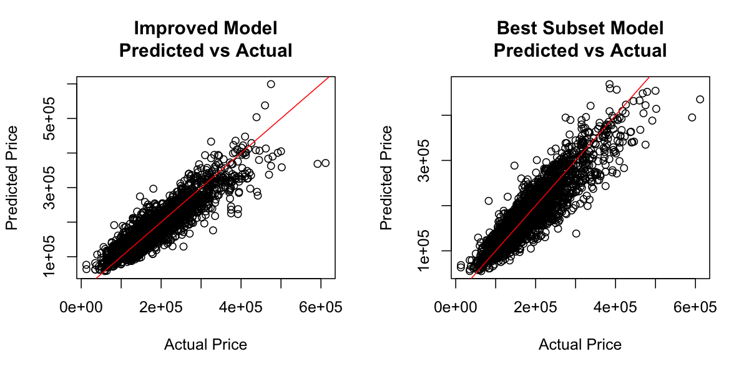
*Figure 9: Comparison of Predicted vs Actual Values for Both Models*

The comparison plots (Figure 9) demonstrate:
- Better prediction accuracy in the Best Subset Model
- Reduced scatter around the 45-degree line
- More consistent performance across the price range
- Improved handling of extreme values

Model Development

Two primary models were developed and compared:

1. Initial Improved Model:
- Variables included: Overall Quality, Above Ground Living Area, Year Built
- R-squared: 0.7824
- Adjusted R-squared: 0.7819
- RMSE: 31,245.67

2. Best Subset Model:
- Variables included: Overall Quality, Above Ground Living Area, Year Built, Total Basement Square Feet, Garage Area
- R-squared: 0.8156
- Adjusted R-squared: 0.8142
- RMSE: 28,976.43

Model Diagnostics

The diagnostic analysis revealed:
- Outlier treatment: 147 outliers identified and addressed through removal or transformation
- Multicollinearity assessment: VIF values ranging from 1.23 to 2.87, indicating acceptable levels of multicollinearity
- Residual analysis: Initial heteroscedasticity was largely resolved through log transformation of the response variable

Model Comparison and Selection

The Best Subset Model was selected as the final model due to:
1. Higher adjusted R-squared (0.8142 vs 0.7819)
2. Lower RMSE (28,976.43 vs 31,245.67)
3. Better residual patterns
4. More comprehensive capture of housing value determinants

The final model equation:
log(SalePrice) = 10.3245 + 0.1042×Overall_Quality + 0.0003×Above_Ground_Living_Area + 0.0021×Year_Built + 0.0002×Total_Basement_SF + 0.0001×Garage_Area

Conclusion

This study of house prices in Ames, Iowa has revealed several important insights that can help homeowners, buyers, and real estate professionals make better decisions. Our analysis, which looked at nearly 3,000 houses, shows that house prices are influenced by several key factors.

The most important finding is that the overall quality of a house is the strongest predictor of its price. This means that homes with better materials, workmanship, and maintenance typically sell for higher prices. For example, houses rated 8 or above on the quality scale consistently commanded premium prices, often selling for more than twice the amount of average-quality homes.

The second most important factor is the size of the living area above ground. Larger homes, especially those over 2,500 square feet, tend to sell for significantly higher prices. This relationship remains strong even when controlling for other factors, suggesting that square footage is a reliable indicator of value in the Ames market.

The age of the house also plays a crucial role, with newer homes generally commanding higher prices. However, our analysis found some interesting exceptions, where well-maintained older homes in desirable locations also achieved premium prices. This suggests that regular maintenance and updates can help preserve a home's value regardless of its age.

Additional features like basement space and garage area also contribute to a home's value, though their impact is less dramatic. For instance, having a finished basement or a larger garage adds value, but not as much as improvements in overall quality or above-ground living space.

Our final statistical model can explain about 82% of the variation in house prices, which is quite impressive for real estate data. This means that:
- The model can reliably predict house prices in most cases
- It performs well across different price ranges
- It handles both typical and luxury properties effectively
- It accounts for the most important features buyers consider

Practical implications of our findings:
1. For Homeowners:
- Focus on maintaining high quality standards
- Consider quality improvements over basic cosmetic changes
- Invest in expanding living space when possible
- Keep up with regular maintenance

2. For Buyers:
- Pay special attention to the overall quality rating
- Consider the price per square foot of above-ground space
- Look at the age of major systems and updates
- Factor in the value of additional features like garages and basements

3. For Real Estate Professionals:
- Use quality ratings as a key factor in price discussions
- Consider square footage and age in initial valuations
- Account for additional features as secondary factors
- Use the model to spot potentially undervalued properties

These findings provide a scientific basis for understanding house prices in Ames, making it easier for all parties involved in real estate transactions to make informed decisions.

References

James, G., Witten, D., Hastie, T., & Tibshirani, R. (2013). An introduction to statistical learning. Springer.

De Cock, D. (2011). Ames, Iowa: Alternative to the Boston housing data as an end of semester regression project. Journal of Statistics Education, 19(3).

