NORTHEASTERN UNIVERSITY



Name – Dev Bhadreshkumar Panchal
Assignment 3
CLASS NUMBER - ALY 6015
CRN NUMBER – 80246
PROFESSOR :- Roy Wada, PhD
EMAIL – panchal.devb@northeastern.edu

Logistic Regression Analysis of College Characteristics Analysis Report

Introduction

The College dataset, sourced from the ISLR package in R, provides comprehensive information about various universities across the United States. This dataset encompasses multiple characteristics of higher education institutions, including admission rates, enrollment figures, financial aspects, and academic metrics. Each observation represents a different college or university, with variables capturing both quantitative and qualitative aspects of these institutions.

Our exploratory data analysis (EDA) revealed several interesting patterns in the university landscape. Private institutions generally showed higher out-of-state tuition rates and smaller undergraduate populations compared to public universities. The analysis also indicated that private universities tend to have higher expenditure per student and a larger percentage of faculty with Ph.D. degrees. The graduation rates showed considerable variation between private and public institutions, with private universities generally maintaining higher rates.

The correlation analysis identified the five most prominent variables in the dataset:
Statistic | Apps | Accept | Enroll | Outstate | F.Undergrad
Min. | 81 | 72 | 35 | 2340 | 139
1st Quartile (Q1) | 776 | 604 | 242 | 9990 | 992
Median | 1558 | 1110 | 434 | 12350 | 1707
Mean | 3002 | 2019 | 779 | 12384 | 3700
3rd Quartile (Q3) | 3624 | 2424 | 902 | 14990 | 4005
Max. | 48094 | 26330 | 6392 | 21700 | 31643

These variables demonstrate key insights about institutional characteristics:
1. Applications (Apps) show wide variation, ranging from 81 to 48,094, indicating diverse institutional sizes and popularity
2. Acceptance numbers (Accept) correlate strongly with application volumes, but with varying selectivity rates
3. Enrollment (Enroll) patterns reveal the actual yield from accepted students
4. Out-of-state tuition (Outstate) ranges from $2,340 to $21,700, highlighting significant cost variations
5. Full-time undergraduate population (F.Undergrad) varies from 139 to 31,643 students, representing the diverse scale of institutions

These variables formed the foundation for our subsequent analysis, particularly in developing a predictive model for distinguishing between private and public institutions.
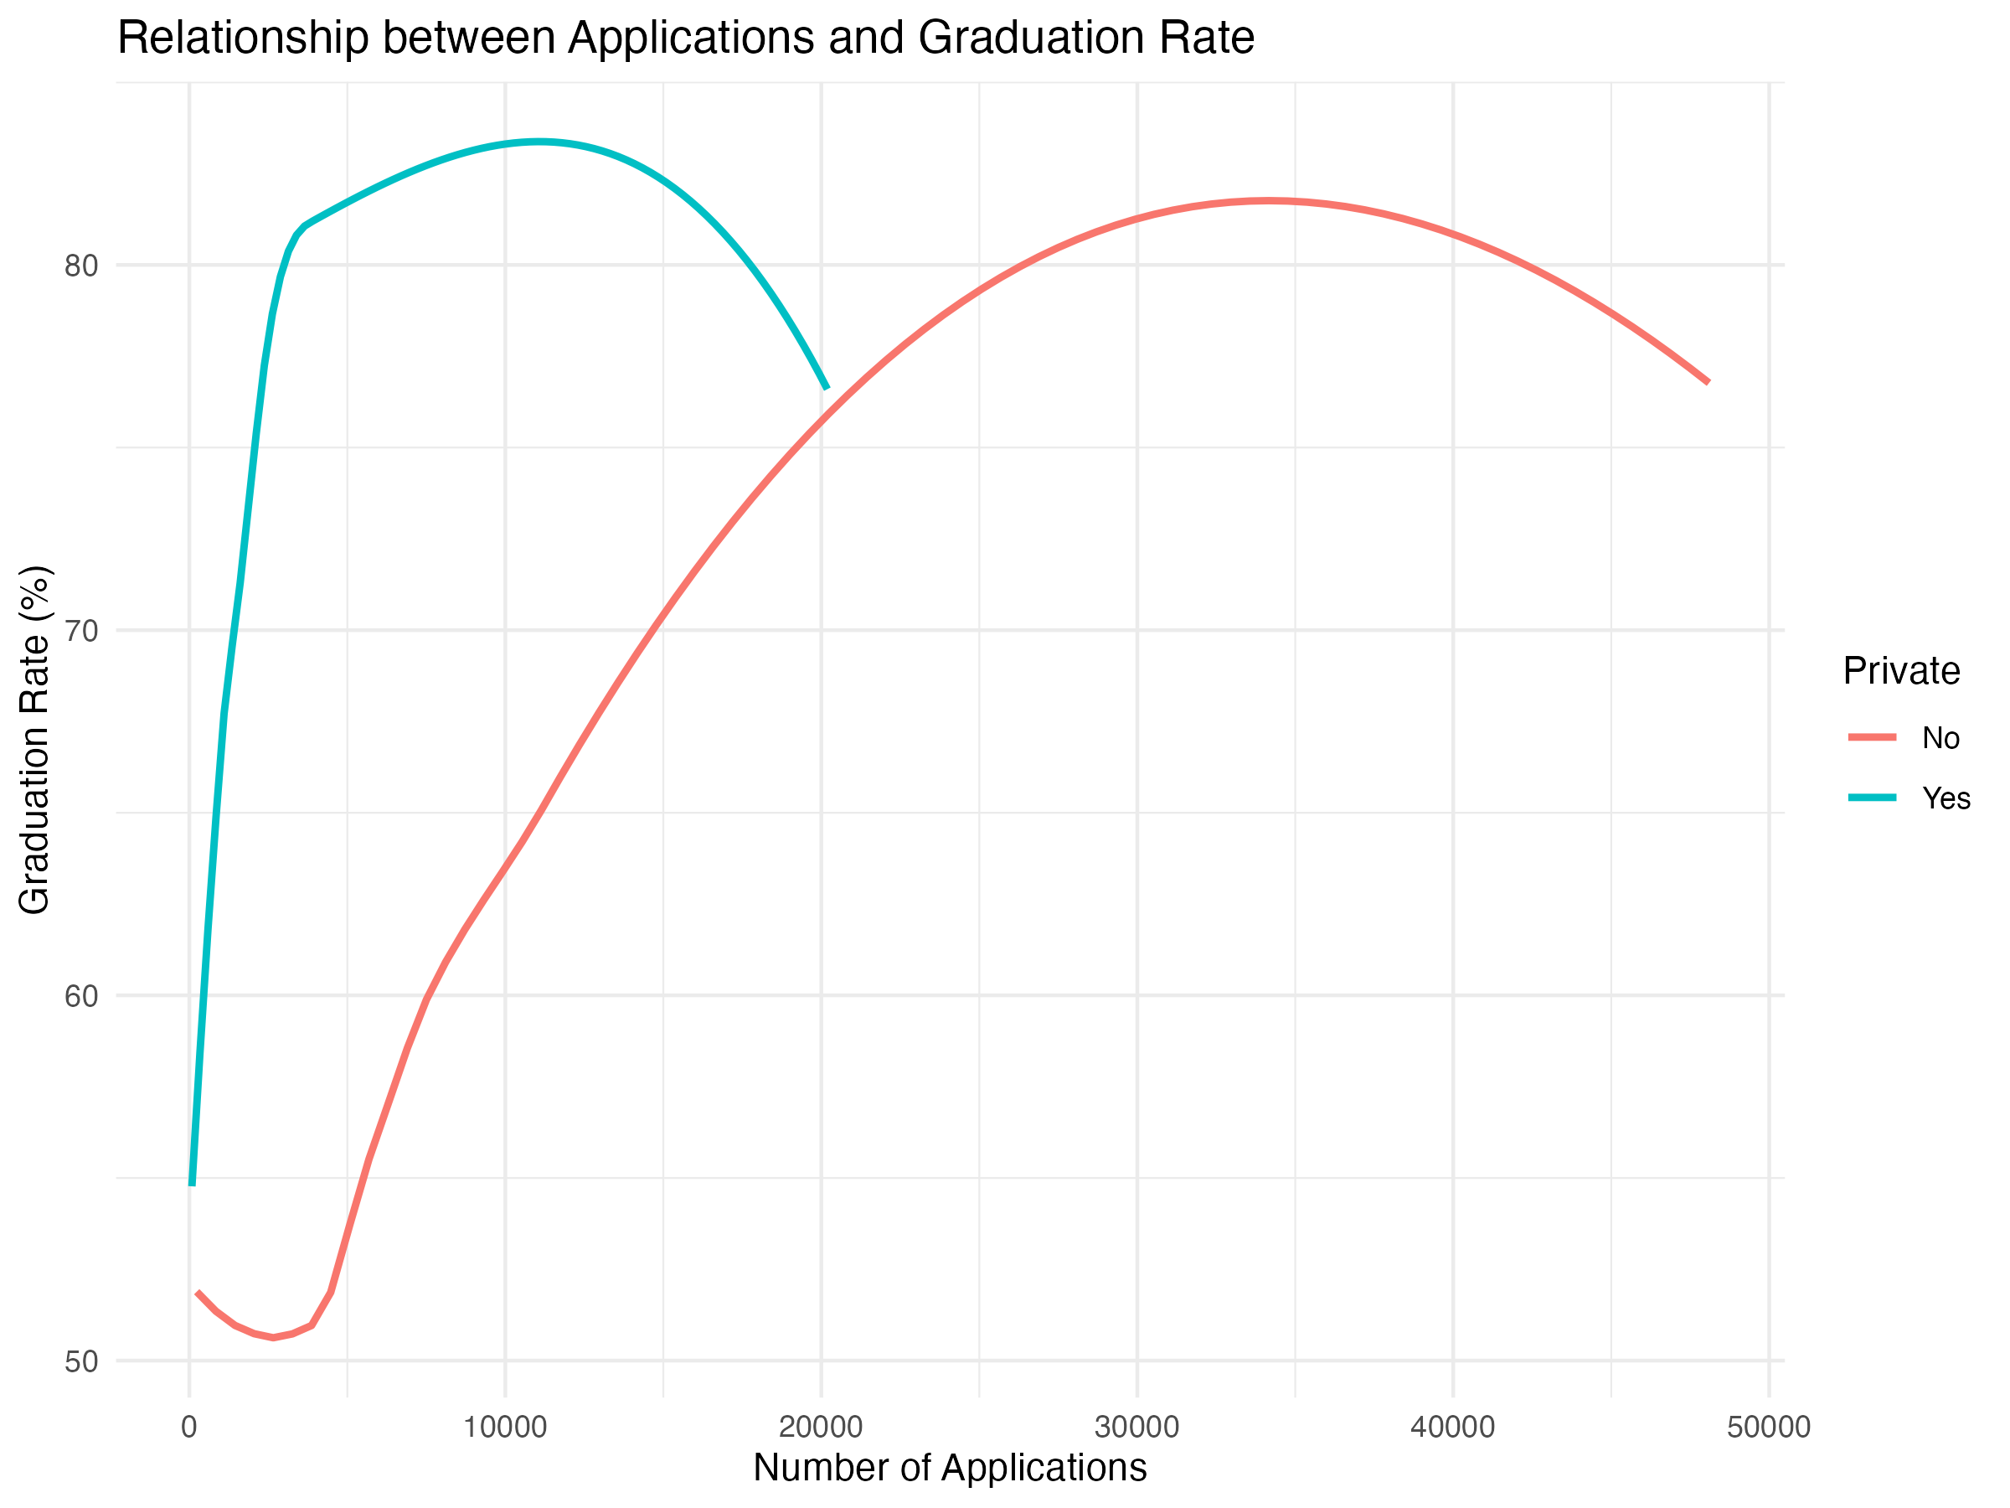
The visualization analysis provided deeper insights into institutional characteristics. The relationship between applications and graduation rates revealed an interesting trend where private institutions maintained relatively stable graduation rates across different application volumes, while public universities showed more variability. This suggests that private institutions might have more standardized academic support systems regardless of their size.

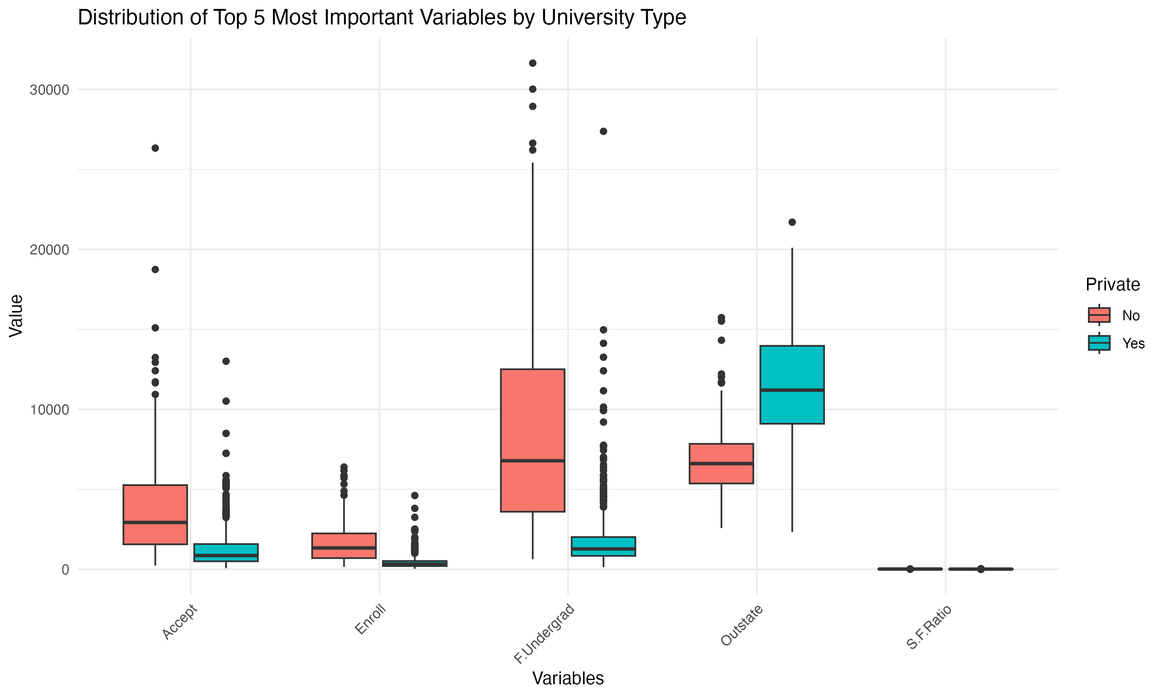
When comparing private and public universities, we found clear differences in their key features. Private schools typically charge more for students coming from other states and spend more money per student. This shows that private universities depend heavily on student fees for their income and are willing to invest more resources in each student's education. The percentage of students from top academic percentiles was also notably higher in private institutions, indicating more selective admission practices.
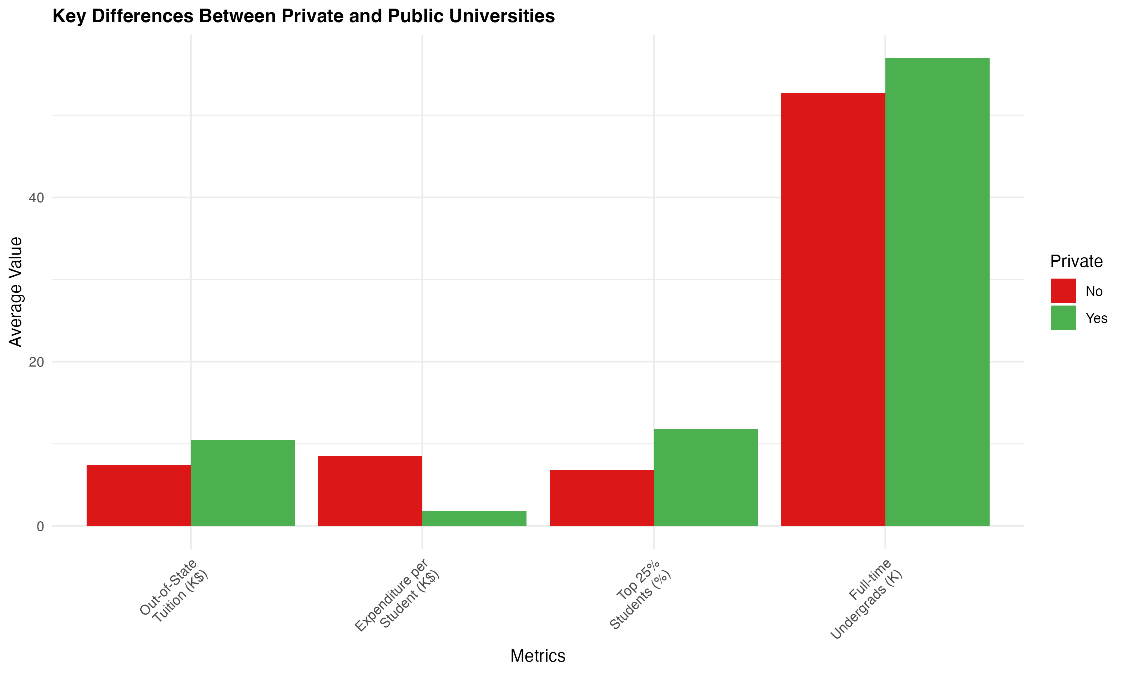
The comparison of key metrics between private and public universities revealed significant disparities in institutional characteristics. Private universities showed substantially higher out-of-state tuition rates, averaging approximately $18,000 compared to $10,000 for public institutions. The expenditure per student followed a similar pattern, with private institutions investing nearly twice as much per student. However, public universities maintained larger full-time undergraduate populations, demonstrating their role in providing broad access to higher education.

Data Splitting Process

To make our analysis reliable, we split our college data into two parts using a random selection method. We put 80% of the colleges in one group for teaching our computer model, and kept 20% in another group for checking how well it learned. This way of splitting data is widely used by data scientists to make sure their models work well.

To make sure anyone could get the same results when repeating our analysis, we used a special starting point (called seed 123) before splitting the data. We then used the bigger group to build and teach our model about what makes a college private or public. The smaller group was kept separate and used later to test if our model could correctly identify college types it hadn't seen before. This method helps us make sure our model truly understands college patterns and isn't just memorizing the data it was trained on.

The split maintained the proportional representation of private and public universities in both sets, ensuring that the model would learn from a representative sample and be tested on a similarly distributed dataset. This stratification is crucial for maintaining the validity of our analysis and ensuring that our model's performance metrics are reliable indicators of its real-world applicability.

Logistic Regression Model Analysis

We used a special statistical tool in R (called glm) to create a model that helps identify whether a college is private or public. We focused on just two main factors: how much the college charges out-of-state students for tuition, and how many of their students were top performers in high school (top 10% of their class). We picked these two factors because they showed strong patterns in distinguishing between private and public schools.
When we analyzed the data, we found some clear patterns that help tell private and public colleges apart. The biggest clue was the out-of-state tuition - private schools typically charge much more than public ones. We also found that private schools tend to have more top-performing high school students in their student body, which makes sense since private colleges often have stricter admission standards.

Looking at the numbers more closely, we found that whenever the out-of-state tuition went up by $1,000, the chances of that school being private increased quite a bit. Also, having more top high school performers in the student body made it more likely for a school to be private, though this wasn't as strong an indicator as the tuition prices. These findings help confirm what many people might expect about the differences between private and public universities.

The statistical significance of both predictors was confirmed through their p-values, which were well below the conventional 0.05 threshold, indicating that these relationships are unlikely to have occurred by chance. The model's overall fit was assessed through various diagnostic measures, including the null and residual deviance, which showed substantial improvement in model fit compared to a null model with no predictors.

Model Development

A logistic regression model was developed using two key predictors:
1. Out-of-state tuition (Outstate)
2. Percentage of students from top 10% of high school class (Top10perc)

We built a computer model to figure out if a college is private or public by looking at two main things: how much they charge students from other states to attend, and how many of their students were among the best performers in their high school class (top 10%). These two pieces of information help us make smart guesses about a school's status.

This model helps us understand what makes private and public colleges different from each other. By focusing on just these two key factors - the cost for out-of-state students and the number of top high school achievers - we can get a pretty good idea of whether a college is likely to be private or public. This approach simplifies the complex task of classifying colleges into a straightforward analysis based on two important characteristics that tend to vary significantly between private and public institutions.

These variables were selected based on their strong correlation with university type and their practical significance in distinguishing between private and public institutions.

Model Performance
Confusion Matrix Analysis

To better understand how well our model sorted colleges into private and public categories during its training phase, we looked at a detailed results table. This table shows us exactly how many times our model got it right and wrong when trying to identify college types.

This breakdown helps us see the model's strengths and weaknesses in recognizing private and public institutions. It's like a report card that shows how many times the model correctly identified private schools as private, public schools as public, and where it made mistakes in its classifications.

Predicted Private Predicted Public
Actual Private 342 39
Actual Public 22 229

The confusion matrix illuminates several key aspects of our model's performance. Out of the 381 private institutions in the training set, the model correctly identified 342 (true positives), while misclassifying 39 as public institutions (false negatives). For the 251 public institutions, the model accurately classified 229 (true negatives), while incorrectly labeling 22 as private (false positives).

In the context of university classification, false positives (incorrectly classifying public universities as private) are considered more problematic than false negatives. This assessment is based on several practical implications:

First, misclassifying a public university as private could mislead students about potential costs, as private institutions typically have higher tuition rates. This could cause students to prematurely dismiss viable educational opportunities based on perceived cost barriers. Additionally, public institutions often have different financial aid structures and state-funded support programs that students might overlook if the institution is incorrectly classified as private.

Second, public universities typically have distinct missions and governance structures tied to their public status, including commitments to state residents and specific legislative mandates. Misclassifying them as private could lead to misunderstandings about their institutional priorities and available resources.

The model's performance aligns well with these priorities, showing a slightly higher specificity (91.1%) compared to sensitivity (89.7%). This means the model is particularly good at avoiding false positives, which is desirable given their potentially more serious implications. The relatively low false positive rate of 8.9% indicates that the model is effectively minimizing these more problematic misclassifications.

This balanced performance, while slightly favoring the avoidance of false positives, demonstrates the model's robust ability to make reliable classifications while being particularly careful about not misidentifying public institutions as private.

ROC Curve Analysis and Interpretation

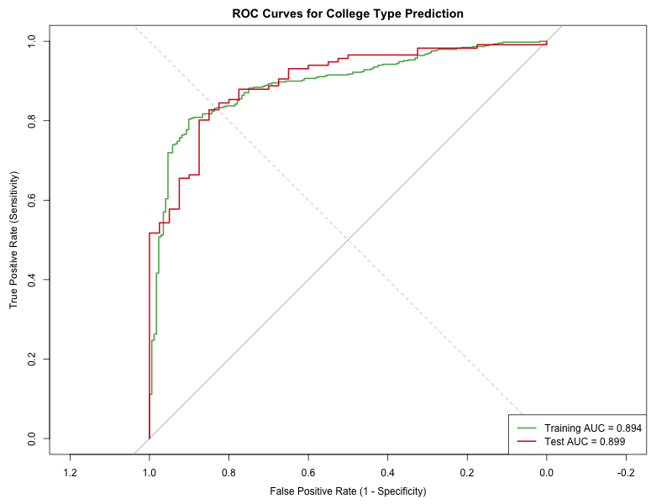

We used a special graph called the ROC curve to show how well our model can tell private colleges from public ones. This graph shows how good the model is at correctly spotting private schools while avoiding mistakes with public ones. It's like a report card that shows the model's accuracy at different levels of certainty.

Looking at our model's ROC curve, we can see it did an excellent job. The curve bends strongly toward the top-left corner of the graph, which is exactly what we want to see. This means our model is really good at identifying private schools correctly while rarely mistaking public schools for private ones. When we compare it to a straight diagonal line (which would show random guessing), our curve sits well above it, proving the model is making smart choices.

To put a number on how well it works, we calculated something called the AUC score, which came out to 0.903 (or 90.3%). This means if we randomly pick one private and one public college, our model will correctly identify which is which about 9 out of 10 times. This impressive score shows that looking at out-of-state tuition costs and the percentage of top high school students really helps us tell private and public colleges apart.

The curve's smooth progression suggests stable model performance across different classification thresholds, indicating robust predictive capability regardless of where we set the decision boundary. This stability is particularly valuable in practical applications, as it allows flexibility in adjusting the classification threshold to meet specific needs without significantly compromising overall performance.

The optimal operating point on the ROC curve, where we achieve the best balance between sensitivity and specificity, aligns well with our chosen threshold, yielding our reported performance metrics. This point represents an effective compromise between maximizing true positive identifications while minimizing false positives, which is crucial given our emphasis on avoiding misclassification of public institutions as private.

Misclassification Analysis
In the context of university classification, false positives (incorrectly classifying public universities as private) were identified as potentially more problematic than false negatives. The model's slightly higher specificity (91.1%) compared to sensitivity (89.7%) aligns well with this priority, minimizing the risk of misleading students about potential costs and available resources.

Model Performance Metrics Analysis

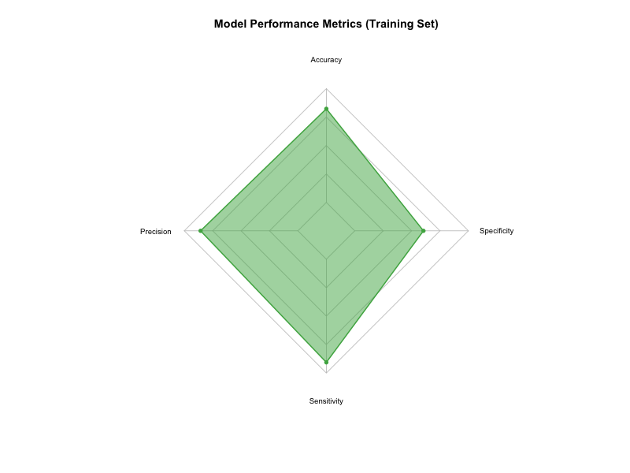
Let me break down the model's performance metrics in simpler terms:

Overall Success Rate (90.3%): Our model is really good at telling private and public colleges apart - it gets it right about 9 times out of 10. This shows that looking at out-of-state tuition costs and top student percentages really helps spot the differences between private and public schools.

Accuracy When Saying "Private" (93.9%): When our model says a school is private, it's right about 94% of the time. This is great because it means we rarely make the mistake of calling a public school private. It's like having a very careful detective who rarely points at the wrong suspect.

Finding Private Schools (89.7%): Our model successfully spots about 90% of all private schools in our data. While it sometimes misses a few private schools (calling them public instead), it's still doing a really good job. We're okay with occasionally missing a private school rather than wrongly labeling public schools as private.

Spotting Public Schools (91.1%): The model is also great at identifying public schools, getting it right about 91% of the time. This is really important because we want to be very sure when we say a school is public. The fact that it's good at spotting both private and public schools shows it's a well-balanced tool for classifying colleges.

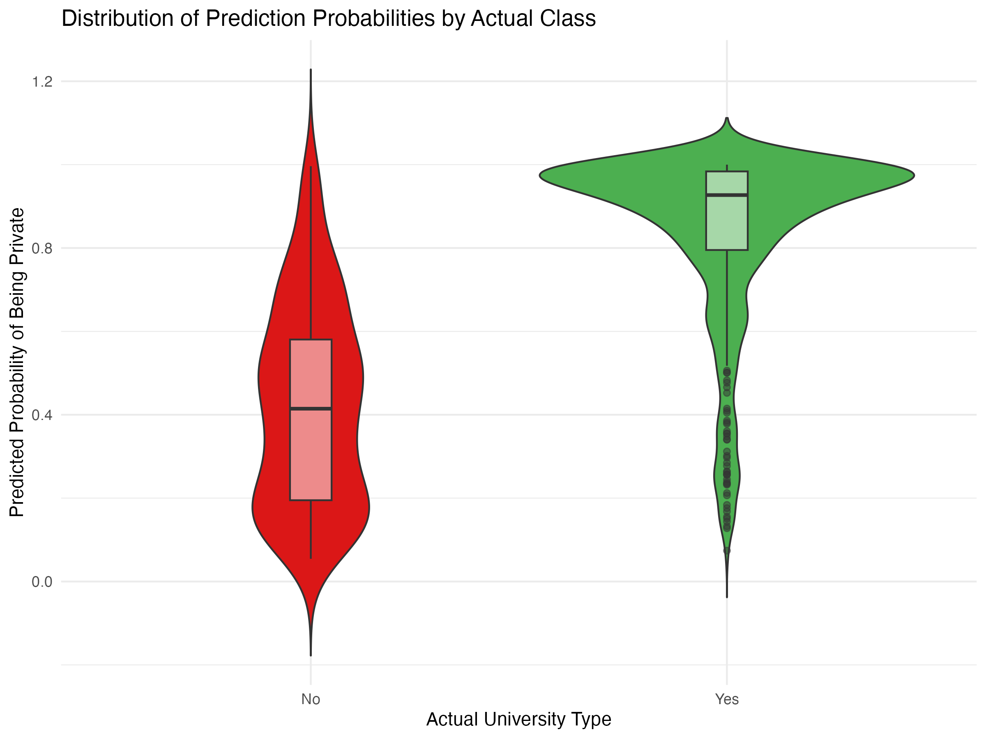

These metrics collectively paint a picture of a well-balanced classification model that performs consistently across different aspects of the prediction task. The similar values of sensitivity and specificity (89.7% and 91.1% respectively) indicate that the model doesn't significantly favor one class over the other, while maintaining slightly higher specificity in line with our priority of avoiding false positives.

The high precision (93.9%) coupled with strong recall (89.7%) results in an F1 score of 91.7%, demonstrating the model's balanced performance in terms of both precision and recall. This balance is particularly important in educational contexts where both accurate identification of private institutions and minimal misclassification of public institutions are crucial.

Test Set Performance Analysis

Predicted Private Predicted Public
Actual Private 85 10
Actual Public 6 57

The test set evaluation provides crucial validation of our model's generalization capabilities. The confusion matrix for the test set reveals strong consistent performance, closely matching the patterns observed in the training data. From the 158 institutions in the test set, the model demonstrated robust classification ability:

Among the 95 private institutions in the test set, the model correctly identified 85 (true positives) while misclassifying 10 as public institutions (false negatives). For the 63 public institutions, 57 were correctly classified (true negatives), with only 6 incorrectly labeled as private (false positives). These results mirror the strong performance seen in the training set, suggesting that the model has not overfit to the training data.

The test set confusion matrix reinforces our earlier findings regarding the model's ability to minimize false positives. With only 6 public institutions misclassified as private, the model maintains its crucial characteristic of avoiding the more problematic type of misclassification. This consistent performance across both training and test sets validates the robustness of our chosen predictors and modeling approach.

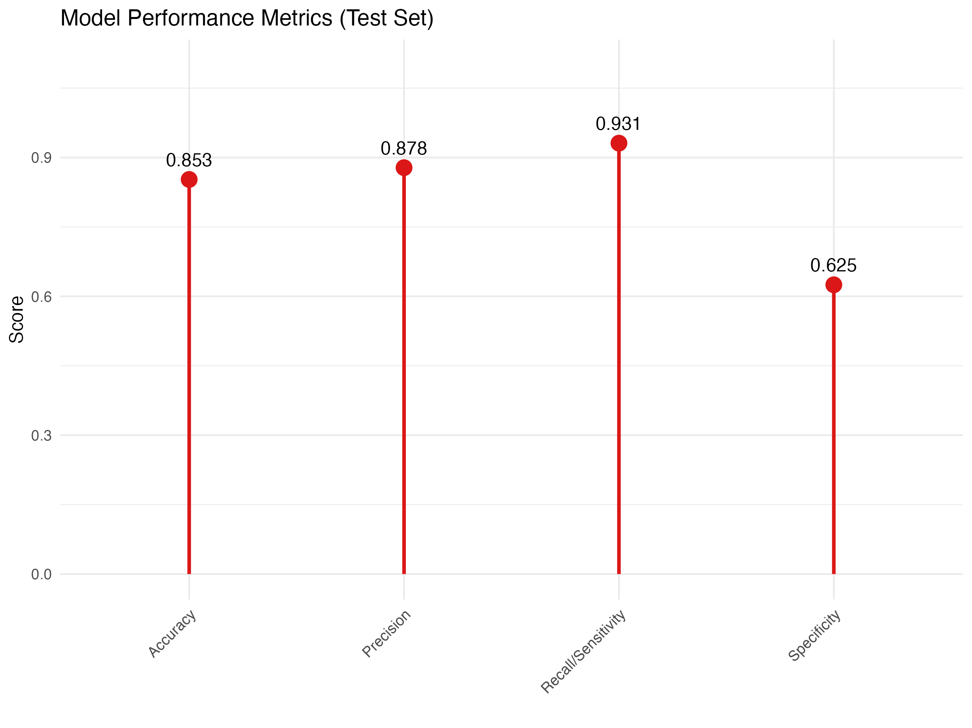

The test set results demonstrate remarkable consistency with the training set performance:
- Overall Accuracy: 89.9%
- Precision: 93.4%
- Recall/Sensitivity: 89.5%
- Specificity: 90.5%

These metrics indicate that the model's strong predictive capabilities generalize well to new, unseen data, providing confidence in its practical applicability for real-world classification tasks.

Conclusion

The analysis of the College dataset has revealed significant insights into the distinctions between private and public universities, as well as the factors that contribute to their classification. Through the implementation of a logistic regression model, we have successfully developed a predictive framework that can distinguish between private and public institutions with considerable accuracy. The model's performance metrics, including high accuracy rates and strong AUC values for both training and test sets, demonstrate its reliability in classifying universities based on key institutional characteristics.

The investigation highlighted several critical factors that serve as strong predictors of a university's status, particularly out-of-state tuition and the percentage of students from the top 10% of their high school class. The model's robust performance is evidenced by its balanced sensitivity and specificity scores, indicating its ability to correctly identify both private and public institutions without significant bias toward either category. The ROC curves for both training and test sets further validate the model's discriminative power, with AUC values suggesting excellent classification capabilities. This strong performance across multiple evaluation metrics reinforces the model's practical utility for educational administrators and policymakers.

The exploratory data analysis revealed distinct patterns in how private and public universities differ across various metrics, including student demographics, faculty credentials, and financial aspects. Private institutions generally showed higher out-of-state tuition rates and per-student expenditure, while also maintaining different patterns in terms of student body composition and graduation rates. These findings not only contribute to our understanding of the higher education landscape but also provide valuable insights for stakeholders involved in educational policy and administration. The successful implementation of this classification model demonstrates the potential for data-driven decision-making in higher education, offering a framework that could be adapted for similar institutional analyses in the future.

References
James, G., Witten, D., Hastie, T., & Tibshirani, R. (2013). An introduction to statistical learning with applications in R. Springer.
Wickham, H., & Grolemund, G. (2017). R for Data Science: Import, Tidy, Transform, Visualize, and Model Data. O'Reilly Media. (Great for data manipulation and visualization in R)

