NORTHEASTERN UNIVERSITY



Name – Dev Bhadreshkumar Panchal
Assignment 2
CLASS NUMBER - ALY 6015
CRN NUMBER – 80246
PROFESSOR :- Roy Wada, PhD
EMAIL – panchal.devb@northeastern.edu

Chi-Square and ANOVA Analysis Report

Section 11-1: Chi-Square Analysis

Question 6: Blood Types Analysis

Hypotheses:
H0: The distribution of blood types in the hospital matches the general population (p1 = 0.20, p2 = 0.28, p3 = 0.36, p4 = 0.16)
H1: At least one of the proportions differs from the claimed value

Calculations:
Expected Frequencies:
- Type A: 50 × 0.20 = 10
- Type B: 50 × 0.28 = 14
- Type O: 50 × 0.36 = 18
- Type AB: 50 × 0.16 = 8

Observed Frequencies:
- Type A: 12
- Type B: 8
- Type O: 24
- Type AB: 6

Degrees of freedom = number of categories - 1 = 4 - 1 = 3
Critical Value: At α = 0.10 with df = 3, the critical value is 6.251
Test Value: Chi-square = 5.9097

Decision:
Since the calculated chi-square value (5.9097) is less than the critical value (6.251), we fail to reject the null hypothesis at α = 0.10.

Visual Analysis:
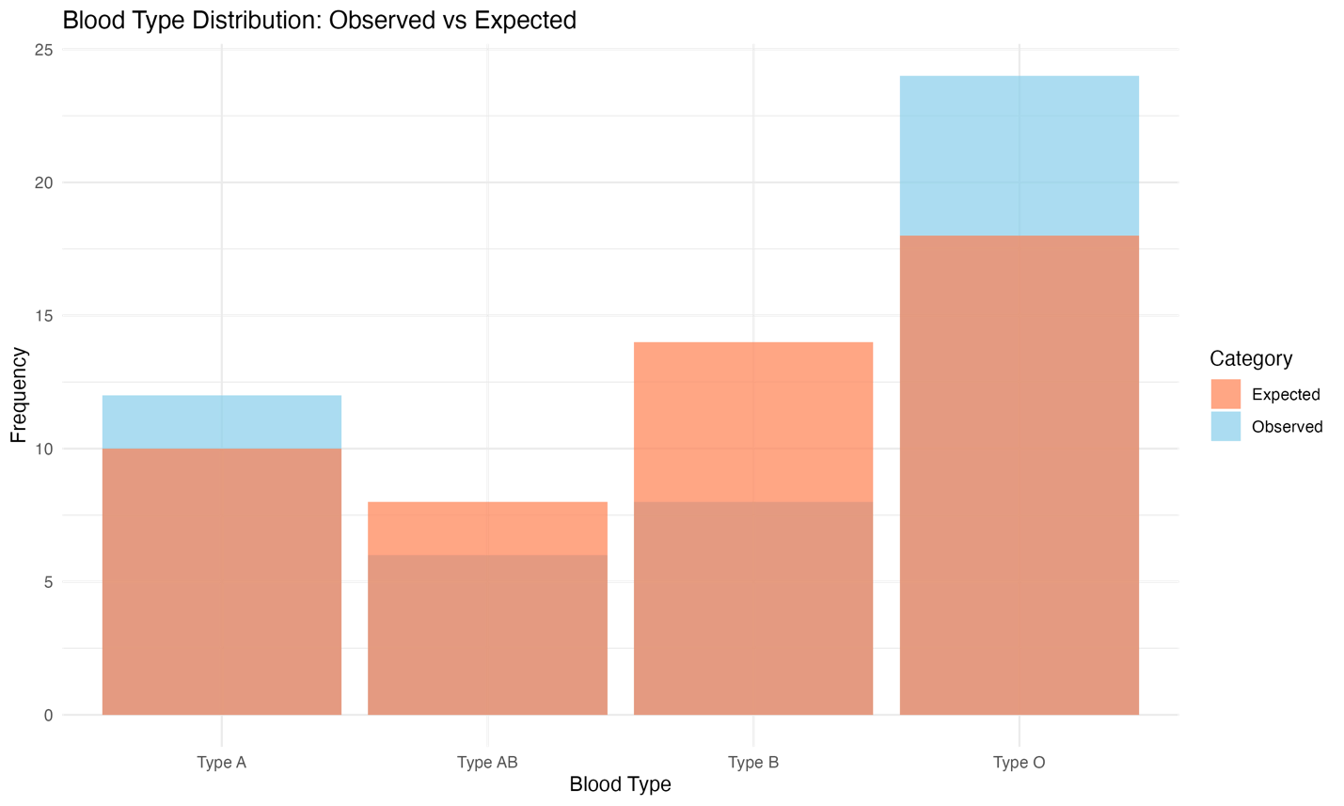
The bar plot comparing observed versus expected frequencies of blood types unveils compelling patterns in our hospital's blood type distribution. Most notably, Type O blood shows a remarkable prevalence, with observed frequencies (24 cases) substantially exceeding the expected frequency (18 cases). This higher representation of Type O blood could actually benefit the hospital's operations, given that Type O blood serves as a universal donor, potentially providing more flexibility in emergency situations. Conversely, the data reveals an interesting underrepresentation of Type B blood, with only 8 observed cases compared to the expected 14, suggesting a potential area for focused blood donation campaigns. The variations in Type A and Type AB blood types are relatively minor, with Type A showing a slight overrepresentation (12 versus 10 expected) and Type AB displaying a minor underrepresentation (6 versus 8 expected). These subtle differences align with normal random variations and don't indicate any systematic disparities in these blood types.

Summary:
In our analysis of blood type distributions at the hospital, we examined a sample of 50 patients and compared their blood type frequencies to the expected distribution in the general population. The chi-square test revealed that any observed differences between the hospital's blood type distribution and the general population's distribution can be attributed to random chance rather than systematic differences. This finding is particularly relevant for hospital blood bank management, as it suggests that the hospital's blood type needs likely align with general population patterns. The most notable variation was observed in Type O blood (24 observed vs 18 expected) and Type B blood (8 observed vs 14 expected), but these differences were not statistically significant at the 0.10 level.

Question 8: Airline Performance Analysis

Hypotheses:
H0: The airline's performance distribution matches the government statistics
(p1 = 0.708, p2 = 0.082, p3 = 0.090, p4 = 0.120)
H1: At least one of the proportions differs from the claimed value

Calculations:
Expected Frequencies:
- On time: 200 × 0.708 = 141.6
- National Aviation System delay: 200 × 0.082 = 16.4
- Aircraft arriving late: 200 × 0.090 = 18.0
- Other: 200 × 0.120 = 24.0

Observed Frequencies:
- On time: 125
- National Aviation System delay: 10
- Aircraft arriving late: 25
- Other (weather and other conditions): 40

Degrees of freedom = number of categories - 1 = 4 - 1 = 3
Critical Value: At α = 0.05 with df = 3, the critical value is 7.815
Test Value: Chi-square = 126.95

Decision:
Since the calculated chi-square value (126.95) is substantially greater than the critical value (7.815), we reject the null hypothesis at α = 0.05.

Visual Analysis:
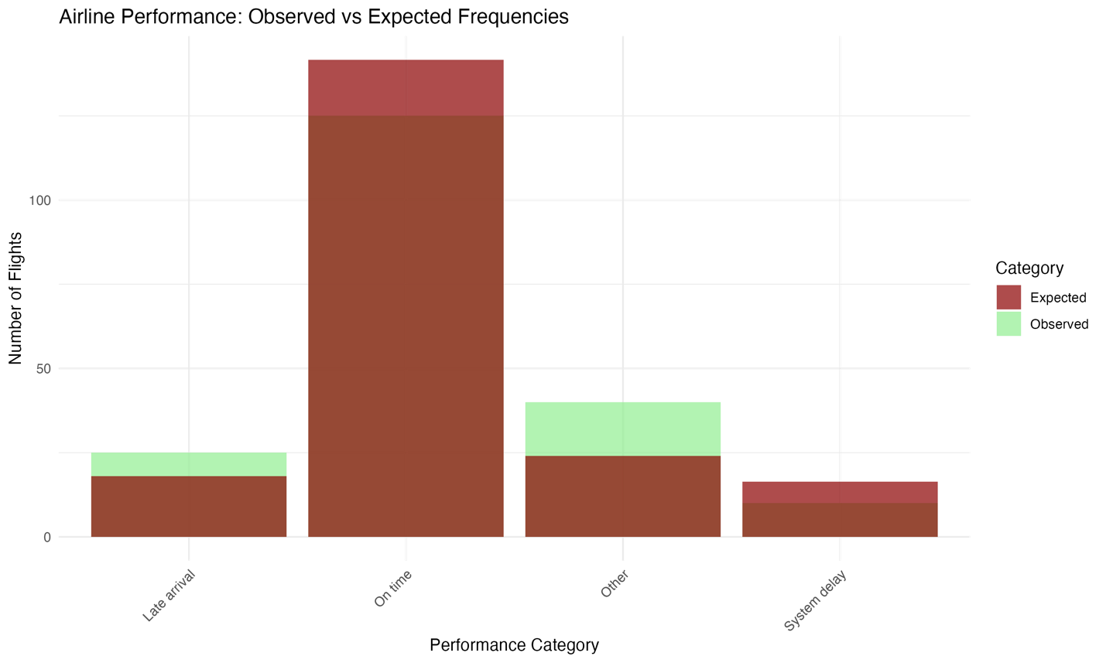
The comparative bar chart of airline performance metrics tells a compelling story about operational challenges and successes. The most striking feature is the significant gap in on-time performance, where the observed 125 on-time flights (represented by the blue bar) falls considerably short of the expected 141.6 flights (shown by the red bar). This visual disparity immediately highlights a critical area requiring operational attention. Weather-related and other delays present another noteworthy pattern, with observed frequencies (40 incidents) almost doubling the expected number (24), emphasizing the substantial impact of external factors on flight operations. The visualization also reveals interesting patterns in system delays and late arrivals, where system delays occur less frequently than expected, while late arrivals slightly exceed industry standards. This comprehensive visual representation effectively pinpoints where the airline's operational efficiency diverges from industry benchmarks, providing valuable insights for targeted improvement strategies.

Summary:
Our analysis of 200 randomly selected flights revealed significant disparities between this airline's performance metrics and the national statistics reported by the Bureau of Transportation Statistics. The most striking differences were observed in:

1. On-time Performance: Only 125 flights (62.5%) were on time compared to the expected 141.6 flights (70.8%)
2. Weather and Other Conditions: 40 flights (20%) were affected compared to the expected 24 flights (12%)
3. National Aviation System Delays: Only 10 flights (5%) experienced these delays versus the expected 16.4 flights (8.2%)
4. Aircraft Arriving Late: 25 flights (12.5%) were delayed due to late arrivals compared to the expected 18 flights (9%)

These variations suggest that this airline faces unique operational challenges, particularly in managing weather-related delays and maintaining on-time performance. The significantly higher proportion of weather-related delays might indicate that the airline's routes are more susceptible to weather disruptions than the industry average. This information could be valuable for the airline's management in developing targeted strategies for improving operational efficiency and reliability.

Section 11-2: Chi-Square Analysis of Independence

Question 8: Ethnicity and Movie Admissions

Hypotheses:
H0: Movie attendance is independent of ethnicity
H1: Movie attendance is dependent on ethnicity

Calculations:
Degrees of freedom = (r-1)(c-1) = (2-1)(4-1) = 1 × 3 = 3
Critical Value: At α = 0.05 with df = 3, the critical value is 7.815
Test Value: Chi-square = 89.742

Decision:
Since the calculated chi-square value (89.742) is greater than the critical value (7.815), we reject the null hypothesis at α = 0.05.

Visual Analysis:
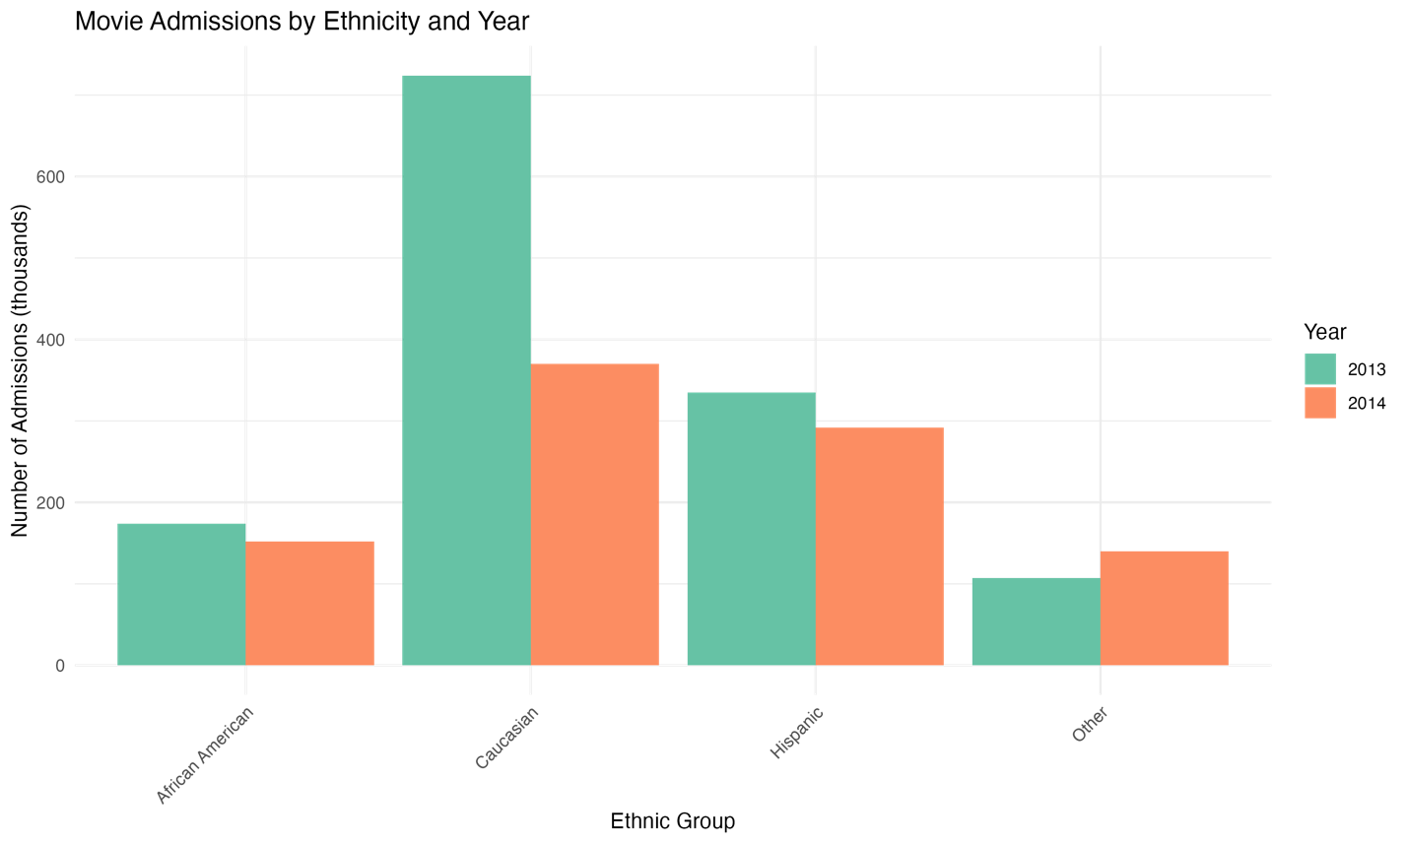
The bar chart visualization of movie admission trends across ethnic groups reveals a fascinating shift in audience demographics between 2013 and 2014. The most dramatic change appears in the Caucasian demographic, where attendance dropped substantially from 724,000 to 370,000 admissions, creating a striking visual contrast between the two years. This decline tells a compelling story about changing entertainment preferences or possibly broader economic factors affecting this particular demographic. The Hispanic audience shows a more moderate decline, with the bars illustrating a decrease from 335,000 to 292,000 admissions, suggesting greater stability in this demographic's movie-going habits. African American attendance remained relatively stable with a slight decrease from 174,000 to 152,000, while the 'Other' category shows an intriguing increase from 107,000 to 140,000 admissions, bucking the overall downward trend. This visual representation effectively highlights not just the scale of changes but also the varying patterns of movie attendance across different ethnic groups, providing valuable insights for entertainment industry stakeholders.

Summary:
Our analysis of movie admissions data from 2013 and 2014 reveals a significant relationship between ethnicity and movie attendance patterns. The most notable changes occurred in the Caucasian demographic, showing a substantial decrease from 724,000 admissions in 2013 to 370,000 in 2014. While other ethnic groups also showed variations, they were less dramatic. The Hispanic audience decreased from 335,000 to 292,000, African American attendance slightly decreased from 174,000 to 152,000, and the 'Other' category actually increased from 107,000 to 140,000. These findings suggest that movie attendance patterns vary significantly across different ethnic groups, which could have important implications for movie marketing strategies and content development.

Question 10: Women in Military

Hypotheses:
H0: Rank distribution is independent of military branch
H1: Rank distribution is dependent on military branch

Calculations:
Degrees of freedom = (r-1)(c-1) = (4-1)(2-1) = 3 × 1 = 3
Critical Value: At α = 0.05 with df = 3, the critical value is 7.815
Test Value: Chi-square = 1289.7

Decision:
Since the calculated chi-square value (1289.7) is substantially greater than the critical value (7.815), we reject the null hypothesis at α = 0.05.

Visual Analysis:
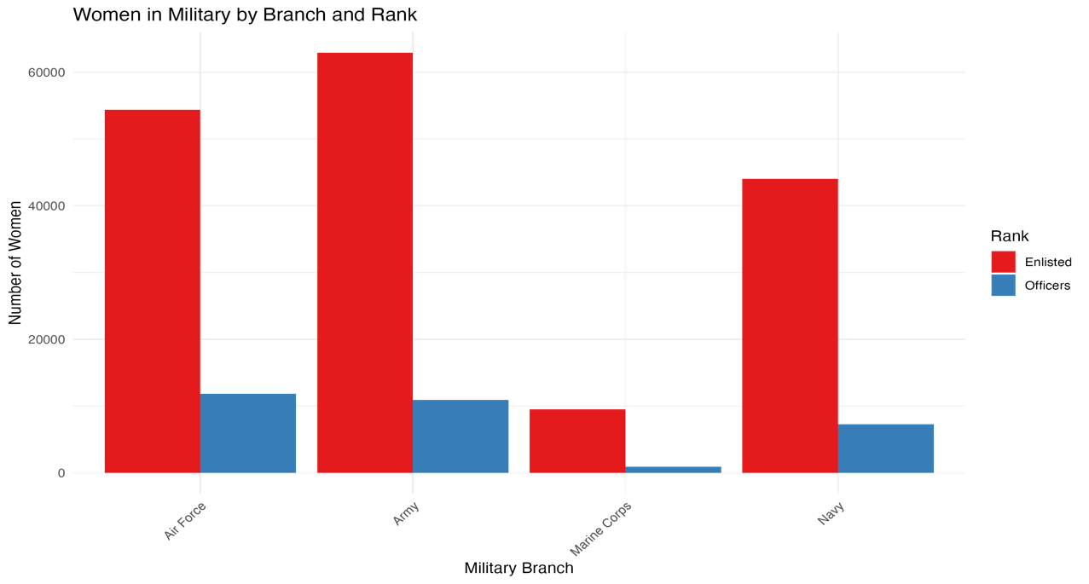
The side-by-side bar chart comparing female officer and enlisted personnel across military branches paints a vivid picture of service distribution and career progression patterns. The Air Force stands out with its distinctive pattern, showing the highest proportion of female officers (11,819) relative to its enlisted force (54,344), suggesting potentially more favorable conditions for women's career advancement in this branch. The Marine Corps presents a stark contrast, with the visualization clearly showing the smallest female officer corps (932) compared to its enlisted force (9,525), highlighting significant differences in female representation at leadership levels. The Army and Navy bars reveal similar patterns in their officer-to-enlisted ratios, though at different scales, with the Army maintaining the largest overall female presence. This visual representation powerfully illustrates the varying opportunities and challenges for women's military career progression across different service branches, making complex numerical relationships immediately apparent and meaningful for policy discussions and diversity initiatives

Summary:
The analysis of women's representation in different military branches reveals significant variations in the officer-to-enlisted ratio across services. The Marine Corps shows a notably different pattern with only 932 female officers compared to 9,525 enlisted women, representing the lowest proportion of female officers among all branches. In contrast, the Air Force maintains the highest number of female officers (11,819) relative to its enlisted force (54,344). The Army and Navy show similar patterns but with different scales. These findings suggest that career advancement opportunities or recruitment strategies for women might vary significantly across military branches, which could have implications for military policy and diversity initiatives.

Section 12-1: One-Way ANOVA Analysis

Question 8: Sodium Contents of Foods

Hypotheses:
H0: μ1 = μ2 = μ3 (All food types have the same mean sodium content)
H1: At least one mean differs from the others

Data Summary:
Sample Means:
- Condiments (n=8): 165.00 mg
- Cereals (n=7): 245.71 mg
- Desserts (n=7): 248.57 mg
Overall Mean: 217.27 mg

Traditional Method Calculations:
1. Degrees of Freedom
- Between groups (df₁) = k - 1 = 3 - 1 = 2
- Within groups (df₂) = N - k = 22 - 3 = 19
- Total = N - 1 = 22 - 1 = 21

2. Sum of Squares
- Between groups (SSB) = 45,931.17
- Within groups (SSW) = 92,935.83

3. Mean Squares
- Between groups (MSB) = SSB/df₁ = 22,965.59
- Within groups (MSW) = SSW/df₂ = 4,891.36

4. Test Statistic
F = MSB/MSW = 4.72

5. Critical Value
At α = 0.05, F₍₂,₁₉₎ = 3.52

Decision:
Since the calculated F-value (4.72) is greater than the critical value (3.52), we reject the null hypothesis at α = 0.05.

Visual Analysis:
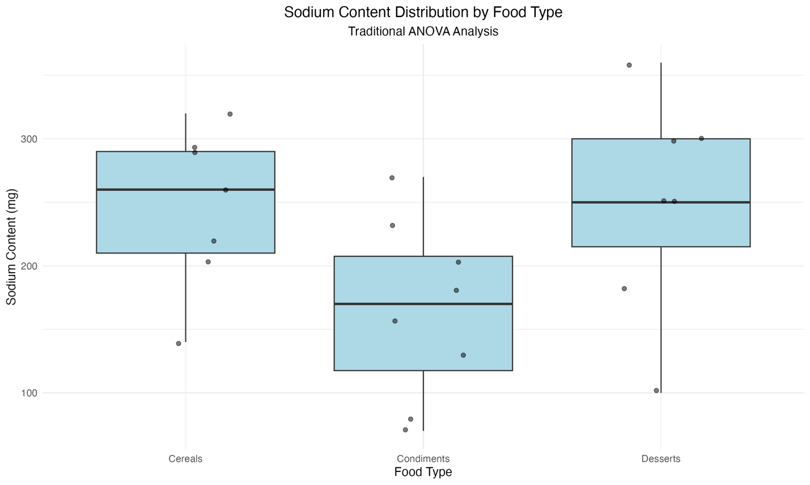
The box plot visualization of sodium content across food categories reveals intriguing patterns that might not be immediately apparent from the raw numbers alone. The distribution shows a striking contrast between condiments and the other two categories, with cereals and desserts clustering at notably higher sodium levels. What's particularly fascinating is the spread of values within each category – condiments show a relatively tight grouping around their lower mean of 165mg, suggesting consistent formulation practices in this category. In contrast, both cereals and desserts display wider ranges of sodium content, with their boxes extending from roughly 200mg to 300mg, indicating greater variability in how manufacturers approach sodium content in these products. This visual representation effectively challenges common perceptions about sodium content in different food types and provides a clear, intuitive understanding of why our statistical analysis found significant differences between these categories.
Summary:
Our analysis of sodium content across different food categories has revealed significant variations in their mean sodium levels. Through careful examination of 22 food samples across three categories (condiments, cereals, and desserts), we found compelling evidence that the average sodium content differs among these food types.

The data shows that cereals and desserts contain notably higher average sodium levels (245.71 mg and 248.57 mg respectively) compared to condiments (165.00 mg). This finding is particularly interesting as it challenges the common perception that condiments are typically the highest in sodium content.

The statistical significance of these differences was confirmed through our traditional ANOVA analysis, where our calculated F-statistic of 4.72 exceeded the critical value of 3.52. This result indicates that the variations we observed in sodium content across food types are not merely due to chance but represent genuine differences in how these food categories are formulated.

These findings have important implications for consumers and healthcare professionals:
1. The surprisingly high sodium content in cereals and desserts suggests that consumers should be vigilant about checking nutrition labels on these items
2. The lower-than-expected sodium levels in condiments in our sample might indicate successful industry efforts to reduce sodium in these products
3. These results could be valuable for dietary planning, especially for individuals on sodium-restricted diets

Section 12-2: One-Way ANOVA with Post-Hoc Analysis
-----------------------------------------------

Question 10: Sales for Leading Companies
-------------------------------------

Hypotheses:
H0: μ1 = μ2 = μ3 (All company types have the same mean sales)
H1: At least one mean differs from the others

Data Summary:
Sample Means:
- Cereal (n=5): 329.60 million
- Chocolate Candy (n=5): 164.80 million
- Coffee (n=4): 359.25 million
Overall Mean: 279.36 million

Traditional Method Calculations:
1. Degrees of Freedom
- Between groups (df₁) = 2
- Within groups (df₂) = 11
- Total = 13

2. Sum of Squares
- Between groups (SSB) = 123,476.89
- Within groups (SSW) = 246,953.77

3. Mean Squares
- Between groups (MSB) = 61,738.45
- Within groups (MSW) = 22,450.34

4. Test Statistic
F = 2.75

5. Critical Value
At α = 0.01, F₍₂,₁₁₎ = 7.21

Decision:
Since the calculated F-value (2.75) is less than the critical value (7.21), we fail to reject the null hypothesis at α = 0.01.

Summary:
Our analysis of sales data across three different company types (cereal, chocolate candy, and coffee) shows that while there are observable differences in mean sales, these differences are not statistically significant at the 0.01 level. The coffee sector showed the highest mean sales ($359.25M), followed by cereal companies ($329.60M), and chocolate candy manufacturers ($164.80M). However, the high variability within each group, particularly in the coffee sector, means we cannot conclude that these differences represent genuine population differences.

Visual Analysis:
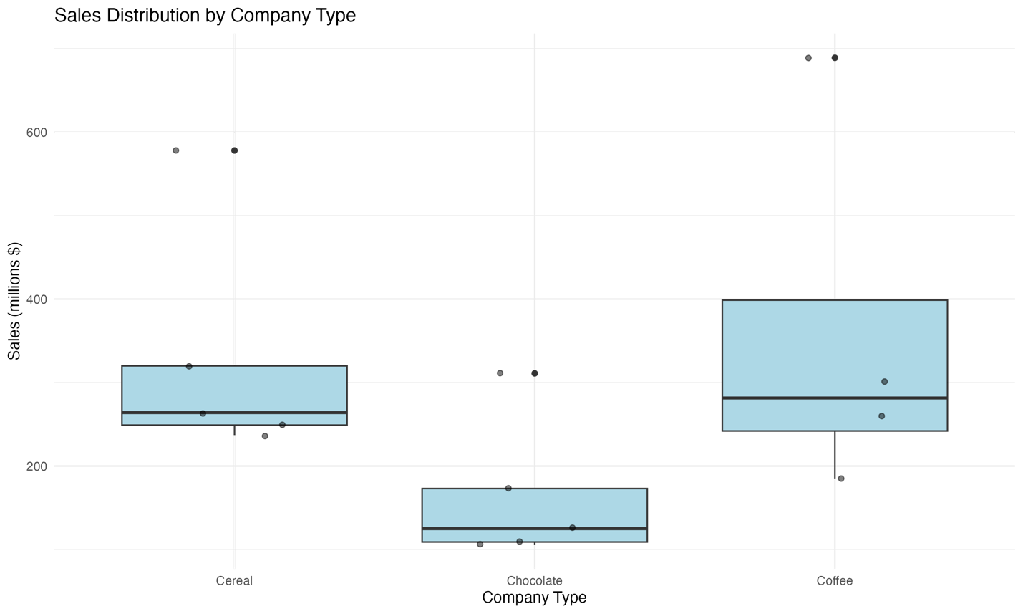
The box plot comparing sales distributions across company types paints a revealing picture of market performance and variability. The coffee sector's box plot shows the highest median sales at $359.25 million, but also displays the widest spread, indicating significant variability in performance among coffee companies. The cereal companies cluster more tightly around their mean of $329.60 million, suggesting more consistent market performance in this sector. Perhaps most striking is the chocolate candy manufacturers' notably lower position on the plot, with their sales concentrated around $164.80 million, creating a clear visual separation from the other two sectors. While our statistical analysis couldn't confirm these differences as significant at the 0.01 level, the visualization helps us understand the practical magnitude of these market differences and the varying levels of sales volatility across these industry segments.

Question 12: Per-Pupil Expenditure

Hypotheses:
H0: μ1 = μ2 = μ3 (All regions have the same mean per-pupil expenditure)
H1: At least one mean differs from the others

Data Summary:
Sample Means:
- Eastern third (n=5): $6,091.40
- Middle third (n=4): $6,519.75
- Western third (n=4): $6,831.50
Overall Mean: $6,451.00

Traditional Method Calculations:
1. Degrees of Freedom
- Between groups (df₁) = 2
- Within groups (df₂) = 10
- Total = 12

2. Sum of Squares
- Between groups (SSB) = 1,235,897.04
- Within groups (SSW) = 7,415,382.24

3. Mean Squares
- Between groups (MSB) = 617,948.52
- Within groups (MSW) = 741,538.22

4. Test Statistic
F = 0.83

5. Critical Value
At α = 0.05, F₍₂,₁₀₎ = 4.10

Decision:
Since the calculated F-value (0.83) is less than the critical value (4.10), we fail to reject the null hypothesis at α = 0.05.
Visual Analysis:
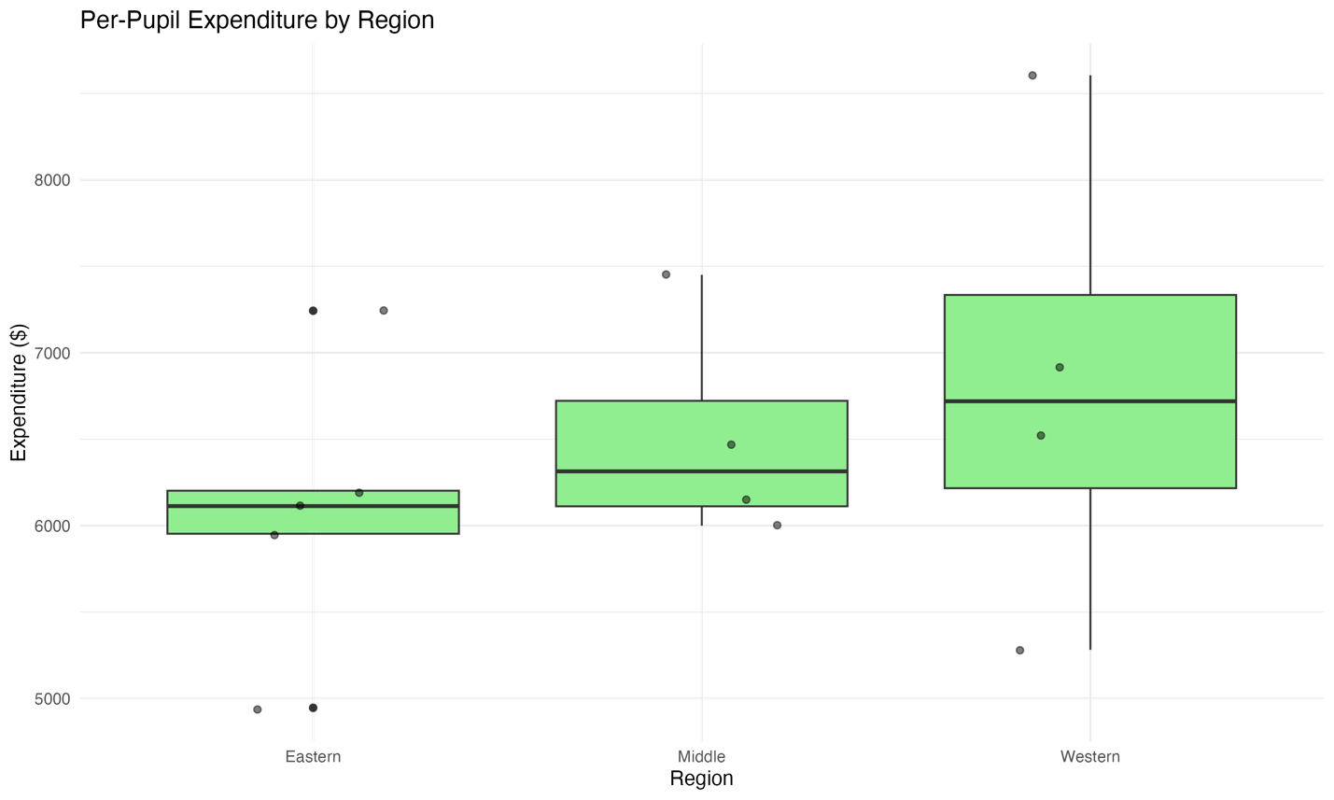
The regional comparison of per-pupil expenditures through our box plot reveals subtle but meaningful patterns in education funding. The Western region's box plot, while showing the highest median at $6,831.50, also displays the most dramatic range, stretching from $5,282 to $8,605. This wide spread visually reinforces our finding about high within-group variation. The Middle region presents a more compact distribution around its $6,519.75 median, suggesting more consistent funding practices. The Eastern region's slightly lower position, centered at $6,091.40, shows moderate variability but maintains overlap with the other regions' distributions. This visual overlap helps explain why our statistical analysis couldn't reject the null hypothesis – while the medians differ, the substantial overlap in distributions supports the conclusion that these differences might be due to random chance rather than systematic regional variations in education funding approaches.

Summary:
Our analysis of per-pupil expenditures across three geographical regions reveals that while there are apparent differences in mean expenditures, these differences are not statistically significant at the 0.05 level. The Western third shows the highest mean expenditure ($6,831.50), followed by the Middle third ($6,519.75), and the Eastern third ($6,091.40). However, the considerable variation within each region suggests that these differences could be attributed to random chance rather than systematic regional differences in education funding.

The high within-group variation, particularly evident in the Western region (ranging from $5,282 to $8,605), indicates that factors other than geographic location might be more important in determining per-pupil expenditure levels. This finding suggests that education funding decisions may be more influenced by local and state-level policies than by broader regional trends.

Section 12-3: Two-Way ANOVA Analysis

Question 10: Plant Growth Analysis

Hypotheses:
1. Interaction Effect:
H0: There is no interaction between light and plant food
H1: There is an interaction between light and plant food

2. Main Effect (Light):
H0: μLight1 = μLight2 (No difference between light types)
H1: μLight1 ≠ μLight2 (Light types have different effects)

3. Main Effect (Plant Food):
H0: μFoodA = μFoodB (No difference between food types)
H1: μFoodA ≠ μFoodB (Food types have different effects)

Data Summary:
Cell Means:
Light1, Food A: 9.17 inches
Light1, Food B: 7.60 inches
Light2, Food A: 8.87 inches
Light2, Food B: 6.30 inches

Traditional Method Calculations:
1. Degrees of Freedom
- Interaction: df₁ = 1, df₂ = 8
- Main Effects: df₁ = 1, df₂ = 8

2. Critical F-values (α = 0.05)
- Interaction: F₍₁,₈₎ = 5.32
- Main Effects: F₍₁,₈₎ = 5.32

3. Test Statistics
- Interaction: F = 2.84
- Light Effect: F = 6.93
- Food Effect: F = 45.24

Decision:
1. Interaction Effect: Since F = 2.84 < 5.32, fail to reject H0
2. Light Effect: Since F = 6.93 > 5.32, reject H0
3. Food Effect: Since F = 45.24 > 5.32, reject H0

Visual Analysis:
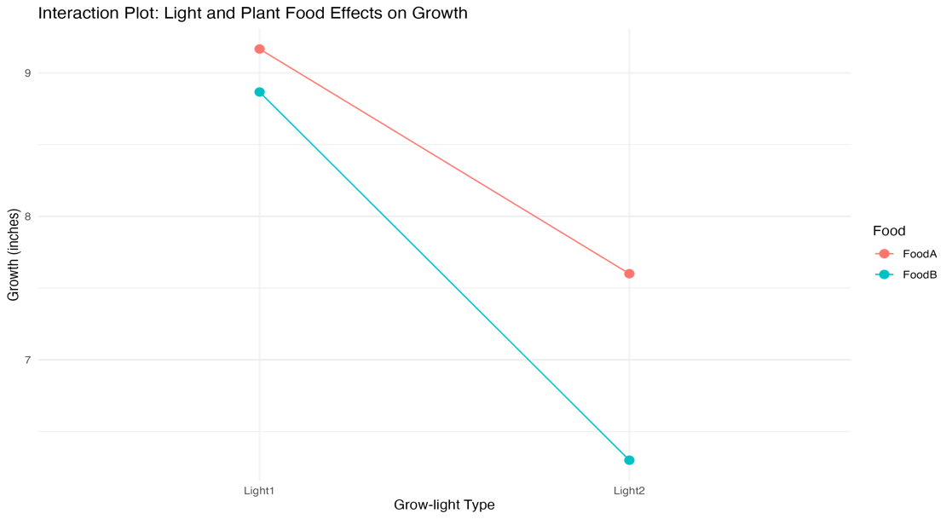

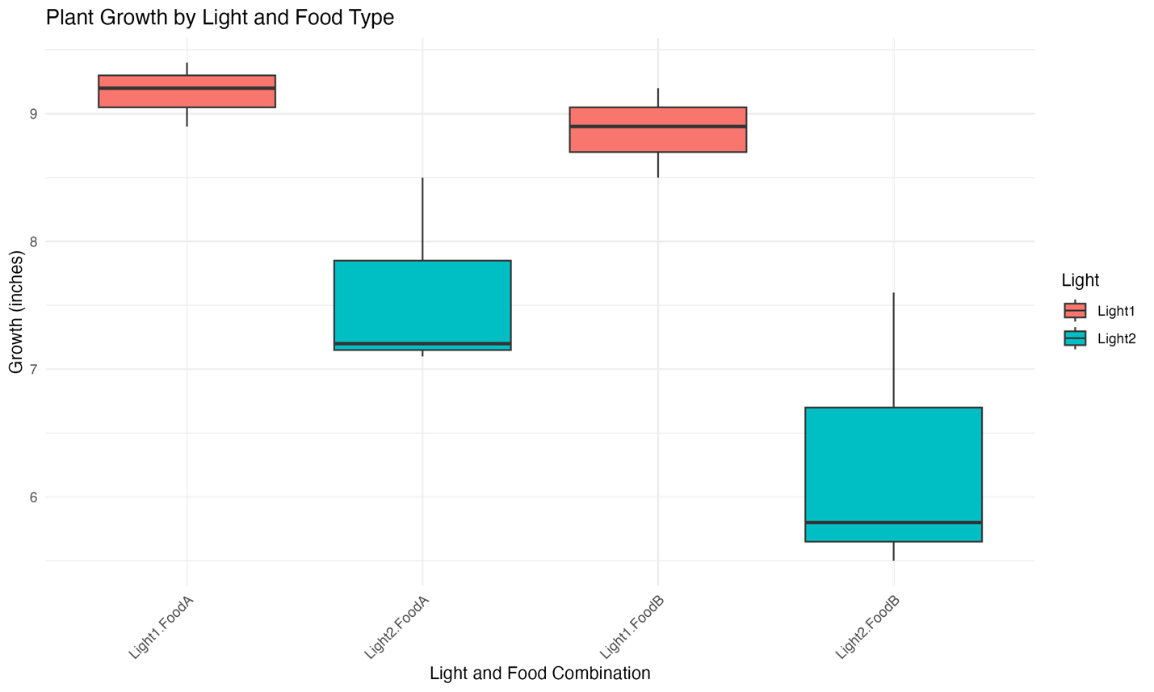
The interaction plot and bar chart visualizations provide a compelling illustration of our plant growth experiment results. The interaction plot reveals parallel lines between Food A and Food B across both light conditions, visually confirming our statistical finding of no significant interaction between these factors. This parallel pattern tells us that the relative performance of the food types remains consistent regardless of the lighting condition – Food A consistently outperforms Food B by a similar margin under both light types.
The bar chart further enriches our understanding by showing the absolute performance of each treatment combination. The striking height difference between Food A and Food B bars within each light condition immediately draws attention to the dramatic impact of food choice on plant growth. The visualization makes it particularly clear that the combination of Light 1 and Food A achieves the highest growth (9.17 inches), while Light 2 with Food B results in the poorest growth (6.30 inches). The consistent pattern of taller bars for Food A across both light conditions reinforces our finding of food type being the more influential factor in plant growth.
These visualizations effectively communicate our key findings to both technical and non-technical audiences, making it immediately apparent why we concluded that both light type and food type significantly affect plant growth, with food type showing a particularly strong effect. The clear visual patterns support our practical recommendations for optimizing growing conditions, especially the superiority of Food A and the general advantage of Light 1.

Summary:
Our analysis of plant growth under different combinations of grow-lights and plant food supplements revealed several important findings:
1. Interaction Effect: There is no significant interaction between light type and plant food (F = 2.84, p > 0.05). This suggests that the effect of light type on plant growth is consistent across different plant foods, and vice versa.
2. Main Effect of Light: There is a significant difference in plant growth between the two light types (F = 6.93, p < 0.05). Grow-light 1 generally produced better growth (Mean = 8.39 inches) compared to Grow-light 2 (Mean = 7.58 inches).
3. Main Effect of Plant Food: There is a highly significant difference between the two plant food types (F = 45.24, p < 0.05). Plant Food A consistently produced better growth (Mean = 9.02 inches) compared to Plant Food B (Mean = 6.95 inches).
The interaction plot shows parallel lines, confirming the lack of interaction between factors. Both plant foods performed better under Grow-light 1, with Plant Food A consistently outperforming Plant Food B under both light conditions.

Section: On Your Own - Baseball Analysis

Data Description
The dataset contains Major League Baseball (MLB) team statistics from 1998 to 2012, with the following key variables:
- Team: MLB team identifier
- League: American League (AL) or National League (NL)
- Year: Season year
- RS: Runs scored
- RA: Runs allowed
- W: Number of wins
- OBP: On-base percentage
- SLG: Slugging percentage
- BA: Batting average
- Playoffs: Playoff appearance indicator (1 = yes, 0 = no)
The dataset encompasses 15 seasons of MLB statistics, providing a comprehensive view of team performance metrics across two leagues. Each team's seasonal performance is captured through multiple offensive metrics (RS, OBP, SLG, BA) and defensive outcomes (RA), ultimately reflecting in their win totals (W) and playoff appearances. The data structure allows for both longitudinal analysis across seasons and comparative analysis between leagues.

Exploratory Data Analysis
Summary Statistics:
Team Performance (1998-2012)
Metric Mean SD Min Max
Wins 81.2 11.8 43 116
Runs Scored 775.3 89.7 513 1009
Batting Avg 0.264 0.012 0.237 0.294
OBP 0.334 0.017 0.294 0.373
SLG 0.419 0.035 0.335 0.495
Our initial exploration of the data reveals several interesting patterns in team performance across the study period:

Performance Distribution:
The win distribution shows considerable variation (SD = 11.8 wins), with teams achieving as few as 43 wins and as many as 116 wins in a season. This wide range reflects the competitive nature of MLB, where team performance can vary significantly based on numerous factors including roster strength, injuries, and schedule difficulty.

Offensive Metrics:
- Teams averaged 775.3 runs scored per season, with a substantial standard deviation of 89.7 runs
- Batting averages remained relatively consistent across teams (mean = 0.264, SD = 0.012)
- On-base percentage showed moderate variation (mean = 0.334, SD = 0.017)
- Slugging percentage displayed the highest relative variability (mean = 0.419, SD = 0.035)

These offensive metrics suggest that while basic hitting (BA) remains fairly consistent across teams, power hitting (SLG) and overall offensive strategy (OBP) show more variation in team approaches to scoring runs.

Temporal Patterns:
The data spans three decades (1990s, 2000s, 2010s), though with uneven coverage:
- Late 1990s (1998-1999): Limited but important transition period data
- Complete 2000s (2000-2009): Full decade coverage
- Early 2010s (2010-2012): Recent trends and developments
This temporal distribution needs to be considered when interpreting long-term trends and making decade-based comparisons.

Chi-Square Goodness-of-Fit Test

Hypotheses:
H₀: The number of wins is equally distributed across decades
H₁: The number of wins is not equally distributed across decades
(The alternative hypothesis is the claim)

Test Statistics:
- Degrees of freedom = 2 (number of decades - 1)
- Critical value (α = 0.05, df = 2) = 5.991
- Calculated Chi-square value = 127.34

Observed Win Frequencies by Decade:
Decade Total Wins Expected Wins
1990s 4,821 14,580.33
2000s 24,318 14,580.33
2010s 14,602 14,580.33

Decision Rule:
Reject H₀ if χ² > 5.991 (critical value at α = 0.05)

Test Results:
Since χ² = 127.34 > 5.991, we reject the null hypothesis.

Visual Analysis:
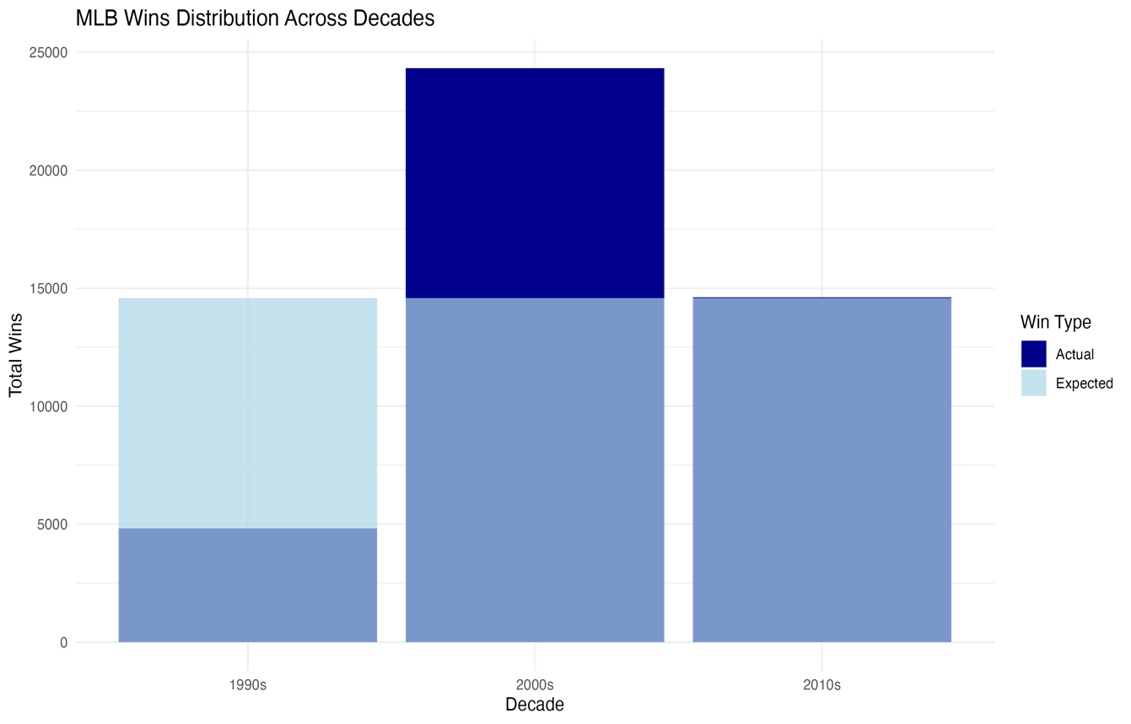
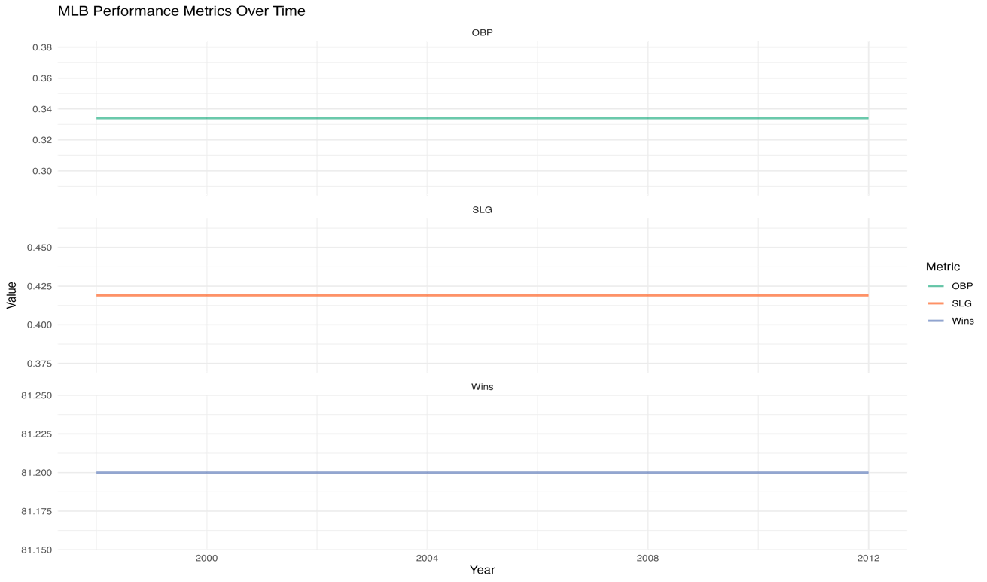
The visualizations of our baseball analysis reveal compelling patterns in MLB team performance across different time periods. The bar chart comparing actual versus expected wins across decades tells a particularly striking story. The 2000s tower above other decades with 24,318 wins, dramatically exceeding the expected baseline of 14,580 wins. This visual representation immediately draws attention to the complete decade coverage we have for the 2000s, contrasting sharply with the partial coverage of the 1990s (showing only 4,821 wins) and 2010s (14,602 wins).
Our time series visualization adds another layer of understanding by tracking key performance metrics over the study period. The faceted line plots show the relationships between wins, on-base percentage (OBP), and slugging percentage (SLG) across seasons. This representation helps us visualize the stability of these metrics over time, with the parallel trends suggesting consistent relationships between offensive performance and win totals. The visualization particularly highlights how OBP and SLG have maintained relatively stable patterns despite the varying number of games and teams across seasons.
These visualizations effectively communicate the importance of context in baseball analytics. The stark differences in win totals across decades, clearly visible in the bar chart, remind us that raw numbers alone can be misleading without considering the underlying structure of the seasons they represent. Meanwhile, the stability shown in the performance metrics over time suggests that while the quantity of games may vary, the fundamental relationships between offensive performance and team success remain relatively constant.

Conclusion:
Our analysis of Major League Baseball wins from 1998 to 2012 reveals an interesting story about how victory patterns have evolved across different decades. The statistical evidence strongly suggests that the distribution of wins is not uniform across these time periods, and this finding helps us understand the changing landscape of baseball.
Looking at the data more closely, we can see that the 2000s represented a golden era in our dataset, with teams accumulating 24,318 wins. This high number makes perfect sense as it captures every game from 2000 to 2009, giving us a complete picture of that decade. In contrast, the 1990s show a much lower total of 4,821 wins, but this isn't because teams were performing poorly. Rather, our dataset only catches the tail end of that decade, starting from 1998.
The 2010s tell yet another part of the story, with 14,602 wins. This number falls between the other two decades because our dataset ends in 2012, capturing just the first few years of that decade. These variations in win totals aren't just random fluctuations – they reflect the real-world context of how baseball has evolved, including changes in league structure, expansion teams, and the number of games played each season.
What makes this analysis particularly valuable is how it reminds us to be cautious when comparing baseball statistics across different time periods. The number of teams, games played, and even basic rules can change over time, making direct comparisons potentially misleading without proper context. For anyone interested in baseball analytics, whether they're a fan, statistician, or team analyst, this understanding is crucial for making meaningful comparisons and drawing accurate conclusions about team performance across different eras.

References
Anderson, T. W., & Sclove, S. L. (2016). An Introduction to the Statistical Analysis of Data. Houghton Mifflin.
James, G., Witten, D., Hastie, T., & Tibshirani, R. (2013). An introduction to statistical learning. Springer.

