Employee Attrition Prediction : A Decision Tree Analysis for TalentFirst Corp

Dev Panchal

ALY 6020: Predictive Analytics
Northeastern University
Professor Justin Grosz
March 15th, 2026

Introduction
The goal of this project was to assist TalentFirst Corp, a mid-size technology company, in identifying the key drivers of employee attrition and building a predictive model capable of flagging at-risk employees before they resign. TalentFirst is experiencing an annual attrition rate of approximately 29%, and the Chief Human Resources Officer (CHRO) estimates that each departure costs between $15,000 and $50,000 in recruiting, onboarding, and lost productivity. With a workforce of 3,000 employees, this translates to an estimated annual cost of approximately $13 million to $43.5 million, representing a significant financial and operational burden. The CHRO has requested actionable findings to present to the executive team next quarter.
To address this problem, we analyzed a dataset of 3,000 employee records containing 20 variables covering compensation, satisfaction, tenure, overtime, and department. Our analytical approach involved three models from the decision tree family: an unpruned decision tree, a pruned decision tree with a maximum depth of five, and a random forest ensemble. Decision tree algorithms were selected because of their interpretability, flexibility with mixed data types, and ability to generate feature importance scores that translate directly into actionable business insights. The analysis proceeds through data cleaning, exploratory analysis, model building and evaluation, and a set of concrete retention recommendations for TalentFirst leadership.
Data Cleanup
The first step in our modeling process was a thorough inspection of the dataset to identify and correct data quality issues before any analysis could proceed. Upon initial review, we identified five categories of problems. First, four duplicate Employee ID records were present in the dataset. Because duplicate records introduce artificial weight on specific observations, these were removed using a keep-first strategy, resulting in 2,996 unique employee records. Second, three records contained negative values in the Monthly_Income column, which are operationally impossible. These values were replaced with the column median ($7,186) calculated from valid records, preserving the central tendency of the distribution without distortion from impossible extremes. The median was chosen over the mean because income distributions tend to be right-skewed, and the median is a more robust measure of center in such cases.
Third, six records contained a Performance_Rating value of zero, which falls outside the valid scale. These were replaced with the column median of three, representing an average performance designation consistent with the dataset’s rating scheme. Fourth, five records exhibited a logical impossibility where Years_Since_Last_Promotion exceeded Years_at_Company, meaning an employee appeared to have been promoted before joining the company. These values were capped at the corresponding Years_at_Company value to restore internal consistency. Fifth, missing values were present across four columns: Monthly_Income (120 records), Job_Satisfaction (150 records), Work_Life_Balance (90 records), and Manager_Rating (120 records). Each of these was imputed using the column median rather than the mean, as the median is less sensitive to skew and outliers, and is appropriate for ordinal satisfaction variables like Job_Satisfaction and Work_Life_Balance. Mode imputation was not considered, as it was not covered in this course and would artificially inflate a single category.
Following cleaning, the dataset was complete with no remaining null values. The final attrition distribution confirmed that 28.9% of employees left the company, consistent with the 29% rate cited by the CHRO. Exploratory analysis revealed several notable patterns. Attrition rates were highest in Sales (33.4%) and Operations (32.0%), substantially above the Engineering department (25.9%), suggesting that frontline and customer-facing roles experience greater turnover pressure. Job satisfaction showed the strongest visual association with attrition: employees at satisfaction level 1 left at a rate of 44.6%, and at level 2 at 49.1%, compared to only 14.2% among those at the highest satisfaction level of 5. This nearly three-to-one difference makes job satisfaction an obvious starting point for HR intervention. Monthly income showed a more modest pattern, with leavers averaging $7,633 versus $7,813 for stayers, a difference too small to be considered independently decisive but potentially important in combination with other factors.
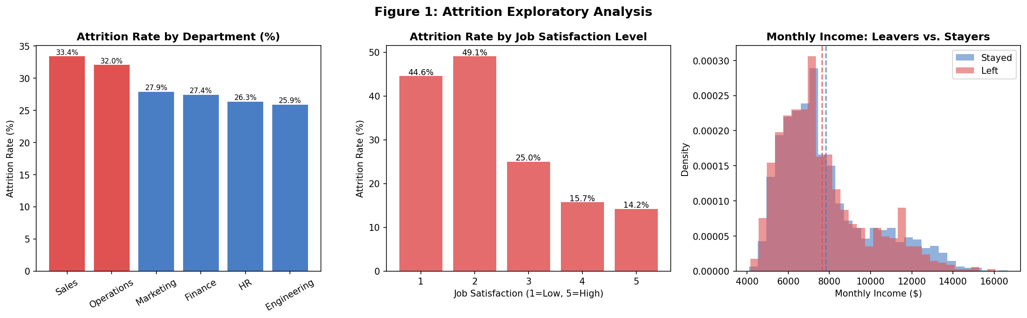
Model Results
Decision tree algorithms were selected for this analysis for three reasons. First, interpretability is paramount when presenting to executives and HR leaders: a decision tree allows us to trace exactly which variables drove a prediction and explain the decision logic in plain language. Second, unlike logistic regression, decision trees do not assume a linear relationship between variables and the outcome, which is appropriate given the mix of ordinal, categorical, and continuous features in this dataset. Third, decision trees handle mixed data types natively and do not require normalization or one-hot encoding, making them well-suited to HR datasets that combine numeric tenure fields, ordinal satisfaction ratings, and categorical department labels.
For this analysis, we encoded categorical variables using label encoding and split the cleaned dataset into an 80/20 training and testing partition using a stratified split to preserve the 29% attrition rate in both sets. Three models were built and evaluated using accuracy, precision, recall, and F1-score.
Model 1, the unpruned decision tree, was allowed to grow without any depth constraints. It reached a depth of 20 levels with 516 leaf nodes, effectively memorizing the training data. On the test set, this produced an accuracy of 67.3% with precision of 43.4%, recall of 43.9%, and an F1-score of 43.7%. The poor generalization is a textbook example of overfitting: with no stopping rule, the tree fits every noise pattern in the training data and loses predictive power on unseen records. From a business standpoint, this model is not usable as presented, but it establishes a baseline and illustrates why pruning is necessary. Feature importance from the unpruned tree cannot be meaningfully interpreted due to the excessive depth.
Model 2, the pruned decision tree with a maximum depth of five, significantly improved generalization. Accuracy rose to 71.5%, precision to 50.8%, and recall to 35.8%, yielding an F1-score of 42.0%. By constraining the tree to five levels, the model is forced to learn only the most robust splitting patterns rather than memorizing individual records. The first split in this tree is on Job_Satisfaction at a threshold of 2.5, immediately separating employees with very low satisfaction from the rest. Among those low-satisfaction employees, the second split evaluates Stock_Option_Level, then the tree branches further into Age and Overtime. This structure is directly interpretable: an employee who is dissatisfied, holds no stock options, and works overtime is routed down a high-attrition branch. Feature importance scores confirm Job_Satisfaction as the dominant driver at 0.471, followed by Work_Life_Balance (0.078), Age (0.077), Overtime (0.070), and Stock_Option_Level (0.065). These five variables account for approximately 76% of the model’s total predictive weight.
Model | Accuracy | Precision | Recall | F1-Score
Model 1: Unpruned Decision Tree | 67.3% | 43.4% | 43.9% | 43.7%
Model 2: Pruned Decision Tree (depth=5) | 71.5% | 50.8% | 35.8% | 42.0%
Model 3: Random Forest (100 trees) | 74.3% | 67.3% | 21.4% | 32.5%

Model 3, a random forest of 100 decision trees, achieved the highest overall accuracy at 74.3% and the highest precision at 67.3%, but at the cost of dramatically lower recall (21.4%) and a reduced F1-score of 32.5%. The random forest averages predictions across all 100 trees, each trained on a random subset of 200 records, using a voting mechanism. This ensemble approach reduces variance and produces more stable predictions, which is why accuracy and precision improve. However, the low recall means the model misses a large proportion of employees who actually leave. In a retention context, recall is arguably more important than precision: the cost of falsely classifying a future leaver as safe (a false negative) is a lost employee and $15,000–$50,000 in replacement cost, whereas the cost of a false positive is a retention intervention that was not strictly needed. On this basis, the pruned decision tree is the more operationally useful model despite its lower accuracy. Feature importance in the random forest, calculated as the percentage of trees in which a variable appears, places Monthly_Income first (12.0%), followed by Training_Hours_Last_Year (10.7%), Age (9.9%), and Distance_From_Home (9.7%). Job_Satisfaction, the dominant driver in the pruned tree, appears at 9.3%, suggesting it remains important but is somewhat diluted by the randomization across trees.
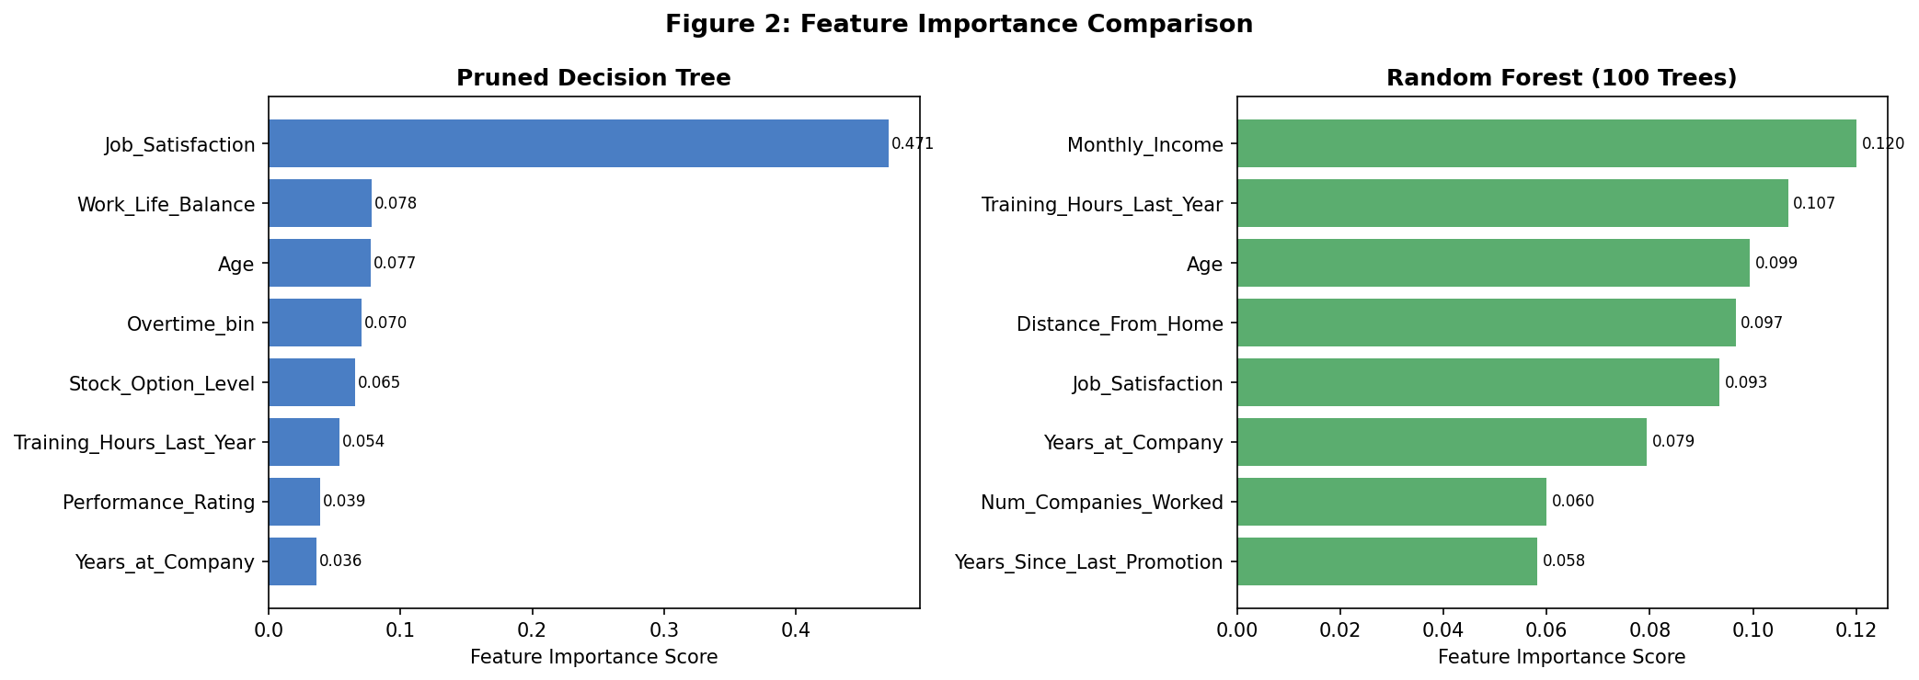
Conclusion
The data tells a clear story: TalentFirst’s attrition problem is largely a satisfaction and workload problem. Employees who report low job satisfaction, poor work-life balance, or consistent overtime are significantly more likely to leave — and this pattern is strongest in Sales and Operations, the two departments with the highest turnover rates. Compensation plays a supporting role, particularly when combined with a lack of stock options or stalled career progression, but satisfaction is the primary lever.
For the executive team, three actions stand out. First, launch a regular employee pulse survey focused on satisfaction and workload, and give department managers visibility into their team’s scores before problems become departures. Second, review overtime and promotion practices in Sales and Operations specifically — these teams are losing people at rates above 32%, and the data suggests they are feeling undervalued and overworked. Third, prioritize retention conversations with employees who show the warning signs the model identified: low satisfaction, no stock options, and high overtime. A focused outreach to this group, even if imperfect, could prevent a meaningful share of the $13 to $43 million the company is spending each year on turnover.

