Project 2 : Home Price Prediction – Horizon Realty

Dev Panchal

ALY 6020: Predictive Analytics
Northeastern University
Professor Justin Grosz
March 1, 2026

Introduction
The goal of this analysis was to assist Horizon Realty, a mid-size real estate brokerage operating in Ames, Iowa, in building a data-driven home pricing model. The VP of Sales posed a specific question: given a property's physical characteristics, what should it list for? To address this, we built a multiple linear regression model trained on approximately 2,930 residential property sales from 2006 to 2010 to predict sale price based on measurable property features. Horizon's agents currently set listing prices based on experience and informal comparables, an approach that introduces significant variability. Overpriced homes sit on the market, require reductions, and signal desperation to buyers, while underpriced homes leave money on the table for both the seller and the firm.
A successful outcome means delivering a regression model with strong explanatory power and interpretable coefficients that agents can use from day one. The model should tell agents not only what a home should sell for, but why — quantifying the dollar impact of quality upgrades, living area, and age-related depreciation in terms that homeowners and buyers can understand and act upon. This analysis directly informs the VP of Sales’ decision on whether to deploy a data-backed pricing tool across the firm’s listings.
Data Cleanup
The first step in our modeling process was to investigate the dataset and verify that our data was sound and of good quality. The dataset contained 2,930 records and 15 variables, spanning numerical, ordinal, and categorical types. An important distinction must be acknowledged upfront: in this dataset, many missing values coded as NA do not indicate absent or unknown data. Rather, they represent structural conditions such as no basement, no fireplace, or no garage. This distinction fundamentally changes the appropriate treatment for each affected column, and we addressed each variable independently. Bsmt Qual (80 missing, 2.7%), Fireplace Qu (1,422 missing, 48.5%), Garage Type (157 missing, 5.4%), and Mas Vnr Type (1,775 missing, 60.6%) were all recoded to descriptive labels reflecting the absence of that feature. Fence, with 80.5% of values missing, was excluded from the regression model entirely, as only 19.5% of properties had any recorded fence quality, providing insufficient variation to be a reliable predictor.
Three variables contained genuinely missing data requiring imputation. For Lot Frontage (490 missing, 16.7%), the distribution was right-skewed (skewness = 1.50), making the global mean susceptible to distortion by large values. We applied a group-by median using Neighborhood as the grouping variable, since frontage varies meaningfully by area and a neighborhood-specific estimate is more realistic than a single global statistic. For Mas Vnr Area (23 missing, 0.8%), cross-referencing with Mas Vnr Type confirmed no masonry type was recorded for the same records, so missing values were filled with zero, reflecting the absence of the feature rather than unknown data. For Total Bsmt SF (1 missing, <0.1%), the single row was dropped, leaving 2,929 usable records. To address outliers, we calculated two standard deviations above and below the mean for each numerical variable and capped any values exceeding those boundaries. This approach was chosen over row deletion because it preserves all 2,929 records while correcting extreme values. SalePrice carried a skewness of 1.74 before capping; after capping the range narrowed from $12,789–$755,000 to $21,074–$340,587 and skewness dropped to 0.81. Quality columns were not capped, as they operate on a bounded 0–5 ordinal scale by design. One engineered feature was created: House Age (2010 minus Year Built), which converts the construction year into a more interpretable variable whose coefficient can be read directly as the dollar impact of one additional year of age at time of sale.
Figures 1 through 3 illustrate key patterns confirmed during exploratory analysis. Figure 1 shows a clear positive linear relationship between above-ground living area and sale price, validating Gr Liv Area as a core model input. Figure 2 reveals that neighborhood exerts a strong influence on price, with NridgHt and NoRidge commanding median prices roughly 60–70% higher than OldTown and BrkSide, though with 28 distinct neighborhoods we excluded it from the regression to avoid dimensionality issues. Figure 3, the correlation heatmap, confirms that Overall Quality has the strongest positive correlation with SalePrice (r = 0.82), followed by Gr Liv Area (r = 0.73) and Total Bsmt SF (r = 0.65), while House Age shows a moderate negative correlation (r = −0.60). No two independent variables exceed a correlation of 0.70 with each other, indicating multicollinearity is not a material concern for this feature set.
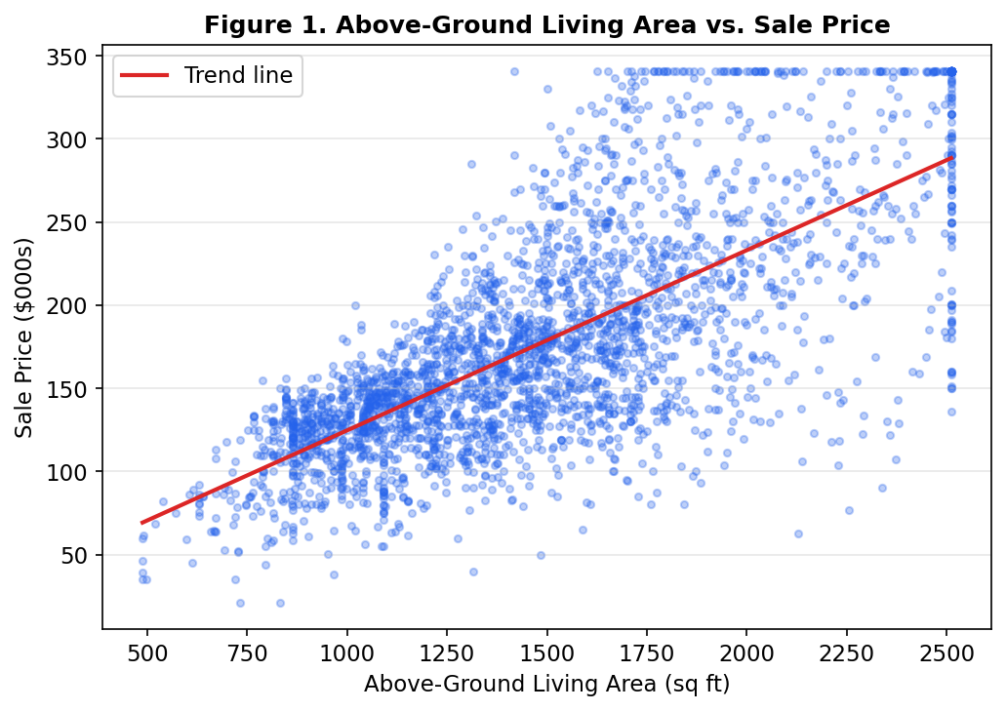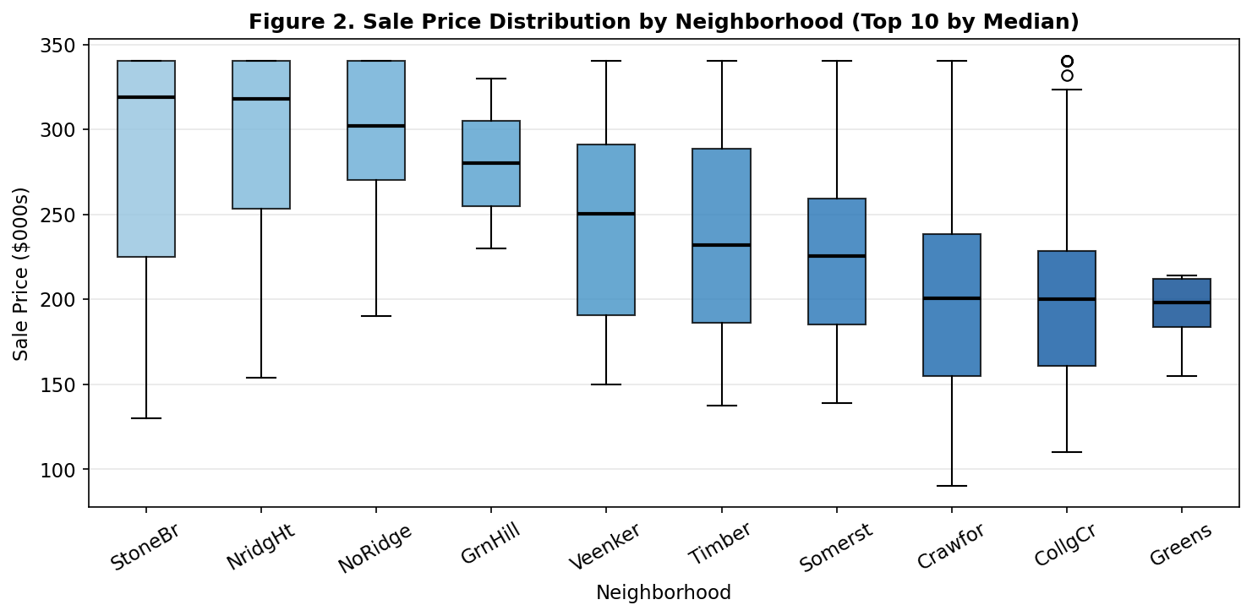
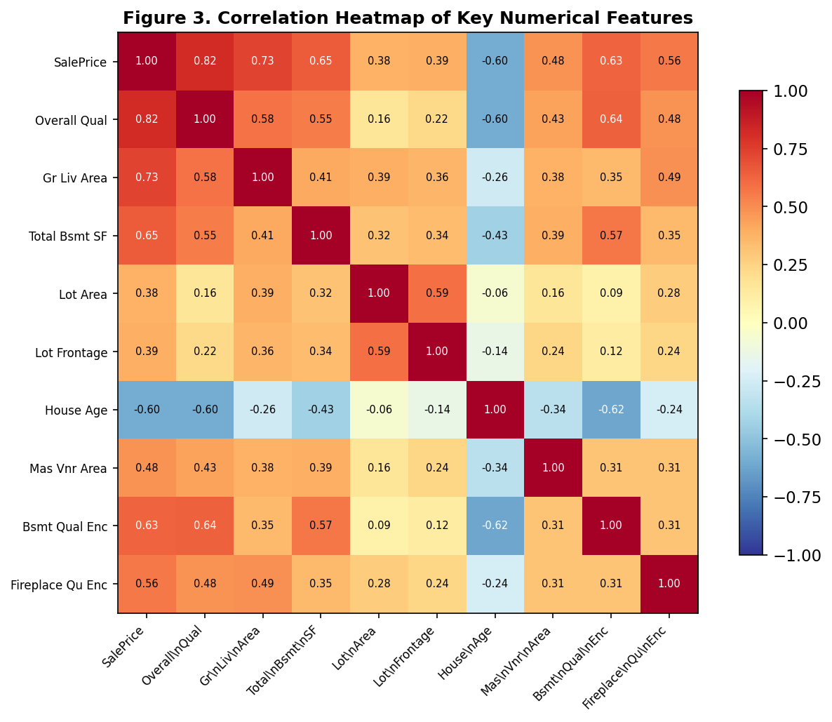
Model Results
We began by creating training and testing datasets to validate our models. An 80/20 split was applied using a fixed random seed (42), resulting in 2,343 training records and 586 test records. Linear regression was selected because the business problem is fundamentally a continuous value prediction problem — the goal is to predict an exact dollar figure rather than classify a property into a category. Multiple regression extends this by allowing all input features simultaneously, each receiving a coefficient that reflects its contribution to price holding all other variables constant. This produces directly interpretable outputs: an agent can tell a seller that upgrading kitchen quality is worth approximately $X in listing price, a statement that comes straight from the model's coefficients. Three models were built and compared. Model 1 was a simple regression using three core structural features: Overall Qual, Gr Liv Area, and Total Bsmt SF, serving as a baseline. Model 2 expanded to all nine analytically appropriate variables: Overall Qual, Gr Liv Area, Total Bsmt SF, Lot Area, Lot Frontage, House Age, Mas Vnr Area, Bsmt Qual Enc, and Fireplace Qu Enc. Each was included on the basis of business relevance and statistical independence. Neighborhood (28 categories) and Garage Type (6 categories) were excluded to avoid inflating the model with high-cardinality dummy variables. Model 3 applied forward stepwise selection using AIC as the optimization criterion, adding features one at a time and stopping when no remaining variable further reduced AIC.
As seen in Table 1 below, moving from Model 1 to Model 2 produces a meaningful improvement across every metric. Adjusted R² increases from 0.8113 to 0.8538, meaning the full model explains approximately 85.4% of the variation in home sale prices. RMSE drops from $30,259 to $26,807, a reduction of $3,452 in average prediction error per home. AIC decreases from 54,867.9 to 54,274.8, confirming the additional variables are justified by improved fit. The stepwise model (Model 3) produced identical results to the full model, which is itself an informative finding: the forward selection procedure retained all nine features, validating that no variable in Model 2 is redundant. We recommend Model 2 as the preferred model. The residual plot in Figure 4 shows largely random scatter around the zero line across the range of predicted prices, consistent with the assumption of homoscedasticity. A mild widening of residuals above $280K reflects that the model was trained predominantly on homes in the $100K–$300K range, and predictions above that threshold should be treated with slightly lower confidence. Figure 5 shows the actual vs. predicted plot, where points track closely along the diagonal through the core price range, confirming reliable performance. All nine features are statistically significant at p ≤ 0.05. Overall Quality is the single most impactful variable, with each one-point improvement on the 1–10 quality scale adding approximately $17,582 to the predicted sale price. Each additional square foot of above-ground living area adds $43.72, and each year of house age reduces price by $384.36. Figure 6 visualizes the dollar impact of all nine features. The coefficient table is provided in the Appendix.
Model | Adj. R² | R² (Test) | RMSE (Test) | AIC
Model 1 — Simple Regression (3 features) | 0.8113 | 0.8088 | $30,259 | 54,867.9
Model 2 — Full Multiple Regression (9 features) | 0.8538 | 0.8499 | $26,807 | 54,274.8
Model 3 — Stepwise Forward (9 features) ✓ | 0.8538 | 0.8499 | $26,807 | 54,274.8
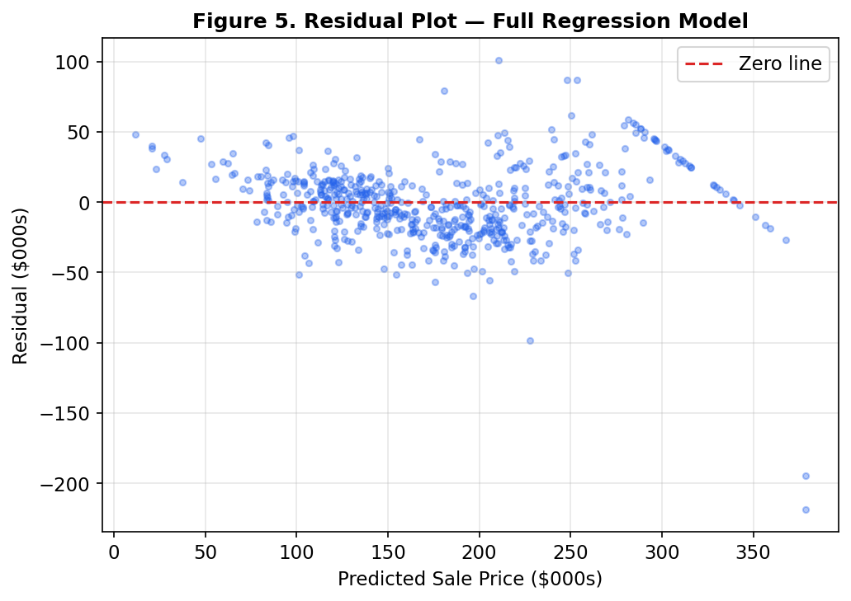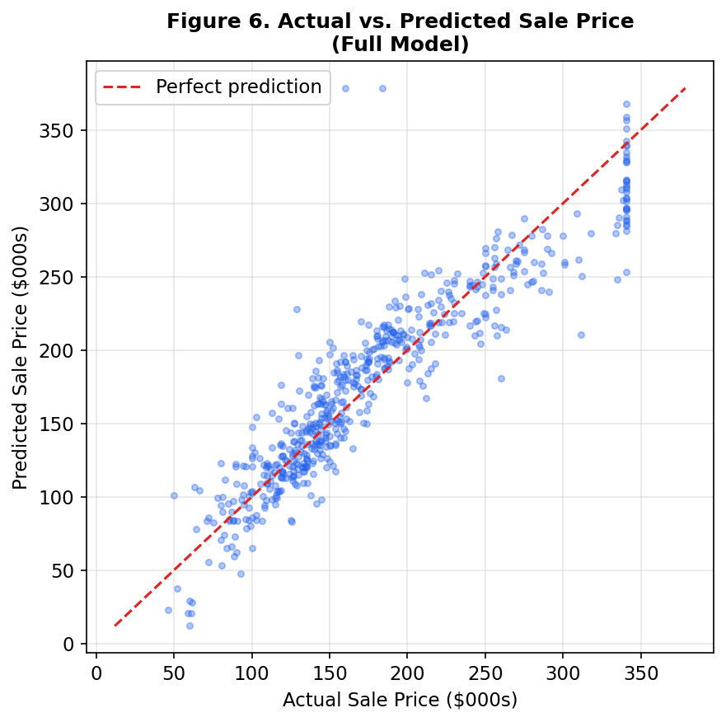
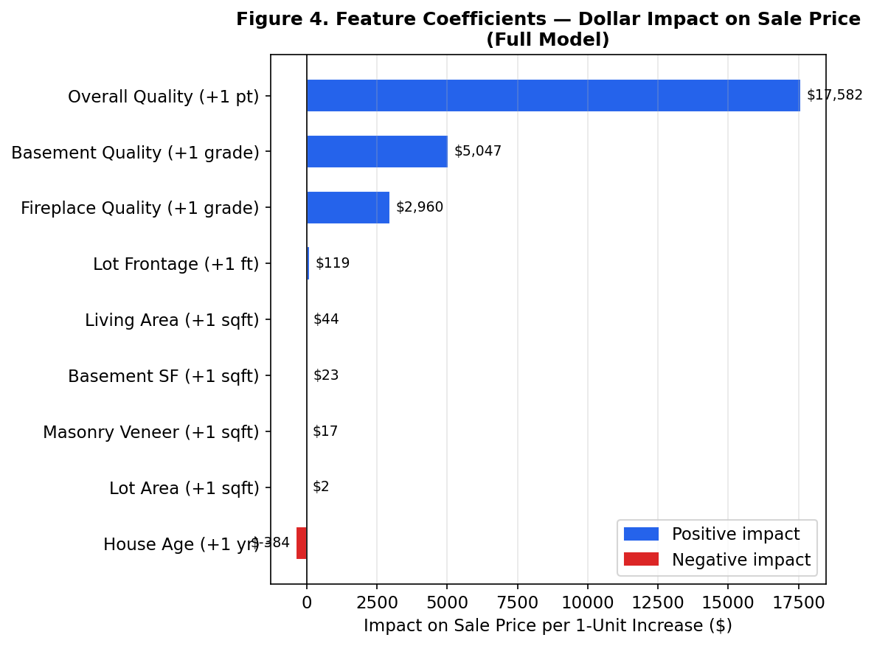
Conclusion
The goal of this analysis was to help Horizon Realty build a reliable, data-driven pricing tool for its agents in the Ames, Iowa market. Through this process we can conclude that the full nine-variable multiple regression model is the most suitable model for deployment, explaining 85.4% of the variation in home sale prices with a typical prediction error of $26,807. Home values in Ames are driven primarily by build quality and usable space. Overall Quality is the dominant driver, with each quality point adding approximately $17,582 to the predicted price. Above-ground living area contributes $43.72 per square foot, basement square footage adds $23.28 per square foot, and each additional year of house age reduces value by $384. Basement quality (+$5,047 per grade) and fireplace quality (+$2,960 per grade) provide meaningful secondary levers that homeowners can act on prior to listing.
We recommend that Horizon Realty deploy this model as an initial pricing reference tool, with agents adjusting the output by 5–10% based on property-specific factors not captured in the data, such as recent renovations, curb appeal, and current market momentum. For homeowners preparing to list, our primary recommendation is to prioritize targeted quality improvements over square footage additions. To illustrate the trade-off directly: a $10,000 kitchen or bathroom refresh sufficient to raise the Overall Quality rating by one point is estimated to return approximately $17,582 in listing price — a net gain of roughly $7,500 on that investment. By contrast, a 200-square-foot structural addition costing $30,000–$40,000 in construction would add only approximately $8,744 in predicted value, resulting in a net loss. The math strongly favors quality over size for most pre-listing budgets. It should be noted that the model was trained on 2006–2010 data and should be retrained annually to remain calibrated to current market conditions. Predictions above $300K carry wider error margins given fewer training observations at that price range. Additional variables such as total bathrooms, garage capacity, and renovation year could further improve model precision in future iterations. Despite these limitations, the current model provides Horizon's agents with a transparent, repeatable, and defensible pricing baseline that removes guesswork from the listing process entirely.

Appendix A: Python Code

# ALY 6020 | Week 2 | Home Price Prediction with Linear Regression | Horizon Realty

import pandas as pd
import numpy as np
import matplotlib.pyplot as plt
import matplotlib.patches as mpatches
from sklearn.linear_model import LinearRegression
from sklearn.model_selection import train_test_split
from sklearn.metrics import r2_score, mean_squared_error
from scipy import stats
import warnings
warnings.filterwarnings('ignore')

# 1. LOAD & INSPECT
df = pd.read_csv('AmesHousing_15cols.csv')
print(f'Shape: {df.shape}')
print(df.isnull().sum()[df.isnull().sum() > 0])
print(df.describe().round(2))

# 2. DATA CLEANING
df2 = df.copy()
# Lot Frontage (490 missing, 16.7%) — right-skewed (skew=1.50), group-by median
# by Neighborhood: frontage varies by area, global mean distorted by outliers
df2['Lot Frontage'] = df2['Lot Frontage'].fillna(
df2.groupby('Neighborhood')['Lot Frontage'].transform('median'))
df2['Lot Frontage'] = df2['Lot Frontage'].fillna(df2['Lot Frontage'].median())
# Mas Vnr Area (23 missing, 0.8%) — no Mas Vnr Type recorded either; fill 0
df2['Mas Vnr Area'] = df2['Mas Vnr Area'].fillna(0)
# Total Bsmt SF (1 missing, <0.1%) — drop single row, negligible data loss
df2 = df2.dropna(subset=['Total Bsmt SF'])
# Structural NAs: not missing data — means feature does not exist
df2['Mas Vnr Type'] = df2['Mas Vnr Type'].fillna('None')
df2['Bsmt Qual'] = df2['Bsmt Qual'].fillna('No Bsmt')
df2['Fireplace Qu'] = df2['Fireplace Qu'].fillna('No Fireplace')
df2['Garage Type'] = df2['Garage Type'].fillna('No Garage')
df2['Garage Yr Blt'] = df2['Garage Yr Blt'].fillna(0)
# Fence (80.5% missing) — excluded from model; insufficient coverage
# Feature engineering
df2['House Age'] = 2010 - df2['Year Built']
# Outlier capping at ±2 std dev (quality encodings are bounded, not capped)
cols_to_cap = ['SalePrice','Lot Area','Gr Liv Area','Total Bsmt SF','Lot Frontage','Mas Vnr Area']
for col in cols_to_cap:
mean, std = df2[col].mean(), df2[col].std()
df2[col] = df2[col].clip(mean - 2*std, mean + 2*std)
# Ordinal encoding: Ex=5, Gd=4, TA=3, Fa=2, Po=1, No feature=0
qual_map = {'Ex':5,'Gd':4,'TA':3,'Fa':2,'Po':1,'No Bsmt':0,'No Fireplace':0}
df2['Bsmt Qual Enc'] = df2['Bsmt Qual'].map(qual_map)
df2['Fireplace Qu Enc'] = df2['Fireplace Qu'].map(qual_map)
print(f'Shape after cleaning: {df2.shape}')

# 3. EDA
BLUE, RED = '#2563EB', '#DC2626'
fig, ax = plt.subplots(figsize=(8, 5))
ax.scatter(df2['Gr Liv Area'], df2['SalePrice']/1000, alpha=0.3, s=12, color=BLUE)
z = np.polyfit(df2['Gr Liv Area'], df2['SalePrice']/1000, 1)
xs = np.linspace(df2['Gr Liv Area'].min(), df2['Gr Liv Area'].max(), 200)
ax.plot(xs, np.poly1d(z)(xs), color=RED, linewidth=2, label='Trend line')
ax.set_xlabel('Above-Ground Living Area (sq ft)'); ax.set_ylabel('Sale Price ($000s)')
ax.set_title('Figure 1. Above-Ground Living Area vs. Sale Price')
ax.legend(); ax.grid(axis='y', alpha=0.3)
plt.tight_layout(); plt.savefig('fig1_scatter.png', dpi=150, bbox_inches='tight'); plt.show()

top10 = df2.groupby('Neighborhood')['SalePrice'].median().nlargest(10).index
order = df2.groupby('Neighborhood')['SalePrice'].median().loc[top10].sort_values(ascending=False).index
fig, ax = plt.subplots(figsize=(11, 5))
bp = ax.boxplot([df2[df2['Neighborhood']==n]['SalePrice'].values/1000 for n in order],
labels=order, patch_artist=True, medianprops=dict(color='black', linewidth=2))
for patch, c in zip(bp['boxes'], plt.cm.Blues(np.linspace(0.4, 0.85, len(order)))):
patch.set_facecolor(c); patch.set_alpha(0.8)
ax.set_xlabel('Neighborhood'); ax.set_ylabel('Sale Price ($000s)')
ax.set_title('Figure 2. Sale Price Distribution by Neighborhood (Top 10 by Median)')
ax.tick_params(axis='x', rotation=30); ax.grid(axis='y', alpha=0.3)
plt.tight_layout(); plt.savefig('fig2_neighborhood.png', dpi=150, bbox_inches='tight'); plt.show()

num_cols = ['SalePrice','Overall Qual','Gr Liv Area','Total Bsmt SF',
'Lot Area','Lot Frontage','House Age','Mas Vnr Area',
'Bsmt Qual Enc','Fireplace Qu Enc']
corr = df2[num_cols].corr().round(2)
fig, ax = plt.subplots(figsize=(9, 7))
im = ax.imshow(corr.values, cmap='RdYlBu_r', vmin=-1, vmax=1)
plt.colorbar(im, ax=ax, shrink=0.8)
ax.set_xticks(range(len(num_cols))); ax.set_yticks(range(len(num_cols)))
ax.set_xticklabels(num_cols, fontsize=8, rotation=45, ha='right')
ax.set_yticklabels(num_cols, fontsize=8)
for i in range(len(num_cols)):
for j in range(len(num_cols)):
v = corr.values[i, j]
ax.text(j, i, f'{v:.2f}', ha='center', va='center', fontsize=7,
color='white' if abs(v) > 0.6 else 'black')
ax.set_title('Figure 3. Correlation Heatmap of Key Numerical Features')
plt.tight_layout(); plt.savefig('fig3_corr.png', dpi=150, bbox_inches='tight'); plt.show()
print('Top correlations with SalePrice:')
print(corr['SalePrice'].drop('SalePrice').sort_values(ascending=False))

# 4. TRAIN-TEST SPLIT & MODEL HELPER
features_simple = ['Overall Qual', 'Gr Liv Area', 'Total Bsmt SF']
features_full = ['Overall Qual','Gr Liv Area','Total Bsmt SF','Lot Area',
'Lot Frontage','House Age','Mas Vnr Area',
'Bsmt Qual Enc','Fireplace Qu Enc']
y = df2['SalePrice'].values

def get_metrics(features):
X = df2[features].values
X_tr, X_te, y_tr, y_te = train_test_split(X, y, test_size=0.2, random_state=42)
m = LinearRegression().fit(X_tr, y_tr)
y_pr_tr = m.predict(X_tr); y_pr_te = m.predict(X_te)
n, k = X_tr.shape
adj_r2 = 1 - (1 - r2_score(y_tr, y_pr_tr)) * (n - 1) / (n - k - 1)
rmse = np.sqrt(mean_squared_error(y_te, y_pr_te))
res = y_tr - y_pr_tr; s2 = np.sum(res**2) / n
aic = 2*(k+1) - 2*(-n/2*np.log(2*np.pi*s2) - np.sum(res**2)/(2*s2))
Xc = np.column_stack([np.ones(n), X_tr])
coef = np.linalg.lstsq(Xc, y_tr, rcond=None)[0]
mse = np.sum((y_tr - Xc@coef)**2) / (n - k - 1)
se = np.sqrt(np.diag(mse * np.linalg.inv(Xc.T @ Xc)))
pv = 2*(1 - stats.t.cdf(np.abs(coef/se), df=n-k-1))
return m, adj_r2, r2_score(y_te, y_pr_te), rmse, aic, coef[1:], pv[1:], y_te, y_pr_te

# 5. MODEL 1 — Simple Regression (3 features)
m1, adj1, r2_1, rmse1, aic1, coef1, pv1, yte1, ype1 = get_metrics(features_simple)
print(f'Model 1 — Simple | AdjR2={adj1:.4f} | R2={r2_1:.4f} | RMSE=${rmse1:,.0f} | AIC={aic1:.1f}')
for f, c, p in sorted(zip(features_simple, coef1, pv1), key=lambda x: x[2]):
print(f' {f:<22} ${c:>10,.2f} p={p:.4f}')

# 6. MODEL 2 — Full Multiple Regression (9 features)
m2, adj2, r2_2, rmse2, aic2, coef2, pv2, yte2, ype2 = get_metrics(features_full)
print(f'Model 2 — Full | AdjR2={adj2:.4f} | R2={r2_2:.4f} | RMSE=${rmse2:,.0f} | AIC={aic2:.1f}')
for f, c, p in sorted(zip(features_full, coef2, pv2), key=lambda x: x[2]):
sig = '***' if p < 0.001 else '**' if p < 0.01 else '*' if p < 0.05 else ''
print(f' {f:<22} ${c:>10,.2f} p={p:.6f} {sig}')

# 7. MODEL 3 — Stepwise Forward Selection (AIC-optimized)
remaining, selected, best_aic = features_full.copy(), [], np.inf
for _ in range(len(features_full)):
best_feat = None
for f in remaining:
_, _, _, _, aic_t, _, _, _, _ = get_metrics(selected + [f])
if aic_t < best_aic:
best_aic = aic_t; best_feat = f
if best_feat:
selected.append(best_feat); remaining.remove(best_feat)
else:
break
m3, adj3, r2_3, rmse3, aic3, coef3, pv3, yte3, ype3 = get_metrics(selected)
print(f'Model 3 — Step | AdjR2={adj3:.4f} | R2={r2_3:.4f} | RMSE=${rmse3:,.0f} | AIC={aic3:.1f}')
print(f'Selected features ({len(selected)}): {selected}')

# 8. MODEL COMPARISON
results = pd.DataFrame({
'Model': ['Model 1 — Simple (3 feat)','Model 2 — Full (9 feat)',f'Model 3 — Stepwise ({len(selected)} feat) ✓'],
'Adj R²': [round(adj1,4), round(adj2,4), round(adj3,4)],
'R² (Test)': [round(r2_1,4), round(r2_2,4), round(r2_3,4)],
'RMSE': [f'${rmse1:,.0f}', f'${rmse2:,.0f}', f'${rmse3:,.0f}'],
'AIC': [round(aic1,1), round(aic2,1), round(aic3,1)]})
print(results.to_string(index=False))

# 9. VISUALIZATIONS
coef_sorted = sorted(zip(features_full, coef2), key=lambda x: x[1])
labels = [f.replace(' Enc','') for f, _ in coef_sorted]
vals = [v for _, v in coef_sorted]
fig, ax = plt.subplots(figsize=(9, 6))
bars = ax.barh(labels, vals, color=[RED if v < 0 else BLUE for v in vals], edgecolor='white', height=0.65)
for bar, val in zip(bars, vals):
ax.text(val + (300 if val >= 0 else -300), bar.get_y() + bar.get_height()/2,
f'${val:,.0f}', va='center', ha='left' if val >= 0 else 'right', fontsize=9)
ax.axvline(0, color='black', linewidth=0.8)
ax.set_xlabel('Impact on Sale Price per 1-Unit Increase ($)')
ax.set_title('Figure 4. Feature Coefficients — Dollar Impact on Sale Price (Full Model)')
ax.legend(handles=[mpatches.Patch(color=BLUE, label='Positive'), mpatches.Patch(color=RED, label='Negative')])
ax.grid(axis='x', alpha=0.3)
plt.tight_layout(); plt.savefig('fig4_coefs.png', dpi=150, bbox_inches='tight'); plt.show()

fig, ax = plt.subplots(figsize=(8, 5))
residuals = yte2 - ype2
ax.scatter(ype2/1000, residuals/1000, alpha=0.35, s=12, color=BLUE)
ax.axhline(0, color=RED, linewidth=1.5, linestyle='--', label='Zero line')
ax.set_xlabel('Predicted Sale Price ($000s)'); ax.set_ylabel('Residual ($000s)')
ax.set_title('Figure 5. Residual Plot — Full Regression Model')
ax.legend(); ax.grid(alpha=0.3)
plt.tight_layout(); plt.savefig('fig5_residual.png', dpi=150, bbox_inches='tight'); plt.show()

fig, ax = plt.subplots(figsize=(6, 6))
mn = min(yte2.min(), ype2.min())/1000; mx = max(yte2.max(), ype2.max())/1000
ax.scatter(yte2/1000, ype2/1000, alpha=0.35, s=12, color=BLUE)
ax.plot([mn, mx], [mn, mx], color=RED, linewidth=1.5, linestyle='--', label='Perfect prediction')
ax.set_xlabel('Actual Sale Price ($000s)'); ax.set_ylabel('Predicted Sale Price ($000s)')
ax.set_title('Figure 6. Actual vs. Predicted Sale Price (Full Model)')
ax.legend(); ax.grid(alpha=0.3)
plt.tight_layout(); plt.savefig('fig6_actual_pred.png', dpi=150, bbox_inches='tight'); plt.show()

Feature | Coefficient | P-value | Business Interpretation
Overall Qual | +$17,582 / pt | p < 0.001 | Each +1 quality point adds ~$17,582 to listing price
Bsmt Qual | +$5,047 / grade | p < 0.001 | Upgrading basement from TA to Gd adds ~$5,047
Fireplace Qu | +$2,960 / grade | p < 0.001 | Upgrading fireplace from Fa to TA adds ~$2,960
Gr Liv Area | +$43.72 / sqft | p < 0.001 | Each additional sqft of living area adds ~$44
Total Bsmt SF | +$23.28 / sqft | p < 0.001 | Each additional basement sqft adds ~$23
Lot Frontage | +$119.43 / ft | p = 0.0011 | Each additional foot of street frontage adds ~$119
Mas Vnr Area | +$17.05 / sqft | p < 0.001 | 100 sqft of masonry veneer adds ~$1,705
Lot Area | +$1.68 / sqft | p < 0.001 | 1,000 additional sqft of lot adds ~$1,680
House Age | −$384 / yr | p < 0.001 | Each additional year of age reduces price by ~$384
Table Coefficient Interpretation — All variables significant at p ≤ 0.05.

