Loan Default Prediction : A Risk Assessment for SecureBank

Dev Panchal

ALY 6020: Predictive Analytics
Northeastern University
Professor Justin Grosz
March 8th, 2026

Introduction
SecureBank wants to know which loan applicants are likely to default before their loans are approved. The Chief Risk Officer (CRO) is the key decision-maker for this analysis. When the bank approves a borrower who later defaults, it loses an average of $15,000. When it wrongly turns away a good borrower, it loses $2,000 in revenue. This means a bad approval is 7.5 times more costly than a bad rejection, so the bank needs a model that is especially careful about who gets approved.
The goal of this analysis is to use past loan data to build a model that flags risky applicants before a loan is issued. A good outcome gives the CRO a clear, data-backed way to make lending decisions that reduces losses without turning away too many good customers. The dataset includes 2,559 past loan records with 21 variables covering each borrower's financial history, employment, age, loan details, and more. About 30% of borrowers in the dataset defaulted on their loans.
Data Cleanup
The dataset was reviewed for missing values, impossible values, and data entry errors. Five issues were found across four columns. Each was handled separately based on the type of data and the shape of its distribution. The table below shows what was found and how each issue was fixed.

Variable | Missing | % Missing | Method | Why
Loan_Amount (negative values) | — | — | Clipped to 0 | Loan amounts cannot be negative. The minimum value was -5,410 DM, which is a data entry error. All negative values were set to 0 before handling missing values.
Loan_Duration_Months | 76 | 3.0% | Median imputation | The distribution is right-skewed (mean = 21 months, median = 18 months). The median is more reliable when data is skewed, as it is not pulled by extreme values.
Loan_Amount | 127 | 5.0% | Median imputation | The distribution is right-skewed (mean = 3,291 DM, median = 2,322 DM). Using the mean would overestimate the typical loan amount, so the median was used instead.
Age | 103 | 4.0% | Mean imputation | The distribution is approximately normal (mean = 35, median = 33). When data is not skewed, the mean and median are nearly equal and either is acceptable. Mean was used.
Employment_Duration | 102 | 4.0% | Middle-tier imputation ("1-4 years") | This is an ordinal variable with 5 levels from unemployed to 7+ years. The middle tier was chosen to avoid assuming the best or worst case for borrowers with no employment on record.

After cleaning, categorical variables were converted into numbers so the models could use them. Variables with a natural order — like checking account balance tiers and savings account levels — were assigned numbers that preserve that order. Variables with only two options, like Has_Telephone and Is_Foreign_Worker, were converted to 0 and 1. All other categorical variables, such as loan purpose and job type, were split into separate yes/no columns using one-hot encoding. The final dataset had 41 columns ready for modeling.
The target variable shows that 70% of borrowers did not default and 30% did. This imbalance means accuracy alone is not a reliable way to measure model performance. A model that predicted no default for every applicant would be right 70% of the time but would catch zero actual defaulters — the exact problem SecureBank is trying to solve. Precision and recall are therefore the more meaningful metrics for evaluating these models.
Before building models, the data was explored visually to find early patterns. The three charts below show the strongest signals found in the data.
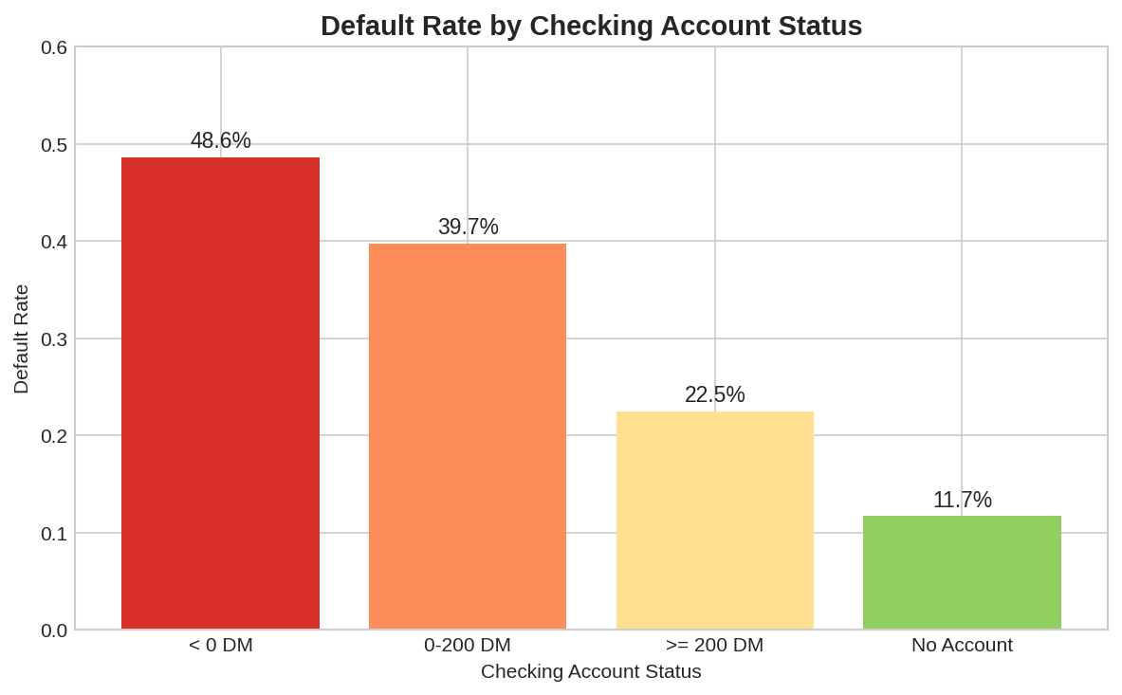
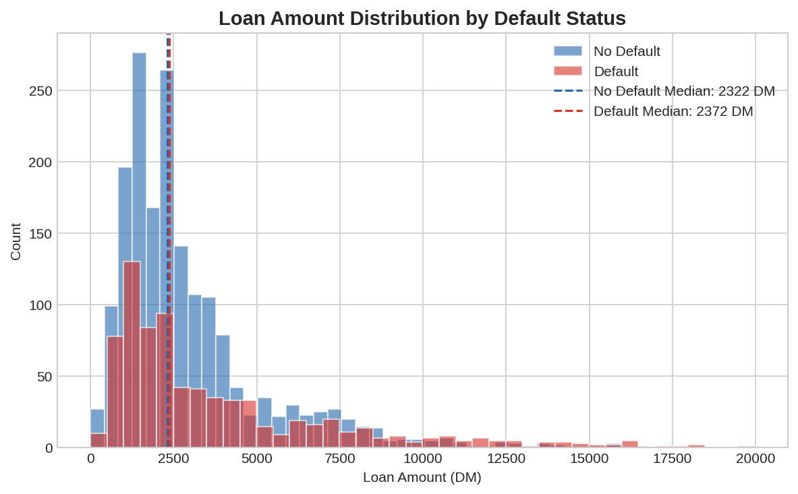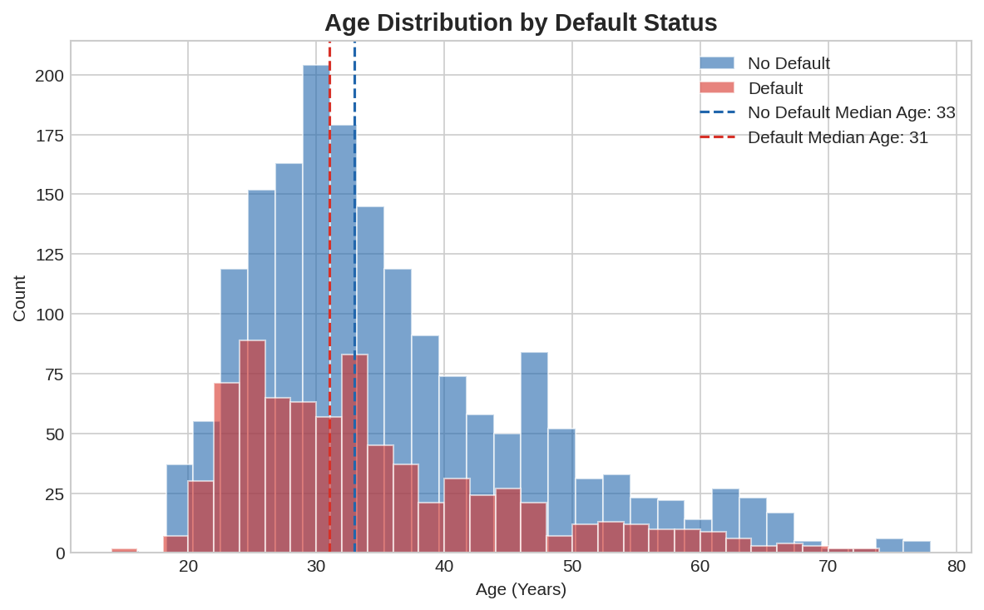

Model Results
Classification models were used because the outcome we are predicting — default or no default — is a yes/no decision, not a number. Two types of models were chosen: Logistic Regression and Support Vector Machine (SVM). Logistic Regression is a solid starting point because it shows exactly which variables are driving the prediction and by how much. SVM was added as a comparison because it can pick up on more complex patterns that a straight-line model might miss. The downside of SVM is that it does not tell us which individual variables matter — it only gives the prediction.
Three models were built and tested on a held-out group of 512 records that were not used during training.
Model 1 — Logistic Regression with all features — gives the clearest picture of which variables matter most. The strongest predictor was checking account status. Each step up in checking account balance reduced the odds of defaulting by about 53%. Savings account status worked the same way — each tier up reduced default odds by around 34%. On the flip side, a higher installment rate as a share of income increased default odds by 40%, and borrowers taking out new car loans were about 39% more likely to default compared to other loan types. These three factors — checking account balance, savings balance, and installment rate — are the clearest warning signs in the data.
Model 2 — Optimized Logistic Regression — used a feature selection process to narrow the 41 variables down to the 15 most useful ones. The variables kept included checking account status, loan duration, loan amount, savings account status, installment rate, age, credit history, loan purpose, personal status, guarantor status, property type, installment plan type, and housing type. Removing the weaker variables kept the model simpler without a meaningful drop in performance, and the key risk factors stayed the same as Model 1.
Model 3 — SVM with RBF Kernel — finds patterns across all variables at once rather than measuring each variable's individual effect. This makes it better at handling complex cases, but it cannot explain why a specific borrower is flagged as high risk. Its strength is purely in prediction accuracy.
The table below shows how all three models performed on the test set.
Model | Accuracy | Precision | Recall | F1-Score | AUC
LR Baseline (All Features) | 0.777 | 0.661 | 0.522 | 0.583 | 0.789
LR Optimized (15 Features) | 0.773 | 0.666 | 0.483 | 0.560 | 0.795
SVM (RBF Kernel) | 0.843 | 0.841 | 0.588 | 0.692 | 0.889

The SVM model had the strongest scores across all metrics. Its precision of 0.840 means that when it flags someone as a likely defaulter, it is correct 84% of the time — which matters a lot when each bad loan costs $15,000. The logistic regression models scored slightly lower but offer something SVM cannot: a clear breakdown of which variables are driving the risk. Both model types are useful for different purposes — one for prediction strength, the other for explaining decisions to regulators or applicants. Given that a bad approval costs $15,000 versus $2,000 for a bad rejection, prioritizing precision is the right call for SecureBank.
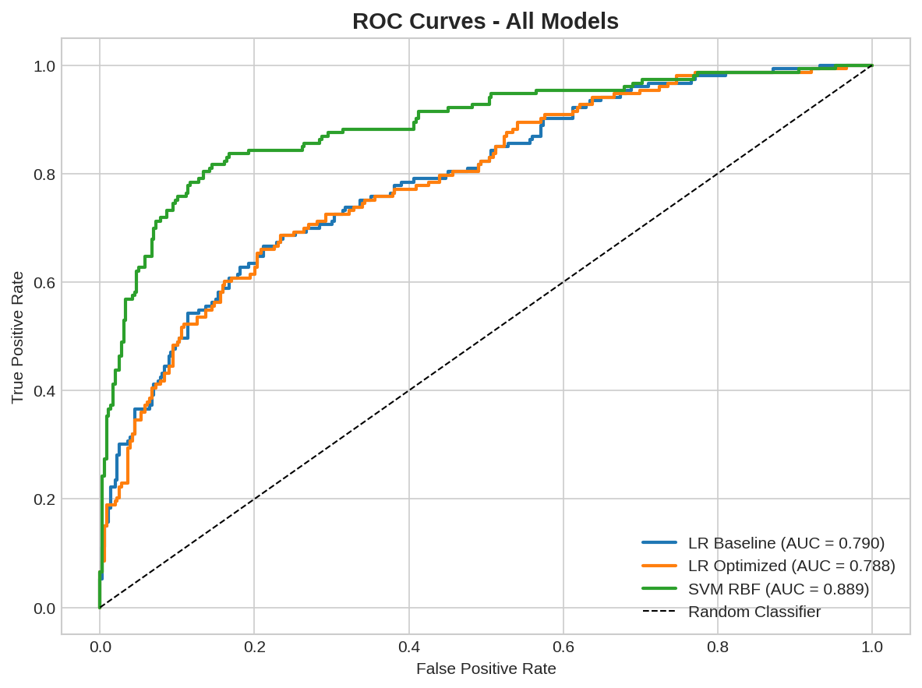
Conclusion
Three borrower characteristics stand out as the clearest predictors of default: checking account balance, savings account balance, and installment rate as a share of income. Borrowers who have a negative checking balance, little to no savings, and a high monthly payment burden are the most likely to default. SecureBank should treat these three as primary red flags during loan review. Applicants who show all three warning signs should receive extra scrutiny — for example, a smaller approved loan amount, a required co-signer, or additional income verification before moving forward.
Going forward, the bank should consider building these risk factors directly into its loan approval process so that decisions are made consistently rather than case by case. It would also be worth monitoring loan outcomes over time and refreshing the analysis as new data comes in, since borrower behavior and economic conditions change. Finally, the bank should be thoughtful about which variables are used in final decisions to avoid any unintended bias or issues with fair lending regulations.

