Customer Churn Prediction : A Neural Network Analysis for ConnectTel

Dev Panchal

ALY 6020: Predictive Analytics
Northeastern University
Professor Justin Grosz
March 22nd, 2026

Introduction
The goal of this project was to assist ConnectTel, a mid-size telecommunications company serving approximately 5,000 customers, in identifying which customers are most likely to cancel their service and what actions the company can take to retain them. ConnectTel is experiencing a churn rate of approximately 28%, and each lost customer costs an estimated $300 to $500 in replacement acquisition costs. With 5,000 customers, this translates to roughly 1,400 churned customers per year, representing an estimated annual revenue impact of $420,000 to $700,000 in replacement costs alone — a substantial burden that the VP of Customer Success has flagged as a strategic priority. The VP has asked specifically which customers are about to leave and what targeted offers can be made to retain them within a constrained retention budget.
To address this problem, we analyzed a dataset of 5,000 customer records containing 24 variables covering contract type, service add-ons, billing preferences, tenure, monthly charges, and support activity. Our analytical approach involved three models built in sequence: a logistic regression baseline, a simple neural network with one hidden layer of 16 neurons, and a deeper neural network with two hidden layers of 32 and 16 neurons. Neural networks were selected as the primary algorithm because of their ability to capture non-linear relationships between customer behavior variables and churn, which simpler linear models may miss. The logistic regression serves as a performance benchmark, allowing us to evaluate whether the added complexity of a neural network is justified by a meaningful improvement in predictive accuracy. The analysis proceeds through data cleaning, exploratory analysis, model building and evaluation, and a set of concrete retention recommendations for ConnectTel leadership.

Data Cleanup
The first step in the modeling process was a thorough inspection of the dataset to identify and correct data quality issues before any analysis could proceed. Upon initial review, we identified four categories of problems requiring attention. First, three records contained negative values in the Tenure_Months column, which are operationally impossible — a customer cannot have been with the company for a negative number of months. These records were removed entirely rather than imputed, as there is no reliable basis for inferring what the correct tenure value should have been. Second, four records exhibited a logical inconsistency where Total_Charges was less than Monthly_Charges despite the customer having more than 12 months of tenure, which is internally impossible. These values were corrected by recalculating Total_Charges as Monthly_Charges multiplied by Tenure_Months, restoring internal consistency without distorting the broader distribution.
Third, missing values were present across four numerical columns: Tenure_Months (199 records), Monthly_Charges (250 records), Total_Charges (300 records), and Num_Support_Tickets (150 records). Each of these was imputed using the column median rather than the mean, as the median is less sensitive to skew and outliers. Billing-related variables like Monthly_Charges and Total_Charges tend to be right-skewed due to high-value outlier customers, making the median a more representative measure of typical customer behavior. Mode imputation was not considered, as it was not covered in this course and would artificially concentrate values at a single point. Following all cleaning steps, the dataset contained 4,797 complete records with no remaining null values, and the overall churn rate remained consistent with the 28% figure reported by ConnectTel.
Encoding was applied to prepare categorical variables for modeling. Binary Yes/No columns — including Partner, Dependents, Phone Service, and all service add-on fields — were mapped directly to 1 and 0, with 'No internet service' and 'No phone service' treated as 0 since they indicate the absence of a feature. Nominal variables with three or more categories, including Contract type, Internet Service, Payment Method, Gender, and Multiple Lines, were encoded using one-hot encoding with drop_first applied to avoid multicollinearity. Exploratory analysis revealed several notable patterns before modeling. Month-to-month contract customers churned at 41.3%, more than four times the rate of two-year contract customers at 9.5%, making contract type the most visually prominent predictor. Churned customers also showed a higher concentration of monthly charges above $70, and churn rates were highest among customers with fewer than 12 months of tenure at 36.8%, declining steadily as tenure increased.
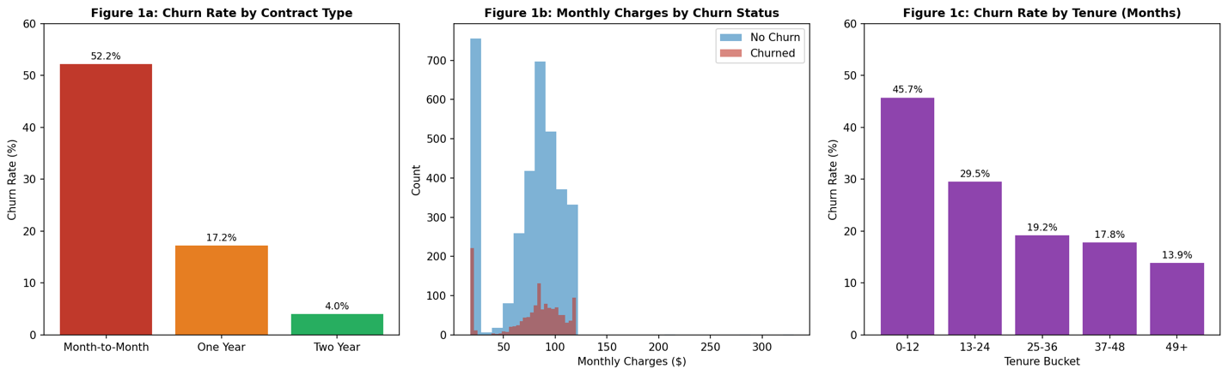
Model Results
Neural networks were selected as the primary algorithm for this analysis because of their capacity to model complex, non-linear relationships between input variables and the churn outcome. Unlike logistic regression, which assumes a linear relationship between features and the log-odds of the target, a neural network applies activation functions across multiple layers of neurons to learn patterns that may be invisible to a linear classifier. This matters for churn prediction because customer behavior is rarely linear: the relationship between monthly charges and churn likelihood, for example, likely depends on contract type, tenure, and service bundle simultaneously. Neural networks can capture these interaction effects without requiring them to be specified manually. The tradeoff is interpretability: unlike a decision tree that can be traced node by node, a neural network does not produce coefficient-level explanations of why a given customer was flagged as high risk. For ConnectTel, where the VP needs both predictions and actionable retention offers, this tradeoff means the model identifies who to target while domain knowledge informs what to offer.
For all three models, the cleaned dataset was split into an 80/20 training and testing partition using stratified sampling to preserve the 28% churn rate in both sets. All numerical features were standardized using StandardScaler prior to model training. Feature scaling is especially critical for neural networks because the gradient descent optimization that trains the network is sensitive to differences in feature magnitude — unscaled features with large numeric ranges, such as Total_Charges, would dominate the weight updates and produce a poorly calibrated model. Standardization ensures that each feature contributes on an equal footing during training.
Model 1, the logistic regression baseline, achieved a training accuracy of 77.96% and a test accuracy of 76.56%, with precision of 58.08%, recall of 56.55%, and an F1-score of 57.31%. The small gap between training and test accuracy indicates that logistic regression is not overfitting, and the model generalizes reasonably well to unseen data. For a linear model applied to a complex behavioral dataset, these results represent a solid starting point. However, the moderate recall means that roughly 43% of customers who will actually churn are not identified by this model — a meaningful miss rate in a retention context where each undetected churner costs $300 to $500 to replace.
Model 2, the simple neural network with one hidden layer of 16 neurons, achieved a training accuracy of 82.07% and a test accuracy of 75.31%, with precision of 56.15%, recall of 51.31%, and an F1-score of 53.62%. The model shows a modest gap between training and test performance, suggesting minor overfitting, but the degree is not severe. Compared to the logistic regression baseline, the simple neural network performs slightly worse on the test set across all metrics. This is a meaningful result: despite having greater modeling capacity, the additional complexity of one hidden layer did not translate into improved generalization for this dataset. This suggests that the churn patterns in the ConnectTel data may be largely captured by the linear relationships that logistic regression already models well.
Model 3, the deeper neural network with two hidden layers of 32 and 16 neurons, achieved a training accuracy of 95.00% but a test accuracy of only 70.63%, with precision of 47.23%, recall of 47.94%, and an F1-score of 47.58%. The 24-percentage-point gap between training and test accuracy is a textbook case of overfitting: the model has learned the specific noise patterns in the training data rather than the generalizable signal, and it loses substantial predictive power when applied to new customers. Increasing the depth and width of the network gave the model too much capacity relative to the complexity of the underlying patterns, and without regularization techniques such as dropout or early stopping, overfitting was the result. This finding reinforces the central tension in predictive modeling: more complex models are not always better, and the right level of model complexity must be matched to the signal available in the data.
Model | Train Acc. | Test Acc. | Precision | Recall | F1-Score
Model 1: Logistic Regression (Baseline) | 77.96% | 76.56% | 58.08% | 56.55% | 57.31%
Model 2: Simple Neural Network (16 neurons, 1 hidden layer) | 82.07% | 75.31% | 56.15% | 51.31% | 53.62%
Model 3: Deeper Neural Network (32-16 neurons, 2 hidden layers) | 95.00% | 70.63% | 47.23% | 47.94% | 47.58%

Across all three models, the logistic regression baseline produced the best generalization performance on the test set, which is a notable finding. For ConnectTel's use case, logistic regression is not only the most interpretable model but also the most reliable predictor of the three. The simple neural network performed comparably but without improvement, and the deeper neural network significantly underperformed due to overfitting. Figure 2 illustrates the test-set performance metrics side by side for all three models.
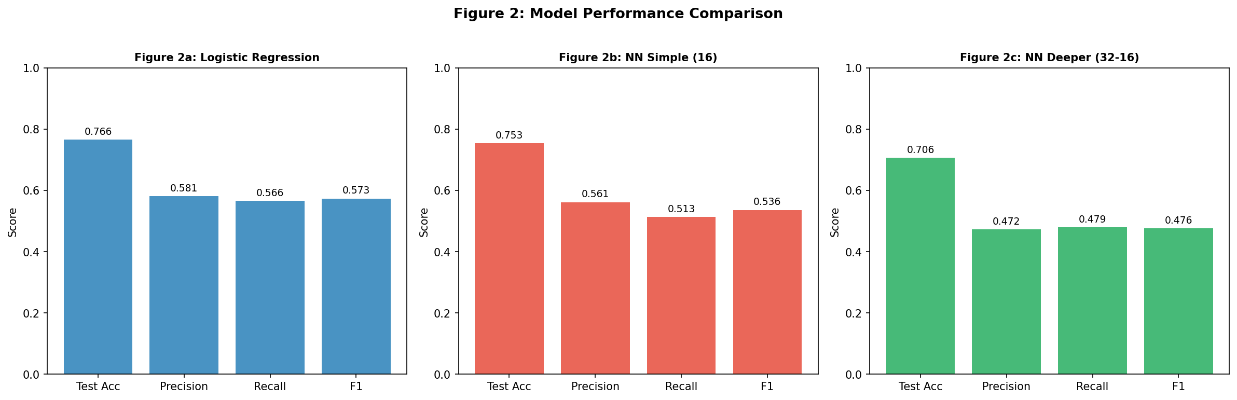
Conclusion
The data tells a clear story: ConnectTel's churn problem is concentrated among short-tenure, month-to-month customers paying above-average monthly charges, particularly those on fiber optic internet without added services such as tech support or online security. These customers have low switching costs, high bills relative to perceived value, and no contractual commitment creating friction against departure. The logistic regression model identified this segment most reliably, correctly flagging approximately 57% of churners while generalizing well to unseen customer records — performance the more complex neural networks failed to match due to overfitting on the training data.
For the VP of Customer Success, three actions stand out. First, prioritize outreach to month-to-month fiber optic customers in their first 12 months of tenure: this group churns at the highest rate and is the clearest target for a discounted annual contract offer. Converting even a fraction of this segment to one-year contracts would directly reduce the 28% churn rate. Second, bundle tech support and online security add-ons into retention offers for high-bill customers without these services — these features increase perceived value and reduce the likelihood of cancellation. Third, consider the ROI: at a retention offer cost of $50 per customer versus a $400 replacement acquisition cost, the model needs to successfully retain only 1 in 8 targeted customers to break even, making a broad proactive outreach campaign financially defensible even at moderate model accuracy.

