Customer Segmentation at Lakeview Mall:
A K-Nearest Neighbors Classification Analysis

Dev Panchal

ALY 6020: Predictive Analytics
Northeastern University
Professor Justin Grosz
February 22, 2026

Introduction
The goal of this analysis was to assist Lakeview Mall, a regional shopping center operating across the Northeast United States, in understanding how to effectively segment its 3,000-plus loyalty program members. The VP of Marketing posed a specific business question: given what we know about a new customer's age, income, and spending patterns, which customer segment do they belong to, and what marketing approach should follow? To address this, we built a K-Nearest Neighbors classification model to classify customers into High, Medium, or Low spending tiers based on demographic and behavioral attributes.
A successful outcome means delivering a reliable classification model that can predict a loyalty member's spending tier at the point of enrollment. The business impact is direct: misclassifying a High-spending customer as Low could damage brand perception and misdirect marketing spend, while accurate segmentation allows the team to personalize campaigns, optimize budget allocation, and increase customer lifetime value across all three segments. This analysis directly informs the VP of Marketing's budget allocation decisions for the upcoming fiscal year.
Data Cleanup
The first step in our modeling process was to investigate the dataset and verify that our data was sound and of good quality. The dataset contained 3,005 records and 12 variables, comprising eight numerical features and three categorical features, with CustomerID serving as a non-analytical identifier that was removed prior to modeling. We converted Gender, Preferred_Category, and Spending_Tier to categorical data types, and identified that Age was stored as a float rather than an integer, which was corrected after imputation. An initial scan for duplicate records uncovered two exact duplicates, which were removed, bringing the total to 3,003 usable records. We also flagged two records where Age exceeded 100 years and three records where Annual_Income_K was negative — both representing clear data entry errors requiring correction.
Four variables were found to contain missing values: Age (150 records, 5.0%), Annual_Income_K (180 records, 6.0%), Visit_Frequency_Monthly (120 records, 4.0%), and Avg_Transaction_Value (90 records, 3.0%). We addressed each variable independently based on its distribution. For Age and Annual_Income_K, which both exhibited mild skew (0.53 and 0.59 respectively), we applied a group-by mean using Spending_Tier. This was preferred over a global mean because spending behavior varies meaningfully across tiers, and replacing all missing values with a single average would obscure that signal. For Visit_Frequency_Monthly, the moderate skew of 0.68 indicated the mean was being pulled upward by high-frequency visitors, so the global median of 5.0 visits per month was used instead. For Avg_Transaction_Value, extreme right skew of 7.88 made the mean ($52.48) an unreliable representation of typical transactions, and so the median of $44.21 was applied.
To address outliers, we calculated two standard deviations above and below the mean for each numerical column and capped any values that exceeded those boundaries. This approach was chosen over row deletion because it preserves all 3,003 records while correcting extreme values, including the erroneous Age and income entries identified earlier. It is important to note that Spending_Score was not capped, as it is a bounded scale by design and all values fell within the valid 1 to 100 range. Figures 1 through 3 below illustrate key distributional patterns confirmed during exploratory analysis. As seen in Figure 1, High-spending customers cluster at higher income ranges while Low-spending customers concentrate at the lower end, confirming income as a strong discriminating variable. Figure 2 shows that High-spending customers visit the mall more frequently, with a median of 8 visits per month compared to 3 for Low-tier customers. Figure 3 further reinforces the separation between tiers when income and spending score are plotted together.
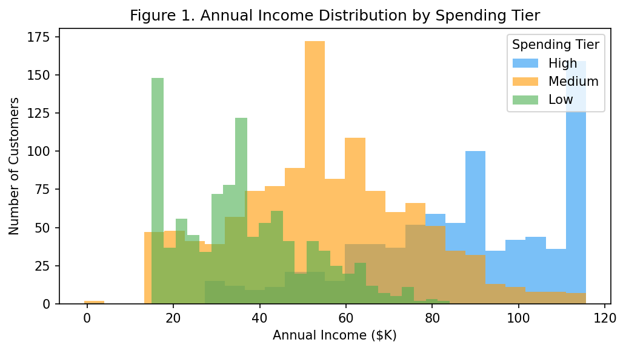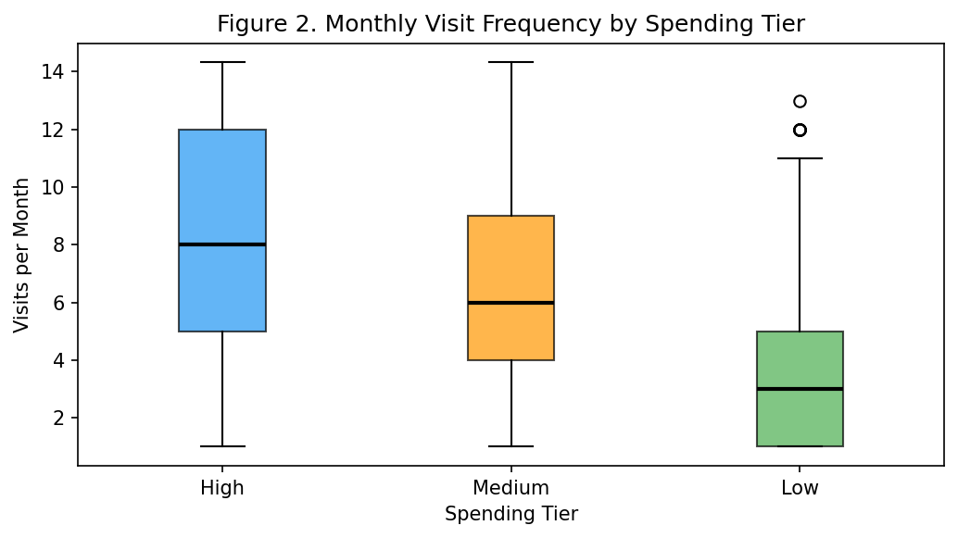

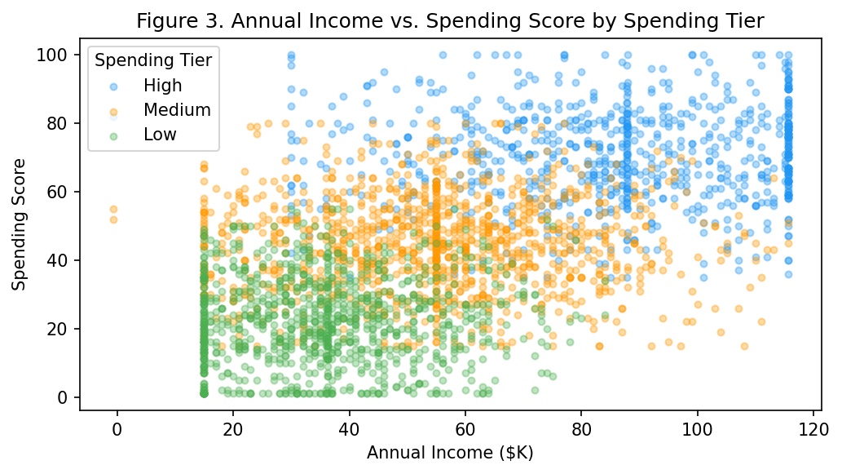

Model Results
We began by creating training and testing datasets to validate our model. An 80/20 stratified split was applied, resulting in 2,402 training records and 601 test records. Stratification ensured that the proportion of High (26.7%), Medium (40.0%), and Low (33.3%) customers was preserved in both sets. We selected three variables for the model: Annual_Income_K, Visit_Frequency_Monthly, and Age. These were chosen based on their business relevance — income reflects purchasing capacity, visit frequency reflects engagement, and age captures life-stage differences in spending behavior. All three were standardized using z-score normalization prior to modeling, as KNN relies on Euclidean distance and unscaled variables with large numeric ranges would dominate similarity calculations. Categorical variables such as Gender and Preferred_Category were excluded as they are not suited to KNN's distance-based framework, and remaining variables were excluded to limit dimensionality and avoid noise.
Three KNN models were trained using K values of 5, 15, and 30. At K = 5, the model achieved an accuracy of 71.05%, correctly classifying 106 of 160 High-tier, 154 of 200 Medium-tier, and 167 of 241 Low-tier customers. The most notable misclassification pattern was confusion between adjacent tiers — primarily Medium customers being classified as High or Low — which carries limited business consequence compared to High-Low confusion, of which there were only 6 and 1 instances respectively. At K = 15, accuracy improved to 71.55%, with High-tier precision rising to 76%. At K = 30, the model achieved its best overall accuracy of 72.38%, with the highest F1-scores across all three tiers. Table 1 summarizes the performance of all three models. Based on these results, we recommend the K = 30 model. It delivers the most consistent and generalized performance, and the stability of accuracy across the three K values indicates that the three selected variables provide a meaningful and reliable signal for classification.
Comparative Model Performance Across K Values
K Value | Accuracy | Avg Precision | Avg Recall | Avg F1-Score
5 | 70.55% | 0.71 | 0.71 | 0.71
15 | 71.55% | 0.71 | 0.72 | 0.71
30 ✓ | 72.38% | 0.72 | 0.72 | 0.72

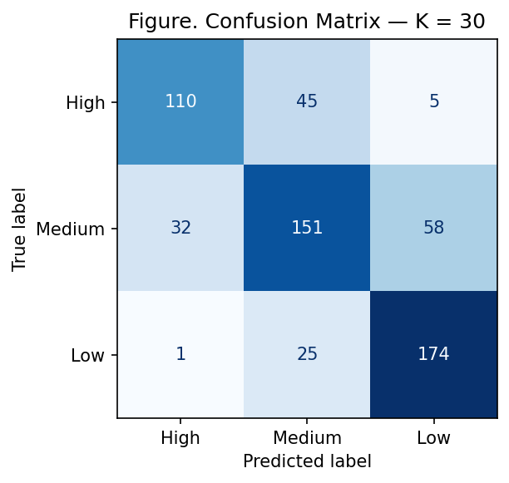

Conclusion
The goal of this analysis was to help Lakeview Mall classify its loyalty program members into actionable spending tiers using a K-Nearest Neighbors model. Through this process we can conclude that the K = 30 model, trained on Annual_Income_K, Visit_Frequency_Monthly, and Age, is the most suitable model for deployment with an accuracy of 72.38%. High-spending customers are characterized by above-average incomes (mean $85.89K), frequent mall visits (mean 8.45 per month), and a younger average age of 35. Low-spending customers have significantly lower incomes (mean $36.23K), visit infrequently (mean 3.56 per month), and tend to be slightly older at an average of 40 years. Medium-spending customers represent the mall's largest segment and greatest conversion opportunity, falling between these two profiles across all three dimensions.
We recommend that Lakeview Mall deploy the K = 30 model to classify new loyalty members at enrollment. For High-spending customers, the focus should be on retention through premium experiences and exclusive early-access programs. For Medium-spending customers, spend-threshold reward incentives could activate conversion to the High tier. For Low-spending customers, visit-frequency campaigns — such as limited-time events or birthday rewards — are likely to yield a higher return than transaction-focused promotions. It should be noted that this model is limited to three variables and does not incorporate all available features. Future iterations should explore incorporating additional variables such as Preferred_Category and Online_Shopping_Pct, and a more scalable algorithm should be evaluated for production deployment, as KNN requires recalculation against the full training set for each new prediction. Despite these limitations, the current model provides a reliable and immediately actionable framework for Lakeview Mall's marketing segmentation strategy.
Appendix A: Python Code

# ALY 6020 | Week 1 | Customer Segmentation with KNN | Lakeview Mall

import pandas as pd
import numpy as np
import matplotlib.pyplot as plt
from sklearn.preprocessing import StandardScaler
from sklearn.model_selection import train_test_split
from sklearn.neighbors import KNeighborsClassifier
from sklearn.metrics import (classification_report, confusion_matrix,
ConfusionMatrixDisplay, accuracy_score)
import warnings
warnings.filterwarnings('ignore')

# 1. LOAD & INSPECT
df = pd.read_csv('mall_customers.csv')
print(f'Shape: {df.shape}')
print(df.isnull().sum()[df.isnull().sum() > 0])
print(df.describe().round(2))

# 2. DATA CLEANING
df_clean = df.copy()
df_clean.drop(columns=['CustomerID'], inplace=True)
df_clean['Gender'] = df_clean['Gender'].astype('category')
df_clean['Preferred_Category'] = df_clean['Preferred_Category'].astype('category')
df_clean['Spending_Tier'] = df_clean['Spending_Tier'].astype('category')

dupes = df_clean.duplicated().sum()
df_clean.drop_duplicates(inplace=True)
print(f'Duplicates removed: {dupes} | New shape: {df_clean.shape}')

print(f'Age > 100 : {(df_clean["Age"] > 100).sum()} records')
print(f'Annual_Income_K < 0: {(df_clean["Annual_Income_K"] < 0).sum()} records')

# Missing value imputation
df_clean['Age'] = df_clean['Age'].fillna(
df_clean.groupby('Spending_Tier')['Age'].transform('mean'))
df_clean['Annual_Income_K'] = df_clean['Annual_Income_K'].fillna(
df_clean.groupby('Spending_Tier')['Annual_Income_K'].transform('mean'))
df_clean['Visit_Frequency_Monthly'] = df_clean['Visit_Frequency_Monthly'].fillna(
df_clean['Visit_Frequency_Monthly'].median())
df_clean['Avg_Transaction_Value'] = df_clean['Avg_Transaction_Value'].fillna(
df_clean['Avg_Transaction_Value'].median())
df_clean['Age'] = df_clean['Age'].round().astype(int)

# Outlier capping at ±2 std dev (Spending_Score not capped — bounded 1-100)
cols_to_cap = ['Age','Annual_Income_K','Visit_Frequency_Monthly','Avg_Transaction_Value']
for col in cols_to_cap:
mean, std = df_clean[col].mean(), df_clean[col].std()
df_clean[col] = df_clean[col].clip(mean - 2*std, mean + 2*std)

# 3. EDA
tier_order = ['High', 'Medium', 'Low']
tier_colors = {'High':'#2196F3', 'Medium':'#FF9800', 'Low':'#4CAF50'}

fig, ax = plt.subplots(figsize=(8, 5))
for tier in tier_order:
ax.hist(df_clean[df_clean['Spending_Tier']==tier]['Annual_Income_K'],
bins=25, alpha=0.6, label=tier, color=tier_colors[tier])
ax.set_xlabel('Annual Income ($K)'); ax.set_ylabel('Number of Customers')
ax.set_title('Figure 1. Annual Income Distribution by Spending Tier')
ax.legend(title='Spending Tier')
plt.tight_layout(); plt.savefig('fig1_income_by_tier.png', dpi=150, bbox_inches='tight'); plt.show()

fig, ax = plt.subplots(figsize=(8, 5))
bp = ax.boxplot([df_clean[df_clean['Spending_Tier']==t]['Visit_Frequency_Monthly'].values
for t in tier_order], labels=tier_order, patch_artist=True,
medianprops=dict(color='black', linewidth=2))
for patch, tier in zip(bp['boxes'], tier_order):
patch.set_facecolor(tier_colors[tier]); patch.set_alpha(0.7)
ax.set_xlabel('Spending Tier'); ax.set_ylabel('Visits per Month')
ax.set_title('Figure 2. Monthly Visit Frequency by Spending Tier')
plt.tight_layout(); plt.savefig('fig2_visits_by_tier.png', dpi=150, bbox_inches='tight'); plt.show()

fig, ax = plt.subplots(figsize=(8, 5))
for tier in tier_order:
s = df_clean[df_clean['Spending_Tier']==tier]
ax.scatter(s['Annual_Income_K'], s['Spending_Score'],
alpha=0.35, label=tier, color=tier_colors[tier], s=15)
ax.set_xlabel('Annual Income ($K)'); ax.set_ylabel('Spending Score')
ax.set_title('Figure 3. Annual Income vs. Spending Score by Spending Tier')
ax.legend(title='Spending Tier')
plt.tight_layout(); plt.savefig('fig3_income_vs_score.png', dpi=150, bbox_inches='tight'); plt.show()

# 4. FEATURE SCALING & TRAIN-TEST SPLIT
features = ['Annual_Income_K', 'Visit_Frequency_Monthly', 'Age']
X = StandardScaler().fit_transform(df_clean[features])
y = df_clean['Spending_Tier']
X_train, X_test, y_train, y_test = train_test_split(
X, y, test_size=0.2, random_state=42, stratify=y)

# 5. KNN MODELS — K = 5, 15, 30
results = {}
for k in [5, 15, 30]:
knn = KNeighborsClassifier(n_neighbors=k)
knn.fit(X_train, y_train)
y_pred = knn.predict(X_test)
acc = accuracy_score(y_test, y_pred)
report = classification_report(y_test, y_pred,
target_names=['High','Medium','Low'], output_dict=True)
print(f'K={k} | Accuracy: {acc:.4f}')
print(classification_report(y_test, y_pred, target_names=['High','Medium','Low']))
fig, ax = plt.subplots(figsize=(6, 5))
ConfusionMatrixDisplay(confusion_matrix(y_test, y_pred,
labels=['High','Medium','Low']),
display_labels=['High','Medium','Low']).plot(ax=ax,colorbar=False,cmap='Blues')
ax.set_title(f'Confusion Matrix - K = {k}')
plt.tight_layout()
plt.savefig(f'fig_cm_k{k}.png', dpi=150, bbox_inches='tight'); plt.show()
results[k] = {'Accuracy':round(acc,4),
'Precision':round(report['weighted avg']['precision'],4),
'Recall':round(report['weighted avg']['recall'],4),
'F1':round(report['weighted avg']['f1-score'],4)}

# 6. MODEL COMPARISON
print(pd.DataFrame(results).T)



