NORTHEASTERN UNIVERSITY

Assignment 2
CLASS NUMBER - ALY 6030
CLASS – Data Warehousing and SQL
CRN NUMBER – 70226
INSTRUCTOR – Na, Yu
ACADEMIC YEAR – FALL 2025
COMPLETION DATE – 23rd November, 2025
STUDENT – Dev Panchal

Assignment 2 – Hospital Nursing

1. Identifying Dimensions from Dimension Tables

bed_type Table:
Dimensions are:
• bed_id [Primary Key – dimension]
• bed_code [dimension]
• bed_desc [dimension]
All three variables in bed_type table are dimensions. The bed_id serves as the primary key & uniquely identifies each bed type. The bed_code & bed_desc provides descriptive information about the bed types and the types are ICU, SICU, etc. There are no facts in this dimension table, as it contains only categorical descriptive data.

business Table:
Dimensions are:
• ims_org_id [Primary Key - dimension]
• business_name [dimension]
• bed_cluster_id [dimension]
The three dimensions selected from the business table are ims_org_id which is also the primary key, business_name which means hospital name, and bed_cluster_id which means grouping category. The variables ttl_license_beds, ttl_census_beds, and ttl_staffed_beds are actually aggregated facts and should not be consider dimensions. Dimensions are descriptive attributes used for slicing and filtering data, while facts are numerical measures.

2. Identifying Facts from the Fact Table

bed_fact Table:
Facts are:
• license_beds [fact - numeric measure]
• census_beds [fact - numeric measure]
• staffed_beds [fact - numeric measure]
The three facts identified are license_beds, census_beds, and staffed_beds. So these are numerical measures which can be aggregated (summed, averaged) for further analysis purposes. The variables ims_org_id and bed_id in this table are foreign keys, which are dimensions even though they appear in the fact table. Foreign keys link fact table to dimension tables and enable the star schema joins.

3. Star Schema Diagram
The star schema below illustrates the relationship between fact table which is none other than bed_fact and the two dimension tables which is business and bed_type. The fact table contains foreign keys that reference the primary keys of the dimension tables, enabling us to join these tables for analysis.
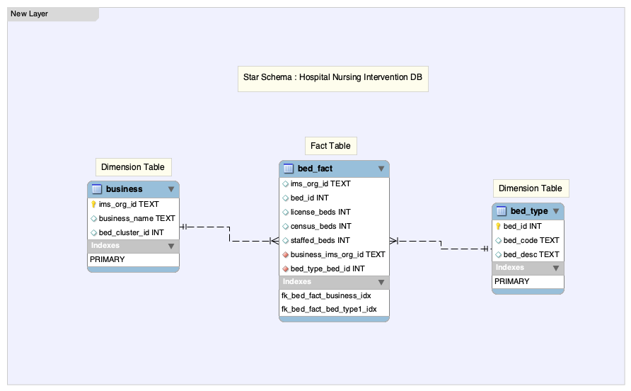

Schema Description:
• The bed_fact table (center) is the fact table containing the measurable data
• The business and bed_type tables are dimension tables providing context
• Foreign keys in bed_fact (ims_org_id and bed_id) link to primary keys in dimension tables
• This creates a 1:Many relationship from each dimension to the fact table
• INNER JOIN operations connect these tables for analysis queries

4a. Analysis for Leadership: Hospitals with ICU or SICU Beds
Report 1: Top 10 Hospitals by Total License Beds (ICU or SICU)
Hospital Name | Total License Beds
Phoenix Childrens Hospital | 247
University of Maryland Medical Center | 220
UC Health University Hospital | 218
Wesley Medical Center, LLC | 214
Vidant Medical Center | 204
Rady Childrens Hospital and Health Center | 200
Dallas County Hospital Association | 195
Saint Lukes Episcopal Hospital Texas Medical Center | 178
The Methodist Hospital | 170
Emory University Hospital | 169

Report 2: Top 10 Hospitals by Total Census Beds (ICU or SICU)
Hospital Name | Total Census Beds
Shands Hospital at the University of Florida | 167
Dallas County Hospital Association | 145
Mercy Medical Center Saint Louis | 142
Los Angeles County University of Southern California Healthcare Network | 139
The Methodist Hospital | 138
University of Minnesota Medical Center Fairview | 129
University of Maryland Medical Center | 127
Brigham and Womens Hospital | 124
Vidant Medical Center | 123
Ronald Reagan University of California Los Angeles Medical Center | 122

Report 3: Top 10 Hospitals by Total Staffed Beds (ICU or SICU)
Hospital Name | Total Staffed Beds
Vidant Medical Center | 203
Rady Childrens Hospital and Health Center | 200
University of Maryland Medical Center | 171
Emory University Hospital | 169
Shands Hospital at the University of Florida | 167
Mercy Medical Center Saint Louis | 163
Wesley Medical Center, LLC | 162
Phoenix Childrens Hospital | 159
Grady Memorial Hospital | 154
Los Angeles County University of Southern California Healthcare Network | 151

4b. Interpretation of Findings from Step 4a
Top Performing Hospitals:
• License Beds: Phoenix Childrens Hospital leads with 247 beds, followed by University of Maryland Medical Center (220 beds)
• Census Beds: Shands Hospital at the University of Florida tops the list with 167 beds
• Staffed Beds: Vidant Medical Center ranks first with 203 beds
Hospitals Appearing on Multiple Lists:
Many hospitals shown consistently across all 3 metrics, indicating robust ICU/SICU capacity:
1. University of Maryland Medical Center
- Appears on all three lists (License #2, Census #7, Staffed #3)
- Demonstrates strong capacity across all bed metrics
2. Vidant Medical Center
- Appears on all three lists (License #5, Census #9, Staffed #1)
- Highest staffed bed count indicates excellent operational capacity
3. The Methodist Hospital
- Appears on two lists (License #9, Census #5)
- Strong census utilization
Pilot Program Implications:
Hospitals appearing on multiple lists make excellent candidates for the intervention pilot program because they demonstrate:
• Consistent high volume across different bed metrics
• Strong operational capacity and patient flow
• Sufficient infrastructure to support intervention programs
• Better statistical power for evaluating intervention outcomes

5a. Drill Down Investigation: Hospitals with BOTH ICU and SICU Beds
This analysis identifies hospitals that have at least 1 ICU bed AND at least 1 SICU bed, representing facilities with comprehensive critical care capabilities.

Report 1: Top 10 Hospitals with BOTH ICU & SICU - License Beds
Hospital Name | Total License Beds
University of Maryland Medical Center | 220
UC Health University Hospital | 218
Shands Hospital at the University of Florida | 167
MCGHealth, Inc | 155
Grady Memorial Hospital | 154
Jackson Memorial Hospital | 151
University of Minnesota Medical Center Fairview | 144
University Hospital in Bexar County | 144
Carolinas Medical Center | 137
Yale New Haven Hospital | 136

Report 2: Top 10 Hospitals with BOTH ICU & SICU - Census Beds
Hospital Name | Total Census Beds
Shands Hospital at the University of Florida | 167
University of Minnesota Medical Center Fairview | 129
University of Maryland Medical Center | 127
Jackson Memorial Hospital | 117
UC Health University Hospital | 110
Carolinas Medical Center | 106
Cedars Sinai Health System | 92
University Hospital in Bexar County | 91
Duke University Health System | 91
The Cleveland Clinic Foundation | 88

Report 3: Top 10 Hospitals with BOTH ICU & SICU - Staffed Beds
Hospital Name | Total Staffed Beds
University of Maryland Medical Center | 171
Shands Hospital at the University of Florida | 167
Grady Memorial Hospital | 154
UC Health University Hospital | 151
University of Minnesota Medical Center Fairview | 144
Carolinas Medical Center | 137
Saint Josephs Hospital and Medical Center | 134
Chattanooga Hamilton County Hospital Authority | 134
Jackson Memorial Hospital | 128
Sunrise Hospital and Medical Center, LLC | 125

5b. Final Recommendation for Leadership
RECOMMENDATION: Based on comprehensive analysis of both Step 4a and Step 5a, I recommend the following two hospitals as the best candidates for the nursing intervention pilot program:
1. UNIVERSITY OF MARYLAND MEDICAL CENTER
Justification:
• Ranks #1 in the "BOTH ICU & SICU" analysis for license beds (220 beds)
• Consistently appears in top rankings across all six drill-down reports
• License Beds: #1 (220), Census Beds: #3 (127), Staffed Beds: #1 (171)
• Demonstrates comprehensive critical care infrastructure with both ICU and SICU capabilities
• High bed utilization indicates strong patient flow and operational efficiency
• Large enough scale to generate statistically significant intervention results
2. SHANDS HOSPITAL AT THE UNIVERSITY OF FLORIDA
Justification:
• Ranks #1 for census beds among hospitals with both ICU & SICU (167 beds)
• Consistently strong performance across all metrics
• License Beds: #3 (167), Census Beds: #1 (167), Staffed Beds: #2 (167)
• Perfect alignment between license, census, and staffed bed counts indicates optimal resource utilization
• High census numbers demonstrate sustained patient volume critical for intervention testing
• Academic medical center setting provides additional research infrastructure support
Why These Two Hospitals?
1. Comprehensive Coverage: Both hospitals have proven capacity in both ICU and SICU settings, ensuring the intervention can be tested across different critical care environments.
2. Volume & Scale: With combined capacity exceeding 300 critical care beds, these sites offer sufficient sample sizes for robust intervention evaluation.
3. Operational Excellence: Both facilities demonstrate high bed utilization rates, indicating efficient operations and consistent patient populations ideal for controlled intervention studies.
4. Comparative Analysis: Selecting one hospital with the highest license beds and another with the highest census beds provides valuable comparative data on intervention effectiveness across different operational profiles.
Both hospitals are major academic medical centers with established research infrastructure, making them well-suited for pilot program implementation and data collection requirements.

