
Assignment 3 : Comparative Analysis of AdaBoost, CatBoost, LightGBM, and HistGradientBoosting

Date: 01-27-2026
Group -1
Abhishek Singh
Dev Bhadreshkumar Lavanya Suresh
Sushmitha Urs A S
Professor – Kasun Samarasinghe

Introduction
Data mining techniques play a critical role in uncovering hidden patterns and relationships within large, complex datasets. In the context of public safety, these techniques can be leveraged to identify spatiotemporal crime patterns that are not immediately observable through descriptive statistics alone. This study applies advanced ensemble learning algorithms to reported crime incidents in Washington, DC during 2025, with the goal of detecting crime hotspots and supporting proactive decision-making.
Rather than predicting individual crime events, the analysis reframes the problem as a binary classification task aimed at identifying high-risk combinations of location and time. By aggregating crime incidents into Ward × Time buckets and labeling elevated crime activity as hotspots, the study aligns predictive modeling with real-world operational needs such as patrol allocation and crime prevention planning. Multiple gradient-based ensemble models are evaluated and compared to determine the most effective approach for hotspot detection.

Data Preprocessing and Cleaning
The raw crime incident dataset was first filtered to include only records occurring in the 2025 calendar year. Timestamp fields were parsed and converted into datetime objects to ensure consistency and accuracy. Records with missing or invalid timestamps or ward identifiers were removed, as these fields are essential for temporal and spatial aggregation.
Temporal features were extracted from the incident start time, including hour of day, day of week, month, and a binary weekend indicator. These features capture cyclical crime patterns and enable models to learn temporal risk structures. Spatial information was retained at the ward level, as this granularity balances interpretability with sufficient data density.
Crime incidents were then aggregated into Ward × Time buckets, and incident counts were calculated for each bucket. To convert the data into a supervised learning format, a binary target variable (HOTSPOT) was created. Buckets with incident counts exceeding the 75th percentile of the training data distribution were labeled as hotspots. This approach reduces noise, mitigates extreme skewness, and creates a meaningful classification target aligned with policy-relevant risk thresholds.
Categorical variables were encoded using one-hot encoding. No feature scaling was applied, as the selected models are tree-based and insensitive to feature magnitude.

Train–Test Split Strategy
A time-based train–test split was employed to reflect real-world forecasting conditions and prevent temporal leakage. Crime data from January through September 2025 were used to train the models, while data from October through December 2025 were reserved for testing.
This approach ensures that model evaluation is conducted on future observations relative to the training period. Unlike random splits, a temporal split provides a more realistic assessment of model performance and generalizability, particularly in datasets where seasonal and time-dependent patterns are prominent.

Model Selection and Explanation
Four advanced ensemble learning models were selected for this study due to their ability to capture nonlinear relationships and interactions among temporal and spatial features.

AdaBoost Classifier
AdaBoost (Adaptive Boosting) is an ensemble method that sequentially trains weak learners, typically shallow decision trees. Each subsequent model focuses more heavily on observations that were misclassified by previous models.
In this study, AdaBoost improves upon simple tree-based approaches by adaptively reweighting difficult-to-classify ward–time buckets. This allows the model to better capture subtle hotspot patterns that may be overlooked by a single decision tree. AdaBoost serves as an effective stepping stone between basic models and more complex gradient-based boosting techniques.

CatBoost Classifier
CatBoost is a gradient boosting algorithm designed to handle categorical variables efficiently and reduce prediction bias. Although ward identifiers were one-hot encoded for consistency across models, CatBoost’s ordered boosting mechanism helps mitigate overfitting and improves generalization.
CatBoost is particularly well-suited for this dataset because it captures complex interactions between time-based features and spatial identifiers while maintaining strong performance on imbalanced classification problems. Its robustness to overfitting makes it valuable for crime data, which often contains noise and irregular patterns.

LightGBM Classifier
LightGBM is a highly efficient gradient boosting framework that uses histogram-based learning and leaf-wise tree growth. These innovations allow the model to train faster and capture complex decision boundaries with fewer computational resources.
In this analysis, LightGBM excels at identifying nonlinear interactions between temporal features such as hour of day and weekend indicators and spatial ward effects. Its ability to handle large feature spaces efficiently makes it well-suited for hotspot detection across multiple locations and time intervals.

Histogram-Based Gradient Boosting (HistGradientBoosting)
Histogram-based Gradient Boosting is a scalable implementation of gradient boosting that discretizes continuous features into bins before training. This reduces computational complexity while maintaining predictive accuracy.
This model provides a balance between performance and interpretability. It captures nonlinear patterns and interactions in the data while being less prone to overfitting than traditional gradient boosting implementations. HistGradientBoosting serves as a strong benchmark for evaluating more advanced boosting frameworks.

Initial Analysis of Model Performance
Initial model evaluation revealed that all four ensemble methods outperformed simpler baseline approaches in terms of hotspot detection accuracy. Models consistently identified elevated crime risk during late evening hours and weekends, particularly in specific wards.
Among the models, gradient-based boosting methods (CatBoost, LightGBM, and HistGradientBoosting) demonstrated stronger discrimination ability than AdaBoost. These models were more effective at capturing complex interactions between temporal and spatial variables, resulting in higher recall for the hotspot class.
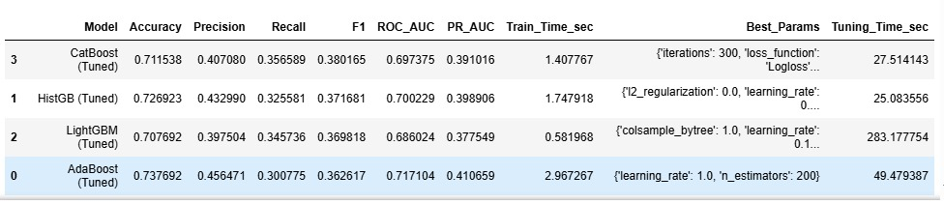

Hyperparameter Tuning
Hyperparameter tuning was conducted using grid search with cross-validation on the training dataset. Key parameters tuned included:
- Number of estimators
- Learning rate
- Maximum tree depth
- Minimum samples per leaf

Hyperparameter tuning was performed using grid search with cross-validation. Improvements were metric-dependent: AdaBoost improved ROC–AUC/PR-AUC, CatBoost improved F1/recall, while HistGB and LightGBM did not improve on the test set.

Confusion Matrix Results

Confusion matrix analysis provides insight into how each model balances false positives and false negatives. Models with higher recall correctly identified a larger proportion of true hotspots, while models with higher precision reduced the number of incorrectly flagged low-risk periods.

CatBoost exhibited the highest F1-score among the tuned models, reflecting the best overall balance between precision and recall. This behavior is particularly important for hotspot prediction, where failing to identify high-risk areas may be more costly than generating additional patrol alerts. AdaBoost, while achieving the strongest ROC–AUC, showed slightly lower recall, indicating a more conservative classification strategy.
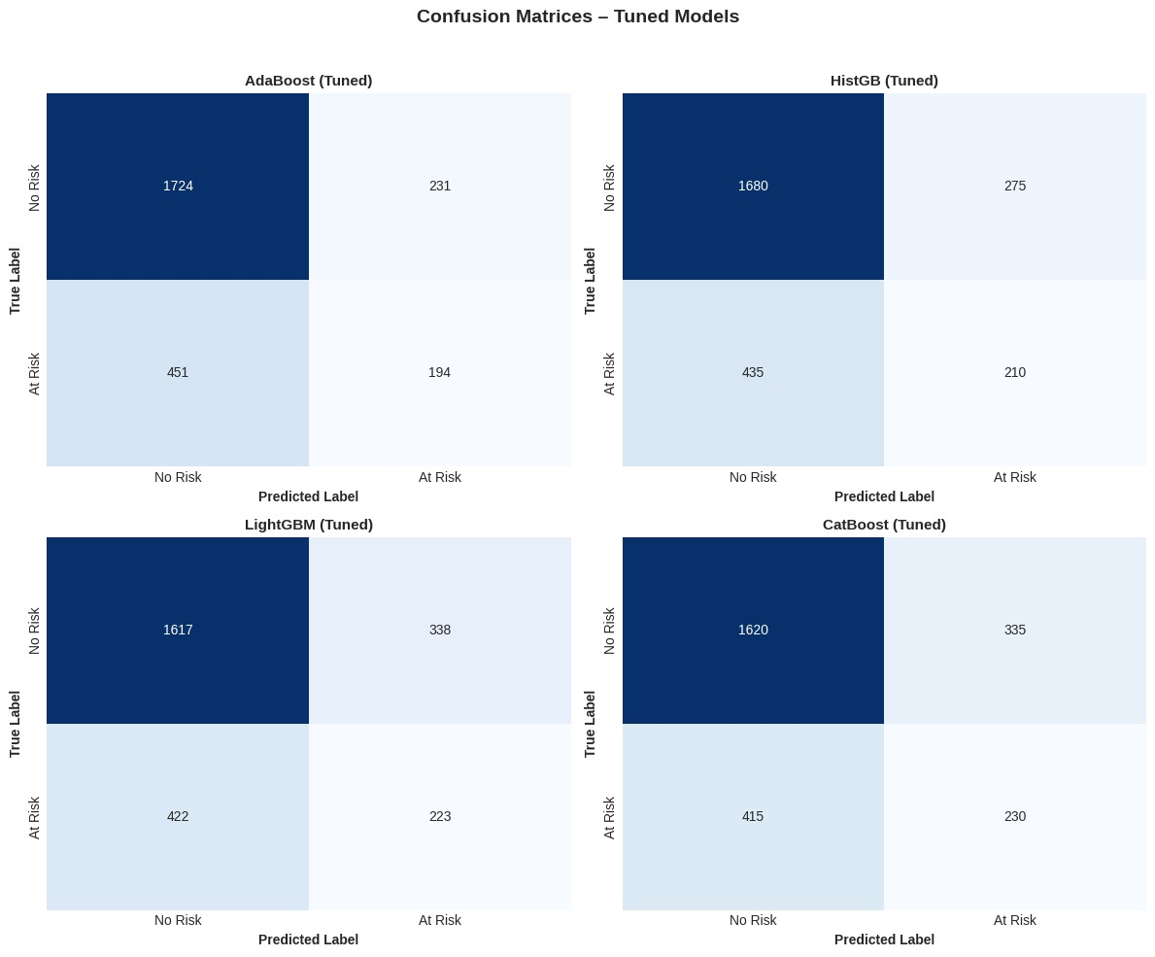

ROC–AUC Interpretation

The Receiver Operating Characteristic (ROC) curve evaluates each model’s ability to distinguish between hotspot and non-hotspot observations across all possible classification thresholds. The Area Under the Curve (ROC–AUC) summarizes this discrimination performance, where a value of 0.5 represents random guessing and values closer to 1.0 indicate stronger separability.

Among the tuned models, AdaBoost achieved the highest ROC–AUC (approximately 0.72), indicating the strongest overall ability to rank high-risk ward–time combinations above low-risk ones. Histogram-Based Gradient Boosting and CatBoost followed closely, with ROC–AUC values near 0.70, while LightGBM exhibited slightly lower discrimination performance. Although differences across models were modest, all tuned models substantially outperformed the random baseline, demonstrating that ensemble learning techniques effectively capture underlying spatiotemporal crime patterns.

Precision–Recall and PR-AUC Analysis

Because crime hotspots represent a minority class, Precision–Recall (PR) curves provide a more informative assessment of model performance than accuracy alone. The PR curve emphasizes the trade-off between precision (false alarm control) and recall (hotspot detection coverage), while the Average Precision (PR-AUC) summarizes performance across recall levels.

Across tuned models, PR-AUC values ranged between approximately 0.38 and 0.41, reflecting meaningful improvement over baseline expectations under class imbalance. AdaBoost and CatBoost demonstrated the strongest PR-AUC performance, indicating a favorable balance between identifying true hotspots and limiting false positives. These results highlight the suitability of boosting-based methods for imbalanced public safety prediction tasks.

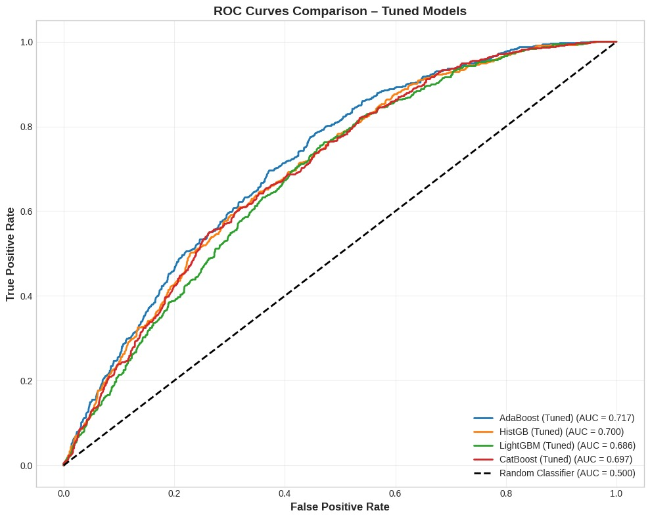

Feature Comparison

CatBoost (Tuned)
- Spatial dominance: WARD_NUM_2, WARD_NUM_3, and WARD_NUM_5 are the strongest predictors, showing that hotspot risk is primarily driven by persistent ward-level patterns.
- Stable temporal influence: Day-of-week and month features contribute meaningfully, indicating weekly and seasonal crime cycles rather than short-term spikes.
- Low noise sensitivity: Limited reliance on hour-level features suggests CatBoost focuses on structural risk factors, making it reliable for long-term hotspot identification.

HistGradientBoosting (Tuned)
- Strong ward effect: WARD_NUM_2 remains the most influential feature, confirming consistent spatial concentration of crime hotspots.
- Time-of-day sensitivity: High importance of HOUR_14, HOUR_18, and HOUR_16 shows the model captures intra-day crime surges, especially afternoon and evening periods.
- Balanced modeling: The model effectively combines location stability with short-term temporal variation, making it suitable for time-specific risk prediction.

LightGBM (Tuned)
- Weekend impact: IS_WEEKEND is the most important feature, indicating crime hotspots are significantly more likely during weekends.
- Interaction-driven learning: High importance across ward, day, and month features shows LightGBM captures complex spatial–temporal interactions.
- Distributed importance: Influence is spread across many predictors, reflecting LightGBM’s ability to model nonlinear patterns without overfitting to a single feature.

AdaBoost (Tuned)
- Ward-driven risk: WARD_NUM_2 and WARD_NUM_5 dominate, reinforcing that geographic location is the primary determinant of hotspot risk.
- Temporal reinforcement: Hour, weekend, and month features jointly influence predictions, highlighting multi-factor hotspot formation.
- Higher sensitivity to noise: Broader spread of feature importance reflects AdaBoost’s focus on misclassified cases, consistent with its comparatively moderate performance.

Comparative Feature Importance Summary

Ward-level spatial features dominate across all models, with WARD_NUM_2 consistently ranked as the most influential predictor, confirming that crime hotspots are primarily driven by persistent geographic patterns.

Models differ in temporal sensitivity: CatBoost captures stable weekly and seasonal trends, HistGradientBoosting responds to time-of-day spikes, LightGBM emphasizes weekend and interaction effects, and AdaBoost distributes importance more broadly, supporting CatBoost as the most reliable model for actionable hotspot detection.

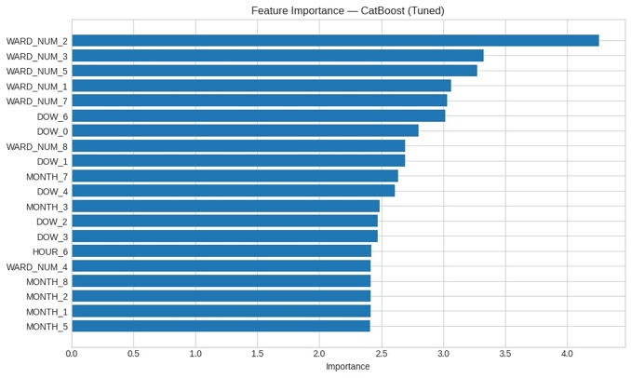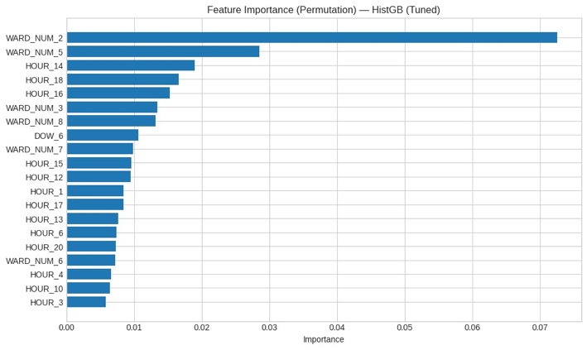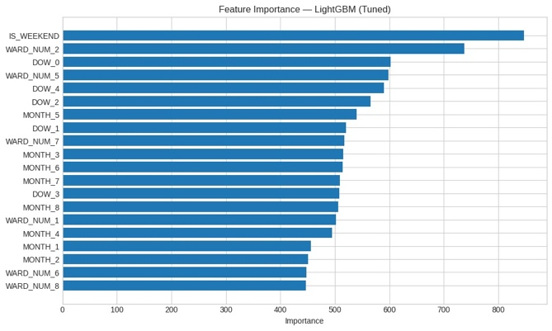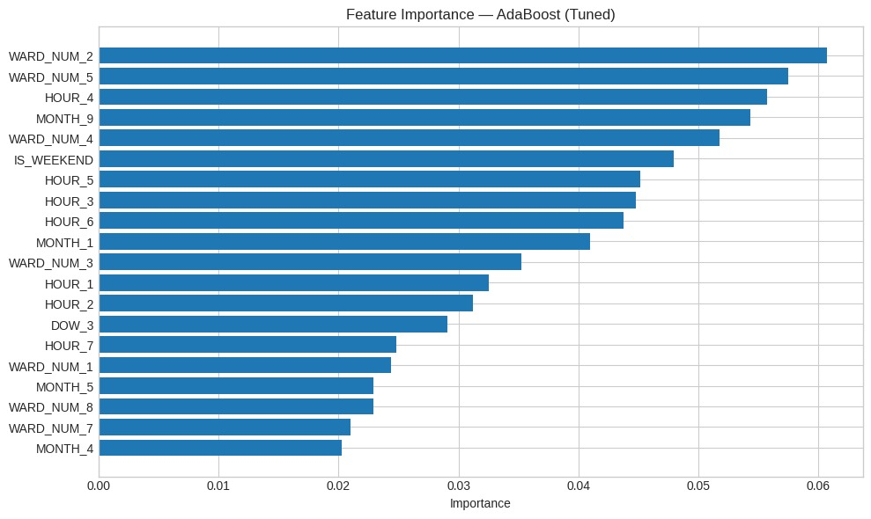

Model Performance Comparison (Baseline vs Tuned)

Four ensemble boosting models—AdaBoost, CatBoost, LightGBM, and Histogram-Based Gradient Boosting (HistGB)—were evaluated for hotspot prediction using consistent training and test splits. Performance was assessed using accuracy, precision, recall, F1-score, ROC–AUC, PR-AUC, and runtime.

Baseline results

In the baseline setting, HistGB produced the strongest F1-score (~0.398) and highest recall (~0.363), indicating it identified hotspots more consistently than the other baseline models. LightGBM achieved a comparable F1-score (~0.391) with similar ROC–AUC (~0.704). CatBoost showed competitive balance across metrics (F1 ~0.381, ROC–AUC ~0.710), while AdaBoost had the lowest recall (~0.216) and F1 (~0.294), suggesting a more conservative classification behavior that missed many hotspot cases despite having a reasonable ROC–AUC (~0.715).

Effect of hyperparameter tuning

After tuning, the performance changes were metric-dependent rather than uniformly improving across all models:

CatBoost (Tuned) achieved the best F1-score (~0.380) and the highest recall (~0.357) among tuned models, indicating the best balance between identifying hotspots and controlling false alarms under class imbalance.

AdaBoost (Tuned) improved substantially in recall (from ~0.216 to ~0.301) and became the best model by ROC–AUC (~0.717) and PR-AUC (~0.411), showing strong ranking/discrimination performance even though its F1 remained lower than CatBoost.

HistGB (Tuned) slightly declined in F1 and PR-AUC compared to baseline, suggesting that the tuned configuration may have reduced generalization on the test set rather than improving it.

LightGBM (Tuned) showed the largest drop in F1 and ROC–AUC, indicating that tuning likely pushed the model toward parameters that fit the training folds well but did not transfer as effectively to the held-out test period.

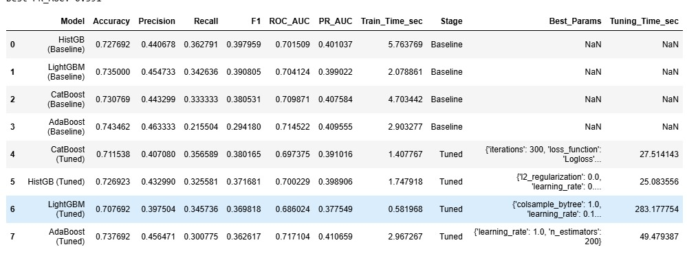

Conclusion
This study demonstrates the value of advanced data mining techniques in uncovering hidden spatiotemporal patterns within large-scale crime datasets. By reframing the problem from individual incident prediction to hotspot classification, the analysis aligns machine learning outputs with real-world public safety objectives.
Through careful data preprocessing, temporal aggregation, and a realistic time-based train–test split, multiple ensemble models were evaluated under conditions that reflect operational deployment. While AdaBoost achieved the highest overall ROC–AUC, indicating strong ranking and discrimination ability, CatBoost emerged as the most effective model for hotspot identification when considering F1-score and recall, which are critical for minimizing missed high-risk areas.
The results indicate that crime risk in Washington, DC is strongly influenced by temporal factors such as time of day and day of week, as well as persistent spatial patterns at the ward level. Feature importance analysis consistently highlighted ward indicators and hourly patterns across all models, reinforcing the stability of these risk drivers.
From a practical perspective, CatBoost’s ability to balance false positives and false negatives makes it particularly well suited for proactive patrol allocation and targeted intervention strategies. Future work should incorporate additional contextual variables such as weather conditions, special events, and socioeconomic indicators to further enhance predictive performance. Overall, this study highlights the effectiveness of ensemble learning methods—particularly CatBoost—for actionable crime hotspot detection.

Business Use cases
1. Core Use Case: Crime Hotspot Identification for Proactive Policing
The primary business application of this analysis is crime hotspot identification, rather than prediction of individual crime incidents. By classifying Ward × Time combinations as either hotspot or non-hotspot periods, the models provide actionable intelligence that supports proactive policing and public safety planning.
Using temporal features (hour of day, day of week, month, weekend indicator) and spatial ward-level information, the models identify periods with elevated crime risk. This reframing aligns directly with operational decision-making, where law enforcement agencies must decide where and when to allocate limited patrol resources, rather than predicting specific crime events.
Because hotspot periods represent a minority of observations, the evaluation emphasizes recall, F1-score, and PR-AUC, ensuring that high-risk periods are not missed. From an operational standpoint, missing a true hotspot is more costly than generating additional patrol alerts.
2. Operational and Strategic Applications
A. Patrol Allocation and Resource Optimization
Problem: Police departments operate under staffing and budget constraints, making uniform patrol coverage inefficient.
Analytics-Driven Solution:
The hotspot classification models—particularly CatBoost—enable departments to identify wards and time windows with consistently elevated risk. By prioritizing periods with higher predicted hotspot probability, agencies can deploy officers more effectively during high-impact hours such as evenings and weekends.
Impact: Improved visibility in high-risk areas, Faster response times, More efficient use of limited personnel, Reduced likelihood of missing emerging hotspot periods.
B. Targeted Crime Prevention and Intervention
Problem: City governments and public safety agencies must decide where to implement preventative measures such as increased lighting, community outreach programs, or surveillance infrastructure.
Analytics-Driven Solution:
Ward-level hotspot predictions reveal persistent spatial risk patterns as well as time-specific surges. This allows decision-makers to distinguish between structurally high-risk areas and short-term temporal spikes.
Impact: Data-supported justification for targeted interventions, Better prioritization of preventative spending, Enhanced coordination between policing and community-based initiatives.
C. Policy Evaluation and Budget Justification
Problem: Policymakers often need quantitative evidence to support budget reallocations or funding requests for public safety initiatives.
Analytics-Driven Solution:
Model outputs provide empirical evidence of when and where crime risk is concentrated. Changes in hotspot frequency over time can be monitored to evaluate the effectiveness of interventions or policy changes.
Impact: Stronger data-backed policy proposals, Transparent performance evaluation of public safety strategies, Improved accountability in budget allocation.
3. Strategic Model Choice for Business and Public Safety Use
Based on comparative performance across recall, F1-score, ROC–AUC, and PR-AUC, CatBoost emerges as the most suitable model for operational deployment. While AdaBoost demonstrated strong ranking ability (ROC–AUC), CatBoost achieved the best balance between identifying true hotspots and controlling false alarms—a critical requirement in public safety contexts.
CatBoost’s robustness to overfitting and consistent performance under class imbalance make it well suited for recurring hotspot monitoring and decision support, where reliability and interpretability are more important than marginal gains in a single metric.
Summary for Stakeholders
This analysis provides a practical framework for transitioning from reactive policing to proactive, data-driven crime prevention. By focusing on hotspot classification rather than individual crime prediction, the models deliver insights that directly support patrol planning, targeted interventions, and evidence-based policy decisions. Among the evaluated approaches, CatBoost offers the most reliable balance of performance and operational relevance for sustained public safety applications.

References
Washington D.C. Open Data. (2025). Crime Incidents in 2025. Data.gov. https://catalog.data.gov/dataset/crime-incidents-in-2025

Appendix


