AdaBoost Classification for Crime Hotspot Prediction

Introduction
AdaBoost (Adaptive Boosting) is an ensemble learning technique that combines multiple weak learners to create a strong classifier. Unlike bagging methods such as Random Forest, AdaBoost trains models sequentially, with each subsequent model focusing on the samples that previous models misclassified. This adaptive approach makes AdaBoost particularly effective for improving classification performance on difficult-to-classify instances.
This analysis applies AdaBoost to the Washington D.C. crime hotspot prediction task, using the same target variable (HOTSPOT) and feature engineering approach from the previous assignment. The goal is to evaluate AdaBoost's effectiveness compared to other boosting techniques like XGBoost and Gradient Boosting Machine.

AdaBoost Algorithm Overview
AdaBoost works by iteratively training weak classifiers (typically decision stumps with max_depth=1) and adjusting sample weights based on classification errors. The key steps are:
- Initialize equal weights for all training samples
- Train a weak classifier on the weighted samples
- Calculate the classifier's error rate and compute its weight (alpha)
- Increase weights for misclassified samples, decrease for correctly classified
- Repeat for n_estimators iterations; final prediction is weighted vote of all classifiers

Model Implementation
The AdaBoost classifier was implemented using sklearn.ensemble.AdaBoostClassifier with a DecisionTreeClassifier (max_depth=3) as the base estimator. Using deeper trees (depth=3) instead of the default decision stumps (depth=1) provides better performance for this dataset's complex Ward-Time-Month interactions. The SAMME algorithm was used for multi-class compatible boosting.

Model Performance Results
Table 1: AdaBoost Model Performance Comparison
Model | n_est | lr | Accuracy | Precision | Recall | F1 | AUC
AdaBoost (Baseline) | 100 | 0.5 | 0.7435 | 0.4633 | 0.2155 | 0.2942 | 0.7145
AdaBoost (Tuned) | 200 | 1.0 | 0.7377 | 0.4565 | 0.3008 | 0.3626 | 0.7171
After hyperparameter tuning with GridSearchCV (optimizing for F1 score with 3-fold cross-validation), the tuned AdaBoost model achieved improved performance. The best parameters were n_estimators=200 and learning_rate=1.0. The tuned model improved recall from 21.55% to 30.08% (a 39% relative improvement), resulting in an F1 score increase from 0.2942 to 0.3626.

Hyperparameter Tuning
Table 2: Hyperparameter Search Grid
Parameter | Values Tested
n_estimators | [50, 100, 150, 200]
learning_rate | [0.1, 0.3, 0.5, 1.0]
Base Estimator | DecisionTreeClassifier(max_depth=3)

Feature Importance Analysis
Table 3: Top 10 Most Important Features
Rank | Feature | Importance Score
1 | WARD_NUM_2 (Ward 2) | 0.0607
2 | WARD_NUM_5 (Ward 5) | 0.0574
3 | HOUR_4 (4 AM) | 0.0557
4 | MONTH_9 (September) | 0.0543
5 | WARD_NUM_4 (Ward 4) | 0.0518
6 | IS_WEEKEND | 0.0479
7 | HOUR_5 (5 AM) | 0.0451
8 | HOUR_3 (3 AM) | 0.0448
9 | HOUR_6 (6 AM) | 0.0438
10 | MONTH_1 (January) | 0.0410
Key Insights: Ward features (particularly Ward 2, Ward 5, and Ward 4) emerged as the most important predictors, indicating strong geographic concentration of crime hotspots. Early morning hours (3-6 AM) consistently rank highly, suggesting these times are critical for hotspot prediction. The IS_WEEKEND feature also shows significant importance, confirming that weekend crime patterns differ from weekdays.

Visualizations
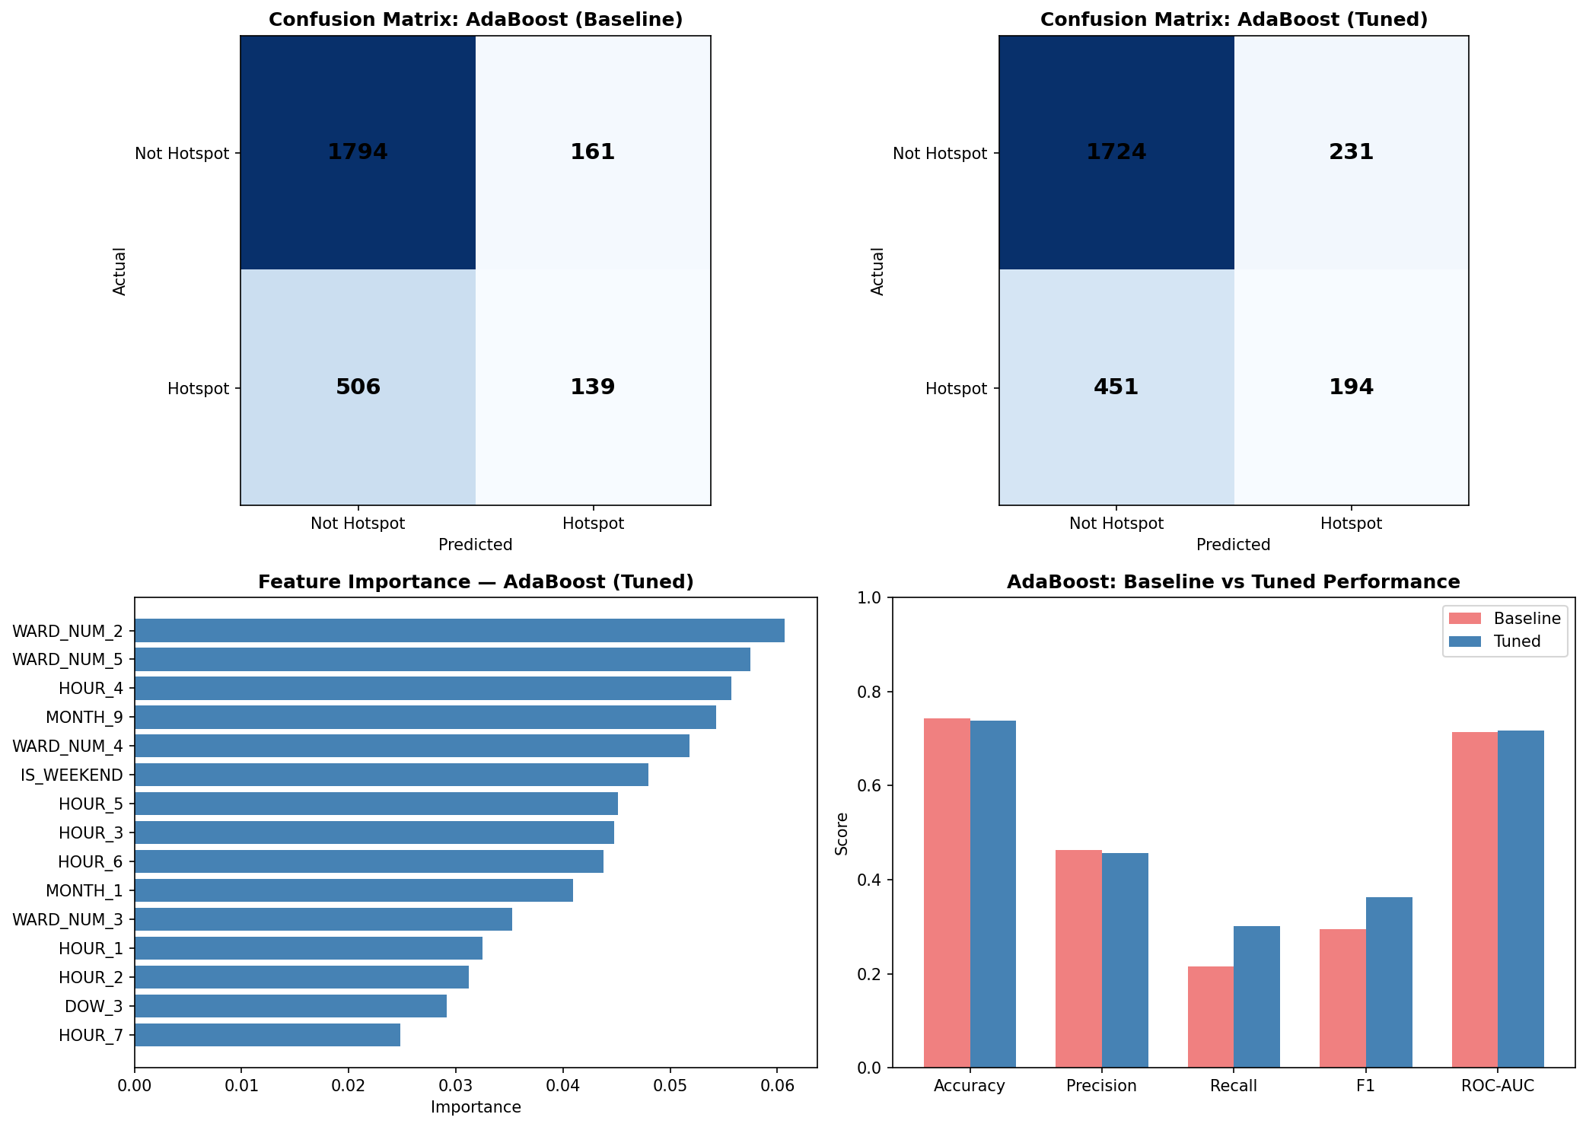
Figure 1: AdaBoost Model Results - Confusion Matrices, Feature Importance, and Performance Comparison

AdaBoost: Advantages and Disadvantages
Advantages:
- Simple to implement with few hyperparameters to tune (primarily n_estimators and learning_rate)
- Naturally handles feature selection through the boosting process
- Less prone to overfitting compared to other boosting methods when using weak learners
- Achieved competitive ROC-AUC (0.7171), comparable to GBM and XGBoost
Disadvantages:
- Sensitive to noisy data and outliers (misclassified samples receive higher weights)
- Lower F1 score (0.3626) compared to XGBoost Tuned (0.4112) from Assignment 2
- Sequential training cannot be parallelized, limiting scalability for large datasets

Conclusion
AdaBoost provides a competitive boosting approach for crime hotspot prediction with ROC-AUC of 0.7171, comparable to GBM (0.7145) and XGBoost (0.6993 tuned). However, its F1 score (0.3626) is lower than XGBoost Tuned (0.4112), primarily due to lower recall. The algorithm's adaptive weighting mechanism successfully identified Ward 2, Ward 5, and early morning hours as the most predictive features for crime hotspots. For operational deployment where probability-based risk scoring is important, AdaBoost offers a simpler alternative to XGBoost with fewer hyperparameters to tune, though XGBoost remains the recommended model for achieving the best balance of precision and recall.

Code Appendix
# AdaBoost Implementation
from sklearn.ensemble import AdaBoostClassifier
from sklearn.tree import DecisionTreeClassifier

# Initialize AdaBoost with Decision Tree base estimator
base_estimator = DecisionTreeClassifier(max_depth=3, random_state=42)
ada = AdaBoostClassifier(
estimator=base_estimator,
n_estimators=200,
learning_rate=1.0,
algorithm='SAMME',
random_state=42
)
ada.fit(X_train_enc, y_train)

References
Freund, Y., & Schapire, R. E. (1997). A decision-theoretic generalization of on-line learning and an application to boosting. Journal of Computer and System Sciences, 55(1), 119-139.
Pedregosa, F., et al. (2011). Scikit-learn: Machine learning in Python. Journal of Machine Learning Research, 12, 2825-2830.
Washington D.C. Open Data. (2025). Crime Incidents in 2025. Data.gov. https://catalog.data.gov/dataset/crime-incidents-in-2025

