

Crime Incidents Analysis Report

Date: 01-13-2026
Dataset: Crime_Incidents_-_2025.csv
Abhishek Singh
Dev Bhadreshkumar Panchal Lavanya Suresh
Sushmitha Urs A S
Professor – Kasun Samarasinghe

Abstract
This dataset contains recorded crime incidents for the year 2025 and provides detailed information on the nature, timing, and location of reported offenses. The data includes variables such as offense type, police district, reporting shift, date and time of occurrence, and geographic coordinates. The purpose of this dataset is to support exploratory and analytical studies aimed at identifying crime patterns, understanding temporal and spatial trends, and assisting law enforcement agencies in making data-driven decisions. By analyzing this dataset, meaningful insights can be derived to improve public safety strategies, optimize resource allocation, and enhance crime prevention efforts.
1. Data Dictionary
The dataset contains 25 columns representing crime incidents in Washington, D.C. Below is the breakdown:
Geographic (6), Administrative (9), Temporal (4) ,Crime Details (3), Identifiers (3)
Feature | Description
CCN | Criminal Complaint Number (Identifier)
REPORT_DAT | Date/Time crime was reported
SHIFT | Police shift (DAY, EVENING, MIDNIGHT)
OFFENSE | Classification of crime (e.g., HOMICIDE)
METHOD | Weapon or method used
BLOCK | Location block address
WARD | City Ward (1-8)
DISTRICT | Police District
NEIGHBORHOOD_CLUSTER | Neighborhood Cluster

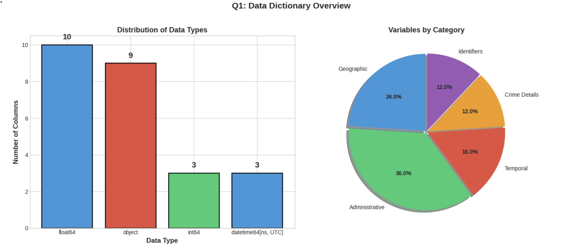

2. Use-Case & Problem Statement
How can we identify patterns in crime occurrence across time, location, and crime type to enable effective resource allocation and predict future crime hotspots?

Key Objectives:
- Temporal Analysis - Identify when crimes occur (hour, day, season)
- Geographic Analysis - Find crime hotspots by ward and neighborhood
- Crime Type Analysis - Understand offense distribution and methods
- Predictive Foundation - Build clean dataset for future modeling
Stakeholders:
- Law Enforcement: Optimize patrol routes and resource allocation
- City Government: Inform policy decisions and investments
- Community Organizations: Develop safety initiatives
- Residents: Make informed decisions about personal safety
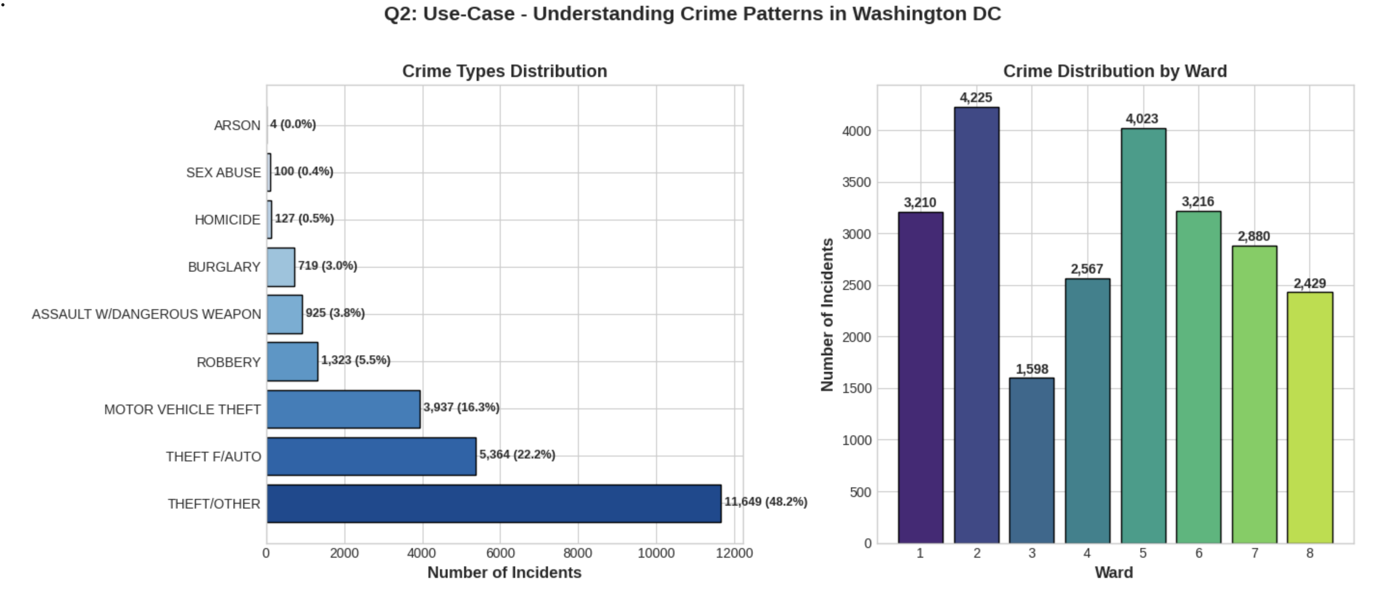
Key Findings:
- THEFT/OTHER is the most common crime: 11,649 incidents (48.2%)
- Ward 2 has the highest crime count: 4,225 incidents
Ward 3 has the lowest crime count: 1,598 incidents

3. Data Exploration & Analysis
The following exploration activities were performed:
- Examined categorical variables (OFFENSE, METHOD, SHIFT, WARD)
- Analyzed temporal patterns (monthly trends)
- Computed descriptive statistics for numeric variables
- Identified value distributions across key features

Based on preliminary analysis, we identified key trends in missing data, crime types, and shifts.
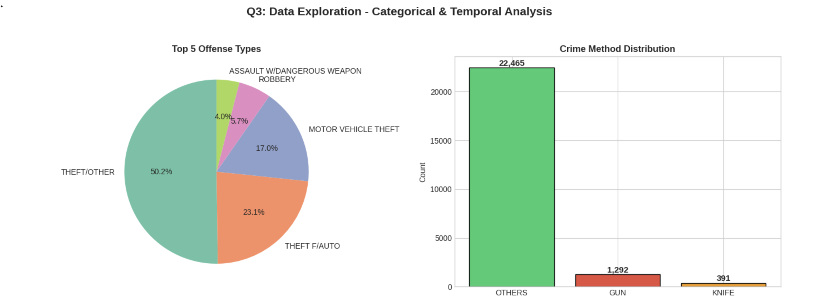

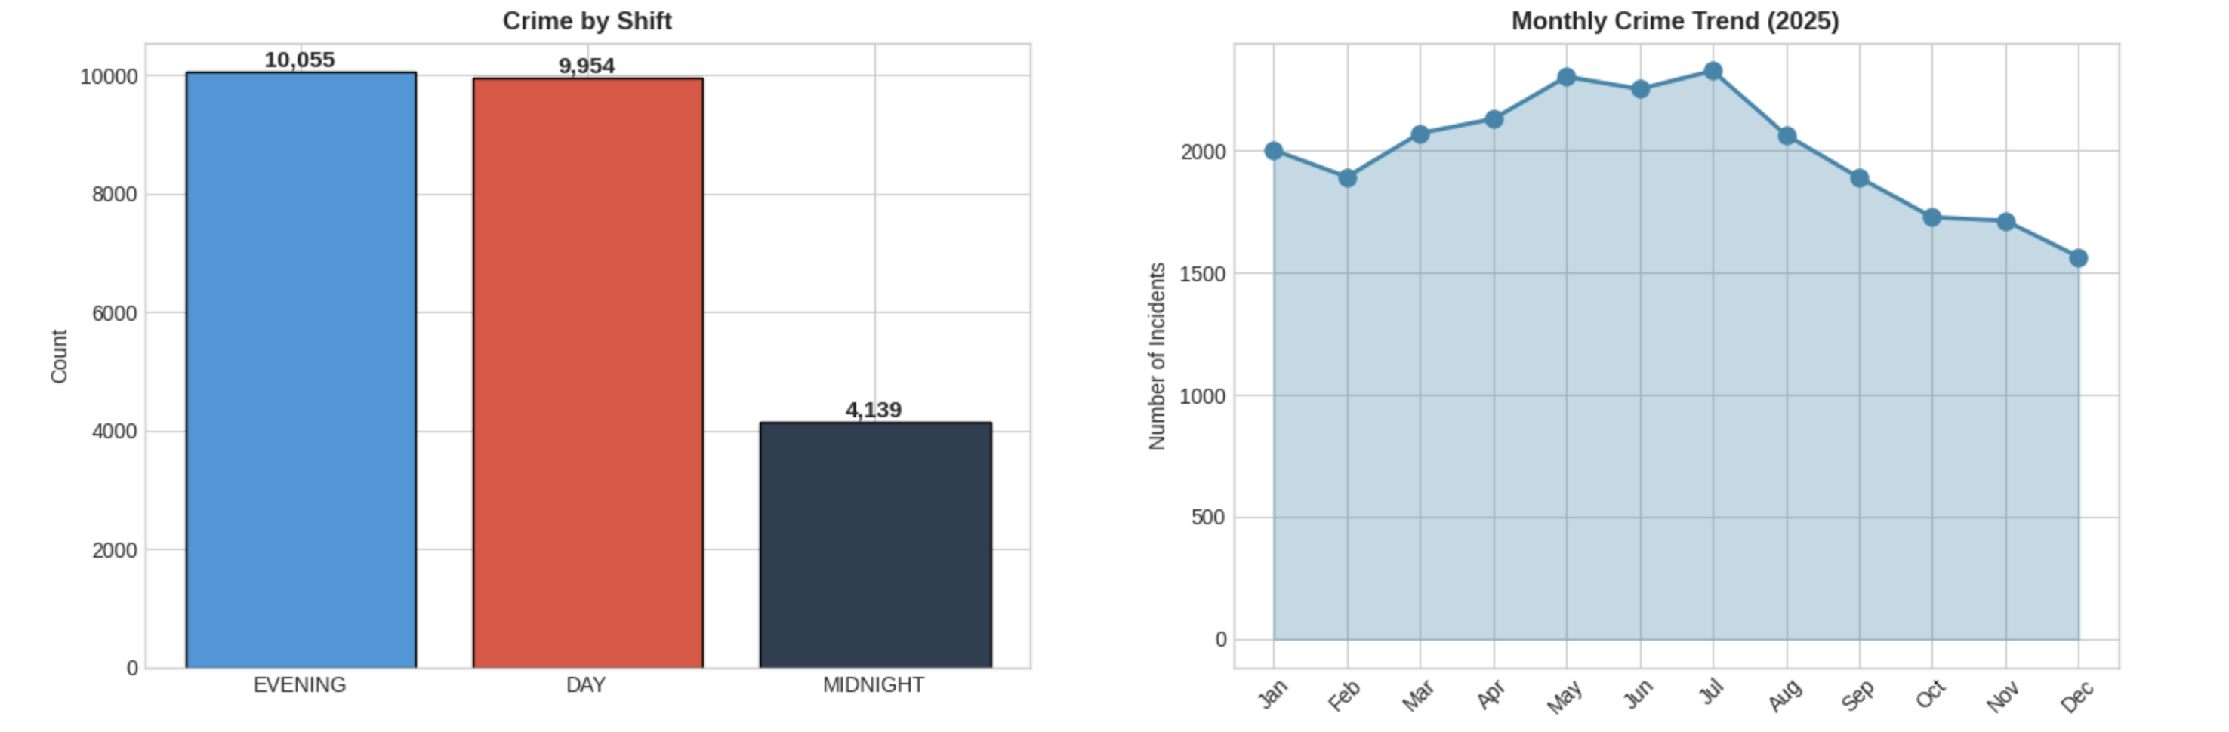
Crime Distribution by Shift
The Evening shift shows the highest volume of reported incidents.

4. Dataset Size
Total Rows (Entries): 24,148
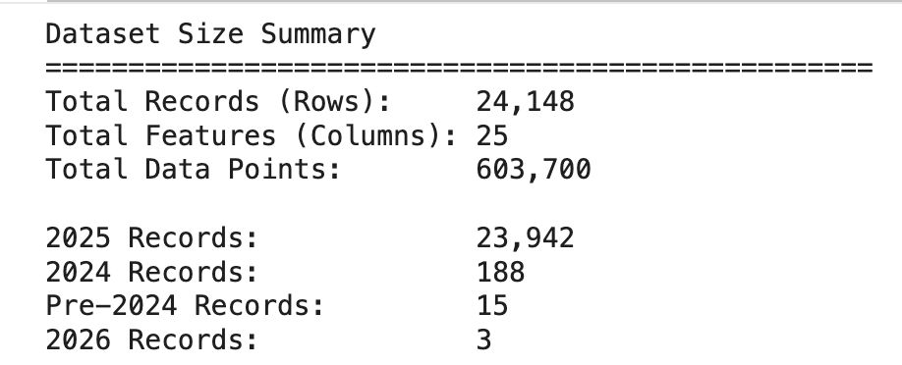
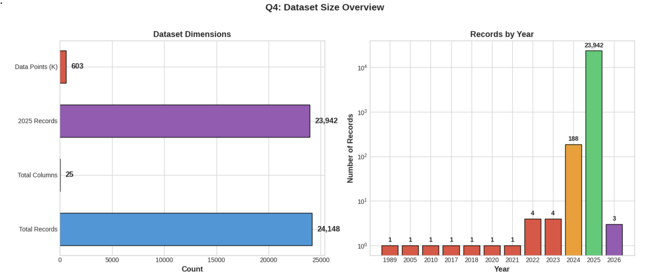

5. Data Quality Summary
- Missing Data:
- OCTO_RECORD_ID is 100% null.
- BID is missing in ~80% of records.
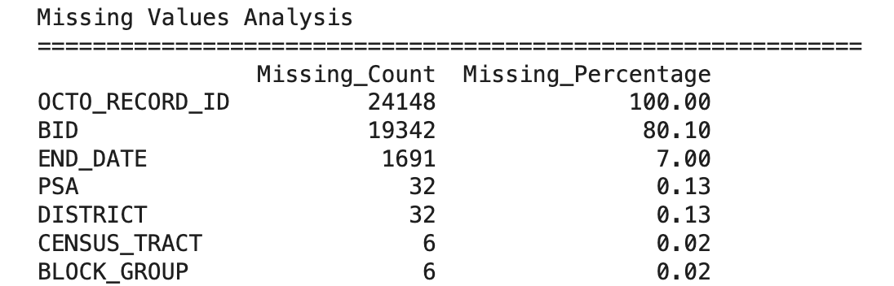
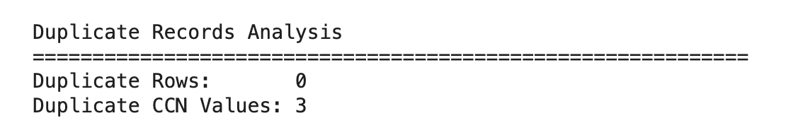
- Cleanliness:
- Data is largely clean but requires filtering for out-of-scope years (non-2025 records) and validation of temporal sequence (Start Date vs Report Date).
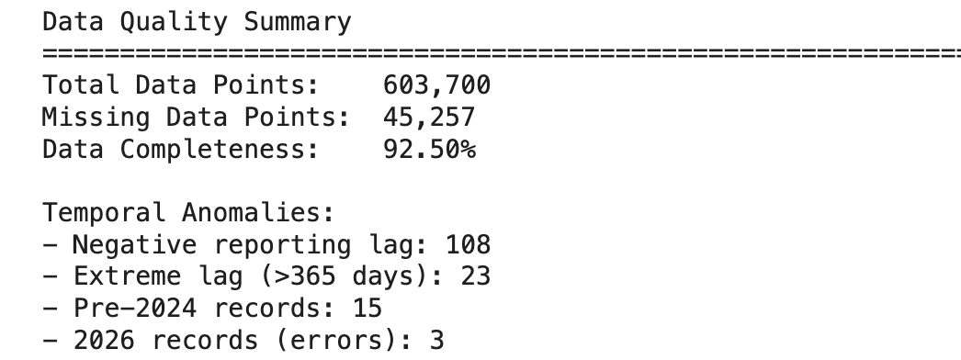

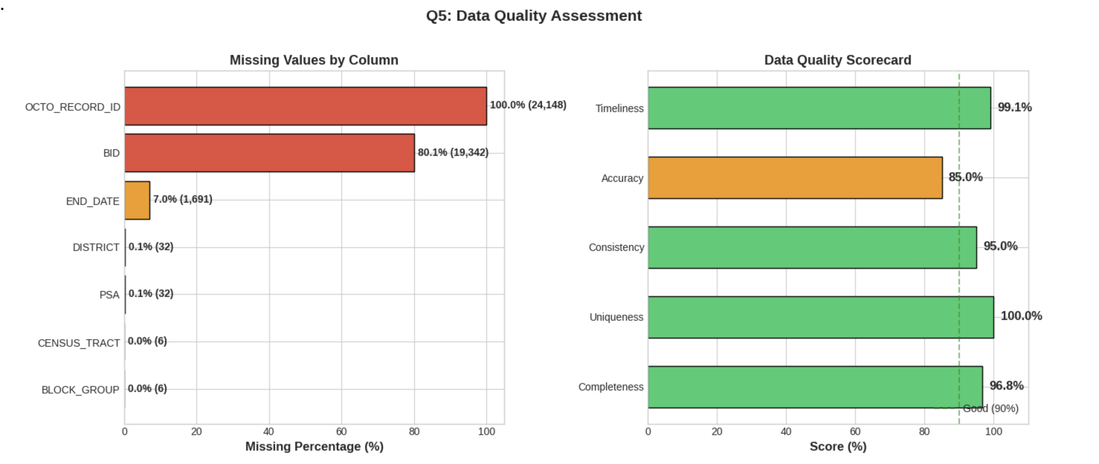

6. Outliers or Suspicious Data
Several checks were performed to identify outliers and suspicious records that could impact the reliability of the analysis.
The following categories of anomalies were evaluated:
- Temporal anomalies
  - Negative reporting lag where the report date occurs before the incident start date
  - Extremely large reporting delays, indicating late or historical data entry
  - Negative event duration where the end date precedes the start date
  - Unusually long event durations that may indicate data entry errors
- Scope-related anomalies
  - Records with incident dates outside the target analysis year (2025)
- Geographic anomalies (when latitude and longitude are available)
  - Coordinates that fall outside a reasonable geographic boundary for Washington, DC
Identifying these issues is critical because such records can distort time-based trends, spatial hotspot analysis, and summary statistics.

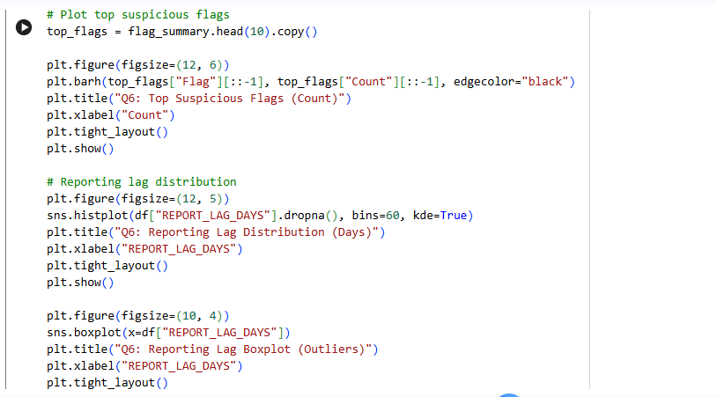

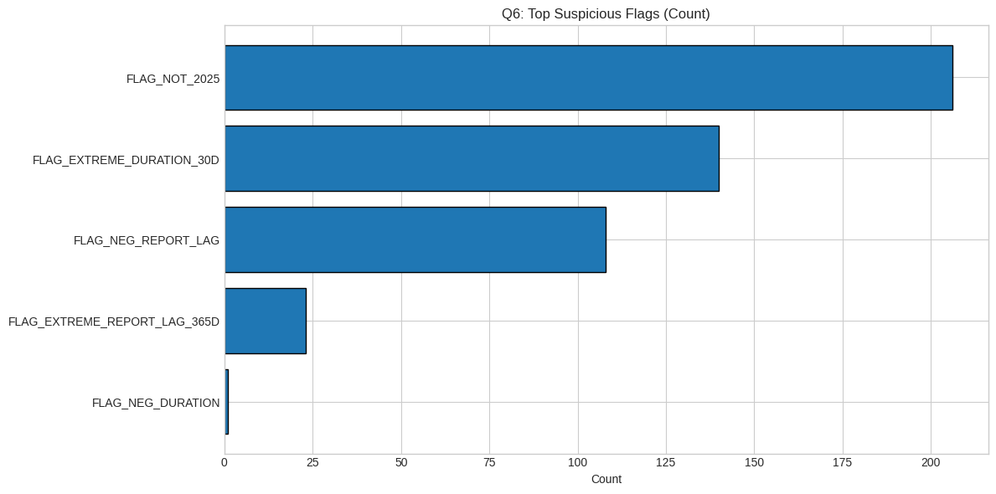

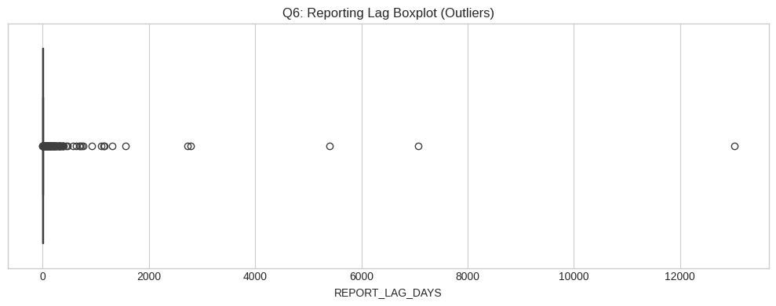

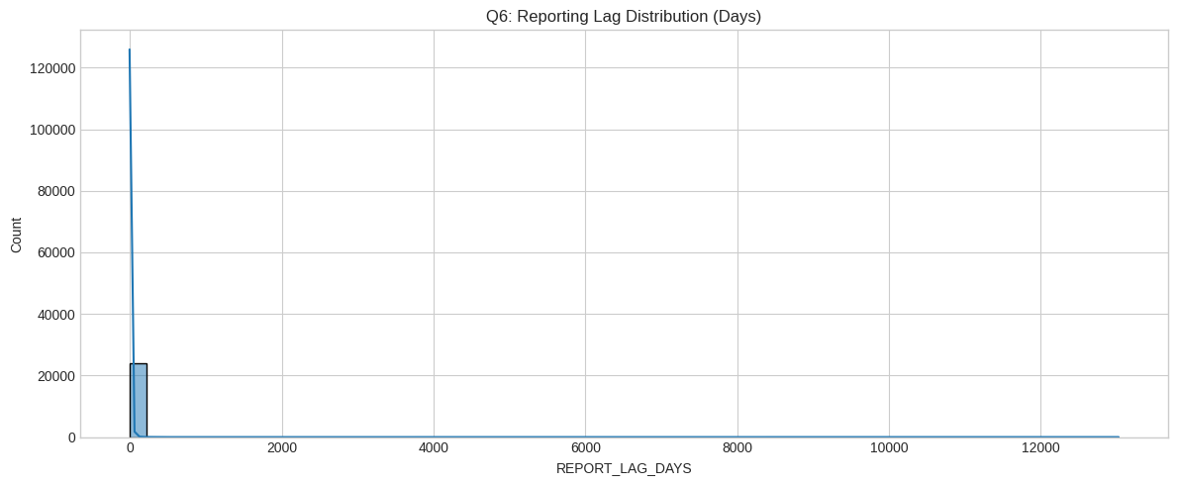

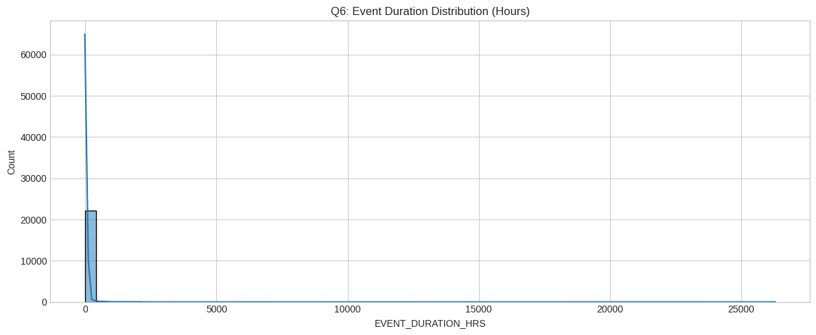

7. Key Findings and Observations
Exploratory analysis revealed several noteworthy patterns in the crime incident data:
- Time-of-day concentration Incident volumes are not uniformly distributed throughout the day. Distinct peak periods are observed, suggesting a strong relationship between crime occurrence and daily human activity patterns.
- Day-of-week variation Certain days consistently show higher incident counts than others, indicating weekly behavioral trends rather than random occurrence.
- Spatial concentration A small number of wards account for a disproportionately large share of reported incidents, highlighting localized crime hotspots.

Why These Findings Matter
These observations are important because:
- They support targeted allocation of public safety resources rather than uniform deployment.
- They provide insight into temporal and spatial patterns that can guide preventative strategies.
- They improve the interpretability and reliability of downstream analytical or predictive models.

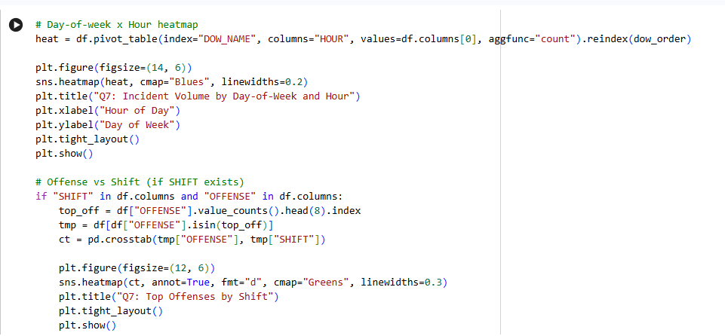
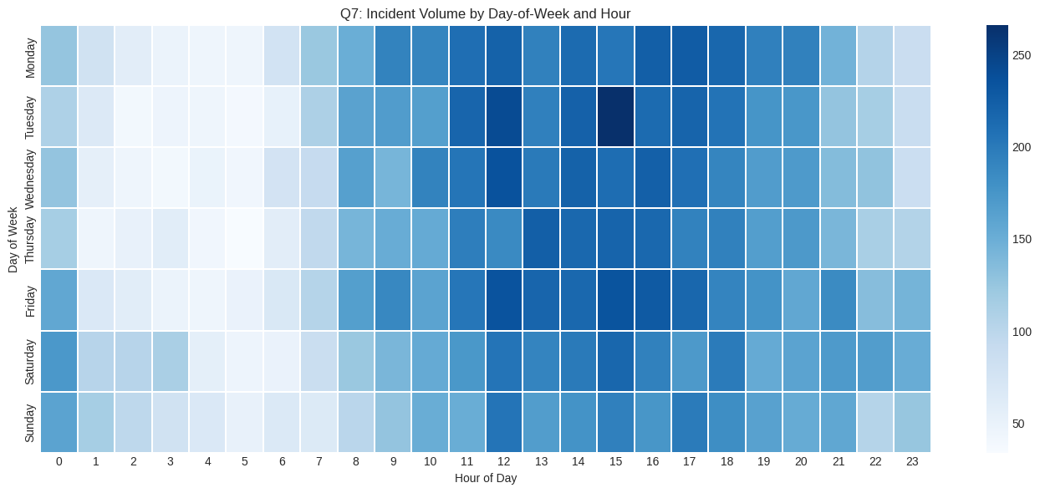

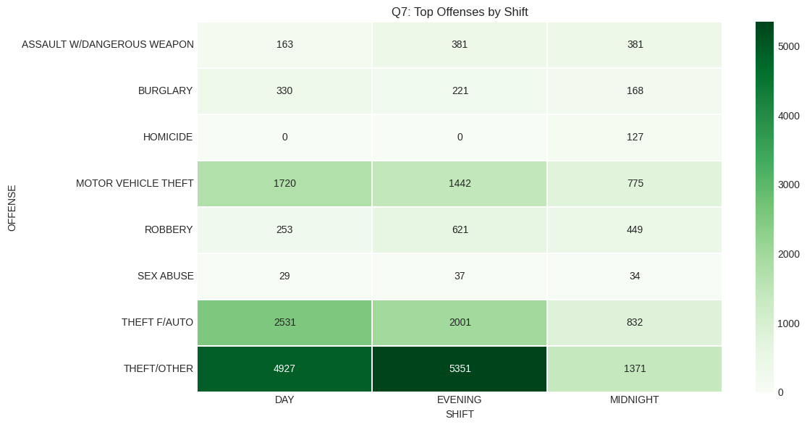

8. Proposed Next Steps – Data Cleansing Strategy
Before performing advanced analysis or modeling, the following data cleansing steps are recommended:
- Scope filtering
  - Restrict analysis to incidents occurring in the year 2025 to align with the dataset’s stated purpose.
- Temporal consistency checks
  - Flag or remove records with negative reporting lag.
  - Remove records with negative event duration.
  - Review records with exceptionally long reporting delays for validity.
- Categorical data standardization
  - Normalize categorical fields such as offense type, method, and shift by trimming whitespace and standardizing text.
  - Convert placeholder values (e.g., “Unknown”, empty strings) to null values.
- Geographic validation
  - Validate latitude and longitude values to ensure they fall within the expected geographic region.
  - Flag or remove records with implausible coordinates.
- Duplicate handling
  - Remove fully duplicated records.
  - For repeated incident identifiers, retain the most recent record based on the report date.
- Missing value strategy
  - Preserve missing values for critical variables while optionally adding indicator flags.
  - Apply limited imputation only where logically justified.
This structured approach ensures data quality while minimizing the loss of valid information.

9. Proposed Feature Engineering
To enhance analytical depth and model performance, the following feature engineering strategies are recommended:

Temporal Features
- Hour of day
- Day of week
- Month and week number
- Weekend versus weekday indicator
- Seasonal categorization (Winter, Spring, Summer, Fall)

Reporting Quality Features
- Reporting lag measured in days
- Reporting lag categorized into meaningful intervals (e.g., same-day, short delay, long delay)

Spatial Features
- Ward, district, and PSA-based encodings
- Geographic binning or clustering when coordinate data is available

Categorical Consolidation
- Grouping infrequent offense types into an “Other” category
- Standardizing and grouping crime methods to reduce category sparsity
These engineered features capture temporal, spatial, and behavioural dimensions of crime incidents and support more robust analysis.

Reference:- https://catalog.data.gov/dataset/crime-incidents-in-2025

Google Collab:- https://colab.research.google.com/drive/1BQbIk403ByNZKcw_x1t4vO4PktxXukNn?usp=sharing

