Crime Hotspot Detection Using Ensemble Learning Methods

Introduction
Data mining techniques play a critical role in uncovering hidden patterns and relationships within large, complex datasets. In the domain of public safety, these techniques enable the identification of spatiotemporal crime patterns that are not readily observable through descriptive statistics alone. As public safety agencies increasingly rely on data-driven insights to allocate limited resources more effectively, there is a growing need to move from reactive responses toward proactive policing strategies.
This study applies advanced ensemble learning algorithms to reported crime incidents in Washington, DC during 2025, building on the exploratory data analysis (EDA) conducted in Module 3 (Week 3). Rather than attempting to predict individual crime events, the analysis reframes the problem as a binary classification task focused on identifying high-risk combinations of location and time. Crime incidents are aggregated into Ward × Time buckets, and periods with elevated activity are labeled as crime hotspots.
This reframing aligns predictive modeling with real-world operational needs, such as patrol allocation, resource optimization, and targeted crime prevention planning. By evaluating and comparing multiple gradient-based ensemble models, the study seeks to determine the most effective approach for detecting crime hotspots and generating actionable insights that support proactive decision-making.
Business Context
The core business question guiding this analysis is:
How can historical crime data be used to identify high-risk ward–time combinations in Washington, DC that can support proactive patrol allocation and targeted intervention strategies?
During the project, this question evolved from understanding where crime occurs to identifying when and where crime risk is persistently elevated. This shift aligns more closely with operational decision-making needs in public safety.

2. Data Overview and EDA Insights
The dataset consists of reported crime incidents in Washington, DC for the 2025 calendar year. Each record includes temporal information (incident start time) and spatial identifiers (ward). In Module 3, the EDA revealed three key insights:
- Spatial Concentration of Crime: Crime incidents were unevenly distributed across wards, with specific wards consistently exhibiting higher incident volumes.
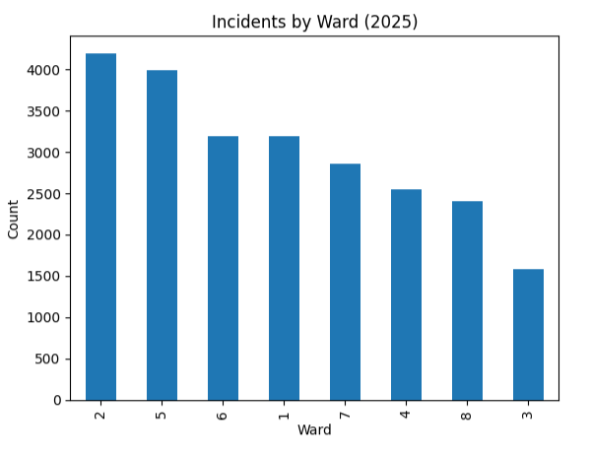
  - Crime incidents by ward (EDA bar chart): This visualization shows a clear concentration of incidents in a small number of wards, motivating the inclusion of ward-level indicators in all predictive models.

- Temporal Patterns: Crime frequency varied significantly by hour of day and day of week, with noticeable increases during evening hours and weekends.
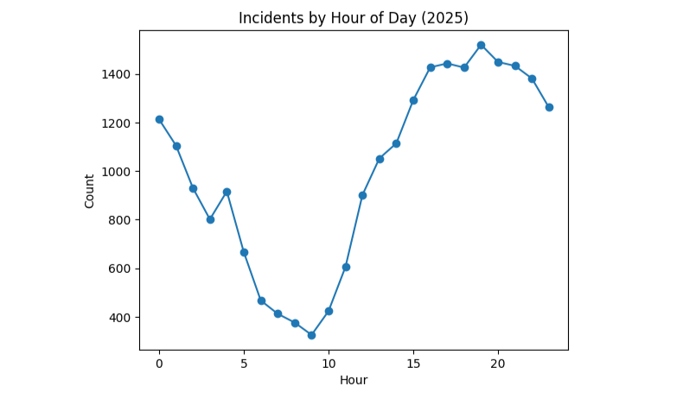
  - Hourly crime distribution: The evening spike observed in this plot supports the creation of hour-of-day features and explains why time-based predictors emerge as important in gradient boosting models.
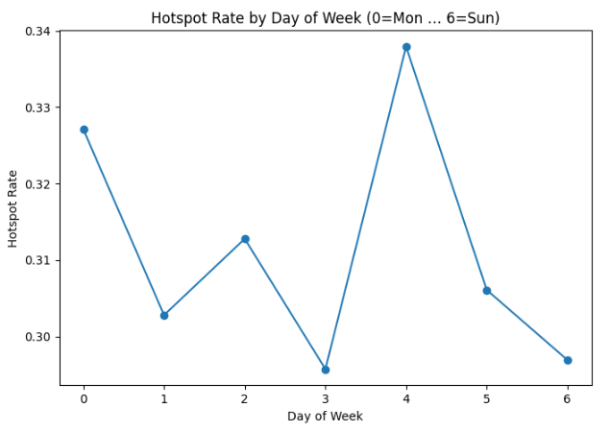
  - Crime by day of week: This visualization highlights weekend effects that later appear as strong predictors in LightGBM and AdaBoost.

- Seasonal Effects: Monthly patterns suggested moderate seasonal variation, indicating that crime risk is not uniform throughout the year.
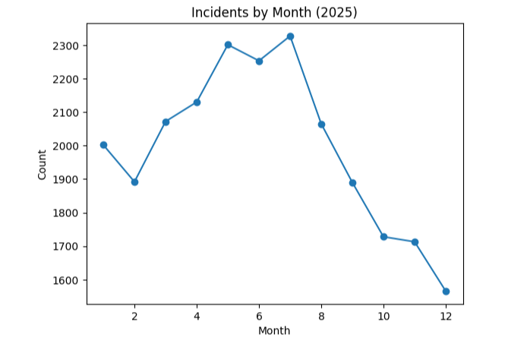
  - Monthly crime trends: This plot illustrates gradual seasonal variation rather than extreme month-to-month volatility, justifying the inclusion of month as a contextual rather than dominant feature.
These insights directly informed feature engineering, aggregation strategy, and model selection in the current analysis.

3. Data Preparation and Feature Engineering

3.1 Cleaning and Filtering
The raw dataset was filtered to include only records from 2025. Records with missing or invalid ward identifiers or timestamps were removed to preserve analytical consistency.

3.2 Temporal Feature Engineering
From the incident start time, the following features were extracted:
- Hour of day
- Day of week
- Month
- Weekend indicator
These features directly operationalize the temporal insights identified during EDA.

3.3 Aggregation and Target Variable Creation
Crime incidents were aggregated into Ward × Time buckets, and incident counts were calculated for each bucket. A binary target variable, HOTSPOT, was defined using the 75th percentile of incident counts in the training data. Buckets exceeding this threshold were labeled as hotspots.
This formulation reduces noise, addresses skewness, and produces a classification target aligned with real-world policing thresholds.

4. Analytical Methodology

4.1 Train–Test Split Strategy
A time-based split was used to avoid temporal leakage:
- Training data: January–September 2025
- Test data: October–December 2025
This approach reflects realistic forecasting conditions and strengthens external validity.

4.2 Model Selection Rationale
Four ensemble learning models were selected due to their ability to capture nonlinear relationships and feature interactions:
- AdaBoost
- CatBoost
- LightGBM
- Histogram-Based Gradient Boosting (HistGB)
Tree-based boosting methods were chosen because they handle mixed feature types well and are robust to feature scaling.

5. Model Training and Evaluation

5.1 Evaluation Metrics
Given class imbalance, evaluation emphasized:
- Recall
- F1-score
- ROC–AUC
- Precision–Recall AUC
Accuracy alone was not considered sufficient due to the minority nature of hotspot periods.
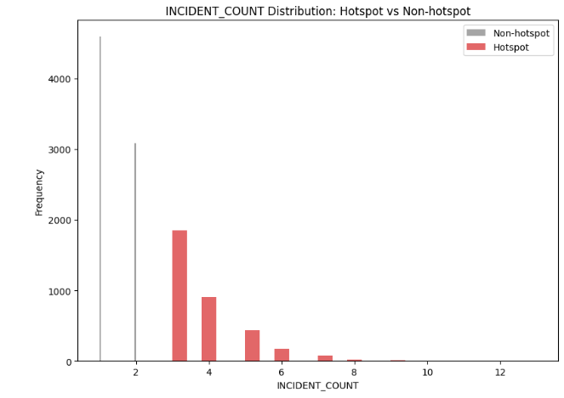
- Class distribution of HOTSPOT vs non-HOTSPOT: This visualization highlights the imbalance problem and explains why recall- and PR-based metrics were prioritized.

5.2 Baseline vs Tuned Performance
Baseline models already outperformed naïve approaches. After hyperparameter tuning:
- CatBoost achieved the strongest balance between recall and precision (highest F1-score).
- AdaBoost delivered the highest ROC–AUC and PR-AUC, indicating strong ranking ability.
- HistGB and LightGBM showed limited or negative gains after tuning, suggesting sensitivity to overfitting.
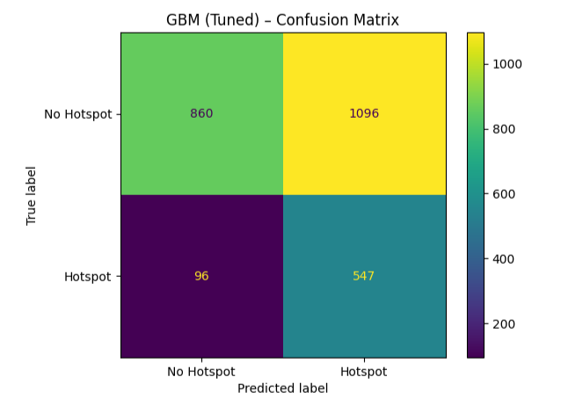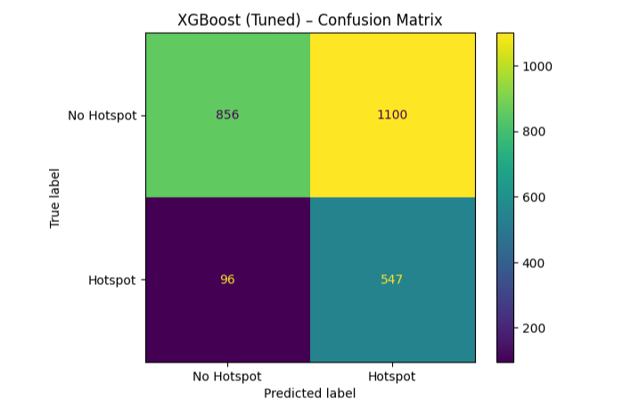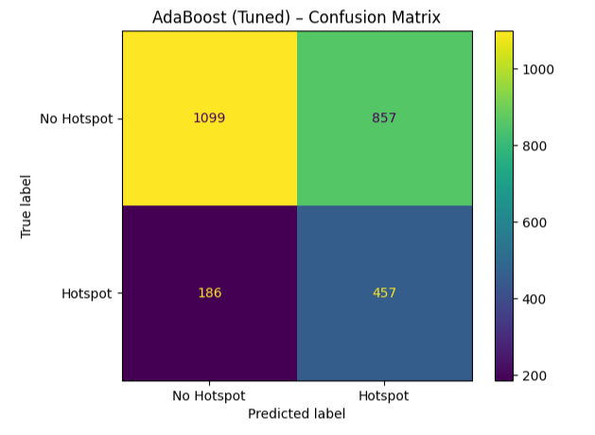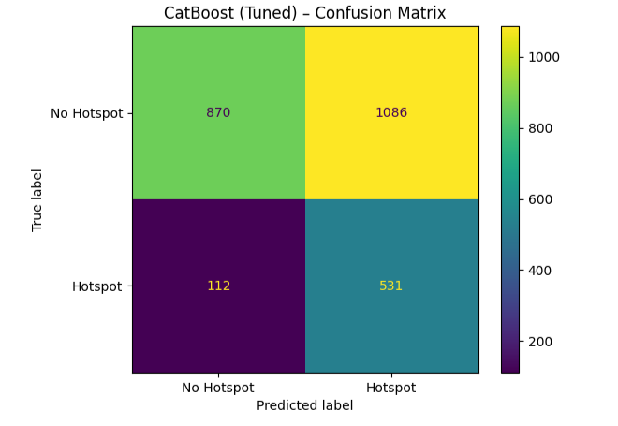
- Confusion matrices for tuned models: These plots illustrate how CatBoost minimizes false negatives relative to other models, which is critical for hotspot detection.
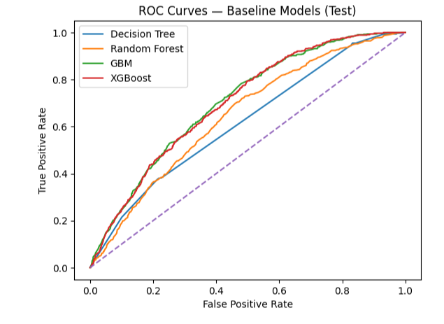
- ROC curves for ensemble models: The ROC comparison demonstrates AdaBoost’s superior ranking ability across thresholds.
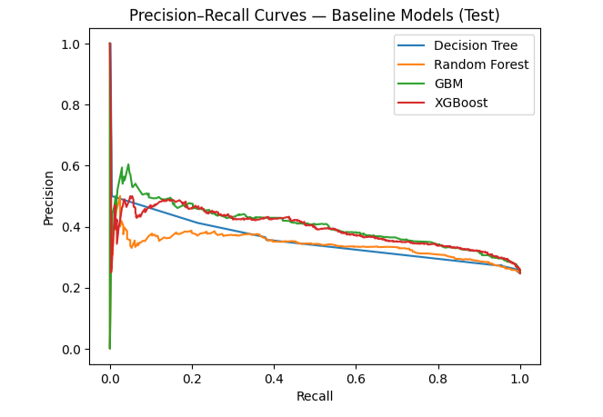
- Precision–Recall curves: These curves confirm that AdaBoost and CatBoost maintain better precision at higher recall levels under class imbalance.
These results demonstrate that performance improvements were metric-specific rather than universal.

6. Model Explainability and Feature Interpretation

6.1 Feature Importance and SHAP Analysis
To interpret model behavior, feature importance and SHAP-based explanations were used.
- Feature importance – CatBoost: Ward indicators dominate the ranking, confirming persistent spatial risk patterns.
- Feature importance – HistGradientBoosting: Hour-of-day features rise in importance, reflecting sensitivity to intra-day crime surges.
- Feature importance – LightGBM: Weekend indicator emerges as a top predictor, aligning with EDA findings.
- Feature importance – AdaBoost: Distributed importance across ward and temporal features reflects AdaBoost’s focus on hard-to-classify cases.
Key findings across models:
- Ward indicators consistently ranked as the most important features, validating the EDA insight that crime risk is spatially concentrated.
- Temporal variables such as hour of day, weekend indicator, and day of week captured cyclical crime patterns.
- Model-specific sensitivity differed: CatBoost emphasized stable spatial and weekly effects, while HistGB and LightGBM were more responsive to time-of-day spikes.
- Figure 13. SHAP summary plot (CatBoost): This visualization shows both the magnitude and direction of feature impact, demonstrating how specific wards and temporal conditions increase hotspot probability.

6.2 Linking Explainability to EDA Insights
- The dominance of ward features confirms persistent geographic risk identified in EDA.
- Hour and weekend importance aligns with observed evening and weekend crime surges.
- Month-level effects reflect the seasonal variation noted during exploratory analysis.
Explainability techniques thus validate and extend earlier descriptive findings.

7. Interpretation of Results
For the data owner (public safety stakeholders), the results indicate that crime risk is not random but structured around stable spatial patterns combined with predictable temporal cycles. The models demonstrate that high-risk periods can be identified reliably using historical data, enabling forward-looking planning rather than reactive response.
The analysis supports the original project objective: transforming raw crime data into actionable intelligence that informs operational decisions.

Business Use cases
1. Core Use Case: Crime Hotspot Identification for Proactive Policing
The primary business application of this analysis is crime hotspot identification, rather than prediction of individual crime incidents. By classifying Ward × Time combinations as either hotspot or non-hotspot periods, the models provide actionable intelligence that supports proactive policing and public safety planning.
Using temporal features (hour of day, day of week, month, weekend indicator) and spatial ward-level information, the models identify periods with elevated crime risk. This reframing aligns directly with operational decision-making, where law enforcement agencies must decide where and when to allocate limited patrol resources, rather than predicting specific crime events.
Because hotspot periods represent a minority of observations, the evaluation emphasizes recall, F1-score, and PR-AUC, ensuring that high-risk periods are not missed. From an operational standpoint, missing a true hotspot is more costly than generating additional patrol alerts.
2. Operational and Strategic Applications
A. Patrol Allocation and Resource Optimization
Problem: Police departments operate under staffing and budget constraints, making uniform patrol coverage inefficient.
Analytics-Driven Solution:
The hotspot classification models—particularly CatBoost—enable departments to identify wards and time windows with consistently elevated risk. By prioritizing periods with higher predicted hotspot probability, agencies can deploy officers more effectively during high-impact hours such as evenings and weekends.
Impact: Improved visibility in high-risk areas, Faster response times, More efficient use of limited personnel, Reduced likelihood of missing emerging hotspot periods.
B. Targeted Crime Prevention and Intervention
Problem: City governments and public safety agencies must decide where to implement preventative measures such as increased lighting, community outreach programs, or surveillance infrastructure.
Analytics-Driven Solution:
Ward-level hotspot predictions reveal persistent spatial risk patterns as well as time-specific surges. This allows decision-makers to distinguish between structurally high-risk areas and short-term temporal spikes.
Impact: Data-supported justification for targeted interventions, Better prioritization of preventative spending, Enhanced coordination between policing and community-based initiatives.
C. Policy Evaluation and Budget Justification
Problem: Policymakers often need quantitative evidence to support budget reallocations or funding requests for public safety initiatives.
Analytics-Driven Solution:
Model outputs provide empirical evidence of when and where crime risk is concentrated. Changes in hotspot frequency over time can be monitored to evaluate the effectiveness of interventions or policy changes.
Impact: Stronger data-backed policy proposals, Transparent performance evaluation of public safety strategies, Improved accountability in budget allocation.
3. Strategic Model Choice for Business and Public Safety Use
Based on comparative performance across recall, F1-score, ROC–AUC, and PR-AUC, CatBoost emerges as the most suitable model for operational deployment. While AdaBoost demonstrated strong ranking ability (ROC–AUC), CatBoost achieved the best balance between identifying true hotspots and controlling false alarms—a critical requirement in public safety contexts.
CatBoost’s robustness to overfitting and consistent performance under class imbalance make it well suited for recurring hotspot monitoring and decision support, where reliability and interpretability are more important than marginal gains in a single metric.
Summary for Stakeholders
This analysis provides a practical framework for transitioning from reactive policing to proactive, data-driven crime prevention. By focusing on hotspot classification rather than individual crime prediction, the models deliver insights that directly support patrol planning, targeted interventions, and evidence-based policy decisions. Among the evaluated approaches, CatBoost offers the most reliable balance of performance and operational relevance for sustained public safety applications.

8. Recommendations

8.1 Operational Recommendations
- Deploy CatBoost as the primary decision-support model for hotspot identification due to its balanced performance.
- Use predicted hotspot probabilities to prioritize patrol coverage during high-risk hours and weekends.

8.2 Data and Feature Enhancements
Future analyses should incorporate:
- Weather conditions
- Special events and holidays
- Socioeconomic indicators
- Calls-for-service data
These variables may improve sensitivity to short-term risk fluctuations.

9. Next Steps and Timeline
If extended, the project would proceed as follows:
- Weeks 1–2: Integrate external contextual datasets
- Weeks 3–4: Apply spatiotemporal clustering and anomaly detection
- Weeks 5–6: Evaluate deep learning sequence models for temporal forecasting

10. Conclusion
This project demonstrates how ensemble learning methods can uncover meaningful spatiotemporal crime patterns and translate them into actionable insights. By reframing the problem as hotspot classification and grounding model interpretation in EDA findings, the analysis delivers both predictive performance and explanatory value.
Among the evaluated approaches, CatBoost offers the most reliable balance of accuracy, recall, and interpretability for sustained public safety use. Overall, the study highlights the power of data mining to support evidence-based decision-making in complex, real-world domains.

