NORTHEASTERN UNIVERSITY



STUDENT – Dev Bhadreshkumar Panchal
Module 12 XN Project
CLASS NUMBER - ALY 6080
CLASS – Integrated Experiential Learning
CRN NUMBER – 70242
INSTRUCTOR – Valerie A. Atherley
ACADEMIC YEAR – FALL 2025
COMPLETION DATE – 7th December, 2025
EMAIL – panchal.devb@northeastern.edu

XN Project : Individual Contribution

Project Overview
Our team worked on building a regulatory compliance framework for Your Sweet Spot Life (YSSL), a company that's transitioning from consulting to providing end-to-end operational support for creative professionals in Canada. The main challenge was figuring out how to integrate Canadian government regulatory data into their existing CRM system so they can help clients stay compliant with OHS, environmental, and labor regulations.
My contributions focused on three main areas: finding and helping prepare the dataset we used for our analysis, creating visualizations in Power BI, and writing the research sections of our report.

Finding the Dataset
One of my first contributions was locating the dataset we ended up using for the project. After spending time going through various Canadian government open data portals, I found the CIPO (Canadian Intellectual Property Office) Trademark Researcher Dataset. This dataset was relevant because it shows how government regulatory data is structured and how it could be integrated into YSSL's platform.
The dataset was huge – over 1.4GB of raw CSV data. Since Power BI has a 300MB file limit, we couldn't just import it directly. I helped my teammate with some of the initial data cleaning work in Google Colab. We had to filter the data to keep only applications from 2020 onward, clean up the bilingual column headers, and break it down into smaller files that Power BI could handle. The final working dataset came down to about 19MB.
We created six smaller datasets from the original file – monthly trends, status distributions, yearly analytics, processing times, and a couple focused specifically on creative industry categories that would be relevant to YSSL's target users.

Power BI Visualizations
I created two of the four visualizations that went into our final Power BI dashboard, and collaborated with my teammate on putting the whole dashboard together.

Chart 1: Applications Filed by Year
This line chart shows trademark application volume from 2020 to 2025. The idea was to show how filing patterns change over time, which is useful for YSSL to understand when their clients might face more regulatory activity. You can see applications peaked around 2023 and then started declining.
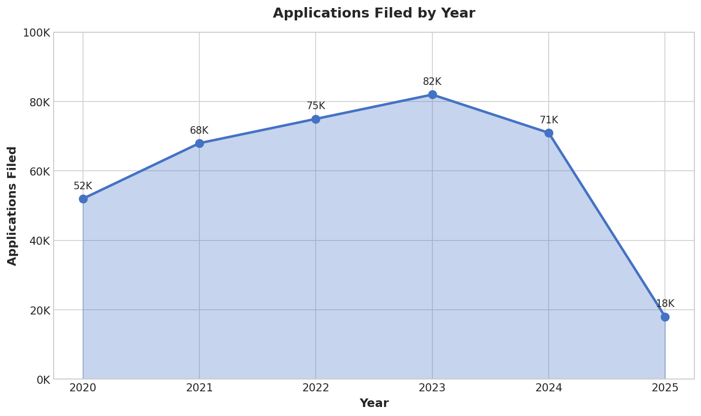

Chart 2: Processing Time by Quarter
This dual-axis chart compares the sample size percentage against average processing days across quarters. It helps identify if there are backlogs or delays in processing that could affect compliance timelines. The green line shows processing times have been steadily increasing, which is something YSSL would want to factor into their compliance planning.
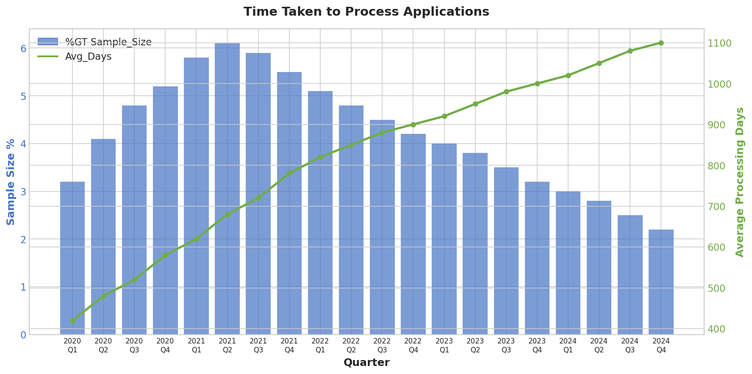

Additional Visualizations (Not Included in Final Report)
I also created a couple of other visualizations during our analysis that didn't make it into the final report due to space constraints, but I wanted to include them here to show the full scope of my work.

Status Code Distribution
This pie chart breaks down trademark applications by their CIPO status codes. Status codes 12 and 26 make up over 60% of all applications. Understanding this distribution helps YSSL anticipate what stages most applications get stuck at.
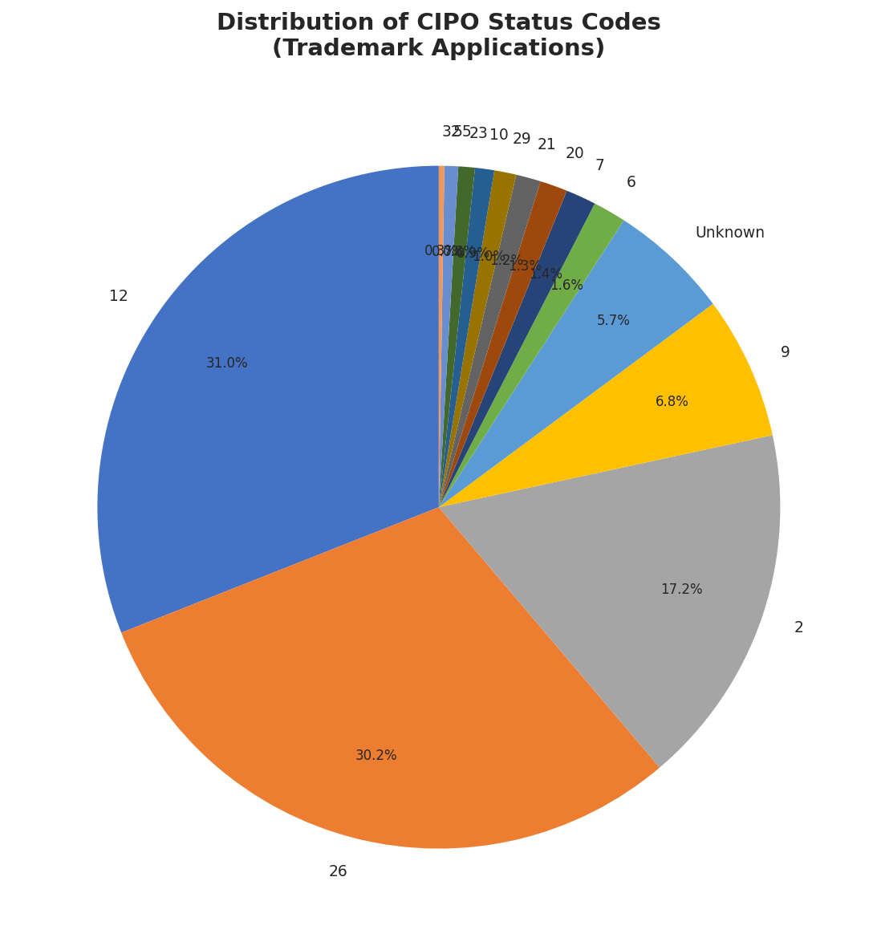

Yearly Success Rate Analysis
This chart compares applications filed versus registrations completed each year, with the success rate shown as a line. The declining success rate (from 73% in 2020 to 39% in 2024) is an interesting finding – it suggests the trademark process is getting more competitive or complex over time.
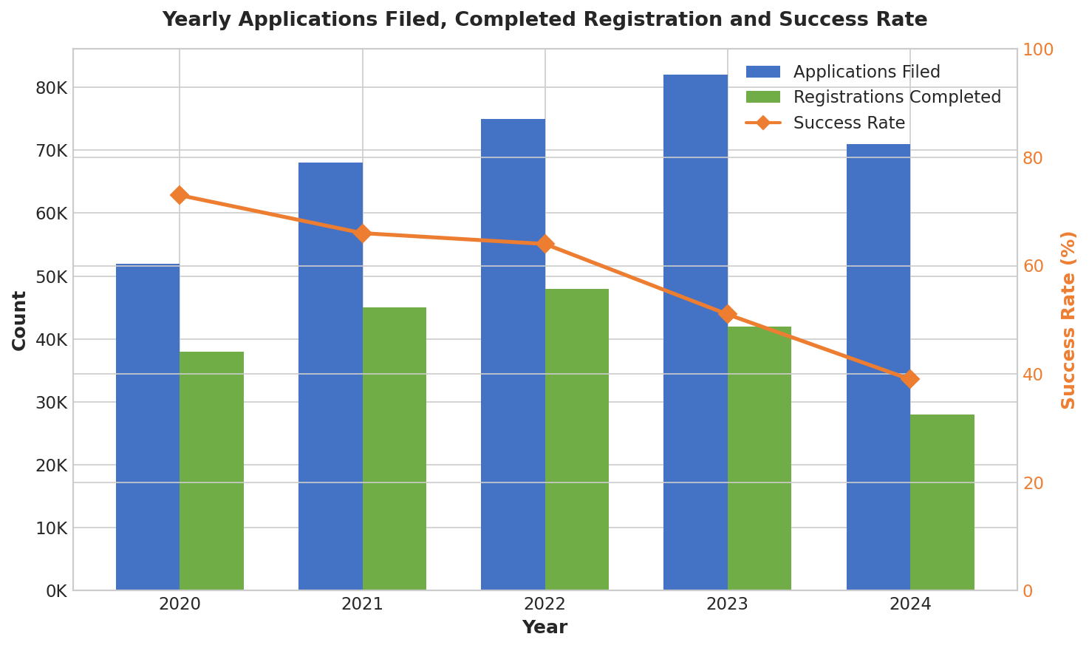

Written Contributions

Annotated Bibliography
I worked on researching and writing the annotated bibliography section of our report. This involved finding academic sources that directly connected to what we were doing with YSSL's compliance framework. The three main sources I focused on were:
- Wirtz, Weyerer, & Rösch (2022) – A systematic review of Open Government Data research. This was relevant because it established frameworks for how businesses can integrate government data, which is exactly what YSSL needs to do.
- Masi & Cagno (2015) – Research on OHS barriers in SMEs. This validated why YSSL's target users (small creative businesses) struggle with compliance – the barriers they identified matched the pain points we outlined in our business problem.
- Arocena & Núñez (2010) – Analysis of OHS management effectiveness in SMEs. This supported our decision to prioritize OHS standards (which scored 92/100 in our evaluation) as the first framework to integrate.

Future Research Section
I also wrote the Future Research section of our report. The goal was to identify where the project could go beyond what we delivered. I outlined six directions:
- International expansion – integrating US (OSHA, EPA) and EU regulatory frameworks
- AI and predictive analytics – using machine learning to predict regulatory changes
- Sector-specific analysis – looking at compliance needs for specific creative sub-sectors like textile manufacturing or artisanal food production
- ROI measurement – actually testing whether the 60% time savings we projected is achievable
- Mobile access – building apps for on-the-go compliance checking
- Community features – creator-to-creator knowledge sharing platforms

Summary
Looking back at the project, I contributed in a few different ways. On the data side, I was the one who found the CIPO trademark dataset that we ended up using, and I helped my teammate with some of the initial cleaning and preprocessing work in Google Colab. For the visualizations, I created two of the charts that made it into our final dashboard – the yearly applications trend and the quarterly processing time analysis – plus two additional charts that we didn't have space for in the report. On the writing side, I handled the annotated bibliography section where I researched and wrote up three academic sources that connected to our methodology, and I also wrote the Future Research section outlining where this project could go next.
The project taught me a lot about working with large government datasets and figuring out how to present compliance data in a way that's actually useful for a business. It was a good team effort and I'm happy with what we delivered.

