NORTHEASTERN UNIVERSITY



Module 4 Group Project

CLASS NUMBER - ALY 6110
CLASS – Big Data and Data Management
CRN NUMBER – 80199
INSTRUCTOR – Daya Rudhramoorthi
ACADEMIC YEAR – Spring 2026
COMPLETION DATE – 3rd May, 2026
GROUP 12 – Qiu Chenhao, Dev Panchal

Introduction
In this group project ,we will conduct explanatory data analysis on the dataset selected from the previous assignment to form a dashboard. This dashboard will generate insights that might be useful for our future work and at the same time let us have a basic understanding about the entire dataset
Visualization 1
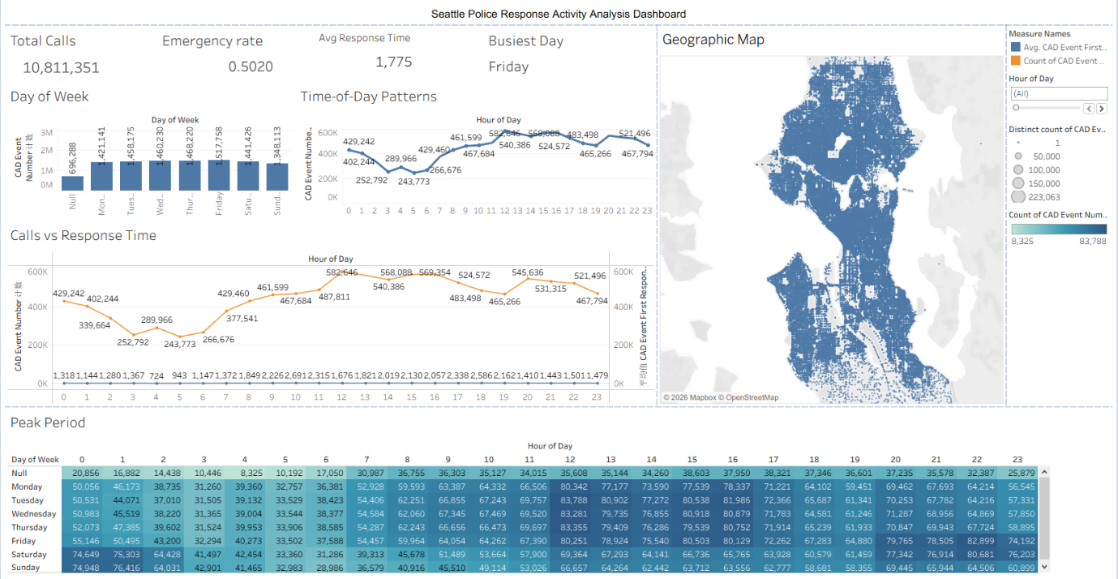
In order to further understand the dataset that our groups selected in week 3 .I generated a dashboard containing 5 different graphs .Each focusing on a different aspect of the dataset .Plot 1 focuses on the number of cases happening everyday of the week .From this visualization we can see that the CAD event count shows an increasing trend starting from Monday to Friday and reaching its peak on Friday. Friday receives the most calls, which seems reasonable since Friday is when people tend to have more free time and release their stress. Therefore, security problems will increase significantly
The second visualization plot is a line graph describing the CAD event number over time .From this graph we can see that lowest call volume happens during the early morning between 3 am and 6 am .As time passes , CAD events start to increase and by 12 pm, the CAD event count reaches its peak .After 12pm,the CAD number will vary within a specific range and start to decline starting from 10 pm , reaching the lower limit again. This line chart clearly shows that the CAD event number is closely related to daily human activity cycles which means that high human activity levels will cause more CAD event.
The third visualization is a dual axis chart that tests the relationship between CAD event numbers and CAD initial response time. Base on the plot ,we can see that as call volume increases, there is also an increase in average response time .This pattern can also be observed when the CAD event number is lower ,the average CAD first response time will also be lower .This result indicates that there is a positive correlation between event number and response delay.
The fourth visualization is a heatmap based on time of day and weekdays .This plot combines both weekdays and time-of-day data together to identify the time periods on specific days that have largest and lowest numbers of CAD events. According to the heatmap, apart from null values Tuesday at 12pm has the largest CAD event number and Sunday at 6am has the lowest. With this heatmap ,the Seattle police department can revise the staff work schedules to avoid understaffing or overstaffing.
The last visualization is a geographic map that records the exact location of every CAD event took place ,Base on the map we can see that CAD events are clustered in central urban areas and has a sparsely distributed in outer regions .We can conclude that the CAD event number is directly related to population density and activity concentration a higher population density correspond to a higher possibility of a CAD event. This result will help the Seattle police department to allocate more officers to places that have a high possibility of CAD events.
This dashboard gives the audience an idea that CAD events are most likely to occur on weekdays during afternoon hours and in central urban area. Outer regions have a significant lower likelihood of CAD events than urban areas. At the same time, as the CAD event count increases ,police officers will need more time for CAD first response.

Visualization 2
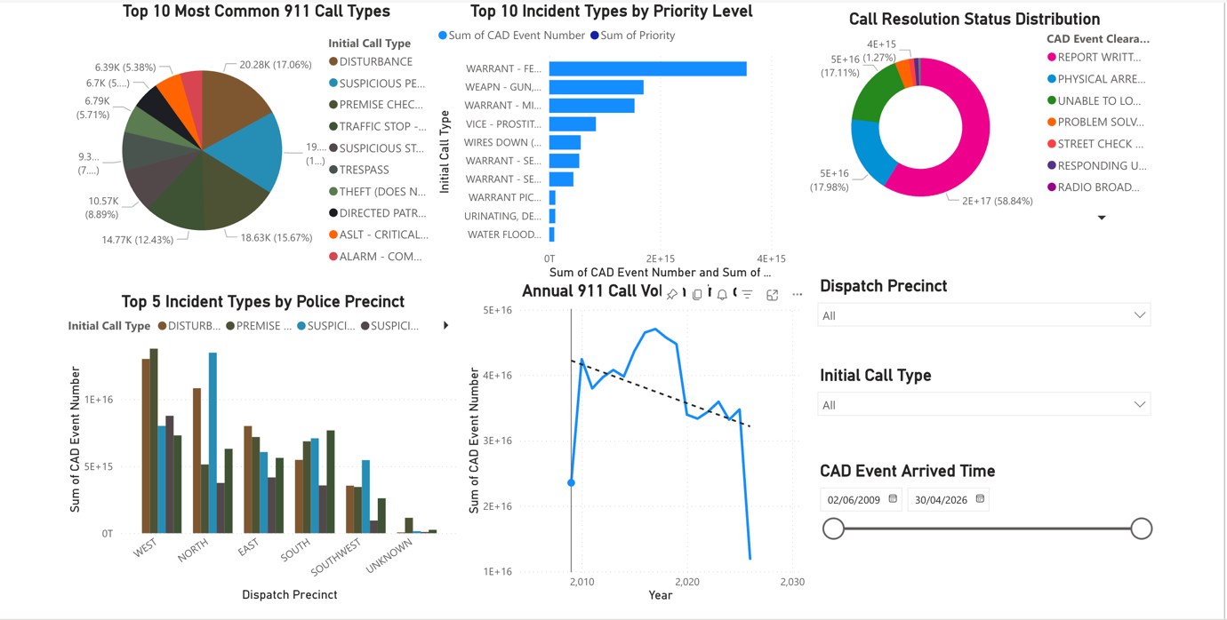
In order to further understand the dataset that our group selected in week 3, I generated a dashboard containing 5 different graphs. Each focusing on a different aspect of the dataset. Plot 1 focuses on the most common types of 911 calls received by the Seattle Police Department. From this visualization we can see that disturbance calls represent the largest portion at nearly 18%, followed by suspicious person reports at around 16%. This pattern makes sense because disturbance calls include arguments, noise complaints, and public disruptions which are common in a dense urban environment like Seattle. Understanding which incident types consume the most police resources helps the department allocate officers and training appropriately. If disturbance calls represent such a large percentage, officers need strong de-escalation and conflict resolution skills.
The second visualization plot is a stacked bar chart describing how different incident types are classified by priority level. From this graph we can see that certain incident types like warrant calls receive consistently high priority classifications, while others like property crimes or parking violations receive lower priorities. As call priority increases, dispatch sends officers more quickly and may send multiple units. This pattern can also be observed when looking at weapon-related calls which almost always receive high priority status. This result indicates that the dispatch system successfully differentiates between emergencies requiring immediate response and less urgent matters that can be handled with more flexible timing. With this information, the Seattle police department can ensure adequate staffing to handle high-priority incidents without neglecting lower-priority calls that still require attention.
The third visualization is a donut chart that shows how 911 calls are ultimately resolved. Based on the plot, we can see that report writing without arrest represents the largest category at nearly 59%, followed by physical arrests at around 18%. This distribution reveals important information about police workload and effectiveness. A high percentage of report-writing outcomes means officers spend significant time on administrative documentation after responding to calls. Physical arrests represent cases where criminal activity was confirmed and suspects were taken into custody. The unable to locate category at 11% indicates situations where the problem had resolved or could not be confirmed by the time officers arrived. Understanding these resolution patterns helps evaluate whether response protocols are effective and whether resources are being deployed efficiently.
The fourth visualization is a clustered column chart based on police precincts and incident types. This plot combines both geographic location and incident categories together to identify which precincts face which types of challenges. According to the chart, the West precinct which covers downtown Seattle experiences significantly higher volumes of disturbances and suspicious person calls compared to other precincts. The North and East precincts show more balanced distributions across different incident types. This geographic variation makes sense because the West precinct includes the commercial core with more nightlife, retail activity, and transient populations. With this information, the Seattle police department can allocate more officers to the West precinct and provide specialized training for the types of incidents that occur most frequently in each area.
The last visualization is a line chart that records the total number of CAD events over time from 2010 to present. Based on the chart we can see that 911 call volumes increased steadily through the 2010s, reaching a peak around 2020 with over 400,000 calls per year. After 2020, there is a significant decline in call volumes, dropping to around 200,000 calls by recent years. We can conclude that this pattern likely reflects multiple factors including the COVID-19 pandemic, changes in policing practices, and shifts in how communities utilize emergency services. The trend line shows an overall downward direction in recent years. This result will help the Seattle police department plan for future staffing needs and budget allocations based on actual demand rather than outdated assumptions about continually increasing call volumes.
This dashboard gives the audience an idea that disturbances and suspicious person calls are the most common incident types in Seattle, that high-priority calls receive faster dispatch, that most calls result in report writing rather than arrests, that the West precinct experiences the highest call volumes, and that overall demand has declined significantly since 2020. The dashboard also includes three interactive filters that allow users to examine specific time periods, precincts, or incident types. These filters make the dashboard a flexible tool for ongoing analysis rather than just a one-time report. At the same time, the dashboard complements my teammate's analysis of temporal patterns and response times to provide a complete picture of Seattle's emergency response operations.

References
City of Seattle. (2026). Call data. Seattle Open Data Portal. https://data.seattle.gov/Public-Safety/Call-Data/33kz-ixgy
Seattle Police Department. (2026). Public data sets - Police. Seattle.gov. https://www.seattle.gov/police/information-and-data/data/public-data-sets

