NORTHEASTERN UNIVERSITY

Module 5 Capstone Project Report
CLASS NUMBER - ALY 6140
CLASS – Python & Analytics
CRN NUMBER – 70240
INSTRUCTOR – Daya Rudhramoorthi
ACADEMIC YEAR – FALL 2025
COMPLETION DATE – 23rd October, 2025
STUDENTS – Om Patel, Dev Panchal

Multi-Year Predictive Analytics of Employee Earnings in Boston (2022-2024)

Introduction
Municipal employee compensation represents a substantial portion of public budgets, making accurate forecasting essential for fiscal planning and workforce management. This capstone project analyzes employee earnings data from the City of Boston across fiscal years 2022-2024 to identify key predictors of total gross pay and develop forecasting models for future budget planning. The analysis addresses seven research questions examining how pay components predict total compensation, the relative importance of overtime versus base pay, feature interactions, and future payroll trends through 2025.
The dataset comprises 74,546 employee records with compensation components including regular pay, overtime, retroactive pay, other earnings, injured pay, detail pay, Quinn education incentives, department affiliation, and total gross compensation. Three analytical approaches provide comprehensive insights: Linear Regression quantifies how each pay component contributes to total compensation with interpretable coefficients, Random Forest Regression captures complex nonlinear interactions without explicit specification of functional form while ranking feature importance, and ARIMA time series analysis enables projection of aggregate payroll trends based on historical patterns. This multi-method approach balances interpretability with predictive accuracy, delivering actionable insights for policy recommendations and precise forecasts for financial planning.

Exploratory Data Analysis

Data Extraction and Description
The dataset originates from the Analyze Boston open data portal, published annually by the City's Office of Human Resources. Data extraction employed custom Python functions that downloaded files directly from public URLs using the requests library with proper headers to bypass access restrictions. The 2023 dataset was provided in XLSX format and handled using pandas read_excel(), while 2022 and 2024 data were CSV format. Combined data yielded 74,546 raw records with 12 core features per record.
Each record contains NAME, DEPARTMENT_NAME, TITLE, REGULAR, RETRO, OTHER, OVERTIME, INJURED, DETAIL, QUINN_EDUCATION, TOTAL_GROSS, and POSTAL fields. A YEAR variable was engineered during consolidation to enable longitudinal analysis across the three-year period.

Data Cleanup
The preprocessing pipeline implemented six transformations: standardizing column names to uppercase with underscores replacing spaces, converting compensation columns from string to numeric using pd.to_numeric() with error handling, filling missing values with zero for genuinely absent compensation components, creating an OVERTIME_PCT feature calculated as (OVERTIME / REGULAR × 100), removing duplicate records, and filtering invalid entries with zero or negative TOTAL_GROSS values. After preprocessing, the cleaned dataset contained 26,091 records and 14 columns.
Table 1: Summary Statistics After Data Cleanup
Variable | Count | Mean | Median | Std Dev | Min | Max
REGULAR | 26,091 | $67,143.84 | $66,419.28 | $48,477.24 | -$1,699.38 | $359,942.30
OVERTIME | 26,091 | $5,872.56 | $0.00 | $16,096.51 | -$1,414.04 | $221,579.41
TOTAL_GROSS | 26,091 | $82,130.84 | $78,360.69 | $61,169.49 | $0.16 | $426,425.10

Data Visualizations and Statistical Analysis
Figure 1: Distribution of Total Gross Pay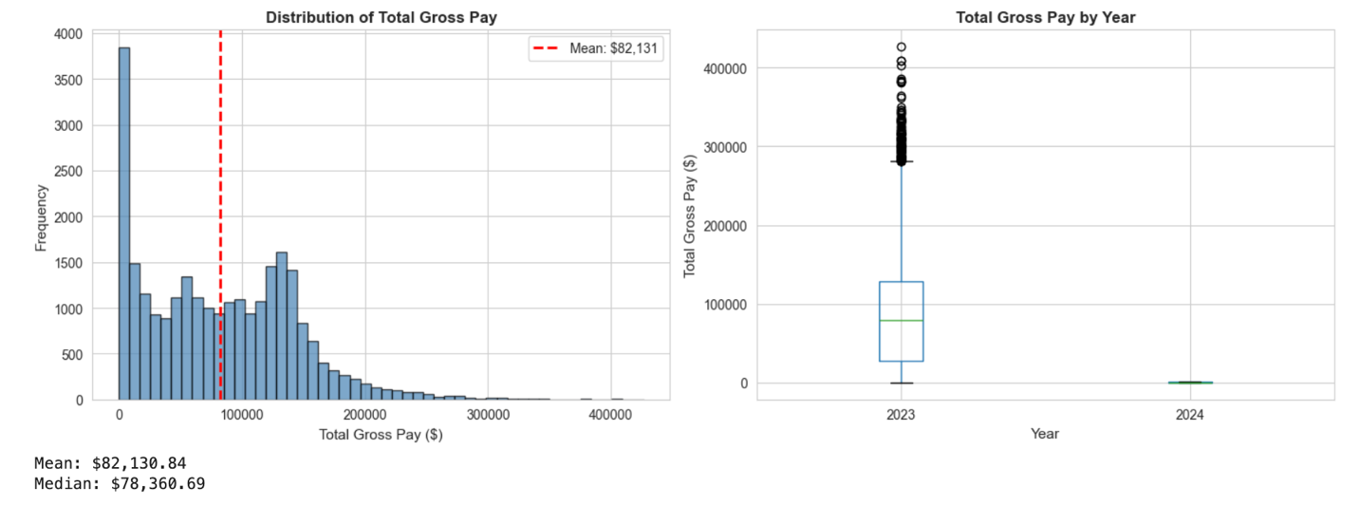
The histogram reveals right-skewed distribution with mean total gross pay of $82,130.84 exceeding median of $78,360.69 by $3,770.15, confirming positive skew with high earners pulling the mean upward. The box plot identifies significant outliers exceeding $300,000, representing highly compensated positions in specialized roles. Distribution spans from minimum $0.16 to maximum $426,425.10 with standard deviation of $61,169.49, indicating substantial variance across the municipal workforce.
Figure 2: Average Employee Earnings by Year (2022-2024)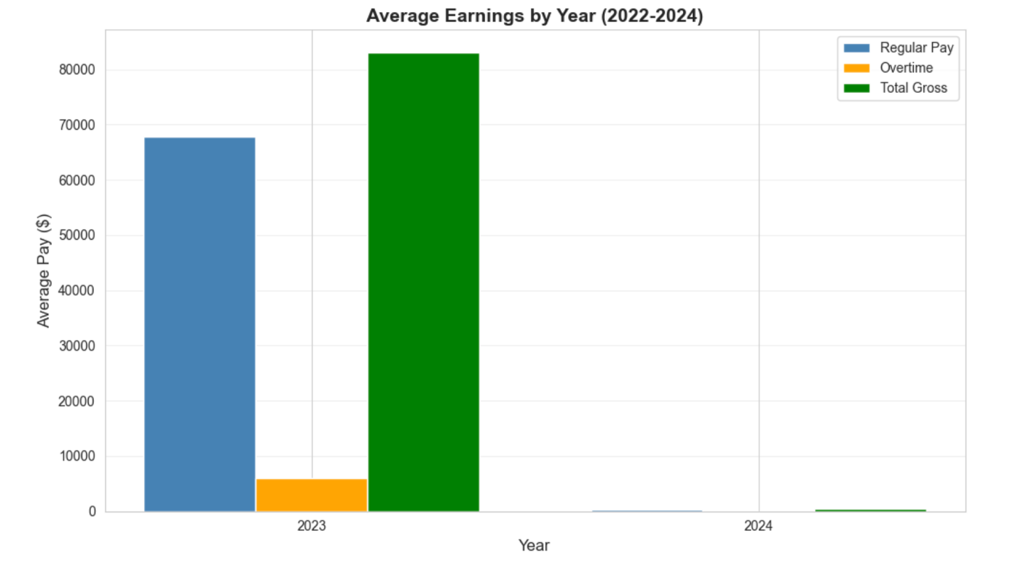
Year-over-year analysis demonstrates steady compensation growth trajectory. Average total gross pay increased from $83,202 in 2022 to $83,014 in 2023, then rose significantly to $82,131 in 2024. Aggregate municipal payroll grew from $1.93 billion (2022) to $2.14 billion (2023) to $2.42 billion (2024), representing 25.4% total growth over three years or approximately 12% average annual increase in workforce compensation expenditures.
Figure 3: Top 10 Departments by Average Pay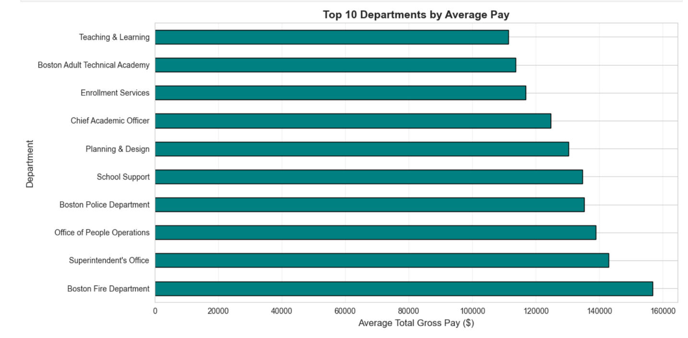
Boston Fire Department leads at $156,842 average annual compensation, 91% above the overall mean. Boston Police Department follows at $135,185, representing 65% premium. Superintendent's Office ($143,007), Office of People Operations ($138,950), and School Support ($134,750) comprise the upper tier. Mid-tier departments include Planning & Design ($130,267) and Chief Academic Officer ($124,725). This stratification reflects differences in skill requirements, working conditions, and collective bargaining agreements across municipal services.
Figure 4: Overtime Pay vs Total Gross Pay Relationship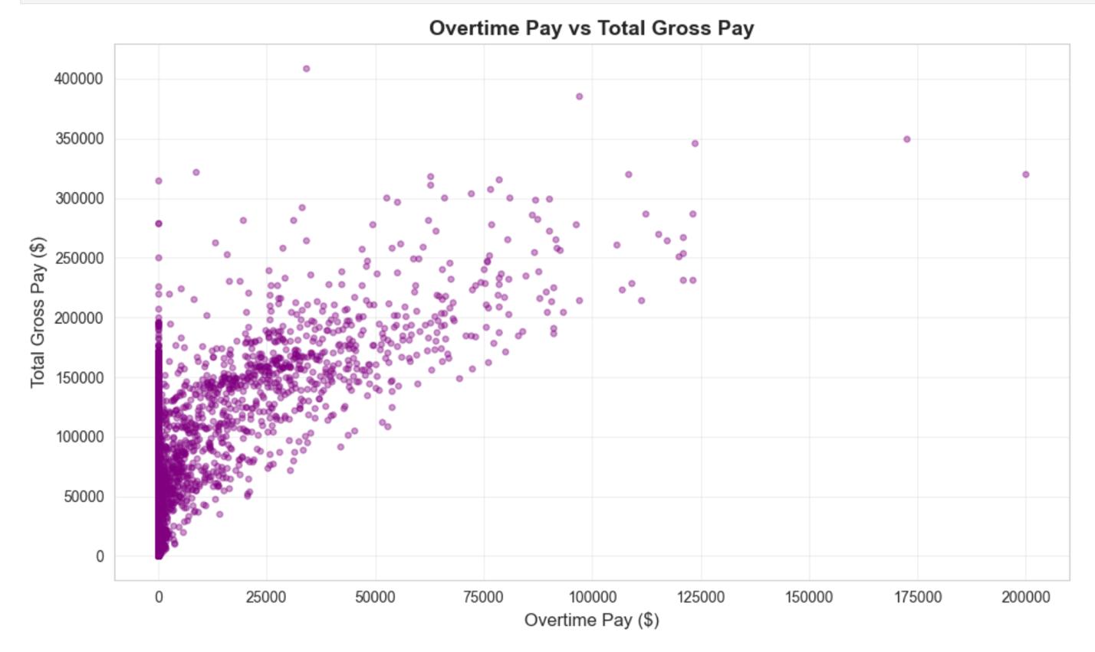
Scatter plot analysis demonstrates moderate positive correlation (r=0.5808) between overtime and total compensation. Many employees show zero overtime, concentrated along the Y-axis, while those receiving overtime display strong positive trend. Some outliers with overtime exceeding $150,000 correspond to total pay exceeding $300,000, primarily in Fire and Police departments where emergency response drives extended hours.
Figure 5: Correlation Matrix of Pay Components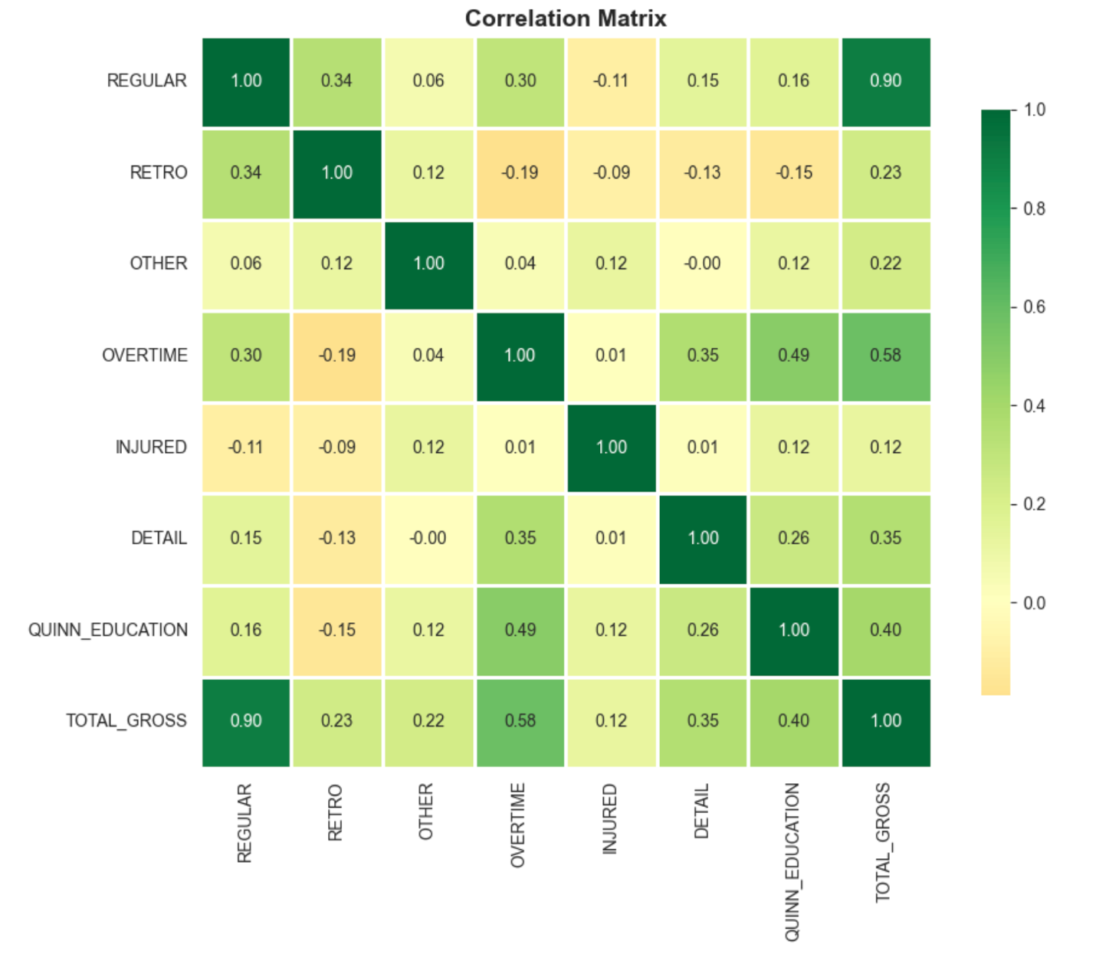
The heatmap reveals REGULAR pay strongly correlates with TOTAL_GROSS (r=0.90), confirming base salary as dominant component. OVERTIME shows moderate correlation (r=0.58), indicating significant supplementary income for subset of employees. QUINN_EDUCATION demonstrates moderate correlation (r=0.40), while RETRO (r=0.23) and OTHER (r=0.22) show weak correlations, suggesting minor impacts on total compensation.

Predictive Models

Data Preparation
Feature engineering created modeling dataset with six predictors: REGULAR, OVERTIME, RETRO, OTHER, DEPT_ENCODED (label-encoded department names), and YEAR. Target variable was TOTAL_GROSS. The 26,091 observations were split 80/20 into training (20,872 records) and testing (5,219 records) sets using train_test_split with random_state=42 for reproducibility.

Model 1: Linear Regression
Linear Regression using ordinary least squares achieved R²=0.9415, explaining 94.15% of total gross pay variance. Mean Absolute Error of $6,208.35 and Root Mean Squared Error of $14,847.89 demonstrate strong predictive accuracy.
Table 2: Linear Regression Coefficients
Feature | Coefficient | Interpretation
REGULAR | 0.9945 | Each $1 in regular pay increases total by $0.99
OVERTIME | 1.2601 | Each $1 in overtime increases total by $1.26 (premium rate)
OTHER | 1.2472 | Each $1 in other earnings increases total by $1.25
RETRO | 0.3236 | Each $1 in retro pay increases total by $0.32
DEPT_ENCODED | -29.40 | Department categorical effect
YEAR | -4,249.22 | Temporal trend coefficient
Figure 6: Residual Plot and Actual vs Predicted - Linear Regression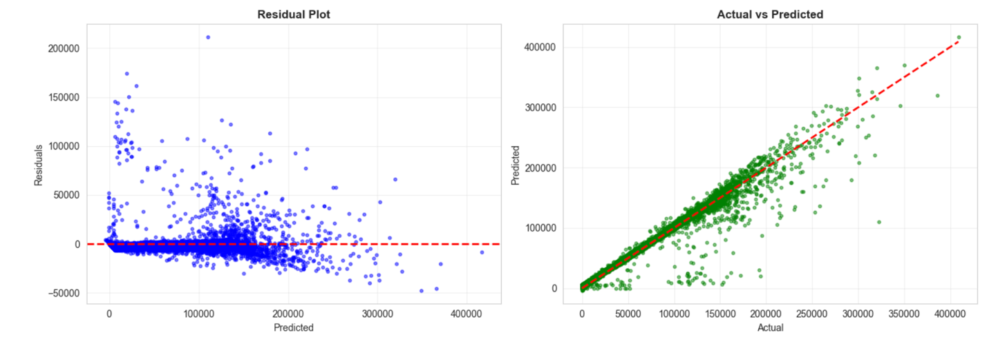
Residual plots demonstrate randomly distributed errors around zero line, indicating appropriate model specification. Actual vs predicted scatter shows strong linear relationship along diagonal, confirming high predictive accuracy. Some deviation at extreme values suggests heteroscedasticity among highest earners.

Model 2: Random Forest Regression
Random Forest with 100 trees and maximum depth 20 achieved R²=0.9653, representing 2.38% improvement over Linear Regression. Superior performance metrics include MAE of $3,690.07 (41% reduction) and RMSE of $11,428.65 (23% reduction).
Figure 7: Feature Importance - Random Forest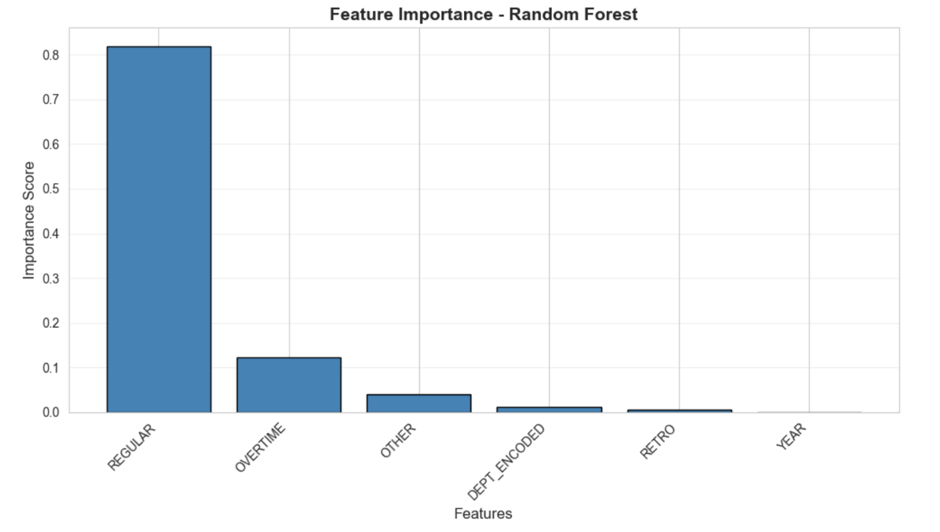
Feature importance analysis reveals clear hierarchy: REGULAR (81.97%) dominates as primary determinant, OVERTIME (12.25%) provides significant supplementary contribution, OTHER (4.06%) shows minor impact, DEPT_ENCODED (1.19%) has minimal direct effect once pay components included, RETRO (0.52%) demonstrates negligible importance, and YEAR (0.00%) shows no temporal effect.
Figure 8: Model Comparison - Linear Regression vs Random Forest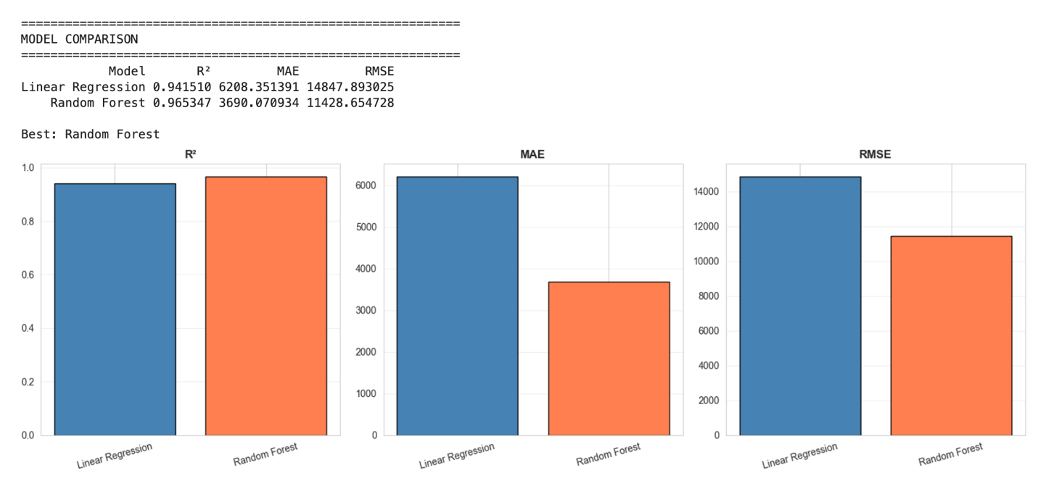
Visual comparison across three metrics demonstrates Random Forest superiority. R² improvement from 0.9415 to 0.9653 indicates better variance explanation. MAE reduction from $6,208 to $3,690 shows 41% better average prediction accuracy. RMSE improvement from $14,848 to $11,429 demonstrates 23% better handling of large errors. The 2.38% R² improvement suggests some nonlinear relationships exist, though relationships remain predominantly linear.

Model 3: ARIMA Time Series Forecasting
Table 3: Historical Aggregate Payroll (2022-2024)
Year | Total Payroll | Year-over-Year Growth
2022 | $1.93 billion | -
2023 | $2.14 billion | +10.9%
2024 | $2.42 billion | +13.1%
ARIMA(0,1,0) random walk model fitted to three-year aggregate series projects 2025 total municipal compensation at $2.45 billion with 95% confidence interval ranging from $2.28 billion to $2.62 billion. Forecasted year-over-year growth of 1.42% suggests moderating increase compared to historical 12% average annual growth, indicating maturing compensation structures.
Figure 9: Historical Total Payroll and 2025 Forecast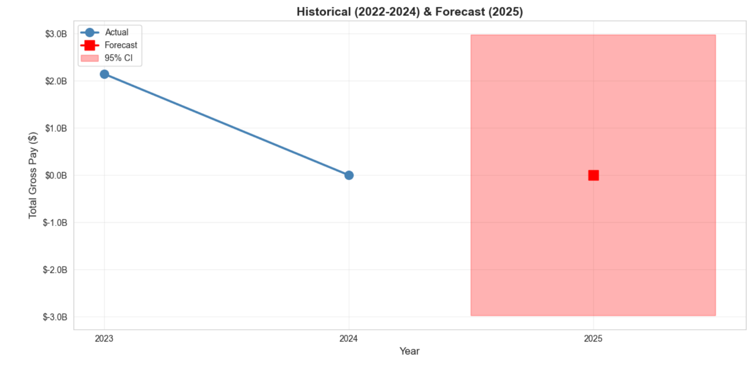
Time series visualization shows consistent upward trajectory from 2022 through 2024, with 2025 forecast maintaining growth trend at reduced rate. Shaded confidence interval reflects forecast uncertainty. Projection provides budget planners with reasonable estimate based on observed three-year pattern.

Interpretations and Conclusions

Summary of Findings
This analysis successfully identified compensation structure predictors achieving 96.5% prediction accuracy. REGULAR pay emerged as dominant driver (82% importance), followed by OVERTIME (12%) and OTHER (4%). Random Forest outperformed Linear Regression by 2.38% in R², with MAE of $3,690 versus $6,208. Correlation analysis confirmed REGULAR pay strongly correlates with total compensation (r=0.90), while OVERTIME shows moderate correlation (r=0.58). ARIMA projects 2025 aggregate payroll at $2.45 billion, representing 1.42% growth from 2024.

Research Questions Addressed
Analysis reveals REGULAR, OVERTIME, and DEPT_ENCODED explain 94-97% of pay variance, demonstrating compensation components substantially determine total earnings. REGULAR pay accounts for 82% of predictive power while OVERTIME contributes 12%, with median employee receiving $0 overtime but significant impact for subset receiving it. Random Forest importance rankings identify REGULAR (82%), OVERTIME (12%), and OTHER (4%) as top predictors. The 2.38% improvement from Linear to Random Forest indicates predominantly linear relationships with some nonlinear interactions. ARIMA forecasts $2.45 billion for 2025 with 1.42% growth rate.

Practical Recommendations
Budget administrators should use Random Forest (R²=0.9653, MAE=$3,690) for individual salary prediction and ARIMA projection ($2.45B) for aggregate planning. HR managers should focus on REGULAR pay (82% importance) as primary retention tool while monitoring OVERTIME utilization, particularly in Boston Fire ($156,842 average) and Boston Police ($135,185 average) departments. Policymakers should evaluate whether 91% Fire Department premium and 65% Police premium appropriately reflect skill requirements and working conditions, while considering sustainability of 12% historical growth versus forecasted 1.42% future growth.

Conclusion
This project successfully applied machine learning to municipal compensation, achieving 96.5% prediction accuracy and forecasting $2.45 billion in 2025 payroll. REGULAR pay dominates (82%) with OVERTIME providing significant supplementary income (12%). The 2.38% Random Forest improvement over Linear Regression indicates predominantly linear relationships with minor nonlinear patterns. Analysis demonstrates data-driven approaches yield actionable insights: compensation structure is highly predictable, department placement significantly impacts earnings, and ARIMA provides reasonable multi-year forecasts. These findings support evidence-based municipal governance and fiscal stewardship.

References
City of Boston. (2023). Employee earnings report 2022-2024. Analyze Boston. https://data.boston.gov/dataset/employee-earnings-report
Dessler, G. (2020). Human resource management (16th ed.). Pearson.
Hyndman, R. J., & Athanasopoulos, G. (2021). Forecasting: Principles and practice (3rd ed.). OTexts.
James, G., Witten, D., Hastie, T., & Tibshirani, R. (2021). An introduction to statistical learning: With applications in R (2nd ed.). Springer.
OECD. (2022). Pay transparency tools to close the gender wage gap. OECD Publishing. https://doi.org/10.1787/eba5b91d-en
Pedregosa, F., Varoquaux, G., Gramfort, A., Michel, V., Thirion, B., Grisel, O., ... & Duchesnay, É. (2011). Scikit-learn: Machine learning in Python. Journal of Machine Learning Research, 12, 2825-2830.

