NORTHEASTERN UNIVERSITY

STUDENT NAME – Dev Bhadreshkumar Panchal
Module 3 Project [ Report ]
CLASS NUMBER - ALY 6050
CLASS – Introduction to Enterprise Analytics
CRN NUMBER – 80311
PROFESSOR – Zhi He
EMAIL – panchal.devb@northeastern.edu

Time Series Forecasting Analysis Report

Introduction
This project aims to analyze and forecast financial time series data using various statistical methods. The dataset provided consists of daily closing stock prices for Amazon (AMZN) and Netflix (NFLX), covering 252 trading days in the year 2020. The objective of this analysis is to evaluate the accuracy of different forecasting techniques, such as exponential smoothing, weighted moving averages, linear regression, and AR(3) models. Additionally, the project includes an analysis of forecasting performance, residual diagnostics for regression models, and an optimal portfolio allocation based on annualized return and risk. All forecasting methods were implemented in R, and their accuracy was assessed using the Mean Absolute Percentage Error (MAPE).

Part 1: Short-Term Forecasting
To begin the short-term analysis, I plotted the time series data for AMZN and NFLX to visually inspect any patterns. Both stocks displayed upward trends with short-term volatility. AMZN showed a relatively stable rise with some minor dips, while NFLX exhibited stronger fluctuations throughout the year. These visual observations hint at possible trends and irregular variations that may affect forecasting accuracy.
- Time Series Plot for AMZN
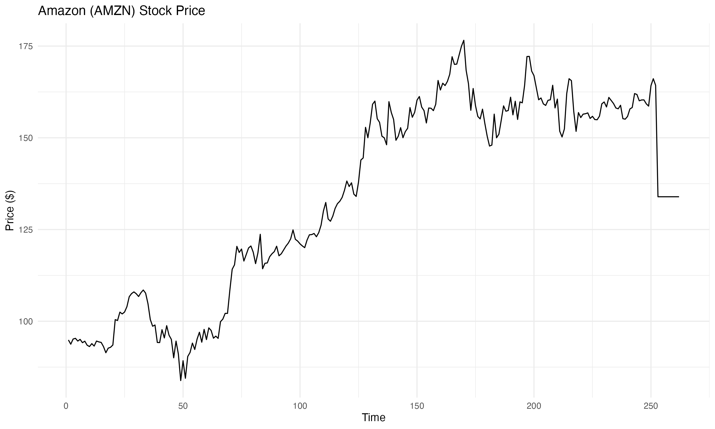
- Time Series Plot for NFLX
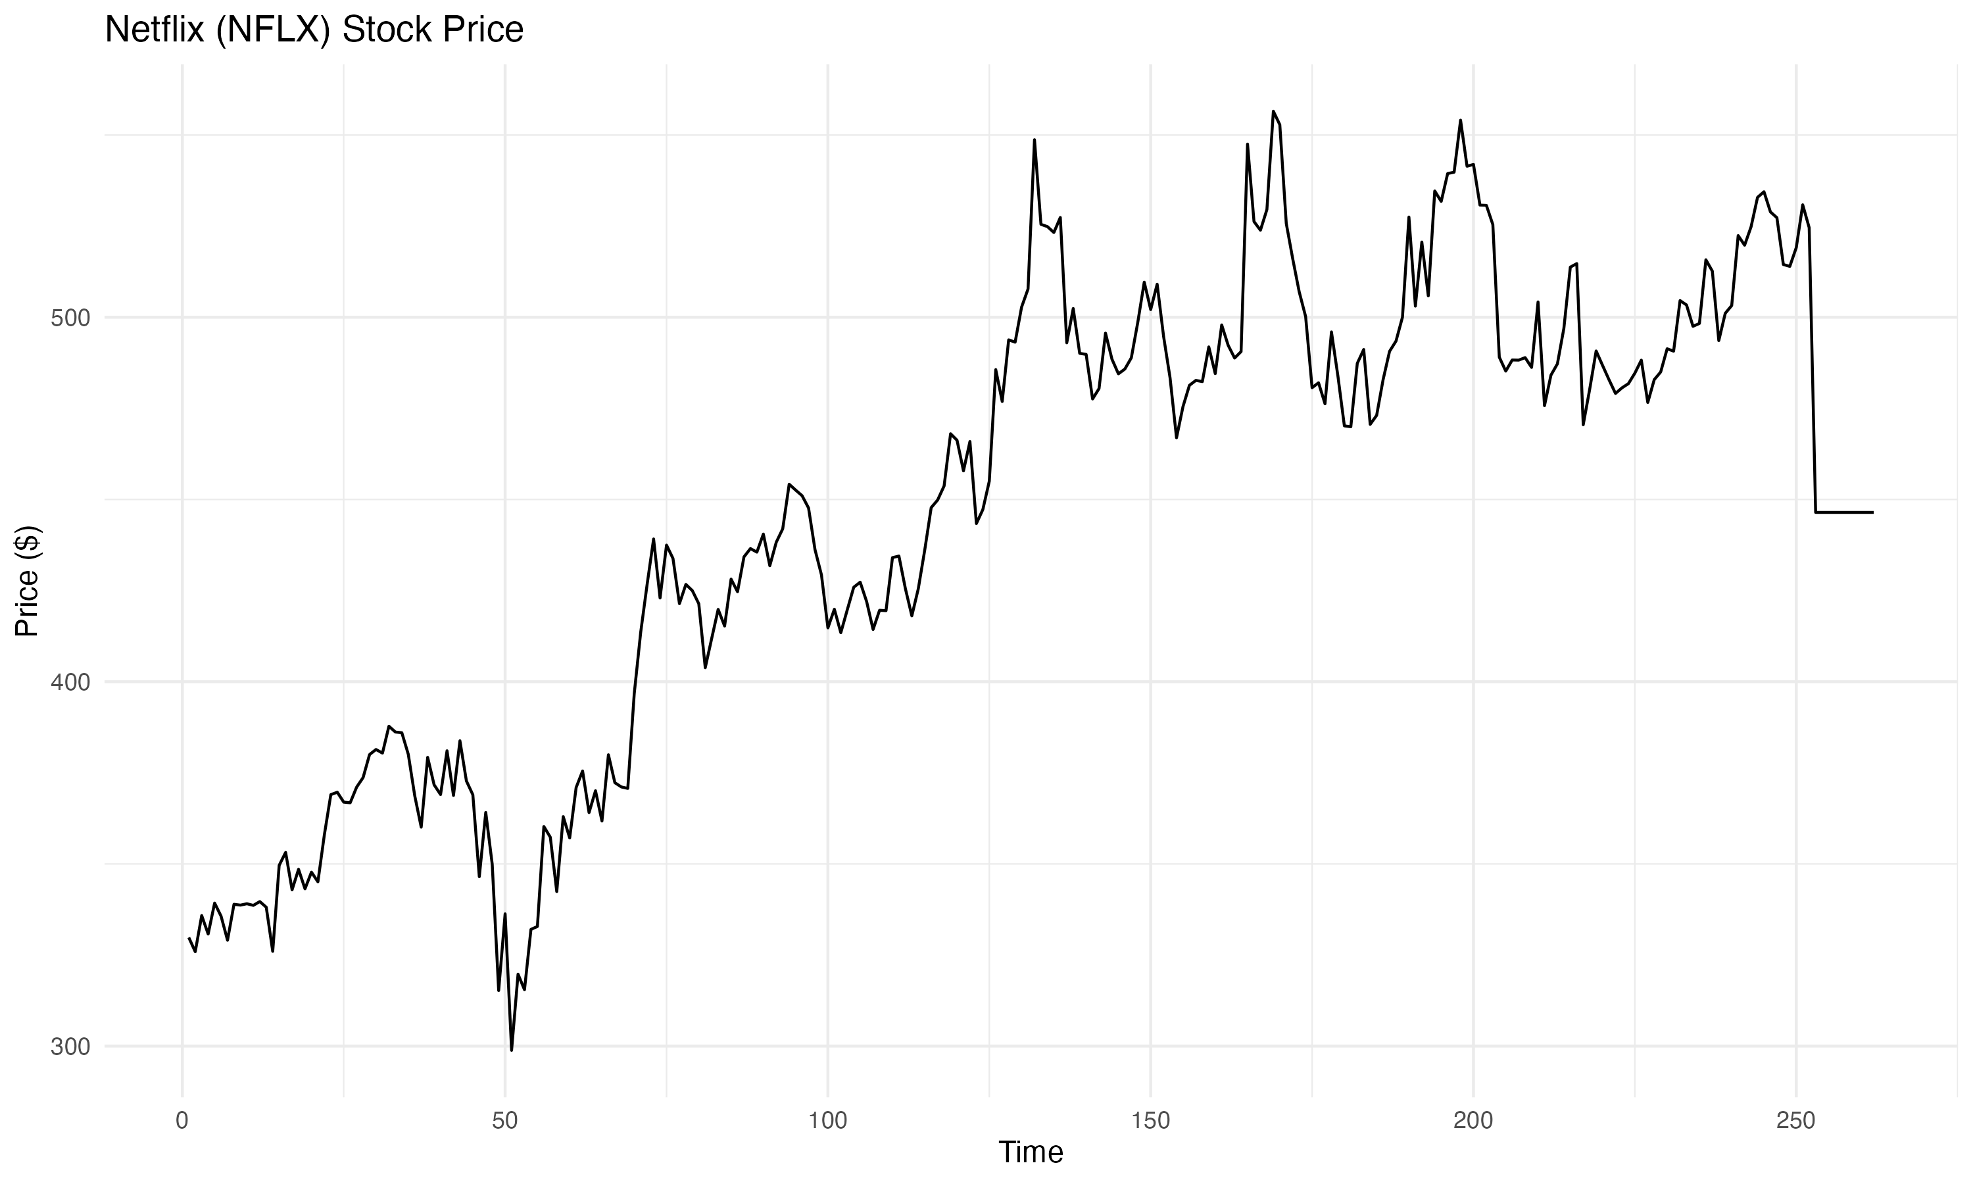
Next, I applied simple exponential smoothing to forecast both stocks using smoothing parameters (alpha) of 0.20, 0.35, 0.50, and 0.65. For AMZN, the lowest MAPE of 1.92% was achieved with α = 0.65, indicating that a higher weighting on recent data resulted in a more accurate forecast. Similarly, NFLX produced the best result with α = 0.65, yielding a MAPE of 2.07%.
Following this, I used Holt’s adjusted exponential smoothing to include trend information, fixing α at 0.65 and testing values of β = 0.20, 0.35, 0.50, and 0.65. The most accurate adjusted forecast for AMZN had a MAPE of 2.01% at β = 0.20, while NFLX achieved a MAPE of 2.26% also at β = 0.20. These results show that accounting for trend provided only marginal improvement for AMZN and had slightly less accuracy than simple smoothing for NFLX.
Method | AMZN MAPE | NFLX MAPE
Exponential Smoothing | 1.92% | 2.07%
Adjusted Smoothing | 2.01% | 2.26%

Part 2: Long-Term Forecasting
In the long-term forecasting section, I first applied a three-period weighted moving average (WMA) with weights 0.25, 0.30, and 0.45. For AMZN, the WMA model produced a MAPE of 2.02% over periods 4 to 252. For NFLX, the MAPE was slightly higher at 2.19%. This suggests that WMA is a reasonable method for short-window smoothing and may offer decent long-range trend following, although it doesn’t adapt well to sudden shifts.
Then, I fitted a linear trend model using data from periods 51 through 252 to forecast stock prices up to period 262. The forecasted prices for periods 253 to 262 were then compared to actual closing prices retrieved from Yahoo Finance.
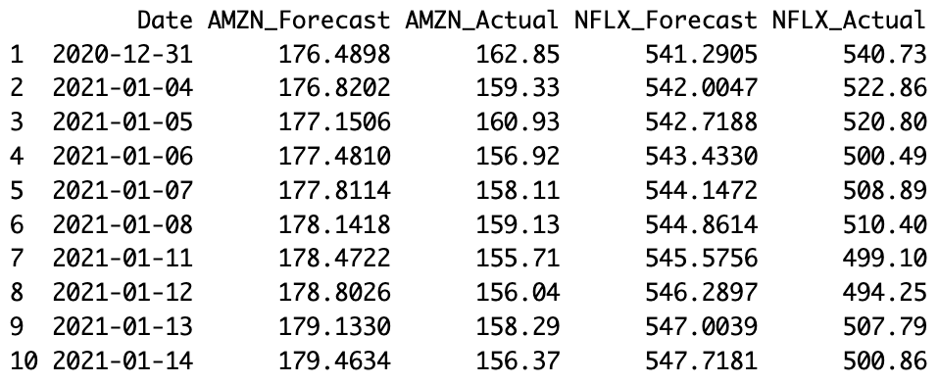
This results in a MAPE of 1.51% for AMZN and 2.91% for NFLX. These are favorable outcomes, showing that the linear trend method maintains reasonably strong performance when extrapolated slightly into the future.

Part 3: Regression Analysis
To assess the suitability of linear regression for forecasting, I fitted a simple linear model for each stock using time (days) as the independent variable. The resulting MAPE values for the regression forecasts over periods 1 through 252 were 7.50% for AMZN and 5.99% for NFLX. These errors are higher compared to other models, indicating that simple regression may not be the best method for capturing the nuances in daily stock movements.
To further examine model appropriateness, I conducted residual analysis using the Durbin-Watson test for autocorrelation, Breusch-Pagan test for homoscedasticity, and the Shapiro-Wilk test for normality. The tests showed significant autocorrelation and heteroscedasticity, and the Q-Q plots indicated deviations from normality.
- Q-Q Plot for AMZN Residuals
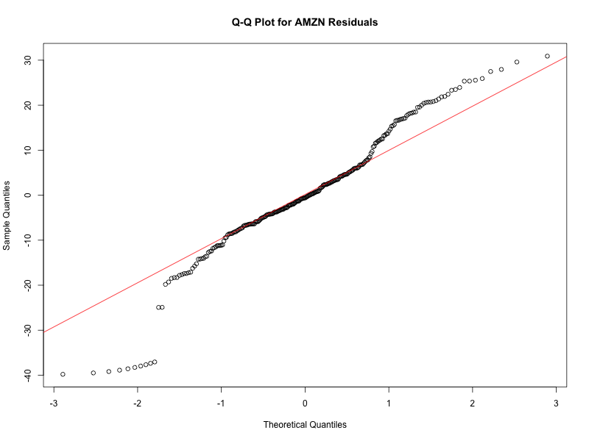
- Q-Q Plot for NFLX Residuals
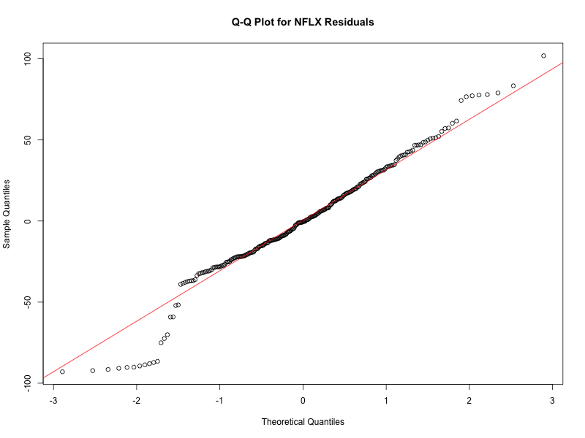
These diagnostics confirm that simple linear regression may violate key assumptions, weakening its reliability for forecasting financial time series data.
Part 4: Baseline Model (AR(3))
As a benchmark, I implemented a rolling average model that predicts each day's price based on the average of the previous three days (AR(3)). The MAPE for AMZN over periods 4 to 252 was 2.15%, and for NFLX it was 2.32%. While not the most accurate method, AR(3) provides a decent baseline for comparison, particularly for stocks with short-term momentum.
Portfolio Allocation Analysis
The final task was to determine the optimal investment allocation between AMZN and NFLX. Using the historical daily log returns, I calculated the annualized return, risk, and Sharpe ratio for different combinations of portfolio weights. The Sharpe ratio was maximized when investing 100% in AMZN and 0% in NFLX. This suggests that AMZN had superior risk-adjusted returns over the observed period.
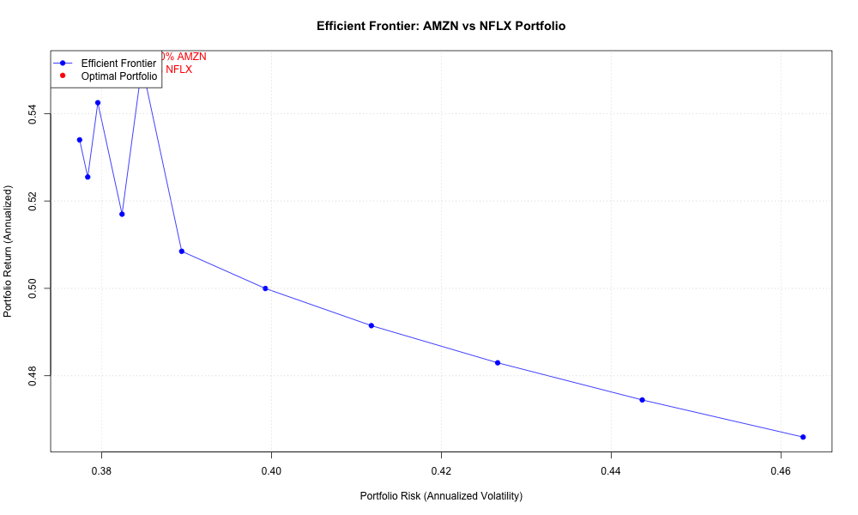
This analysis indicates that from a risk-return perspective, an AMZN-heavy portfolio would have performed better during this period, despite NFLX having competitive forecasting accuracy in some methods.
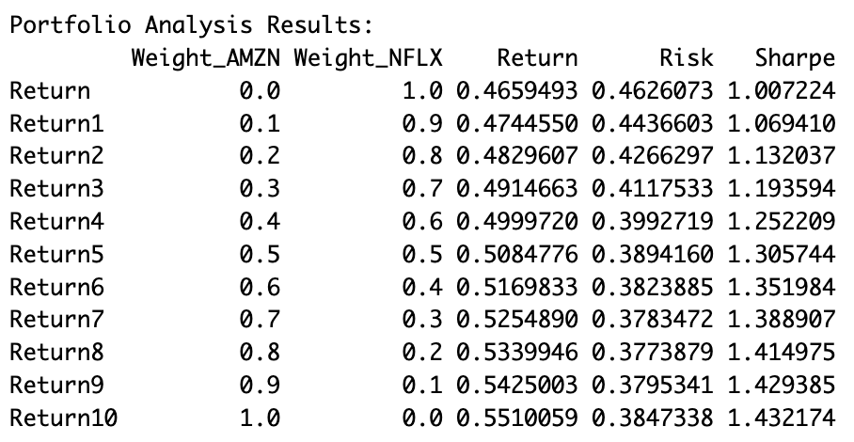
Summary of Forecasting Accuracy
The summary of MAPE values across all methods is presented below:
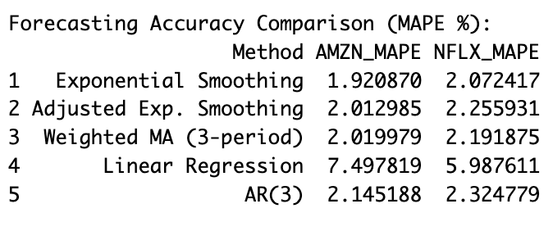
Overall, exponential smoothing was the most accurate method for short-term forecasting, especially for AMZN. The AR(3) and weighted moving averages also performed reliably. Linear regression showed relatively higher error and violated several statistical assumptions.
This comprehensive analysis highlights the importance of using appropriate forecasting techniques depending on the structure and behavior of financial time series data.
References
Hyndman, R. J., & Athanasopoulos, G. (2018). Forecasting: Principles and Practice (2nd ed.). OTexts. https://otexts.com/fpp2/
Yahoo Finance. (2021). Historical data for Amazon and Netflix. https://finance.yahoo.com/
Venables, W. N., & Ripley, B. D. (2002). Modern applied statistics with S (4th ed.). Springer.

