NORTHEASTERN UNIVERSITY

STUDENT NAME – Dev Bhadreshkumar Panchal
Module 4 Project [ Report ]
CLASS NUMBER - ALY 6050
CLASS – Introduction to Enterprise Analytics
CRN NUMBER – 80311
PROFESSOR – Zhi He
EMAIL – panchal.devb@northeastern.edu

Inventory Management Decision Modeling and Simulation Analysis Report

Introduction
This report addresses the inventory management decision problem presented in ALY6050 Module 4. The primary aim is to build a decision support model that minimizes total inventory costs by determining the optimal order quantity under both deterministic and uncertain demand conditions. Inventory management plays a vital role in ensuring financial stability and operational efficiency. This analysis helps management balance the trade-off between ordering costs and holding costs, avoiding both stockouts and excess inventory. The first section involves the implementation of a classic Economic Order Quantity (EOQ) model using known values for demand and costs. The second section introduces demand uncertainty through a triangular probability distribution, analyzed using Monte Carlo simulation. Together, these parts provide a holistic view of inventory optimization strategies applicable in real-world settings.

Analysis - Part I: Deterministic Inventory Model
In the deterministic setting, we began with fixed values: annual demand of 12,000 units, a unit price of $159.99, an annual holding cost rate of 11.5%, and a per-order cost of $179.99. Calculating the EOQ that minimizes the overall inventory cost—which takes into account both ordering and holding costs—was the task at hand.. A function was constructed to compute total cost over a range of possible order quantities from 100 to 3,000 units. The EOQ was found by locating the quantity that minimized total cost. The result, shown in the cost curve graph below, identifies the approximate optimal order quantity as 480 units, corresponding to the lowest point on the curve.
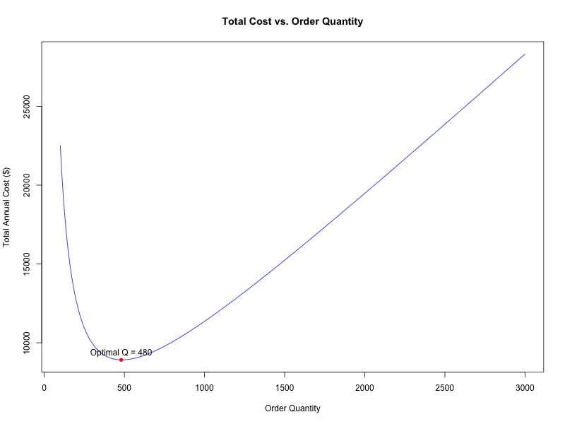
To verify the numerical solution, we also calculated the analytical EOQ using the formula √(2DS/CH). The EOQ computed analytically was 484.55 units, confirming that our programmatically found value is accurate. The corresponding minimum total cost was approximately $8,915. This validates the model's implementation for minimizing cost using EOQ.
A key component of the assignment was to compute the total cost if the company orders 1.8 times the EOQ, as per company policy. The model calculated the company policy order quantity as 872.19 units. When plugged into the total cost formula, the resulting cost was higher than that at EOQ, emphasizing the cost impact of over-ordering.
To understand how sensitive the model is to changes in its parameters, we performed a two-way sensitivity analysis. The holding rate was varied from 8% to 11.5% in 0.1% increments, and the order cost was varied from $150 to $210 in $10 increments. For each combination, the EOQ and total cost were computed and visualized using a heatmap. The plot below shows how small changes in costs or rates can lead to significant increases in total inventory cost.
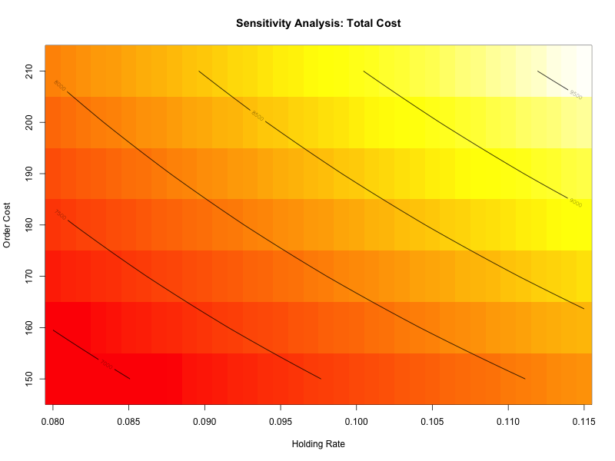
This part of the analysis concluded by summarizing key metrics: the EOQ was about 480–485 units, the corresponding total cost was around $8,915, and the optimal interval between orders was about 14.6 days. This deterministic analysis confirms that the EOQ model is reliable under stable demand and cost assumptions, offering a robust baseline for inventory planning.

Analysis - Part II: Simulation with Triangular Distribution
Using a triangular probability distribution with a minimum of 8,000 units, a maximum of 15,000 units, and a most likely value of 12,000 units, the second portion of the assignment introduces uncertainty in annual demand. From this distribution, we produced 3,000 random demand values using a random seed of 80311. We recalculated the EOQ, total cost, and annual order volume for each simulated demand.
The simulation allowed us to answer three sub-questions as outlined in the assignment description:
First, we calculated the mean of the 3,000 simulations and created a 95% confidence range to estimate the projected minimum overall cost. With a 95% confidence interval between $9,352 and $9,614, the average minimum total cost was roughly $9,483. The near-normal distribution of cost values is displayed in a histogram with a density curve placed on it (see below).
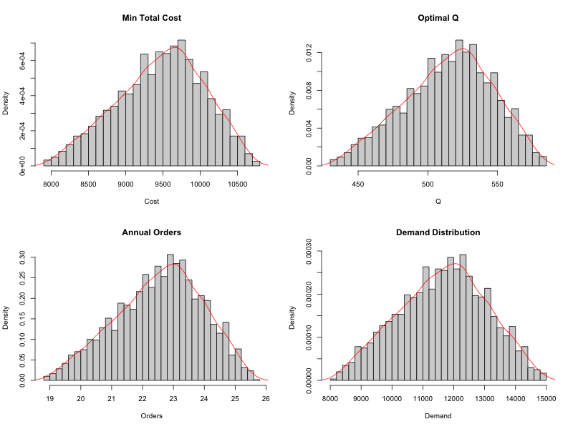
Second, the expected optimal order quantity was estimated similarly. The mean was around 512 units with a 95% confidence interval of roughly 498 to 526. The distribution of Q values was slightly skewed, reflecting variability in demand.
Third, we examined the expected number of annual orders, calculated by dividing simulated demand by simulated EOQ. The average was around 23.2 orders per year, with a 95% confidence interval of about 22.5 to 24.0 orders. This analysis provides important managerial insight: even under uncertain demand, EOQ-like logic holds and can offer stable planning guidelines.
To evaluate which statistical distribution best fits the simulation results, we applied the `fitdistrplus` package to the total cost values. Both normal and lognormal fits were evaluated using the Akaike Information Criterion (AIC). While both fits were reasonable, the lognormal slightly outperformed the normal. Normality was formally assessed using the Shapiro-Wilk test. The test results indicated that total cost and order quantity are reasonably normal, but not perfectly so, validating the need for simulation over simplistic assumptions.

Conclusion
This project demonstrated the development and application of inventory decision models using both deterministic and probabilistic frameworks. The EOQ model offers a mathematically optimal solution under known parameters, while simulation expands the analysis into real-world scenarios with uncertain demand. By combining cost modeling, sensitivity analysis, and simulation, the project offers actionable insights for inventory managers. Under both models, key metrics such as EOQ, total cost, and number of orders were identified with precision, supporting better operational decision-making. The findings emphasize the importance of quantitative modeling and simulation in modern supply chain management.

References
Bluman, A. G. (2018). Elementary statistics: A step by step approach (10th ed.). McGraw-Hill Education.
Silver, E. A., Pyke, D. F., & Thomas, D. J. (2017). Inventory and production management in supply chains (4th ed.). CRC Press.
Delignette-Muller, M. L., Pouillot, R., Denis, J. B., & Dutang, C. (2015). fitdistrplus: An R package for fitting distributions. Journal of Statistical Software, 64(4), 1–34.

