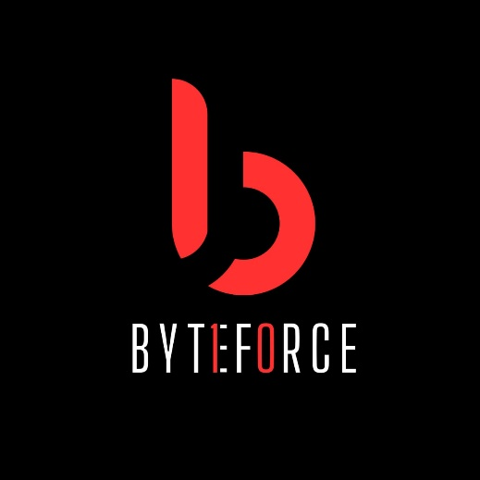

The Tech Club Presents

A Bit - Coding Challenge and Quiz Event

Objective:
To organize a fun and competitive coding event, fostering innovation, teamwork, and problem-solving skills among computer science students, while promoting the department's academic excellence.

Event Details:
- Date: TBD
- Time: TBD
- Venue: TBD
- Duration: 1hr 30mins
- Target Audience: Computer Science students (UG/PG)

Event Format:
1. Debugging Round (individual)
2. Blind Coding Round (individual)
3. Coding Challenge Round (individual/team-based)

Agenda:
1. Registration and Welcome (10 minutes)
2. Debugging Round (20 minutes)
- Participants will be given buggy code to debug and correct.
3. Blind Coding Round (15 minutes)
- Participants will write code without seeing the output.
4. Coding Challenge Round (40 minutes)
- Participants will write code to solve problems.
5. Prize Distribution and Closing (15 minutes)

Benefits:
1. Enhances coding skills, problem-solving abilities, and logical thinking.
2. Encourages teamwork and collaboration.
3. Fosters healthy competition among students.
4. Promotes departmental unity and camaraderie.
5. Provides a platform for students to showcase talents 1
.

Organizing Committee:
- Shailesh Kumar- President
-Ayush Dwivedi – Vice President
- Lavanya Sharma - General Secretary
- Ankit Samanta |Yug Prakash – Student Coordinators
-
-
-
-
-

Resources Required:
1. Venue and infrastructure
2. Computing equipment and software
3. Prize money and certificates
4. Promotional materials (posters, flyers, social media)
5. Refreshments

Timeline:
- [Date] - Proposal submission
- [Date] - Event promotion and registration
- [Date] - Event execution
- [Date] - Evaluation and feedback

Budget:
- Estimated budget: [Amount]
- Breakdown:
- Venue and infrastructure: [Amount]
- Computing equipment and software: [Amount]
- Prize money and certificates: [Amount]
- Promotional materials: [Amount]
- Refreshments: [Amount]

Conclusion:
"A Bit" coding event aims to create an engaging and competitive environment, promoting academic excellence and departmental unity.

Approval Request:
We respectfully request your approval for organizing "A Bit" coding event. Your support will enable us to provide a valuable experience for our students.

Thank you for considering our proposal.

Best regards,
Vice President- Ayush Dwivedi

