Language Modeling (next word prediction given a sequence)
OCR
Handwriting recognition

Statistical Language Models:
N-gram LM, Bidirectional LM, Exponential LM, continuous space LM, …

Neural Language Models:
Recurrent neural networks, sequence-to-sequence models, transformers, …

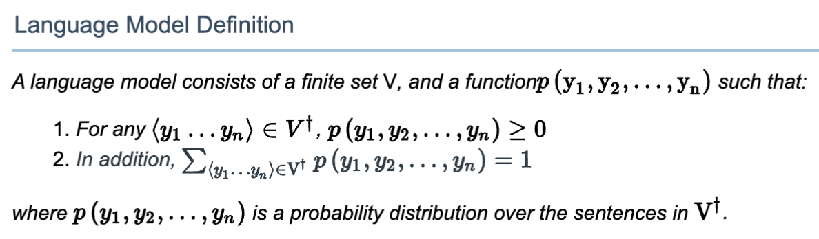
c: count of sentences x1,x2,...,xn in corpus
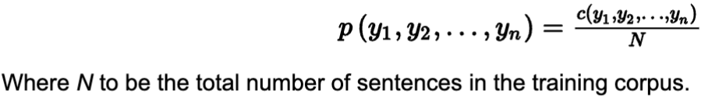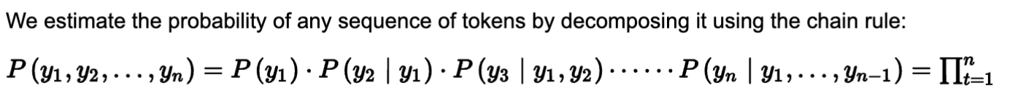

- N gram
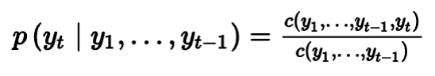
- Bi gram
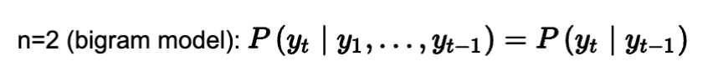

- Tri gram

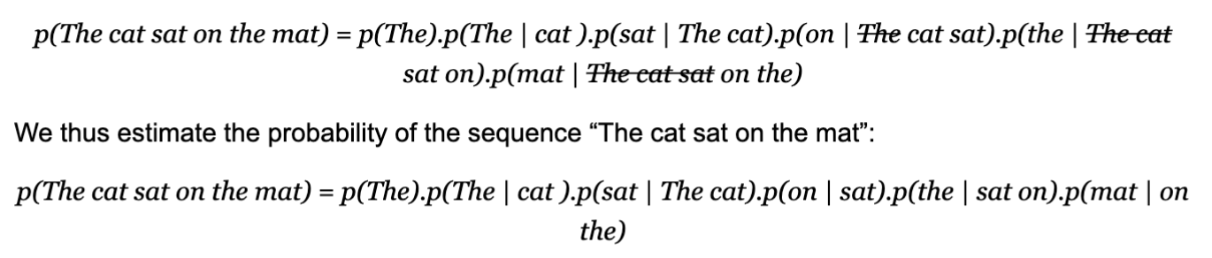
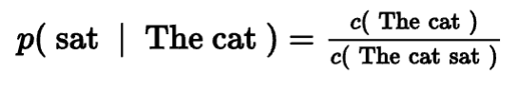
The denominator could be zero if the sequence “The cat sat” does not occur in the corpus
c(The cat sat) = 0
and the probability p(the | sat on) becomes undefined.
One potential solution to address this problem is to use linear interpolation to approximate the conditional probability. 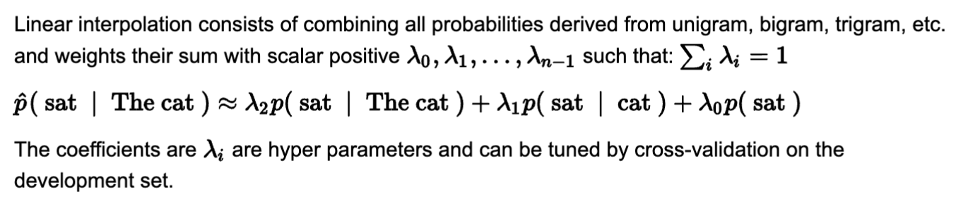

- Smoothing techniques to prevent zeros (numerator/denominator)
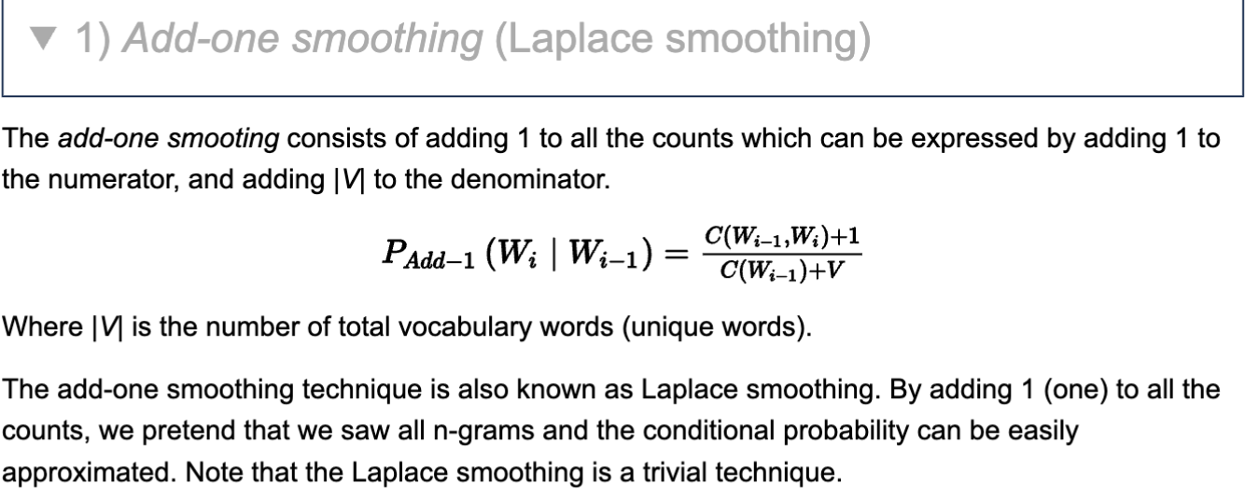
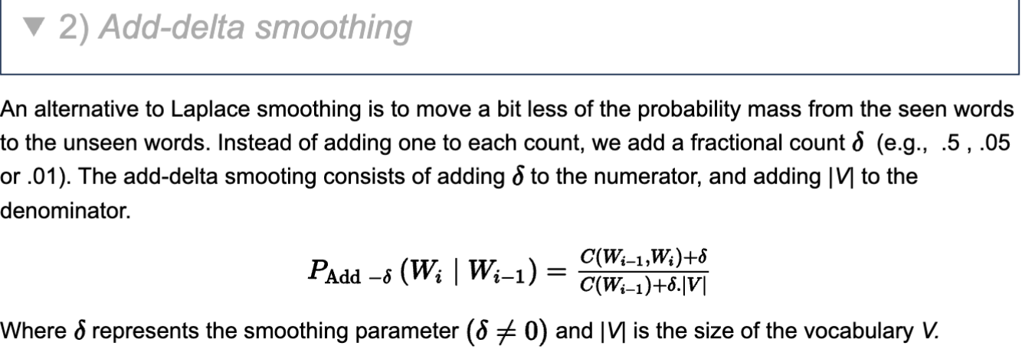
The smoothing parameter delta is a hyper-parameter and could be tuned using:
1. The elbow plot by plotting ‘performance metric’ versus delta hyper-parameter.
2. The grid search over possible delta values and cross-validation to evaluate the ‘performance metric’ to choose the optimal values.

Text Generation with N-gram Language models
Predict next token given any sequence of predecessor tokens
- Greedy sampling
- Standard sampling
- Sampling with temperature
- Top-k sampling
- Top-p (nucleus) sampling
1. Predict the probability distribution of the next token over all tokens in the vocabulary and given previous context in the sequence,
2. Sample from this distribution by selecting the token with the highest probability.
3. Appen the selected token to the sequence
4. Repeat 1 to 3 (until a maximum the sentence length is reached).

In general, N-gram language models are often used at the word-level.
A Word-by-word generation is useful in many applications such as:
- Auto-completion: given an incomplete sentence, complete it.
- Story generation: continue a story given the first sentences.
- Code generation: given a code description, generate the code.
In addition, N-gram language models have also been used at character-level in stemming (separate the root word from the suffix) and spelling detection and correction.

LIMITATION = non-fluency in long texts
- Incapable of capturing long contexts

Neural Language Models
Neural Language Models (NLM) address the n-gram data sparsity issue through parameterization of words as vectors (word embeddings) and using them as inputs to a neural network. The parameters are learned as part of the training process. Word embeddings obtained through NLMs exhibit the property whereby semantically close words are likewise close in the induced vector space.

- allow conditioning on increasingly large context sizes with only a linear increase in the number of parameters
- they alleviate the need for manually designing backoff orders
- they support generalization across different contexts

EVOLUTION
- 1 hidden layer + CBoW
- RNN
- CNN
- Recursive NN
- LSTM : overcome vanishing gradient
- Encoder-Decoder – Transformers
- BERT, ERNIE, GPT-2, GPT-3, ROBERTa

Neural Language Models=
- They do not require smoothing to avoid zero probability
- They can handle much longer sequence of tokens
- They generalize over contexts of similar tokens.
limitation = extensive time required to train them in order to improve their performance
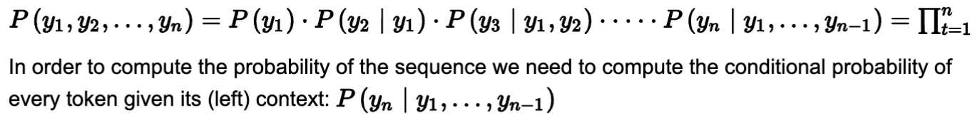

TRAINING
- Encode the context:
the objective is to map the previous context (sequence of tokens) to a vector representation.
Using the vector representation, a neural network predicts a probability distribution for the next token.
The neural network to encode the context could of any types; recurrent neural networks (Simple RNN, LSTM, GRU), convolutional neural networks (e.g., Conv1D) etc.
- Generate a probability distribution for the next token: the objective is to generate the probability distribution over all tokens in the vocabulary.

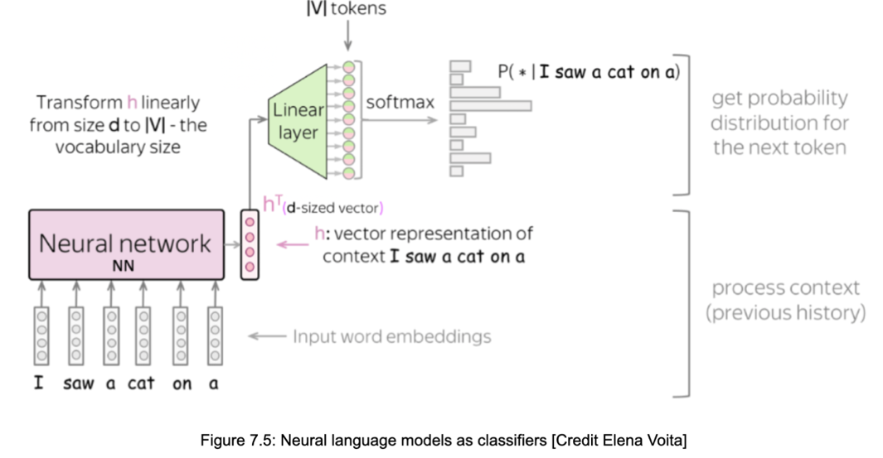

depicts the transformation between the representation h-vector of size d into a vector of size |V|. The linear layer has a |V| output and can be also seen as a dot product between the h-vector of size d and |V| d-size vectors (columns) each of which corresponds to a token in the vocabulary. The vector representation of classes can be seen as output word embeddings.
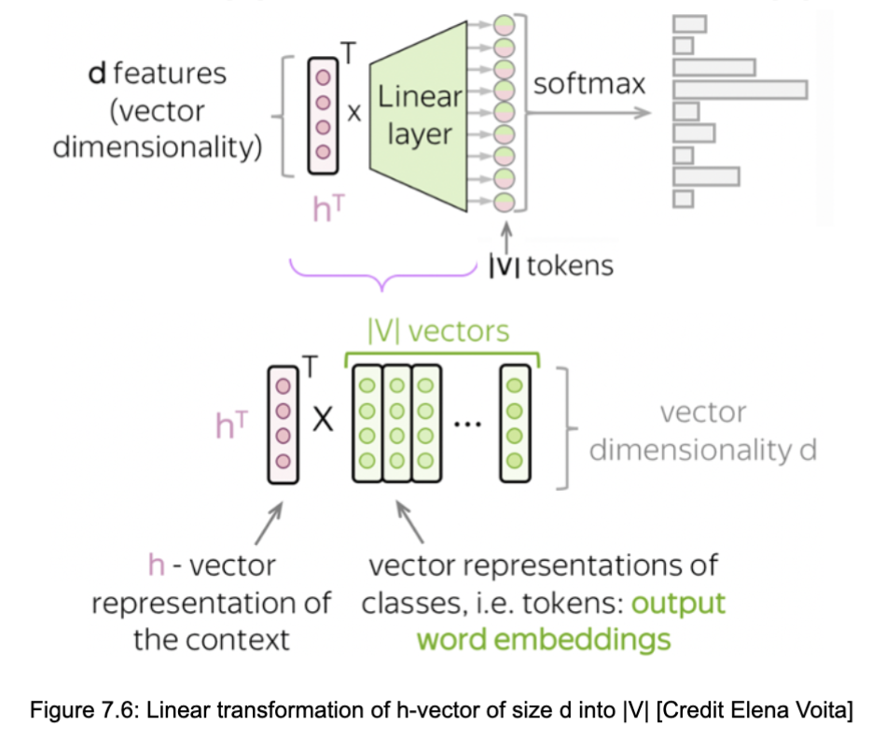
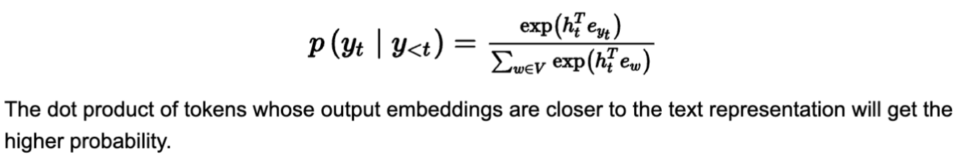
TRAINING NN
- Predict probability distribution of the next token
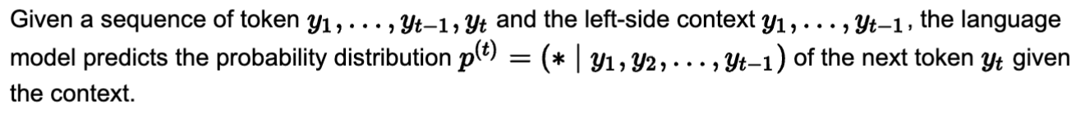

- One hot encoding to assign the probability

- Cross Entropy loss function for Multi-Class Classification
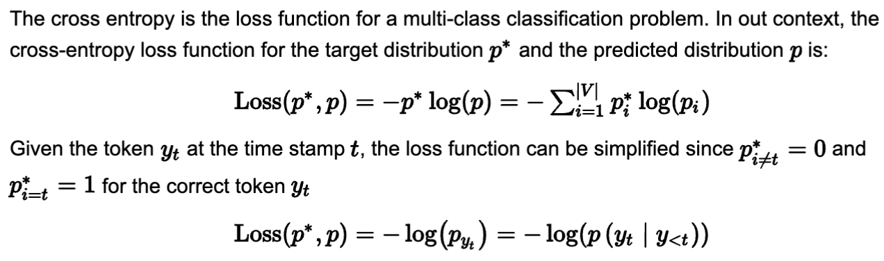
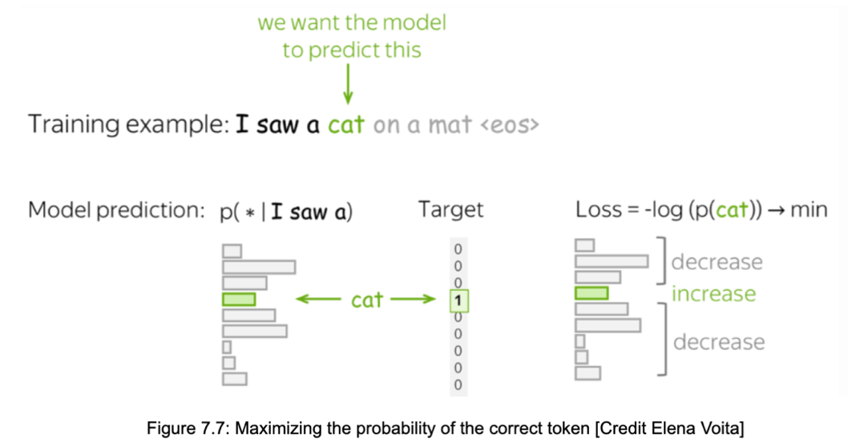
At each step, the language model maximizes the probability assigned to the correct token and minimizes to zeros the probabilities of the rest of tokens.
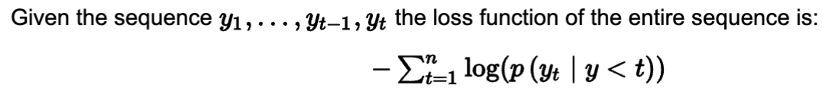
RNNs
(Simple RNN, LSTM, GRU, etc.)
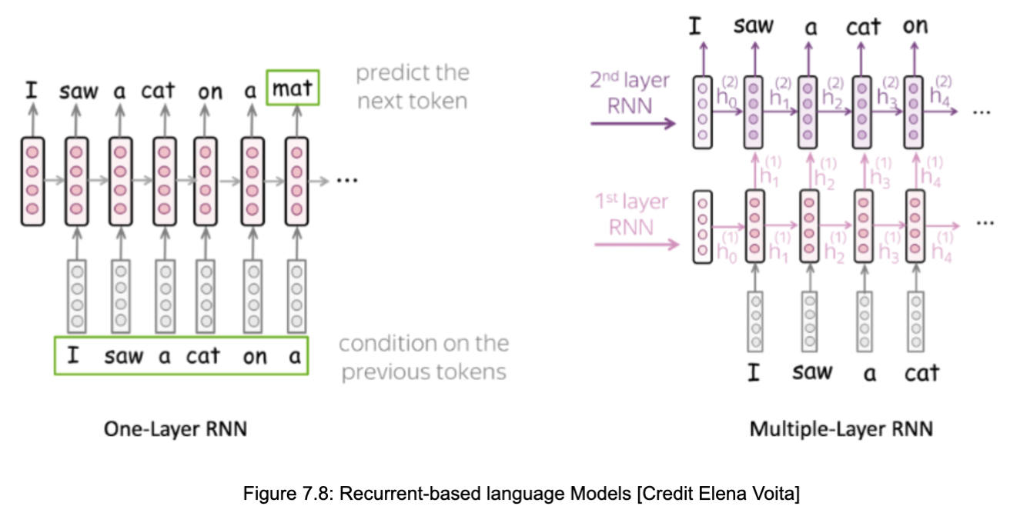
In one-layer recurrent network, the current state contains information about previous tokens. This information is used as input to predict the next token.
In multiple-layer recurrent network, recurrent layers are stacked on top of each other. The hidden states from one layer are forwarded to the next layers.

CNNs in NLP
Capture long-term dependency in Computer Vision , and NLP
- Left-to-right language models predict the next token given the context of previous tokens. By applying padding to a sequence, it becomes possible to shift tokens to the right
- A positional encoding is a representation of the “location” or “position” of token in a sequence. positional information is very important for language models. In the context of CNNs, not using pooling helps to preserve positional information.
- By staking many layers, deep neural networks NNs may suffer from gradient vanishing. Residual connections (also known as skip connection) connect output of one earlier convolutional layer to the input of another future convolutional layer several layers later. By such residual connections boost the networks' ability to overcome vanishing gradients
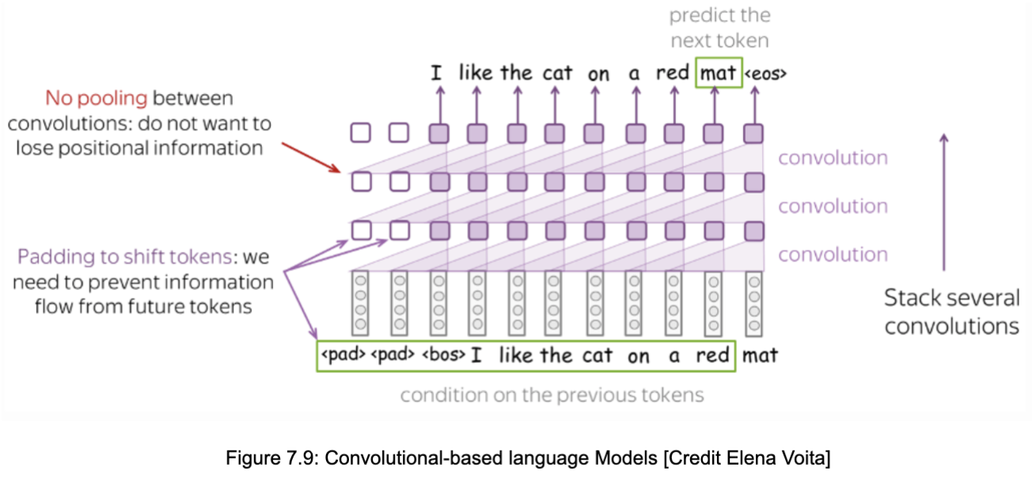

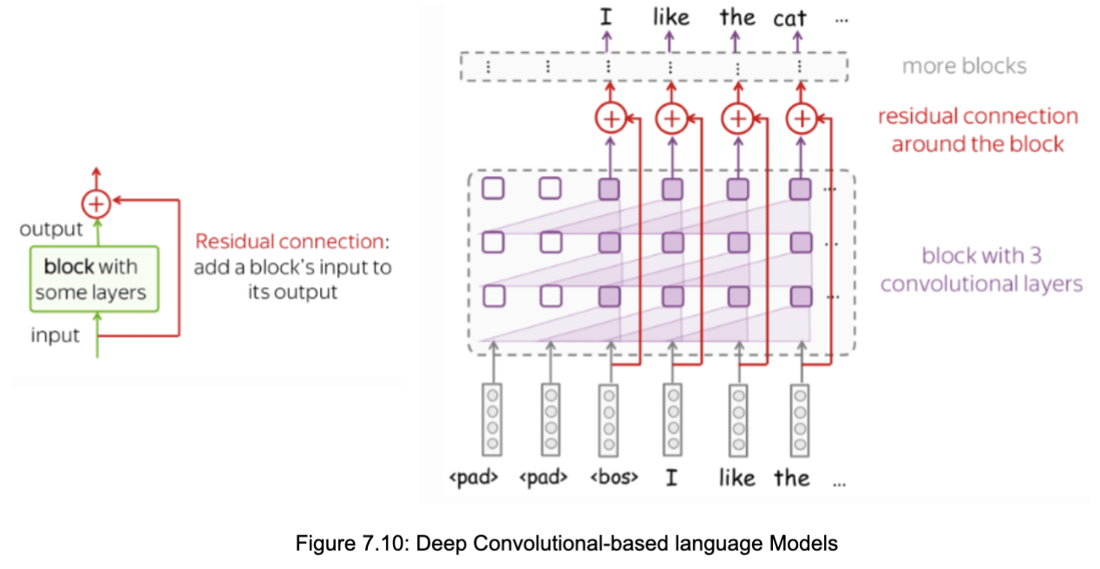

EVALAUTION
- EXTRINSIC
This approach evaluates language models by employing them in an
Actual task (e.g., machine translation) and measure final loss and accuracy values. However, this approach is computationally expensive and requires to train a full system.
- INTRINSIC
This approach evaluates the language model itself without considering a
specific task. Despite that the intrinsic evaluation is not as “good” as the extrinsic evaluation, it helps to quickly compare models. Perplexity is an example of metric to intrinsically evaluate a language model.
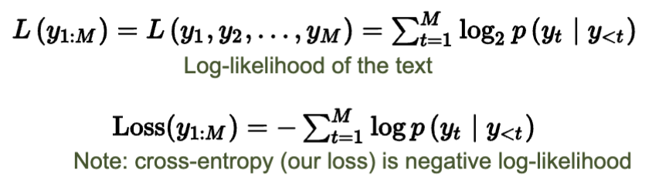

- Log-likelihood = -(Cross Entropy Loss function)
- PERPLEXITY ,
between
1 (model is perfect, correct tokens; log probability =0)
and
|V| (worst perplexity, model doesn’t test the data, assigns probability = 1/|V| to all tokens regardless of context)
