Seq2seq = encoder decoder
Seq of tokens -> Encoder -> vector (latent representation)
Latent representation = word embedding, vector/tensor
Encoding vector -> Decoder -> produces desired output
Eg, language translation 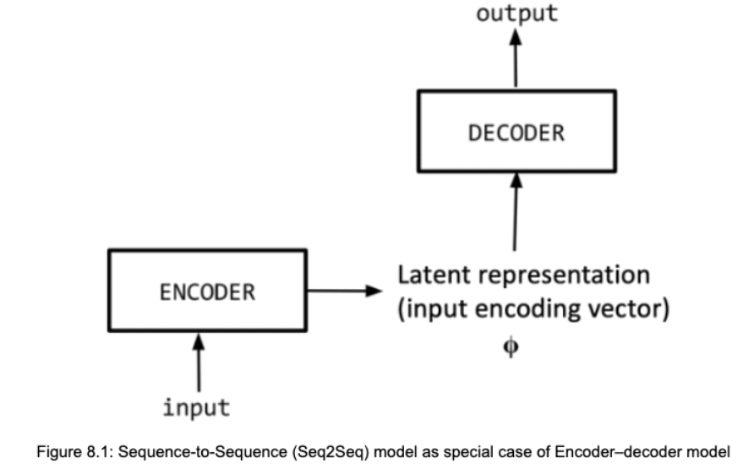
PROBLEM in seq2seq = difficult to produce vector when length on input sequence gets longer and longer => ATTENTION mechanism:
- Query
- Key : keys are queries to retrieve a context from a stored value
- Value : values are all of the input’s information
Vanilla seq2seq : Encoder = RNN, Decoder = RNN (can be LSTM, BiLSTM, GRU)
Get rid of Vanishing Gradient : use LSTMs instead of RNN
Embedders for entire set of tokens create 1 vector
Same size of latent space representation is a BOTTLENECK
- Creates a hidden state, d = dimension of decoder
- Passed to Fully connected network
- FCN converts word embedding of size d(o/p from hidden state of decoder) to V = size of the vocabulary.
- Softmax for the prob distribution

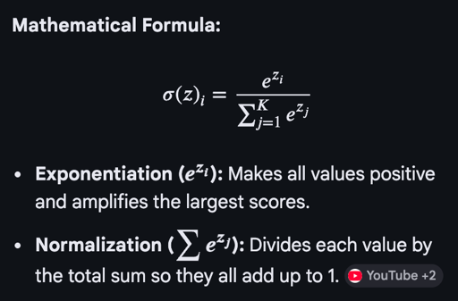

Seq2Seq
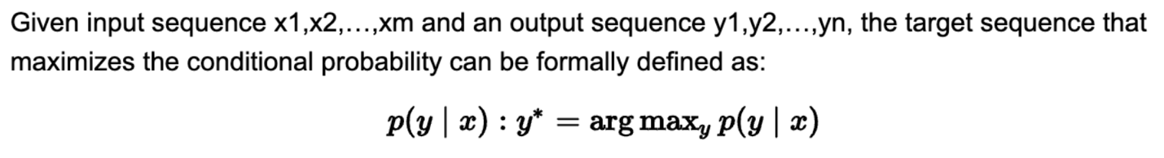
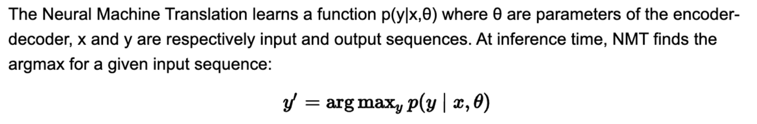
Theta = hyperparameters of encoder and decoder
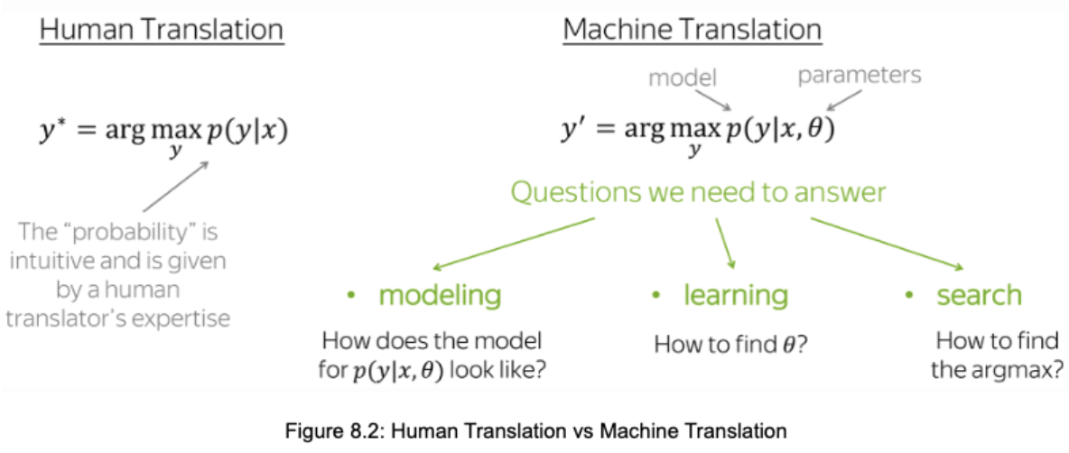
Building machine translation system requires three components:
1. Modeling - how to define the neural network model for p(y|x,θ) ?
Encoder-decoder, Attention and Transformer, …
2. Learning - how to learn the parameters θ by fitting the model p(y|x,θ)?
3. Inference - how to find the best output sequence y for a given input sequence x?

Encoder-Decoder= simple RNN, LSTM, BiLSTM, GRU
which turns a sequence into a lower-dimensional latent representation (encoding). The sequence decoder generates from the latent vector a target sequence
CONDITIONAL LANGUAGE MODELS
decoder
Latent
encoder

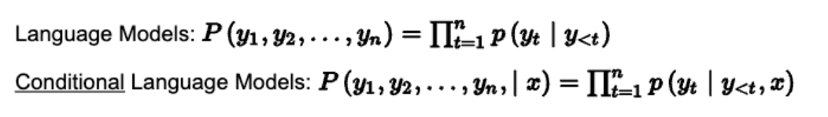
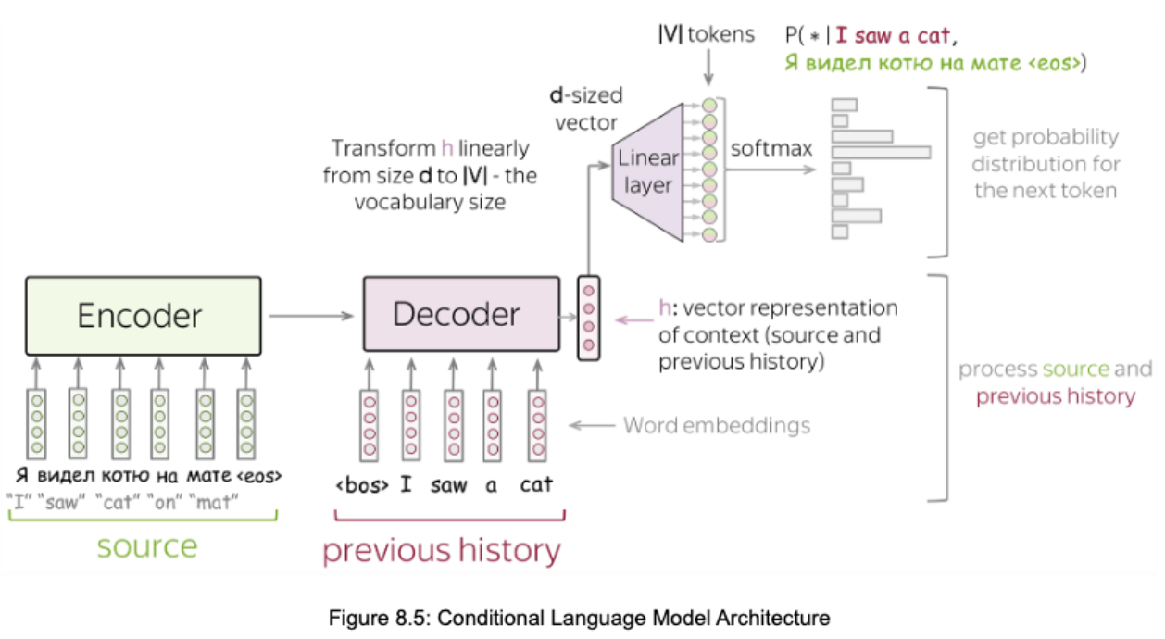
Simplest way = 2RNNs as encoder, decoder

INFERENCE VS BEAM SEARCH
Core mathematical reason why we use Beam Search instead of just Greedy Decoding. It focuses on the difference between finding the best local choice versus the best global sequence.
Here is the breakdown of that central inequality:

- The Global Optimum (Left Side)

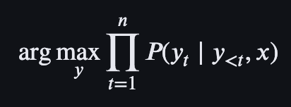
- What it means: This represents the true goal of machine translation or text generation. We want to find the sequence of words ($y$) that has the highest combined probability for the entire sentence, given the input ($x$).
- The Problem: To find this perfectly, you would technically have to calculate the probability of every possible sentence in existence, which is computationally impossible (exhaustive search).

- The Greedy Approach (Right Side)

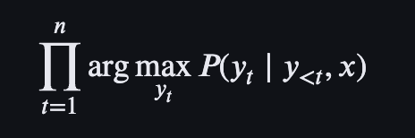
- What it means: This is what Greedy Decoding actually does. At every single step ($t$), it simply picks the one word ($y_t$) that has the highest probability right now.
- The Inequality ($\neq$): The "not equal" sign is the most important part. It tells us that the most likely sentence is rarely made up of the most likely individual words.
- Example from your image: At the first step, "A" might have a slightly higher probability than "The." A greedy model would pick "A" and never look back. However, "The" might lead to a much more coherent and high-probability sentence later on ("The cat sat on the mat"). By picking "A" immediately, the greedy model "locks" itself into a sub-optimal path.

- Beam Search: The Mathematical Middle Ground

Beam search doesn't try to calculate every path (exhaustive), and it doesn't just pick one path (greedy). Instead, it tracks $k$ paths (the "beam width").
Mathematically, at each step, it keeps the top $k$ sequences that maximize:
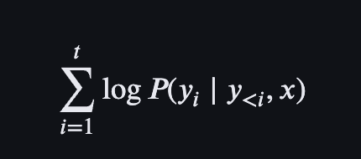

(Note: We use log probabilities here because adding logs is mathematically equivalent to multiplying probabilities, but it prevents the numbers from becoming too small for a computer to handle.)

Summary of the Visual
- Greedy would follow only one line in that tree. If it makes a mistake at the first fork, it's stuck.
- Beam Search (as shown by the green and grey lines) explores multiple "hypotheses" simultaneously. Even if "The" started with a lower score than "A," if the total probability of "The cat sat on the mat" ends up being higher, the model will correctly choose it as the final output.

Probability of a sentence=

Surprisingly, we cannot find the argmax (i.e., exact solution) because the the total number of
hypotheses to check is extremely large |V|^n, which is not feasible in practice.

ATTENTION Mechanism
Fixed latent vector (embedding) becomes difficult when length of input becomes longer and longer
Decoder finds it difficult to find relevant chunks
- in the attention mechanism, the decoder decides at each step which parts of the source sequence are more important.
- Independently, the encoder does not have to compress the entire source sequence into a single vector.
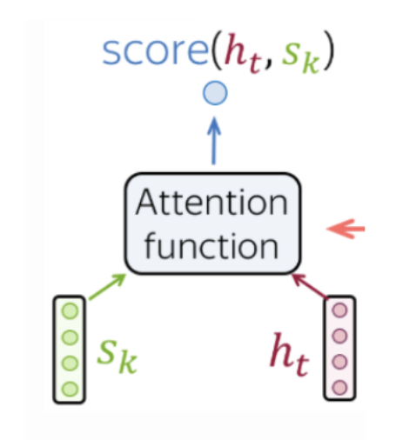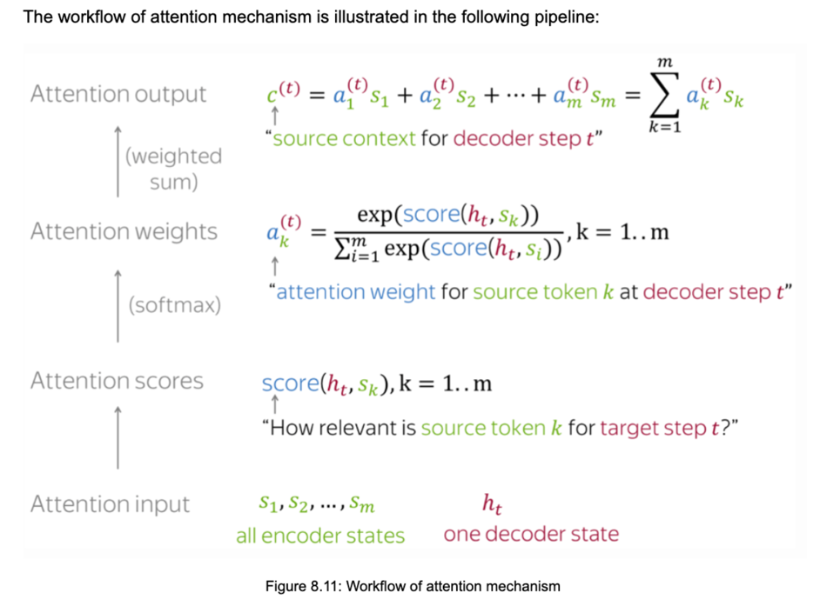
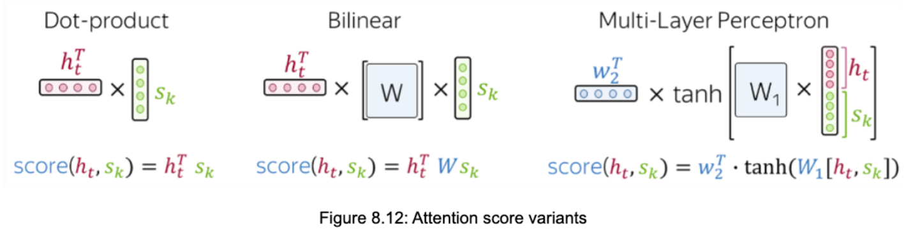
Domain specific task => Bilinear
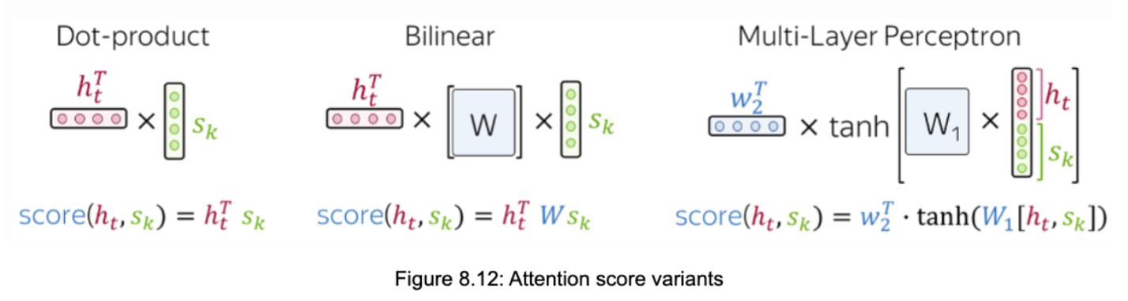
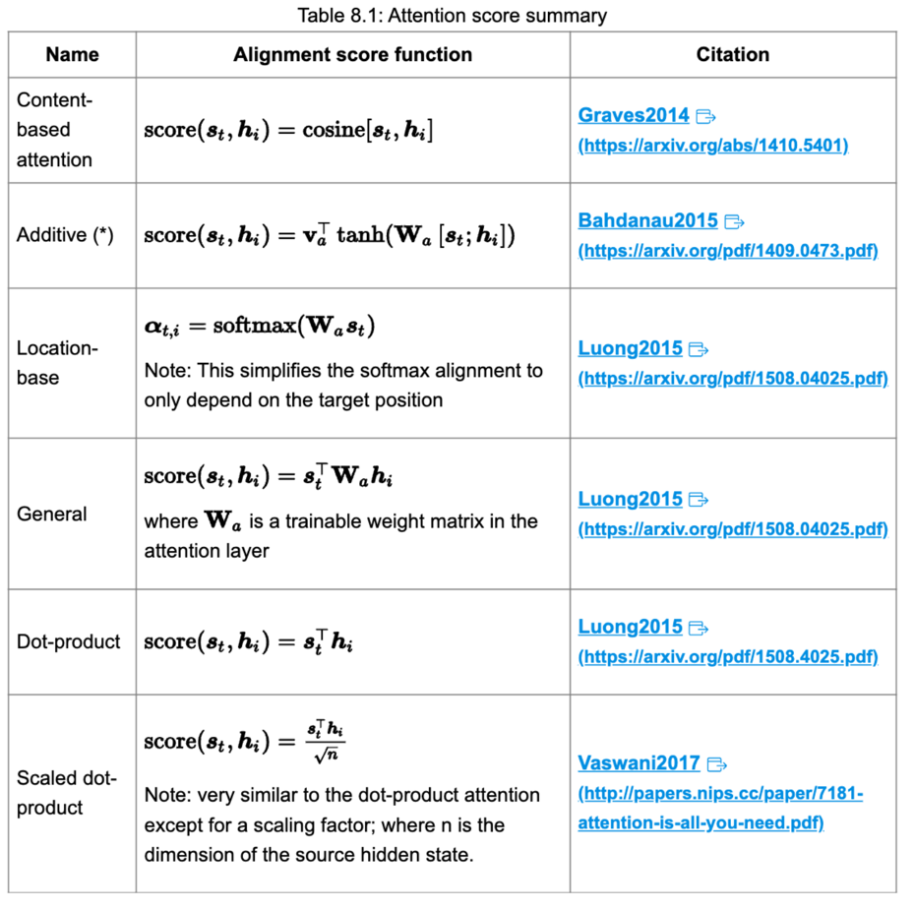

TRANSFORMER
The self-attention mechanism compares every token in the input sequence to every other token in the sequence, including itself to build contexts.
It then reweights the embedding of each token to include its contextual relevance.
Without RNNs or convolution
- Query: asking for information
- Key: saying that it has some information
- Value matrices: giving the information

Wq * input vector = Query vector
Wk * input vector = Key vector
Wv * input vector = Value vector
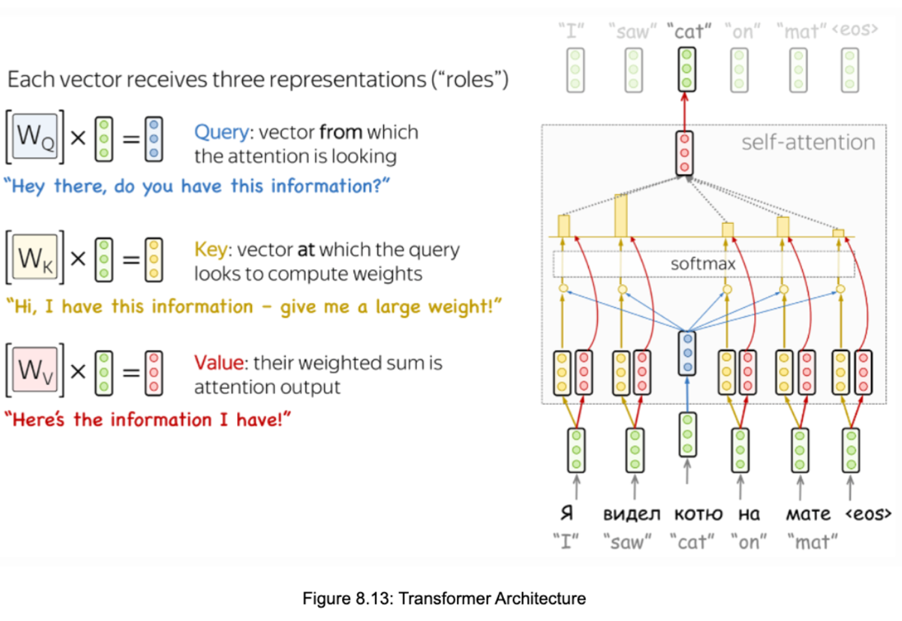
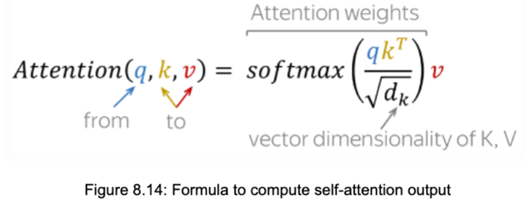

Transformer Architecture
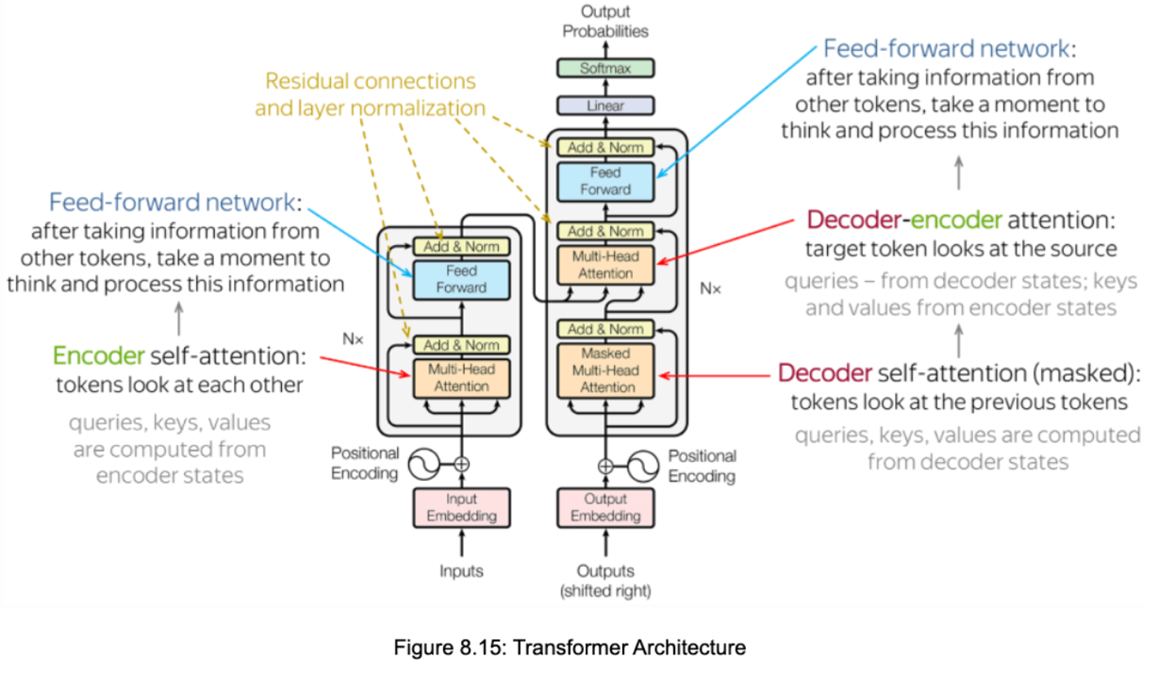
  - Feed forward blocks
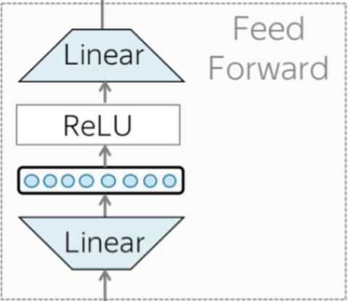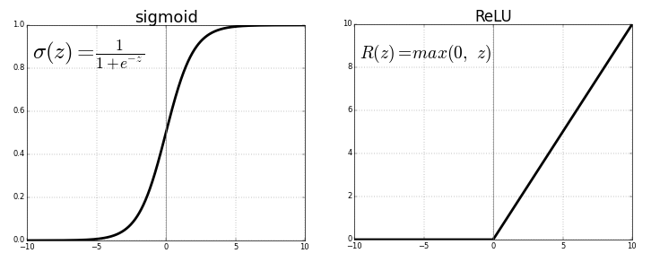
  - Residual Connections
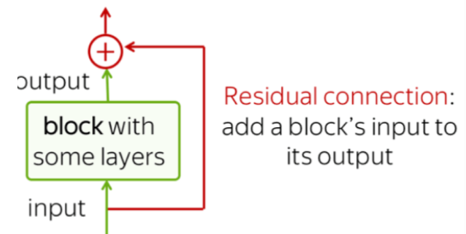
  - Layer Normalization
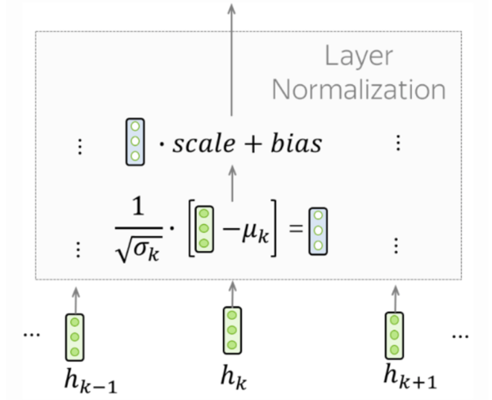
  - Positional encoding
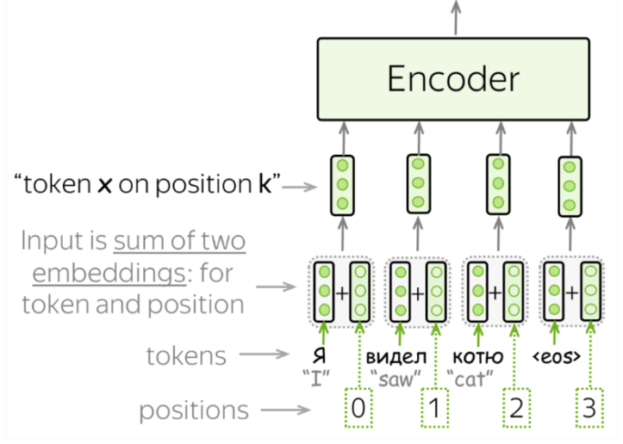
Variants of transformer –
ENCODER
DECODER
ENCODER-DECODER
