TRANSFER LEARNING
Q | GloVE, Word2Vec | CoVe, ELMo | GPT, BERT
Encoded | words | Words in context embeddings | Words in context
Used in downstream | i/p for task specific models | i/p for task specific models | Instead of task specific models
CoVe, ELMo give better performances
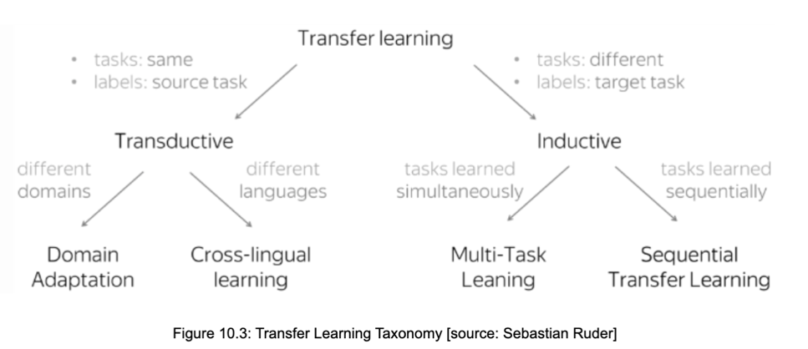
Sequence transfer learning – source and target need not be similar
1. Source model trained on large unlabeled text corpus (source data)
2. Adaptation phase: source model trained on labeled data (target data) to perform a supervised task
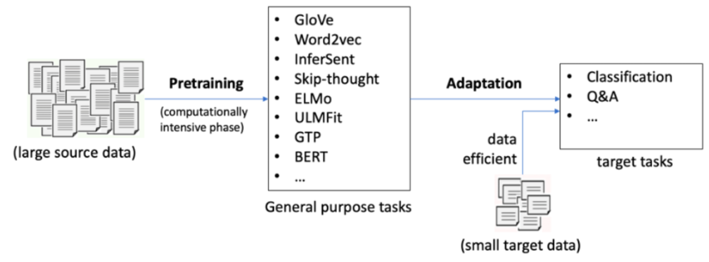
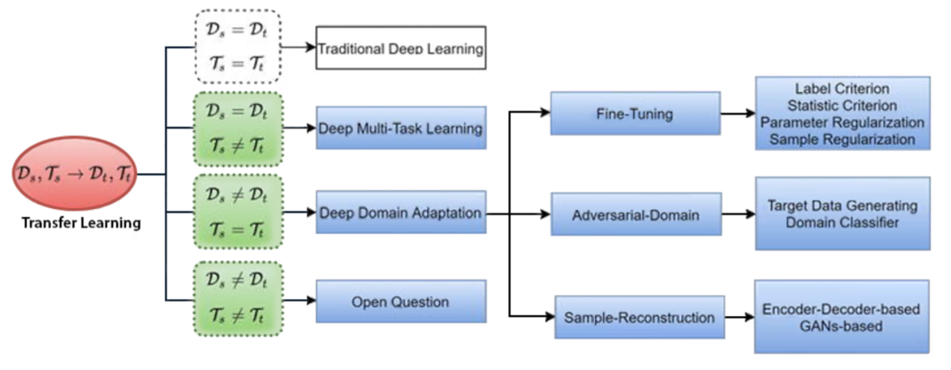
EG, Text Classification
- Train word embeddings, tokenize sentences to vectors
Use pre-trained Word2Vec, GloVe on large corpus of unlabeled data
Create your own embeddings
Issue=We will only know words specific to task; not learn relationships
- Use pre-trained Word2Vec, GloVe for word embeddings
Then fine-tune it on small corpus of labeled data for text classification
Issue = pre-trained word embeddings are statics and not updated during the training of neural network ; MULTIPLE MEANING WORDS , eg = BANK, Out of Vocabulary (OOV)

- Initialize word embedding layer with pretrained word embedding (Word2Vec, GloVe)
Fine-tune it on a small corpus of labeled data for text classification

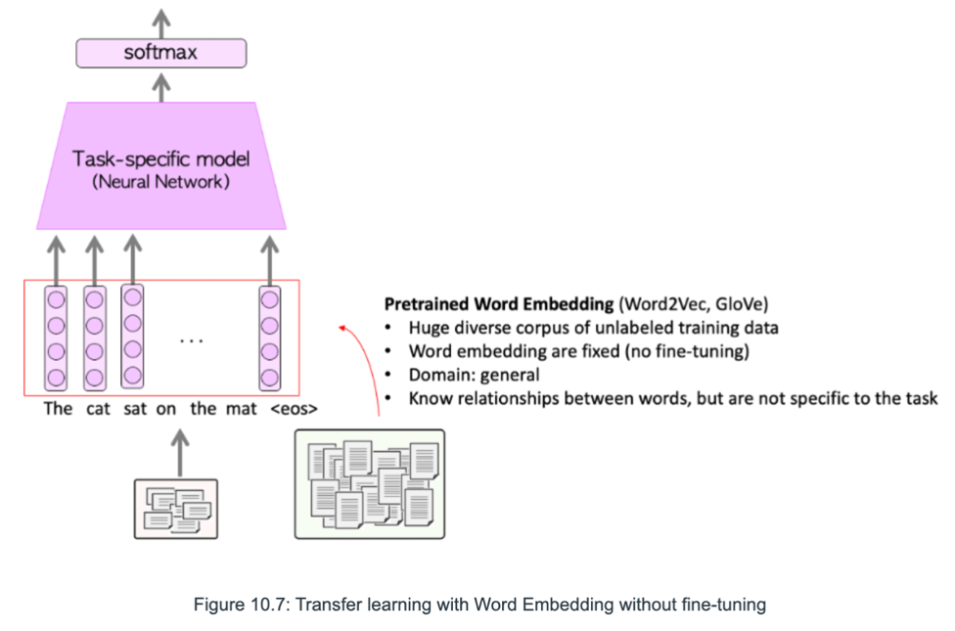

TRANSFER LEARNING WITH CONTEXTUALIZED WORDS
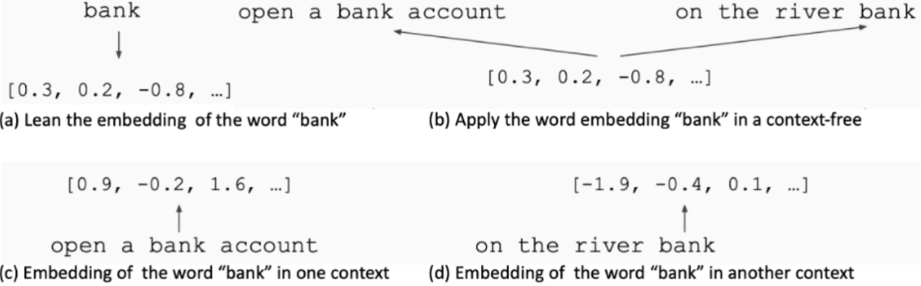
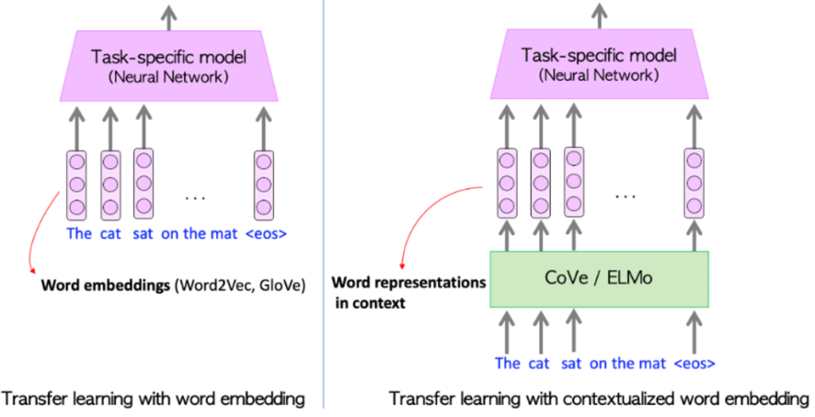

CONTEXTUALIZED WORD VECTORS WITH CoVe
CoVe = Context Vectors
Word embeddings + context
Encoder for vector representation
Check left and right to understand context
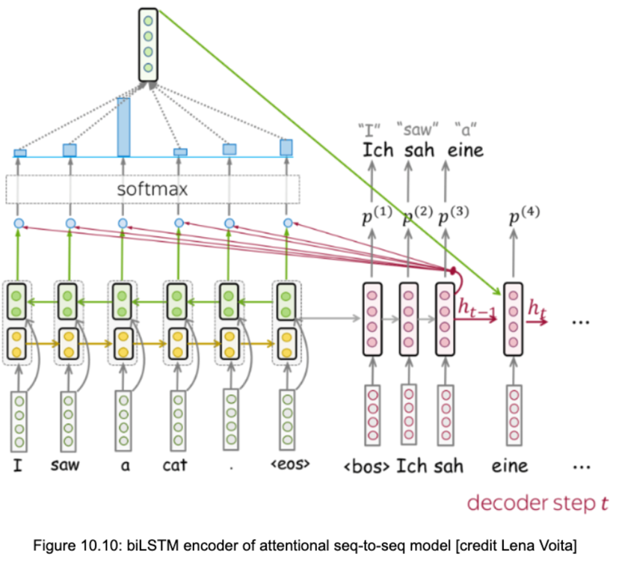
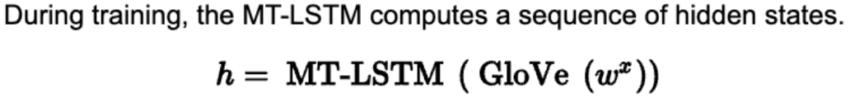
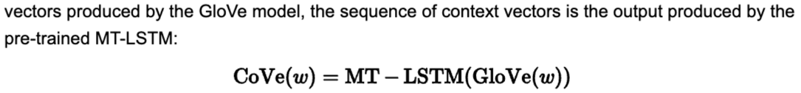
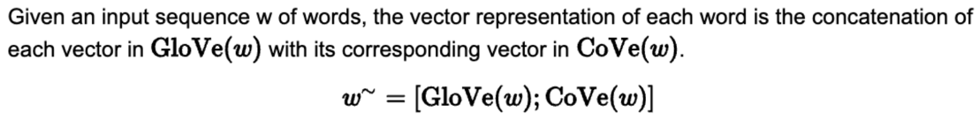

CONTEXTUALIZED WORD VECTORS WITH ELMo
Embedding from Language models
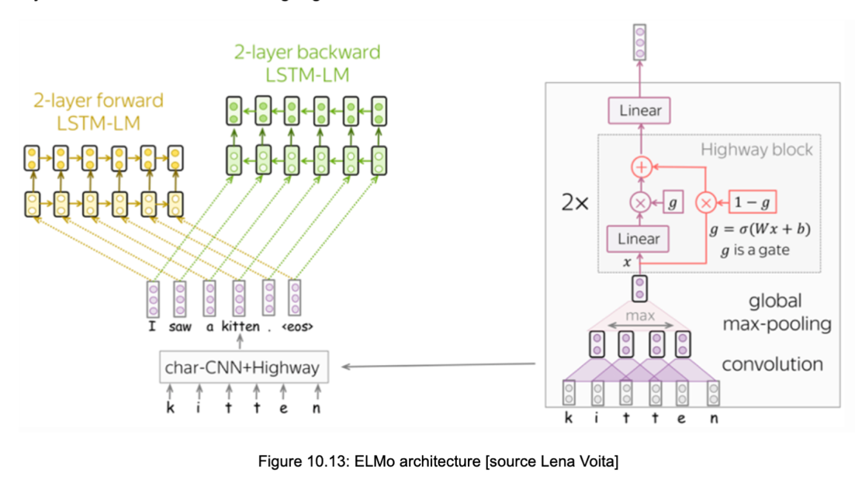
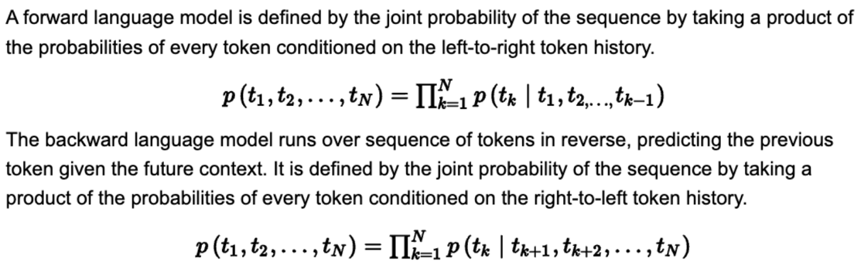
Combines forward and backward language models to maximize log likelihood
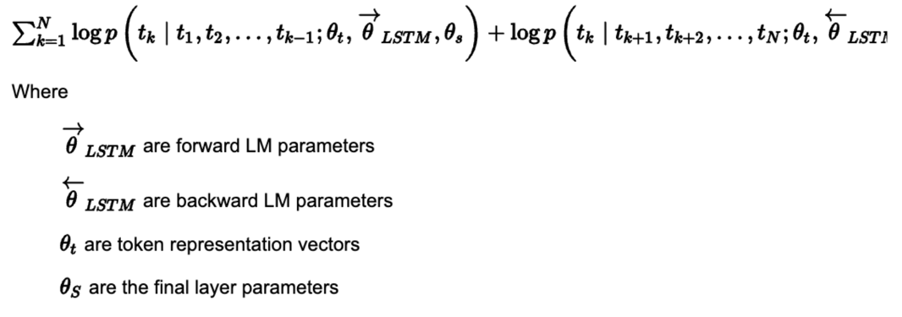
Character level CNN + 2 layers BiLSTM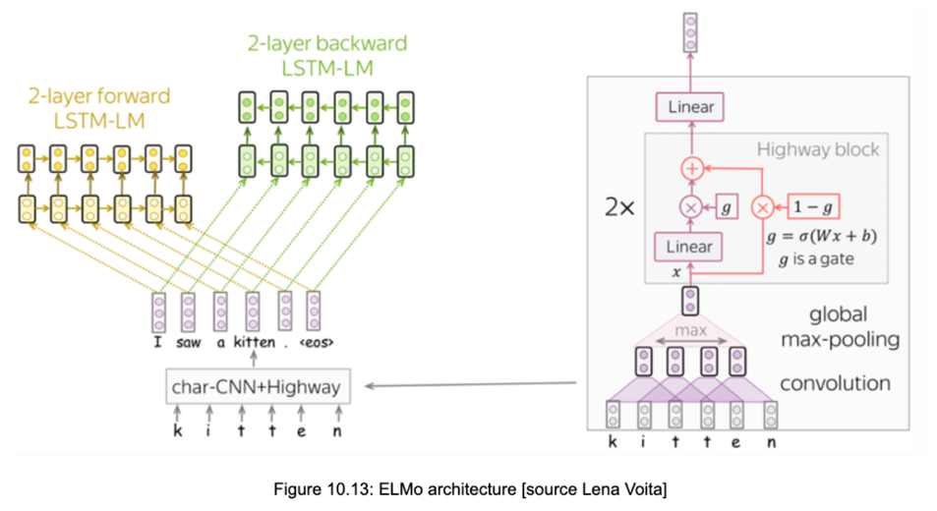
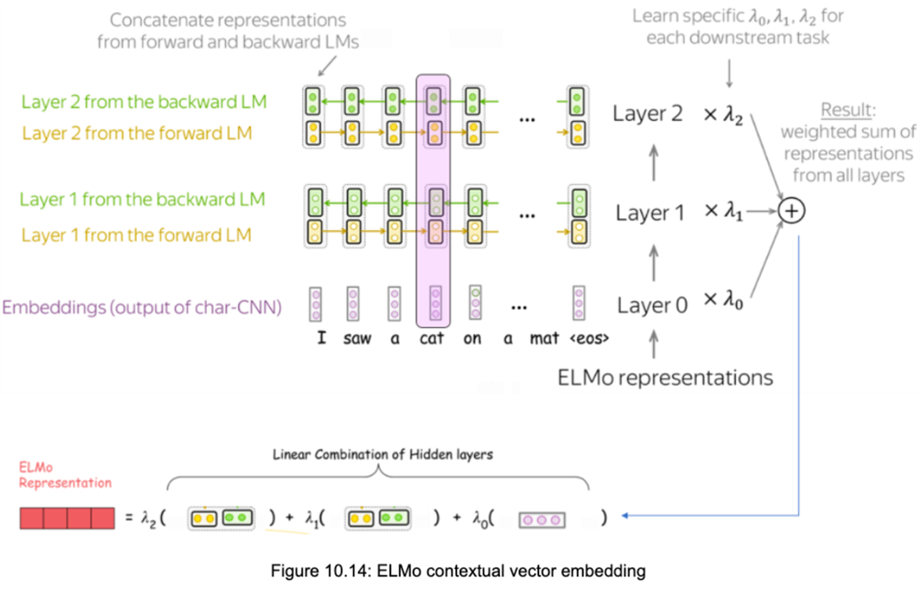
For examples,
layer 0 encodes only word-level information
whereas layers 1 and 2 encode words in context and high-level information from the higher layers of the corresponding language model.

- BETTER OPTIONS NOW: (replace entire task specific models)
  - GPT
  - BERT (Bidirectional Encoder Representation from Transformers)
- Word embeddings (Word2Vec, GloVe) replace one-hot-encoding
- Contextualized word vectors (CoVe, ELMo) replaced word embeddings

