FRAMES = 1D representation of voice samples

F=1/Time
Amplitude directly proportional to loudness
20 Hz <= Human hearing range <= 20000 Hz

- Audio waves
- Convert to digital form – Sampling, Quantization

END TO END SPEECH RECOGNITION SYSTEMS
Digital signal = X
Word = W
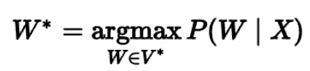

ASR = Automatic Speech Recognition
Encoder-Decoder
Audio -> Speech task (SPEECH RECOGNITION)
i/p & o/p sequences can have diff lengths
- Special compression stage to produce shorter acoustic feature sequence
X = x1,x2,...,xn before feeding encoder
SUB-SAMPLING PROCESS
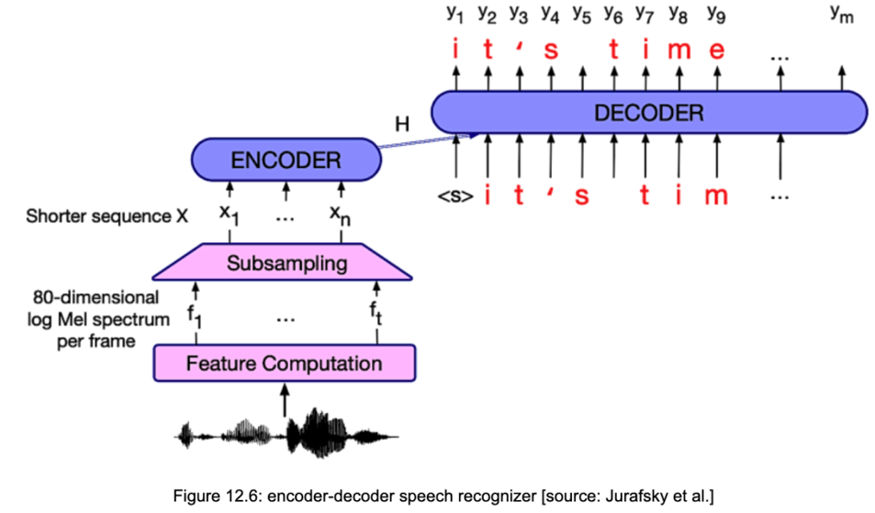

CTC
Epsilon = blanks
Merges double letter

