Learning Objectives
- Explore the basics of Natural Language Processing (NLP) using Python
- Learn how to perform sentiment and emotion classification using the lexicon-based NRC classifier
To understand the discussions presented here I will recommend you revise the basics of Python that were introduced in Lesson 1. Before we start discussing about text analytics and the NLP tasks let us first understand why this lesson is important in this course. As you are aware that the data available to us for research/analysis can be either structured or unstructured. In earlier lessons we have focused on analyzing the structured (tabular) data and in that process, we have learnt how to mine the hidden information in the data by utilizing the different analytics techniques. In a similar manner, unstructured (text, video, audio etc.) data also contains a lot of hidden information that can be mined. For example, a very commonly known social media site Twitter contains a corpus of tweets which are just 140-280 character long but holds a wealth of information on how an individual communicate their thoughts, emotions (happiness, anxiety, depression etc.) and feelings within their social network. By performing sentiment analysis and/or emotion classification on tweets we can infer the thoughts and feelings of the individuals on any given topics. From this discussion you must have got an intuition that unstructured data are equally as valuable as the structured data. However, we must pre-process the unstructured data before we can apply some functions on it to mine the information hidden in it. Also, the type of analysis we can do on the unstructured data is very different from the techniques that we have learnt in past to mine the structured data.
In this lesson you will be introduced to some basic NLP tasks that will be needed to pre-process the data before applying any functions on it. In this lesson you will be required to write Python scripts for performing the NLP tasks. For sentiment and emotion classification we will use the R scripting language and demonstrate how the lexicon-based NRC classifier can be used for sentiment and emotion classification.
Natural Language Processing Tasks
The language data that all NLP tasks depend upon is called the text corpus or simply corpus. A corpus is a large set of text data that can be in any one of the languages like English, French, and so on. The corpus can consist of a single document or a bunch of documents. The source of the text corpus can be social network sites like Twitter, blog sites, open discussion forums etc.
A paragraph is the largest unit of text handled by an NLP task. Paragraph can be further broken down into sentences. Tokenizers that can split a document into paragraphs are available in Python libraries. Sentences are the next level of lexical unit of language data. A sentence encapsulates a complete meaning or thought and context. It is usually extracted from a paragraph based on boundaries determined by punctuations like period. The sentence may also convey opinion or sentiment expressed in it. In general, sentences consist of parts of speech (POS) entities like nouns, verbs, adjectives, and so on. There are tokenizers available to split paragraphs to sentences based on punctuations. Phrases are a group of consecutive words within a sentence that can convey a specific meaning. Some of the NLP tasks extract key phrases from sentences for search and retrieval applications. The next smallest unit of text is the word. The common tokenizers split sentences into text based on punctuations like spaces and comma. One of the problems with NLP is ambiguity in the meaning of same words used in different context.
n-grams - A sequence of characters or words forms an n-gram. For example, character unigram consists of a single character, a bigram consists of a sequence of two characters and so on. Similarly, word n-grams consists of a sequence of n words. In NLP, n-grams are used as features for text classification.
Bag-of-words – Bag-of-words in contrast to n-grams does not consider word order or sequence. It captures the word occurrence frequencies in the text corpus. Bag-of-words is also used as features in tasks like sentiment analysis and topic identification.
No let us go ahead and install the necessary packages in Python to get some hands-on the NLP tasks.
Installing NLTK and its modules
Open command prompt and execute the following commands
pip install -U nltk
pip install -U numpy
Note: Start a command prompt in the windows computer and type the above commands (see below)
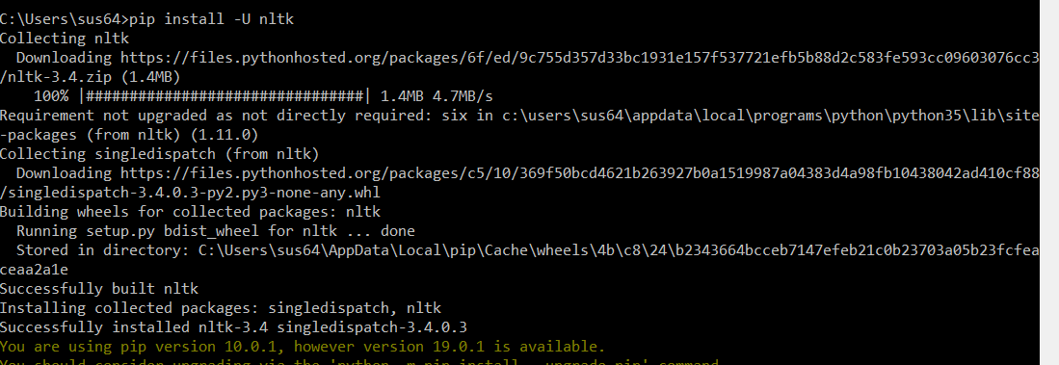
Now type the following commands in the command prompt
Python
Once you get the prompt “>>>” type the following commands (as shown below)
import nltk
nltk.download()
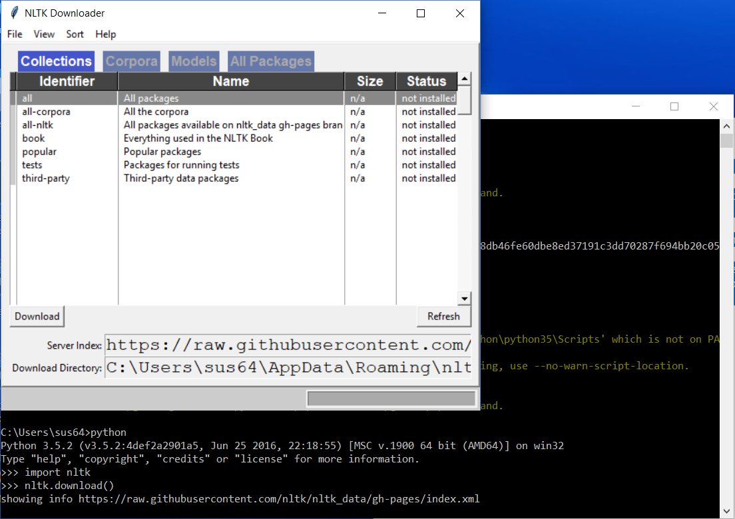
Note: You should be able to see the NLTK Downloader GUI navigator window from Githubusercontent.com
Now click on the tab “All Packages”
Double click on the packages you want to install (see the figure below)
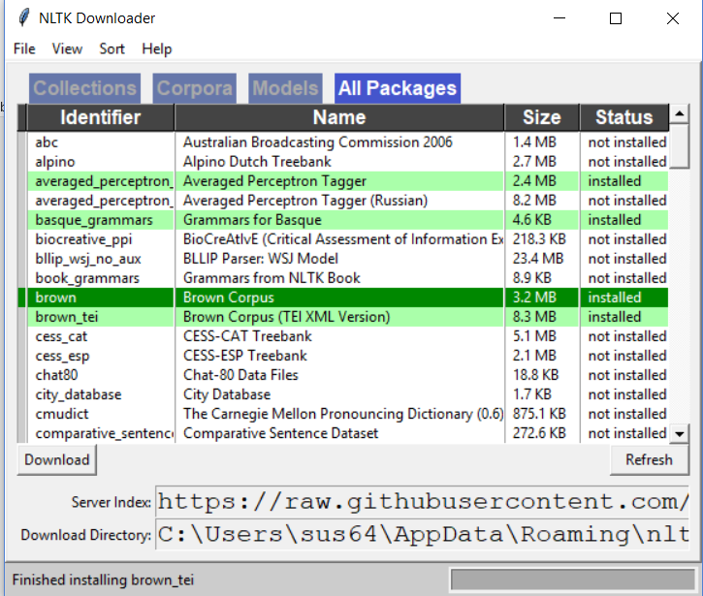
Note: In the bottom you should see the status message that will indicate the status of the installation of the packages. The status bar on the bottom right will show you how much of the task is completed at any given time.
Go ahead and install the following packages
Identifier | Name
Brown | Brown Text Corpus
Gutenberg | Gutenberg Text Corpus
Max_ne_chunker | Module for text chunking
Movie_reviews | Movie review sentiment polarity data
Product_reviews_1 | Basic product reviews corpus
punkt | Word and sentence tokenizer modules
treebank | Penn Treebank dataset sample
Twitter_samples | Twitter messages sample
Universal_tagset | Universal POS tag mapping
Webtext | Web text corpus
wordnet | WordNet corpus
Words | Word list
stopwords | Stopwords Corpus
swadesh | Swadesh Wordlists

Tokenization
Tokenization of text is one of the NLP tasks which is about pre-processing the texts. Let us now perform tokenization on a sample of tweets. See the Python code below using which tokenizing of the sample tweets can be performed.
# Perform tokenization on the sample tweets
# first import the nltk package
import nltk
# from the nltk corpous import twitter_samples and rename it as ts
from nltk.corpus import twitter_samples as ts
# show the contents of the corpus
ts.fileids()
**************************************OUTPUT******************************
['negative_tweets.json', 'positive_tweets.json', 'tweets.20150430-223406.json']
****************************************************************************
# Now let us get a sample of tweets from the corpus
samples_tw = ts.strings('tweets.20150430-223406.json’)
# let us see one sample tweet
samples_tw[20]
**************************************OUTPUT******************************
"@B0MBSKARE the anti-Scottish feeling is largely a product of Tory press scaremongering. In practice most people won't give a toss!"
****************************************************************************
# Now let us tokenize a sample tweet
# import the in-built word tokenizer and rename it as wtoken
from nltk.tokenize import word_tokenize as wtoken
wtoken(samples_tw[20])
**************************************OUTPUT******************************
['@', 'B0MBSKARE', 'the', 'anti-Scottish', 'feeling', 'is', 'largely', 'a', 'product', 'of', 'Tory', 'press', 'scaremongering', '.', 'In', 'practice', 'most', 'people', 'wo', "n't", 'give', 'a', 'toss', '!']
Note here that the resultant array has special characters @ and !. Do we need them?
****************************************************************************
#To split text based on punctuation do the following steps
from nltk import wordpunct_tokenize
wordpunct_tokenize(samples_tw[20])
**************************************OUTPUT******************************
['@', 'B0MBSKARE', 'the', 'anti', '-', 'Scottish', 'feeling', 'is', 'largely', 'a', 'product', 'of', 'Tory', 'press', 'scaremongering', '.', 'In', 'practice', 'most', 'people', 'won', "'", 't', 'give', 'a', 'toss', '!']
Note that anti-scottish is separated in to anti, -, and scottish
****************************************************************************
#Did you know we can build customized tokenizers: build a custom tokenizer using RegEx patterns
from nltk import regexp_tokenize
patn = '\w+’
regexp_tokenize(samples_tw[20],patn)
*********************************************OUTPUT***********************
['B0MBSKARE', 'the', 'anti', 'Scottish', 'feeling', 'is', 'largely', 'a', 'product', 'of', 'Tory', 'press', 'scaremongering', 'In', 'practice', 'most', 'people', 'won', 't', 'give', 'a', 'toss']
Isn’t this what we needed in the first place.
****************************************************************************
# Now let us try
patn = '\w+|[!,\-,]'
regexp_tokenize(samples_tw[20],patn)
******************************************OUTPUT**************************
['B0MBSKARE', 'the', 'anti', '-', 'Scottish', 'feeling', 'is', 'largely', 'a', 'product', 'of', 'Tory', 'press', 'scaremongering', 'In', 'practice', 'most', 'people', 'won', 't', 'give', 'a', 'toss', '!']
****************************************************************************
What differences can you note?
Stemming
The next NLP task that we will perform on the text is stemming. Stemming is a text preprocessing task for transforming related or similar variants of a word (such as walking) to its base form (to walk), as they share the same meaning. One of the basic stemming actions is to reduce a plural word to its singular form: apples is reduced to apple. The Porter algorithm used by the stemmer utilizes various language-specific rules (in this case, English) to arrive at the stem words. One of these rules is removing suffixes such as “ing” from the word.
# import the nltk package and the PorterStemmer package for stemming
import nltk
from nltk.stem import PorterStemmer
# create a stemming instance
stemming = PorterStemmer()
# Now perform stemming
stemming.stem("enjoying")
stemming.stem("enjoys")
stemming.stem("enjoyable")
******************************************OUTPUT**************************
‘enjoy’
Note for each of the three lines executed you will see the same output i.e. ‘enjoy’
****************************************************************************
The nltk.stem.snowball module includes the snowball stemmers for other languages, such as French, Spanish, German, and so on. Snowball is a stemming language that can be used to create standard rules for stemming in different languages. We can also create custom stemmers, using the following regular expressions as shown below
#Create a RegEx stemmer that removes ‘able’ or ‘ing’ with 4 as the minimum length of strring to stem
from nltk.stem import RegexpStemmer
regexp_stemmer = RegexpStemmer("able$|ing$",min=4)
regexp_stemmer.stem("flyable")
regexp_stemmer.stem("flying")
**************************************OUTPUT******************************
‘fly’
Note that the last two lines will have the same output i.e. ‘fly’
****************************************************************************
Stopwords
Commonly used words in English such as the, is, he, and so on, are generally called stop words. Stop word removal is another common preprocessing step for an NLP application. In this step, we remove words that do not signify any importance to the document, such as grammar articles and pronouns.
# import the stopwords package from nltk.corpus
from nltk.corpus import stopwords
# Use the English stopwords
sw_l = stopwords.words('english')
# show the stopwords from the “English” language
sw_l[20:40]
*******************************************OUTPUT*************************
['himself', 'she', "she's", 'her', 'hers', 'herself', 'it', "it's", 'its', 'itself', 'they', 'them', 'their', 'theirs', 'themselves', 'what', 'which', 'who', 'whom', 'this']
****************************************************************************
# Remove stopwords from an example sentence
example_text = "This is an example sentence to test stopwords"
example_text_without_stopwords=[word for word in example_text.split()
if word not in sw_l]
example_text_without_stopwords
*****************************************OUTPUT***************************
['This', 'example', 'sentence', 'test', 'stopwords']
****************************************************************************
NLTK provides stop word corpora for 21 languages. Let us look at the percentage of stop words in a specific text corpus, using the following code:
# import the gutenburg corpus and extract all the words
from nltk.corpus import gutenberg
words_in_hamlet = gutenberg.words('shakespeare-hamlet.txt')
# Now get all the stopwords for the English language
from nltk.corpus import stopwords
sw_l = stopwords.words('english')
# Retrieve all the words from the gutenburg corpus after removing the stopwords
words_in_hamlet_without_sw = [word for word in words_in_hamlet if word
not in sw_l]
# Now compute the percentage of actual words in the gutenburg corpus
len(words_in_hamlet_without_sw)*100.0/len(words_in_hamlet)
**************************************OUTPUT******************************
69.2612%
****************************************************************************
Let us analyze the Web text data in NLTK
# Now let us import the webtext corpus
from nltk.corpus import webtext
# retrieve all the sentences from the corpus
webtext_sentences = webtext.sents('firefox.txt')
# retrieve all the words in the corpus
webtext_words = webtext.words('firefox.txt')
# get the statistics of the corpus
# Total number of sentences
len(webtext_sentences)
*****************************************OUTPUT***************************
1142
****************************************************************************
# Total number of words
len(webtext_words)
*****************************************OUTPUT***************************
102457
****************************************************************************
# determine the size of the vocabulary
vocabulary = set(webtext_words)
len(vocabulary)
********************************************OUTPUT************************
8296
****************************************************************************
# Now let us determine the frequency distribution of words
# What are the top 30 words in a document?
frequency_dist = nltk.FreqDist(webtext_words)
sorted(frequency_dist, key=frequency_dist.__getitem__,reverse=True)[0:30]
******************************************OUTPUT**************************
['.', 'in', 'to', '"', 'the', "'", 'not', '-', 'when', 'on', 'a', 'is', 't', 'and', 'of', '(', 'page', 'for', 'with', ')', 'window', 'Firefox', 'does', 'from', 'open', ':', 'menu', 'should', 'bar', 'tab']
What is the issue here? – Lot of the highly frequent words seem to be stop words
****************************************************************************

# Now let us determine the frequency distribution of the larger words in the corpus
large_words = dict([(k,v) for k,v in frequency_dist.items() if
len(k)>3])
frequency_dist = nltk.FreqDist(large_words)
# install matplotlib
pip install matplotlib
#import pylab from the matplotlib package
From matplotlib import pylab
# Plot the frequency distribution plot
frequency_dist.plot(50,cumulative=False)
*******************************************OUTPUT*************************
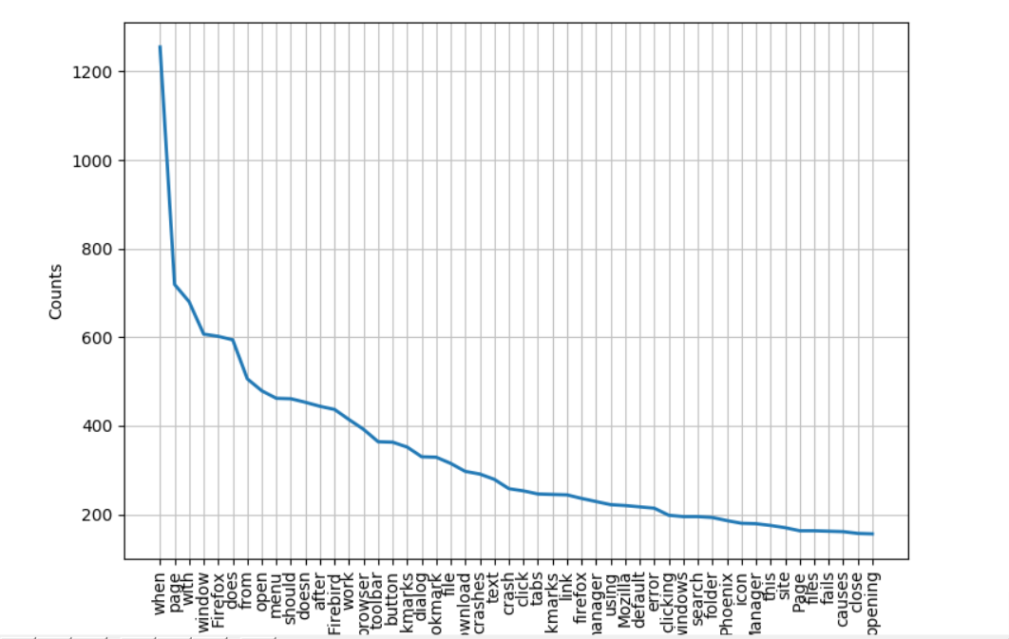
****************************************************************************
# Now let us create a word cloud
# First install wordcloud
Pip install wordcloud
# Now type the following commands – obtain the frequency distribution of words and use the # bilinear interpolation to construct the word cloud
from wordcloud import WordCloud
wcloud = WordCloud().generate_from_frequencies(frequency_dist)
# import the matplotlib.pyplot package
import matplotlib.pyplot as plt
plt.imshow(wcloud, interpolation='bilinear')
plt.axis("off")
# show the word cloud
plt.show()
***********************************OUTPUT*********************************
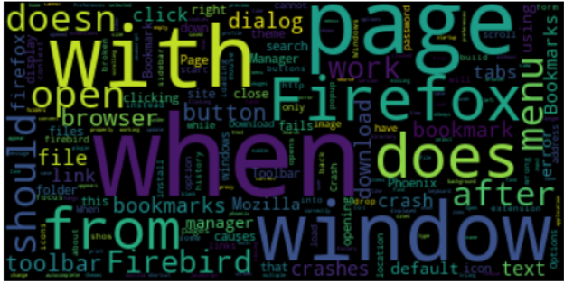
Note: The highly frequent words will appear as larger words. The smaller the size of the word the less frequent they are
****************************************************************************
POS Tagging
POS refers to categorizing the words in a sentence into specific syntactic or grammatical functions. In English, the main parts of speech are nouns, pronouns, adjectives, verbs, adverbs, prepositions, determiners, and conjunctions. POS tagging is the task of attaching one of these categories to each of the words or tokens in a text. NLTK provides both a set of tagged text corpus and a set of POS trainers for creating custom taggers. The most common tagged datasets in NLTK are the Penn Treebank and Brown Corpus. The Penn Treebank consists of a parsed collection of texts from journal articles, telephone conversations, and so on. The Brown Corpus consists of text from 15 different categories of articles (science, politics, religion, sports, and so on).
# Import the nltk package and perform tokenization
import nltk
text1 = nltk.word_tokenize("I left the room")
text2 = nltk.word_tokenize("Left of the room")
# Now let us perform universal POS tagging
nltk.pos_tag(text1,tagset='universal')
***************************************OUTPUT*****************************
[('I', 'PRON'), ('left', 'VERB'), ('the', 'DET'), ('room', 'NOUN')]
****************************************************************************
nltk.pos_tag(text2, tagset='universal’)
*************************************OUTPUT*******************************
[('Left', 'NOUN'), ('of', 'ADP'), ('the', 'DET'), ('room', 'NOUN')]
****************************************************************************
What difference do you see in POS tagging of text1 and text2?
# Let us consider another example and first tokenize the sentence
example_sent = nltk.word_tokenize("The company is located in South Africa")
example_sent
************************************OUTPUT*******************************
['The', 'company', 'is', 'located', 'in', 'South', 'Africa']
# Now let us perform the default POS tagging
tagged_sent = nltk.pos_tag(example_sent)
tagged_sent
************************************OUTPUT********************************
[('The', 'DT'), ('company', 'NN'), ('is', 'VBZ'), ('located', 'VBN'), ('in', 'IN'), ('South', 'NNP'), ('Africa', 'NNP')]
****************************************************************************
What is the issue here? Isn’t South Africa a GPE (Geopolitical entity)?
Sentiment and Emotion Classification
The advent of social media and microblogging sites has paved the path for individuals and communities to freely express their opinions, feelings, and thoughts on a variety of topics in the form of short and limited size texts. A very commonly known social media site is Twitter, through which short messages (a.k.a. tweets) can be posted by individuals. These tweets with a 140 to 280-character limitation hold a wealth of information on how an individual communicates their thoughts, emotions (happiness, anxiety, depression etc.) and feelings within their social network. Not only the emotions of individuals, but the emotions of a larger groups (such as a certain country, state etc.) can be identified by analyzing the tweets. More commonly expressed state of emotions and feelings include anger, disgust, fear, joy, love, sadness, surprise, tensed etc. Twitter is a large repository that houses billions of tweets which is a rich ensemble of emotions, sentiments, and moods. Unlike conventional texts, tweets are peculiar in nature due to their inherent structure and size. This makes the determination of emotions of an individual or for larger group i.e. Emotion classification, a very challenging task. Table 1 provides more examples of tweets that expresses different types of emotions.
Table 1 Examples of emotion tweets
Emotion | Tweet
Happy | Woot I finally got an iPod with video
Sadness | It certainly is a sin and a shame that they are not eaten at the right time
Anger | My sister will remain in Michigan, so I thought I would be coming back here occasionally but she and I have had several vicious scarring fights this summer
Surprise | What do you mean by that
Challenges associated with emotion classification
Unlike the conventional texts, tweets are peculiar in terms of their structure and size. Primarily, they are restricted to a length of 140 to 280 characters. Secondly, due to this limitation the language used by people in tweets to express their emotions is very different when compared to the other digitized documents like blogs, articles and news. A major challenge is posed by the availability of a very large number of features in the tweets. Each tweet when presented as a vector of features exponentially increases the size of the available features as the corpus would contain millions of features for a given topic. The third major challenge is inherent to the characteristics of a classifier type. For example, supervised classifiers need labeled data for training. Due to the large volume of twitter messages, it would be time consuming and tedious to manually annotate them with emotion classes and later use it to identify the emotions expressed in an unlabeled data set. Fourthly, the inherent nature of the different types of emotions makes it very difficult to differentiate between them. According to the Circumplex model there are 28 affect words or emotions. In the two-dimensional circular space, these emotions differ from each other by a small angle. Few emotions are clustered so close to each other that it becomes very hard to differentiate between them.
What is the Circumplex Model and how are the 28 different emotions related?
The Circumplex model is a very popular model of human emotions, which characterizes affective experience through two dimensions: valence and arousal (Hasan, M., Rundensteiner, E., & Agu, E., 2014, Russell, J.A., 1980). The Circumplex model suggests that emotions can be distributed in a two-dimensional circular space with the vertical axis representing the Arousal and the horizontal axis representing the valence. In this two-dimensional circular space, the center of the circle represents a neutral valence and a medium level of arousal. All the emotional states can be represented with any level of the valence and arousal. The figure 1 below pictorially represents the two-dimensional circular space of the Circumplex model in which the positions of the 28 affect words are indicated.
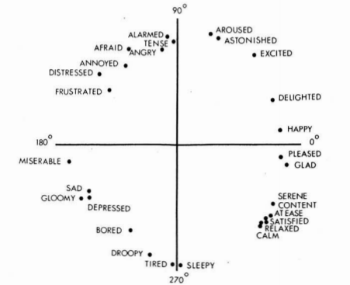
Figure 1 Two-dimensional Circumplex model for 28 affect words (Russell, J.A., 1980)

In figure 1, happy is at an angle of 7.8º from the positive x-axis and represents a slight increase in arousal. Exactly at 90º is the emotion surprise which represents zero valence. Beyond 90º, a situation that involves negative valence and decrease in arousal which can be best described by the emotion anger occurs. Beyond 180º a state of negative arousal and negative valence is experienced such as sadness (Russell, J.A., 1980).

Types of classifier
Though there are a limited number of labeled datasets available to train the classifiers, not all datasets are as efficient in providing a classifier with a critical set of features to differentiate between the various categories of emotions. When the supervised classifiers are cross-validated on the training dataset the prediction accuracy in different folds are not so significant. On the other hand, unsupervised classifiers suffer from the fact that the emotion classes are clustered very close to each other thus making it very hard to accurately annotate the clusters with different emotion classes. Therefore, lexicon-based classification techniques are preferable for emotion classification. Example of a popular Lexicon-based emotion classifier is NRC
Lexicon-based NRC Classifier
Mohammad and Turney have compiled emotion annotations for about 14,182 words by crowdsourcing to the Mechanical Turk. The lexicon more commonly referred to as NRC emotion association lexicon or EmoLex, has annotations for eight different emotions including anger, anticipation, disgust, fear, joy, sadness, surprise, trust and two sentiments namely negative and positive. This lexicon corpus was constructed based on the measures namely the Strength of Association (SOA) and Pointwise Mutual Information (PMI). To begin with n-grams were generated from the dataset containing emotion-labeled headline sentences. For each of the generated n-grams a PMI was computed which determines the association of an n-gram with a class. At the same time a secondary PMI i.e. PMI’ is computed for each n-grams that determines the association of an n-gram with the other class labels. Finally, for each n-gram the SOA is computed across each emotion classes which is the difference of PMI and PMI’. If an n-gram has a stronger tendency to occur in a sentence with an emotion label, than in a sentence that does not have the label, then that n-gram-emotion pair will have a SOA score greater than zero. Such n-grams are associated with that emotion class. These n-grams are considered as potential lexicons that can determine an emotion class in a sentence. The PMI measure on the other hand is well-known to be the poor estimator of the association for low-frequency events. Therefore, the PMI values for the n-grams that have a very low frequency of occurrence in the dataset are not robust. Generally, such n-grams that are not so frequent in the dataset should be removed from the dataset. A major drawback of the lexicon-based classifier is that the classification of an unknown sentence (instance) is not possible if a lexicon is not found in that instance.
For more information about the NRC classifier and its implementation in R visit the link https://cran.r-project.org/web/packages/syuzhet/vignettes/syuzhet-vignette.html.
Let us see some example for sentiment and emotion classification on several English texts using the Lexicon-based NRC classifier. Here, we will exploit the implementation of the NRC classifier in the syuzhet package. This tutorial is implemented using R scripts.
# First install and load the syuzhet package in R
install.packages(“syuzhet”)
library(syuzhet)
# Let us consider several instances (sentence) to perform sentiment and emotion classification
my_example_text <- "I begin this story with a neutral statement.
Basically this is a very silly test.
You are testing the Syuzhet package using short, inane sentences.
I am actually very happy today.
I have finally finished writing this package.
Tomorrow I will be very sad.
I won't have anything left to do.
I might get angry and decide to do something horrible.
I might destroy the entire package and start from scratch.
Then again, I might find it satisfying to have completed my first R package.
Honestly this use of the Fourier transformation is really quite elegant.
You might even say it's beautiful!"
# Create a character object to get the NRC sentiments
s_v <- get_sentences(my_example_text)
class(s_v)
***************************************OUTPUT****************************
character
# Now let us get the sentiments and emotions
nrc_data <- get_nrc_sentiment(s_v)
nrc_data
*************************************OUTPUT*******************************
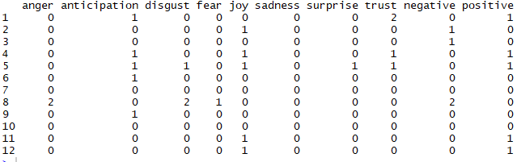
The 12th sentence here You might even say it’s beautiful expresses the emotion joy and a positive sentiment. In a similar way, you can interpret the emotions and sentiments within the others. If an emotion type is more intensely expressed in the sentence, then the cell corresponding to that column will hold a high value.
***************************************************************************
# Now let us pick those sentences that expresses the anger emotion
angry_items <- which(nrc_data$anger > 0)
s_v[angry_items]
****************************************OUTPUT****************************
[1] "I might get angry and decide to do something horrible."
Note that this is the 8th sentence.
****************************************************************************
# Now let us pick those sentences the expresses the joy emotion
joy_items <- which(nrc_data$joy > 0)
s_v[joy_items]
***************************************OUTPUT*****************************
[1] "Basically this is a very silly test."
[2] "I am actually very happy today."
[3] "I have finally finished writing this package."
[4] "Honestly this use of the Fourier transformation is really quite elegant."
[5] "You might even say it's beautiful!"
Note that there are 5 sentences that expresses the emotion joy
***************************************************************************
Reference
- Mohammad, S., Turney, P. (2011). Emotions Evoked by Common Words and Phrases: Using Mechanical Turk to Create an Emotion Lexicon. Proceedings of the NAACL-HLT 2010 Workshop on Computational Approaches to Analysis and Generation of Emotion in Text.
- Russell, J.A. (1980). A Circumplex model of affect. Journal of Personality and Social Psychology, 39, 1161-1178.
- Hasan, M., Rundensteiner, E., Agu, E. (2014). EMOTEX: Detecting Emotions in Twitter Messages. Academy of Science and Engineering.
- Srinivasan, S.M., and Prashanth, R., “Comparing different classifiers and feature selection techniques for emotion classification”, International Journal of Society Systems Science, 10(4), 2018, pp. 259-284.
- Arumugam R., Shanmugamani, R., “Hands-On Natural Language Processing with Python”, Packt Publishing, ISBN 978-1-78913-949-5, 2018.
- “NRC Word-Emotion Association Lexicon”, retrieved from https://saifmohammad.com/WebPages/NRC-Emotion-Lexicon.htm, retrieved on March 5, 2019.
- “Introduction to Syuzhet package”, retrieved from https://cran.r-project.org/web/packages/syuzhet/vignettes/syuzhet-vignette.html, retrieved on March 5, 2019.
- Chapman, C., and Feit, E. McDonnell, “R for Marketing Research and Analytics”, Springer, ISBN 978-3-319-14436-8, 2015.

