At the end of this lesson, you will be able to:
- Explore the discipline of Natural Language Processing (NLP)
- Discuss the basics of Natural Language Processing Tasks and other essential methods for NLP.
- Dive into the NLP libraries and demonstrate how they can be useful for Natural Language Processing related tasks.

Natural Language Processing
Computers are very useful for performing scientific computations and process tabular data (e.g., spreadsheets or databases). However, human beings generally communicate in words (speech), not in the form of tables. Natural language refers to the way humans communicate with each other. Written text is one way to convey the meanings of words and sentences to the person who read them. We are surrounded by text in different formats: Books, letters, Menus, Email, SMS, Web Pages, and so much more. Given the importance of this type of data, we need methods to understand and reason about information that humans speak or write in a similar way to other types of data (numeric data). Working with natural language data is a challenging task for computers despite more than 50 years of study of natural language processing by linguistics and computers scientists.
Natural Language Processing, or NLP for short, is a subfield of Computer Science and linguistics and involves the interactions between computers and humans.
The study of NLP refers to the automatic manipulation of natural languages, like speech and text. Most work in NLP – which has both theoretical and applied elements – is aimed at making computers understand text and identify meaningful information and eventually improve the relationship between computers and basic language. NLP encompasses approaches to help machines understand, interpret, and generate human languages. For this reason, NLP is sometimes described as natural language understanding (NLU) and natural language generation (NLG) methods.

Phases of Natural Language Processing
Lexical Analysis: is often the entry point to many NLP data pipelines and involves identifying and analyzing the structure of words. Lexicon of a language refers to the collection of words and phrases. The lexical analysis decomposes the text into paragraphs, sentences, and words, and performs Lexicon Normalization. Stemming and Lemmatization are the most common lexicon normalization techniques:
- Stemming: is the process of reducing derived words to their word stem or root form generally a written word form like “ing”, “ly”, “es”, “s”, etc.
- Lemmatization: Lemmatization is the process of reducing a group of words into their lemma or dictionary form. It reduces a word to its lemma based on its POS (Parts of Speech), the meaning of the word in the sentence, the meaning of the word in the nearby sentences.
Syntactic Analysis: also referred to as “parsing”, allows the extraction of phrases which convey more meaning than just the individual words by themselves, such as in a noun phrase. It checks grammar, arrangements of words, and the interrelationship between them. Syntactical parsing involves Dependency Grammar and Part of Speech (POS) tags.
Semantic Analysis: Retrieves the appropriate interpretation of the meaning of sentences that are semantically correct.
Discourse Integration: deals with the analysis of structure and meaning of text beyond a single sentence, making connections between words and sentences to define the context.
Pragmatic Analysis: deals with the study of meanings in a given language. Process of extraction of insights from the text with the use of real-world knowledge and understanding of how this impacts the meaning.

The Science of Linguistics
Linguistics is the scientific study of language. Linguists (experts in linguistics) are scientists who apply the scientific method to questions about the nature and function of language, including its grammatical structures, semantics, meaning, phonetics (speech sounds).
Classical linguistics examine the relationship between written and spoken language as well as evaluating rules of the language.
Mathematical linguistics refers to mathematicians who are working on natural languages and focusing exclusively on the use of discrete mathematical formalisms and automata theory for studying natural languages.
Computational linguistics is the modern study of linguistics, which applies computer science to the analysis, synthesis and comprehension of written and spoken languages.
Computational linguistics is used in real-time machine translation (MT), speech recognition (SR) systems, text-to-speech, synthesizers, interactive voice response, systems, search engines and text editors. Computational linguistics is an interdisciplinary field of study and seeks to improve the relationship between computers and basic language. It requires expertise in Machine Learning (ML), Deep Learning (DL), Artificial Intelligence (AI), Cognitive Computing and Neuroscience.

Learning Approaches to Natural Language Processing Tasks
Rule-based Natural Language Processing
Rule-based Natural Language Processing is the oldest approach to NLP. It focuses on pattern-matching or parsing to find, for examples, what words are nouns, or what verbs end in -ing. regular expressions and context free grammars are used to write pattern-matching, which can be thought of as "fill in the blanks" templates. Rule based NLP can have high performance in specific use cases but cannot easily generalize to new applications.
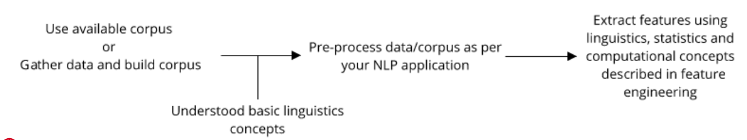

Statistical Natural Language Processing
Computers make it possible to store and analyze massive amounts of written and spoken languages in both structured and unstructured formats. In the 1990s, statistical methods and statistical machine learning emerged and eventually replaced the classical top-down rule-based approaches to processing languages. The statistical approach process natural languages include descriptive statistics, inferential statistics and applied machine learning such as probabilistic modeling, likelihood maximization, and linear classifiers.
Data-Driven methods for natural language processing have now become so popular that they must be considered mainstream approaches to computational linguistics. ... A strong contributing factor to this development is undoubtedly the increase amount of available electronically stored data to which these methods can be applied; another factor might be a certain disenchantment with approaches relying exclusively on hand-crafted rules, due to their observed brittleness.
- Page 358, The Oxford Handbook of Computational Linguistics, 2005.
The statistical dominance of computational linguistics led to NLP being described as Statistical Natural Language Processing:
I view computational linguistics as having both a scientific and an engineering side. The engineering side of computational linguistics, often called natural language processing (NLP), is largely concerned with building computational tools that do useful things with language, e.g., machine translation, summarization, question- answering, etc. Like any engineering discipline, natural language processing draws on a variety of different scientific disciplines.
- How the statistical revolution changes (computational) linguistics, 2009.
Statistical Natural Language Processing heavily relies on feature engineering, which requires careful design and considerable expertise, and then applies machine learning techniques.
Statistical NLP relies on symbol-based representations of textual information. For example, language entries such as words and phrases are considered as distinct symbols and used as units for semantic representation. Many semantic representation methods take words, as the minimum units for semantic representation, which are either used to further estimate the conditional probabilities of next words (e.g., n-gram) or used to represent semantic meanings of text (e.g., bag-of-words models).
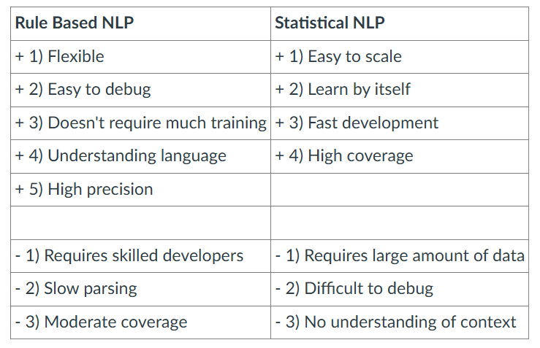
Rule-Based NLP vs. Statistical NLP [source https://pub.towardsai.net/natural-language-processing-nlp-with-python-tutorial-for-beginners-1f54e610a1a0]
It turns out the symbol-based semantic representation causes many issues in NLP, namely:

1. The data sparsity problem
The frequency distribution of words approximately follows a simple mathematical form known as Zipf ’ s law (power-law distribution). The Zip’s Law or Power Law states that frequency of a word is inversely proportional to rank of the word. For example, if you count the number of times each word appears in a given document and assign a rank order on the frequency of each word in the frequency table (e.g., the most frequent word has the rank 1, the second most frequent work has given rank 2 and so on). Thus, the most frequent word will occur approximately twice as often as the second most frequent word, three times as often as the third most frequent word, etc. Due to the power-law distribution of words, the n-gram method performance, for example, with large-scale corpora, will decay dramatically for those few-shot words.

2. Lack of a unified scheme for semantic representation
In NLP, multiple-grained entries in natural languages from words, phrases, sentences, paragraphs to documents. It turns out that is difficult to find a unified symbol set to represent the semantic meanings for all of them simultaneously. In fact, many NLP tasks, such as Information Retrieval, require to measure “semantic relatedness” between words/phrases and documents. The absence of a unified scheme for semantic representation led to distinct and divergent approaches for different tasks in NLP.
Statistical NLP has turned another corner and is now strongly focused on the use of deep learning neural networks to both perform inference on specific tasks and for developing robust end-to-end NLP systems.

Machine Learning
Machine learning, a subcategory of AI, is the science of getting computers to learn from data to perform to perform prediction or classification without being explicitly programmed.
In other words, machine learning aims to automatically learn computer programs, called a model, from labeled training data to make useful predictions. A typical machine learning system consists of four tasks:
- Training data
  - Collect and build a corpus (set of documents) with markups.
- Feature engineering
  - Identify word types, construct surrounding words, etc.
- Training a model on parameters
  - Fit the model on test data
- Inference
  - Apply the trained model to test data to find for example most probable words, next word, or best category.
A typical machine learning system consists of three components:
Machine Learning = Representation + Objective + Optimization.
The first component consists to transform collect data (training data) into internal representations such as feature vectors. Data representation determines how much useful information can be extracted from training data to perform classification or prediction. Then by designing an appropriate objective function, we apply optimization algorithms to find the optimal parameter that minimize the objective function.
Data representation is thus a crucial component to build machine learning model. For this reason, traditional machine learning algorithms require careful feature engineering as preprocessing to build feature representations from raw data. It turns out that feature engineering is a tedious task, time consuming, and requires considerable expertise and customized feature engineering algorithms.
Machine learning is a broad field and composed of three areas: supervised learning, unsupervised learning, and reinforcement learning.

Supervised Learning
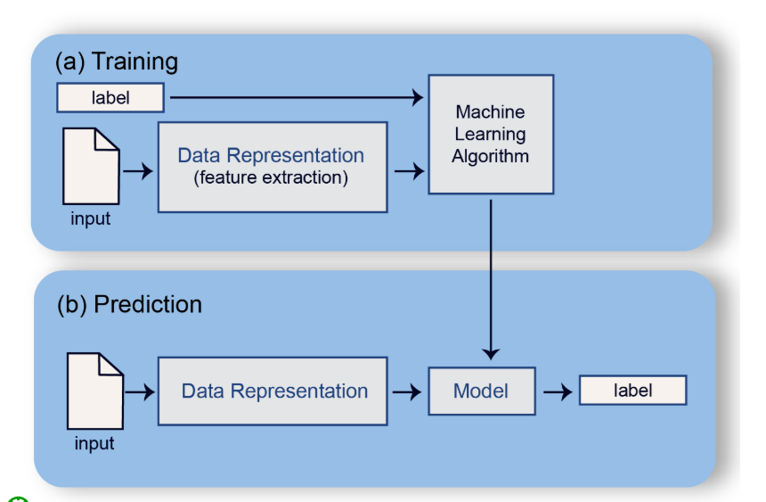
Supervised learning describes a class of problem of predicting labels given input features. A model will learn a mapping between input examples and the target variable. For example, we might want to predict whether or not a mail is a “spam” or “not spam” (also called ham). The class “spam” or “ham”, would be the label and the supervised learning algorithm produces a model that maps any input examples to a label prediction.
There are two main types of supervised learning problems:
- Classification tasks: involve predicting a class label (categorical variables).
- Regression tasks: involve predicting a numerical label (continuous variables).
Both classification and regression problems may have one or more input features of any data type, such as numerical or categorical.

Unsupervised Learning
Unsupervised learning describes a class of problems that involves learning a model to describe or extract relationships between elements in input data. Unsupervised learning operates upon only the input data without labels or target variables and does not have a signal correcting the model.
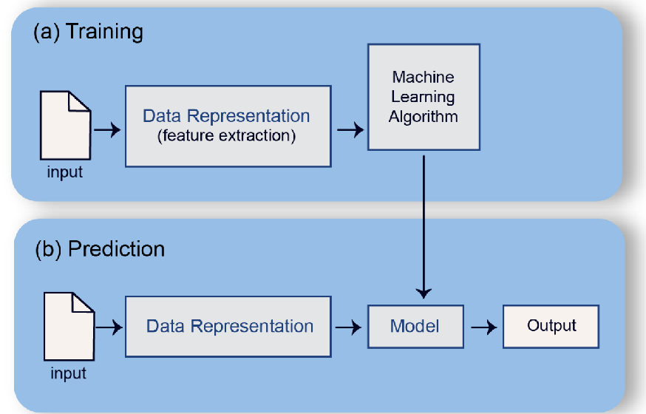
There are many types of unsupervised learning problems:
1. Clustering tasks: involve finding groups in data.
2. Dimensionality Reduction: involve creating lower-dimensional representations of data.
Also, others learning approaches exist such as: Reinforcement Learning, Transfer Learning and Semi-Supervised Learning.

Reinforcement Learning
Reinforcement learning describes a class of problems where an agent interacts with an environment over a series of time steps. At each step, the agent receives some observation from the environment, selects an action and receives a reward from the environment. Reinforcement learning applies to various learning tasks such as robotics, conversational chatbot and video games.
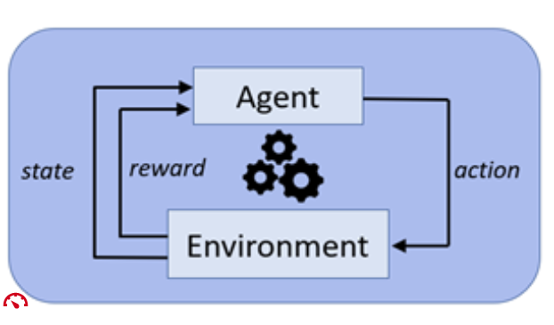

Transfer Learning and Multitask Learning
Transfer learning is a subfield of machine learning focused on sharing knowledge and representations between problems. In Figure 6, a CNN model is trained from scratch with a large dataset to classify vehicles (cars, trucks, buses, etc.). The knowledge gained while learning can be embedded in a new object detection model with a small dataset to recognize cars and trucks.
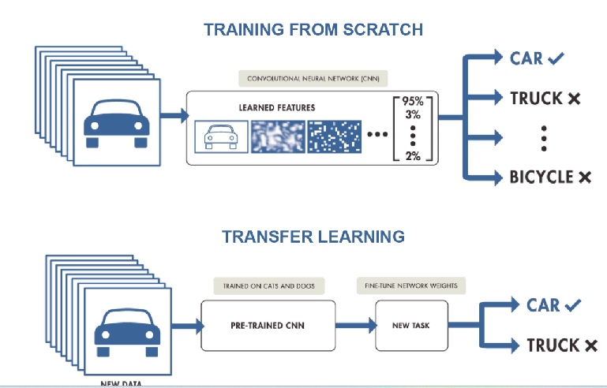
Multi-tasks is a subfield of machine learning in which multiple learning tasks are learned at the same time using the same training dataset. Multi-task learning improves learning efficiency and accuracy for the task-specific models, when compared to single task learning (training one model per task separately).
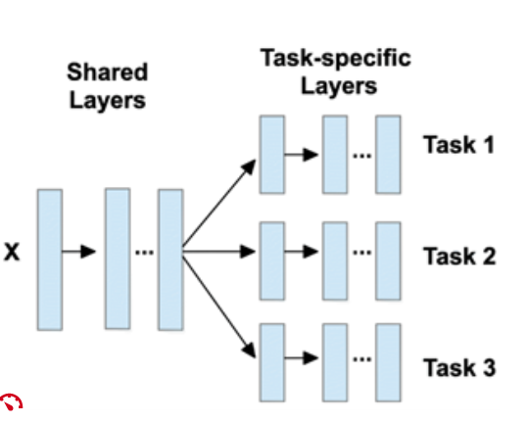
These techniques become popular in both deep learning, NLP and speech recognition.

Natural Language Processing: A Brief History
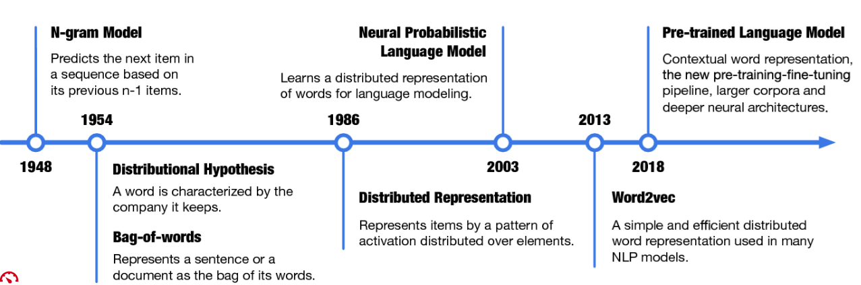
The timeline for the development of representation learning in NLP. (Representation Learning and NLP by Zhiyuan Liu, Yankai Lin and Maosong Sun)
Natural Language Processing and Speech recognition have history of extensive studies and show how ideas developed over time. By understanding the history of NLP, it becomes easy to put the current solutions and methods into proper context.
The above figure illustrates the evolution of NLP and the main contributions of distributed representations. Intuitively, words would be the minimum units in natural languages.

One-hot vectors
In early stage of NLP, vectors, called one-hot vectors (a.k.a “1-of-K” or “one-hot” encoding vectors) are used to represent words in a computer-readable format. This encoding uses a sparse vector of length-K, representing each of the words in a length-K vocabulary.
After building the vocabulary (unique list of all words in all documents), one-hot vector, representing a word has the dimension of the vocabulary size, K, and has the value of “1” at the word’s corresponding position and “0” to other positions. One-hot vectors are simple representations, but they do not carry any semantic information about words.
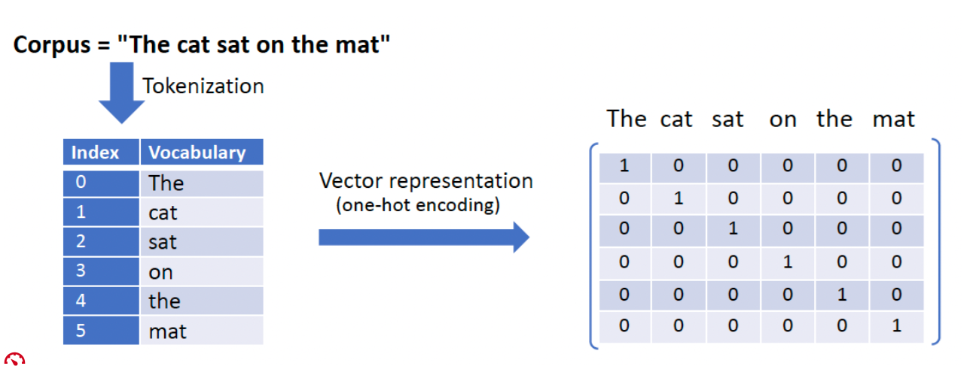

n-gram model
One of the earliest ideas of word representation was the n-gram model (Claude E Shannon. A mathematical theory of communication. Bell system technical journal, 27(3):379–423, 1948) in which a “word is characterized by the company it keeps.” ( John R Firth. A synopsis of linguistic theory,1930–1955.1957) The idea is when we want to predict the next word in a sequence of words, we usually examine some previous words. In the case of n-gram, we simply look at the previous n − 1 words.
Given a large number of documents (called corpus), it is possible to count each word and estimate its probability under the condition of all combinations of n − 1 previous words. By such, these probabilities are used to predict the next word in sequences of words. Each word is thus represented by a vector of probabilities, reflecting the meanings of the word in different contexts.
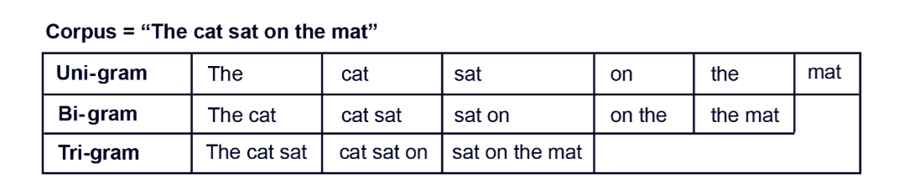

Distributional Hypothesis
The idea of n-gram models is coherent with the distributional hypothesis: "words with similar linguistic contexts have similar meanings." In another phrase, “a word is characterized by the company it keeps." Distributional hypothesis is one of the ways to give the definition of word Meaning. Distributional hypothesis forms the fundamental idea of many NLP models, from word2vec to BERT and becomes the theoretical foundation of distributional semantics (aka vector space semantics).
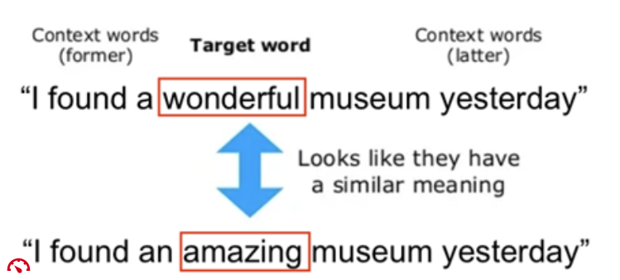

Bag of Words (BOW) Models
The Bag-Of-Words model (Zellig S Harris. Distributional structure. Word, 10(2–3):146–162,1954) is another example of the distributional hypothesis where each document is viewed as a bag of its words, disregarding the order of their appearance in the document. Each document is then represented as a vocabulary-size vector, in which each word that has appeared in the document has a score (e.g., the numbers of occurrences) to indicate its weights in the document. The BOW model has successfully applied applications such as spam filtering, text classification, and information retrieval, proving that the distributions of words can serve as a good representation for text.
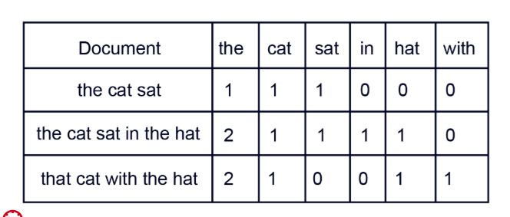

Distributed representation
Word representations in Bag-Of-Words and the n-grams models are vectors with values that match one entry (e.g., word scores in BOW models). In this context, vectors are sparse representation in high dimensional space. In addition, the one-to-one correspondence between concepts and representation elements is called a local representation or symbol-based representation.
In distributed representation, on the other hand, each entity (or attribute) is represented by a pattern of activation distributed over multiple elements, and each computing element is involved in representing multiple entities (James L McClelland, David E Rumelhart, PDP Research Group, et al. Parallel distributed processing. Explorations in the Microstructure of Cognition, 2:216–271, 1986).
A distributed representation refers to the concept in which an object / feature / concept / word can be represented as a vector of component values. The distributed representation occurs when some concept or meaning is represented by the neural network as a pattern of activation distributed over multiple processing units (neurons). The meaning is thus not locally represented by a single unit. In other words, it means that neural network model decomposes the input (e.g., word) and hierarchy extracting features from it up to the point where several neurons (distributed across the network) are used to represent the input and approximate an output. The output is the distributed representation represented as a dense vector in low dimensional space.
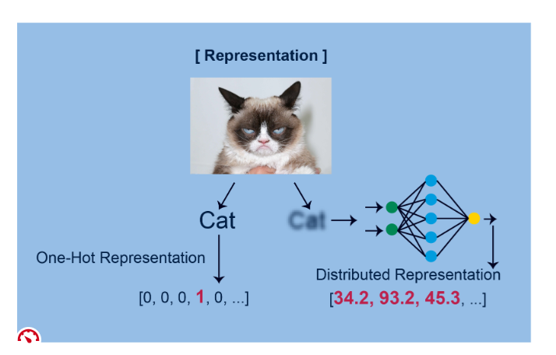
Distributed representation (https://www.wionews.com/photos/grumpy-to-lil-bub-take-a-look-at-internets-5-famous-cats-403565#garfi-403553)
Distributed representation has been proved to be efficient since hidden properties can be learned from large-scale data. With the popularity and success of deep learning networks, distributed representation becomes the most used approach for representation learning.

Word embeddings
Based on the distributional hypothesis, representation learning for NLP has evolved from symbol-based representation to distributed representation and took a big leap with Neural Probabilistic Language Model (NPLM)(1) (Yoshua Bengio, Réjean Ducharme, Pascal Vincent, andChristian Jauvin. A neural probabilistic language model. Journal of Machine Learning Research, 3(Feb):1137–1155, 2003). Put it simply, a language model predicts the next word in a sequence given the sequence of words already present (n-gram models are simple language models). Language models are crucial components in many NLP applications such as machine translation and speech recognition.
When NPLM is trained on large corpora, it first assigns a distributed vector for each word, then uses a neural network to learn the joint probability of sentences. Word embeddings (i.e., low-dimensional word vectors) are simply the learned parameters (hidden layers), and they encode semantic meanings about the words, verified by the performance of NPLM.

Word2Vec
Word embeddings map discrete words into informative low-dimensional dense vectors. Many methods are inspired by NPLM and employ neural networks to embed words into distributed representations.
For examples, word2vec, GloVe, and fastText are trained on large-scale corpora and use the language modeling objective to optimize distributed representations as model parameters.
In Figure 1.14, the word2vec algorithm trains a neural network that is optimized on a corpus of sentences. Given a the word w (w=”chased”) as input from the corpus sentences, the neural network predicts each of the words c (e.g., dog, cat, etc.) that are located within a context window C (C= “The slow dog chased the fat cat”) surrounding the word c.
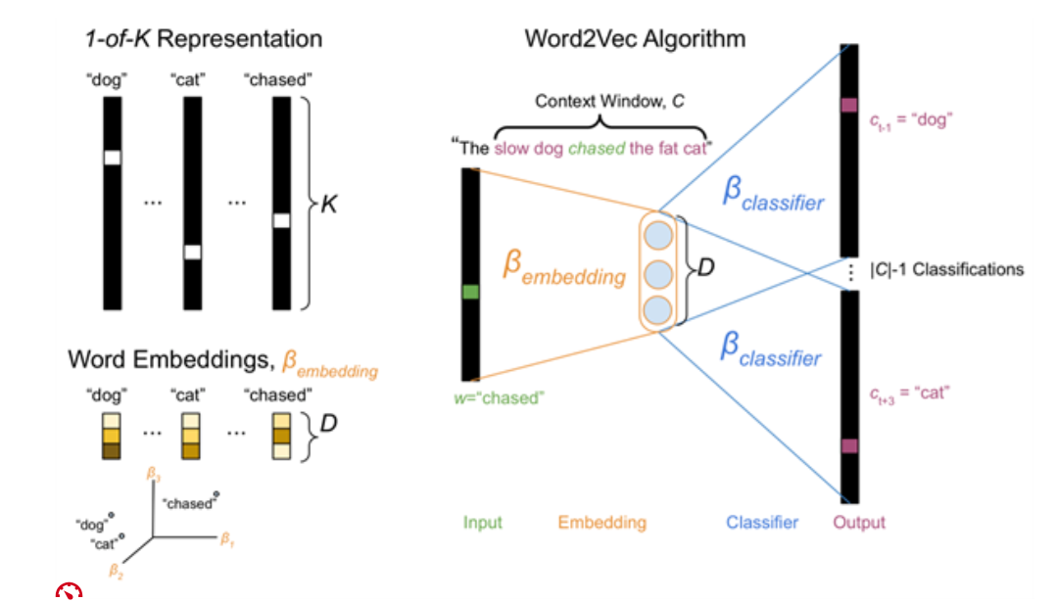
Illustration of the Word2Vector (https://dustinstansbury.github.io/theclevermachine/info-theory-word-embeddings)

Pre-trained Language Models
Representation learning in NLP took a big leap with transformers (attention models) applied to language modeling.
BERT (Bidirectional Encoder Representations from Transformers) is a transformer language model with a variable number of encoder layers and self-attention heads. BERT was pretrained on two tasks: 1) predict them from context (language modeling) and predict next sentence. As a result of the training process, BERT learns to calculate dynamic representations for the words based on their context (e.g., contextual embeddings for words) which is useful for words with multiple meanings. After pretraining, which is computationally expensive, it becomes a common practice to fine tune BERT with less resources on smaller datasets to perform a specific NLP task.
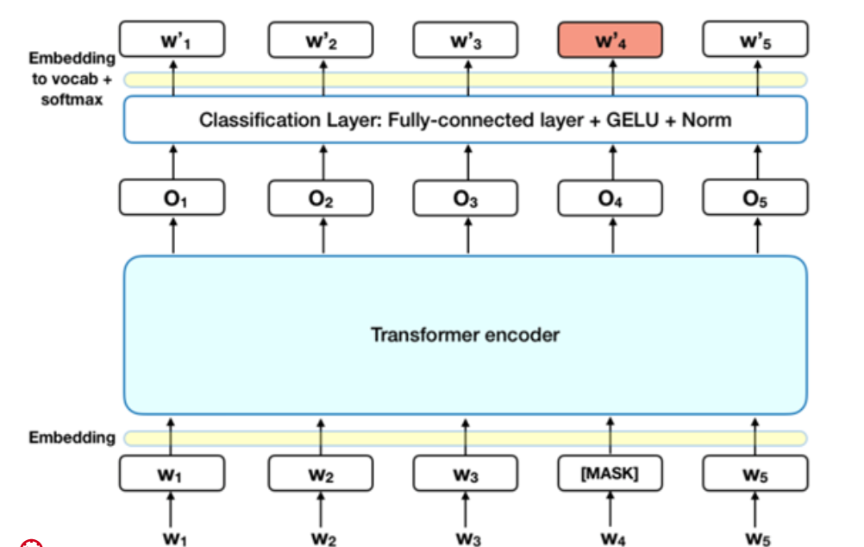
BERT Architecture (https://towardsdatascience.com/bert-explained-state-of-the-art-language-model-for-nlp-f8b21a9b6270)
A different approach, which is also popular in NLP tasks, of pre-trained language models (PLM is ELMo which is feature-based training. In this approach, a pre-trained neural network produces word embeddings which are then used as features in NLP models.
Recently, emerged PLMs like XLNet, RoBERTa, DistilBERT and GPT3 have taken the NLP landscape by a storm and start a new trend of the pretraining fine-tuning models, outperforming the state-of-the-art on several NLP tasks.

Tools and Libraries
Many popular open-source resources are now available to build end-to-end NLP systems. In the section below, we provide a non-exhaustive list of libraries (NLP, deep learning, or speech analytics) and datasets

Natural Language Processing
Popular open-source libraries for natural language processing include:
Select the tabs below to see some open-source libraries:
Natural Language Toolkit (NLTK)The Natural Language Toolkit, or NLTK for short, is an open-source suite of libraries for symbolic and statistical natural language processing for English. It was developed by the University of Pennsylvania.

Features:
- Tokenization.
- Part Of Speech tagging (POS).
- Named Entity Recognition (NER).
- Classification.
- Sentiment analysis.
- Packages of chatbots.
Use-cases:
- Recommendation systems.
- Sentiment analysis.
- Building chatbots.

SpaCyA
high-performance Python-based toolkit for advanced natural language processing. SpaCy is open-source and supported by Explosion AI.
Features:
- Tokenization.
- Part Of Speech tagging (POS).
- Named Entity Recognition (NER).
- Classification.
- Sentiment analysis.
- Dependency parsing.
- Word vectors.
Use-cases:
- Autocomplete and autocorrect.
- Analyzing reviews.
- Summarization.

Gensim
A Python-based, open-source toolkit that focuses on vector space and topic modeling of text documents.
Features:
- Latent semantic analysis.
- Non-negative matrix factorization.
- TF-IDF.
Use-cases:
- Converting documents to vectors.
- Finding text similarity.
- Text summarization.
Features:
- Tokenization.
- Part Of Speech tagging (POS).
- Named Entity Recognition (NER).
- Classification.
- Sentiment analysis.
- Dependency parsing.
- Word vectors.
Use-cases:
- Autocomplete and autocorrect.
- Analyzing reviews.
- Summarization.

Other NLP libraries:
Stanford CoreNLP: A Java-based toolkit of linguistic analysis tools for processing natural language text. CoreNLP was developed by Stanford University.
OpenNLP: An open-source machine learning toolkit for processing text in natural language. OpenNLP is a sponsored by the Apache Project.
AllenNLP: An NLP research library built in PyTorch.
Pattern: Pattern is an NLP Python framework for a web mining, NLP and Network Analysis.
TextBlob: TextBlob is a Python library for processing textual data. It provides a simple API for diving into common natural language processing (NLP) tasks.

