At the end of this lesson, you will be able to:
- Understand the challenges in processing unstructured data.
- Explore the workflow of text processing using the NLTK and Scikit-learn libraries.
- Use tokenization to generate different representations of text data: words, sentences, vectors.
- Define a pipeline to clean the data and remove stop-words and punctuation.
- Pre-process the text with stemming and lemmatization, and explore properties of words such as homonymy, polysemy, synonymy and hyponymy.
- Enrich the pre-processed text with Part of Speech tags and perform different filtering to select chunks of sentences.
- Explore text data with histograms of frequency distributions and WordcCloud.

Text Analysis Overview
Text analysis (TA) is a machine learning technique used to automatically extract machine-readable information from unstructured text. It aims to identify patterns and valuable insights from the body of text.
For example, analyzing textual social media (tweets, blog posts, online reviews, ...) written by clients in restaurants websites aims to learn new facts or trends about menus and services. Text analysis helps restaurants to develop different NLP tasks:
- Sentiment analysis
- Topic Modelling

Sentiment analysis
Sentiment analysis (or opinion mining) is a (NLP) task used to determine whether the underlying sentiment is positive, negative or neutral. It helps managers to understand the social sentiment of their menus or service while monitoring online social posts. The table below shows examples of sentences and their corresponding sentiment.
My coffee was not that great. | neutral?
I did not think my coffee was great. | negative
I did not expect my coffee to be this great. | positive
I was disappointed with the quality of the coffee. | negative
I was not disappointed with the quality of the coffee. | positive

Topic Modelling
Topic Modelling refers to the task of identifying topics (words) that best describes a set of documents. These topics will only emerge from unsupervised classification of a set of blog posts, similar to clustering on numeric data, to find natural groups of items.
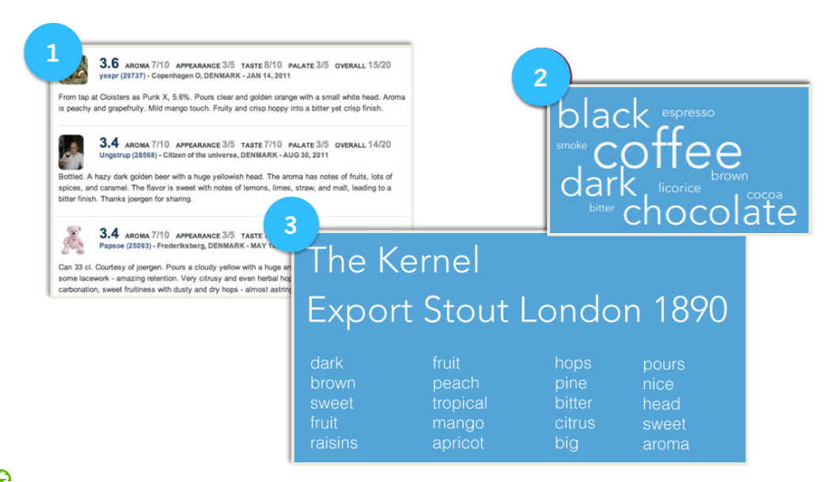
In the above figure each review is assigned a list of topics. Each topic is a cluster of similar words like coffee, dark, black, espresso, etc.

Challenges in Processing Unstructured Data
One of the main challenges in text analysis is the problem of the curse of dimensionality (high dimensionality). The curse of dimensionality refers to various phenomena that arise when analyzing and organizing documents where every possible word represents a dimension. For example, computers require numeric representations of words (e.g., one-hot encoding vector representation) to process them. Consider the book ‘Green Eggs and Ham’ by Dr. Seuss, which he wrote with just fifty different words. This means each word is represented by a vector of 50 (features). A book with 100,000 unique words leads to huge sparsity associated with such high-dimensional vector of 50,000 features. The corpus of documents is then represented by a huge matrix which takes large space in computer memory and requires extensive computations.
The other major challenge with text analysis is that the data is unstructured data. Unstructured data is the data which does not conform to a data model (e.g. database schema), making it difficult to store and process in traditional relational databases. The vast majority of new data being generated today by human or machines is unstructured data. The form of unstructured data is either textual or binary: A text file may contain the contents of various tweets or blog postings whereas the binary files are often media files that contain image, audio or video data. Figure 2.3 shows unstructured data in different forms, including text files and documents, websites, sever logs, email messages, images and audio clips, videos, and posts from social media sites, just to mention a few.
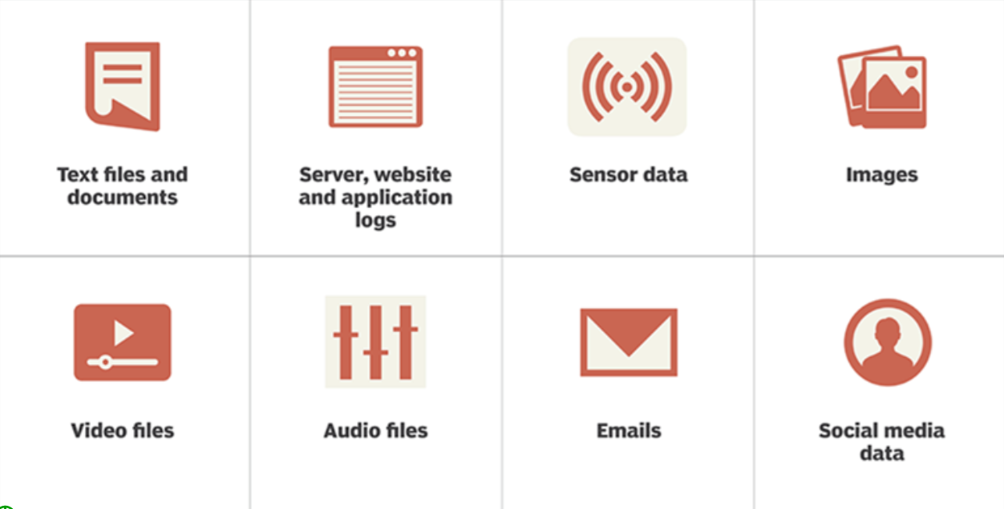

Unstructured data examples
Processing and storing unstructured datasets is a challenge in NLP because they require a special purpose logic. For examples:
- Video files require a correct codec (coder-decoder) to play them.
- Unstructured data cannot be queried using SQL but they can be saved as Binary Large Objects (BLOB).
Most common challenges we face in NLP are around unstructured data and non-trivial tasks to represent and visualize abstract concepts in documents. It turns out that countless combinations of subtle relationships among concepts make software incapable of “reading” or “understanding” text or speech.
Unlike Machine Learning algorithms that work with structured data (tabular data), computers cannot understand raw and unstructured text. The figure below shows the difference between how a human and computers would explain the text that Raphael sent to Chloe. Obviously, Raphael is trying to build his relationship with Chloe, but computers not only require representations of the natural language in a way they can process but also linguistic tasks to deal with the linguistic ambiguity such as subtleties, sarcasm, jokes, wordplay, phonetic similarities between words etc.
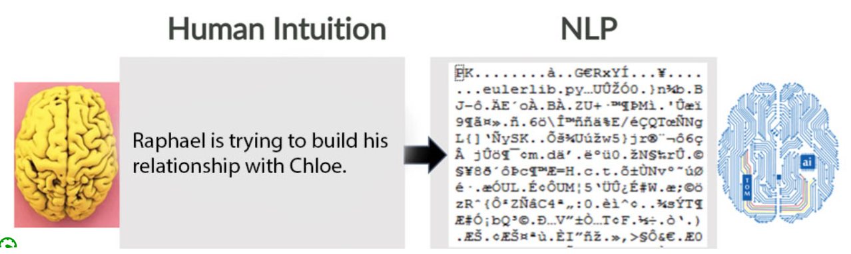

Representation of text in computers
The aim of NLP is to perform special tasks of linguistic analysis that essentially helps computers “read” or “understand” text. Linguistic tasks include (but not limited to):
- Bag of Words
- Vector representation of words
- Part-of-speech tagging
- Parsing trees
- Entity/relation extraction
- Automatic Summarization

Text Processing: A Workflow View
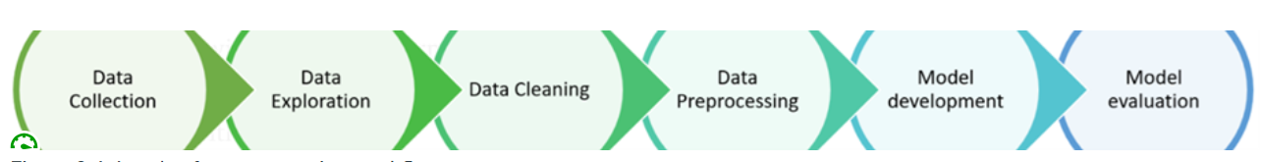
Levels of text processing workflow
As illustrated in the above figure a typical text analysis workflow consists of several phases, each of which consists of steps to process a textual corpus:
Data Collection
Read text files
Data Representation
Word
Sentences
Data Preprocessing
Data Cleaning
Stemming
Lemmatization
Additional cleaning
Exploratory Analysis
Frequency
WordCloud
Before introducing these phases, we will use the Natural Language Toolkit (NLTK) the text analysis with examples in Python. We must first have to install NLTK. From your Jupyter Notebook run the following installation steps.
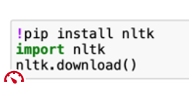
A pop up will give you the option to download all packages which gives you all of the tokenizers, chunkers, other lemmatizers, stemmers, and all of the corpora.
In the NLP community, the vocabulary used to refer to the text includes terms such as:
- Corpus: denotes the body of text (singular). Corpora is the plural of corpus.
- Lexicon: refers to words and their meanings.
- Token: refers to “entity” that is a part of the text (e.g., word, sentence, message, or entire document).

Data Collection
Data Collection consists of collecting and reading raw text and documents with text formats and structures.

Read Text Files

To illustrate the text analysis, we will read and process The Prophet book by Kahlil Gibran. Kahlil Gibran (1883- 1931) was a Lebanese American artist, poet, and writer. The Prophet is one of his masterpieces published in 1923 and translated into more than twenty languages. The book is available online (https://www.gutenberg.org/files/58585/58585-h/58585-h.htm) and can be downloaded here (https://www.gutenberg.org/ebooks/58585).
We start by opening and reading the book saved as Plain Text UTF-8. It is good practice to check the data type of text file. The last instruction shows that the type is a `String`.
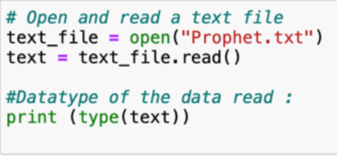
We then list the content of text file.
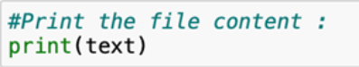
We then check the length of the text.
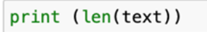
Data Representation
Before cleaning and exploring the text, we need to break up the text into words, phrases, elements (aka “tokens”). We thus can tokenize the text to unigrams (single words), bigrams (pairs of words),...n-grams (group of n-words).
Sentence Representation
The following code imports the NLTK library and splits the text by sentences. The text counts 614 sentences.
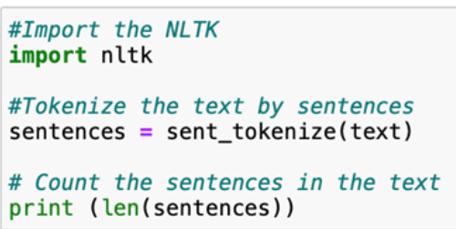
We examine the content of the text after tokenization.
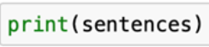
Word Representation
Another way of tokenization is to break up the text into words.
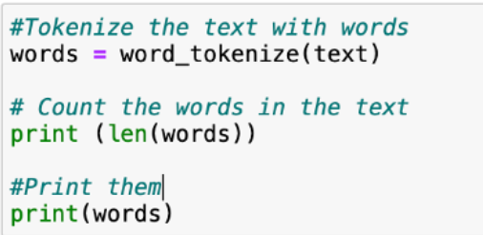
Word Properties
It is important to find relations among words and their senses when processing text. Relationships between words include:
- Homonymy: same form, but different meaning (e.g., bank: riverbank, financial institution)
- Polysemy: same form, related meaning (e.g. bank: blood bank, financial institution)
- Synonymy: different form, same meaning (e.g. singer, vocalist)
- Hyponymy: one word denotes a subclass of another (e.g. breakfast, meal)
WordNet is a large lexical database of English. It groups words based on their meanings. WordNet resembles a thesaurus, containing nouns, verbs, adjectives and adverbs into sets of cognitive synonyms (called synsets). Each synset defines a distinct concept. Synsets are interlinked by means of conceptual-semantic and lexical relations. Some words have only one Synset and some have several Synsets.
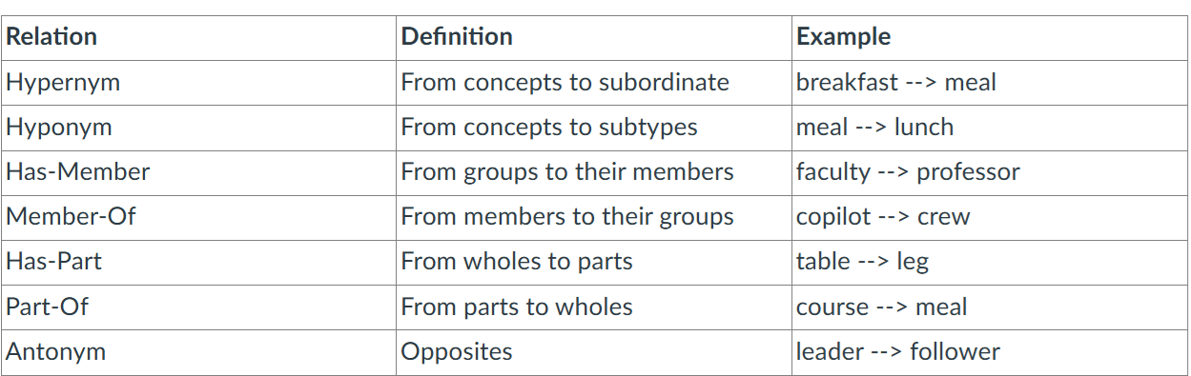
Bag-of-Words
The Bag of Words (BoW) is an algorithm that counts how many times a word appears in a document. The word counts make it possible to compare documents and compute their similarities.
BoW is also a method for preprocessing text for input in applications like search, document classification and topic modeling and deep-learning neural networks. Bag of words relies on the word tokenization to generate unigrams (a.k.a single word) tokenization across the corpus and then aggregate them using different approaches such as TF-IDF, Binary and Frequency counts. These are very simple aggregation approaches. BoW thus represents each word as a separate variable having numeric weights.
The general workflow of the Bag-of-word can be depicted as follows:
Raw documents => Clean text => Tokenize Words (Unigram) => Build Vocabulary => Generate Vector representations (e.g., Frequency Counts, TF-IDF)
- Raw documents refer to the original texts to process by the Word-of-Bag analysis.
- Clean Text aims at cleaning raw text from some unnecessary words (e.g., punctuation marks and stop-words).
- Tokenize words splits sentence into tokens or words (unigrams).
- Build Vocabulary aims at generating a dictionary of total unique words in the entire corpus. Each word has a unique index.
- Generate Vector represents each word as a vector where each element is the frequency or the weight of the word in every document or sentences.

Data Preprocessing

Data Cleaning
The goal of text cleaning is to standardize the text as much as possible, so that words with the same intent are grouped together. Text may contain stop words like ‘the’, ‘is’, ‘are’ which can be filtered from the text.
There is no universal list of stop words in NLP research, however the NLTK module contains a list of stop words.
The first step is to remove punctuations and stop-words. The following code removes punctuations by setting all letters to their lower cases.
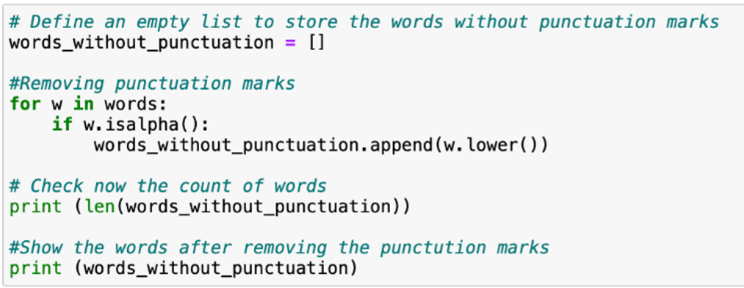
Stop-words are words that from a non-linguistic view do not carry information. Stop words have only a functional role in the text and we usually remove them to help the NLP tasks to perform better.
There is no universal list of stop-words in NLP. The NLTK module contains a list of stop words which depends on your language which one you are using to process the text.
Let’s first load the list of stop-words (English) and remove them from the list of words without punctuations.
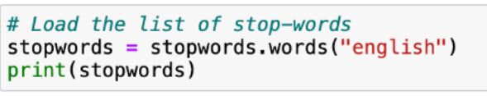
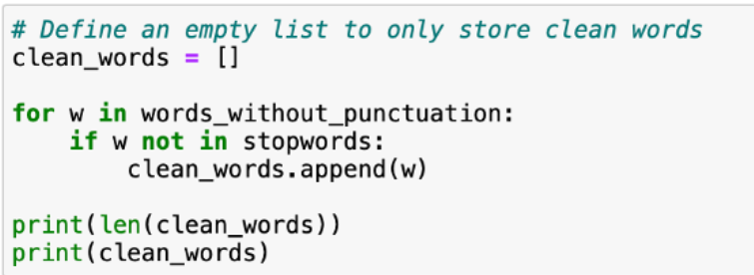
Additional cleaning could be applied to remove spaces, remove any special characters (%,?,!), remove unwanted URLs, HTML tags, hashtag, stop words, numeric and alphanumeric words, and special characters.
Stemming
Different forms of the same word are usually problematic for text analysis since they have different spelling and similar meaning. Stemming is a process of transforming a word into its stem (normalized form) in such a way that the words of similar kind lie under a common stem. For example – The "Study", "Studying", "Studies", "Studied" lie under the same stem ‘studi.
Some few common rules in English of the Porter stemming are:
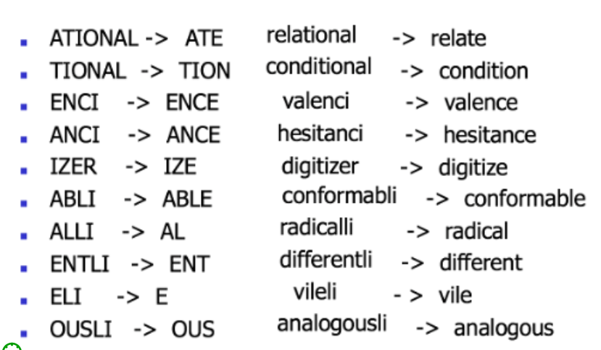
In the following example, we import the PorterStemmer and define the Wordlist to respectively illustrate the stemming with the list of ["Pray","Praying","Prayers","Prayed"] and the list of ["studies","leaves","decreases","plays"].
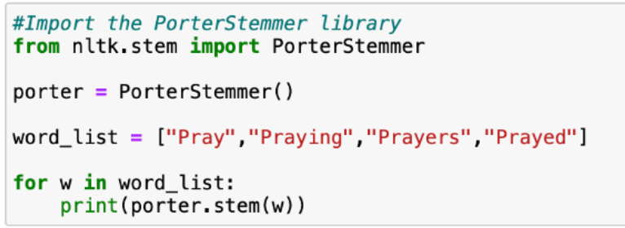
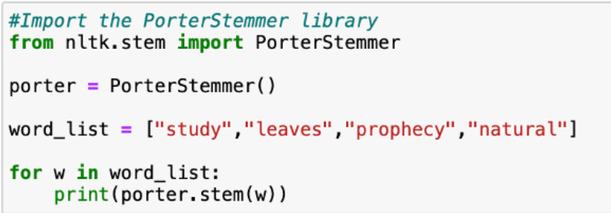
The Snowball Stemmer is known as the Porter2 stemming algorithm which fix some issues of Porter Stemmer.
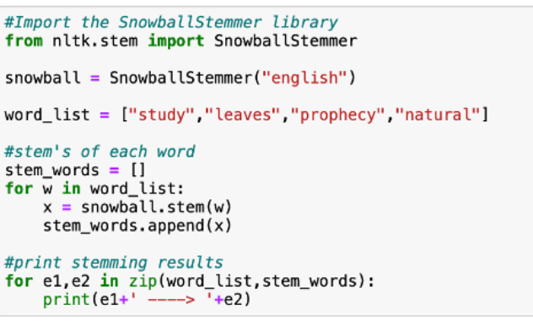
Let’s print the languages supported by Snowball Stemmer.
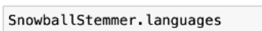
Lemmatization
Lemmatization is similar to stemming but uses morphological analysis of words to group together the different inflected forms of a word so they can be analyzed as a single item. The algorithm relies on dictionaries to look through in order to link the form back to its lemma. Lemmatization is often preferred over Stemming because of its morphological analysis.
Original | Stemmed | Lemmatized
walked | walk | walk
are | are | be
natural | natur | natural
processing | process | process
Compared to the PorterStemmer, the WordNet Lemmatizer brings context to the words.
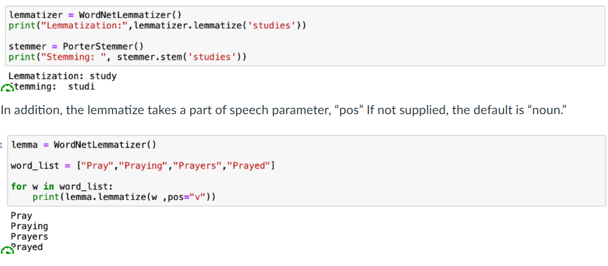
In this example, the “pos” parameter takes “v” to denote a verb.
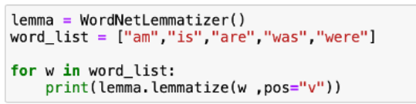
Exploratory Analysis
After the tokenization, it becomes possible to explore the document and apply statistical analysis such as:
- Frequency: Count of times each word appears in the corpus
- Word cloud: graphical representation of word frequency which is often used to depict words in different sizes
- conditional frequencies: Count of times each word appears in the corpus dependent on an additional criterion
- Concordance: A list showing all the appearances of a text of phrase
- Similar: Returns words in a range of contexts similar to that of the input word
- Collocations: Sequences of words that usually appear together
Frequency
In the following code, we compute the frequency of words before removing top-words and plot the frequency distribution of 20 most frequent words.
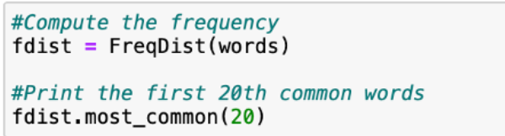
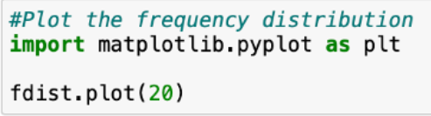
Similarly, we compute the frequency of words after removing punctuations and plot the frequency distribution of 20 most frequent words.
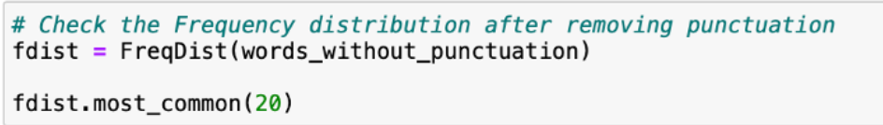
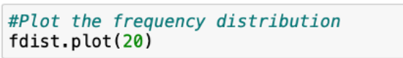
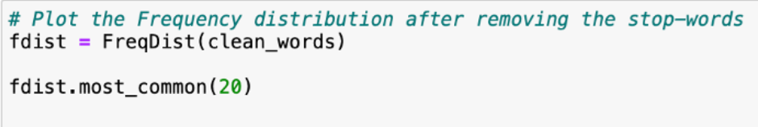
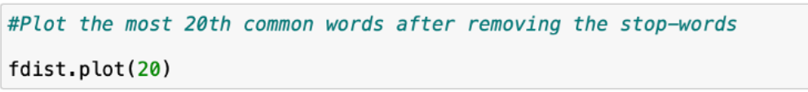
Word Cloud
Word Cloud is a graphical representation of word frequency which is often used to depict words in different sizes and give greater prominence to words that appear more frequently in the source text.
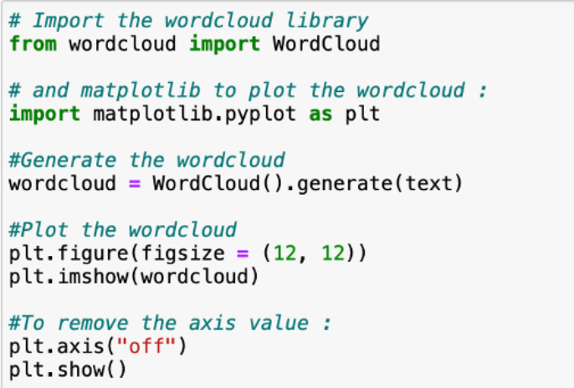
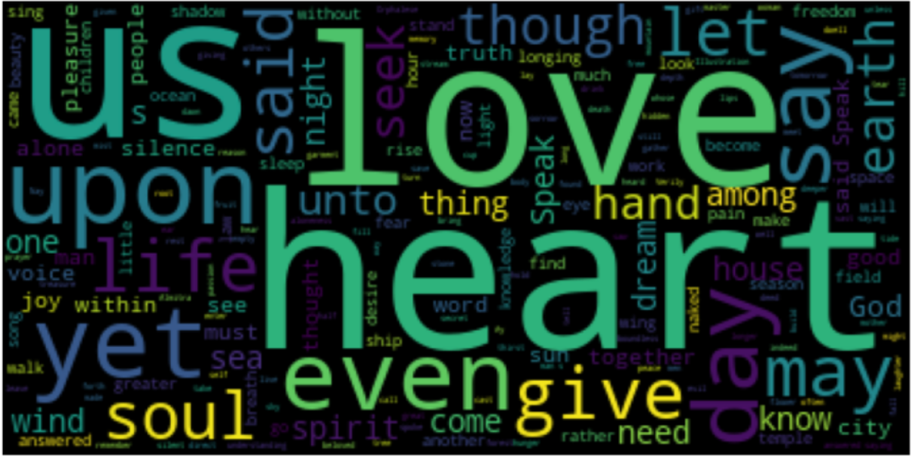
Model Development and Evaluation
Once the textual data is cleaned and words are encoding with numeric vectors, many supervised and unsupervised machine learning can be applied to perform NLP tasks. The objective of the model development and evaluation is to build models to find non-trivial, hidden, previously unknown and potentially useful patterns in large textual datasets. In addition, algorithms such Naive Bayes and K-means clustering can be used to tackle problems such as text classification and topic extraction.
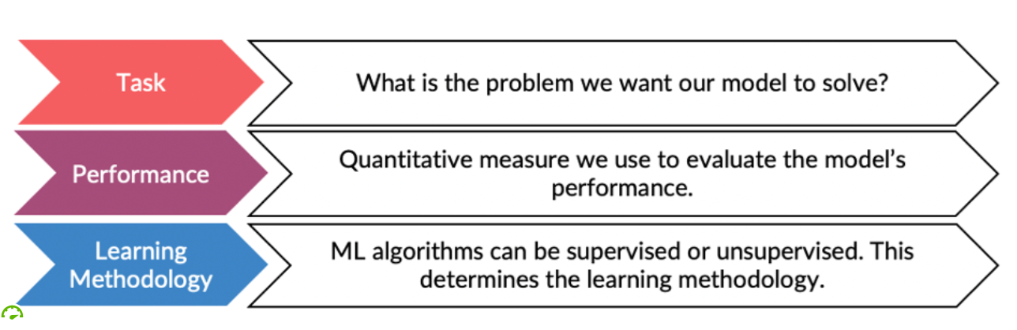

References
  - Goodfellow, I., Bengio, Y., Courville, A. (2016). Machine Learning Basics. Deep Learning Book. MIT Press. Source: http://www.deeplearningbook.orgLinks to an external site.
  - Gibran, K. (1923). The Prophet; Published by Alfred A Knopf, Inc.; A Borzoi (hardcover) Book, ASIN: B004S0ZKJO

