Group Discussion Assignment 1

Group 3
Aryaman Singh Dev
Assia Bensafia
Saakshaat Saini
Venkata Sai Renusree Bandaru (Renu Bandaru)

Assia’s Response

Sentiment Analysis
Sentiment analysis is a Natural Language Processing (NLP) task that looks at text and determines the emotion behind it, usually classifying it as positive, negative, or neutral. It is often called opinion mining because it focuses on understanding how people feel about a topic. For example, a sentence like “This phone is amazing and fast” would be considered positive, while “The battery life is terrible” would be negative. According to IBM, sentiment analysis helps analyze large amounts of text to identify these types of opinions, while Speech and Language Processing explains it as a text classification problem where models learn to detect sentiment in language.
Sentiment analysis works by combining NLP and machine learning to understand and classify text. It takes unstructured data like reviews, tweets, or emails and determines whether the overall tone is positive, negative, or neutral. For instance, if a company analyzes customer feedback and sees many comments like “I love this product”, it indicates positive sentiment, while repeated phrases like “this app keeps crashing” indicate negative sentiment. IBM explains that systems can use rule-based methods, machine learning, or a mix of both to identify these patterns. Cision adds that this helps organizations understand how customers feel about their products or services and respond accordingly.
- Examples
Product Reviews :In product reviews, sentiment analysis helps determine whether customers are satisfied or dissatisfied. For example, a review like “This laptop is amazing and lightweight” would be classified as positive, while “The battery life is terrible” would be classified as negative. This allows companies to quickly understand what customers like or dislike about a product.
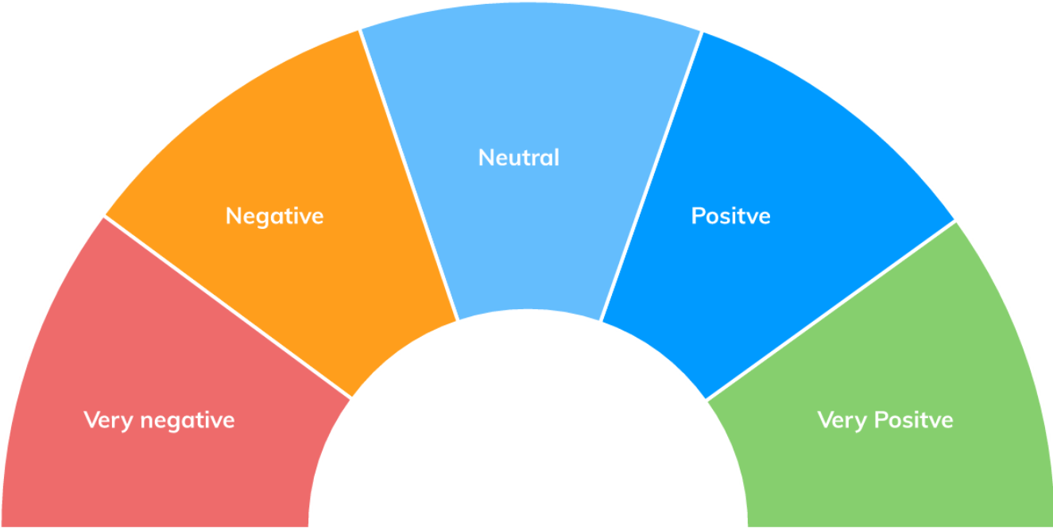
Figure 1: Image Source: Concepts adapted from IBM (Sentiment Analysis) and Cision (What is Sentiment Analysis)

Social media: Sentiment analysis is also widely used on social media to track public opinion. For example, a post like “I love the new update!” shows positive sentiment, while “This app keeps crashing and is frustrating” shows negative sentiment. Companies use this information to monitor their brand reputation and respond to customer feedback in real time.
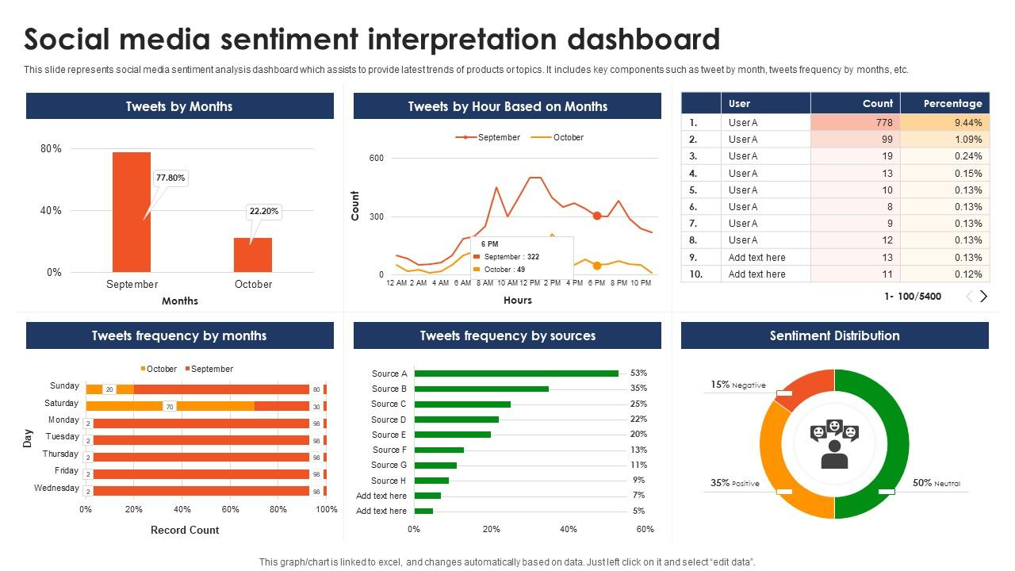
Figure 2:Concepts adapted from IBM, Cision, and Speech and Language Processing
Customer Feedback: Organizations also use sentiment analysis to evaluate customer feedback such as surveys, emails, or support messages. For example, “The support team was very helpful” would be positive, while “I didn’t get help in time” would be negative. This helps businesses identify issues and improve customer experience.
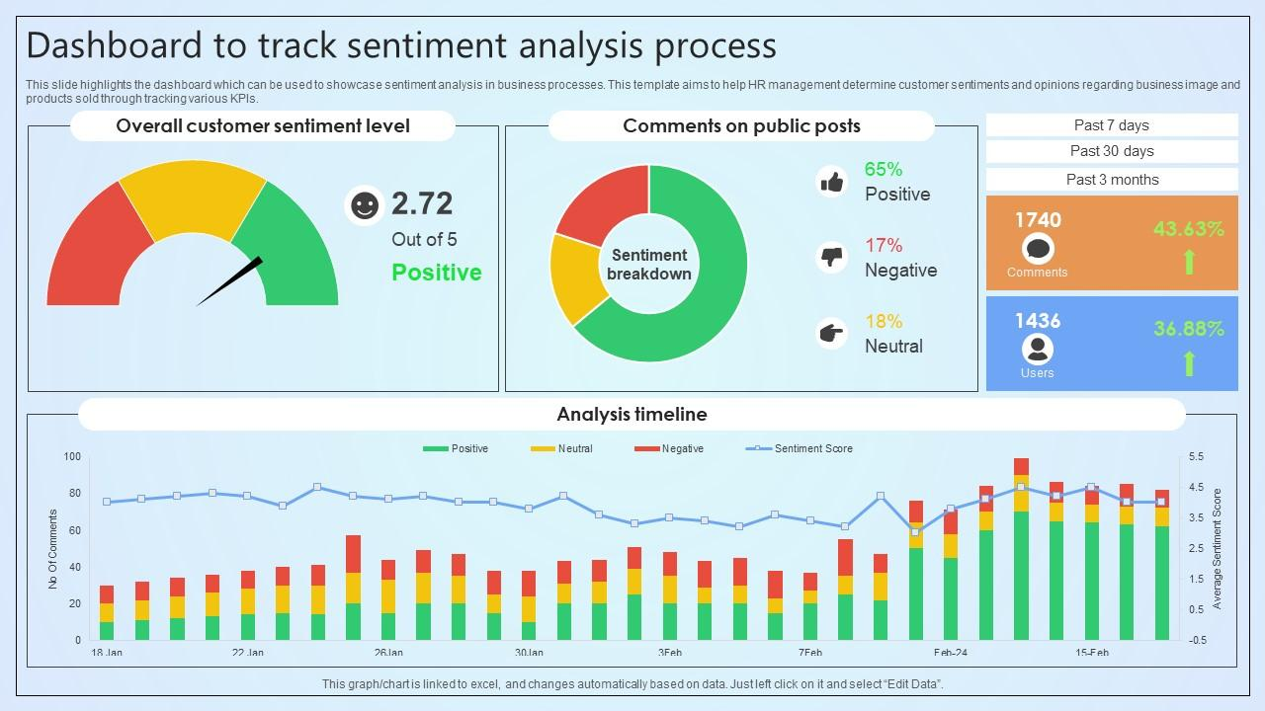
Figure 3:Concepts adapted from IBM and Speech and Language Processing
- The Importance of Sentiment Analysis
Sentiment analysis is important because it helps organizations make sense of large amounts of text data quickly. Instead of reading thousands of reviews or comments, companies can automatically detect whether customers are happy or dissatisfied. This helps improve products, monitor brand reputation, and respond to customer concerns faster. IBM highlights its role in improving customer experience, while Cision emphasizes its importance in marketing and public relations.
- References
- IBM. (n.d.). Sentiment analysis. https://www.ibm.com/think/topics/sentiment-analysis
- Cision. (n.d.). What is sentiment analysis? https://www.cision.com/resources/articles/what-is-sentiment-analysis/
- Jurafsky, D., & Martin, J. H. (n.d.). Speech and language processing (3rd ed.). https://web.stanford.edu/~jurafsky/slp3/

Saakshaat ’s Response
Word segmentation refers to the process of breaking down a continuous string of text into distinct, meaningful words, which helps in understanding and processing the information effectively. This step is essential in natural language processing (NLP) because computers need text to be divided into smaller units, known as tokens, before they can carry out tasks such as searching, translating, or analyzing sentiment. For example, a string like “IloveDataScience” can be separated into “I love Data Science,” making it much easier to read and comprehend. Segmentation is also vital in English for contexts like hashtags, URLs, or speech recognition, where spaces aren’t always present.
However, word segmentation can be tricky due to its ambiguity and dependence on context. For instance, “choosespain.com” could be interpreted as either “choose Spain” or “choose pain,” and the right interpretation relies heavily on the context in which it appears. This challenge is even more pronounced in languages such as Chinese or Japanese, where words are not separated by spaces. Take the Chinese sentence “我喜欢学习,” which translates to “我 / 喜欢 / 学习” (I / like / studying). Without appropriate segmentation, grasping the meaning of such text would be quite challenging.
In summary, word segmentation is key to helping machines understand human language by organizing raw text into meaningful elements. It enhances the accuracy of various NLP tasks and is commonly utilized in applications such as search engines, chatbots, and language processing models.

References:
https://en.wikipedia.org/wiki/Text_segmentation
https://en.wikipedia.org/wiki/Natural_language_processing

Renu’s Response
Part of speech tagging -
Part‑of‑speech (POS) tagging is a preprocessing NLP task in which each word in a sentence is labeled with its grammatical category such as noun, verb, adjective, etc., based on both its meaning and its context. POS tagging is crucial for understanding the syntactic structure of a sentence and identifying grammatical roles, helping parsers, chatbots, and search systems interpret sentence structure and meaning more accurately, and therefore supporting machine understanding of natural language.
There are different kinds of POS tags. POS tags are short codes representing specific parts of speech. Common POS tags include Noun (NN), Verb (VB), Adjective (JJ), Adverb (RB), Pronoun (PRP), Preposition (IN), Conjunction (CC), Determiner (DT), and Interjection (UH)
There are different types of POS tagging as well:
- Rule Based Tagging assigns POS tags based on predefined grammatical rules
- Transformation-Based Tagging (TBT) refines a series of context-based transformations. It starts with initial tags and improves them iteratively by applying transformation rules.
- Statistical POS Tagging uses probabilistic models to assign grammatical categories (e.g noun, verb, adjective) to words in a text, and it learns patterns from large, annotated corpora using machine learning techniques.
- Machine-Learning Based Tagging utilizes machine learning algorithms such as decision trees, support vector machines, or neural networks to learn patterns from data giving emphasis to contextual information.
- Deep-Learning Based tagging uses deep learning models, such as recurrent neural networks (RNNs) and long short-term memory networks (LSTMs) for POS tagging, capturing complex contextual dependencies.
References -
- POS(Parts-Of-Speech) Tagging in NLP - https://www.geeksforgeeks.org/nlp/nlp-part-of-speech-default-tagging/
- What is Parts of Speech (POS) Tagging Natural Language Processing - https://medium.com/@sujathamudadla1213/what-is-parts-of-speech-pos-tagging-natural-language-processing-in-2b8f4b07b186
- Part of Speech Tagging : Natural Language Processing - https://youtu.be/fv6Z3ZrAWuU?si=Ug2Nx-rUX2zfpf15

Aryaman’s Response
Semantic Textual Similarity – (Text pair matching)
Semantic Textual Similarity (STS) is a core Natural Language Processing (NLP) task that measures the degree of semantic equivalence between two snippets of text. It determines how similar two pieces of text are in terms of their meaning rather than whether they share common words. Unlike simple keyword matching, which relies on overlapping strings, STS evaluates the underlying meaning. It typically assigns a score on a continuous scale (often 0–5), where a higher score indicates that the two texts convey the same information, even if they use entirely different vocabulary.

Key Characteristics
- Meaning over Syntax: It captures nuanced relationships between sentences that may share no common words. For example: The couch is comfy Vs The sofa is comfortable.
- Granular Scoring: Unlike binary classification (similar/not similar), STS provides a spectrum of similarity, allowing for partial matches.
- Bidirectional: In standard STS, the similarity of Sentence A to Sentence B is identical to the similarity of Sentence B to Sentence A.
- Vector Embeddings: Modern STS relies on transforming text into high-dimensional vectors; the closeness of these vectors (often calculated via Cosine Similarity) determines the score.

Score | Relationship | Description
5 | Completely equivalent | The two sentences mean exactly the same thing.
4 | Mostly equivalent | Same meaning, but some unimportant details differ.
3 | Roughly equivalent | They share the main topic but have some important differences.
2 | Not equivalent | They share some details but are not expressing the same idea.
1 | Related topic | They are on the same general topic but share no specific details.
0 | Completely different | The two sentences are on entirely different topics.

Examples
- High Similarity (Score: 4.8):

Text A: The cat is sitting on the mat
Text B: A cat sits on a mat.
- Moderate Similarity (Score: 3.2):

Text A: The movie was excellent and entertaining.
Text B: I really enjoyed the film.
- Low Similarity (Score: 1.1):

Text A: Python is a programming language.
Text B: Python is a type of snake.

Applications
- Information Retrieval: Enhancing search engines to find results that match the intent, not just the keywords.
- Plagiarism Detection: Identifying rephrased content that attempts to bypass literal string matching.
- Chatbots: Matching a user's query to the most semantically relevant answer in a FAQ database.
- Machine Translation Evaluation: Comparing a machine-generated translation against a human reference to check for accuracy in meaning.

References
- Sentence Embeddings using Siamese BERT-Networks (SBERT)
- SemEval-2017 Task 1: Semantic Textual Similarity Multilingual and Cross-lingual Focused Evaluation
https://alt.qcri.org/semeval2017/task1/
- Textual Similarity - Hugging Face Tasks
https://www.youtube.com/watch?v=VCZq5AkbNEU

