Embeddings –
Static embedding = word2vec/glove- eg, bank gives same context (financial institution vs river)
Contextual embedding = BERT- eg, 2 separate embeddings

Vectorization drawbacks –
- Dimensionality curse
- Out-of-vocab (OOV)
- Requires order of term frequency in the document
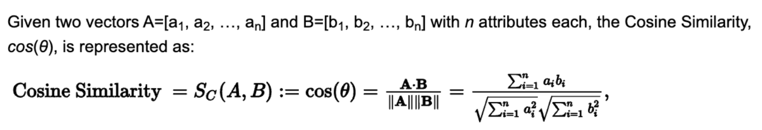

Distributional Similarity : meaning of word depends on context around target word
Distributed representation across tasks : Word2Vec, Doc2Vec, Gene2Vec, Prot2Vec, Node2Vec, Tweet2Vec, Emoji2Vec etc.

Based on Lesson 4 and the Basic Vectorization section, here are the mathematical formulas for the similarity and distance metrics you mentioned.

1. Euclidean Distance
This measures the "as-the-crow-flies" distance between two points in space. For two vectors $A$ and $B$:
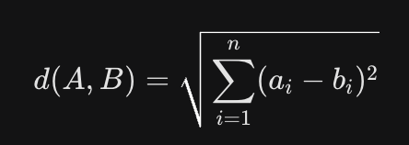
- Interpretation: A smaller value means the documents are more similar.

2. Jaccard Similarity
This is used for comparing sets of words (ignoring frequency).
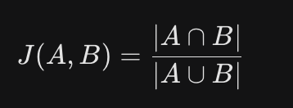
- Calculation: (Number of words in both) / (Total unique words in both).

3. Dice Coefficient
Similar to Jaccard, but it weights the intersection more heavily.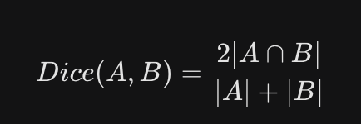
- Interpretation: Often used to measure how much two strings or sets overlap.

4. Lin Similarity
As noted in your Vector Semantics notes, this is a universal similarity metric based on Information Content (IC).

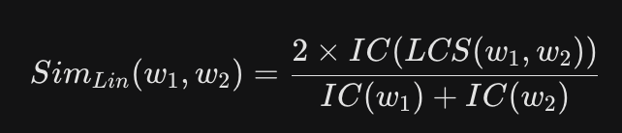
- LCS: Lowest Common Subsumer (the most specific "parent" concept they share).
- IC: Information Content, usually calculated as -log P(concept)

5. Kullback-Leibler (KL) Divergence
Used to compare two probability distributions $P$ and $Q$.
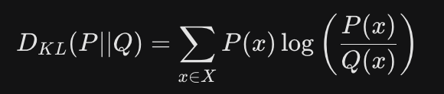
- Note: This is non-symmetric, meaning $D_{KL}(P || Q) \neq D_{KL}(Q || P)$. It measures the "extra information" required to represent $P$ using $Q$.

Summary of Differences
Metric | Formula Focus | Symmetry
Euclidean | Physical distance between coordinates | Symmetric
Jaccard | Set intersection vs. Union | Symmetric
Dice | Doubled intersection vs. Total size | Symmetric
Lin | Shared information in a hierarchy | Symmetric
KL Divergence | Difference in probability distributions | Non-Symmetric
Would you like to see a step-by-step calculation of Jaccard vs. Dice using a simple sentence example from your CBOW section?

Distributional Similarity
Meaning of a word understood by CONTEXT the word is in (surrounding words)
Similar context words are related
Denotation : (opposite of distributional similarity) literal meaning of word, precise meaning; devoid of emotion, attitude, metaphor
For example:
“He is a star.” The literal meaning of the word “star” is “planet,” but from the context, the word “star”
refers to a person that is growing quickly in popularity.
Distributional hypothesis
Eagle vs aeroplane diff because of context
Similar context => representation close to each other
Distributional Representation (word representation based on context) (approximates of distributed representation)
Textual vicinity === context
Vectors from co-occurrence matrix (co-occurrence of words and their context)
- one-hot
- bag of words
- bag of n-grams
- TF-IDF
Where the dimension of the co-occurrence matrix is equal to the vocabulary’s size |V| of the corpus.
Distributed Representation
related to the distributional hypothesis and distributional representation schemes.
- Unlike vectors in distributional representation, distributed representation schemes build
  - dense (i.e., hardly any zeros)
  - compact vectors of real numbers (i.e., low dimensional). The significant reduction of their dimensionality (e.g., 64 or 100 dimensions)
- make them computationally efficient
- much smaller than the vocabulary size of the corpus.
- opposite of localist representations (e.g., one-hot encoding)
- designed to capture similarity between related words.
- may be transformed by using matrix multiplication or by using non-linear functions to detect word analogy relationships for example.
- Word2vec and GloVe are typical distributed representations for large vocabulary sizes.

VECTOR SEMANTICS –
EMBEDDING = distributional based vectors -> distributed based vectors MAPPING
Static Embeddings (Word2Vec & GloVe):
- The Approach: Every word gets one fixed vector.
- The Flaw: These models struggle with polysemy (words with multiple meanings).
- Example: In Word2Vec, the word "bank" has the same vector whether you are talking about a "river bank" or a "savings bank." It averages the two meanings into one confusing middle ground.
- Word2vec
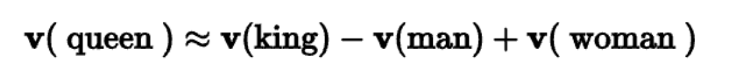
Contextualized Embeddings (BERT):
- The Approach: The vector for a word changes based on the words surrounding it.
- The Benefit: BERT creates a different mathematical representation for "bank" in the sentence "I sat on the river bank" than it does for "I went to the bank to deposit money."

WORD EMBEDDING ALGORITHMS (pre-trained word embedding)
Learns real valued vector representation from large corpus of distributional representation
Word2vec -> captures both semantic (king-man+woman=queen) and syntactic (apple-apples=car-cars) relationships through vector operation
USED WHEN WE HAVE A CORPUS
Low dimensional (50-500)
- CBoW (Continuous bag of words)
  - learns word representations so that they can predict a target word given its context words (syntactic relationships)
- Skip-gram
  - earns word representations to predict the context words given a target word (semantic relationship between words)
- Hierarchical softmax
- Negative sampling

- CBoW : for each center of word, predict target words with sliding window (size=2k+1 = words to the left + words to the right; window size = k)
Assign probability, P(W1 ,W2 , ...., Wn ) to the whole sentence m
(given =context word ; predict = target words)
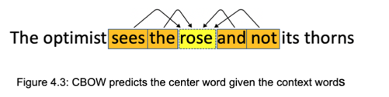

- used to learn word embeddings (like Word2Vec)
- Architecture:
  - One Hot encoding for all vocab in the corpus
  - Average/aggregated context vector
  - Difficult in polysemy (capture multiple meanings), Requires large corpus
  - L = window size hyperparameter
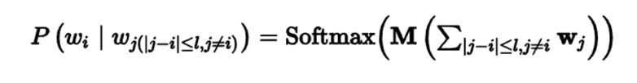
minimizing sum of negative log probabilities
- Cross Entropy Loss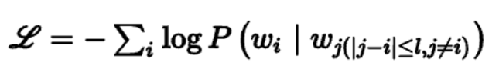
- Softmax activation for final probability in range {0,1}
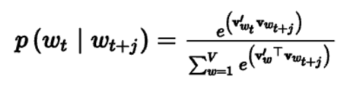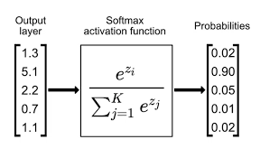
- Skip-gram
(given = target word ; predict = context words)
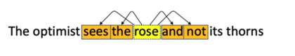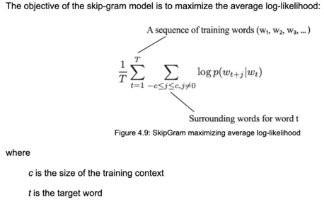
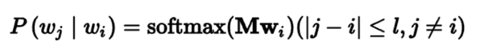 M = weight matrix, w_i = word
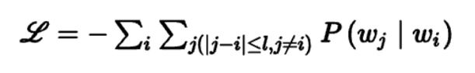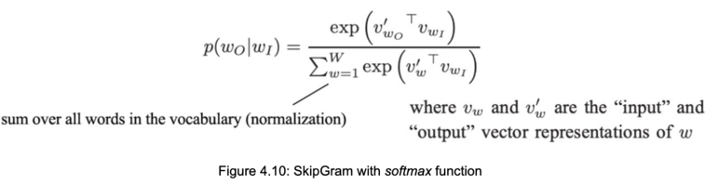shorter training contexts result in vectors that capture syntactic relationships whereas larger context windows lead to capture semantic relationships.
- HIERARCHICAL SOFTMAX
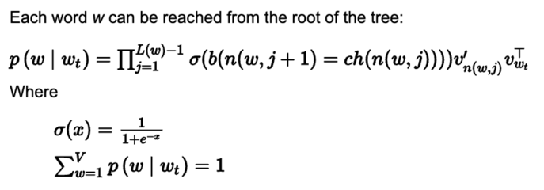
The hierarchical softmax constructs a binary tree of classes for all words and estimates the probability of a word by estimating the conditional probability
of its corresponding hierarchical class.

- NEGATIVE SAMPLING
Based on NCE (Noise Contrastive Estimation)
Approximates the probability of the target word
Samples k words as negative samples according to word frequency
Calculates softmax over k+1 words
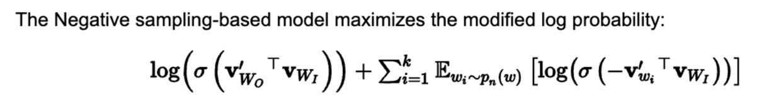
We want the Sigmoid probability of the actual context-target pairs to be high.

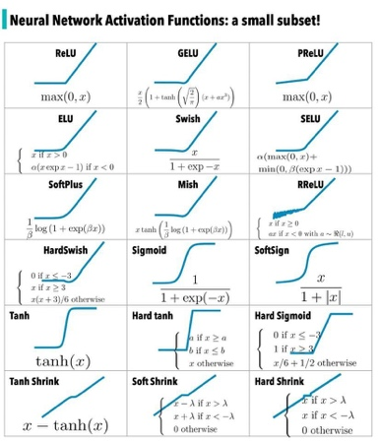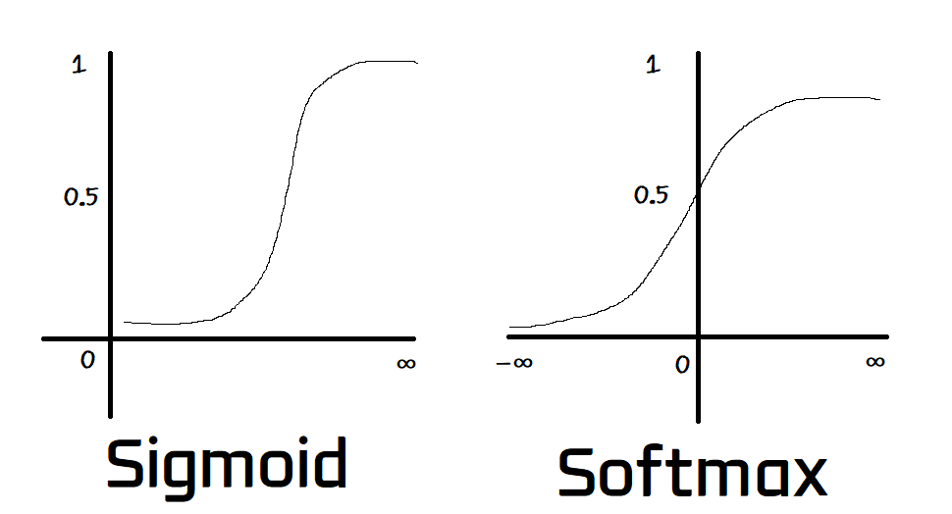

- GloVe (Global Vectors) = co-occurrence matrix (semantic+syntactic relationships; like word2vec)
USED WHEN WE DON’T HAVE A CORPUS
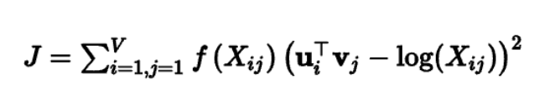
V is the size of the vocabulary,
Xij is the count of times that words i and j co-occur in the corpus
f is a weighting function that acts to reduce the pact of frequent counts, and
ui and vj are word vectors.

Calculate J, then gradient descent to tweak the numbers
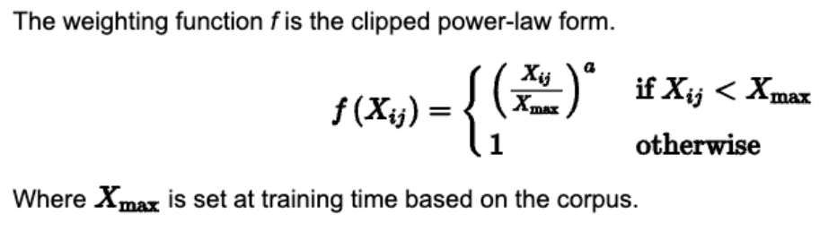

PCA
2D data
X_i’s
Y_j’s
Avg of X_i
Avg of Y_j
Shift Center at origin

To explain PCA mathematically, let's use a small, manageable dataset of two genes measured in three mice. This will allow us to walk through the manual calculations for centering, rotating, and finding the first Principal Component (PC1).

1. The Dataset
Imagine we have two variables (Gene 1 and Gene 2) and three samples (Mice):
Mouse | Gene 1 (X) | Gene 2 (Y)
Mouse A | 10 | 11
Mouse B | 11 | 12
Mouse C | 8 | 9

2. Step 1: Center the Data
PCA requires the data to be centered at the origin $(0,0)$. We do this by subtracting the mean of each column from every value.
- Mean of Gene 1 ($\bar{X}$): $(10 + 11 + 8) / 3 = 9.67$
- Mean of Gene 2 ($\bar{Y}$): $(11 + 12 + 9) / 3 = 10.67$
Centered Data:
- Mouse A: $(10 - 9.67, 11 - 10.67) = (0.33, 0.33)$
- Mouse B: $(11 - 9.67, 12 - 10.67) = (1.33, 1.33)$
- Mouse C: $(8 - 9.67, 9 - 10.67) = (-1.67, -1.67)$

3. Finding the Best Fitting Line (PC1)
PCA now tries to draw a line through $(0,0)$ that fits these three points as closely as possible.
- The Math Strategy: PCA maximizes the Sum of Squared Distances ($SS$) from the origin to the projected points on the line.
- The Observation: Notice that for every point, $X$ and $Y$ are identical ($0.33 = 0.33$, etc.). This means the points fall perfectly on a 45-degree diagonal line.
- The Slope: Since $Y$ increases exactly as much as $X$, the slope is $1$. For every 1 unit of Gene 1, we have 1 unit of Gene 2.

4. Step 3: Calculate the Unit Vector (Eigenvector)
The "recipe" for PC1 must be scaled so that its total length is 1. We use the Pythagorean theorem:
$$\text{Length} = \sqrt{1^2 + 1^2} = \sqrt{2} \approx 1.41$$
To get the Unit Vector (Eigenvector), divide the direction by the length:
- Gene 1 Loading: $1 / 1.41 = \mathbf{0.707}$
- Gene 2 Loading: $1 / 1.41 = \mathbf{0.707}$
Result: The Eigenvector for PC1 is $[0.707, 0.707]$. This means both genes contribute equally to the first principal component.

5. Step 4: Calculate the Variation (Eigenvalue)

($d = X . u1 + Y .u2$) ; (u1,u2)=( 0.707, 0.707)
To find the Eigenvalue (the amount of variation captured by PC1), we project the points onto the line and sum their squares. The distance of a projected point $(x, y)$ onto a unit vector $[u_1, u_2]$ is calculated as $d = (x \cdot u_1) + (y \cdot u_2)$.
- Distance A: $(0.33 \times 0.707) + (0.33 \times 0.707) \approx 0.467$
- Distance B: $(1.33 \times 0.707) + (1.33 \times 0.707) \approx 1.881$
- Distance C: $(-1.67 \times 0.707) + (-1.67 \times 0.707) \approx -2.361$
Now, square them and sum them (Sum of Squares):
$$SS = (0.467)^2 + (1.881)^2 + (-2.361)^2 \approx 0.218 + 3.538 + 5.574 = \mathbf{9.33}$$
The Eigenvalue is typically this sum divided by $(n-1)$:
$$\text{Eigenvalue} = 9.33 / (3 - 1) = \mathbf{4.665}$$

Summary of Results
- PC1 Eigenvector: $[0.707, 0.707]$ (The direction of maximum spread).
- Eigenvalue: $4.665$ (The "strength" or variation of that spread).
- Interpretation: Because Gene 1 and Gene 2 are perfectly correlated in this example ($10,11 \to 11,12 \to 8,9$), PC1 captures 100% of the variation, and any PC2 would have an Eigenvalue of $0$.
Would you like me to show you how to calculate the Scree Plot percentages if we had a second component with a smaller eigenvalue?

Visualization embedding
t-SNE (t Stochastic Neighboring Embedding)
- Visualize high-D data and project to two- or three-dimensional data
- Similarity of points on scatter plot
- Dist bw 2 points
- Plot on normal curve
- Unscaled similarity score given
- Scale the similarity score so that they add up to 1
- Less dense regions = wider curves
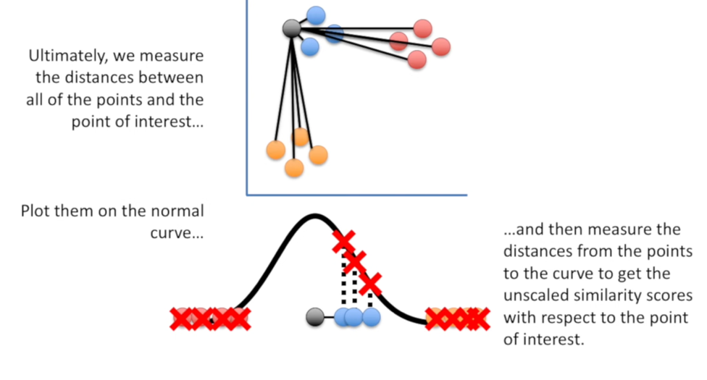

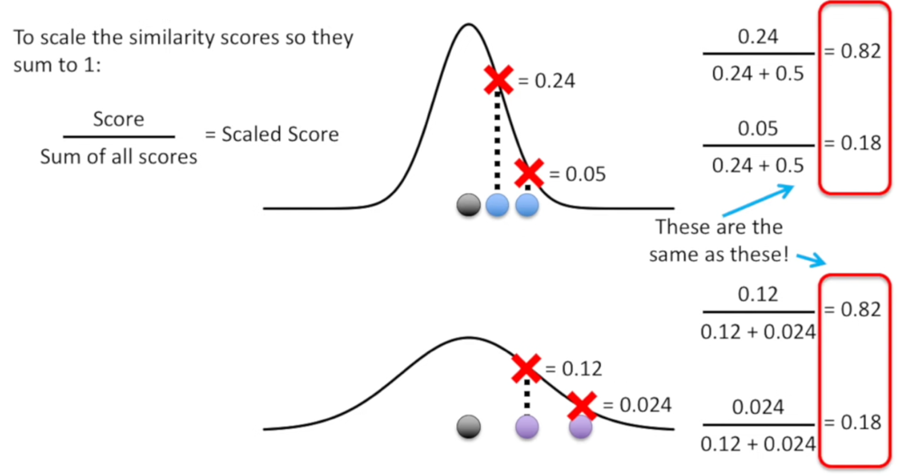

- Similarity scores are nearly the same(ratios are same)
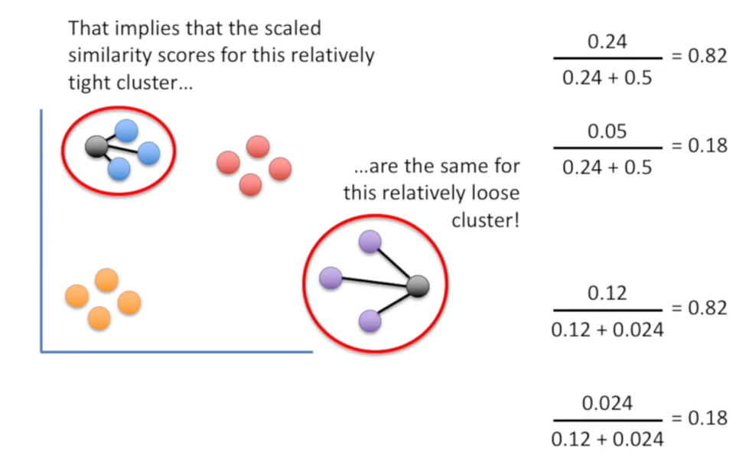

- Reality –
perplexity = expected density

- t-distribution is used for t in t-SNE
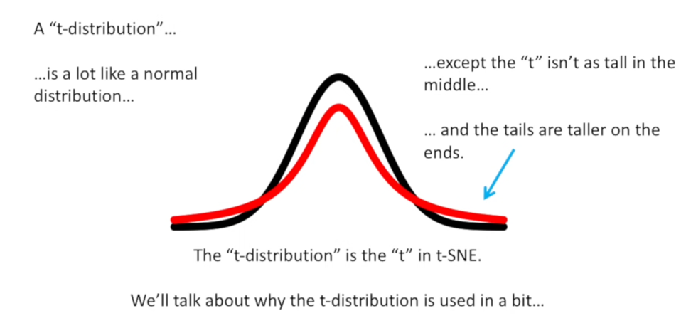
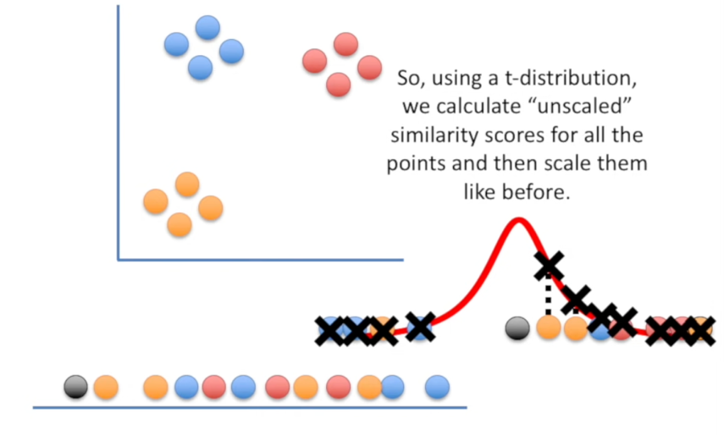
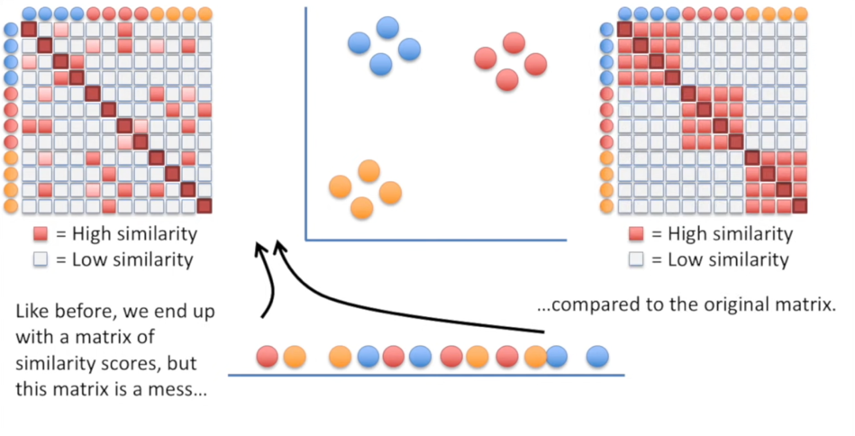
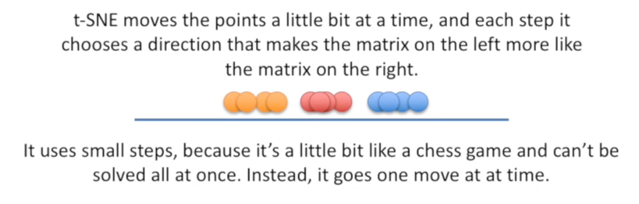

LESSON 5
CNNs discuss how their characteristics and what make them suitable for text classification such as:
- detecting spam filtering
- detecting sentiment from movie reviews
Text classification is sometimes also referred to as topic classification, text categorization, or document categorization

Applications –
- Content classification: aims to classify large amounts of textual data, including news websites, blogs, online bookshelves, product reviews, reddit review and tweets.
- Customer support: identify sentiments and opinions about and experiences of products or services.
- E-commerce: analyze customers’ perception of a product or service based on their reviews.
- Language identification which aims to identifying the language of new tweets, posts automatic language translation (detect the language in Google Translate).
- Authorship attribution which aims to identify unknown authors of texts from a list of known authors in fields such as forensic analysis to literary studies.
- Triaging posts in online support forums to classify text classification from clinical data.
- Fake news and misinformation which aim to segregate fake news from real news.

Convolutional Neural Networks
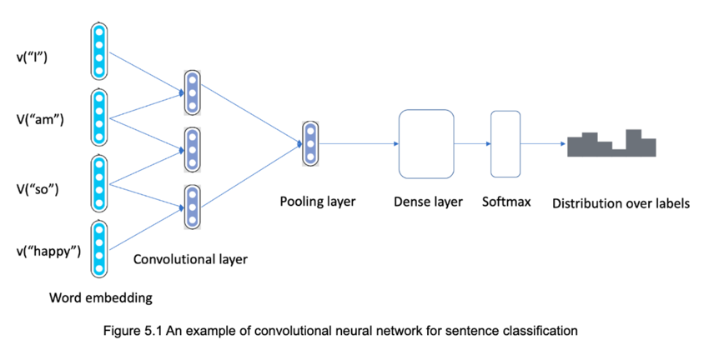
CONV operation + Max pool/average pool + Dense layer + Softmax activation function
Main building blocks include:
  - Word Embedding: A distributed and dense representation of words. Words that have a similar meaning based on their context also have a similar representation in the embedding space.
  - Convolutional layers: a model that extracts linguistics features and patterns (e.g. tokens or sequences of tokens) from input sentences represented using a word embedding.
  - Fully Connected layers: restructure the extracted patterns to generate a predictive output using activation functions such as Softmax in text classification problem.
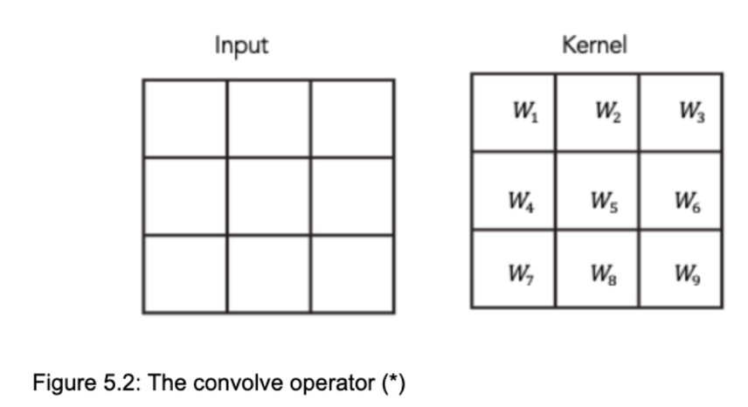
Convolution layer = feature map
The convolutional layer output is sometimes called a feature map to denote
- the learned representations (features or patterns) from the spatial dimensions (eg, width and height)
- In computer vision, images are resented as a three-dimensional structure/tensor (channel, height, width) which with a height, width and depth (also called channel).
- Each pixel, at a given point in the image, is encoded as three-color channels: red, blue and green channels, and has a color intensity in each color channel with value ranging from 0 to 255 -> (R,G,B) = [0,255] PIXEL VALUES
To build a convolution layer for input with multiple channels, we need to construct a tensor of convolution filters with the same number of input channels as the input data. Each kernel convolves one input channel at a time.
C_i = channels of input tensor = input channels of convolution kernel
Convolution filter window = k_h * k_w

CONV FILTER (3D tensor) = c_i * k_h * k_w
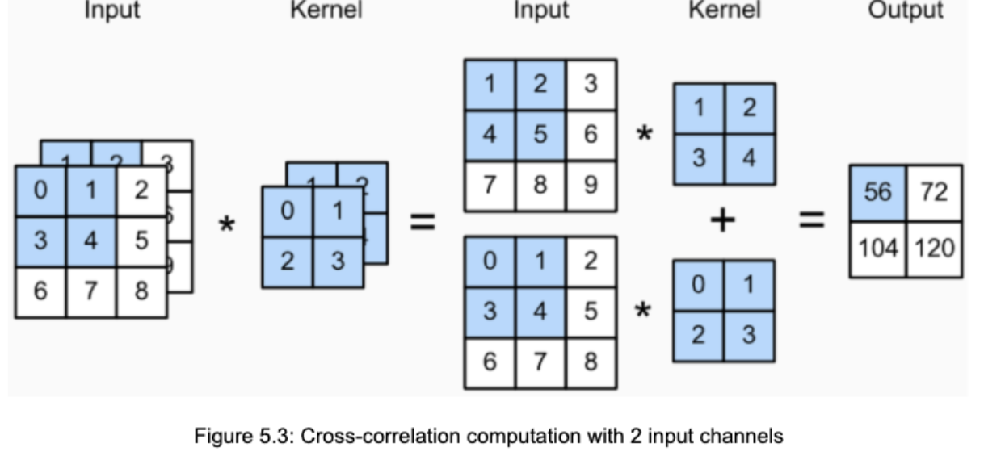
Output tensor has 1 channel
Eg, 3 channels+2 kernels -> vertical edge & horizontal edge filter
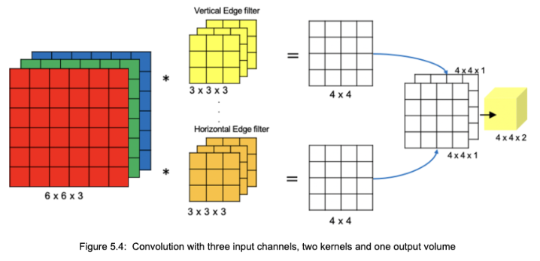
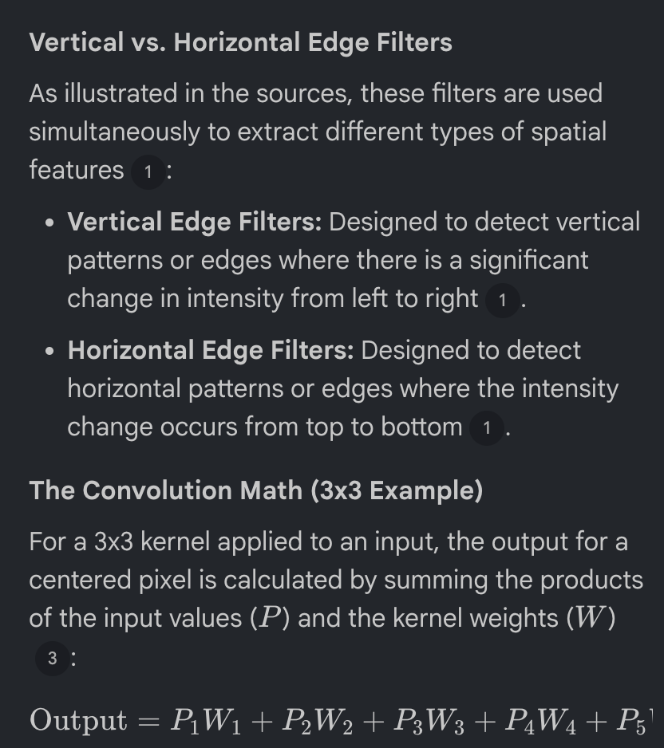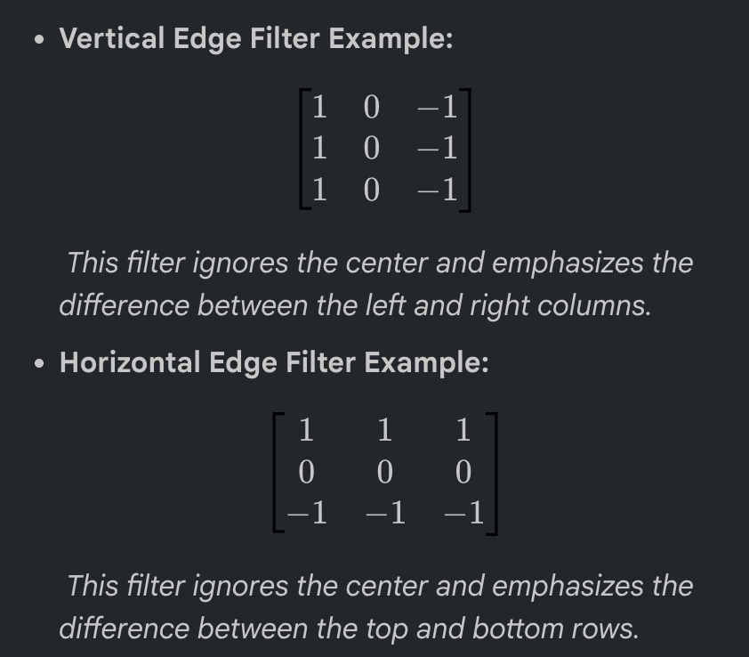

MAX POOL & AVERAGE POOL ->
Down sampling feature maps by summarizing average presence of feature 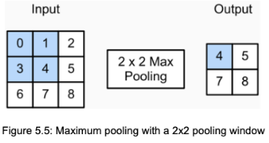
SINGLE LAYER CNN [use case = sentence classification]
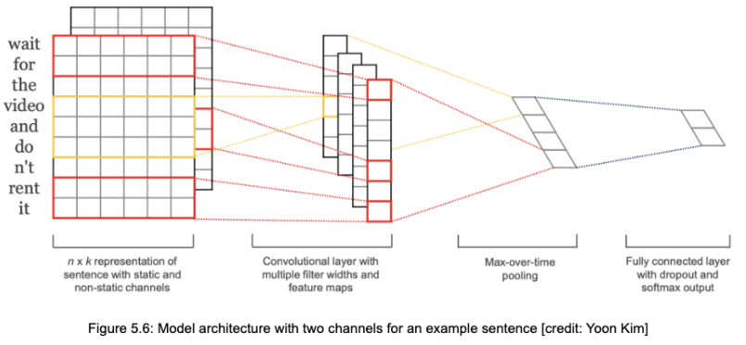
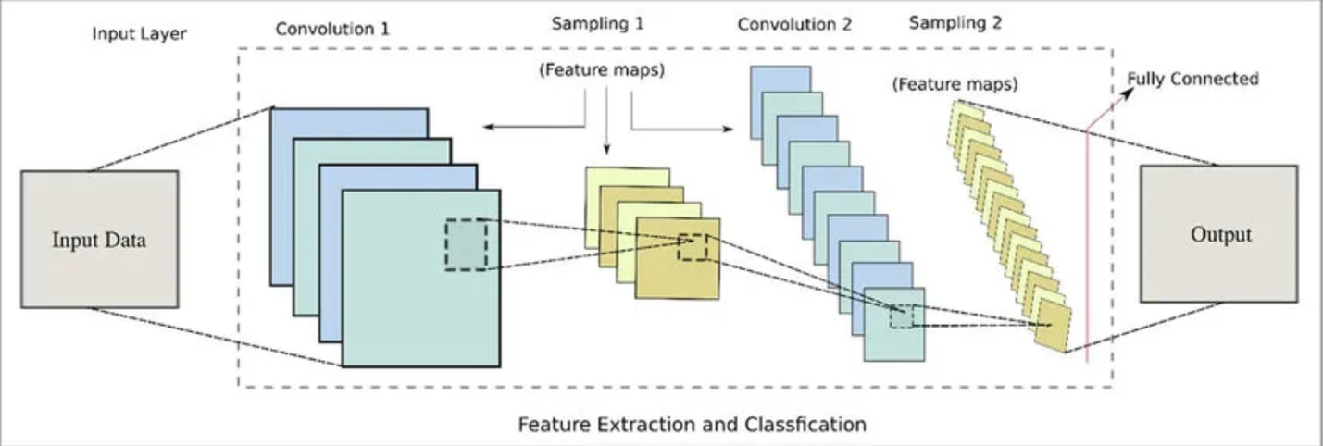
Convolution layers = map features into input dataset
Filters = used on input dataset
Feature maps
Pooling layers = feature engineering/dimensionality reduction

Convolution over inputs
There are some parameters associated with that sliding filter like how much input to take at once and by what extent should input be overlapped.
- Stride: Size of the step filter moves every instance of time.
- Filter count: Number of filters we want to use.
- Activation function
- Padding surrounding input (improves performance, filter size and stride fits well)

Pooling layer
- Prevents overfit (memorize>learning)
- Max pool OR Average pool

Dense layer
- Scale, rotate, transform vector by multiplying Matrix and vector
- Last dense layer with 1 parameter because binary classification
model.add(Dense(250, activation='relu'))
model.add(Dense(1, activation='sigmoid'))

Flatten layer
- 3D data to 1D vector
Optimizer and Loss function

CNN for text classification
if the data is not embedded then there are many various embeddings available open-source like Glove and Word2Vec.

Transfer function: rectified linear
Kernel sizes: 2, 4, 5
Number of filters: 100
Dropout rate: 0.5
Weight regularization (L2): 3
Batch Size: 50
Update Rule: Adadelta
Find optimal hyperparameters:
- Batch size
- Filter sizes
- Number of filters
- Regularization parameters

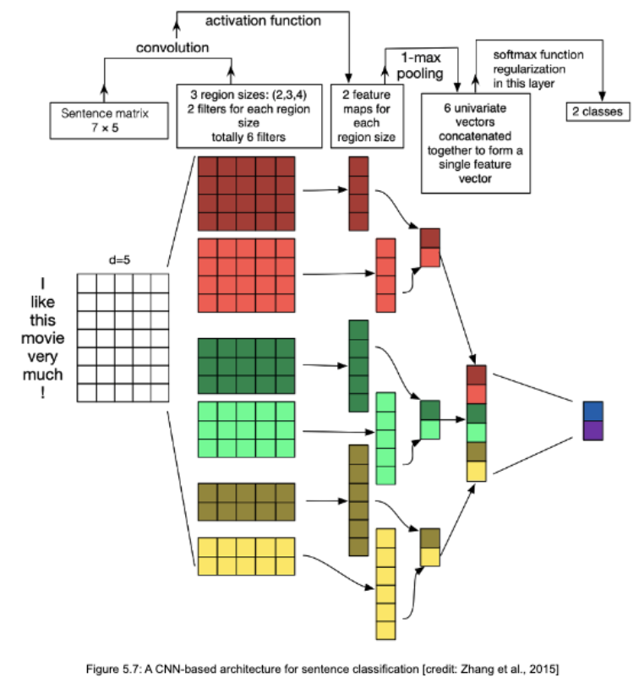
CNN for text classification
- Pre-trained Word2Vec and GloVe embeddings instead of one-hot encoders
- 1 max pool outperformed by other pool
- Drop regularization (little effect on performance) – Dropout is a regularization technique
- Grid search across kernel sizes (1-10) and find optimal configuration for NLP task

Character-level CNNs
Text documents modeled with character-level representations
- Learn hierarchical structure of words, sentences, paragraphs
- Eliminate cleaning and pre-processing

The character encoding is done by a vector representation (one-hot encoding), prescribing an alphabet of size m for the input language.
The sequence of characters is encoded as a sequence of such m sized vectors with fixed length l0. Any character exceeding length l0 is ignored,
and any characters that are not in the alphabet including blank characters are represented as all-zero vectors
L=1024

